***Before Optimization***

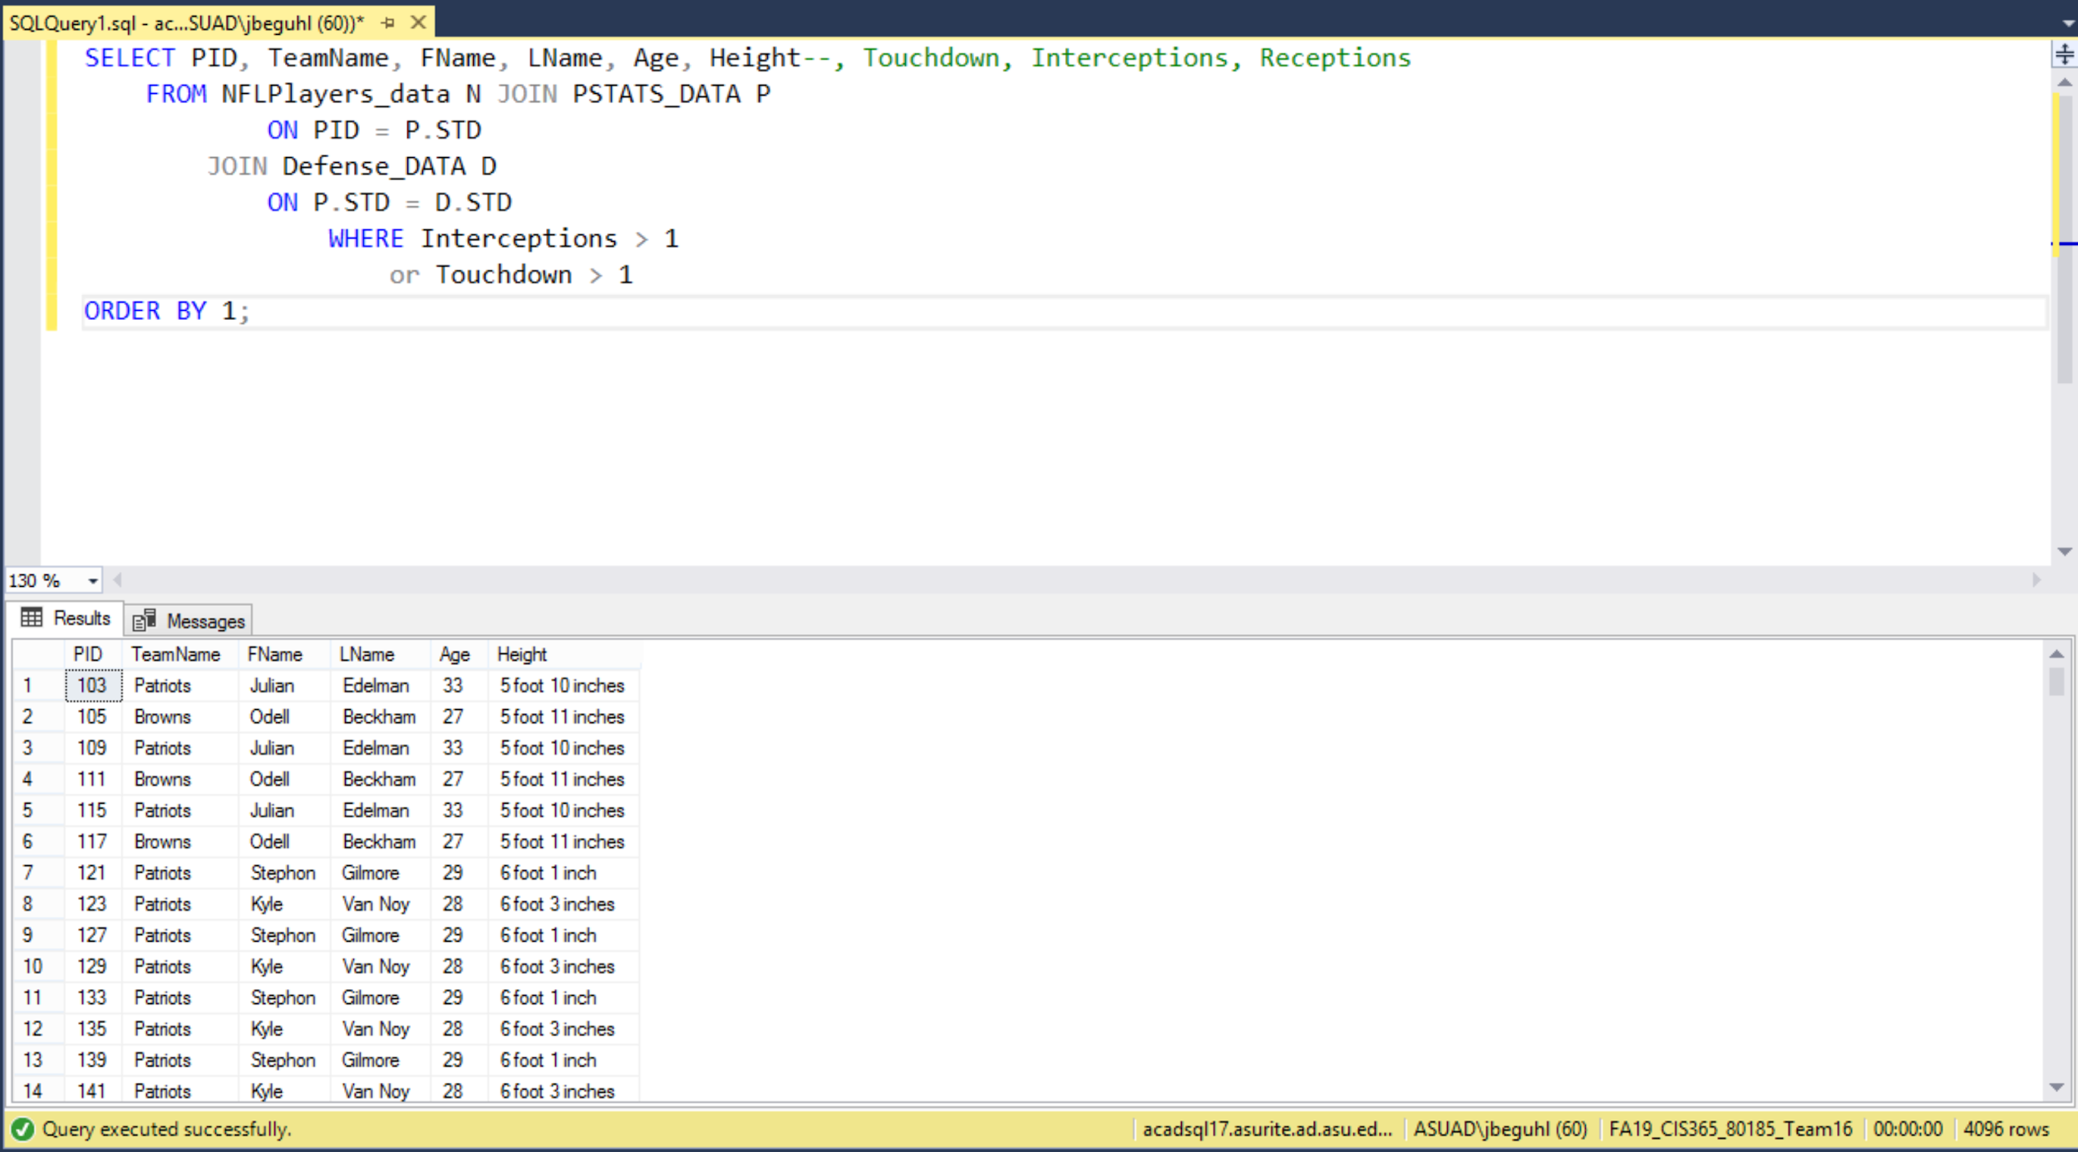

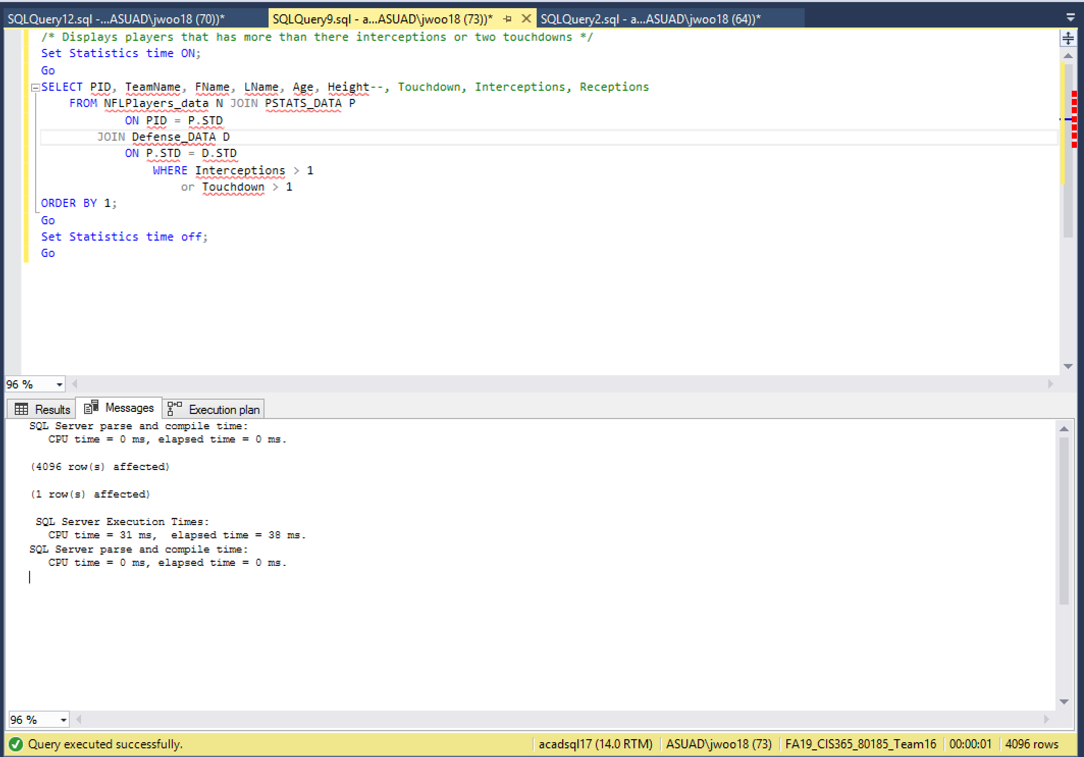

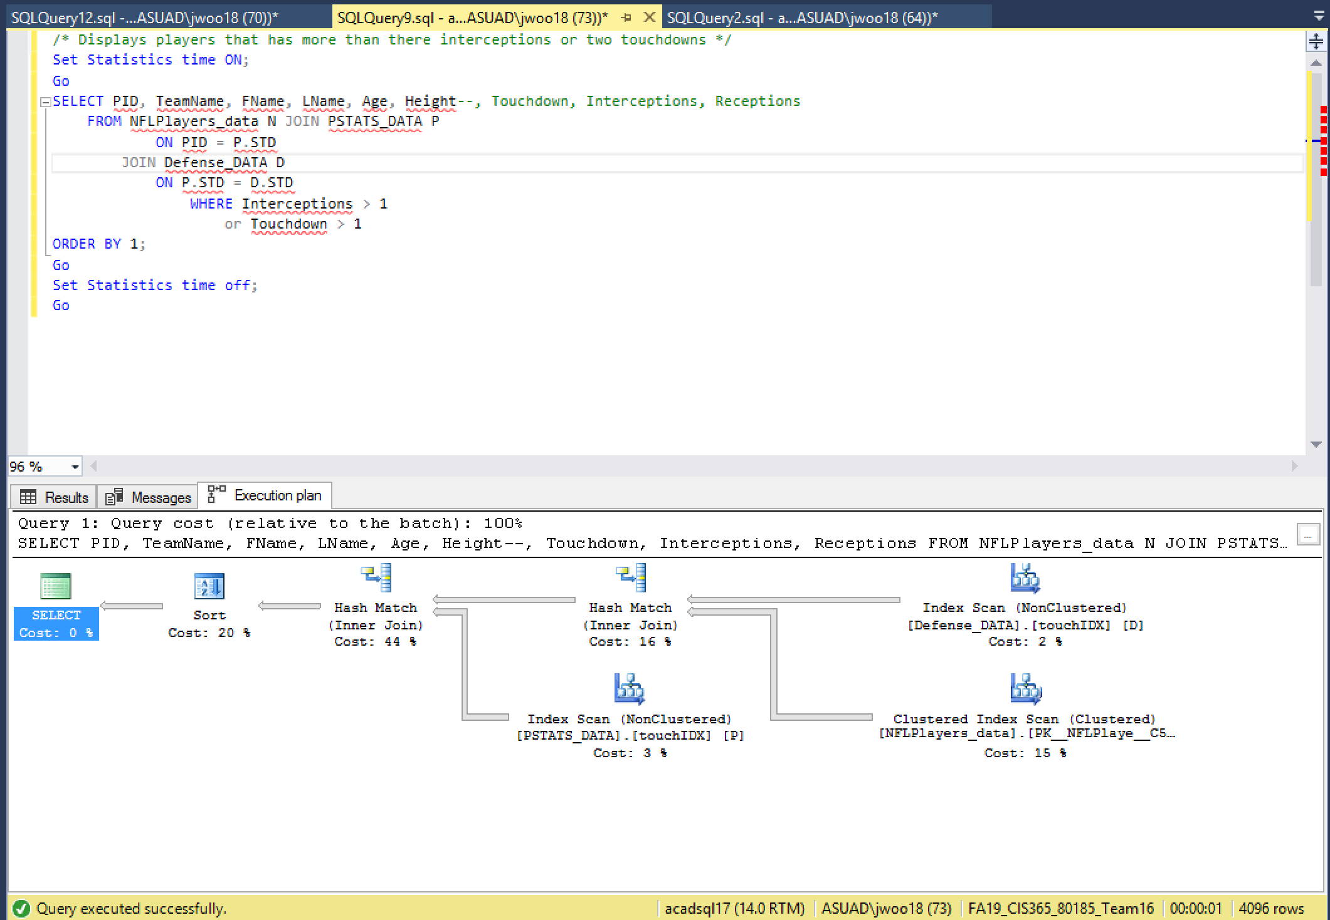

***After optimization***

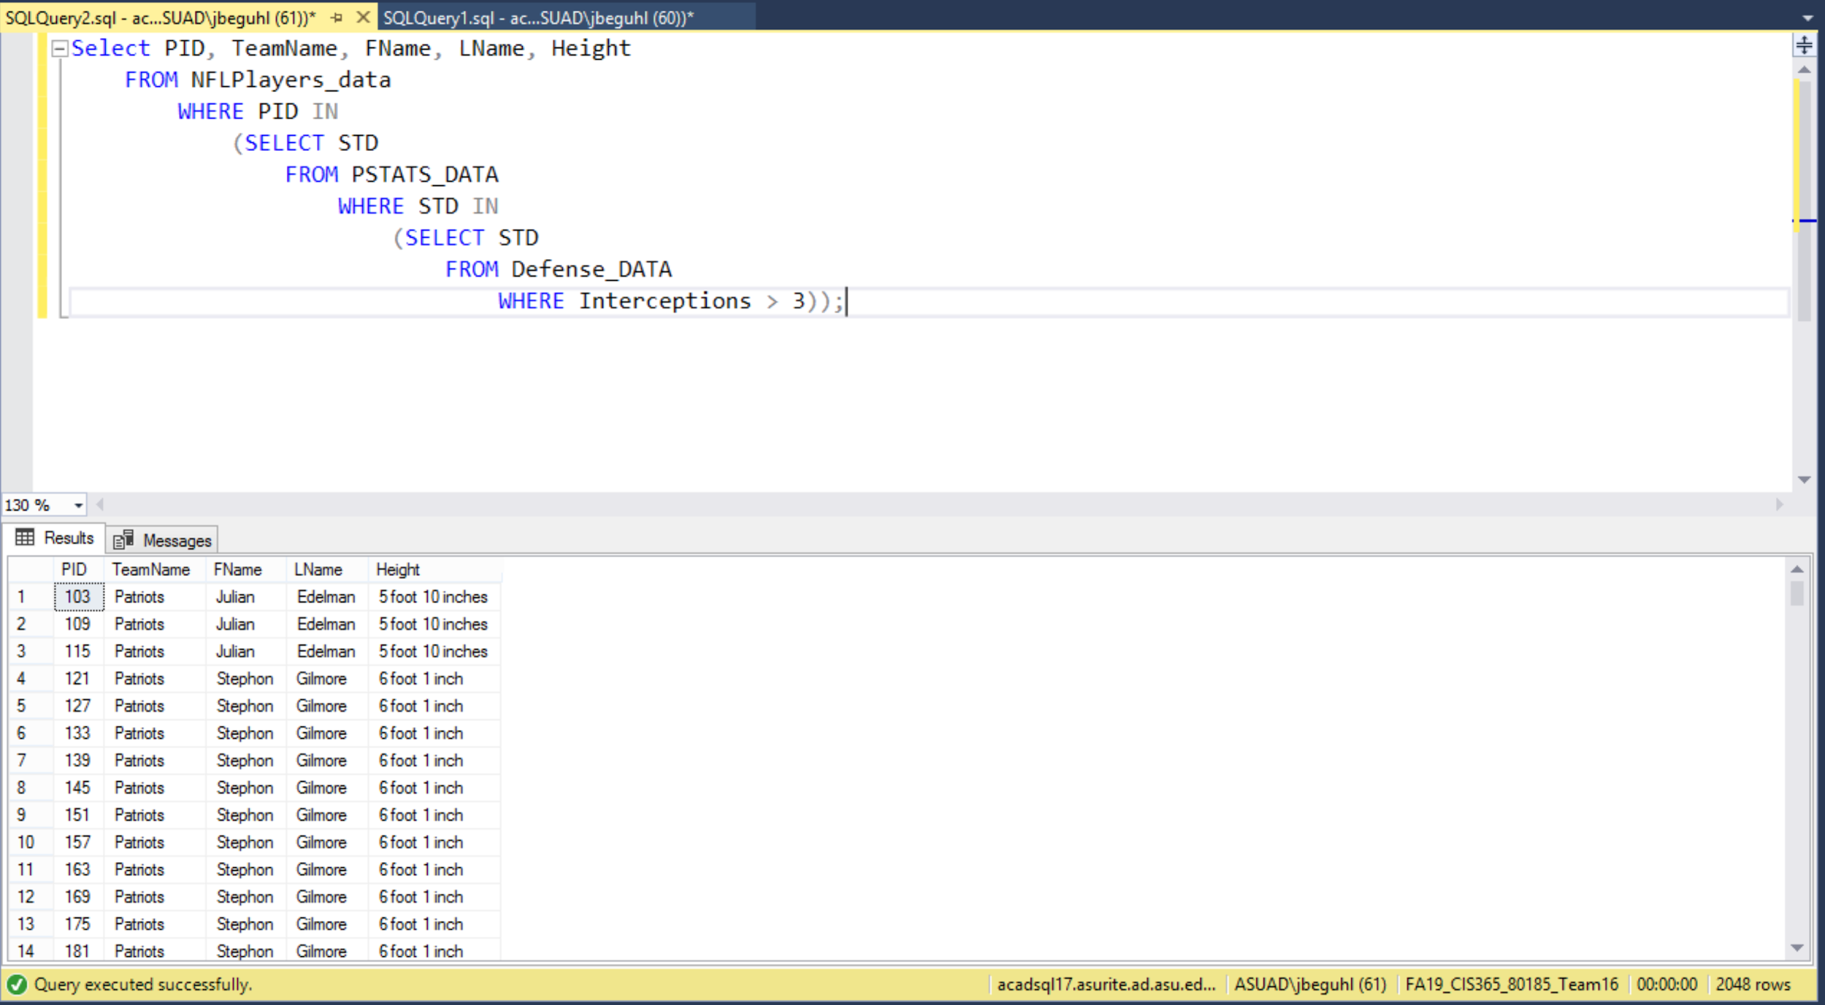

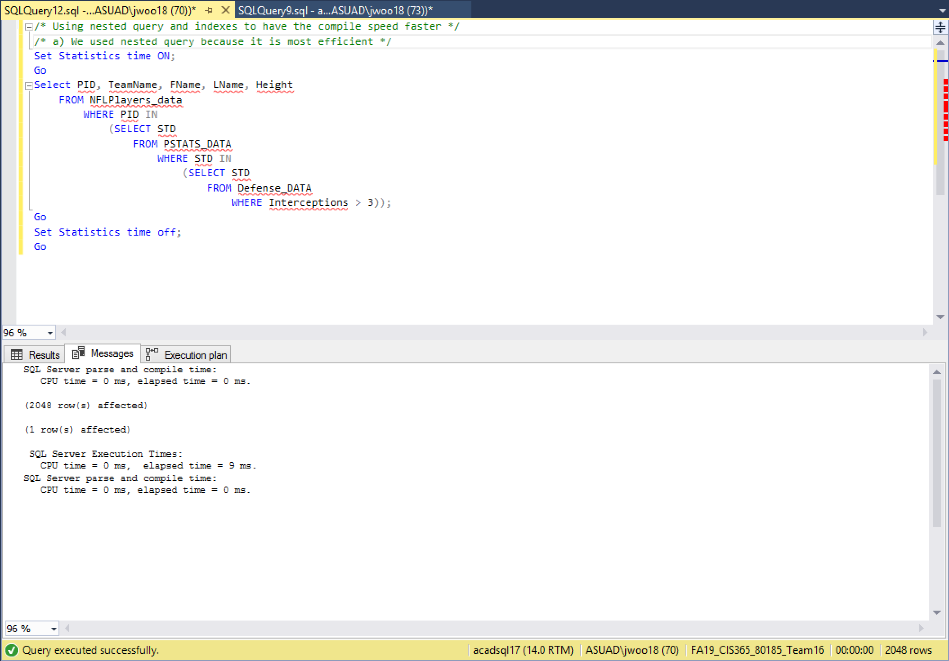

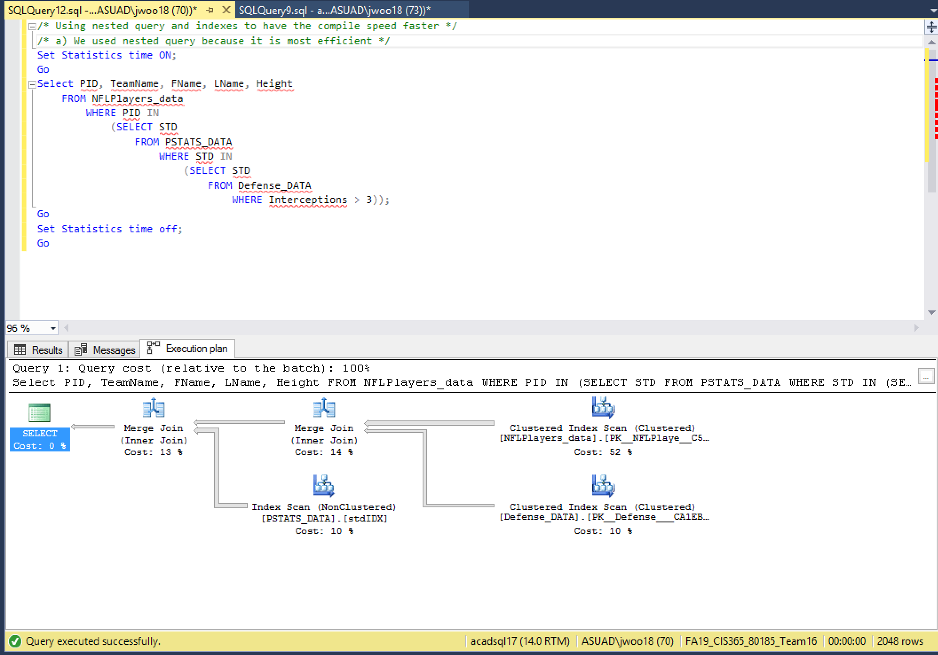

***Findings***

We found that before optimizing our query and improving the physical design it was more taxing on the DBMS. Once we did use nested queries instead of using joins the query was less harsh on the DBMS as shown in the Query plan. The execution time was reduced by more than four times once we implemented the nested queries. To further improve the query we would add more tables and refine the optimized query even further.