**SAAD ASSIGNMENT FINAL:**

|  |  |
| --- | --- |
| **Group Members** | **Roll number** |
| **Ankit Acharya** | **NPI000140** |
| **Anmol Malla Thakuri** | **NPI000141** |
| **Jiten Chapagain** | **NPI000150** |
| **Pukar Nepali** | **NPI000165** |
| **Rangin Basnet** | **NPI000167** |
| **Satindra Bahadur Khadka** | **NPI000178** |

**Introduction**

This system was created as per the request from the Pacific health club. The request was to create a system which helps to manage the details of members, instructors and classes, various fees as well as updated payment, attendance of member and instructor and their respective classes, etc. This system was successfully created from a lot of research and hard work of our company. This project consists of research of various things in analysis phase, uses of various website and software designer in design phase, lots of software, hardware as well as human resources in implementation phase. This system tries its best to fulfill its purpose.

**Acknowledgement**

We would like to express our inner joy to APU and Infomax college family. We would heartly thank our faculty teacher Mr. Jupiter Tamrakar for endless support and guidelines through out the project. We had an awesome experience as a group doing this assignment. As a team each member’s participation was amazingly admirable. We had an amazing learning experience during the whole process and had a wonderful time.

**Introduction of the Company:**

Pokhara based company Bytes Enterprises Ltd was founded in 2015 which is manage by highly experienced Information technology (IT) Professional in order to provide service in software development area, security-based design, IT groundwork Management Company in our home country Nepal.

We have branches in majors’ cities of our country like Pokhara, Kathmandu, Chitwan and Butwal. Furthermore, we have more than 50 employees working with us. From the past few years Bytes Enterprise has provided an extensive range of technology. Beside this, through its partnership companies are achieving goal that cannot be achieved by a single company alone. Our experts have many years of experience in advising organization and implementing proposed solution and customer-requested solution.

**Logo**



**Vision**

Becoming a leading technology provider in Asia by developing high quality mobility products and services, partnering with the most renowned mobility solution providers to meet customer expectations and achieve a measurable competitive advantage. On the other hand, our main vision is to become an international company that symbolizes value and proven high-quality service. To be a reference in development of software and information technology.

**Mission**

To become an integral partner for our customers by combining localization, best practices and excellent services to provide and manage the best vendors and service providers in the field of information technology. Our mission is to continuously improve the quality of service that we are providing to customer through our service and become the leading IT Company in the region.

**Motto**

“FOR EVERY TECH SOLUTION”

**Overview of the business process of the new proposed management system.**

With our assist, you can easily manage your administrative obligations, make payments, and even market  your business. Make advertisements to run on social Medias and create a custom website to introduce your  product with a free trial. Excellent beginning. Allow clients to book yoga classes directly from Google search  results, as well as provide virtual classes. Rent out yoga equipment. Take care of employees and payroll. Manage member and attendance reports. Create automated waitlists for full classes. Create and send online wavers. Allow group bookings for clients to book together with friends. ​

**Problems and their solutions:**

The recent working model of “One Pacific Health Club” has many issues within it which may obstruct in the mission and vision of the club to become one of the leading institutions of its kind. Here all the system are carried out manually and are paper based. Member registration, assigning them their private class routine, billing system, bookings done for classes etc. all are done by the staffs manually on paper. Besides this instructor’s routine, staffs record like attendance are to be maintained. All these stuffs need a plenty of paper work which is not hassle free. Thus, the system could have many flaws in costumer services and office management. Some of the common challenges of the existing system are discussed below.

**Problem and Causes:**

1. **Time consuming**:

Obviously, people of this era are more time conscious then they had been ever. People have no patience to wait for longer period of time. Thus, working in manual system taking more time of costumer produce dis satisfaction among the costumers.

1. **Complication in file handling:**

Since the information are written manually and stored in files it is difficult to find any piece of information within short period of time. This keeps the employee engaged and slowdowns the entire system.

1. **Economic burden:**

In file-based system more staffs are required to run the institution smoothly as employees need to stick on small task like searching files etc. for longer period of time. So, it creates economic burden to the stakeholders.

1. **Transaction error**:

Since all the transactions are carried out manually there are chances of human errors.

1. **Time clashes:**

Since schedules are generated by the employees manually i.e., no software is used, thus time may clash which may create a problem. E.g., an instructor assigned two classes at the same time.

1. **Data insecurity:**

In this system there is no back up of any data or information which can create havoc situation to the institution at any time due to loss of data.

1. **Business analysis**:

Business reports should be generated manually which is difficult and takes time.

 In common the above problems in the existing working model leads the health club to serious problem in coming future. The dissatisfaction in the costumer will decrease the flow of students in the health club. This may create financial problems so that the club may not survive in this competitive market.

**Their Solution:**

1. **Centralized Database:**

It ensures the solution for many of the above-mentioned problems. It secures the data, saves the time of employee and helps to operate the institution flawlessly.

1. **Online mode of service:**

Online mode of service provides ease of access to the costumer. The health club reaches to mass people which helps to increase its number of costumers. It saves time for both costumer and the institution.

1. **Digital payment channel:**

This will make the transaction activities automated and cashless. Thus, costumer doesn’t need to carry cash with them and no transaction errors.

**The aim and objective of the Proposed System:**

* The proposed system aims to completely digitize the existing system with database management system providing all required online mode of services.
* We aim to provide costumer reliable and handy mode of service.
* Costumer should no longer stay in queue waiting for their turn instead they can do all registration, payment bookings online.
* Costumer can view their class schedules on their mobile and are notified earlier about any changes regarding their schedules, payments, holidays etc.
* The new system will have data backup for the institution at any kind of undesired circumstances.
* There will be no any human errors during billing and other transactions will be flawless.
* New system will save time and requires less number of staff to operate.

**System development life cycle:**

It is the method of planning, analysis, designing, implementing and maintaining the new proposed system and software of the organization. It define the overall process of maintaining the main them of the software and overall development phenomenon. According to the case, our task is to make the new software and system of pacific health club.

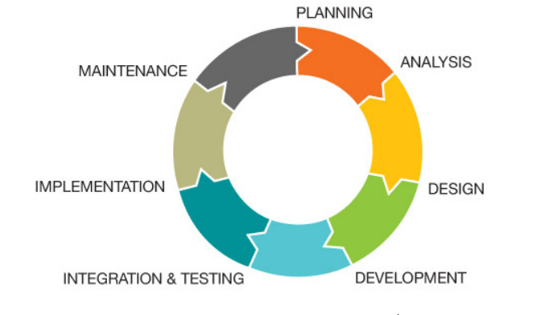

**Planning stage:**

It is the main stage in the SDLC phase in which make the fundamental structure of task, finding out the different study about the different task that will harms the project activates. The main purpose of this phase is to perform a preliminary investigation to evaluate an all form of opportunities and problem. Whereas, in pacific health club, we make plan in different stages from managing detail to producing reports of the member involving the payment detail.

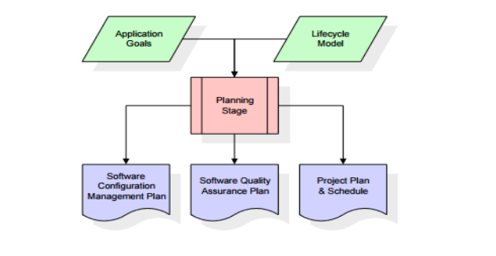

The making plans segment in our proposed gadget is done via way of means of the chosen team`s individuals to acquire contributions from the pinnacle control or the figures’ sources with inside the gym. Our decided on individuals will perform a little initial investigations approximately the gym issues and the preferred dreams so one can be written with inside the initial investigations document. This document defines the all of the obligations so one can be executed, monitored, managed and the venture closing.

**Analysis**

In this stage we made the system requirement document with the help of preliminary investigation report. The main purpose of the stage is to build a logical modes for the new system which overcome the old management system. The best solution are taken for the guide of the project. Furthermore this phase determine the responsible person of the project and the deadline of the project.

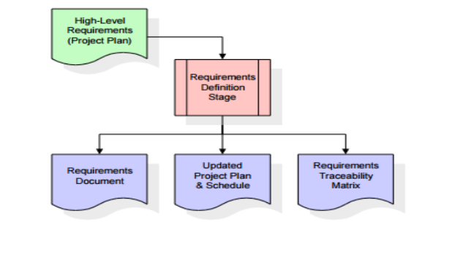

**Design**

In this third phase of the system development life cycle we created all document required for the system. This phase explain the required specification, feature of operation of the purposed system. In different words, it's far the manner of making ready diagrammatic representations of the architectural version both logical and bodily primarily based totally at the SRS. All the permitted necessities in file could have unique proposals that define the software program capabilities in element. They may be defined as useful ladder maps, boundary diagrams, enterprise policies and technique figures, pseudocode or flowchart, or an entity-dating diagram with an information dictionary. As soon as the layout level is finished and permitted, every obligation could take its personal layout detail which suggests how the machine fulfils the wishes and the way it's going to have interaction with the relaxation stages.

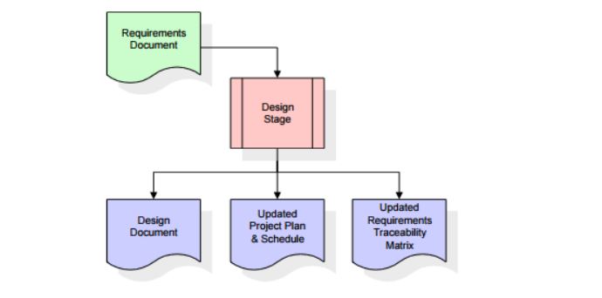

**Implementation stage**

As the new system is deployed, some activities will be included in the implementation phase. The actual development of the process is started in this phase likes programming code. As long as the project documentation for the earlier stage is detailed and written in a well-organized way, the code implementation will run very well. The developer is responsible for preparing the data entry set and ensuring that the code is created when the expected output meets Jim's requirements. In this phase, the conceptual structure is no longer present because it is already implemented in the programming source. The software will then be installed and gym users (members, instructors, etc.)

 Will be able to work and test on the fresh arrangement. In last phase, you need to document the system data to know in what way the system is fully functional and how it works.

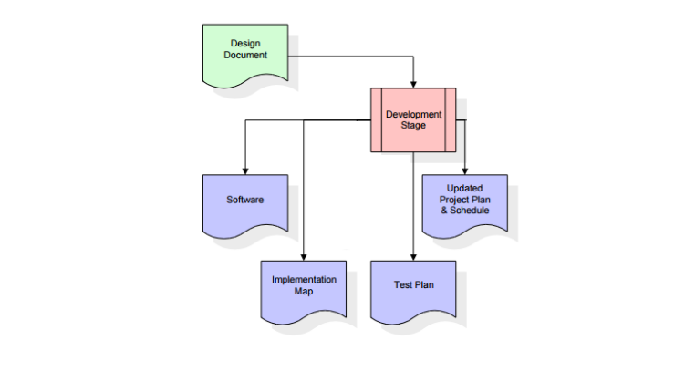

**Maintenance and support:**

After all the above phases the last phases of is to maintain the system in a proper order with its possible outcome. This system help to maintain the system to meet the requirement criteria. In this stage the system is update where there will be some of the changes in the system like adding and removing the system phase. In addition for the safety of the system our team will be in touch and help the system user to get all the idea from the system and maintain the security.

**Gann chart:**

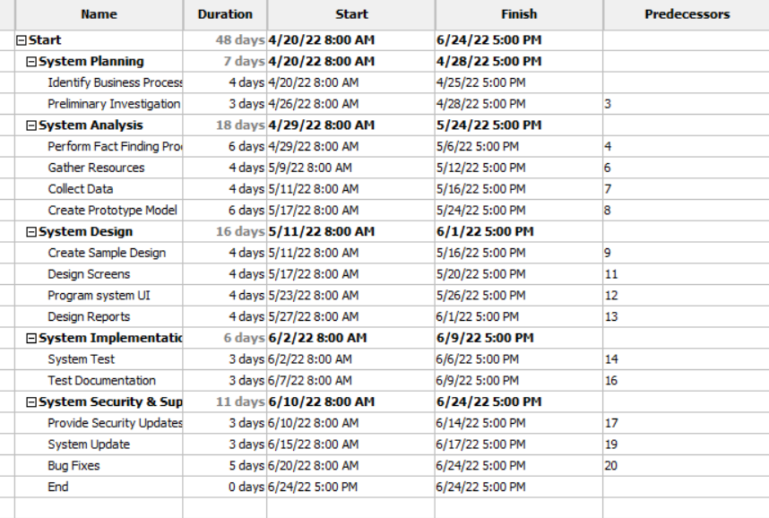

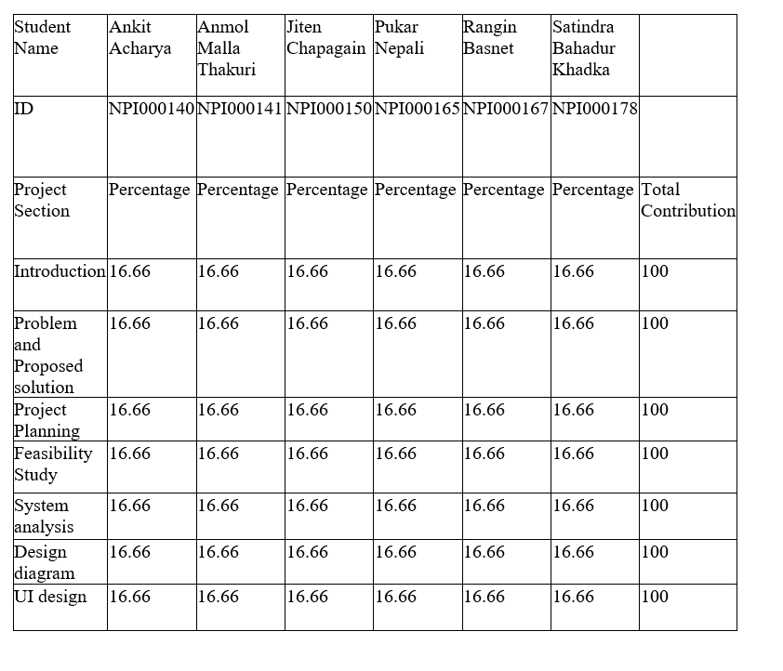

**Feasibility Study**

Feasibility study is carried out on the second phase of SDLC when request for change in the existing system is approved. Whenever we think of implementing a new system the first and foremost thing, we think of is the feasibility of the new system.

Feasibility study provides us the detail of whether or not the project has a reasonable chance of success, considering the following constraints.

1. Scheduled time table
2. Cost allocated
3. Technical availability
4. Operational feasibility

It helps the project manager to investigate the pros and cons of the project before investing too much of time and money. If any problems are detected in this phase management team can take decision to overcome them.

**Operational feasibility**

The feasibility of the new framework is measured in this case. It helps exploit opportunities and satisfies requirements as they emerge during the increase of the project. It ensures that both management and consumers remain on board. The current business condition and improvement targets are considered in an Operational feasibility estimation to see by what means well the planned project fits in. Conveyance data and existing business processes are also considered.

The project feasibility evaluation examines whether the proposed improvement project is compatible with the company's current commercial environment and goals for upgrading, information delivery, shared culture, and current business procedures.

 It is imperative to ensure that the desired performance is met during proposal and improvement by conveying such framework secondary limitations as reliability, maintainability, supportability,

**Pieces framework of operational feasibility**

* **P(Performance)**

The letter P in pieces is described as the need to improvise the performance of the system. It helps to identify the system reply period and throughput. Throughout is the quantity of work done in a particular period, and reply period is the mediocre delay between a contract or appeal and the reply to that contract or from the system.   
   
There was a huge amount delay in response time in the current One Health Pacific Club monitoring framework. This manual framework is flawed and misleading the user which is ruining their business**.** The proposed framework can store lesson dates and appointments i.e., schedule in a route that can be viewed and updated electronically. The framework should be able to make the user interface of booking forms and creating invoices to individuals daily and print instructor private class and regular class scheduling. Electronic tasks can also reduce response time. In addition, the framework needs to be able to properly retrieve customer data as needed.   
   
Additionally, you can use this proposed framework to provide individuals with confirmation messages to confirm their appointment the day before the lesson.   
   
 

* **I(Information)**

Next, I which stands for “Information” indicates whether the current framework can generate promising and valuable accurate data for the user or customer. This is because the current One Health Pacific Club framework is such as: B. The teacher writes down the post in diary. Both the user and the clients are unable to retrieve or create accurate data due to the high likelihood of human error. In situations where members need to change class times with an individual trainer, the coach will need to find the forename in the diary. This takes a lot of time and can increase the cost of the client’s phone. The proposed framework can solve the problems that arise by keeping all customer evidence in one database. Generating a database of clubs avoids data redundancy and allows teachers to access client information by simply entering the client’s membership number with the support of a high-tech scheme, members no longer must wait to change their reservations and can look up stored on the system.

* **Economic**

The letter E in pieces is described as the costs and revenues that will be required to assess whether completion is reasonable and feasible.

 The new framework will not only save money but also saves us from wasting our times for the necessary research. The maintenance cost of new framework is more compare to the currently used framework. But the news framework will tackle the problems that the currently system can handle barely. The use of new framework will provide our company efficient result and also provides us more profits.

Because the framework will provide the majority of the services, the new framework's expences will be paid by revenues over time.

* **Control**

Next Letter C stands for “Control” it essentially takes security of the framework as a fundamental reasons. It offers to protect our framework against scam, frauds and make sure that our framework is working under high surveillance plus secure our data and information.

Nowadays, all the information are secured under high surveillance. For examples: Only the authorized people are permitted to get to that data even beneath surveillance.

To make information even more secure from the third person , “Username’, ‘Password’, ‘OTP’, ‘Biometric Detection’ are used widely. The security of information can be done by installing the latest antivirus and make sure that the antivirus is updated as require. This is to protect the each minor plus major information of the members as well as company

* **Efficiency:**

Since “One Pacific Health Club” is a growing organization and needs to handle multiple range of documents regarding the following:

Membership regestration with multiple schemes for various costumer groups.

Payment schemes with different discount offers and annual schemes.

Handle multiple classes schedules on costumer choice basis.

Handle payament and billing system.

Obviously it is a tedious job to perform it mannually, maintaining required degree of efficiency. Thus , to obtain maximum efficiency company need to upgrade themselves on digital Information System.New system will be reliable, flexible and scalable fo their growing market.

* **Service:**

With the new computerized system, “One Pacific Health Club” will be intelligent to provide earlier, systematized and improved services. The authorized website of “One Pacific Health Club” should also deliver all the evidence in their authorized website so costumer can entree their timetables and make booking online. Costumers will get hassle free services and it will also save their time and money.

**Technical Feasibility**

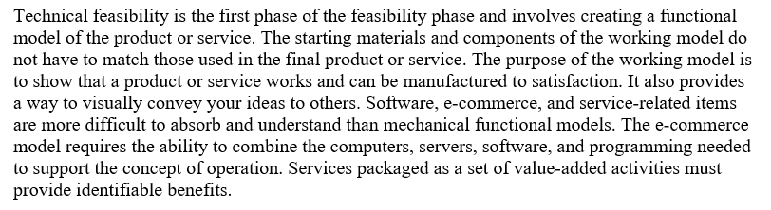

All the required technical/hardware devices are as follows:

1) **Dell EMC POWER EDGE R540:**

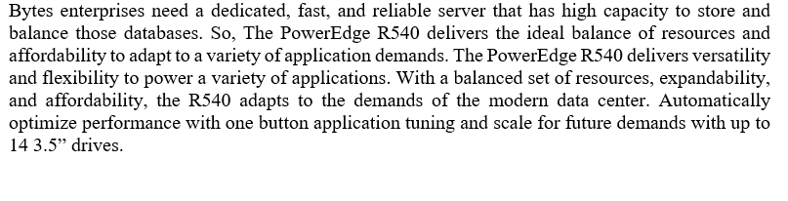

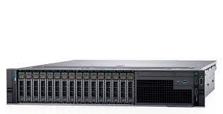

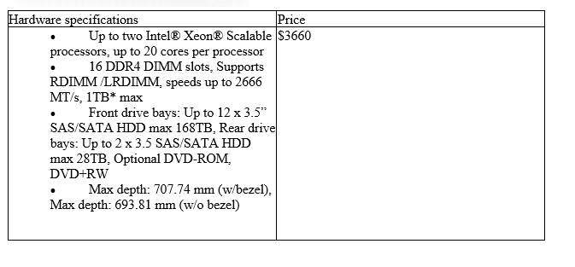

2) **DELL INSIRON  27 7000 SERIES**:   
Employes at Bytes Enterprise need powerful desktop to work smoothly and efficiently. For smooth work Dell inspiron 27 7000 series fill the gap. Its powerful processor and bright screens help employees work efficiently and help with keeping records. It has major build quality and executions.



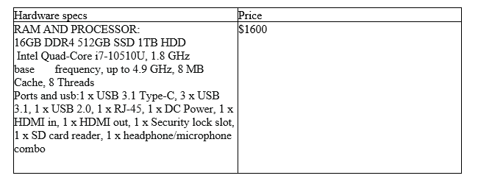

3) **ASUS ROG GT-AX11000:**

Bytes enterprises need high speed next-gen wireless performance.

To fill that gap asZcus’s router is suitable. It is a gaming router with provides high speed data transmission service for the company.   
This router provides,

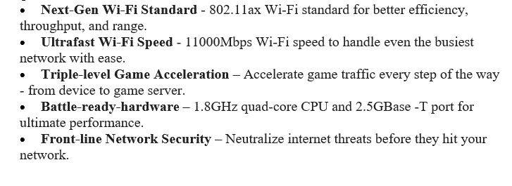



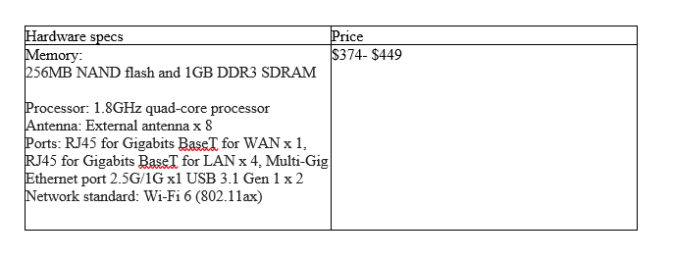

4) **DELL PRINTER C-1660W**

Bytes enterprises need proper colored documents. For that company we need high speed color printer. For proper documentation and printing Dell’s printer of model C-1660w fills the gap in the company. It has dazzling, good color print with an easy-to-use, cheap maneuver.



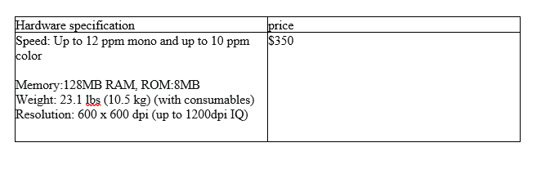

**Financial Feasibility**

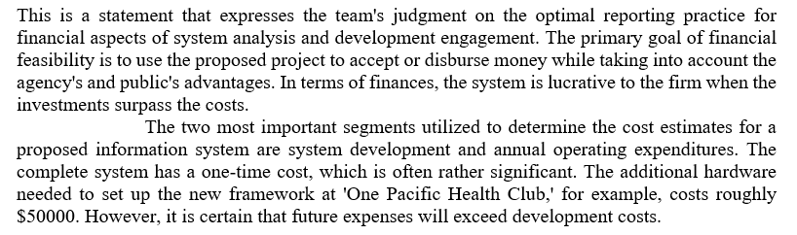

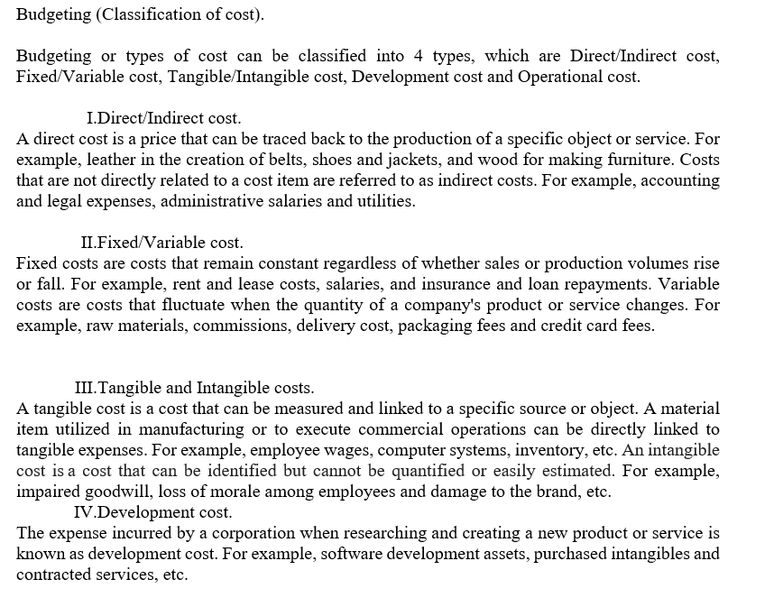

The table below shows the development cost of ‘One Pacific Health Club’ –

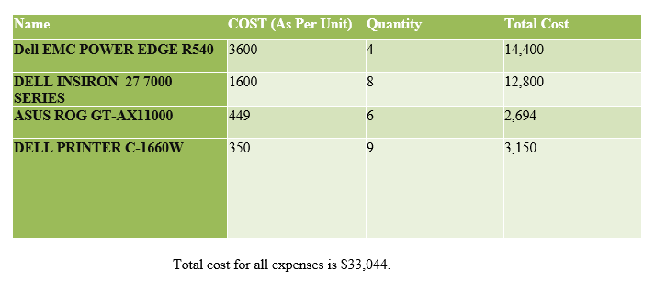

1. Operational cost.

The operational cost is the cost spent after the framework has been put up and is being utilized. For example, maintenance and repairs, property taxes, office supplies, depreciation and advertisement, etc.

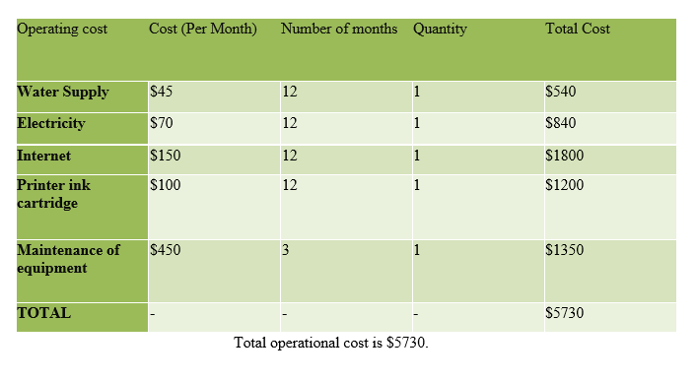

* 1. Return Study.

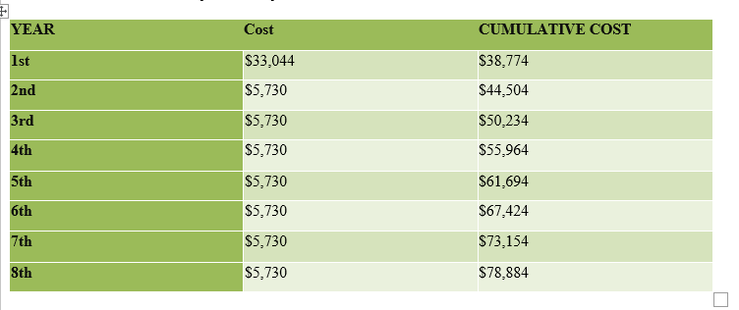

1. Profit Study.

Participation Fee $250 each month.

Predictable sum of memberships: 40 memberships.

Income per month: $10,000.

Income per year: $120,000.

In conclusion, the total income per year will be $120,000.

1. 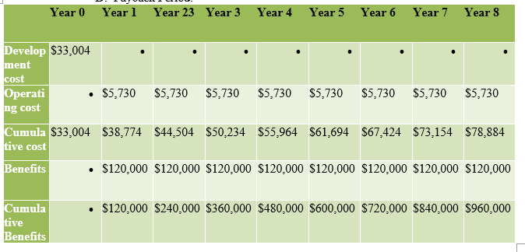Payback Period.

The cost and benefit totals are shown in the table above. According to the chart, 'One Health Pacific Club' drive begin receiving aids once the total value of the benefits exceeds that of the total cost.

1. Return on Investment.

The formula for return on investment (ROI): (Final value – initial value)/initial value

[**Where final value is Total Benefit and initial value is Total Cost.]**

**Final benefit = Total benefit – Total cost**

**= $960,000  –  $78,884**

**= $881,116**

Now,

**ROI =**$881,116/$105,879

       = 8.32%

Therefore, the return on investment is 8.32%.

So, in conclusion, this technique is a profitable system that will help 'One Pacific Health Club'.

**Schedule feasibility**

Schedule feasibility can be defined as the possibility of a specific project which to be completed under the certain period of time (deadline) by the proper planning. It is a method of determining when the project will be completed.

If the project is about to be completed under the certain time than there exist high appraised of schedule feasibility and if the project is not complete under certain time, then, schedule feasibility is unfeasible.

If the projects take longer time than estimated because of some issues then that projects may lose its position, benefits and also the funds which will be needed in future. If the project needs to complete as per the plan i.e. before deadline then the project manager needs to stick to the plan and show some proper attention to the schedule feasibility.

Basically, schedule feasibility shows, in what way the jobs ought to be alienated besides the quantity of time that should be fixed for the project's successfully end.

 

**Functional Requirement**

A developer's functional requirements are product features or functions that must be implemented by users in order to fulfil their needs.

It is crucial to make sure that both the development team and the stakeholders are fully aware of what they state. When developing systems, functional requirements describe how the system performs under specific circumstances.

* System should provide member detail along with their instructor and classes detail which help to know the information about member and all the things related with the system.
* Our system provide the information about the fees related structure and give information related to personal classes and extra fees structure.
* Our system need to be able to renew the member type and following payment.
* Our system should be able to store the attendance details.
* Our system need to be able to reload the time table for private classes.
* Overall report of all the member which were involved in our system should be manage.
* This system should provide all the necessary report which is are important for the member and the health club and should make the receipt of all the financial task involve in this company.

**Non-Functional**

Its requirement describes area that can cast-off to assess the function of a system, rather than specific behaviors.

The practical supplies that describe specific behavior or functions are contrasted with those that define general behavior or functions.

* The system must have good and easily understandable user interface.
* The system must allow the member to be able to pay the payment in various way.
* This system must give fine example of related work in introduction user interface.
* We should remove possible data duplication in our system.
* The personal information of both member and staff must highly confidential.
* This system help Class pre booking in a group and notification must be send in time.
* The information of payment detail must be renew of the member as soon as possible.

**ER-Diagram**

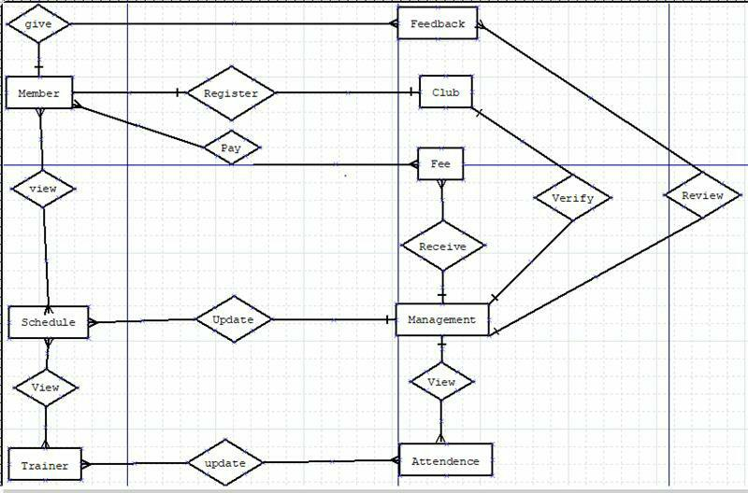

**Context Diagram:**

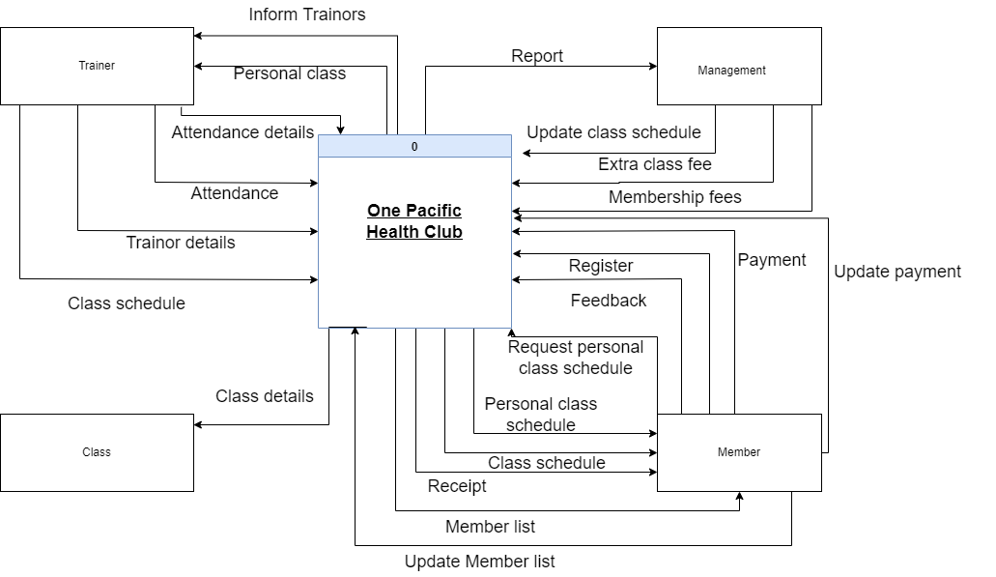

**Context Diagram**

**Level 0 Data flow diagram:**

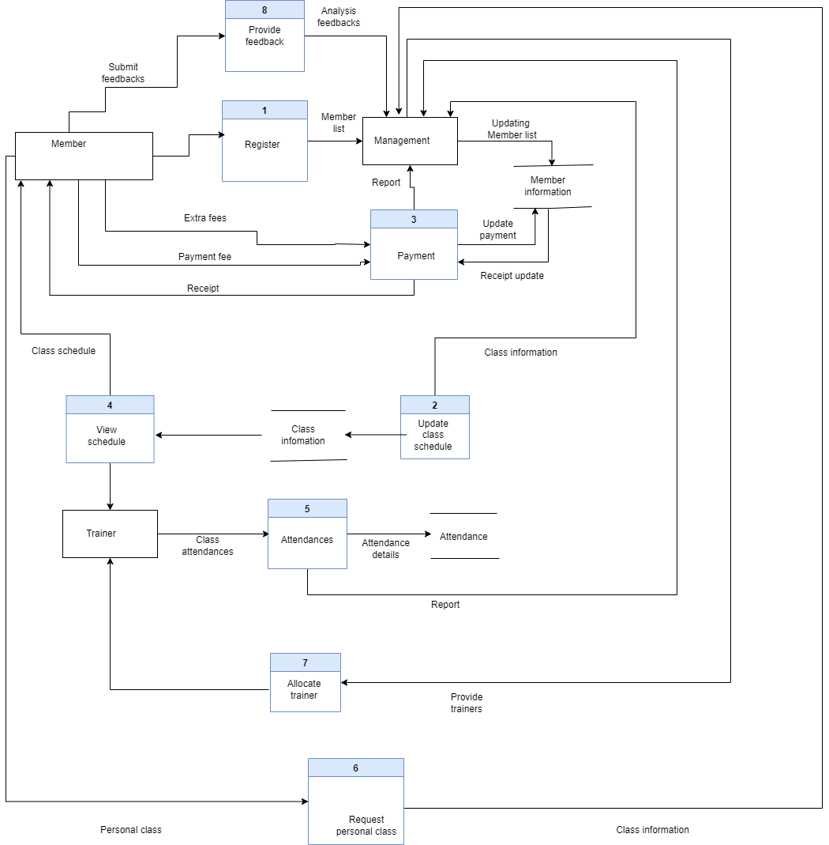

**Input and Output Graphic User Interface Design:**

**Login interface:**

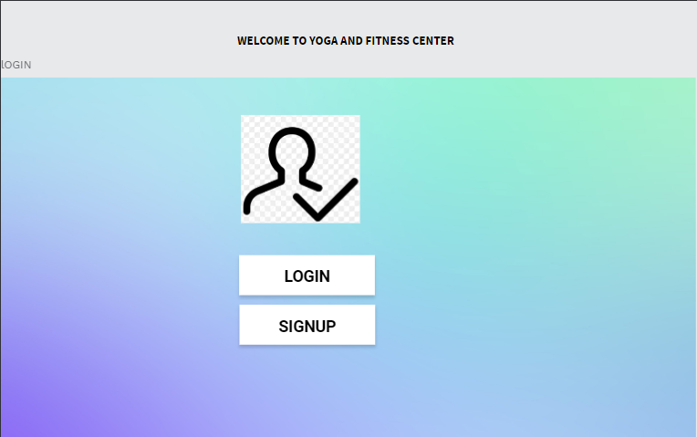

This is the first view of the web-based system of “One Pacific Health Club” where the visitor can choose to login or signup. If they are already the member of the health club they can just login.

**Sign in Page:**

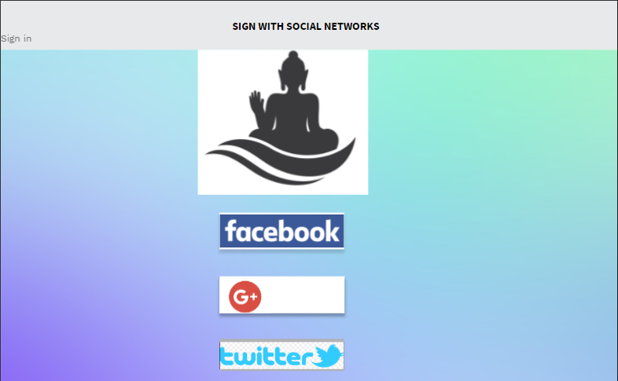

New costumer can sign in to the system using any of their social accounts for their ease.

It will save their time and make them to easy to sign in.

**Class Schedule:**

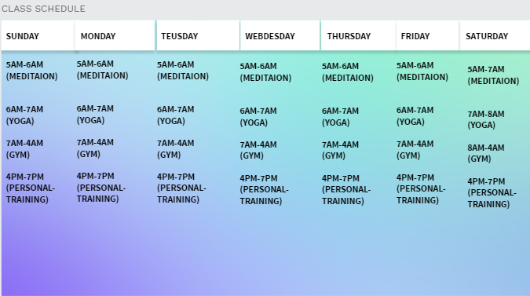

From the above page user can easily view the class schedules and choose the schedule as per their feasible time. It make them to do it all in a single touch making it easy and fun.

Interface Showing Payment mode:

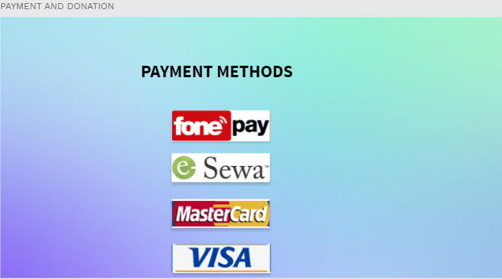

Costumer can choose any of the above digital payment channel and make payment. This provide them multiple choice for payment option. Multiple options also helps the club to widen its range in the market.

**Feedback form:**

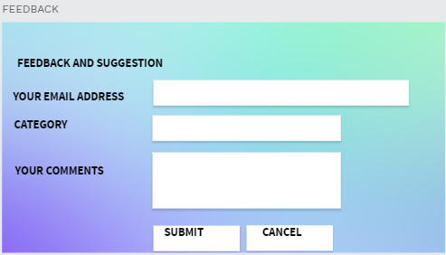

This feedback form lets costumer to leave their comments which helps the club to know more about themselves and bring required chances in the club.

**Payment receipt:**

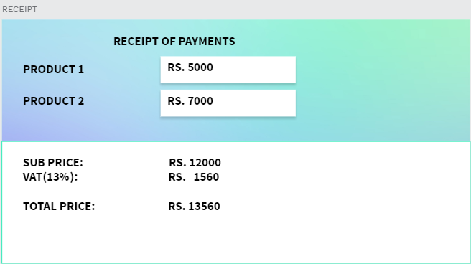

This lets costumer to view and download digital payment they make.

**Registration interface:** 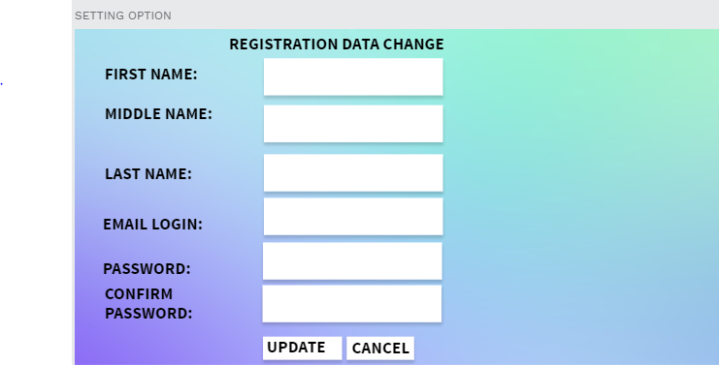

This option will help user to change their own details and login password.

**Employee login interface:**

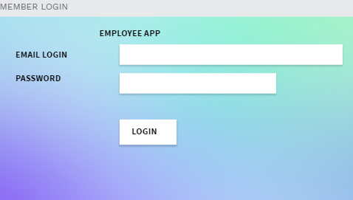

Employee can use this interface to login to the system to change or update any kind of information regarding the club.

**INDIVIDUAL ASSIGNMENTS**

**INTERVIEW (NPI000140-Ankit Acharya)**

Interview is a mostly used common technique for the purposes of achieving better result in any type of business also commonly known requirement gathering. An Interview is the process of gaining information through questions, answers and discussions. Tanking interview is also an form of taking data from the outsource. There are various way of finding the outsource information through the medium of interview. Like as, e-meeting is one of the mostly use medium nowadays because they can be done in a very systematic manner with in a small area and provide a large about of information from the source. You can get the quick feedback from the main source and note out it.

Merits: -

1. It provides flexibility for both interviewers and interview candidates. It helps take the pressure off of both parties, making the process more enjoyable for everyone.
2. It is more convenient and easier than sending emails, as the interviewees can accept or decline the interview by answering the questions and sending their answer.

1. Non-verbal behavior is very important in the interview process. The interviewer can judge the non-verbal behavior of a respondent and use it to determine if they are genuine or not

1. It can be conducted at an office or at a neutral location like your home or a park. They have different tools used in conducting interviews which are mostly face-to-face or on phone.
2. The interviewer can also judge the spontaneity of the respondent by posing questions at different times in the interview, and different places in the questionnaire.

Demerits: -

1. It can be a very expensive and time-consuming process.
2. Interviewer biases are unintentional and unintentional biases can distort the results of an experiment.
3. Interview surveys are a great way to collect data from your audience. However, there’s always a worry that your respondents feel less anonymous on an interview survey than they do when completing a traditional online questionnaire.
4. In this type of study access to respondents is limited since they can be anywhere around the world.

Code of Investigation method: - The standard procedure for customer service that has been mastered by the employees is best exemplified by a checklist of duties and responsibilities. Interview include filling out the appropriate forms, answering customer phone calls, providing service to using non-hierarchical customer communications, repairing minor problems and making customer feel valued. Through the Interview, it was determined that the checklist utilized in taking notes and making a record of observations can be efficiently utilized for day-to-day interpersonal meetings leading to a reduction in paper consumption and decrease the time required for producing data.

Related Questions: -

1. What issues are you facing with the current processes?

Our manually operated system requires many employees to handle and take a while to finish.

1. Who will benefit from the system?

Each one of the members and trainers has their own privileges in the system.

1. How can the system be improved?

An online system for public classes must be developed that allows users to view their class schedule and pay via credit card or via phone.

1. By what way the member take your system?

Internet and cellphone applications are used to get the job done.

1. How should the account be managed?

They must obtain a password and username from us so they can log in and see the class schedule, make payments, update their information, leave comments, and request classes.

1. Where will the data be stored?

The database server will store the data.

1. What new services should be added to the system?

A view my classes and update my details option should be included in the trainer menu***.***

Data Dictionary: -

Dataflow:

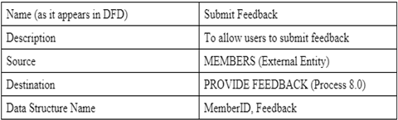

Process:

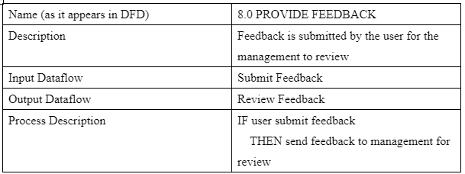

DFD (level-1)

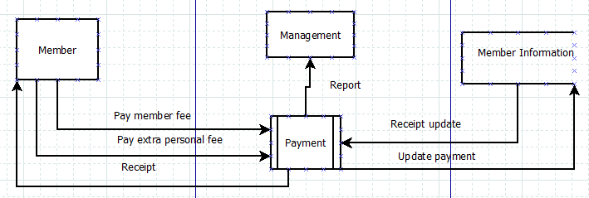

**Questionnaire (NPI000150-Jiten Chapagain)**

A questionnaire is a research instrument that contains a set of questions and their answers. The questions are randomly arranged so that the order in which they are asked does not affect responses. Unlike a survey, a questionnaire does not have a specific target population or recipients for which it is intended. In terms of scope and depth, it may be more narrowly targeted, covering one or two main topics whereas a survey encompasses many different topics. A questionnaire typically employs standardized methods for data collection and analysis in order to ensure consistency across studies and increase reliability.

Merits: -

1. Questionnaires is the main and important things to find the exact impact of anything from the large amount of audience. They are simple to design and can be conducted quickly.
2. Social media and the Internet enable one to reach out to respondents in a very easy manner. The World Wide Web can be used as a distribution platform that connects with both local and national audience.
3. Questionnaires are good for sensitive & ego-related questions and can be used to collect data on a larger scale.
4. Researchers commonly gather quantitative data using questionnaires. Questionnaires can provide researchers with.

either corroborating or disputing information, depending on their intent. Researchers can easily quantify the data collected through questionnaires using either manual or computer-based techniques.

Demerits: -

1. There is no method to comprehend human behavior, attitudes, and feelings, according to many experts, questionnaires are inadequate. Questionnaires may also be too cluttered and too long, in addition to being inadequate.
2. There is no way to adequately assess human behavior, attitudes, and feelings, according to many experts. Likewise, questionnaires might be too cluttered and too long.
3. Inappropriate questionnaires may not be well suited to some respondents, resulting in a low response rate.
4. There are several types of improper questions, and some questions are excessively direct. These questions do not help researchers acquire good information. Many researchers also believe questionnaires are without value because they acquire information without explanation.
5. Inadequately designed questionnaires usually do not consider the needs of people with physical or mental disabilities or people from diverse cultural backgrounds.

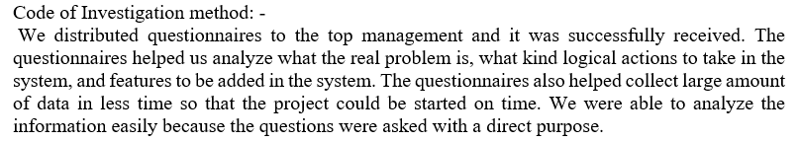

Related Questions: -

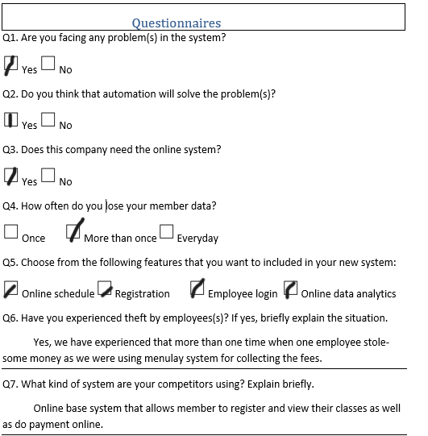

Dictionary: -

Dataflow:

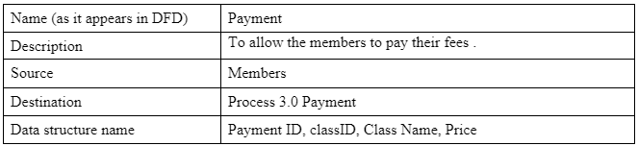

Process:

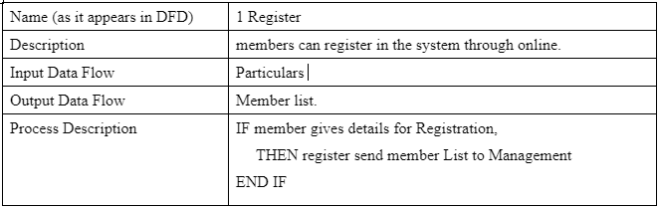

 DFD (level-1)

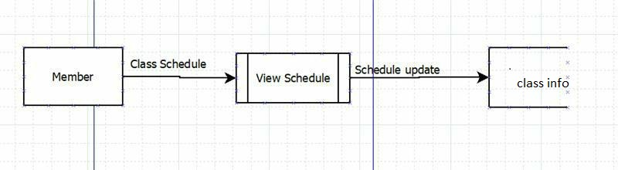

**Observation: (NPI000141-Anmol Malla)**

Observation is a simple and effective way to gain insight into requirements. Do not waste time and money trying to gather requirements from your end users and stakeholders unless you are sure you have observed them in action. Observation is one of the core elements of a project. In fact, it stems from observation—the act of seeing and knowing more about your subject matter, whether that’s a product or a process. When it comes to observing your product or process, you’re going to want to focus on the smallest items first.

Advantages

1. The observation method is an easy, mostly non-technical way to learn. These methods usually do not require a lot of technical understanding and minimal training is expected.
2. The observation method does not directly interact with the observed, but instead relies on an observer to determine the value of the observed object.
3. It display the same phenomenon of the natural occurrence of the things. This approach emphasizes the importance of listening and recording detail observations while they are still fresh in your mind.
4. The observation method of survey is a research design that needs the least amount of respondent cooperation and attention as possible.

Disadvantages

1. The observation method is the best way to collect data, but not everything could be observed.
2. The cost of surveillance is in height because it requires you to be there until you have gathered sufficient data to make a decision.
3. A great deal of time and energy are required to observe.
4. Researchers use documents as a tool to determine the past life of a person. Sometimes, however, these documents are not accurate.

Questions related to Observation.

* + 1. Does Observation Produce reliable and accurate data?

Answer: Yes, observation produces more accurate and reliable data.

b) Does Observation produce every aspect of outdated and incomplete data?

Answer: Yes, Observation produces every aspect of incomplete data and outdated data.

c) Will it help in authentication of collected data?

Answer: It is helpful in many situation whereas, there is doubt and complexity in some of the data management.

d) Can we call Observation as gleaning information?

Answer: Yes, there is no better way of gleaning or gathering information better than Observation.

e) Can we consider Observation as accurate?

Answer: Not exactly, we cannot consider Observation accurate because Researchers use documents as a tool to determine the past life of a person. so, we cannot consider Observation as accurate.

**Summary**

The question was asked to the management teams and the response was successful. It is for analyzing and inspecting the real issue for the users and adding more features in the system for making it simple and easy for the members and newcomers.

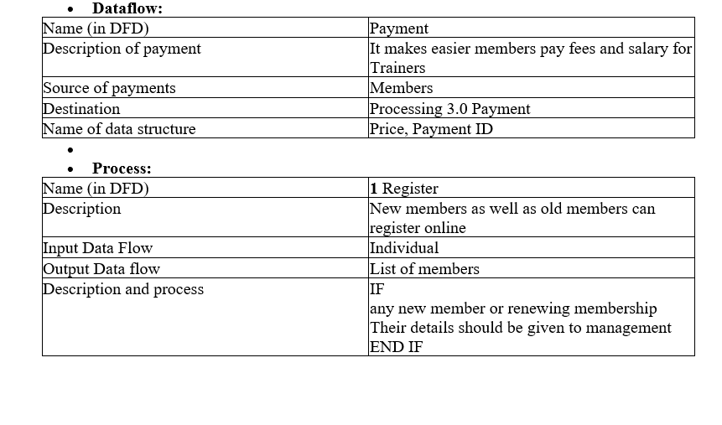**Data Dictionary**:

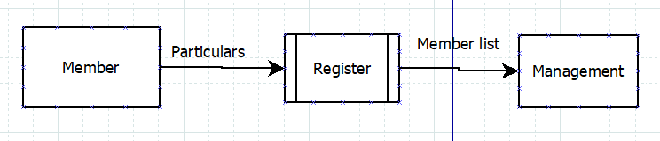 DFD (level-1)

**Prototyping (NPI000178) Satindra Khadka.**

When it comes to comprehending a concept or idea, the majority of people are visual. Rapid prototyping services aid in visualizing the finished product, enabling the design team to understand the function and target market.

**The advantages of using prototyping are-**

1. The model is very flexible so it will be easy to detect errors.
2. Because there is room for improvement, new criteria may be readily met.

1. The developer can utilize it in the future for trickier projects.
2. It improves both users' and developers' understanding of the system.
3. Deployment channels are chosen very early on, and integration needs are very clearly known.
4. It works well with an online system.
5. It guarantees higher levels of comfort and client satisfaction.

Nothing is perfect as it is the same case with this model so,

**The disadvantage of using prototyping are-**

1. This model Is very expensive.
2. Because client expectations are always changing, the documentation is inadequate.
3. Visualization of early prototype may create the demand of the unavailable product from costumer.
4. Customer dissatisfaction can been seen when they see the early proto type.
5. There might be a flawed or insufficient problem analysis.
6. The system's complexity might rise as a result.

**Related Questions.**

1. Does the prototype carry out its intended function?

Ans. Yes, the prototype does function as we envisioned.

1. Does your target market think this product was created with them in mind?

Ans. So far, the customer feedback has been great but there are still holes that have to be filled as some of our customers do not like it at all and some of them have encountered bugs.

1. Would they suggest the final product to a friend? How probable or unlikely?

Ans. It is really likely that the customers will recommend the final product to a friend.

1. Are there any obstacles or distractions on their path?

Ans. Our prototype was created with all the features that our customers would like to do, and the interface is simplistic and does not overwhelm our users although we are going to improve on the interface making it even better in the final product.

1. In their own words, how would they characterize this product?

Ans. According to our users they describe this product as ambitious and also point out that we are heading in the right direction with this prototype.

**Code of investigation method-**

The questions that were asked above are to gain the user’s opinion about our prototype. The opinion of a customer is far better than our own because the target is to meet their expectations.

**Data Dictionary.**

Dataflow-

|  |  |
| --- | --- |
| Name. | Class Attendance. |
| Specification of Attendance. | The main objective is to check if our members are attending the class or not. |
| Main Source. | Trainer. |
| Destination. | Attendances (5). |
| Data structure specification. | Trainer ID, Attendance. |

Process-

|  |  |
| --- | --- |
| Name. | Attendance. |
| Specification. | For review the attendance goes directly to management. |
| Data flow inward. | Class Attendance. |
| Data flow outward. | Report. |
| Specification of phenomenon. | The helper takes attendance of the members and after that the report is sent to the management for review. |

**DFD level 1.**

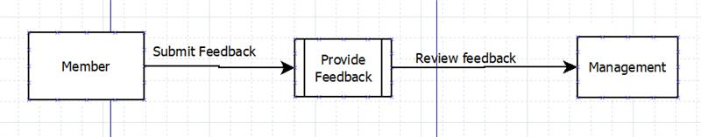

**Sampling :( NPI000167- Rangin Basnet)**

Sampling technically is the collection of subsets of data of any form. Here sample data may refer to individuals, group of individuals, sample of office documents etc. In any research process sampling helps to save capital, time and effort.

It is not always possible to collect data or information from entire population for different reason. Thus, sampling is also used in other form of fact-finding techniques like interview, document review, observation, etc. It is impossible to take interview of entire office staffs or costumers, it not possible to observe each and every office document, thus sampling is required.

Different sampling techniques can be used as per the need. Some of them are as follows:

1. Simple random sampling:

Providing each individual equal probability of being selected by randomly creating a number for each member.

1. Stratified Random Sampling:

It divides population into different groups by their similar attributes and sample is taken from each group.

For e.g., office documents can be classified as emails, costumer complaints, costumer reviews etc.

1. Cluster Random Sampling:

Here sample are divided into different cluster not with similar attributes but with different attributes so that each cluster is a small representation of the whole population and required number of clusters is taken as sample according to the size of sample.

1. Systematic Random Sampling:

Here sampling is done by forming a certain rule in the beginning so that no biasness occurs while taking the sample.

## **Some of the Advantages of sampling are briefly discussed below**.

1. **It is cost efficient:**

Conducting research in small size instead of total population hugely lowers the cost of the research.

1. **Time saving:**

Sampling saves the time without affecting the outcome of research.

1. **Convenient:**

In a large organization size of population keeps on changing within the research period. It is not always possible to measure the exact characteristics of larger population. So generalizations with small sample size would be more convenient.

1. **Suitable for limited resource:**

Sampling can be carried out with low budget and few number of human resources.

1. **Higher Accuracy:**

Research can be carried with higher accuracy since researcher can have adequate understanding with the respondents as the sample size is manageable.

## **Some of the dis-advantages of sampling are briefly discussed below.**

### Biasness:

Biasness arises when sample is not taken appropriately considering the fact that attributes and characteristics of population may completely vary. Some time it may be done willingly.

**Difficulties in selecting a truly representative sample:**

### It is not possible to take samples which exactly represents the total population.

### Lack of proper knowledge:

### Lack of proper knowledge of sampling techniques leads to in appropriate conclusions.

### Impossibility of sampling:

### Sometimes due to small size of universe and too heterogeneous nature of the population it is impossible to have proper sample representing the universe.

### Mode of sampling Used:

### Since the size of population was not too large simple random sampling was done and 20 costumers were randomly selected for research.

 DFD (level-1)

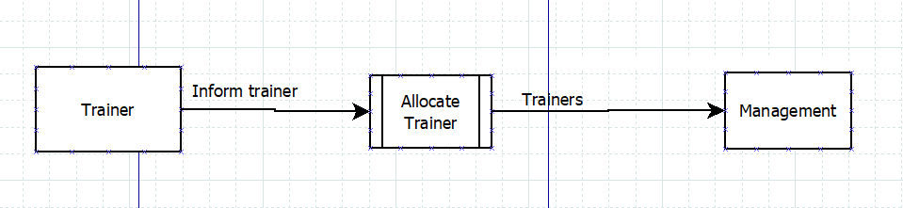

**Document Review :( NPI000165- Pukar Nepali)**

Description  
every project begins as a blank sheet of paper. Finding a starting point can be difficult when beginning a project. Document analysis can help you get things going. You can begin project requirement gathering by analyzing documents in order to establish what parameters you must work with. Because every project begins as a blank sheet of paper, document analysis will provide you with a strong foundation from which to generate questions.  
Finding out who you should be communicating with, what data is missing, what business rules exist, and how to work within them is what it will help you with.

**Advantages:**

1. It ensures that the researcher does not become physically involved with the subject matter, thus allowing for free investigation. Furthermore, the document is not subject to reactivity, especially if it is written for some other purpose.

2. it’s possible to study a document through time using the document study approach. Since most documents incorporated in a diary are spontaneous, the author’s instant feelings and observations are reflected.

3. It is more likely for an author to confess in a document than in an interview or mailed questionnaire study, especially one that is read-only and after his or her death.

**Disadvantages**:

1. the document was not written for social research purposes but for some other purpose (probably to make money). As a result, the documents are often fictionalized and exaggerated.

2. Papers are not well suited for preserving certain documents, which are typically written on paper.

3. Researchers encounter difficulties coding and analyzing many documents that are incomplete, unstandardized.

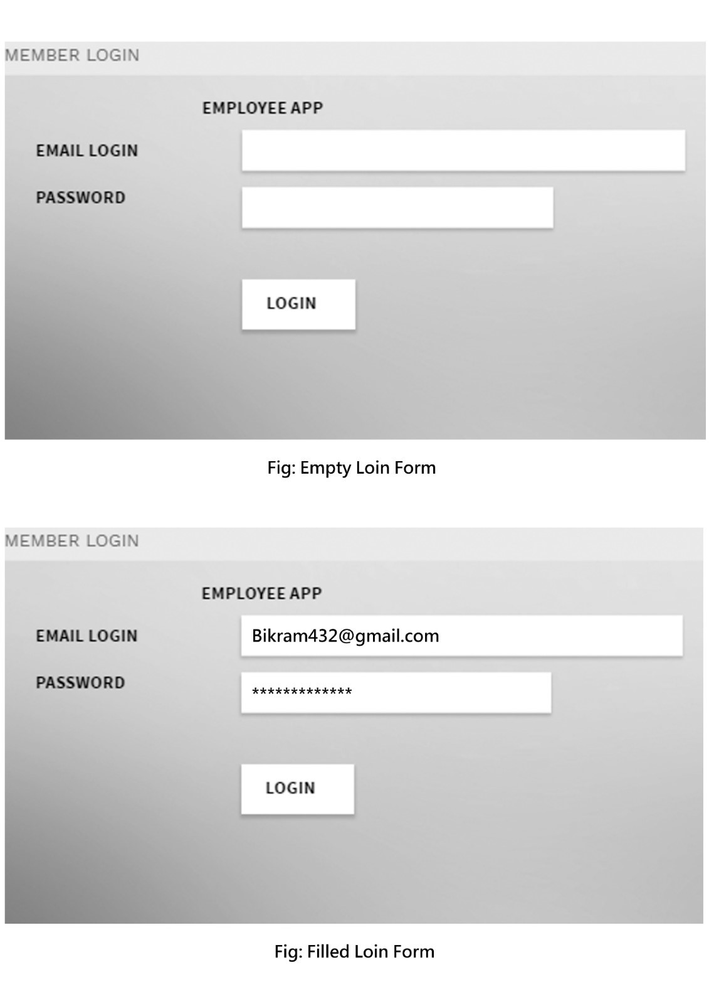

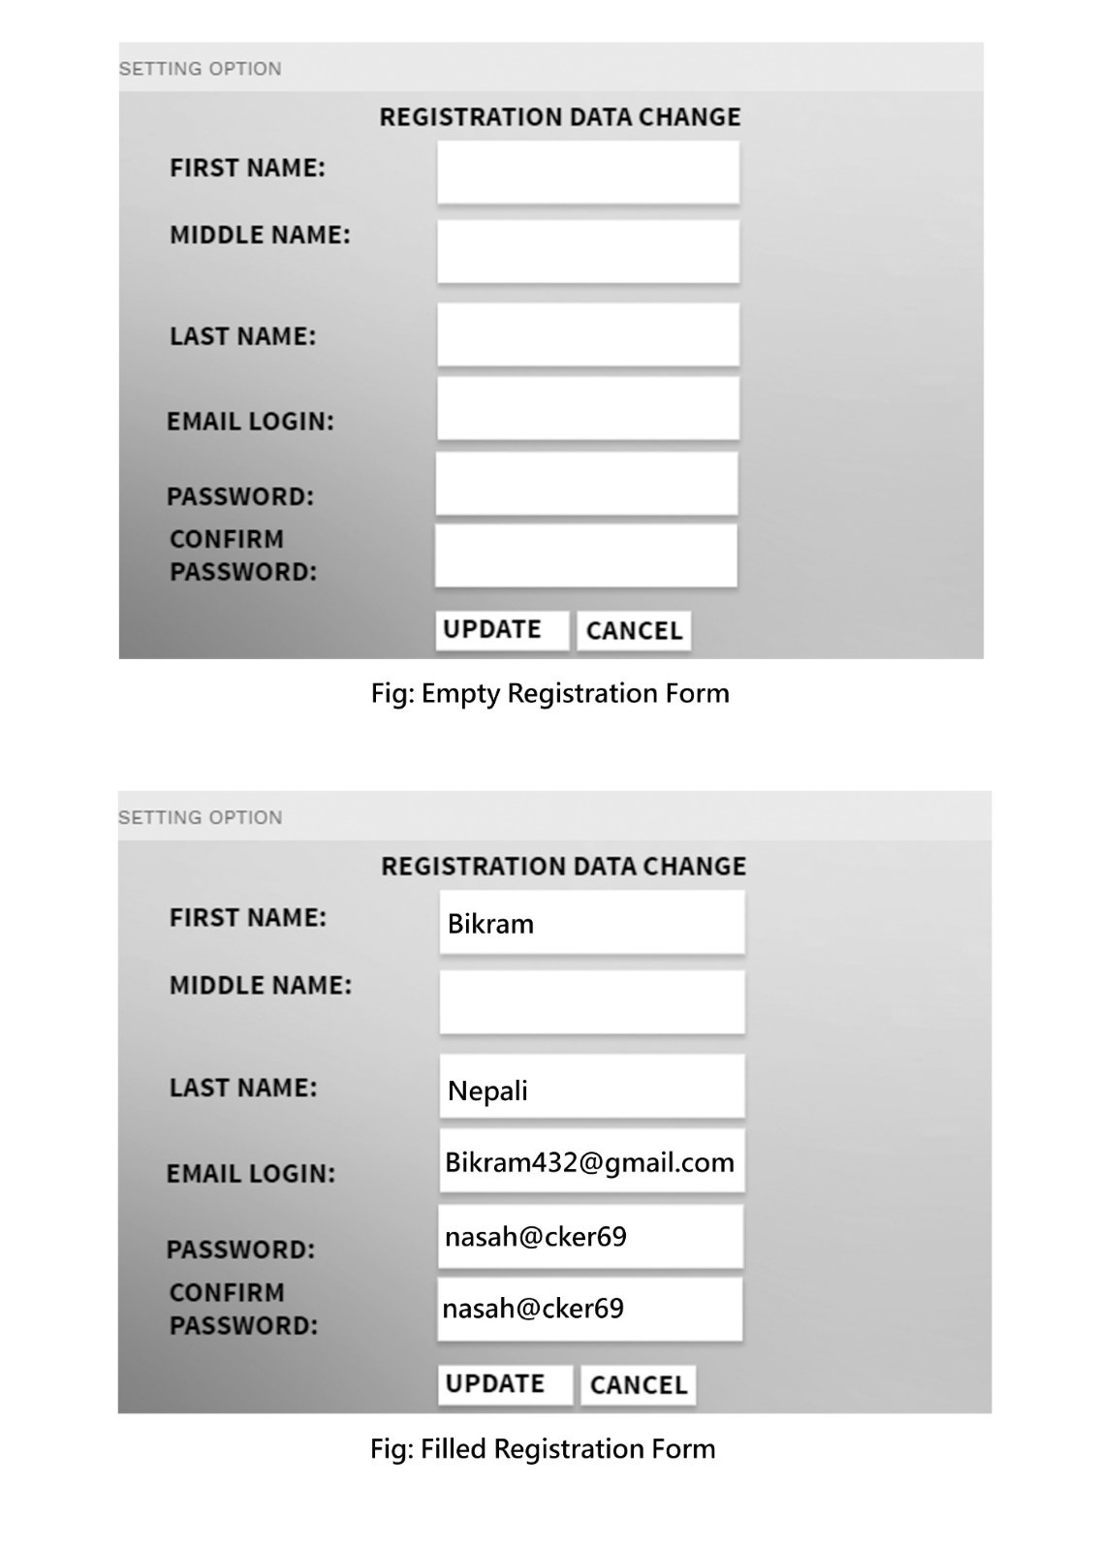

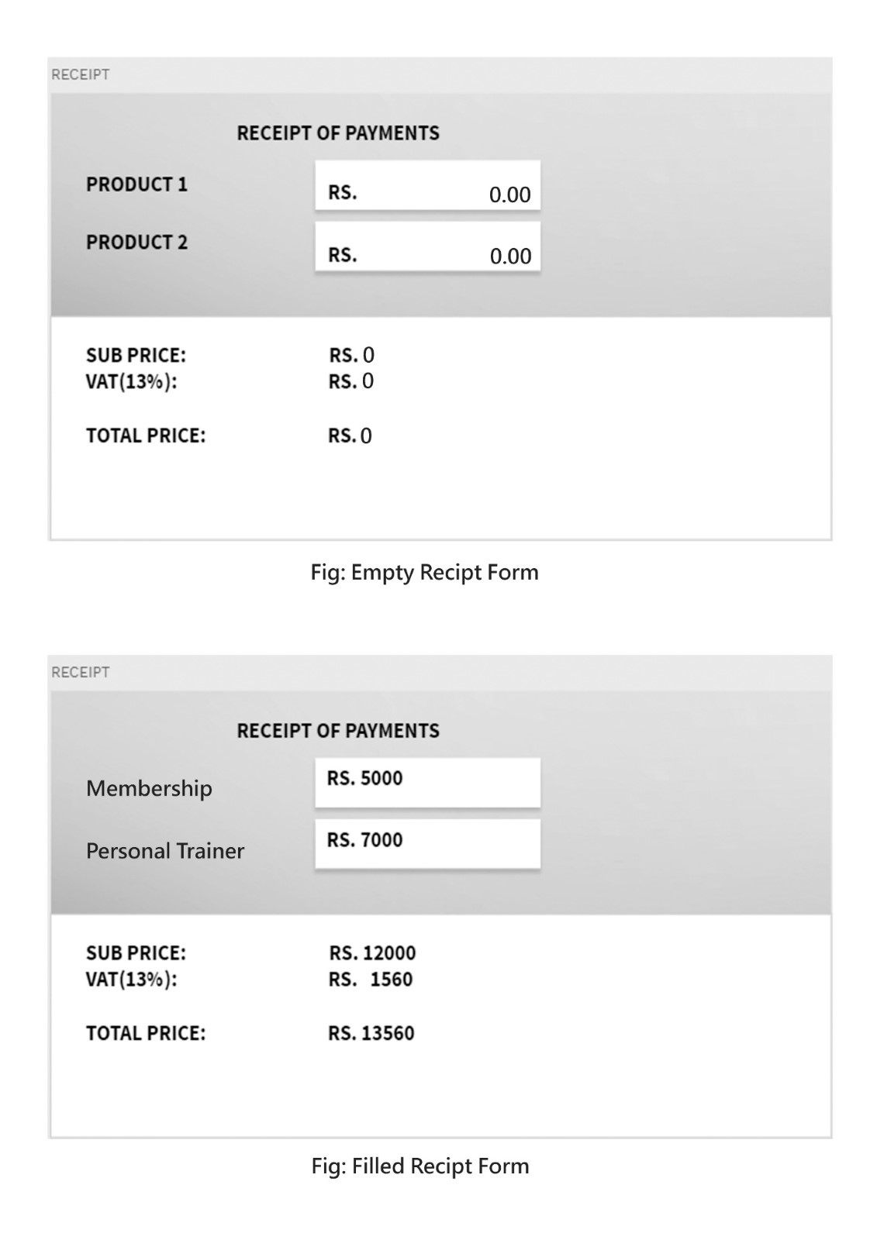  
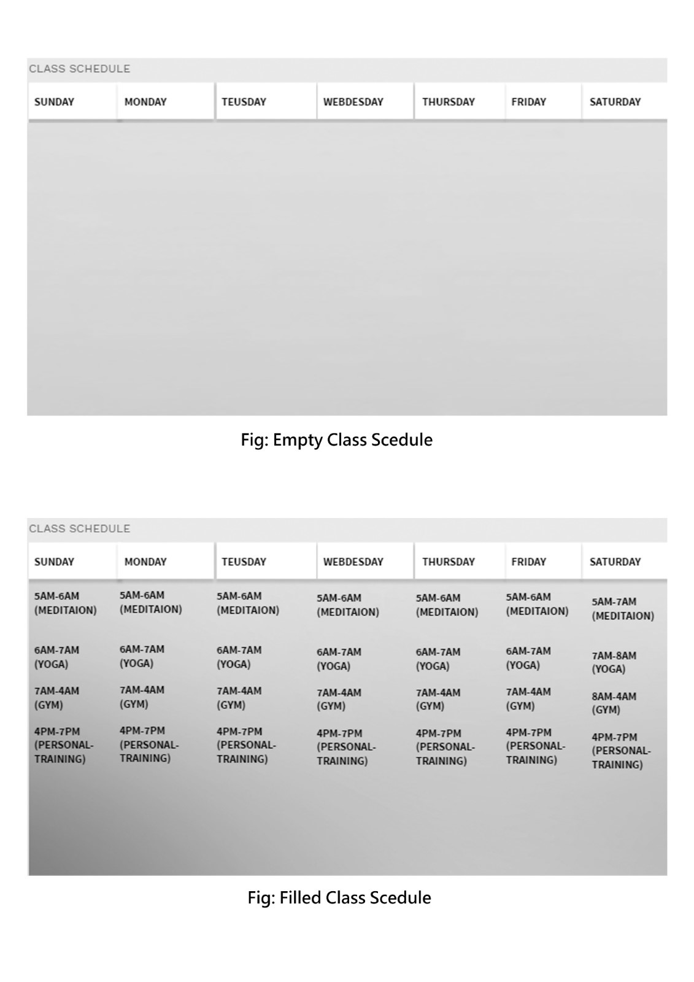

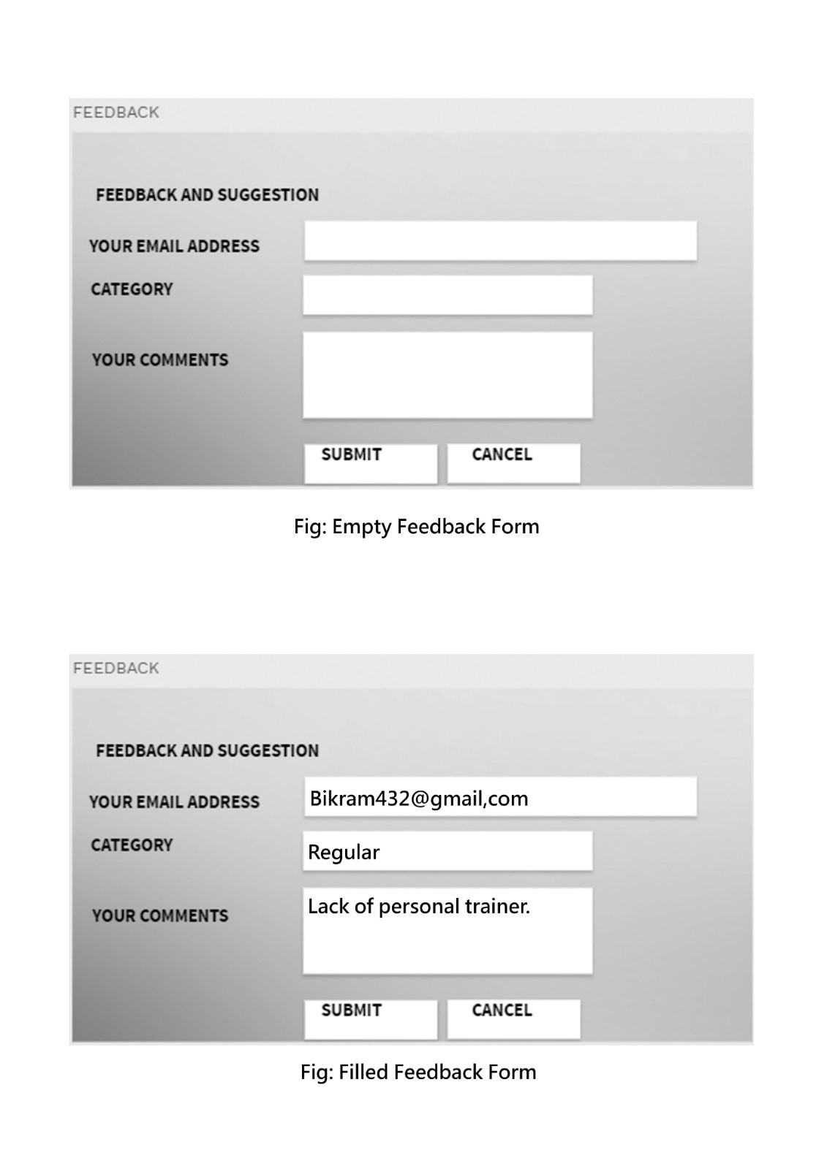

**Question related to the Document Review**

1. Is there any need of the documents on any of the company?

* Yes, it is compulsory in any of the company.

1. Does the document review make changes in system of the company?

* Yes, Documents review is one of the factor which affects the improvement of the company.

1. Do we need to hire someone for the Document Review?

* Documents Review is directly connected to the user so that you need to hire some with enough experiences.

**Summary**

The Document Review can be done on both online and offline. This can also do directly consulting with the user. Because of the direct contact with the user this process helps the system to be improved.

Every single move of the user can be tracked with this method. Progress as well as regress can be find out easily using this process.

**Data Dictionary:**

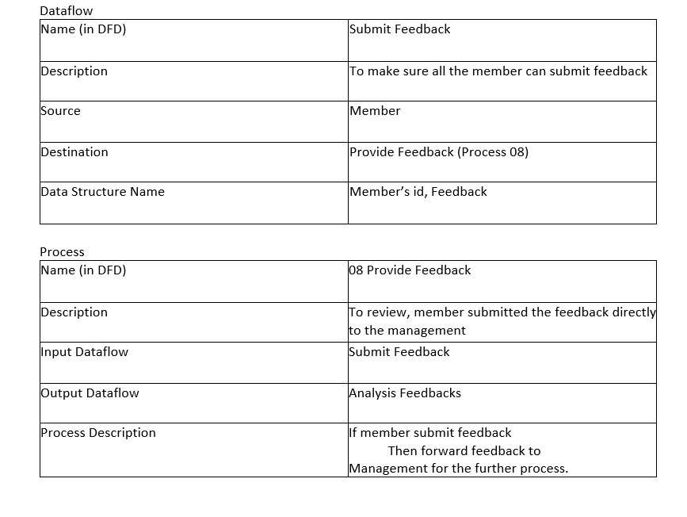

DFD (level-1)

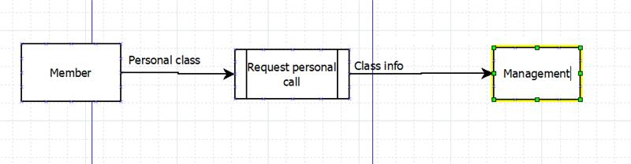

**CONCLUSION:**

While coming to the end of the project we as a team had learnt a lot. Working skill on software’s like Dia and Microsoft Visio has improved. Working on group and coordinating among the members gave great learning experience. Facing the problems regularly and coping them with group effort had increased group culture and our analytical skills.

At last, we concluded that regular brainstorming sessions in group to come up with new and innovative ideas always helps to accomplish a challenging project like this.

**Reference**

*IBM Z. (51) Server (redbooks.ibm, April 2022)*

[*https://www.redbooks.ibm.com/redbooks/pdfs/sg245444.pdf*](https://www.redbooks.ibm.com/redbooks/pdfs/sg245444.pdf)

*Intel Ghost NUC Canyon (simplynuc.com,n.d)*

[*https://simplynuc.com/ghost-canyon/*](https://simplynuc.com/ghost-canyon/)

*Router (asus.com,n.d)*

[*https://www.asus.com/Networking-IoT-Servers/WiFi-Routers/ASUS-WiFi-Routers/RT-AC86U/*](https://www.asus.com/Networking-IoT-Servers/WiFi-Routers/ASUS-WiFi-Routers/RT-AC86U/)

*HP Color LaserJet Pro M255dw (hp.com, n.d)*

[*https://www.hp.com/us-en/shop/pdp/hp-color-laserjet-pro-m255dw*](https://www.hp.com/us-en/shop/pdp/hp-color-laserjet-pro-m255dw)

*Payment Terminal (clearlypaymetns.com, n.d)*

[*https://www.clearlypayments.com/products/terminals/*](https://www.clearlypayments.com/products/terminals/)

*Technical Feasibility (indeed.com)*

[*https://www.indeed.com/career-advice/career-development/technical-feasibility#:~:text=Technical%20feasibility%20is%20the%20process,way%20to%20tracking%20your%20sales*](https://www.indeed.com/career-advice/career-development/technical-feasibility#:~:text=Technical%20feasibility%20is%20the%20process,way%20to%20tracking%20your%20sales)*.*

*Cluster Sampling (*[*scribbr.com*](http://www.scribbr.com/)*, n.d)*

[*https://www.scribbr.com/methodology/cluster-sampling/#:~:text=In%20cluster%20sampling%2C%20researchers%20divide,that%20are%20widely%20geographically*](https://www.scribbr.com/methodology/cluster-sampling/#:~:text=In%20cluster%20sampling%2C%20researchers%20divide,that%20are%20widely%20geographically)

*Probability Samping (statcan.gc.ca, n.d)*

*https://www150.statcan.gc.ca/n1/edu/power-pouvoir/ch13/prob/5214899-eng.htm*