**System development life cycle**

System development life cycle is the process of planning, analysis, designing, implementing and maintaining the new proposed system and software of the organization. The SDLC life cycle defines methodology for improving the quality of software and the overall development process. According to the case, our task is to make the new software and system of pacific health club.

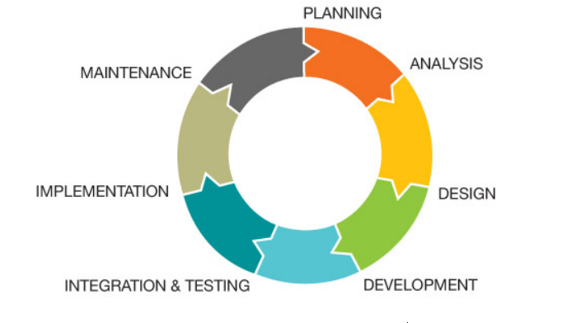

**Planning stage**

It is the first stage in the SDLC phase which make the fundamental structure of project, carrying out the different study about the different task that will affect the project activates. The main purpose of this phase is to perform a preliminary investigation to evaluate an all form of opportunities and problem. Whereas, in pacific health club, we make plan in different stages from managing detail to producing reports of the member involving the payment detail.

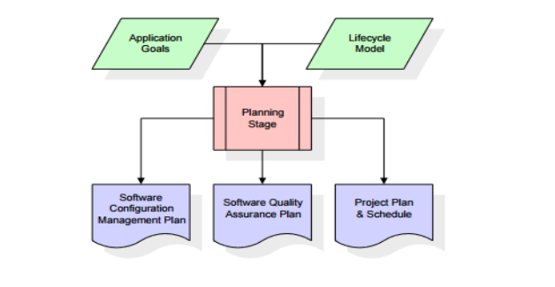

The making plans segment in our proposed gadget is done via way of means of the chosen team`s individuals to get inputs from the pinnacle control or the information`s sources with inside the gym. Our decided on individuals will perform a little initial investigations approximately the gym issues and the preferred dreams so one can be written with inside the initial investigations document. This document defines the all of the obligations so one can be executed, monitored, managed and the venture closing.

**Analysis**

In this stage we made the system requirement document with the help of preliminary investigation report. The main purpose of the stage is to build a logical modes for the new system which overcome the old management system. The best solution are taken for the guide of the project. Furthermore this phase determine the responsible person of the project and the deadline of the project.

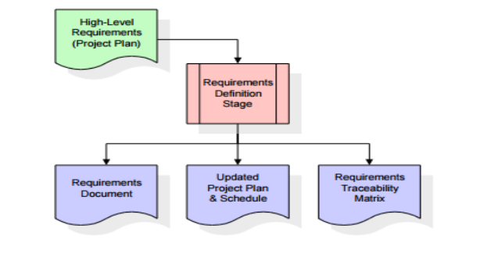

In addition, the analysis phase removes all possible uncertainties in the project and begins the baseline for the next phase. All of this is achieved through requirements-gathering techniques such as interviews, surveys, document reviews, and observations by group members.

**Design**

In this third phase of the system development life cycle we created all document required for the system. This phase explain the required specification, feature of operation of the purposed system. In different words, it's far the manner of making ready diagrammatic representations of the architectural version both logical and bodily primarily based totally at the SRS. All the permitted necessities in file could have unique designs that describe the software program capabilities in detail. They may be defined as useful hierarchy diagrams, interface diagrams, enterprise policies and technique diagrams, pseudocode or flowchart, or an entity-dating diagram with an information dictionary. Once the layout level is finished and permitted, every requirement could have its personal layout detail which suggests how the machine satisfies the wishes and the way it's going to have interaction with the relaxation stages.

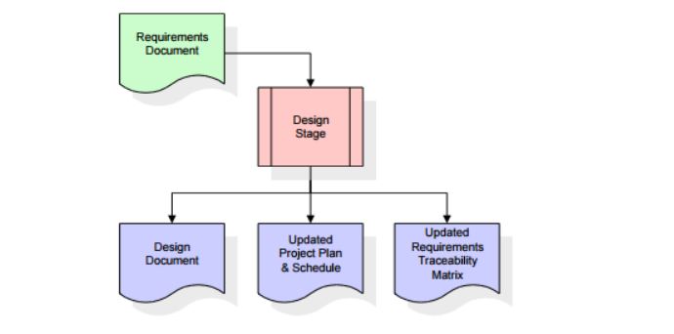

**Implementation stage**

As the new system is deployed, some activities will be included in the implementation phase. The actual execution of the project begins and the programming code begins. As long as the design documentation for the previous phase is detailed and written in a well-organized way, the code implementation will run very well. The developer is responsible for preparing the data entry set and ensuring that the code is created when the expected output meets Jim's requirements. In this phase, the conceptual structure is no longer present because it is already implemented in the programming source. The software will then be installed and gym users (members, instructors, etc.)

Will be able to work and test on the new system. At the end of this phase, you need to document the system information to understand how the system is fully functional and how it works.

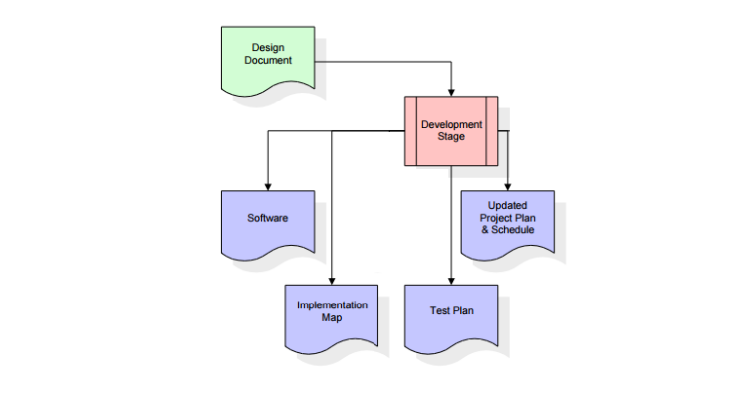

**Maintenance and support**

After the implementation phase is complete and the system is released, maintenance services will be provided to ensure that the system continues to meet the requirements. You can make changes or additions to your system at this stage to keep it up to date. In addition, our team keeps in touch with Jim to ensure reliable execution of business processes and safety.