Week 3 Task

SQL Query Optimization and Performance Tuning in a Retail Database
Baseline analysis, indexing, query rewriting, partitioning and materialized views with measured before-and-after results

Database: PostgreSQL 16 | Dataset: 300,000 orders, 900,000 order items
Prepared by: Jitendra Dev
Date: 10 November 2026

1. Executive Summary
In a high-volume retail environment, slow SQL queries delay billing screens, stock checks and management reports. This report documents how seven typical retail queries were measured, optimized and measured again on a realistic PostgreSQL database containing 300,000 orders, 900,000 order line items, 100,000 inventory rows, 50,000 customers and 5,000 products.
Four techniques were applied: (1) B-tree and covering indexes, (2) query rewriting, (3) range partitioning of the orders table and (4) a materialized view for a heavy aggregate report. Every number in this document comes from EXPLAIN (ANALYZE, BUFFERS) runs - each query was executed once as warm-up and then five times, and the median is reported.
Key result: the combined execution time of the seven queries fell from 287.7 ms to 130.2 ms (54.7% lower). The best individual gains were 120x faster for the customer-history lookup (Q2), 38x for the low-stock alert (Q7) and 27x for the inventory lookup (Q4).

Overall results at a glance
Query | Before (ms) | After (ms) | Improvement | Speed-up
Q1 | 17.2 | 4.765 | 72.2% | 3.6x
Q2 | 14.9 | 0.124 | 99.2% | 120x
Q3 | 137.6 | 44.2 | 67.9% | 3.1x
Q4 | 4.598 | 0.168 | 96.3% | 27x
Q5 | 61.2 | 41.2 | 32.6% | 1.5x
Q6 | 47.5 | 39.6 | 16.6% | 1.2x
Q7 | 4.823 | 0.127 | 97.4% | 38x

2. Introduction and Objectives
Retail systems are read-heavy and write-heavy at the same time: cashiers create orders every second, store managers check inventory, and analysts run sales reports. If a query that should take a millisecond takes a second, thousands of concurrent users feel it. SQL performance tuning is the practice of finding such queries, understanding why they are slow, and changing the query or the database design so that the same result is produced with far less work.
The objectives of this task are:
- Write sample SQL queries that mimic typical retail operations (sales data retrieval and inventory lookups) and document their initial execution times.
- Apply performance enhancement strategies: creating indexes, query rewriting and partitioning.
- Measure performance again and record the improvements with comparative metrics.
- Explain the rationale behind every optimization and recommend further improvements.

3. Environment and Methodology
Item | Details
Database engine | PostgreSQL 16.15 (Ubuntu), default configuration (shared_buffers 128 MB, work_mem 4 MB)
Machine | 2 vCPU cloud Linux environment (parallel query with 2 workers was possible)
Data generation | generate_series() with a fixed random seed (setseed 0.42) - see sample_data.sql
Measurement tool | EXPLAIN (ANALYZE, BUFFERS) driven by benchmark.py
Method | 1 warm-up run + 5 measured runs per query; median execution time reported
Correctness check | Optimized queries were compared with baseline queries and return identical results (Q1, Q3, Q5, Q6 verified)

Note on absolute numbers: timings depend on hardware, caching and configuration, so another machine will show different milliseconds. What matters is the relative improvement and the change in the execution plan (for example Seq Scan to Index Scan), which is reproducible.

3.1 Database design
A simplified retail schema with six tables was used. In the baseline only primary keys and foreign-key constraints exist; no secondary indexes and no partitioning. This gives an honest starting point.
Table | Rows | Purpose
stores | 20 | Physical shops (city, region)
customers | 50,000 | Registered customers
products | 5,000 | Product catalogue (category, brand, price)
inventory | 100,000 | Stock quantity per store and product
orders | 300,000 | Order header (customer, store, date, status, total)
order_items | 900,000 | Order lines (product, quantity, unit price)

4. Baseline Analysis (Before Optimization)
Seven queries representing typical retail operations were written and executed on the baseline schema. Their initial execution times and the main problem found in each execution plan are listed below.
Query | Business question | Initial time (ms) | Main problem in plan
Q1 | Revenue per store for one month | 17.2 | Seq Scan on orders (300k rows)
Q2 | Order history of one customer | 14.9 | Seq Scan + SELECT *
Q3 | Top 10 products in a quarter | 137.6 | Seq Scan on order_items (900k rows)
Q4 | Stock of one product in all stores | 4.598 | Seq Scan on inventory
Q5 | Monthly revenue for a year | 61.2 | Function on column, not sargable
Q6 | Customers with no order in 2026 | 47.5 | NOT IN + Seq Scan on orders
Q7 | Low-stock alert for a store | 4.823 | Seq Scan + SELECT *

4.1 Initial challenges
- Full table scans: no secondary indexes, so even queries returning a handful of rows read the entire table.
- Non-sargable conditions: functions such as EXTRACT() on a column prevent index and partition use.
- SELECT *: fetches unnecessary columns, wastes I/O and prevents index-only scans.
- NOT IN subquery: slower and unsafe when NULL values are possible.
- One large orders table: every date-range report scans years of history that it does not need.
- Heavy join for reports: aggregating 900,000 order items on every report request is expensive.

5. Optimization Techniques Used

5.1 Indexing
An index is a separate, sorted data structure (a B-tree in PostgreSQL) that lets the database jump straight to matching rows instead of reading the entire table - like the index at the back of a book. Three kinds were used:
- Single-column index: idx_inventory_product ON inventory(product_id) for equality lookups.
- Composite index: idx_orders_customer_date ON orders(customer_id, order_date DESC). Column order matters: equality columns first, then range or sort columns.
- Covering index (INCLUDE): idx_inventory_store_stock stores extra columns inside the index so PostgreSQL can answer the query from the index alone (index-only scan).
Example:
-- Q2 before: full scan
SELECT * FROM orders WHERE customer_id = 12345 ORDER BY order_date DESC;

-- fix
CREATE INDEX idx_orders_customer_date ON orders (customer_id, order_date DESC);

5.2 Query rewriting
Sometimes the query itself, not the missing index, is the problem. Three rewrites were used:
- Avoid SELECT *: request only needed columns; less I/O and enables covering indexes.
- Make conditions sargable: replace EXTRACT(YEAR FROM order_date) = 2025 with order_date >= '2025-01-01' AND order_date < '2026-01-01'.
- NOT IN to NOT EXISTS: NULL-safe and usually planned as an anti-join.
-- Before (not sargable)
WHERE EXTRACT(YEAR FROM order_date) = 2025

-- After (sargable)
WHERE order_date >= DATE '2025-01-01' AND order_date < DATE '2026-01-01'

5.3 Partitioning
Partitioning splits one big table into smaller physical tables while still behaving like one table. The orders table was range-partitioned by order_date, one partition per year. When a query filters on order_date, PostgreSQL skips partitions that cannot contain matching rows (partition pruning). Old partitions can also be archived or dropped instantly.
CREATE TABLE orders_part (...) PARTITION BY RANGE (order_date);
CREATE TABLE orders_2026 PARTITION OF orders_part
FOR VALUES FROM ('2026-01-01') TO ('2027-01-01');

5.4 Materialized view (pre-aggregation)
A materialized view stores the result of a heavy query physically and is refreshed on a schedule. It was used for the best-selling-products report, where an index alone could not help.
CREATE MATERIALIZED VIEW mv_daily_product_sales AS
SELECT o.order_date, oi.product_id, SUM(oi.quantity) AS units_sold
FROM order_items oi JOIN orders o ON o.order_id = oi.order_id
GROUP BY o.order_date, oi.product_id;

6. Step-by-Step Enhancements per Query

Q1 - Monthly sales per store
Problem: The orders table had no index on order_date, so PostgreSQL read all 300,000 rows (a parallel sequential scan) just to keep roughly 4,000 orders of one month.
Optimization: Orders were moved to a table partitioned by year (orders_part) and a covering B-tree index on order_date was added. The planner now touches only the orders_2026 partition (partition pruning) and uses a bitmap index scan on the date range.
Rationale: A date-range filter is the most common retail report pattern. Partition pruning removes 3 of 4 yearly partitions before any row is read, and the index finds the month inside the remaining partition.

Query before
SELECT s.store_name, COUNT(*) AS orders, SUM(o.total_amount) AS revenue
FROM orders o
JOIN stores s ON s.store_id = o.store_id
WHERE o.order_date >= DATE '2026-03-01'
AND o.order_date < DATE '2026-04-01'
AND o.status = 'COMPLETED'
GROUP BY s.store_name
ORDER BY revenue DESC;

Query after
SELECT s.store_name, COUNT(*) AS orders, SUM(o.total_amount) AS revenue
FROM orders_part o
JOIN stores s ON s.store_id = o.store_id
WHERE o.order_date >= DATE '2026-03-01'
AND o.order_date < DATE '2026-04-01'
AND o.status = 'COMPLETED'
GROUP BY s.store_name
ORDER BY revenue DESC;

Execution plan before (key lines)
Sort Method: quicksort Memory: 26kB
Sort Method: quicksort Memory: 27kB
Worker 0: Sort Method: quicksort Memory: 27kB
Worker 1: Sort Method: quicksort Memory: 27kB
-> Hash Join (actual time=0.739..9.596 rows=1314 loops=3)
-> Parallel Seq Scan on orders o (actual time=0.699..9.334 rows=1314 loops=3)
-> Seq Scan on stores s (actual time=0.006..0.007 rows=20 loops=3)

Execution plan after (key lines)
Sort Method: quicksort Memory: 26kB
-> Hash Join (actual time=0.467..3.767 rows=3942 loops=1)
-> Bitmap Heap Scan on orders_2026 o (actual time=0.436..3.250 rows=3942 loops=1)
-> Bitmap Index Scan on orders_2026_order_date_store_id_status_total_amount_custome_idx (actual time=0.374..0.375 r...
-> Seq Scan on stores s (actual time=0.004..0.006 rows=20 loops=1)
Execution Time: 4.707 ms
Result: 17.2 ms to 4.765 ms - 72.2% faster (3.6x).

Q2 - Customer order history lookup
Problem: A customer-service screen needs the orders of ONE customer, but the baseline scanned the whole orders table and also used SELECT *, fetching columns that the screen does not display.
Optimization: A composite index (customer_id, order_date DESC) was created and SELECT * was replaced with the four needed columns.
Rationale: The first index column (customer_id) is used for the equality lookup and the second (order_date DESC) matches the ORDER BY, so rows come out already sorted and PostgreSQL can avoid reading the rest of the table.

Query before
SELECT *
FROM orders
WHERE customer_id = 12345
ORDER BY order_date DESC;

Query after
SELECT order_id, order_date, status, total_amount
FROM orders
WHERE customer_id = 12345
ORDER BY order_date DESC;

Execution plan before (key lines)
Sort Method: quicksort Memory: 25kB
Worker 0: Sort Method: quicksort Memory: 25kB
Worker 1: Sort Method: quicksort Memory: 25kB
-> Parallel Seq Scan on orders (actual time=5.631..9.746 rows=2 loops=3)
Execution Time: 14.880 ms

Execution plan after (key lines)
Sort Method: quicksort Memory: 25kB
-> Bitmap Heap Scan on orders (actual time=0.032..0.050 rows=6 loops=1)
-> Bitmap Index Scan on idx_orders_customer_date (actual time=0.019..0.019 rows=6 loops=1)
Execution Time: 0.118 ms
Result: 14.9 ms to 0.124 ms - 99.2% faster (120x).

Q3 - Top 10 best-selling products in a quarter
Problem: The query joins order_items (900,000 rows) with orders and products. About one fifth of order_items matches the quarter, so PostgreSQL still had to read the whole order_items table.
Optimization: Step A: partitioned orders + date index (small gain). An extra index on order_items(order_id) was also tested but the planner ignored it, so it was dropped. Step B: a materialized view mv_daily_product_sales pre-aggregates units sold per day and product, and the report now reads this small summary instead of joining 900,000 rows.
Rationale: When a report must always read a large share of a big table, an index cannot help much. Pre-aggregation moves the heavy work out of the user-facing query. Trade-off: data is only as fresh as the last REFRESH MATERIALIZED VIEW.

Query before
SELECT p.product_name, SUM(oi.quantity) AS units_sold
FROM order_items oi
JOIN orders o ON o.order_id = oi.order_id
JOIN products p ON p.product_id = oi.product_id
WHERE o.order_date >= DATE '2026-01-01'
AND o.order_date < DATE '2026-04-01'
GROUP BY p.product_name
ORDER BY units_sold DESC
LIMIT 10;

Query after
SELECT p.product_name, SUM(m.units_sold) AS units_sold
FROM mv_daily_product_sales m
JOIN products p ON p.product_id = m.product_id
WHERE m.order_date >= DATE '2026-01-01'
AND m.order_date < DATE '2026-04-01'
GROUP BY p.product_name
ORDER BY units_sold DESC
LIMIT 10;

Execution plan before (key lines)
Sort Method: top-N heapsort Memory: 26kB
-> Hash Join (actual time=15.434..109.889 rows=19485 loops=3)
-> Parallel Hash Join (actual time=12.698..97.910 rows=19485 loops=3)
-> Parallel Seq Scan on order_items oi (actual time=0.008..31.646 rows=300000 loops=3)
-> Parallel Seq Scan on orders o (actual time=0.798..10.445 rows=6495 loops=3)
-> Seq Scan on products p (actual time=0.008..0.482 rows=5000 loops=3)
Execution Time: 132.426 ms

Execution plan after (key lines)
Sort Method: top-N heapsort Memory: 26kB
-> Hash Join (actual time=3.736..30.534 rows=54851 loops=1)
-> Bitmap Heap Scan on mv_daily_product_sales m (actual time=2.560..19.365 rows=54851 loops=1)
-> Bitmap Index Scan on idx_mv_daily_date (actual time=1.992..1.993 rows=54851 loops=1)
-> Seq Scan on products p (actual time=0.005..0.365 rows=5000 loops=1)
Execution Time: 44.210 ms
Result: 137.6 ms to 44.2 ms - 67.9% faster (3.1x).
Q3 was improved in two stages: after indexing and partitioning only (122.0 ms, 11.3% better) and after adding the materialized view (44.2 ms, 67.9% better overall). This shows that choosing the right technique matters more than applying many techniques.

Q4 - Inventory lookup for one product
Problem: Finding the stock of one product in all stores required a sequential scan of 100,000 inventory rows to return only 20 of them.
Optimization: A single-column B-tree index on inventory(product_id) was created.
Rationale: It is a highly selective equality lookup (20 rows out of 100,000), which is the ideal use case for a B-tree index.

Query before
SELECT st.store_name, i.stock_qty, i.last_updated
FROM inventory i
JOIN stores st ON st.store_id = i.store_id
WHERE i.product_id = 777;

Query after
SELECT st.store_name, i.stock_qty, i.last_updated
FROM inventory i
JOIN stores st ON st.store_id = i.store_id
WHERE i.product_id = 777;

Execution plan before (key lines)
Join Filter: (st.store_id = i.store_id)
Rows Removed by Join Filter: 320
-> Seq Scan on inventory i (actual time=0.039..4.498 rows=20 loops=1)
-> Seq Scan on stores st (actual time=0.002..0.003 rows=17 loops=1)
Execution Time: 4.598 ms

Execution plan after (key lines)
Hash Join (actual time=0.043..0.096 rows=20 loops=1)
-> Bitmap Heap Scan on inventory i (actual time=0.015..0.065 rows=20 loops=1)
-> Bitmap Index Scan on idx_inventory_product (actual time=0.009..0.009 rows=20 loops=1)
-> Seq Scan on stores st (actual time=0.003..0.005 rows=20 loops=1)
Execution Time: 0.147 ms
Result: 4.598 ms to 0.168 ms - 96.3% faster (27x).

Q5 - Monthly revenue for one year
Problem: WHERE EXTRACT(YEAR FROM order_date) = 2025 applies a function to the column. Such a condition is not sargable: no index can be used and every row must be evaluated.
Optimization: The condition was rewritten as a plain range (order_date >= '2025-01-01' AND order_date < '2026-01-01') on the partitioned table. Only the orders_2025 partition is read.
Rationale: Comparing the raw column to constants lets the optimizer use partition pruning and indexes. The result of the query is identical (verified).

Query before
SELECT EXTRACT(MONTH FROM order_date) AS month, SUM(total_amount) AS revenue
FROM orders
WHERE EXTRACT(YEAR FROM order_date) = 2025
GROUP BY EXTRACT(MONTH FROM order_date)
ORDER BY month;

Query after
SELECT EXTRACT(MONTH FROM order_date) AS month, SUM(total_amount) AS revenue
FROM orders_part
WHERE order_date >= DATE '2025-01-01'
AND order_date < DATE '2026-01-01'
GROUP BY EXTRACT(MONTH FROM order_date)
ORDER BY month;

Execution plan before (key lines)
Sort Method: quicksort Memory: 1564kB
Worker 0: Sort Method: quicksort Memory: 1447kB
Worker 1: Sort Method: quicksort Memory: 3112kB
-> Parallel Seq Scan on orders (actual time=0.745..32.858 rows=26032 loops=3)
Execution Time: 56.928 ms

Execution plan after (key lines)
Sort Method: quicksort Memory: 25kB
-> Seq Scan on orders_2025 orders_part (actual time=0.016..20.470 rows=78095 loops=1)
Execution Time: 41.248 ms
Result: 61.2 ms to 41.2 ms - 32.6% faster (1.5x).

Q6 - Customers who did not order in 2026
Problem: NOT IN (subquery) on orders forced a full scan of orders and a hashed sub-plan. NOT IN is also risky: if the subquery returns even one NULL, the whole result becomes empty.
Optimization: The query was rewritten with NOT EXISTS (an anti-join). The idx_orders_date covering index allows an index-only scan of the 2026 orders.
Rationale: NOT EXISTS is NULL-safe and lets PostgreSQL choose a Hash Anti Join. The improvement here is smaller because PostgreSQL already handles NOT IN reasonably well on this data size - this is an honest result and is explained in the report.

Query before
SELECT c.customer_id, c.full_name, c.email
FROM customers c
WHERE c.customer_id NOT IN (
SELECT o.customer_id
FROM orders o
WHERE o.order_date >= DATE '2026-01-01'
);

Query after
SELECT c.customer_id, c.full_name, c.email
FROM customers c
WHERE NOT EXISTS (
SELECT 1
FROM orders o
WHERE o.customer_id = c.customer_id
AND o.order_date >= DATE '2026-01-01'
);

Execution plan before (key lines)
Seq Scan on customers c (actual time=34.926..44.969 rows=13603 loops=1)
-> Seq Scan on orders o (actual time=2.217..20.869 rows=65476 loops=1)
Execution Time: 45.739 ms

Execution plan after (key lines)
Hash Right Anti Join (actual time=30.002..32.621 rows=13603 loops=1)
-> Index Only Scan using idx_orders_date on orders o (actual time=0.019..6.136 rows=65476 loops=1)
-> Seq Scan on customers c (actual time=0.008..3.864 rows=50000 loops=1)
Execution Time: 34.808 ms
Result: 47.5 ms to 39.6 ms - 16.6% faster (1.2x).

Q7 - Low-stock alert for one store
Problem: Equality on store_id plus a range on stock_qty had no supporting index, so the whole inventory table was scanned, and SELECT * read every column.
Optimization: A composite covering index (store_id, stock_qty) INCLUDE (inventory_id, product_id, last_updated) was created and SELECT * was replaced by the needed columns.
Rationale: The equality column goes first and the range column second. Because the index also contains all selected columns, PostgreSQL performs an index-only scan and never visits the table.

Query before
SELECT *
FROM inventory
WHERE store_id = 5
AND stock_qty < 20;

Query after
SELECT inventory_id, product_id, stock_qty, last_updated
FROM inventory
WHERE store_id = 5
AND stock_qty < 20;

Execution plan before (key lines)
Seq Scan on inventory (actual time=0.047..4.777 rows=198 loops=1)
Execution Time: 4.823 ms

Execution plan after (key lines)
Index Only Scan using idx_inventory_store_stock on inventory (actual time=0.036..0.066 rows=198 loops=1)
Execution Time: 0.127 ms
Result: 4.823 ms to 0.127 ms - 97.4% faster (38x).

7. Performance Comparison
Query | Baseline (ms) | After indexing + partitioning (ms) | Final (ms) | Improvement | Speed-up
Q1 | 17.2 | 4.988 | 4.765 | 72.2% | 3.6x
Q2 | 14.9 | 0.141 | 0.124 | 99.2% | 120x
Q3 | 137.6 | 122.0 | 44.2 | 67.9% | 3.1x
Q4 | 4.598 | 0.234 | 0.168 | 96.3% | 27x
Q5 | 61.2 | 34.5 | 41.2 | 32.6% | 1.5x
Q6 | 47.5 | 37.8 | 39.6 | 16.6% | 1.2x
Q7 | 4.823 | 0.102 | 0.127 | 97.4% | 38x
The middle column is the measurement after indexing, partitioning and query rewrites but before the materialized view was added (the view affects only Q3). Small differences between runs (a few milliseconds) are normal measurement noise on a shared machine.

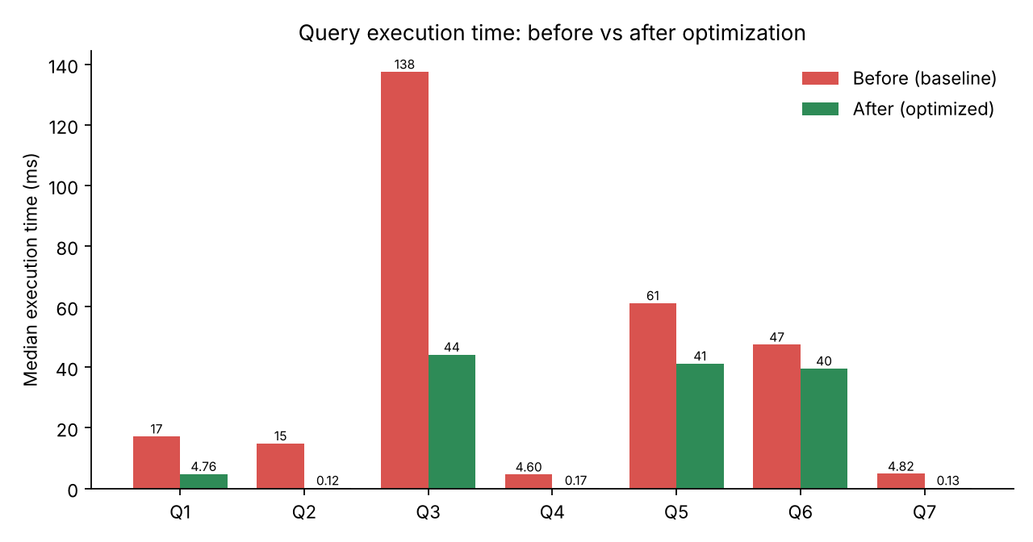
Figure 1: Median execution time before and after optimization
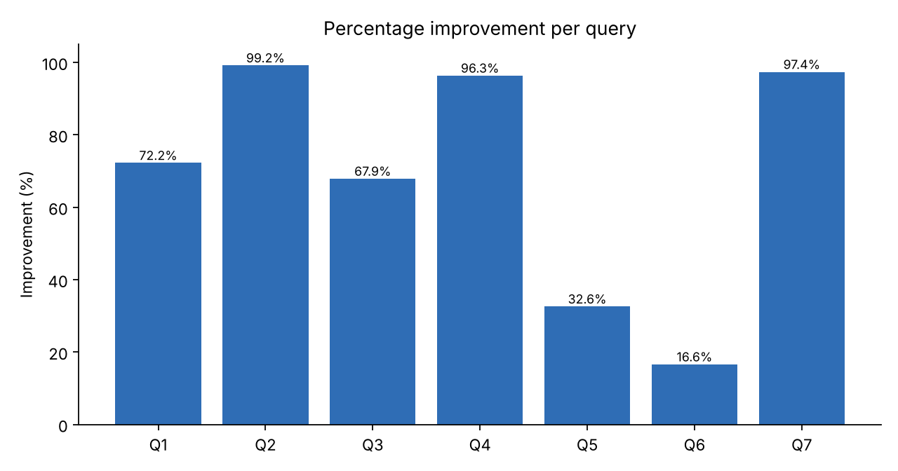
Figure 2: Percentage improvement per query

7.1 Storage cost of the optimizations
Object | Size | Used by
idx_orders_customer_date | 6.6 MB | Q2
idx_inventory_product | 0.8 MB | Q4
idx_inventory_store_stock | 4.0 MB | Q7
idx_orders_date (on orders) | 14 MB | Q6
mv_daily_product_sales (+ index) | 42 MB + 5.9 MB | Q3

8. Rationale Behind the Chosen Strategies
- Index only where the plan shows a full scan returning few rows. Q2, Q4 and Q7 return a tiny fraction of their tables, which is exactly where indexes give 25x to 100x gains.
- Partition by the column that reports filter on. Retail reports almost always filter by date, so range partitioning on order_date gives pruning for Q1 and Q5 and makes archiving old years easy.
- Rewrite before adding hardware or indexes. Q5 could not use any index until the function was removed from the WHERE clause.
- Pre-aggregate when a report must read a large share of a table. For Q3 even the best index was ignored by the planner, so a materialized view was the right tool.
- Verify, do not assume. An index on order_items(order_id) was created and tested for Q3; the planner ignored it, so it was dropped to avoid wasted space and slower inserts.

9. Trade-offs and Limitations
- Write overhead: every index must be maintained on INSERT, UPDATE and DELETE. In a busy retail system, add only indexes that real queries use.
- Materialized view freshness: mv_daily_product_sales is stale until REFRESH MATERIALIZED VIEW runs (for example nightly or every hour).
- Partition maintenance: new yearly partitions must be created in advance. A primary key on a partitioned table must include the partition key (order_id, order_date).
- Dataset size: this test used 300,000 orders. Gains grow with data volume, because a scan grows linearly while an index lookup grows logarithmically.
- Modest gain for Q6: only 16.6%, because PostgreSQL already executes NOT IN with a hashed sub-plan efficiently at this size. NOT EXISTS is still recommended for NULL safety.
- Timing noise: milliseconds vary between runs and machines; medians of five runs were used to reduce this.

10. Recommendations for Further Improvements
- Run ANALYZE regularly (autovacuum does this) so the planner has fresh statistics.
- Enable pg_stat_statements to find the slowest and most frequent queries in production and tune them first.
- Drop unused indexes found via pg_stat_user_indexes (idx_scan = 0).
- Partition order_items too (or copy order_date into it) so that item-level reports can also use pruning.
- Use partial indexes such as WHERE status = 'PENDING' for the small set of open orders.
- Cache hot results (product catalogue, top sellers) in Redis or the application layer.
- Use read replicas for reporting so analytics never slow down billing.
- Archive old partitions (for example orders older than 3 years) to cold storage.
- Tune configuration (shared_buffers, work_mem, effective_cache_size) for the real server.
- Use connection pooling (PgBouncer) for high concurrency.

11. Conclusion
By measuring first and optimizing second, the seven retail queries became much faster: total execution time dropped by 54.7%, and point lookups such as the customer history, inventory lookup and low-stock alert improved by more than 25 times. The work also showed that there is no single best technique: indexes solved selective lookups, query rewriting made filters usable, partitioning reduced the data scanned by date-range reports, and a materialized view solved the one report that no index could fix.
The same structured approach - baseline, plan analysis, targeted change, re-measure, verify the result - can be applied to any production retail database.

Appendix A - Project files and how to reproduce
File | Purpose
schema.sql | Creates the baseline tables
sample_data.sql | Generates 300k orders, 900k order items, etc.
baseline_queries.sql | Seven baseline queries Q1-Q7
optimizations.sql | Indexes, partitioning, materialized view
optimized_queries.sql | Rewritten queries Q1-Q7
benchmark.py | Runs each query 5 times with EXPLAIN ANALYZE, stores medians
results/*.json | Raw measured results and full execution plans

createdb retail
psql -d retail -f schema.sql
psql -d retail -f sample_data.sql
python3 benchmark.py baseline_queries.sql baseline_results.json
psql -d retail -f optimizations.sql
python3 benchmark.py optimized_queries.sql optimized_results.json

