***INTEGRATION OF MEAN-VARIANCE MODEL AND STOCHASTIC INDICATOR FOR PORTFOLIO MANAGEMENT***

* **JITENDRA PADMANABHUNI (20MA20039)**

**ABSTRACT**The Mean-Variance model introduced by Markowitz involves analyzing market data over a period of time and deciding on a portfolio at the end of the period. However, the Mean-Variance model is unable to predict the dynamic nature of the market and, hence, is not suitable for buying or selling based on market conditions. This challenge can be overcome via Technical Analysis. This paper involves using the stochastic indicator (also called the KD index) along with the Markowitz Model to determine the timing of buying or selling an asset. The new investment strategies provide more agility to the investors than the mean-variance model.

**PRELIMINARIES**

**KD INDEX**

The KD index, also known as the stochastic indicator, holds widespread usage in the realm of futures trading. This indicator operates on the premise that the price of an asset often concludes its movement close to the upper or lower bounds of an upward or downward trend period. Consequently, the stochastic indicator initiates its process by computing the raw stochastic value (RSV) using the following formula:

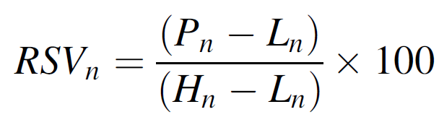

where Pn, Ln, and Hn represent the current closing price, the lowest closing price, and the highest closing price during n periods, respectively. Then, the KD index is

defined as follows:

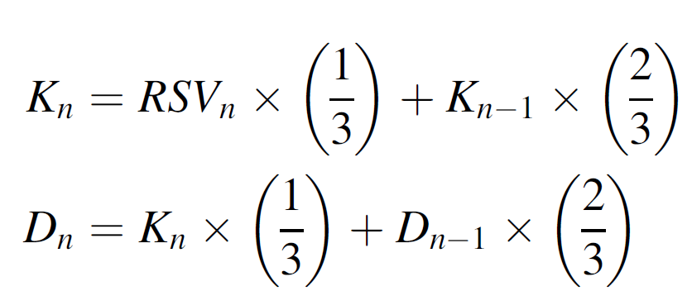

where K1 = D1 = 50. In this study, whenever Kn - 1 ≤ Dn - 1 and Kn  > Dn, a

buying signal is generated; whenever Kn - 1 ≥ Dn - 1 and Kn  < Dn, a selling

signal is generated.

**METHODOLOGY**

**MODERATE INVESTMENT STRATEGY**

The moderate investment strategy combines the mean-variance optimized portfolio with the KD index's buy signal to select assets for investment. In this strategy, equal weight is assigned to each chosen asset, as outlined below:

1. Solve the mean–variance model to yield the optimized portfolio w = (w1; w2; . . .; wn);
2. B = ϕ ;
3. For each asset i satisfying wi > 0;
4. If KD index shows a buying signal, then add i to B;
5. For each asset i ∈ B;
6. Buy asset i with wealth 1/|B|.

**AGGRESSIVE INVESTMENT STRATEGY**

The aggressive strategy, the third in line, relies exclusively on the KD index's buy signal for asset selection in investments. Nevertheless, equal weight is allocated to each chosen asset, as depicted below:

1. B = ϕ ;
2. For each asset i;
3. If KD index shows a buying signal, then add i to B;
4. For each asset i ∈ B;
5. Buy asset i with wealth 1/|B|.

**RESULTS**

| Strategy | Average Return for 100 Days | Standard Deviation of Return for 100 Days |
| --- | --- | --- |
| Mean-Variance Model | -0.0511 | 0.5974 |
| Moderate | -0.0209 | 0.0957 |
| Aggressive | -0.0224 | 0.1113 |