index.html
<!DOCTYPE html>
<html>
<body>
<form action="add">
Enter 1 number : <input type="text" name = "num1"><br>
Enter 2 number : <input type = "text" name = "num2"> <br>
<input type="submit" value="add">
</form>
</body>
</html>

AddServlet.java
package com.telusko;

import java.io.IOException;
import java.io.PrintWriter;

import jakarta.servlet.http.HttpServlet;
import jakarta.servlet.http.HttpServletRequest;
import jakarta.servlet.http.HttpServletResponse;

public class AddServlet extends HttpServlet{

// TODO Auto-generated method stub
public void service(HttpServletRequest req, HttpServletResponse res) throws IOException{
int i = Integer.parseInt(req.getParameter("num1"));
int j = Integer.parseInt(req.getParameter("num2"));
int k = i + j;
PrintWriter out = res.getWriter();
out.println("result is : " + k);

}

}

Web.xml
<?xml version="1.0" encoding="UTF-8"?>
<web-app xmlns:xsi="http://www.w3.org/2001/XMLSchema-instance" xmlns="https://jakarta.ee/xml/ns/jakartaee" xsi:schemaLocation="https://jakarta.ee/xml/ns/jakartaee https://jakarta.ee/xml/ns/jakartaee/web-app_6_0.xsd" id="WebApp_ID" version="6.0">

<!-- whenever client request for addition of two numbers tomcat server check whether it has AddSServlet.java file for that it checks the web.xml file if file is not available then -->
<!-- whenver i request for add my server should call AddServlet-->
<servlet>
<servlet-name>abc</servlet-name>
<servlet-class>com.telusko.AddServlet</servlet-class>
</servlet>

<servlet-mapping>
<servlet-name>abc</servlet-name>
<url-pattern>/add</url-pattern>
</servlet-mapping>
</web-app>

package com.telusko;

import java.io.IOException;
import java.io.PrintWriter;

import jakarta.servlet.RequestDispatcher;
import jakarta.servlet.ServletException;
import jakarta.servlet.http.HttpServlet;
import jakarta.servlet.http.HttpServletRequest;
import jakarta.servlet.http.HttpServletResponse;

public class AddServlet extends HttpServlet{

// TODO Auto-generated method stub
public void doPost(HttpServletRequest req, HttpServletResponse res) throws IOException, ServletException{
int i = Integer.parseInt(req.getParameter("num1"));
int j = Integer.parseInt(req.getParameter("num2"));
int k = i + j;
req.setAttribute("k", k);
RequestDispatcher rd = req.getRequestDispatcher("sq");
rd.forward(req, res);

}

}

<?xml version="1.0" encoding="UTF-8"?>
<web-app xmlns:xsi="http://www.w3.org/2001/XMLSchema-instance" xmlns="https://jakarta.ee/xml/ns/jakartaee" xsi:schemaLocation="https://jakarta.ee/xml/ns/jakartaee https://jakarta.ee/xml/ns/jakartaee/web-app_6_0.xsd" id="WebApp_ID" version="6.0">

<!-- whenever client request for addition of two numbers tomcat server check whether it has AddSServlet.java file for that it checks the web.xml file if file is not available then -->
<!-- whenver i request for add my server should call AddServlet-->
<servlet>
<servlet-name>abc</servlet-name>
<servlet-class>com.telusko.AddServlet</servlet-class>
</servlet>

<servlet-mapping>
<servlet-name>abc</servlet-name>
<url-pattern>/add</url-pattern>
</servlet-mapping>

<servlet>
<servlet-name>pqr</servlet-name>
<servlet-class>com.telusko.SqServlet</servlet-class>
</servlet>

<servlet-mapping>
<servlet-name>pqr</servlet-name>
<url-pattern>/sq</url-pattern>
</servlet-mapping>
</web-app>

package com.telusko;

import java.io.IOException;
import java.io.PrintWriter;

import jakarta.servlet.http.HttpServlet;
import jakarta.servlet.http.HttpServletRequest;
import jakarta.servlet.http.HttpServletResponse;
public class SqServlet extends HttpServlet {
public void doPost(HttpServletRequest req, HttpServletResponse res) throws IOException{
int k = (int) req.getAttribute("k");
k=k*k;
PrintWriter out = res.getWriter();
out.println("result is : " + k);

}
}

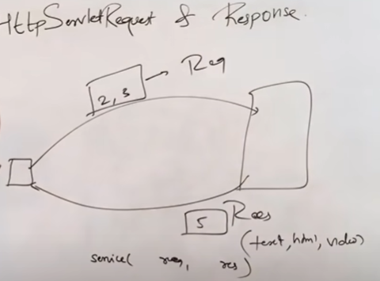

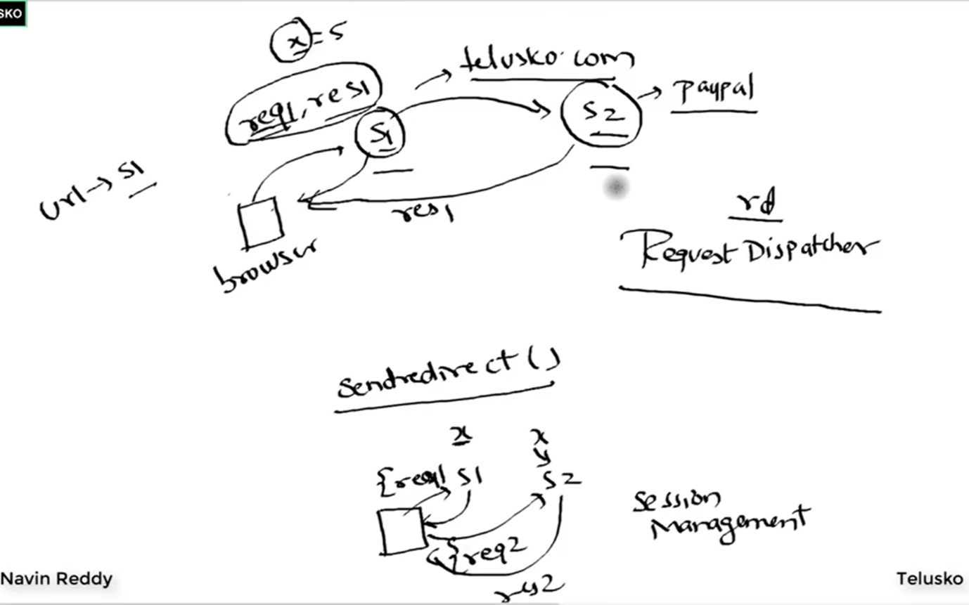

1. URL rewriting:
package com.telusko;

import java.io.IOException;
import java.io.PrintWriter;

import jakarta.servlet.RequestDispatcher;
import jakarta.servlet.ServletException;
import jakarta.servlet.http.HttpServlet;
import jakarta.servlet.http.HttpServletRequest;
import jakarta.servlet.http.HttpServletResponse;

public class AddServlet extends HttpServlet{

// TODO Auto-generated method stub
public void doGet(HttpServletRequest req, HttpServletResponse res) throws IOException, ServletException{
int i = Integer.parseInt(req.getParameter("num1"));
int j = Integer.parseInt(req.getParameter("num2"));
int k = i + j;
res.sendRedirect("sq?k=" + k); //URL rewriting
// RequestDispatcher rd = req.getRequestDispatcher("sq");
// rd.forward(req, res);

}

}

package com.telusko;

import java.io.IOException;
import java.io.PrintWriter;

import jakarta.servlet.http.HttpServlet;
import jakarta.servlet.http.HttpServletRequest;
import jakarta.servlet.http.HttpServletResponse;
public class SqServlet extends HttpServlet {
public void doGet(HttpServletRequest req, HttpServletResponse res) throws IOException{
int k = Integer.parseInt(req.getParameter("k")) ;
k=k*k;
PrintWriter out = res.getWriter();
out.println("result is : " + k);

}
}

OR
2.
Sessions
package com.telusko;

import java.io.IOException;
import java.io.PrintWriter;

import jakarta.servlet.RequestDispatcher;
import jakarta.servlet.ServletException;
import jakarta.servlet.http.HttpServlet;
import jakarta.servlet.http.HttpServletRequest;
import jakarta.servlet.http.HttpServletResponse;
import jakarta.servlet.http.HttpSession;

public class AddServlet extends HttpServlet{

// TODO Auto-generated method stub
public void doGet(HttpServletRequest req, HttpServletResponse res) throws IOException, ServletException{
int i = Integer.parseInt(req.getParameter("num1"));
int j = Integer.parseInt(req.getParameter("num2"));
int k = i + j;
HttpSession session = req.getSession();
session.setAttribute("k", k);
res.sendRedirect("sq");
// RequestDispatcher rd = req.getRequestDispatcher("sq");
// rd.forward(req, res);

}

}

package com.telusko;

import java.io.IOException;
import java.io.PrintWriter;

import jakarta.servlet.http.HttpServlet;
import jakarta.servlet.http.HttpServletRequest;
import jakarta.servlet.http.HttpServletResponse;
import jakarta.servlet.http.HttpSession;
public class SqServlet extends HttpServlet {
public void doGet(HttpServletRequest req, HttpServletResponse res) throws IOException{
HttpSession session = req.getSession();

int k = (int) session.getAttribute("k");

k=k*k;
PrintWriter out = res.getWriter();
out.println("result is : " + k);

}
}

Or

3. Cookie

package com.telusko;

import java.io.IOException;
import java.io.PrintWriter;

import jakarta.servlet.RequestDispatcher;
import jakarta.servlet.ServletException;
import jakarta.servlet.http.Cookie;
import jakarta.servlet.http.HttpServlet;
import jakarta.servlet.http.HttpServletRequest;
import jakarta.servlet.http.HttpServletResponse;
import jakarta.servlet.http.HttpSession;

public class AddServlet extends HttpServlet{

// TODO Auto-generated method stub
public void doGet(HttpServletRequest req, HttpServletResponse res) throws IOException, ServletException{
int i = Integer.parseInt(req.getParameter("num1"));
int j = Integer.parseInt(req.getParameter("num2"));
int k = i + j;
Cookie cookie = new Cookie("k", k + "");
res.addCookie(cookie);

res.sendRedirect("sq");
// RequestDispatcher rd = req.getRequestDispatcher("sq");
// rd.forward(req, res);

}

}

package com.telusko;

import java.io.IOException;
import java.io.PrintWriter;

import jakarta.servlet.http.Cookie;
import jakarta.servlet.http.HttpServlet;
import jakarta.servlet.http.HttpServletRequest;
import jakarta.servlet.http.HttpServletResponse;
import jakarta.servlet.http.HttpSession;

public class SqServlet extends HttpServlet {
public void doGet(HttpServletRequest req, HttpServletResponse res) throws IOException{
int k=0;
Cookie cookies[] = req.getCookies();
for(Cookie c : cookies) {
if(c.getName().equals("k"))
k=Integer.parseInt(c.getValue());
}

k=k*k;
PrintWriter out = res.getWriter();
out.println("result is : " + k);

}
}

ServletContext and ServletConfig:
package com.telusko;
import java.io.IOException;
import java.io.PrintWriter;

import jakarta.servlet.RequestDispatcher;
import jakarta.servlet.ServletConfig;
import jakarta.servlet.ServletContext;
import jakarta.servlet.ServletException;
import jakarta.servlet.http.Cookie;
import jakarta.servlet.http.HttpServlet;
import jakarta.servlet.http.HttpServletRequest;
import jakarta.servlet.http.HttpServletResponse;
import jakarta.servlet.http.HttpSession;
public class MyServlet extends HttpServlet{
protected void doGet(HttpServletRequest req, HttpServletResponse res) throws IOException, ServletException{
PrintWriter out = res.getWriter();
out.print("Hi<br>");

//If you have multiple servlet which share same value go for servlet context and if we have different value for different servlet go for servlet config
// ServletContext ctx = getServletContext();
ServletConfig cg = getServletConfig();
String str = cg.getInitParameter("Name");
out.print(str);
}
}

<?xml version="1.0" encoding="UTF-8"?>
<web-app xmlns:xsi="http://www.w3.org/2001/XMLSchema-instance" xmlns="https://jakarta.ee/xml/ns/jakartaee" xsi:schemaLocation="https://jakarta.ee/xml/ns/jakartaee https://jakarta.ee/xml/ns/jakartaee/web-app_6_0.xsd" id="WebApp_ID" version="6.0">

<!-- whenever client request for addition of two numbers tomcat server check whether it has AddSServlet.java file for that it checks the web.xml file if file is not available then -->
<!-- whenver i request for add my server should call AddServlet-->
<display-name>DemoApp</display-name>

<servlet>
<servlet-name>abc</servlet-name>
<servlet-class>com.telusko.AddServlet</servlet-class>

</servlet>

<servlet-mapping>
<servlet-name>abc</servlet-name>
<url-pattern>/add</url-pattern>
</servlet-mapping>

<servlet>
<servlet-name>pqr</servlet-name>
<servlet-class>com.telusko.SqServlet</servlet-class>

</servlet>

<servlet-mapping>
<servlet-name>pqr</servlet-name>
<url-pattern>/sq</url-pattern>
</servlet-mapping>

<servlet>
<servlet-name>abc1</servlet-name>
<servlet-class>com.telusko.MyServlet</servlet-class>
<init-param>
<param-name>Name</param-name>
<param-value>Sukesh</param-value>
</init-param>
</servlet>

<servlet-mapping>
<servlet-name>abc1</servlet-name>
<url-pattern>/home</url-pattern>
</servlet-mapping>

<context-param>
<param-name>Name</param-name>
<param-value>Vicky</param-value>
</context-param>

<context-param>
<param-name>Phone</param-name>
<param-value>samhone</param-value>
</context-param>

</web-app>

Sometime programmer doesn’t like XML file code so they don’t write servlet mapping in web.xml file instead they use annotations in servlet program example:
This can be done by commenting web.xml file code and use @WebServlet(“/add”) at the top this is called the Servlet Annotation Configuration

Why Jsp?
JSP is the advanced technology of Servlets, it helps to write java code inside HTML tags whereas in Servlets we write HTML tags inside java class.
add.jsp file:
<%@ page language="java" contentType="text/html; charset=ISO-8859-1"
pageEncoding="ISO-8859-1"%>
<!DOCTYPE html>
<html>
<head>
<meta charset="ISO-8859-1">
<title>Insert title here</title>
</head>
<body bgcolor="cyan">
<%
int i = Integer.parseInt(request.getParameter("num1"));
int j = Integer.parseInt(request.getParameter("num2"));
int k = i + j;
out.println("result is : " + k);
%>

</body>
</html>

index.html file will be same just we have to change action = “add.jsp” there there is no use of AddServlet.java file
In Servlets we have to define the class extends HTTPServlets then creting method doGet() or service() and then creating objects of Httprequest and Httpresponse and Printwriter which make Servlet more tedious to learn.
If we can use JSP then why to use servlets?
Basically on tomcat server actually servlets runs, so first JSP file is converted into Servlet then these servlets runs in the Tomcat server and as a programmer we go for the jsp as it is easy for the programmer we don’t need to create classes, extends it creating objects these things is taken care by Servlets.
From the below image we just write code in jsp file don’t need to create objects the code in jsp file places in suitable positions in servlets like scriplet placed in service method inside servlet and the declaration section placed inside the class but outside the service method in servlet i.e as a instance members. And directive in jsp file placed at the top of servlet and expressions in jsp file is place inside out.printwriter() method i.e out.printwriter(expression in jsp file)
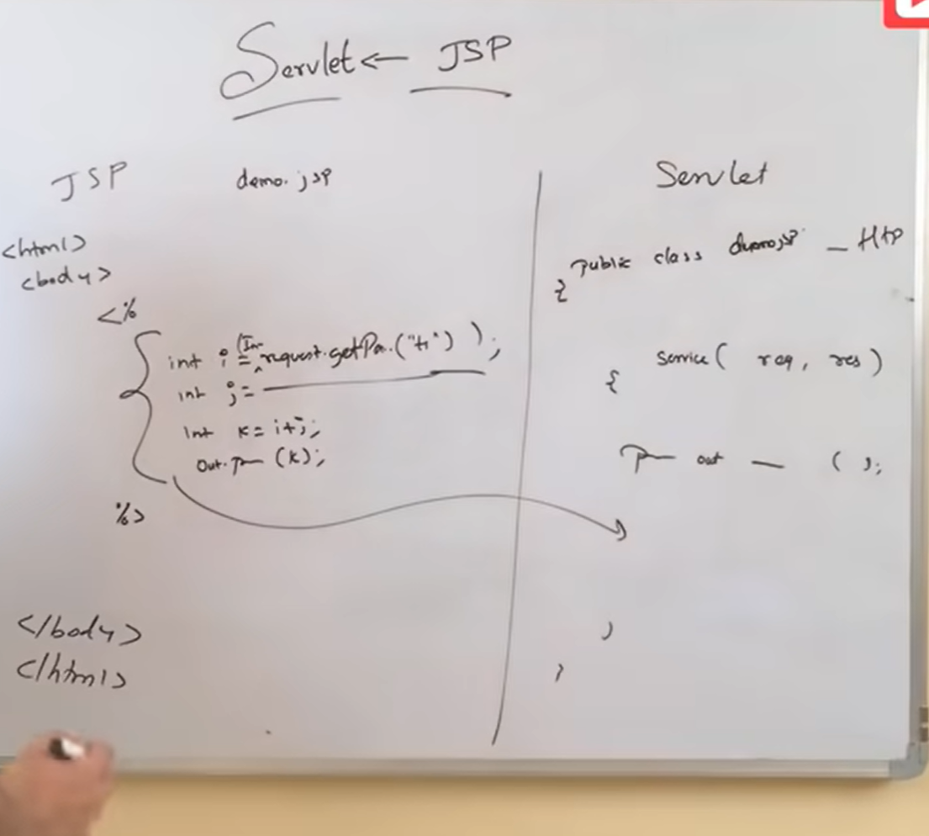

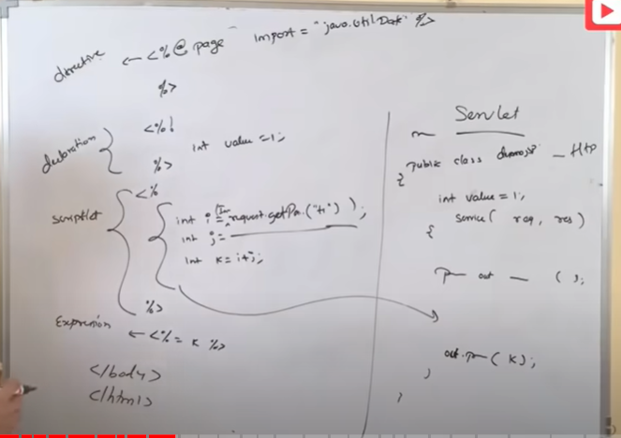

If our intention is to create dynamic page show the content on the page then go for jsp and if our intentions is to process the dynamic pages then for that we have servlets

Exception Handling:
Home.jsp
<%@ page language="java" contentType="text/html; charset=ISO-8859-1"
pageEncoding="ISO-8859-1" errorPage = "error.jsp"%>
<%@ page import = "java.util.ArrayList" %>

<%@include file = "header.jsp" %>
<!DOCTYPE html>
<html>
<head>
<meta charset="ISO-8859-1">
<title>Insert title here</title>
</head>
<body>
<%
/* try{
int k = 9/0;
}
catch(Exception e){
out.println("Error " + e.getMessage());
} */

int k = 9/0;
%>

</body>
</html>

Error.jsp
<%@ page language="java" contentType="text/html; charset=ISO-8859-1"
pageEncoding="ISO-8859-1" isErrorPage="true"%>
<!DOCTYPE html>
<html>
<head>
<meta charset="ISO-8859-1">
<title>Insert title here</title>
</head>
<body bgcolor="red">
error
<%= exception.getMessage() %>
</body>
</html>

JDBC in jsp:
Steps to connect to database:
- Import the Packages
- Load the drivers using the forName() method
- Register the drivers using DriverManager
- Establish a connection using the Connection class object
- Create a statement
- Execute the query
- Close the connections

<%@ page language="java" contentType="text/html; charset=ISO-8859-1"
pageEncoding="ISO-8859-1"%>
<%@ page import = "java.sql.*" %>
<!DOCTYPE html>
<html>
<head>
<meta charset="ISO-8859-1">
<title>Insert title here</title>
</head>
<body>

<%
String url = "jdbc:mysql://localhost:3306/sakila";
String username = "root";
String password = "root";
String sql = "select * from actor where actor_id=5";
Class.forName("com.mysql.jdbc.Driver");
Connection con = DriverManager.getConnection(url, username, password);
Statement st = con.createStatement();
ResultSet rs = st.executeQuery(sql);
rs.next();

%>

Actor_id : <%= rs.getString(1) %> <br>
Name : <%= rs.getString(2) %>

</body>
</html>

MVC:
Model–view–controller (MVC) is a software design pattern[1] commonly used for developing user interfaces that divides the related program logic into three interconnected elements. This is done to separate internal representations of information from the ways information is presented to and accepted from the use.
Let’s imagine an end-user sends a request to a server to get a list of students studying in a class. The server would then send that request to that particular controller that handles students. That controller would then request the model that handles students to return a list of all students studying in a class.
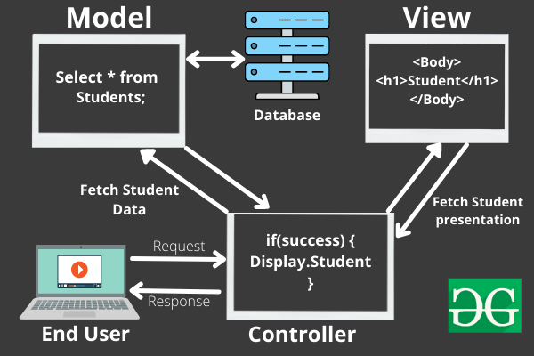
The flow of Data in MVC Components
The model would query the database for the list of all students and then return that list back to the controller. If the response back from the model was successful, then the controller would ask the view associated with students to return a presentation of the list of students. This view would take the list of students from the controller and render the list into HTML that can be used by the browser.
The controller would then take that presentation and returns it back to the user. Thus ending the request. If earlier the model returned an error, the controller would handle that error by asking the view that handles errors to render a presentation for that particular error. That error presentation would then be returned to the user instead of the student list presentation.
As we can see from the above example, the model handles all of the data. The view handles all of the presentations and the controller just tells the model and view of what to do. This is the basic architecture and working of the MVC framework.
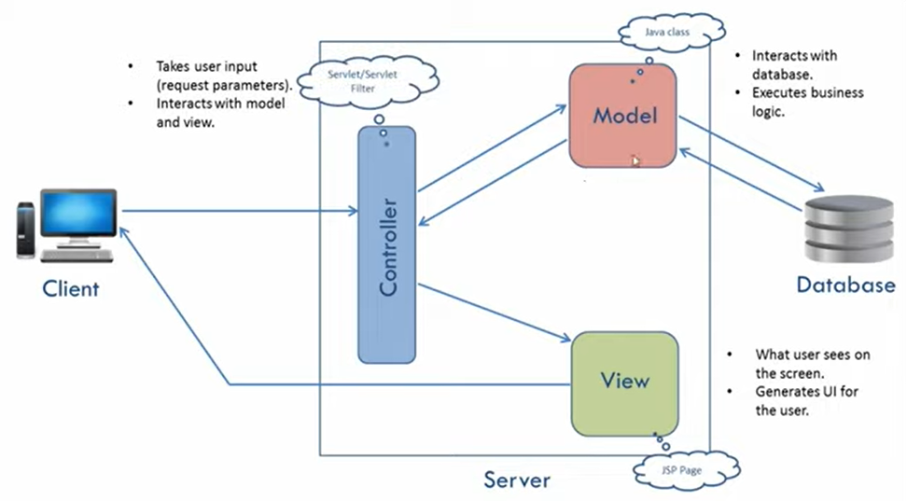

JSTL (JSP Standard Tag Library):
The JSP Standard Tag Library (JSTL) represents a set of tags to simplify the JSP development.
Why to use JSTL
- Fast Development JSTL provides many tags that simplify the JSP.
- Code Reusability We can use the JSTL tags on various pages.
- No need to use scriptlet tag It avoids the use of scriptlet tag.

JSTL Tags
There JSTL mainly provides five types of tags:
Tag Name | Description
Core tags | The JSTL core tag provide variable support, URL management, flow control, etc. The URL for the core tag is http://java.sun.com/jsp/jstl/core. The prefix of core tag is c.
Function tags | The functions tags provide support for string manipulation and string length. The URL for the functions tags is http://java.sun.com/jsp/jstl/functions and prefix is fn.
Formatting tags | The Formatting tags provide support for message formatting, number and date formatting, etc. The URL for the Formatting tags is http://java.sun.com/jsp/jstl/fmt and prefix is fmt.
XML tags | The XML tags provide flow control, transformation, etc. The URL for the XML tags is http://java.sun.com/jsp/jstl/xml and prefix is x.
SQL tags | The JSTL SQL tags provide SQL support. The URL for the SQL tags is http://java.sun.com/jsp/jstl/sql and prefix is sql.

JSTL EL(Expression language):
The JSTL EL or JSTL Expression Language is used by JSP programmers in order to avoid the usage of Java Code for accessing data. The EL statements are always used within { } along with the prefix $. Here is a simple example in which EL expression is used on the JSP page.
DemoServlet.class
import java.io.IOException;

import jakarta.servlet.RequestDispatcher;
import jakarta.servlet.ServletException;
import jakarta.servlet.annotation.WebServlet;
import jakarta.servlet.http.HttpServlet;
import jakarta.servlet.http.HttpServletRequest;
import jakarta.servlet.http.HttpServletResponse;

@WebServlet("/DemoServlet")
public class DemoServlet extends HttpServlet {
protected void doGet(HttpServletRequest request, HttpServletResponse response) throws ServletException, IOException
{
String name = "navin";
request.setAttribute("label", name);
RequestDispatcher rd = request.getRequestDispatcher("display.jsp");
rd.forward(request, response);
}

}

display.jsp
<%@ page language="java" contentType="text/html; charset=ISO-8859-1"
pageEncoding="ISO-8859-1"%>
<!DOCTYPE html>
<html>
<head>
<meta charset="ISO-8859-1">
<title>Insert title here</title>
</head>
<body>

<%--
<%
String name = request.getAttribute("label").toString();
out.println(name);
%>
--%>
<!-- Or below is the EL so that jsp programmer don't need to use java code-->
${label}
</body>
</html>

Core Tags in JSTL:
Sql tags:
JSTL SQL Tags
The JSTL sql tags provide SQL support. The url for the sql tags is http://java.sun.com/jsp/jstl/sql and prefix is sql.

The SQL tag library allows the tag to interact with RDBMSs (Relational Databases) such as Microsoft SQL Server, mySQL, or Oracle. The syntax used for including JSTL SQL tags library in your JSP is:
<%@ taglib uri="http://java.sun.com/jsp/jstl/sql" prefix="sql" %>
Instead of writing all the steps of connecting of jsp to database we can use sql tag of JSTL.

<%@ page language="java" contentType="text/html; charset=ISO-8859-1" pageEncoding="ISO-8859-1" %>
<%@ page import="java.io.*,java.util.*,java.sql.*"%>
<%@ taglib uri="http://java.sun.com/jsp/jstl/core" prefix="c"%>
<%@ taglib uri="http://java.sun.com/jsp/jstl/sql" prefix="sql"%>
<!DOCTYPE html>
<html>
<head>
<meta charset="ISO-8859-1">
<title>Insert title here</title>
</head>
<body>
<sql:setDataSource var="db" driver="com.mysql.jdbc.Driver" url="jdbc:mysql://localhost/sakila" user="root" password="root"/>
<sql:query dataSource="${db}" var="rs" >select * from actor</sql:query>

<c:forEach var="actors" items="${rs.rows}">
<br> <c:out value="${actors.actor_id}"></c:out> : <c:out value="${actors.first_name}"></c:out> <c:out value="${actors.last_name}"></c:out><br>
</c:forEach>
</body>
</html>

JSTL function Tags:
<%@ page language="java" contentType="text/html; charset=ISO-8859-1" pageEncoding="ISO-8859-1" %>
<%@ page import="java.io.*,java.util.*,java.sql.*"%>
<%@ taglib uri="http://java.sun.com/jsp/jstl/core" prefix="c"%>
<%@ taglib uri="http://java.sun.com/jsp/jstl/functions" prefix="fn" %>
<!DOCTYPE html>
<html>
<head>
<meta charset="ISO-8859-1">
<title>Insert title here</title>
</head>
<body>
<c:set var="str" value="Navin Reddy is a Java Trainer"/>
<!-- ${str} Prints the String-->
<%-- Length : ${fn:length(str)} shows the length of string --%>

<!-- slpitting the string on the basis of space -->
<c:forEach var ="s" items="${fn:split(str,' ')}" >
<br>
${s}
</c:forEach>
<br>
<!-- finding index of "is" in str -->
index of "is" : ${fn:indexOf(str,"is")}
<br>
<!-- contains checks the particular string in the given string -->
String contains "Java" : ${fn:contains(str,"java") }
<br>

<!-- using core if else tags-->
<c:if test="${fn:contains(str,'Java') }">
Java is there
</c:if>

<c:if test="${fn:endsWith(str,'Trainer') }">
string ends with trainer
</c:if>

</body>
</html>

Servlet Filter
A filter is an object that is invoked at the preprocessing and postprocessing of a request.It is mainly used to perform filtering tasks such as conversion, logging, compression, encryption and decryption, input validation etc.
The servlet filter is pluggable, i.e. its entry is defined in the web.xml file, if we remove the entry of filter from the web.xml file, filter will be removed automatically and we don't need to change the servlet.
For creating any filter, you must implement the Filter interface. Filter interface provides the life cycle methods for a filter.
Method | Description
public void init(FilterConfig config) | init() method is invoked only once. It is used to initialize the filter.
public void doFilter(HttpServletRequest request,HttpServletResponse response, FilterChain chain) | doFilter() method is invoked every time when user request to any resource, to which the filter is mapped.It is used to perform filtering tasks.
public void destroy() | This is invoked only once when filter is taken out of the service.

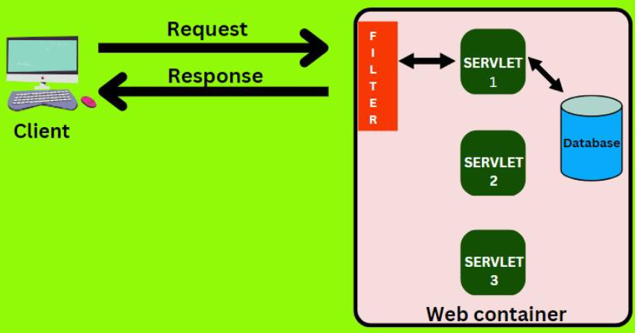

Home.jsp:
<%@page language="java" contentType="text/html; charset=ISO-8859-1"
pageEncoding="ISO-8859-1"%>

<!DOCTYPE html>
<html>
<head>
<meta charset="ISO-8859-1">
<title>Insert title here</title>
</head>
<body>

<form action="addAlien">
Roll no. : <input type = "text" name="aid"><br>
Name : <input type = "text" name = "aname"><br>
<input type = "submit"><br>
</form>

</body>
</html>

Filter for checking roll number greater than 0:
package com.demo;

import java.io.IOException;
import java.io.PrintWriter;

import jakarta.servlet.Filter;
import jakarta.servlet.FilterChain;
import jakarta.servlet.FilterConfig;
import jakarta.servlet.ServletException;
import jakarta.servlet.ServletRequest;
import jakarta.servlet.ServletResponse;
import jakarta.servlet.annotation.WebFilter;

/**
* Servlet Filter implementation class DemoFilter
*/
@WebFilter("/addAlien")
public class DemoFilter implements Filter {

/**
* Default constructor.
*/
public DemoFilter() {
// TODO Auto-generated constructor stub
}

/**
* @see Filter#destroy()
*/
public void destroy() {
// TODO Auto-generated method stub
}

/**
* @see Filter#doFilter(ServletRequest, ServletResponse, FilterChain)
*/
public void doFilter(ServletRequest request, ServletResponse response, FilterChain chain) throws IOException, ServletException {
// TODO Auto-generated method stub
// place your code here
PrintWriter out = response.getWriter();
int aid = Integer.parseInt(request.getParameter("aid"));
// pass the request along the filter chain
if(aid>1)
chain.doFilter(request, response);
else
out.print("roll number cannot be negative");
}

/**
* @see Filter#init(FilterConfig)
*/
public void init(FilterConfig fConfig) throws ServletException {
// TODO Auto-generated method stub
}

}

Filter for checking name should be greater than 3 length:
package com.demo;

import java.io.IOException;
import java.io.PrintWriter;

import jakarta.servlet.Filter;
import jakarta.servlet.FilterChain;
import jakarta.servlet.FilterConfig;
import jakarta.servlet.ServletException;
import jakarta.servlet.ServletRequest;
import jakarta.servlet.ServletResponse;
import jakarta.servlet.annotation.WebFilter;

/**
* Servlet Filter implementation class Filter2
*/
@WebFilter("/addAlien")
public class Filter2 implements Filter {

/**
* Default constructor.
*/
public Filter2() {
// TODO Auto-generated constructor stub
}

/**
* @see Filter#destroy()
*/
public void destroy() {
// TODO Auto-generated method stub
}

/**
* @see Filter#doFilter(ServletRequest, ServletResponse, FilterChain)
*/
public void doFilter(ServletRequest request, ServletResponse response, FilterChain chain) throws IOException, ServletException {
// TODO Auto-generated method stub
// place your code here
PrintWriter out = response.getWriter();
String aname = request.getParameter("aname");
// pass the request along the filter chain
if(aname.length()>3)
chain.doFilter(request, response);
else
out.print("Enter name more than 3 characters");
}

/**
* @see Filter#init(FilterConfig)
*/
public void init(FilterConfig fConfig) throws ServletException {
// TODO Auto-generated method stub
}

}

Login page
login.jsp
<%@ page language="java" contentType="text/html; charset=ISO-8859-1"
pageEncoding="ISO-8859-1"%>
<!DOCTYPE html>
<html>
<head>
<meta charset="ISO-8859-1">
<title>Insert title here</title>
</head>
<body>

<form action = "Login" method = "post">
Enter Username: <input type="text" name="uname"><br>
Enter Password: <input type="password" name="pass"><br>
<input type="submit" value = "login">
</form>
<%-- Display the error message if it exists --%>
<% String errorMessage = (String) session.getAttribute("errorMessage"); %>
<% if (errorMessage != null) { %>
<p style="color: red;"><%= errorMessage %></p>
<% } %>
</body>
</html>

Welcome.jsp
<%@ page language="java" contentType="text/html; charset=ISO-8859-1"
pageEncoding="ISO-8859-1"%>
<!DOCTYPE html>
<html>
<head>
<meta charset="ISO-8859-1">
<title>Insert title here</title>
</head>
<body>
<%
//removing cache of welcome page so that if i got logout from that, the cache of welcome page should be deleted and we cannot access the welcome page by back button
response.setHeader("Cache-Control","no-cache, no-store, must-revalidate"); //HTTP 1.1
response.setHeader("Pragma","no-cache"); //HTTP 1.0
response.setHeader("Expires","0"); //Proxies
if(session.getAttribute("username") == null){
response.sendRedirect("login.jsp");
}
%>
Welcome ${username}
<a href="videos.jsp">Videos here</a>

<form action="Logout">
<input type="submit" value="Logout">
</form>
</body>
</html>

Videos.jsp
<%@ page language="java" contentType="text/html; charset=ISO-8859-1"
pageEncoding="ISO-8859-1"%>
<!DOCTYPE html>
<html>
<head>
<meta charset="ISO-8859-1">
<title>Insert title here</title>
</head>
<body>
<%
response.setHeader("Cache-Control","no-cache, no-store, must-revalidate"); //HTTP 1.1
response.setHeader("Pragma","no-cache"); //HTTP 1.0
response.setHeader("Expires","0"); //Proxies

if(session.getAttribute("username")==null)
response.sendRedirect("login.jsp");
%>

<iframe width="560" height="315" src="https://www.youtube.com/embed/OuBUUkQfBYM?si=E0E-AO-vdXVrmU5c" title="YouTube video player" frameborder="0" allow="accelerometer; autoplay; clipboard-write; encrypted-media; gyroscope; picture-in-picture; web-share" allowfullscreen></iframe>
</body>
</html>
aboutus.jsp
<%@ page language="java" contentType="text/html; charset=ISO-8859-1"
pageEncoding="ISO-8859-1"%>
<!DOCTYPE html>
<html>
<head>
<meta charset="ISO-8859-1">
<title>Insert title here</title>
</head>
<body>
This is vicky singh
Teaching you all Java...
</body>
</html>

Login.java
package com.login;

import java.io.IOException;
import java.sql.SQLException;

import com.login.dao.LoginDatabase;

import jakarta.servlet.ServletException;
import jakarta.servlet.annotation.WebServlet;
import jakarta.servlet.http.HttpServlet;
import jakarta.servlet.http.HttpServletRequest;
import jakarta.servlet.http.HttpServletResponse;
import jakarta.servlet.http.HttpSession;

@WebServlet("/Login")
public class Login extends HttpServlet {
protected void doPost(HttpServletRequest request, HttpServletResponse response) throws ServletException {
// TODO Auto-generated method stub
String uname = request.getParameter("uname");
String pass = request.getParameter("pass");
LoginDatabase login = new LoginDatabase();
HttpSession session = request.getSession();
try {
if(login.check(uname, pass)) {
session.setAttribute("username",uname);
response.sendRedirect("welcome.jsp");
}
else {
session.setAttribute("errorMessage", "Username or password is incorrect.");
response.sendRedirect("login.jsp");
}
} catch (SQLException | IOException e) {
// TODO Auto-generated catch block
e.printStackTrace();
}
}
}

Logout.jsp
package com.login;

import java.io.IOException;

import jakarta.servlet.ServletException;
import jakarta.servlet.annotation.WebServlet;
import jakarta.servlet.http.HttpServlet;
import jakarta.servlet.http.HttpServletRequest;
import jakarta.servlet.http.HttpServletResponse;
import jakarta.servlet.http.HttpSession;

@WebServlet("/Logout")
public class Logout extends HttpServlet {

protected void doGet(HttpServletRequest request, HttpServletResponse response) throws ServletException, IOException {
HttpSession session = request.getSession();
session.removeAttribute("username");
session.invalidate();
response.sendRedirect("login.jsp");
}

}

LoginDatabase.java
package com.login.dao;

import java.sql.*;
public class LoginDatabase {
String sql = "select * from login where uname=? and pass=?";
String url = "jdbc:mysql://localhost:3306/sakila";
String username = "root";
String password = "root";
public boolean check(String uname, String pass) throws SQLException {
try {
Class.forName("com.mysql.jdbc.Driver");
Connection con = DriverManager.getConnection(url, username, password);
PreparedStatement st = con.prepareStatement(sql);
st.setString(1,uname);
st.setString(2, pass);
ResultSet rs = st.executeQuery();
if(rs.next())
return true;
} catch (ClassNotFoundException e) {
// TODO Auto-generated catch block
e.printStackTrace();
}
return false;
}
}

Maven project:
index.jsp
<html>
<body>
<h2>Hello World!</h2>
<form action = "getAlien">
<input type = "text" name="aid">
<input type = "submit">
</form>
</body>
</html>

GetAlienController.java
package com.telusko.web;

import com.telusko.web.dao.AlienDao;
import com.telusko.web.model.Alien;

import jakarta.servlet.RequestDispatcher;
import jakarta.servlet.http.HttpServlet;
import jakarta.servlet.http.HttpServletRequest;
import jakarta.servlet.http.HttpServletResponse;

public class GetAlienController extends HttpServlet {
private static final long serialVersionUID = 1L;
protected void doGet(HttpServletRequest request, HttpServletResponse response) {
try {
int aid= Integer.parseInt(request.getParameter("aid"));
AlienDao dao = new AlienDao();
Alien a1 = dao.getAlien(aid);
request.setAttribute("alien", a1);
RequestDispatcher rd = request.getRequestDispatcher("showAlien.jsp");
rd.forward(request, response);
}
catch(Exception e) {
e.printStackTrace();
}
}
}
AlienDao.java
package com.telusko.web.dao;

import java.sql.Connection;
import java.sql.DriverManager;
import java.sql.ResultSet;
import java.sql.SQLException;
import java.sql.Statement;

import com.telusko.web.model.Alien;

public class AlienDao {
public Alien getAlien(int aid) {
Alien a = new Alien();
try {
Class.forName("com.mysql.jdbc.Driver");
Connection con = DriverManager.getConnection("jdbc:mysql://localhost:3306/sakila", "root", "root");
Statement st = con.createStatement();
ResultSet rs = st.executeQuery( "select * from navin where aid=" + aid);
if(rs.next())
{
a.setAid(rs.getInt("aid"));
a.setAname(rs.getString("aname"));
a.setTech(rs.getString("tech"));
}

} catch (Exception e) {
// TODO Auto-generated catch block
e.printStackTrace();
}
return a;
}
}

Alien.java
package com.telusko.web.model;

public class Alien {
private int aid;
private String aname;
private String tech;
public int getAid() {
return aid;
}
public void setAid(int aid) {
this.aid = aid;
}
public String getAname() {
return aname;
}
public void setAname(String aname) {
this.aname = aname;
}
public String getTech() {
return tech;
}
public void setTech(String tech) {
this.tech = tech;
}
@Override
public String toString() {
return "Alien [aid=" + aid + ", aname=" + aname + ", tech=" + tech + "]";
}

}

showAlien.jsp
<%@page import="com.telusko.web.model.Alien"%>
<%@ page language="java" contentType="text/html; charset=ISO-8859-1"
pageEncoding="ISO-8859-1"%>
<!DOCTYPE html>
<html>
<head>
<meta charset="ISO-8859-1">
<title>Insert title here</title>
</head>
<body>
<%
Alien a1 = (Alien)request.getAttribute("alien");
out.println(a1);
%>
</body>
</html>

