# Program 01: Write a C++ program to get the size of different type of datatypes.

**Code :**

#include <iostream>

using namespace std;

void printIntro(string topic, string time){

cout <<"Topic : "<< topic<< endl ;

cout << "Author: Jitendra Kumar Sahu" << endl ;

cout <<"Time : "<< time << endl << endl;

}

int main(){

printIntro("Square of integer","28-09-23 13:57") ;

int x ;

cout << "Enter an integer : ";

cin>> x ;

cout << x << " cube = " << x*x*x << endl ;

return 0 ;

}

Output:

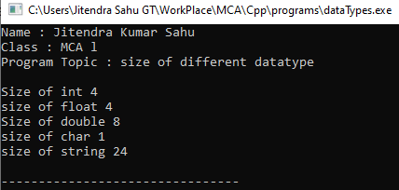

# Program 02: Write a C++ program to perform arithmetic operations using arithmetic operators.

**Code :**

#include <iostream>

using namespace std ;

void printIntroWithTopic(string programTopic){

cout <<"Name : Jitendra Kumar Sahu"<< endl ;

cout << "Class : MCA l" << endl ;

cout <<"Program Topic : " << programTopic << endl << endl ;

}

int main(){

printIntroWithTopic("Arithemetic Operators ") ;

int a ,b ;

cout << "Enter value of a and b : " ;

cin >> a >> b ;

cout << "addition Operator, a + b : " << a+b << endl ;

cout << "substraction Operator, a - b : " << a-b << endl ;

cout << "multiplication Operator, a * b : " << a*b << endl ;

cout << "divid Operator, a / b : " << a/b << endl ;

cout << "modulo Operator, a % b : " << a%b << endl ;

cout << "pre increament Operator, ++a : " << ++a << endl ;

cout << "post increament Operator, a++ : " << a++ << endl ;

cout << "pre decreament Operator, --b : " << --b << endl ;

cout << "post decreament Operator, b-- : " << b-- << endl ;

return 0 ;

}

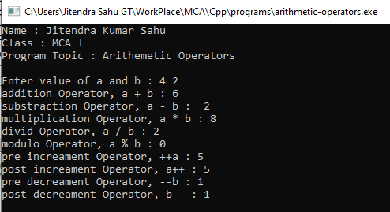

# Program 03: Write a C++ program to demonstrate the different types of relational operators .

**Code :**

#include <iostream>

using namespace std ;

void printIntroWithTopic(string programTopic){

cout <<"Name : Jitendra Kumar Sahu"<< endl ;

cout << "Class : MCA l" << endl ;

cout <<"Program Topic : " << programTopic << endl << endl ;

}

int main(){

printIntroWithTopic("Relational Operators") ;

int a, b ;

cout << "0 = FALSE\n1 = TRUE\n" ;

cout << "Enter values for a and b " ;

cin >> a >> b ;

cout <<a << " == "<<b <<" : "<< (a==b) << endl ;

cout <<a << " != "<<b <<" : "<< (a!=b) << endl ;

cout <<a << " > "<<b <<" : "<< (a>b) << endl ;

cout <<a << " < "<<b <<" : "<< (a<b) << endl ;

cout <<a << " >= "<<b <<" : "<< (a>=b) << endl ;

cout <<a << " <= "<<b <<" : "<< (a<=b) << endl ;

return 0 ;

}

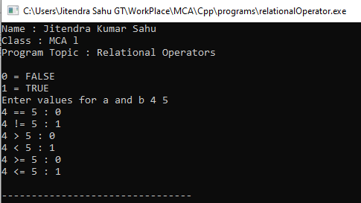

# Program04: Write a C++ program to demonstrate the logical operators(&&,||,!) .

**Code :**

#include <iostream>

using namespace std ;

void printIntroWithTopic(string programTopic){

cout <<"Name : Jitendra Kumar Sahu"<< endl ;

cout << "Class : MCA l" << endl ;

cout <<"Program Topic : " << programTopic << endl << endl ;

}

int main(){

printIntroWithTopic("Logical Operators") ;

bool a = true , b = false ;

cout << a << " && "<< b <<" : " << (a && b) << endl ;

cout << a << " || "<< b <<" : "<< (a || b) << endl ;

cout << "!"<< a << " : "<< !b << endl ;

return 0 ;

}

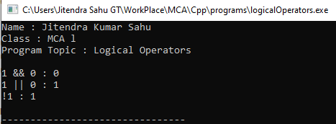

# Program 05: Write a C++ program to demonstrate the Bitwise operators .

**Code :**

#include <iostream>

using namespace std ;

void printIntro(){

cout <<"Name: Porogram to demonstrate Bitwise Operator "<< endl ;

cout << "Author: Jitendra Kumar Sahu" << endl ;

cout <<"Date: 28-09-23 13:03" << endl << endl;

}

void bitwise(int a , int b){

int res = a & b ;

cout << "a & b : " << res << endl ;

res = a | b ;

cout << "a | b : " << res << endl ;

res = a << b ;

cout << "a << b : " << res << endl ;

res = a >> b ;

cout << "a >> b : " << res << endl ;

res = ~b ;

cout << "~b : " << res << endl ;

}

int main(){

printIntro() ;

int a, b ;

cout << "Enter the value of a and b : " ;

cin >> a >> b ;

bitwise(a,b) ;

return 0 ;

}

**Output:**

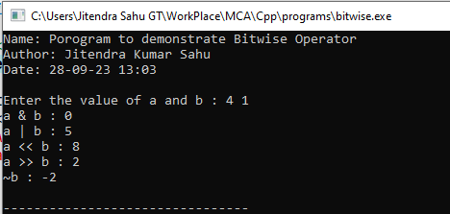

# Program 06: Write a C++ program to read radius of a circle, calculate area and perimeter and display them.(using const constant).

**Code :**

#include <iostream>

using namespace std ;

void printIntro(){

cout <<"Name: Porogram to demonstrate area of Circle "<< endl ;

cout << "Author: Jitendra Kumar Sahu" << endl ;

cout <<"Date: 28-09-23 13:15" << endl << endl;

}

void area(int radius){

const float PI = 22/7 ;

cout <<"Area of circle : " << PI*radius*radius;

}

int main(){

printIntro() ;

int radius;

cout << "Enter value of radius : " ;

cin >>radius ;

area(radius) ;

return 0 ;

}

Output:

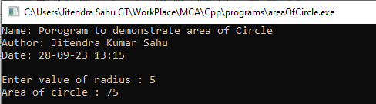

# Program 07: Write a C++ program for Assuming that res starts with the value 25 and p with 3,so print the following code:-

**cout<<res--;**

**cout<<++res;**

**p=p*++res;**

**code :**

#include<iostream>

using namespace std;

void printIntro(){

cout << "Author: Jitendra Kumar Sahu" << endl ;

cout <<"Date: 28-09-23 13:15" << endl << endl;

}

int main()

{

printIntro() ;

int res = 25 , p = 3 ;

cout << "res-- "<<res--<< endl ;

cout << "++res "<<++res << endl ;

p = p * ++res ;

cout << "p * ++res " << p << endl ;

return 0;

}

Output :

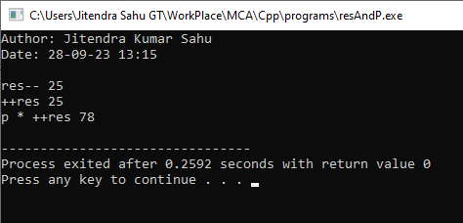

# Program 08: Write a C++ program to input number of week’s day(1-7) and translate to its equivalent name of the day of the week using switch case.

**Code :**

#include <iostream>

using namespace std ;

void printIntro(){

cout <<"Name: Week day with switch case "<< endl ;

cout << "Author: Jitendra Kumar Sahu" << endl ;

cout <<"Date: 28-09-23 13:15" << endl << endl;

}

int main()

{

printIntro() ;

int n ;

cout << "Enter day of the week " ;

cin>> n ;

switch (n)

{

case 1 : cout << "Monday" << endl ;

break ;

case 2 : cout <<"Tuesday"<< endl ;

break ;

case 3 : cout <<"Wednessday" << endl ;

break ;

case 4 : cout <<"Thursday"<< endl ;

break ;

case 5 : cout <<"Friday"<< endl ;

break ;

case 6 : cout <<"Saturday"<< endl ;

break ;

case 7 : cout <<"Sunday"<< endl ;

break ;

default : cout << "You may have entered a wrong day" ;

}

return 0 ;

}

**Output:**

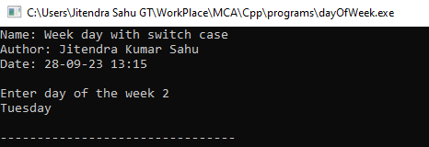

# Program 09: Write a C++ program to make basic calculator using switch case.

**Code :**

#include <iostream>

using namespace std ;

void printIntro(){

cout<<"Topic : basic arithmetic with switch case "<<endl;

cout<<"Author: Jitendra Kumar Sahu"<<endl;

cout<<"MCA 1st sem"<<endl;

cout<<"date: 01-10-23 23:36"<<endl;

}

int main()

{

printIntro() ;

float n1, n2 , result;

char operation ;

cout << "Enter calculation " ;

cin >> n1 >> operation >> n2 ;

bool isValidOperation = true ;

switch (operation) {

case '+' : result = n1 + n2 ;

break ;

case '-' : result = n1 - n2 ;

break ;

case '/' : result = n1 / n2 ;

break ;

case '*' : result = n1 * n2 ;

break ;

default : cout << "You may have entered an invalid operation"<< endl;

isValidOperation = false ;

}

if (isValidOperation) cout << "result " << result << endl ;

}

Output:

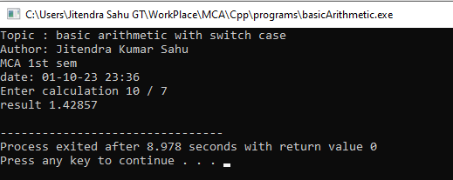

# Program 10: Write a C++ program to find largest number among three numbers using ternary Operator.

**Code :**

#include <iostream>

using namespace std ;

void printIntro(){

cout <<"Name: Finding largest of three number using Ternary"<< endl ;

cout << "Author: Jitendra Kumar Sahu" << endl ;

cout <<"Date: 28-09-23 13:15" << endl << endl;

}

int main()

{

printIntro() ;

int a, b ,c ;

cout << "enter values for a,b and c : " ;

cin>> a>> b >> c ;

int max = (a>b && a>c)?a:((b>c)?b:c );

cout << "max : " << max << endl ;

return 0 ;

}

Output :

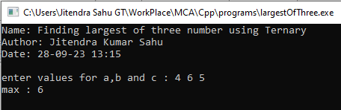

# Program11: Write a C++ program using for loop to print numbers from 1 to 10.

**Code :**

#include <iostream>

using namespace std ;

void printIntro(string topic, string time) {

cout<<"Topic : " << topic << endl ;

cout<<"Author : Jitendra Kumar Sahu" << endl ;

cout << "Time : "<< time << endl ;

cout <<"_____________________*_____________________"<< endl ;

}

int main(){

printIntro("Programm to print numbers 1 to 10","26-10-23 21:43") ;

for(int i =1 ; i<=10 ; i++ )

cout << i << endl ;

return 0 ;

}

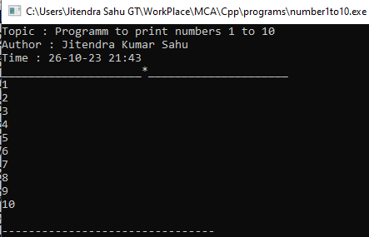

Program12: Write a C++ program to display 2,4,6,8…….,18,20 using while loop.

**Code :**

#include <iostream>

using namespace std ;

void printIntro(string topic, string time){

cout <<"Topic : "<< topic<< endl ;

cout << "Author: Jitendra Kumar Sahu" << endl ;

cout <<"Time : "<< time << endl << endl;

}

void printTable(int n){

int i = 1 ;

while(i <= 10 ){

cout << i * n <<"," ;

i++ ;

}

}

int main(){

printIntro("Table of 2","28-09-23 13:36") ;

printTable(2) ;

return 0 ;

}

Output :

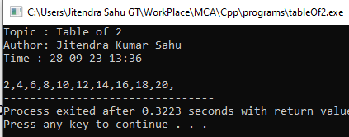

# Program 13 : Write a C++ program to print following patterns-

# * * * * b) * c) 1 d) *

# * * * * * 1 2 * *

# * * * * * 1 2 3 * * *

# * * * * * 1 2 3 4 * * * *

**Code :**

#include <iostream>

using namespace std;

void triangle1(int n){

for (int i = 0; i < n; i++){

for (int j = 0; j <= i; j++){

cout << "* ";

}

cout << endl;

}

}

void triangle2(int n){

for (int i = n; i > 0; i--){

for (int j=0 ; j < i ; j++)

cout << "* " ;

cout << endl;

}

}

void triangle3(int n){

for(int i = 1 ; i <= n ; i++){

for (int j = 0; j <= n; j++){

j <= n - i ? cout <<" " : cout <<"* " ;

}

cout << endl ;

}

}

void numericPattern(int n){

for (int i = 1 ; i<= n ; i++ ){

for(int j = 1 ; j <= i ; j++ )

cout << j << " " ;

cout << endl ;

}

}

int main()

{

int n;

cout << "Enter the n : ";

cin >> n;

cout << "pattern A \n" ;

triangle2(n) ;

cout << endl ;

cout << "pattern B \n" ;

triangle1(n) ;

cout << endl ;

cout << "pattern C \n" ;

numericPattern(n) ;

cout << endl ;

cout << "pattern D \n" ;

triangle3(n) ;

cout << endl ;

return 0;

}

**Output :**

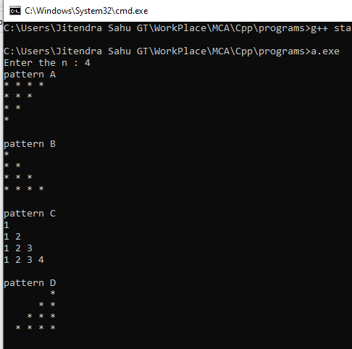

Program14: Write a C++ program to display the cube of the number up to an integer.

**Code :**

#include <iostream>

using namespace std ;

void printIntro(string topic, string time){

cout <<"Topic : "<< topic<< endl ;

cout << "Author: Jitendra Kumar Sahu" << endl ;

cout <<"Time : "<< time << endl << endl;

}

int main(){

printIntro("Square of integer","28-09-23 13:57") ;

int x ;

cout << "Enter an integer : ";

cin >> x ;

for(int i = 1 ; i <= x ; i++)

cout << i << " cubed " << i*i*i << endl ;

return 0 ;

}

**Ouput :**

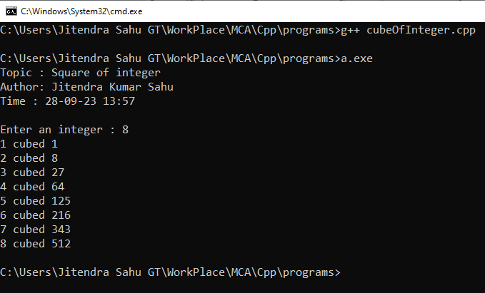

Program15: Write a C++ program to check for equality of two numbers without using arithmetic or comparison operator.

**Code :**

#include <iostream>

using namespace std ;

void printIntro(string topic, string time) {

cout<<"Topic : " << topic << endl ;

cout<<"Author : Jitendra Kumar Sahu" << endl ;

cout << "Time : "<< time << endl ;

cout <<"_____________________*_____________________"<< endl ;

}

int main(){

printIntro("Equality without comparison","26-10-23 22:38") ;

int a,b ;

cout << "enter two numbers : " ;

cin >> a >>b ;

a ^ b ? cout << "Not Equal" : cout<< "Equal" ;

cout << endl ;

return 0 ;

}

**Output:**

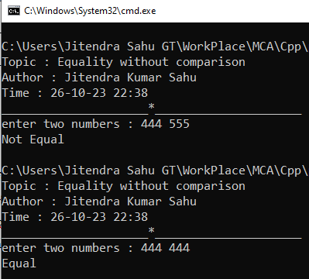

Program 16: Write a C++ program to calculate value of 132 x 8 without using “*” operator

**Code :**

#include <iostream>

using namespace std ;

void printIntro(string topic, string time){

cout <<"Topic : "<< topic<< endl ;

cout << "Author: Jitendra Kumar Sahu" << endl ;

cout <<"Time : "<< time << endl << endl;

}

int main(){

printIntro("Multiplication of 132 and 8 using bitwise", "28-09-23 17:54") ;

cout << (132 << 3) << endl ;

return 0 ;

}

**Output:**

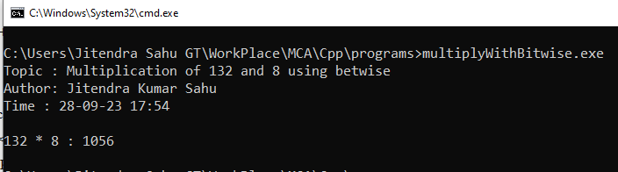

Program 17: Write a C++ program to find Area of rectangle (using #define).

**Code :**

#include <iostream>

using namespace std ;

#define length 5

#define width 6

#define area (length * width )

void printIntro(string topic, string time){

cout <<"Topic : "<< topic<< endl ;

cout << "Author: Jitendra Kumar Sahu" << endl ;

cout <<"Time : "<< time << endl << endl;

}

int main(){

printIntro("Area of rectangle", "28-09-23 17:54") ;

cout << "area of rectangle of 5 by 6 : " ;

cout << area << endl ;

return 0 ;

}

Output

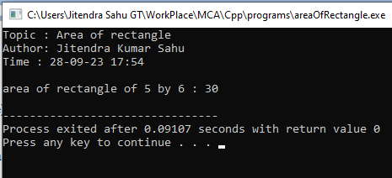

Program 18: Write a C++ program to demonstrate explicitly typecasting..

#include <iostream>

using namespace std ;

void printIntro(string topic, string time){

cout <<"Topic : "<< topic<< endl ;

cout << "Author: Jitendra Kumar Sahu" << endl ;

cout <<"Time : "<< time << endl << endl;

}

int main(){

printIntro("Explicit type casting", "28-09-23 18:27");

float x = 5.54 ;

int casted = (int)x ;

cout << "it typecasts float "<< x << " to int " << casted << endl ;

return 0 ;

}

**Output:**

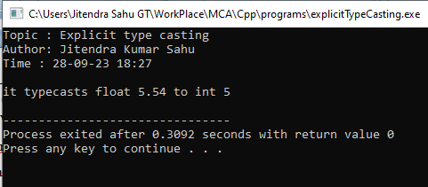

Program 19: Write a C++ program to display addition of first 1 to 20 odd numbers and also display addition of first 1 to 20 even numbers.

**Code :**

#include<iostream>

using namespace std;

void printIntro(string topic, string time) {

cout<<"Topic : " << topic << endl ;

cout<<"Author : Jitendra Kumar Sahu" << endl ;

cout << "Time : "<< time << endl ;

cout <<"_____________________*_____________________\n"<< endl ;

}

int main()

{

printIntro("sum even and odds till 20","27-10-13 08:51") ;

int numberOfDigits = 10 ;

int OddStart = 1 , EvenStart = 2, OddResult = 0 , EvenResult =0;

while (numberOfDigits--){

OddResult += OddStart ;

EvenResult += EvenStart ;

OddStart +=2 ;

EvenStart += 2;

}

cout << "Sum of odd numbers till 20 : "<< OddResult<<endl ;

cout << "Sum of even numbers till 20 : "<< EvenResult<<endl ;

}

**Output:**

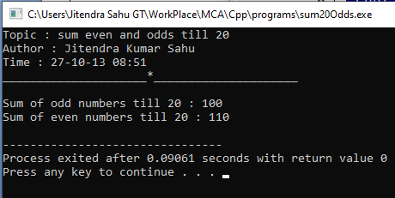

Program 20: Write a C++ program for a given problem – where age will be taken as input by the user and if age is greater than 18 and gender is “Male(M/m)” than print message to send him to “Room number 10” for voting and if gender is “Female(F/f)” than print message to send her to “Room number 12”,if gender is none of these two than send them to “Room number 8”.also given message “Not eligible for voting” in case of age is less than 18.(using nested if control structure)

**Code :**

#include<iostream>

using namespace std;

void printIntro(string topic, string time) {

cout<<"Topic : " << topic << endl ;

cout<<"Author : Jitendra Kumar Sahu" << endl ;

cout << "Time : "<< time << endl ;

cout <<"_____________________*_____________________\n"<< endl ;

}

int main()

{

printIntro("Voting Eligiblity","27-10-13 08:51") ;

int age ;

char gender ;

cout << "Enter gender(m/) and age : " ;

cin >> gender >> age ;

if (age >= 18 ) {

if(gender=='m' || gender=='M')

cout << "Go to room number 10 to vote" ;

else if(gender=='f' || gender=='F')

cout << "Go to room number 12 to vote" ;

else cout << "Go to room number 8 to vote" ;

}else {

cout << "Not Eligible for voting!" << endl ;

}

return 0;

}

**Output :**

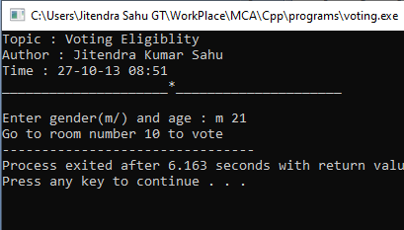

Program 21: Write a C++ program to print Hollow square pattern using for loop..

**Code :**

#include <iostream>

#define area (length * width )

using namespace std ;

void printIntro(string topic, string time){

cout <<"Topic : "<< topic<< endl ;

cout << "Author: Jitendra Kumar Sahu" << endl ;

cout <<"Time : "<< time << endl << endl;

}

void hollowSqure(int n){

for(int i = 1 ; i <= n ; i++){

for (int j = 1 ; j<= n ; j++)

if(j==1 || j == n || i==1 || i==n) cout << " *" ;

else cout << " " ;

cout << endl ;

}

}

int main(){

printIntro("Hollow Square", "28-09-23 18:37");

int n ;

cout << "Enter width : ";

cin >> n ;

hollowSqure(n);

return 0 ;

}

**Output:**

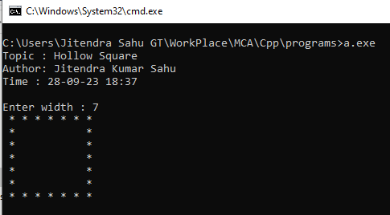

Program22: Write a C++ program to take input between 1-25 at runtime and display “Thank you user” for selecting number between 1-25 otherwise display ”please enter number between 1-25 only!!”.(using while loop).

**Code :**

#include <iostream>

#include<ctime>

using namespace std;

int main() {

cout<<"Shubham Kumar Singh "<<endl;

cout<<"MCA- 1sem"<<endl;

time_t now = time(0);

char* dt = ctime(&now);

cout<<"Date and Time is: "<<dt<<endl;

int number;

while (true) {

cout << "Enter a number between 1 and 25: ";

cin >> number;

if (number >= 1 && number <= 25) {

cout << "Well Done!" << endl;

break; // Exit the loop if the input is valid

} else {

cout << "Please enter a number between 1 and 25 only!!" << endl;

}

}

return 0;

}

**Output :**

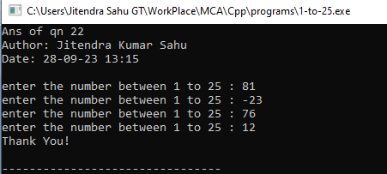

Program23: Write a C++ program to find number is positive, negative or zero using “ goto ” jump statement..

**Code :**

#include <iostream>

using namespace std ;

void printIntro(string topic, string time) {

cout<<"Topic : " << topic << endl ;

cout<<"Author : Jitendra Kumar Sahu" << endl ;

cout << "Time : "<< time << endl ;

cout <<"_____________________*_____________________"<< endl ;

}

int main(){

printIntro("","") ;

int n = 0;

do{

cout << "Enter a number : " ;

cin >> n ;

if(n > 0 ) cout << "Positive" ;

else if(n < 0 ) cout << "Negative" ;

else cout << "Zero" ;

cout << endl ;

}while(n != 0) ;

return 0 ;

}

**Output:**

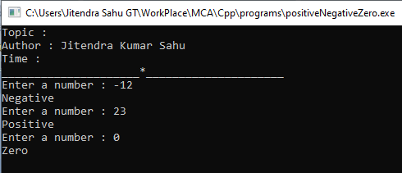

Program 24: Write a C++ program to differentiate break and continue jump statement.

**Code**

#include <iostream>

using namespace std ;

void printIntro(string topic, string time){

cout <<"Topic : "<< topic<< endl ;

cout << "Author: Jitendra Kumar Sahu" << endl ;

cout <<"Time : "<< time << endl << endl;

}

int main(){

printIntro("Break and Continue", "28-09-23 18:37");

int n = 20 ;

for (int i = 1 ; i <= 20 ; i++){

// continue statment will only skip some iterations

if ( i > 4 && i <= 10 ) {

cout << "Continue" << endl ;

continue ;

}

// break will get the controll out of the loop

if ( i == 16 ) {

cout << "Break" << endl ;

break ;

}

cout << i << endl ;

}

return 0 ;

}

**Output:**

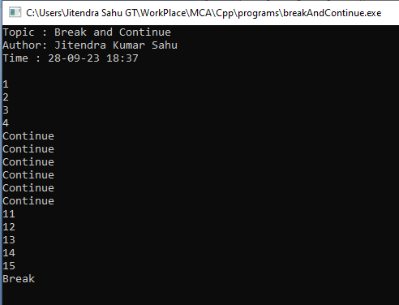

Program 25. Write a C++ program to display details of 5 students’ detail should be contained student name, roll number, marks using structure.

**Code :**

#include <iostream>

using namespace std ;

void printIntro(string topic, string date) {

cout << "Program topic : "<< topic << endl ;

cout << "Author : Jitendra Kumar Sahu" << endl ;

cout << "Date : "<< date << endl ;

cout <<"-----------------*-----------------"<< endl ;

}

struct Student {

int roll ;

string name ;

int marks ;

};

int main() {

printIntro("Structure demonstration : storing details of 5 students' ","06-10-23 15:52") ;

int n = 5 ;

Student s[n] ;

cout << "Enter student details \n" ;

for(int i = 0 ; i< n ; i++ ) {

cout << "Enter roll, name of student "<< (i+1) << " : "<< endl ;

cin >> s[i].roll ;

getline(cin,s[i].name) ; // this line is for handling dump

getline(cin,s[i].name) ;

cout << "Enter marks : " ;

cin >> s[i].marks ;

}

for(int i = 0 ; i < n ; i++ ) {

cout << endl << endl<< "Printing record of Student "<< (i+1) << endl ;

cout << "Roll : "<< s[i].roll << endl ;

cout << "Name : "<< s[i].name << endl ;

cout << "Marks : " << s[i].marks << endl ;

}

return 0 ;

}

**OUTPUT :**

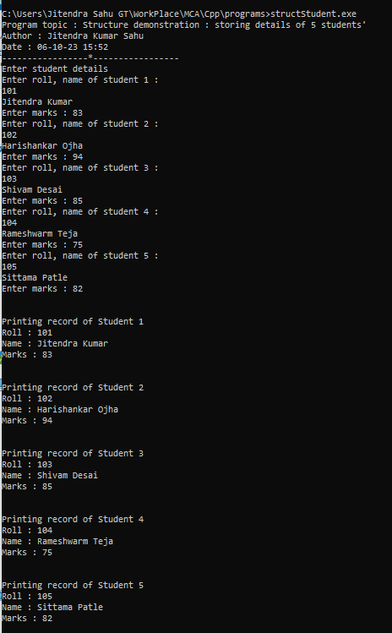

Program 26. Write a C++ program to create a structure named “Date” which contains three members Day, Month, Year and display current date entering by the user using function definition.

**Code :**

#include <iostream>

using namespace std ;

void printIntro(string topic, string date) {

cout << "Program topic : "<< topic << endl ;

cout << "Author : Jitendra Kumar Sahu" << endl ;

cout << "Date : "<< date << endl ;

}

struct Date {

int day, month, year ;

void getDate() {

cin >> day >> month >> year ;

}

void printDate() {

cout << day<< "-" << month << '-' << year << endl ;

}

};

int main() {

printIntro("Date using structure","06-10-23 15:59") ;

Date d = {6,10,2023} ;

cout << "Enter date "<< endl ;

d.getDate() ;

d.printDate() ;

return 0 ;

}

**Output ;**

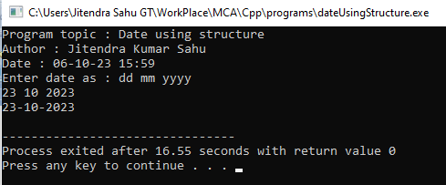

Program : 27. Write a C++ program to demonstrate enum with switch case.

**Code :**

#include <iostream>

using namespace std ;

// definition of enumuration

enum week{

mon=1, tue, wed , thu, fri ,sat ,sun

};

void printIntro(string topic, string date) {

cout << "Program topic : "<< topic << endl ;

cout << "Author : Jitendra Kumar Sahu" << endl ;

cout << "Date : "<< date << endl ;

cout << "------------*-----------" << endl ;

}

int main() {

printIntro("week day with enum", "06-10-23 16:36") ;

cout << "Enter an integer between 1 and 7 : ";

int x ;

cin >> x ;

switch(x){

case mon : cout << "Monday" << endl ;

break ;

case tue : cout << "Tueday" << endl ;

break ;

case wed : cout << "Wednessday" << endl ;

break ;

case thu : cout << "Thursday" << endl ;

break ;

case fri : cout << "Friday" << endl ;

break ;

case sat : cout << "Saturday" << endl ;

break ;

case sun : cout << "Sunday" << endl ;

break ;

default : cout << "Nahi, mai mere ek week me " << x << " din nahi hota" ;

}

return 0 ;

}

**Output :**

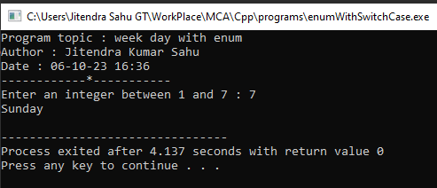

Program : 28. Write a C++ program to create an enum having number of enum list or elements and count the size of elements inside the enum.

**Code :**

#include<iostream>

using namespace std;

enum numbers{

one = 1 , two, three , four,five, six , seven , eight , nine ,ten

};

void printIntro(string topic, string time){

cout << "Program topic : " << topic<< endl ;

cout << "Author : Jitendra Kumar Sahu" << endl ;

cout << "Time : "<< time << endl ;

cout << "---------------*----------------"<< endl<< endl ;

}

int main()

{

printIntro("printing numbers with enum","10-10-23 02:59") ;

cout << one << " one"<< endl ;

cout << two << " two" << endl ;

cout << three << " three"<< endl ;

cout << four << " four" << endl ;

cout << five << " five" << endl ;

cout << six << " six" << endl ;

cout << seven << " seven" << endl ;

cout << eight << " eight" << endl ;

cout << nine << " nine"<< endl ;

cout << ten << " ten" << endl ;

}

**Output :**

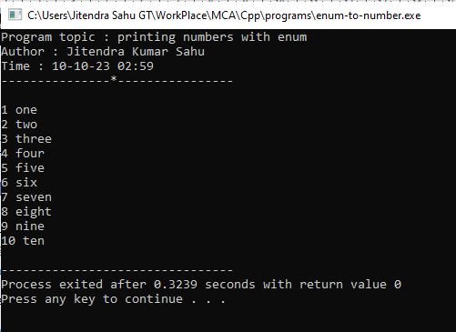

Program 29. Write a C++ program to swap two values without using third variable.

**Code :**

#include<iostream>

using namespace std;

void printIntro(string topic, string time){

cout << "Program topic : " << topic<< endl ;

cout << "Author : Jitendra Kumar Sahu" << endl ;

cout << "Time : "<< time << endl ;

cout << "---------------*----------------"<< endl<< endl ;

}

void swap(){

int a = 5, b = 6 ;

cout << "a " << a << endl ;

cout << "b " << b << endl ;

a = a + b ;

b = a - b ;

a = a - b ;

cout << "\nafter swap : " << endl ;

cout << "a " << a << endl ;

cout << "b " << b << endl ;

}

int main()

{

printIntro("Swap number without using thired variable","10-10-23 03:18");

swap();

return 0 ;

}

**Output :**

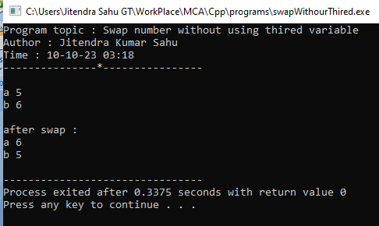

Program 30. Write a C++ program to swap two values using third variable of call by address function invoking.

**Code :**

#include<iostream>

using namespace std;

void printIntro(string topic, string time){

cout << "Program topic : " << topic<< endl ;

cout << "Author : Jitendra Kumar Sahu" << endl ;

cout << "Time : "<< time << endl ;

cout << "---------------*----------------"<< endl<< endl ;

}

void swap(int *a, int *b){

int temp = *a;

*a = *b;

*b = temp ;

cout << "\nafter swap : " << endl ;

cout << "a : " << *a << endl ;

cout << "b : " << *b << endl ;

}

int main()

{

printIntro("Swap number using call by address ","10-10-23 01:18");

int a = 2 , b = 4 ;

cout << "\nbefore swap : " << endl ;

cout << "a : " << a << endl ;

cout << "b : " << b << endl ;

swap(&a, &b);

return 0 ;

}

**Output :**

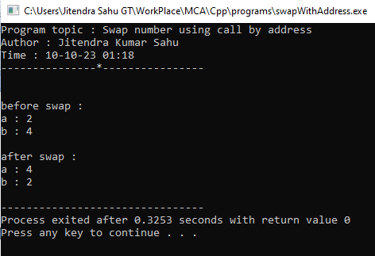

Program 31. Write a C++ program to illustrate working of call by value of a function invoking.

**Code :**

#include <iostream>

using namespace std ;

void printIntro(string topic, string time) {

cout<<"Topic : " << topic << endl ;

cout<<"Author : Jitendra Kumar Sahu" << endl ;

cout << "Time : "<< time << endl ;

cout <<"_____________________*_____________________"<< endl ;

}

void change(int a){

//changing value

a = a+1 ;

cout<< "updated value at function : "<< a <<endl ;

}

int main(){

printIntro("Illustration of call by value","28-10-23 19:08") ;

int x = 5 ;

cout << "before call " << x << endl ;

change(x) ;

cout << "after call " << x << endl ;

return 0 ;

}

**Output :**

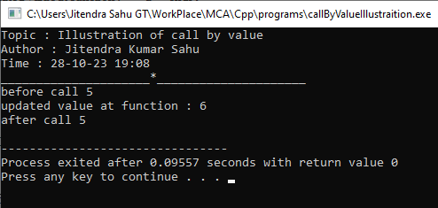

Program 32. Write a C++ program to illustrate working of call by reference method of a function invoking.

**Code :**

#include <iostream>

using namespace std ;

void printIntro(string topic, string time) {

cout<<"Topic : " << topic << endl ;

cout<<"Author : Jitendra Kumar Sahu" << endl ;

cout << "Time : "<< time << endl ;

cout <<"_____________________*_____________________"<< endl ;

}

void change(int &a){

//changing value

a = a+1 ;

cout<< "updated value at function : "<< a <<endl ;

}

int main(){

printIntro("Illustration of call by refference","28-10-23 19:08") ;

int x = 5 ;

cout << "before call " << x << endl ;

change(x) ;

cout << "after call " << x << endl ;

return 0 ;

}

**Output :**

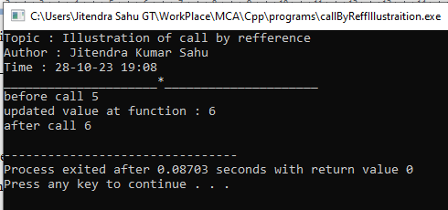

Program 33. Write a C++ program to calculate simple interest using default arguments.

**Code :**

#include <iostream>

using namespace std ;

void printIntro(string topic, string time) {

cout<<"Topic : " << topic << endl ;

cout<<"Author : Jitendra Kumar Sahu" << endl ;

cout << "Time : "<< time << endl ;

cout <<"_____________________*_____________________"<< endl ;

}

float getSimpleInterest(float p=0,float r=0 , float t=0){

return (p*r*t)/100;

}

int main(){

printIntro("Calculate simple interest using default argument","28-10-23 19:30") ;

float p = 100, r = 5 , t = 5 ;

cout << "simple interest : " << getSimpleInterest(p,r,t);

cout << endl ;

return 0 ;

}

**Output:**

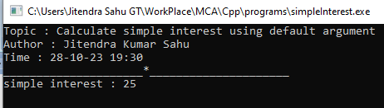

Program 34. Write a C++ program using function template to add two integers and two float number.

**Code :**

#include <iostream>

using namespace std ;

void printIntro(string topic, string time) {

cout<<"Topic : " << topic << endl ;

cout<<"Author : Jitendra Kumar Sahu" << endl ;

cout << "Time : "<< time << endl ;

cout <<"_____________________*_____________________"<< endl ;

}

template <typename T>

void add(T a, T b){

cout << a+b << endl ;

}

int main(){

printIntro("Addition using Template function","28-10-23 19:49") ;

cout << "sum of ints : " ;

add(6,11) ;

cout << endl ;

cout << "sum of floats : " ;

add(6.5,11.2) ;

cout << endl ;

return 0 ;

}

**Output :**

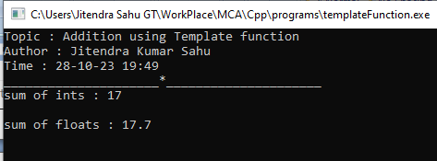

Program 35. Write a C++ program to create simple calculator using class templates.

**Code :**

#include <iostream>

using namespace std;

void printIntro(string topic, string time)

{

cout << "Topic : " << topic << endl;

cout << "Author : Jitendra Kumar Sahu" << endl;

cout << "Time : " << time << endl;

cout << "_____________________*_____________________" << endl;

}

template <typename T, typename U>

class Calc

{

public:

void operate(T a, T b, char operation)

{

switch (operation)

{

case '+':

cout << a + b << endl;

break;

case '-':

cout << a - b << endl;

break;

case '*':

cout << a * b << endl;

break;

case '/':

cout << a / b << endl;

break;

default:

cout << "Operation not defined " << endl;

}

}

};

int main()

{

printIntro("calculator using template class", "28-10-23 19:57");

Calc<int, int> c;

Calc<float, float> d;

int a = 5, b = 6;

float x = 5.2f, y = 5.3f;

cout << a << " + " <<b << " : " ;

c.operate(a, b, '+');

cout << a << " - " <<b << " : " ;

c.operate(a, b, '-');

cout << a << " * " <<b << " : " ;

c.operate(a, b, '*');

cout << a << " / " <<b << " : " ;

c.operate(a, b, '/');

cout << x << " + " << y << " : " ;

d.operate(x, y, '+');

cout << x << " - " << y << " : " ;

d.operate(x, y, '-');

cout << x << " * " << y << " : " ;

d.operate(x, y, '*');

cout << x << " / " << y << " : " ;

d.operate(x, y, '/');

return 0;

}

**Output:**

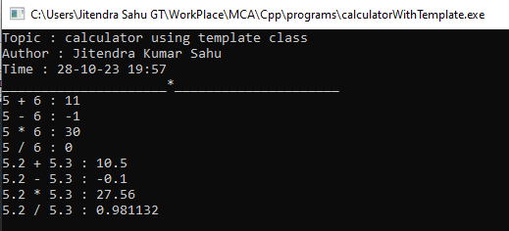

**Program 36. Write a C++ program using inline function to calculate area of circle.**

**Code:**

#include <iostream>

using namespace std ;

void printIntro(string topic, string date) {

cout << "Program topic : "<< topic << endl ;

cout << "Author : Jitendra Kumar Sahu" << endl ;

cout << "Date : "<< date << endl ;

cout << "____________*____________"<<endl << endl ;

}

inline float area(int r){

const float pi = 22/7 ;

return pi*r*r ;

}

int main() {

printIntro("inline function to calculate simple interest","02-11-23 15:34") ;

int radius = 5 ;

cout << "area of circle : " << area(radius) ;

return 0 ;

}

**Code ::**

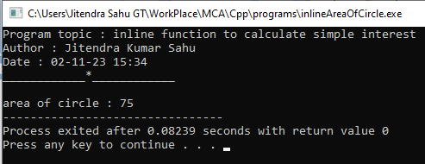

Program 37. Write a C++ program to demonstrate function overloading.

**Code :**

#include <iostream>

using namespace std ;

void printIntro(string topic, string date) {

cout << "Program topic : "<< topic << endl ;

cout << "Author : Jitendra Kumar Sahu" << endl ;

cout << "Date : "<< date << endl ;

cout << "____________*____________"<<endl << endl ;

}

int add(int a, int b){

return a+b ;

}

int add(int a, int b , int c){

return a+b+c ;

}

int main() {

printIntro("function overloading","02-11-23 15:34") ;

cout << "Addition of 2 integers : " << add(2,3) << endl ;

cout << "Addition of 3 integers : " << add(2,3,4) << endl ;

return 0 ;

}

**Output :**

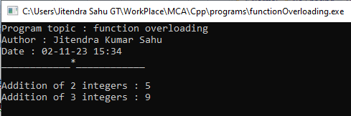

Program 38. Write a C++ program to find the size of 1-D, 2-D and multidimensional array.

**Code :**

#include <iostream>

using namespace std ;

void printIntro(string topic, string time) {

cout<<"Topic : " << topic << endl ;

cout<<"Author : Jitendra Kumar Sahu" << endl ;

cout << "Time : "<< time << endl ;

cout <<"_____________________*_____________________"<< endl ;

}

int main(){

printIntro("size of different types of array","02-11-23 18:16") ;

int p, r, c ;

cout << "\n1D array \n" ;

cout << "enter number of elements : " ;

cin >> c ;

int arr1d[c] ; // 2d array

cout << "number of elements : " << c << endl ;

cout << "size : " << sizeof(arr1d) << endl ;

cout << "\n2D array \n" ;

cout << "enter number of rows and columns : " ;

cin >> r >> c ;

int arr2d[r][c] ; // 2d array

cout << "number of elements : " << (r*c)<< endl ;

cout << "size : " << sizeof(arr2d) << endl ;

cout << "\n3D array \n" ;

cout << "enter number of pages, rows and columns : " ;

cin >> p >> r >> c ;

int arr3d[p][r][c] ; // 3d array

cout << "number of elements : " << (p*r*c)<< endl ;

cout << "size : " << sizeof(arr3d) << endl ;

return 0 ;

}

Output :

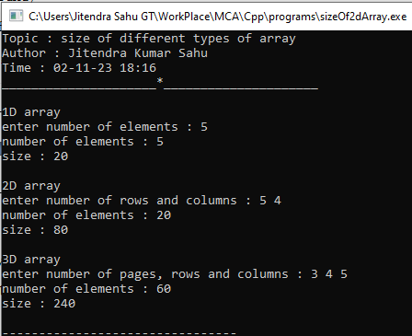

Program 39. Write a C++ program create and display one-D array of size 7 and also display average of all the elements.

**Code :**

#include <iostream>

using namespace std ;

void printIntro(string topic, string time) {

cout<<"Topic : " << topic << endl ;

cout<<"Author : Jitendra Kumar Sahu" << endl ;

cout << "Time : "<< time << endl ;

cout <<"_____________________*_____________________"<< endl ;

}

int main(){

printIntro("avarage of array elements","02-11-23 18:08") ;

int n = 7, sum = 0 ;

int arr[n] = {12,13,14,15,16,17,18} ;

cout <<"Array elements : " ;

for(int i = 0 ; i < n ; i++ ){

cout << arr[i] << " ";

sum += arr[i] ;

}

cout << endl ;

cout << "average : " << (sum/n) << endl ;

return 0 ;

}

**Output :**

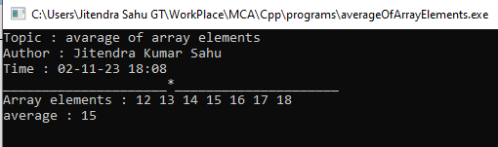

Program 40. Write a C++ program to input 5 numbers in an array and print all the numbers from the backside of the array.

**Code :**

#include <iostream>

using namespace std ;

void printIntro(string topic, string time) {

cout<<"Topic : " << topic << endl ;

cout<<"Author : Jitendra Kumar Sahu" << endl ;

cout << "Time : "<< time << endl ;

cout <<"_____________________*_____________________"<< endl ;

}

int main(){

printIntro("Print Reversed Array","02-11-23 18:00") ;

int n = 5 ;

int arr[n] = {11,12,13,14,15} ;

cout << "Our array : " << endl ;

for (int i = 0 ; i < n ; i++ ){

cout << arr[i] << " " ;

}

cout << endl ;

cout << "in reversed order : " << endl ;

for (int i = n-1 ; i >= 0 ; i--){

cout << arr[i] << " " ;

}

cout << endl ;

return 0 ;

}

**Output :**

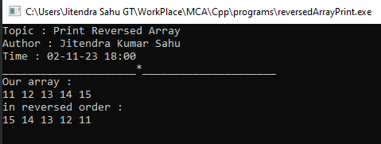

Program 41. Write a C++ program create class named “Student”, having two data member of private specifier name rollno and marks. and make marks data member as array of size 5. Student class also contains public member function named getdata( ) , showdata( ), and totalmarks( ) which will define outside of the class. getdata( ) will take input from the user only, showdata( ) will show the input data from the user, and totalmarks( ) will sum all the 5 marks of subject and display the total marks.

**Code :**

#include <iostream>

using namespace std;

void printIntro(string topic, string time)

{

cout << "Topic : " << topic << endl;

cout << "Author : Jitendra Kumar Sahu" << endl;

cout << "Time : " << time << endl;

cout << "_____________________*_____________________" << endl;

}

class Student

{

int roll, marks[5];

string name;

public:

void getData();

void showData();

void totalMarks();

};

void Student ::getData()

{

cout << "enter roll , name : ";

cin >> roll;

getline(cin, name);

getline(cin, name);

cout << "enter five marks : ";

for (int i = 0; i < 5; i++){

cin >> marks[i];

}

}

void Student ::showData()

{

cout << "roll : " << roll << endl;

cout << "name : " << name << endl;

for (int i = 0; i < 5; i++){

cout << "marks : " << (i + 1) << " " << marks[i] << endl;

}

}

void Student ::totalMarks()

{

int sum = 0;

for (int i = 0; i < 5; i++)

{

sum += marks[i];

}

cout << "Total marks : " << sum << endl;

}

int main()

{

printIntro("Class student", "02-11-23 20:49");

Student jitendra;

jitendra.getData();

jitendra.showData();

jitendra.totalMarks();

return 0;

}

**Output :**

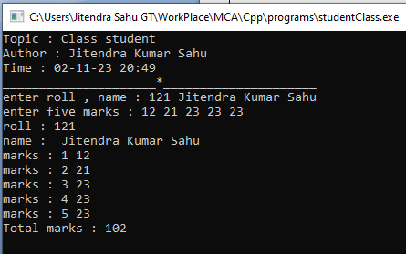

Program 42. Write a C++ program to find greatest number among three numbers implementing the nesting of member function.

**Code :**

#include <iostream>

using namespace std ;

void printIntro(string topic, string time) {

cout<<"Topic : " << topic << endl ;

cout<<"Author : Jitendra Kumar Sahu" << endl ;

cout << "Time : "<< time << endl ;

cout <<"_____________________*_____________________"<< endl ;

}

class ThreeNum{

public :

int a , b ,c ;

int max(int x, int y){

return x > y ? x : y ;

}

void display(){

cout << "a : " <<a ;

cout << ", b : " <<b ;

cout << ", c : " <<c << endl ;

}

void displayMax(){

cout << "max : " << max(a,max(b,c)) << endl ;

}

};

int main(){

printIntro("Nesting of member function","02-11-23 22:33") ;

ThreeNum t ;

t.a = 43 ;

t.b = 45 ;

t.c = 63 ;

t.display() ;

t.displayMax() ;

return 0 ;

}

**Output :**

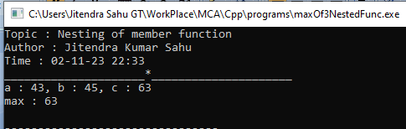

Program 43 Write a C++ program to create class named “My_class”, having two private member of integer type. And perform addition, multiplication, and subtraction operation inside the class body.

**Code :**

#include <iostream>

using namespace std ;

void printIntro(string topic, string time) {

cout<<"Topic : " << topic << endl ;

cout<<"Author : Jitendra Kumar Sahu" << endl ;

cout << "Time : "<< time << endl ;

cout <<"_____________________*_____________________"<< endl ;

}

class Calculator{

int a = 5 , b = 4 ;

public :

void add(){

cout << "sum : " << a+b << endl;

}

void sub(){

cout << "sub : " << a-b << endl ;

}

void mult(){

cout << "mult : " << a*b << endl;

}

void div(){

cout << "div : " << a/b << endl ;

}

};

int main(){

printIntro("class as calculator","02-11-23 22:42") ;

Calculator c ;

c.add() ;

c.sub() ;

c.mult() ;

c.div() ;

return 0 ;

}

**Output :**

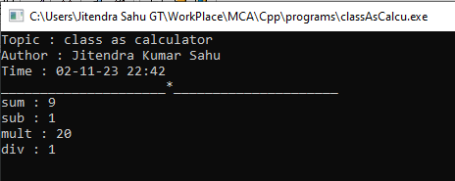

Program.44 Write a C++ program to make outside function inline.

**Code :**

#include <iostream>

using namespace std ;

void printIntro(string topic, string time) {

cout<<"Topic : " << topic << endl ;

cout<<"Author : Jitendra Kumar Sahu" << endl ;

cout << "Time : "<< time << endl ;

cout <<"_____________________*_____________________"<< endl ;

}

inline int inlineSqure(int x){

return x*x ;

}

int main(){

printIntro("Outside function inline","02-11-23 23:41") ;

int k = 5 ;

cout << k << " squared = " << inlineSqure(k) << endl ;

return 0 ;

}

**Output :**

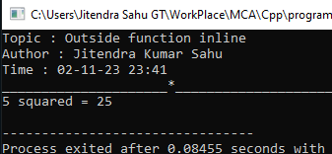

Program.45 Write a C++ program to keep count of created object using static member.

**Code :**

#include <iostream>

using namespace std ;

class A{

static int numberOfObjects ;

public :

// a static function that uses static variable

static int getNumberOfObjects(){

return numberOfObjects ; // returning static variable

}

void admit(){

numberOfObjects++ ;

}

} ;

int A :: numberOfObjects = 0 ;

void printIntro(string topic, string time) {

cout<<"Topic : " << topic << endl ;

cout<<"Author : Jitendra Kumar Sahu" << endl ;

cout << "Time : "<< time << endl ;

cout <<"_____________________*_____________________"<< endl ;

}

int main(){

printIntro("count of object using static","23-11-23 17:53") ;

A object1 , object2 , object3; // creating object

// calling function that work on static variable

object1.admit() ;

object2.admit() ;

object3.admit() ;

cout << "number of objects : " ;

cout << A::getNumberOfObjects() << endl ;

return 0 ;

}

**Ouput** **:**

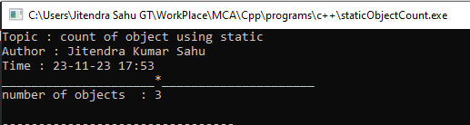

Program 46. Define a class candidate in C++ with the following description:=

Private member:-

• A data member RNo (Registration Number) of type long.

• A data member Name of type string.

• A data member Score of type float.

• A data member Remarks of type string.

• A member function AssignRem( ) to assign Remarks as per the Score obtained by a candidate. Score range and the respective Remarks are shown as follows:

Score Remarks

>=50 Selected

Less than 50 Not Selected

Public member:-

• A member function Enter( ) to allow user to enter values for RNo, Name, Score and call function AssignRem( ) to assign the remarks.

• A member function DISPLAY( ) to allow user to view the content of all the data members.

**Code :**

#include <iostream>

using namespace std ;

class Student{

string name, remarks ;

int rno, score ;

void assignRem() ;

public :

void enter() ;

void display() ;

} ;

void Student :: assignRem(){

score >= 50 ? remarks = "selected" : remarks = "not selected" ;

}

void Student :: enter(){

cout << "Enter registration number : " ;

cin >> rno ;

cout << "Enter name : " ;

getline(cin,name) ;

getline(cin,name) ;

cout << "Enter score : " ;

cin >> score ;

assignRem() ;

}

void Student :: display(){

cout << "-------------------------\n";

cout << "registration no : " << rno << endl ;

cout << "name : " << name << endl ;

cout << "score : " << score << endl ;

cout << "remarks : " << remarks << endl ;

}

void printIntro(string topic, string time) {

cout<<"Topic : " << topic << endl ;

cout<<"Author : Jitendra Kumar Sahu" << endl ;

cout << "Time : "<< time << endl ;

cout <<"_____________________*_____________________"<< endl ;

}

int main(){

printIntro("Nesting of member function","23-11-23 17:53") ;

Student jitendra ;

jitendra.enter() ;

jitendra.display() ;

return 0 ;

}

**Ouput :**

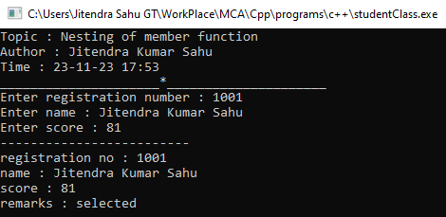

Program 47. Write a C++ program to implement single inheritance.

**Code :**

#include <iostream>

using namespace std ;

class Parent{

public :

int parentDataMember ;

} ;

class Child : public Parent{

public :

int childDataMember ;

void setParentDataMember(int x){

parentDataMember = x ;

}

void setChildDataMember(int x){

childDataMember = x ;

}

void printValues(){

cout << "Child Data member value : "<< childDataMember << endl ;

cout << "Parent Data member value : "<< parentDataMember << endl ;

}

} ;

void printIntro(string topic, string time) {

cout<<"Topic : " << topic << endl ;

cout<<"Author : Jitendra Kumar Sahu" << endl ;

cout << "Time : "<< time << endl ;

cout <<"_____________________*_____________________"<< endl ;

}

int main(){

printIntro("Single inheritence","23-11-23 17:53") ;

Child object ;

object.setParentDataMember(1) ;

object.setChildDataMember(2) ;

object.printValues() ;

return 0 ;

}

**Output :**

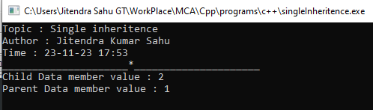

Program 48. Write a C++ program to implement multiple inheritance.

**Code :**

#include <iostream>

using namespace std ;

class Father{

public :

void cookFood(){

cout << "I am cooking rice!"<< endl ;

}

} ;

class Mother{

public :

void goToOffice(){

cout << "I am going to office"<<endl ;

}

} ;

class Child : public Father , public Mother{

public :

void eat(){

cout << "I am eating rice" << endl ;

}

} ;

void printIntro(string topic, string time) {

cout<<"Topic : " << topic << endl ;

cout<<"Author : Jitendra Kumar Sahu" << endl ;

cout << "Time : "<< time << endl ;

cout <<"_____________________*_____________________"<< endl ;

}

int main(){

printIntro("Multiple Inheritence","23-11-23 17:53") ;

Child jitendra ;

jitendra.cookFood() ;

jitendra.eat() ;

jitendra.goToOffice() ;

return 0 ;

}

**Output :**

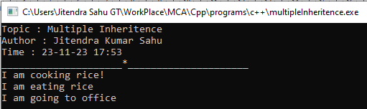

Program 49.Write a C++ program to implement multilevel inheritance..

**Code :**

#include <iostream>

using namespace std ;

class Vhicle{

public :

void start(){

cout << "Vhicle is starting!"<< endl ;

}

} ;

class Car: public Vhicle{

public :

void run(){

cout <<"Car is running!"<<endl ;

}

} ;

class Creta : public Car{

public :

void accelerate(){

cout << "accelerating the speed" << endl ;

}

} ;

void printIntro(string topic, string time) {

cout<<"Topic : " << topic << endl ;

cout<<"Author : Jitendra Kumar Sahu" << endl ;

cout << "Time : "<< time << endl ;

cout <<"_____________________*_____________________"<< endl ;

}

int main(){

printIntro("Multiple Inheritence","23-11-23 17:53") ;

Creta yourCreta ;

yourCreta.start() ;

yourCreta.run() ;

yourCreta.accelerate() ;

return 0 ;

}

**Output :**

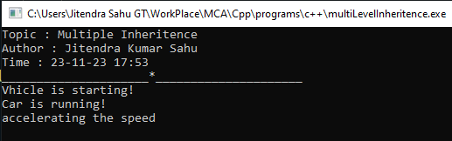

Program : 50.Write a C++ program to initialize three integer values through constructor using parameter.

**Code :**

#include <iostream>

using namespace std;

class ParamConstruct

{

private:

// Three private members

int num1, num2, num3;

public:

// constructor declaration

ParamConstruct(int num1, int num2, int num3);

void printData();

};

// constructor definition

ParamConstruct::ParamConstruct(int num1, int num2, int num3){

this->num1 = num1;

this->num2 = num2;

this->num3 = num3;

}

void ParamConstruct ::printData(){

cout << "num1 : " << num1 << endl;

cout << "num2 : " << num2 << endl;

cout << "num3 : " << num3 << endl;

}

void printIntro(string topic, string time){

cout << "Topic : " << topic << endl;

cout << "Author : Jitendra Kumar Sahu" << endl;

cout << "Time : " << time << endl;

cout << "------------------*------------------" << endl;

}

int main(){

printIntro("Parametrized constructor demonstration", "24-11-23 22:46");

int num1, num2, num3;

cout << "Enter three integers : " ;

cin >> num1 >> num2 >> num3 ;

// creating object while passing values in to constructor

ParamConstruct obj(num1, num2, num3);

cout << "printing the members of object...\n";

obj.printData();

return 0;

}

**Output :**

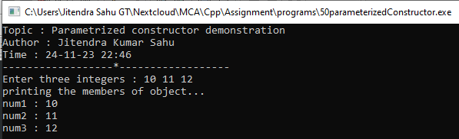

Program 51.Write a C++ program to illustrate order of invocation for these, Define two class first class named “Sub” and second named “Mark” in C++ with the following description:=

Class “Sub” contains -

Private member:-

• A data member ppr1_code of type int.

• A data member ppr2_code of type int.

Public member:-

• A default constructor which initializes and display the private member of its class.

Class “Mark” contains –

Private member:-

• A data member ppr1_mark of type float.

• A data member ppr2_mark of type float.

Public member:-

• A Parameterized constructor which initializes and display the private member of its class.

create an object of Sub class inside these class.

**Code :**

#include <iostream>

using namespace std ;

class Sub{

int ppr1_code , ppr2_code ;

public :

Sub(){

ppr1_code = 101 ;

ppr2_code = 102 ;

cout << "ppr1_code : " << ppr1_code << endl ;

cout << "ppr2_code : " << ppr2_code << endl ;

cout << "internal object constructor called!\n" ;

}

};

class Mark{

float ppr1_mark , ppr2_mark ;

public :

Mark(float a, float b){

ppr1_mark = a ;

ppr2_mark = b ;

cout << "ppr2_mark : " << ppr2_mark << endl ;

cout << "ppr2_mark : " << ppr2_mark << endl ;

cout << "external object constructor called!\n" ;

}

Sub temp ;

};

void printIntro(string topic, string time) {

cout<<"Topic : " << topic << endl ;

cout<<"Author : Jitendra Kumar Sahu" << endl ;

cout << "Time : "<< time << endl ;

cout <<"_____________________*_____________________"<< endl ;

}

int main(){

printIntro("program to illustrate order of invocation","23-11-23 21:36") ;

Mark object(5.1,6.2) ;

return 0 ;

}

**Output :**

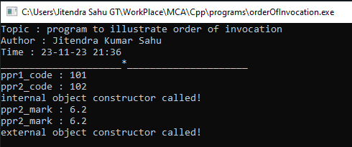

Program 52. Write a C++ program to invoke a constructor having default argument.

**Code**

#include <iostream>

using namespace std ;

class Test{

int var ;

public :

Test(int a = 20){

var = a ;

cout << "var initilized! "<< endl ;

cout << "var = : " << var << endl ;

}

};

void printIntro(string topic, string time) {

cout<<"Topic : " << topic << endl ;

cout<<"Author : Jitendra Kumar Sahu" << endl ;

cout << "Time : "<< time << endl ;

cout <<"_____________________*_____________________"<< endl ;

}

int main(){

printIntro("invoke constructor having default arguments","23-11-23 21:55") ;

Test object ;

return 0 ;

}

**Output**

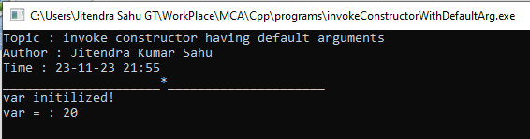

Program : 53. Write a C++ program to copy one object variable to another object using copy constructor.

**Code**

#include <iostream>

using namespace std ;

class Test {

int a ;

int b ;

public :

Test(int x , int y){

a = x ;

b = y ;

}

// copy constructor

Test(const Test &object){

a = object.a ;

b = object.b ;

}

void getData(){

cout << "a : " << a << endl ;

cout << "b : " << b << endl ;

}

};

void printIntro(string topic, string time) {

cout<<"Topic : " << topic << endl ;

cout<<"Author : Jitendra Kumar Sahu" << endl ;

cout << "Time : "<< time << endl ;

cout <<"_____________________*_____________________"<< endl ;

}

int main(){

Test t(22,55) ;

Test p(t) ;

cout <<"values of object 1 \n" ;

t.getData() ;

cout<<"\nvalues of object 2 \n" ;

p.getData() ;

return 0 ;

}

**Output**

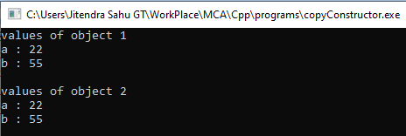

Program 54. Write a C++ program to perform constructor overloading having three constructor within a class.

**Code**

#include <iostream>

using namespace std ;

class Scooter{

string brandName ;

string color ;

public :

Scooter(){

brandName = "Honda" ;

color = "white" ;

}

Scooter(string clr){

brandName = "Suzuki" ;

color = clr ;

}

Scooter(string var, string clr){

brandName = var ;

color = clr ;

}

void printDetails(){

cout << "Brand Name : " << brandName << endl ;

cout << "color : " << color <<endl<< endl ;

}

} ;

void printIntro(string topic, string time) {

cout<<"Topic : " << topic << endl ;

cout<<"Author : Jitendra Kumar Sahu" << endl ;

cout << "Time : "<< time << endl ;

cout <<"_____________________*_____________________"<< endl ;

}

int main(){

printIntro("Constructor overloading","23-11-23 22:14") ;

Scooter activa ;

Scooter pleasure("red") ;

Scooter mastro("hero","blue") ;

activa.printDetails() ;

pleasure.printDetails() ;

mastro.printDetails() ;

return 0 ;

}

**Output**

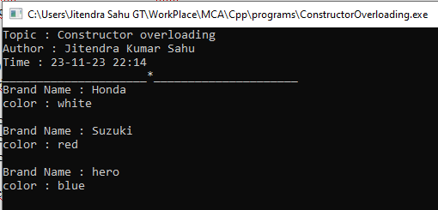

Program 55. Write a C++ program to allocate and deallocate memory at run time for a variable.

**Code**

#include <iostream>

using namespace std ;

void printIntro(string topic, string time) {

cout<<"Topic : " << topic << endl ;

cout<<"Author : Jitendra Kumar Sahu" << endl ;

cout << "Time : "<< time << endl ;

cout <<"------------------*------------------"<< endl ;

}

int main(){

printIntro("Dynamic memory allocation","23-11-23 22:32") ;

int *ptr = new int() ;

if (ptr == NULL )

cout << "unable to allocate memory!" ;

else{

*ptr = 34 ;

cout <<"value at ptr = " << *ptr << endl ;

delete ptr ;

cout << "ptr deleted!" ;

}

return 0 ;

}

**Output**

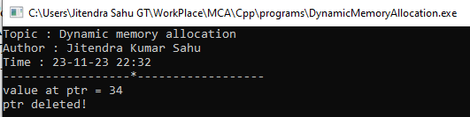

Program 56. Write a C++ program to demonstrate run time polymorphism(function overriding).

**Code :**

#include <iostream>

using namespace std ;

void printIntro(string topic, string time){

cout << "Topic : " << topic << endl ;

cout << "Author : Jitendra Kumar Sahu" << endl ;

cout << "Time : " << time << endl ;

cout << "____________________*___________________" << endl ;

}

class Super{

public :

void print(){

cout << "output from super class" << endl ;

}

} ;

class Sub{

public :

void print(){

cout << "output from sub class" << endl ;

}

};

int main(){

printIntro("runtime polymorphism", "06:40 09-dec-2023") ;

Sub object ;

object.print() ;

return 0 ;

}

**Output :**

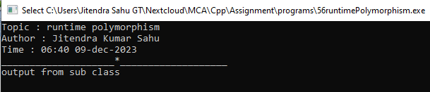

Program 57. Write a C++ program to create a class named “Student” having two private member name type string and age type int. and in public section class contain one member function named “Stu_info” which initializes the data members of its class at run time and one another member function named “Show_info” which display the detail of a student (name,age). And invoke them using pointer to object.

**Code :**

#include <iostream>

using namespace std ;

class Student{

string name ;

int age ;

public :

void Stu_info(){

cout << "enter name of student : " ;

getline(cin,name) ;

cout << "enter age of student : " ;

cin >> age ;

}

void Show_info(){

cout << "Name : " << name << endl ;

cout << "Age : " << age << endl ;

}

} ;

void printIntro(string topic, string time){

cout << "Topic : " << topic << endl ;

cout << "Author : Jitendra Kumar Sahu" << endl ;

cout << "Time : " << time << endl ;

cout << "____________________*___________________" << endl ;

}

int main(){

printIntro("pointer to object", "06:48 09-dec-2023") ;

Student jitendra ;

Student *ptr = &jitendra ;

ptr->Stu_info() ;

ptr->Show_info() ;

return 0 ;

}

**Output :**

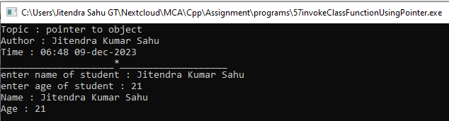

Program 58. Write a C++ program to illustrate functioning of this pointer.

**Code :**

#include <iostream>

using namespace std ;

class Student{

string name ;

int age ;

public :

void setStdInfo(string name , int age) {

this->name = name ;

this->age = age ;

}

void printStdInfo(){

cout << "name : " << name << endl ;

cout << "age : " << age << endl ;

}

} ;

void printIntro(string topic, string time){

cout << "Topic : " << topic << endl ;

cout << "Author : Jitendra Kumar Sahu" << endl ;

cout << "Time : " << time << endl ;

cout << "____________________*___________________" << endl ;

}

int main(){

printIntro("This pointer", "11:51 10-DEC-2023") ;

Student s1 ;

string name ;

int age ;

cout << "enter student name : " << endl ;

getline(cin,name) ;

cout << "enter student age : " << endl ;

cin >> age ;

s1.setStdInfo(name, age) ;

s1.printStdInfo() ;

return 0 ;

}

**Output**

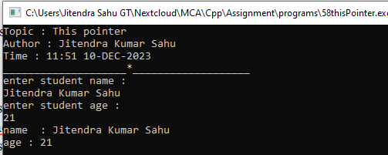

Program 59. Write a C++ program to create two classes (named First_class and Second_class), and perform multiplication of two number (where first number is public data member of First_class and second number is public data member of Second_class) using friend function.

**Code :**

#include <iostream>

using namespace std ;

class SecondClass ;

class FirstClass{

public :

int a ;

FirstClass(){

this->a = 20 ;

}

friend int multiply(FirstClass fobj, SecondClass sobj) ;

} ;

class SecondClass{

public :

int b ;

SecondClass(){

this->b = 20 ;

}

friend int multiply(FirstClass fobj, SecondClass sobj) ;

} ;

int multiply(FirstClass fobj, SecondClass sobj) {

return fobj.a * sobj.b ;

}

void printIntro(string topic, string time){

cout << "Topic : " << topic << endl ;

cout << "Author : Jitendra Kumar Sahu" << endl ;

cout << "Time : " << time << endl ;

cout << "____________________*___________________" << endl ;

}

int main(){

printIntro("Friend function", "06:10 09-DEC-2023") ;

FirstClass a ;

SecondClass b ;

cout <<"result of multiplication : " << multiply(a,b) << endl ;

cout << "working! " << endl ;

return 0 ;

}

**Output :**

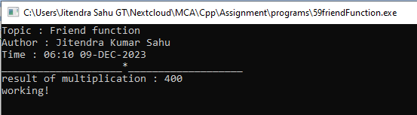

Program 60. Write a C++ program to the working of virtual function.

**Code :**

#include <iostream>

using namespace std ;

class Super{

int var = 1 ;

public :

virtual void print(){

cout << "value of var at super : " << var << endl ;

}

};

class Sub : public Super {

int var = 2 ;

public :

void print(){ // overridden function

cout << "value of var at sub class : " << var << endl ;

}

};

void printIntro(string topic, string time) {

cout<<"Topic : " << topic << endl ;

cout<<"Author : Jitendra Kumar Sahu" << endl ;

cout << "Time : "<< time << endl ;

cout <<"------------------*------------------"<< endl ;

}

int main(){

printIntro("Pointer to derived class","05-12-23 18:05") ;

Super *pointer ; // Pointer of super class

Sub object ; // Sub class object

pointer = &object ;

pointer->print() ;

return 0 ;

}

**Output :**

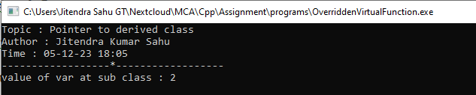

Program 61. Write a C++ program to the working of pure virtual function.

**Code :**

#include <iostream>

using namespace std ;

class Super{ // now the class whould be reffered as abstract class

int var = 1 ;

public :

// pure virtual function

virtual void print() = 0 ;

};

class Sub : public Super {

int var = 2 ;

public :

void print(){ // overridding the function

cout << "value of var at sub class : " << var << endl ;

}

};

void printIntro(string topic, string time) {

cout<<"Topic : " << topic << endl ;

cout<<"Author : Jitendra Kumar Sahu" << endl ;

cout << "Time : "<< time << endl ;

cout <<"------------------*------------------"<< endl ;

}

int main(){

printIntro("pure virtual function","05-12-23 18:05") ;

Super *pointer ; // Pointer of super class

Sub object ; // Sub class object

pointer = &object ;

pointer->print() ;

return 0 ;

}

**Output :**

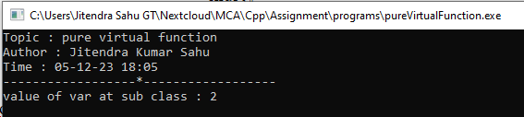

Program 62. Write a C++ program to find large number between two number using friend class.

**Code :**

#include <iostream>

using namespace std ;

class TwoNumbers{

int a, b ;

public :

TwoNumbers(int a, int b) {

this->a = a ;

this->b = b ;

}

friend class Larger ;

} ;

class Larger{

public :

Larger(TwoNumbers tn){

cout << "larger number is : " << endl ;

tn.a > tn.b ? cout << tn.a : cout << tn.b ;

cout << endl ;

}

} ;

void printIntro(string topic, string time){

cout << "Topic : " << topic << endl ;

cout << "Author : Jitendra Kumar Sahu" << endl ;

cout << "Time : " << time << endl ;

cout << "____________________*___________________" << endl ;

}

int main(){

printIntro("Program to demonstrait friend class","06:20 09-DEC-2023") ;

int a , b ;

cout << "enter two numbers : " ;

cin >> a >> b ;

TwoNumbers tw(a,b) ;

Larger large(tw) ;

return 0 ;

}

**Output :**

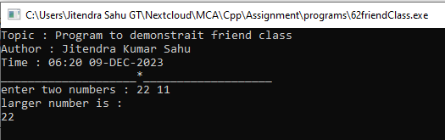

Program 63. Write a C++ program to for operator overloading to compare two objects are equal are not using == operator.

**Code :**

#include <iostream>

using namespace std ;

class Complex{

int a, b ;

public :

Complex(int a, int b){

this->a = a ;

this->b = b ;

}

bool operator == (const Complex c2){

return (a == c2.a && b == c2.b) ;

}

void print(){

cout << a << " + "<< b <<'i' << endl ;

}

};

void printIntro(string topic, string time) {

cout<<"Topic : " << topic << endl ;

cout<<"Author : Jitendra Kumar Sahu" << endl ;

cout << "Time : "<< time << endl ;

cout <<"------------------*------------------"<< endl ;

}

int main(){

printIntro("binary operator overloading","05-12-23 18:36") ;

// creating three object of complex class

Complex a(5,10) , b(10,20), c(10,20) ;

cout << "a : " ;

a.print();

cout << "b : " ;

b.print();

cout << "c : " ;

c.print();

string res ;

a == b ? res = "yes" : res = "no" ;

cout << "a == b : " << res << endl ;

b == c ? res = "yes" : res = "no" ;

cout << "b == c : " << res << endl ;

return 0 ;

}

**Output :**

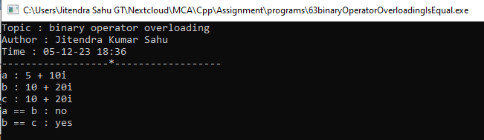

Program 64. Write a C++ program to illustrate unary operator overloading on increment operator by using member function.

**Code :**

#include <iostream>

using namespace std ;

class Complex{

int a, b ;

public :

Complex(int a, int b){

this->a = a ;

this->b = b ;

}

void operator ++ (){

a++ ;

b++ ;

}

void print() {

cout << a << " + " << b << 'i' << endl ;

}

};

void printIntro(string topic, string time) {

cout<<"Topic : " << topic << endl ;

cout<<"Author : Jitendra Kumar Sahu" << endl ;

cout << "Time : "<< time << endl ;

cout <<"------------------*------------------"<< endl ;

}

int main(){

printIntro("unary operator overloading","05-12-23 18:36") ;

Complex a(5,10);

cout << "before increament : " << endl ;

a.print() ;

++a ;

cout << "after increament : " << endl ;

a.print() ;

return 0 ;

}

**Output :**

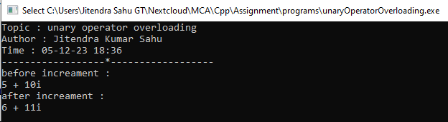

Program 65. Write a C++ program to add two complex number using + operator overloading by friend function.

**Code :**

#include <iostream>

using namespace std ;

class Complex{

int a, b ;

public :

Complex(){}

Complex(int a, int b){

this->a = a ;

this->b = b ;

}

friend Complex operator + (const Complex c1, const Complex c2);

void print(){

cout << a << " + "<< b <<'i' << endl ;

}

};

Complex operator + (const Complex c1, const Complex c2){

Complex c ;

c.a = c1.a + c2.a ;

c.b = c1.b + c2.b ;

return c ;

}

void printIntro(string topic, string time) {

cout<<"Topic : " << topic << endl ;

cout<<"Author : Jitendra Kumar Sahu" << endl ;

cout << "Time : "<< time << endl ;

cout <<"------------------*------------------"<< endl ;

}

int main(){

printIntro("operator overloading using friend function","05-12-23 18:36") ;

Complex a(5,10) , b(10,20);

Complex c = a + b ;

cout << "a : " ;

a.print();

cout << "b : " ;

b.print();

cout << "c i.e. a + b = " ;

c.print();

return 0 ;

}

**Output :**

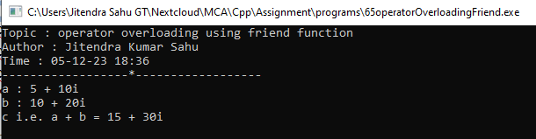

Program 66. Write a C++ program to illustrate unary minus operator overloading using friend function

**Code :**

#include <iostream>

using namespace std ;

class TwoNumber{

public :

int a, b ;

TwoNumber(){} // default constructor

TwoNumber(int a, int b){

this->a = a ;

this->b = b ;

}

// declration of friend operator function

friend TwoNumber operator - (const TwoNumber c1);

void print(){

cout <<"a : " << a << endl <<"b : "<< b << endl ;

}

};

// definition of friend operator function

TwoNumber operator - (TwoNumber c1){

c1.a = -c1.a ;

c1.b = -c1.b ;

return c1 ;

}

void printIntro(string topic, string time) {

cout<<"Topic : " << topic << endl ;

cout<<"Author : Jitendra Kumar Sahu" << endl ;

cout << "Time : "<< time << endl ;

cout <<"------------------*------------------"<< endl ;

}

int main(){

printIntro("operator overloading using friend function","05-12-23 18:36") ;

TwoNumber object(5,10);

cout << "object : \n" ;

object.print();

object = -object ;

cout << "-object \n" ;

object.print();

return 0 ;

}

**Output :**

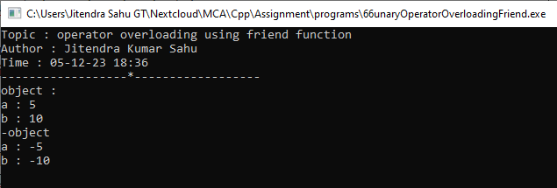

Program 67. WAP to demonstrate the use of  >> and getline( ) for reading the string.

**Code :**

#include <fstream>

#include <iostream>

using namespace std;

void printIntro(string topic, string time) {

cout << "Topic : " << topic << endl;

cout << "Author : Jitendra Kumar Sahu" << endl;

cout << "Time : " << time << endl;

cout << "_____________________*_____________________" << endl;

}

int main() {

printIntro(

"program to illustrate\nextraction operator and getline() function.",

"13-12-23 21:36");

try {

ifstream myFile("Info.txt", ios::in);

string s1, s2;

getline(myFile, s1); // use of getline()

cout << "content read using getline from file : \n" << s1 << endl;

cout << "content read using >> operator : \n"; // example of extraction

// operator (>>)

myFile >> s2;

cout << s2 << endl;

} catch (const std::exception& e) {

cout << "Exception : ";

std::cerr << e.what() << '\n';

}

return 0;

}

**Output :**

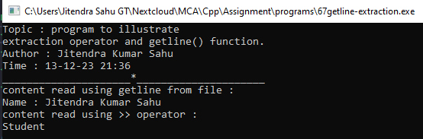

Program 68. WAP to create a file named “Rudra” using constructor.

**Code :**

#include <iostream>

#include <fstream>

using namespace std;

void printIntro(string topic, string time){

cout << "Topic : " << topic << endl;

cout << "Author : Jitendra Kumar Sahu" << endl;

cout << "Time : " << time << endl;

cout << "_____________________*_____________________" << endl;

}

int main(){

printIntro("Creating a file with C++", "13-12-23 21:36");

try{

// creating a file with constructor

fstream myFile("Rudra.txt", ios::out);

cout << "successfully created file...." << endl;

}

catch (const std::exception &e){

cout << "Unable to create file." << endl;

cout << "Exception : " << e.what() << endl;

}

return 0;

}

**Output :**

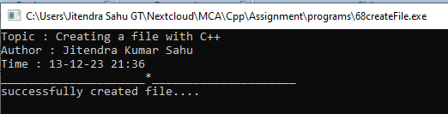

Program 69. WAP to create a file name “Info” using open function having details about your name,age,class and address.and display them into the console using eof().

**Code :**

#include <iostream>

#include <fstream>

using namespace std;

void printIntro(string topic, string time){

cout << "Topic : " << topic << endl;

cout << "Author : Jitendra Kumar Sahu" << endl;

cout << "Time : " << time << endl;

cout << "_____________________*_____________________" << endl;

}

int main(){

printIntro("File reading", "13-12-23 21:36");

try{

fstream myFile("Info.txt");

char c;

while (c = myFile.get()){

cout << c;

if (c == EOF) {//use of end of file

cout << "[Reached end of file (EOF)]";

break;

}

}

}

catch (const std::exception &e){

cout << "Exception : " << e.what() << endl;

}

return 0;

}

**Output :**

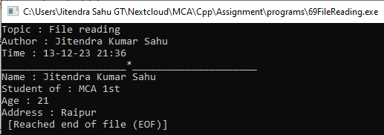

Program 70.WAP to perform truncate operation in a file existing file named “File”.

**Code:**

#include <fstream>

#include <iostream>

using namespace std;

void printIntro(string topic, string time) {

cout << "Topic : " << topic << endl;

cout << "Author : Jitendra Kumar Sahu" << endl;

cout << "Time : " << time << endl;

cout << "_____________________*_____________________" << endl;

}

int main() {

printIntro("Program to TRUNCATE File", "05:30 13-11-2023");

const char fileName[5] = "File" ;

try {

ifstream myFile(fileName, ios::in); // opening file in reading mode

cout << "content of the file BEFORE TRUNCATE\n" << endl;

string s;

while (getline(myFile, s)) { // reading content line by line

cout << s; // printing content of line

}

cout << endl << endl;

myFile.close();

ofstream file(fileName, ios::trunc); // open file with truncate

cout << "Successfully TRUNCATE\n" << endl;

myFile.close();

cout << "content of the file AFTER TRUNCATE\n" << endl;

while (getline(myFile, s)) {

cout << s;

}

cout << endl;

myFile.close();

} catch (const exception &e) {

cerr << "Sorry something went wrong! \n";

cerr << e.what() << endl;

}

return 0;

}

**Output :**

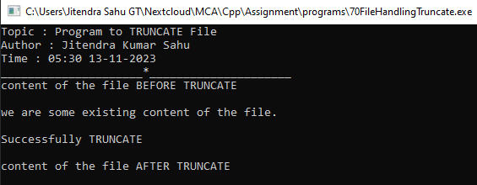

Program 71.WAP to open existing file name “Shiva” in append mode to add some content in a file.

**Code:**

#include <fstream>

#include <iostream>

using namespace std;

void printIntro(string topic, string time) {

cout << "Topic : " << topic << endl;

cout << "Author : Jitendra Kumar Sahu" << endl;

cout << "Time : " << time << endl;

cout << "_____________________*_____________________" << endl;

}

int main() {

const char fileName[10] = "Shiva.txt";

printIntro("Program to append content File", "05:30 13-11-2023");

try {

ifstream myFile(fileName, ios::in); // opening file in reading mode

cout << "content of the file BEFORE APPEND\n" << endl;

string s;

while (getline(myFile, s)) { // reading content line by line

cout << s; // printing content of line

}

cout << endl << endl;

myFile.close();

} catch (const exception &e) {

cerr << "Sorry something went wrong! \n";

cerr << e.what() << endl;

}

try {

ofstream myFile(fileName, ios::app); // open file with truncate

// APPENDING content to file

myFile << "\nWE ARE THE NEW CONTENT APPENDED TO FILE SHIVA.TXT\n";

cout << "Successfully APPENDED!\n" << endl;

myFile.close();

} catch (const std::exception &e) {

std::cerr << e.what() << '\n';

}

try {

ifstream myFile(fileName, ios::in);

cout << "content of the file AFTER Append\n" << endl;

string s;

while (getline(myFile, s)) {

cout << s;

}

cout << endl << endl;

myFile.close();

} catch (const std::exception &e) {

std::cerr << e.what() << '\n';

}

return 0;

}

**Output :**

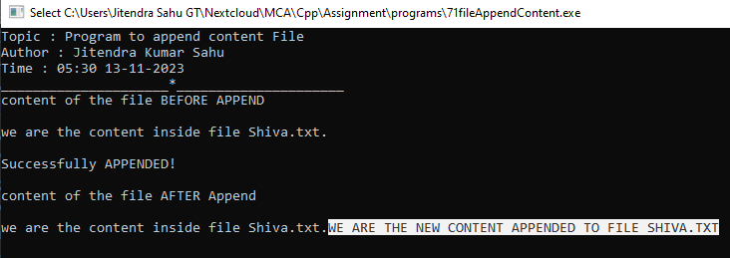

Program 72.WAP to find current position of input/output pointer of a file.

**Code:**

#include <fstream>

#include <iostream>

using namespace std;

void printIntro(string topic, string time) {

cout << "Topic : " << topic << endl;

cout << "Author : Jitendra Kumar Sahu" << endl;

cout << "Time : " << time << endl;

cout << "_____________________*_____________________" << endl;

}

int main() {

const char fileName[10] = "Shiva.txt";

printIntro("finding File pointer position", "05:30 13-11-2023");

try {

ifstream myFile(fileName, ios::in); // opening file in reading mode

// printing file pointer postion

string s;

cout << "file pointer position before reading : " << myFile.tellg() << endl << endl;

while (getline(myFile, s)) { // reading content line by line

cout << s; // printing content of line

}

// printing file pointer postion

cout << "\n\nfile pointer position after reading : " << myFile.tellg() << endl;

cout << endl ;

myFile.close();

} catch (const exception& e) {

cerr << "Sorry something went wrong! \n";

cerr << e.what() << endl;

}

return 0;

}

**Output :**

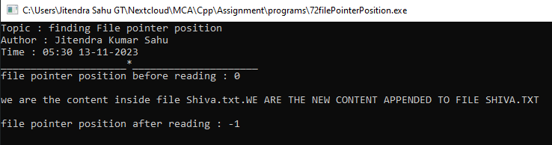

Program 73.WAP to differentiate read( ) and getline( ) function.

**Code:**

#include <fstream>

#include <iostream>

using namespace std;

void printIntro(string topic, string time) {

cout << "Topic : " << topic << endl;

cout << "Author : Jitendra Kumar Sahu" << endl;

cout << "Time : " << time << endl;

cout << "_____________________*_____________________" << endl;

}

int main() {

printIntro("Program to differentiate read() and getLine()", "05:30 13-11-2023");

const char fileName[10] = "Shiva.txt";

char buff[11];

buff[10] = '\0';

try {

ifstream myFile(fileName, ios::in); // opening file in reading mode

myFile.read(buff, 10); // reading 10 characters using read()

cout << "content of the file using read() : " << endl;

cout << buff << endl;

cout << "content of the file using getline() : " << endl;

string s;

while (getline(myFile, s)) { // reading content line by line

cout << s; // printing content of line

}

cout << endl << endl;

myFile.close();

} catch (const exception& e) {

cerr << "Sorry something went wrong! \n";

cerr << e.what() << endl;

}

return 0;

}

**Output :**

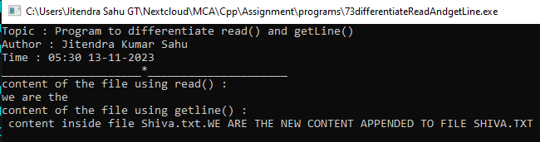

Program 74. WAP to demonstrate manupulators(setw, setprecision, setbase, setfill).

**Code:**

#include <iomanip>

#include <iostream>

using namespace std;

void printIntro(string topic, string time) {

cout << "Topic : " << topic << endl;

cout << "Author : Jitendra Kumar Sahu" << endl;

cout << "Time : " << time << endl;

cout << "--------------------*--------------------" << endl;

}

int main() {

printIntro("Program to demonstrate some iomanip functions",

"05:30 13-11-2023");

const int num = 123;

const double pi = 3.14159265358979323846;

cout << "setw() \n";

cout << setw(10) << num << endl;

cout << setw(10) << pi << endl;

cout << "\nsetprecision() \n";

cout << setprecision(6) << num << endl;

cout << setprecision(6) << pi << endl;

cout << "\nsetbase() \n";

cout << setbase(16) << num << endl;

cout << setbase(8) << pi << endl;

cout << "\nsetfill() \n";

cout << setfill('*')<< setw(10) << num << endl;

cout << setfill('#')<< setw(10) << pi << endl;

return 0;

}

**Output :**

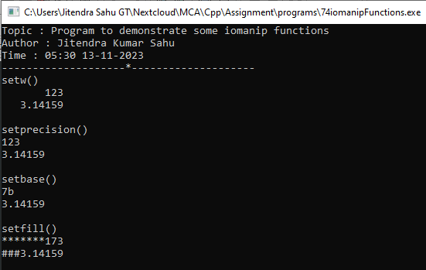

Program 75.WAP which reads input from the keyboard whose width specified with 8 and unused space filled with '#'and input should be left-justified.

**Code:**

#include <iomanip>

#include <iostream>

using namespace std;

void printIntro(string topic, string time) {

cout << "Topic : " << topic << endl;

cout << "Author : Jitendra Kumar Sahu" << endl;

cout << "Time : " << time << endl;

cout << "--------------------*--------------------" << endl;

}

int main() {

printIntro("Aligning output left and setfill #",

"05:30 13-11-2023");

string name ;

cout << "enter name : " ;

getline(cin,name) ;

cout << "\nleft aligned output\n";

cout << left << setw(30) << setfill('#')<< name << endl;

return 0;

}

**Output :**

