# Program 1. WAP to create a linear array named LA of size 6,and perform traversing operation on it using function name "Traverse".

**Code:**

#include <stdio.h>

#include "intro.c"

void traverse(int *arr, int n) {

for (size_t i = 0; i < n; i++) {

printf("%d ", arr[i]);

}

}

int main() {

printIntro("creating and traversing an array");

int n = 6;

int LA[] = {4, 5, 7, 8, 3, 9};

printf("array created of size %d\nenter item to be stored\n",n) ;

for(int i = 0 ; i < n ; i++){

printf("enter item %d : ",(i+1)) ;

scanf("%d",&LA[i]) ;

}

printf("Traversing array...\n");

traverse(LA, n);

return 0;

}  
**Output:**

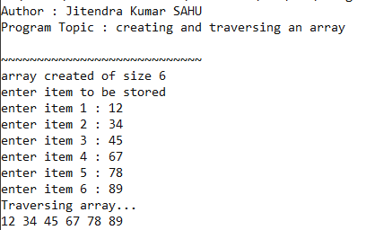

# Program 2. WAP to insert an element from a linear array using function name "Insert".

**Code:**   
#include <stdio.h>

#include "intro.c"

void traverse(int *arr, int n) {

for (size_t i = 0; i < n; i++) {

printf("%d ", arr[i]);

}

}

void insert(int *arr, int n, int *indexOfLastItem) {

for (size_t i = 0; i < n; i++) {

arr[i] = i * 3;

*indexOfLastItem += 1;

}

}

void insertAtPosition(int *arr, int position, int n, int *indexOfLastItem) {

if (*indexOfLastItem >= n - 1) {

printf("no more items can be inserted\n ");

return;

}

if (*indexOfLastItem != -1 ) {

// shift items backward

for (size_t i = *indexOfLastItem; i >= position; i--) {

arr[i + 1] = arr[i];

}

}

printf("Enter element to be inserted : ");

scanf("%d", &arr[position]);

*indexOfLastItem += 1;

}

int main() {

printIntro("inserting elements to array using function");

int n = 10;

int indexOfLastItem = -1;

int LA[n];

int position;

insert(LA, 6, &indexOfLastItem);

printf("Array elements :\n");

traverse(LA, indexOfLastItem);

printf("\nenter position : ");

scanf("%d", &position);

insertAtPosition(LA, position, 10, &indexOfLastItem);

printf("Array elements :\n");

traverse(LA, indexOfLastItem);

return 0;

}

**Output:**

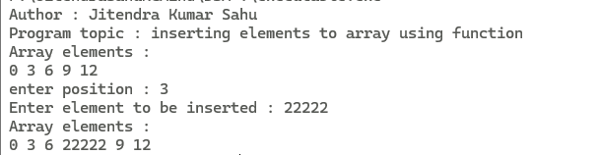

# Program 3. WAP to delete an element from a linear array using function name "delete".

**Code:**

#include <stdio.h>

#include "intro.c"

void deleteFromPosition(int *arr, const int position, int *indexOfLastItem) {

if (position < 0 || position > *indexOfLastItem) {

printf("\nCan not be deleted!");

return;

}

printf("\ndeleted item : %d\n", arr[position]);

// move items forward

for (size_t i = position; i < *indexOfLastItem; i++) {

arr[i] = arr[i + 1];

}

*indexOfLastItem -= 1;

}

int main() {

printIntro("Deleting item from given postion in array");

int LA[10] = {23, 56, 8, 98, 5, 3, 687, 5};

int indexOfLastItem = 7;

printf("Array elements are : \n");

for (size_t i = 0; i < indexOfLastItem; i++) printf("%d ", LA[i]);

int position;

printf("\nenter position item to be deleted from : ");

scanf("%d", &position);

deleteFromPosition(LA, position, &indexOfLastItem);

for (size_t i = 0; i < indexOfLastItem; i++) printf("%d ", LA[i]);

return 0;

}

**Output:**

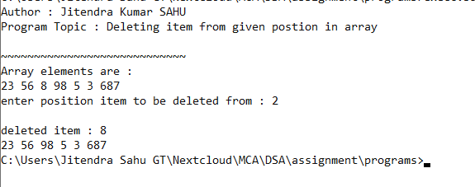

# Program 4. WAP to create a single node in linked list.

**Code:**   
#include <stdio.h>

#include <stdlib.h>

#include "intro.c"

typedef struct node node ;

struct node

{

int data ;

node *next ;

};

int main() {

printIntro("creating a single node in linked list.");

node *START = NULL ;

node *loc = (node*)malloc(sizeof(node)) ;

loc->data = 50 ;

loc->next = NULL ;

START = loc ;

printf("data at node : %d\n",START->data);

return 0;

}  
 **Output:  
  
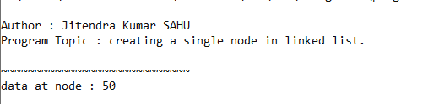**

# Program 5. WAP to create linked list at compile time having 4 node.

Code:   
#include <stdio.h>

#include <stdlib.h>

#include "intro.c"

typedef struct node node;

struct node {

int data;

node *next;

};

node *getNode(int data) {

node *newNode = (node *)malloc(sizeof(node));

if(newNode==NULL) exit(1) ;

newNode->data = data;

newNode->next = NULL;

return newNode;

}

void traverse(node *start) {

node *loc = start;

if (!loc)

{ printf("no node exist!\n") ;

return;

}

printf("\n");

while (loc) {

printf("|%d|%X|", loc->data, loc->next);

if (loc->next) printf(" -> ");

loc = loc->next;

}

printf("\n\n");

}

int main() {

printIntro("linked list having 4 node at compile time");

node *start = NULL;

// insertion of first node

node *loc = getNode(1);

start = loc;

loc->next = getNode(2);

loc = loc->next;

loc->next = getNode(3);

loc = loc->next;

loc->next = getNode(4);

loc = loc->next;

printf("node(s) at linked list");

traverse(start);

return 0;

}  
 **Output:**

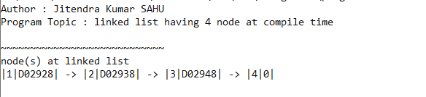

# Program 6. WAP to create linked list having 4 node at runtime.

**Code:**   
#include <stdio.h>

#include <stdlib.h>

#include "intro.c"

typedef struct node node;

struct node {

int data;

node *next;

};

node *getNode(int data) {

node *newNode = (node *)malloc(sizeof(node));

if(newNode==NULL) exit(1) ;

newNode->data = data;

newNode->next = NULL;

return newNode;

}

void traverse(node *start) {

node *loc = start;

if (!loc)

{ printf("no node exist!\n") ;

return;

}

printf("\n");

while (loc) {

printf("|%d|%X|", loc->data, loc->next);

if (loc->next) printf(" -> ");

loc = loc->next;

}

printf("\n\n");

}

int main() {

printIntro("linked list having node(s) at runtime");

node *start = NULL;

node *loc = NULL;

int n;

printf("how many nodes linked list should contain ? : ");

scanf("%d", &n);

for (int data, i = 0; i < n; i++) {

printf("Enter data for node %d : ", i + 1);

scanf("%d", &data);

if (start == NULL) {

loc = getNode(data);

start = loc;

} else {

loc->next = getNode(data);

loc = loc->next;

}

}

printf("nodes of linked list\n") ;

traverse(start);

return 0;

}  
 **Output:  
  
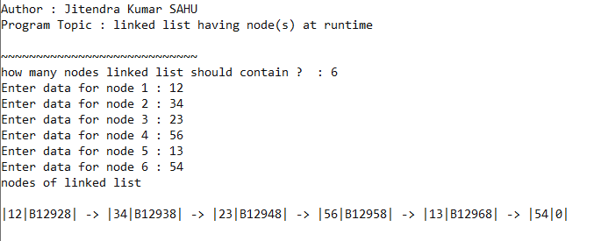**

# Program 7. WAP to perform trversing in linked list using function named "Traverse".

**Code:**   
#include <stdio.h>

#include <stdlib.h>

#include "intro.c"

typedef struct node node;

struct node {

int data;

node *next;

};

node *getNode(int data) {

node *newNode = (node *)malloc(sizeof(node));

if(newNode==NULL) exit(1) ;

newNode->data = data;

newNode->next = NULL;

return newNode;

}

void traverse(node *start) {

node *loc = start;

if (!loc)

{ printf("no node exist!\n") ;

return;

}

printf("\n");

while (loc) {

printf("|%d|%X|", loc->data, loc->next);

if (loc->next) printf(" -> ");

loc = loc->next;

}

printf("\n\n");

}

int main() {

printIntro("traversing in linked list using function named \"Traverse()\"");

node *start = NULL;

node *loc = NULL;

int n;

printf("how many nodes linked list should contain ? : ");

scanf("%d", &n);

for (int data, i = 0; i < n; i++) {

printf("Enter data for node %d : ", i + 1);

scanf("%d", &data);

if (start == NULL) {

loc = getNode(data);

start = loc;

} else {

loc->next = getNode(data);

loc = loc->next;

}

}

printf("nodes in linked list : \n") ;

traverse(start);

return 0;

}  
 **Output:  
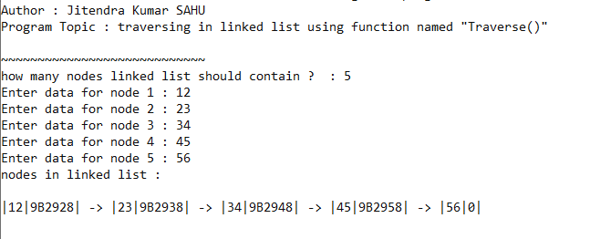**

# Program 8. WAP to insert a node at the begining of the linked list.

**Code:**   
#include <stdio.h>

#include <stdlib.h>

#include "intro.c"

typedef struct node node;

struct node {

int data;

node *next;

};

node *getNode(int data) {

node *newNode = (node *)malloc(sizeof(node));

if(newNode==NULL) exit(1) ;

newNode->data = data;

newNode->next = NULL;

return newNode;

}

void traverse(node *start) {

node *loc = start;

if (!loc) {

printf("no node exist!\n");

return;

}

printf("\n");

while (loc) {

printf("|%d|%X|", loc->data, loc->next);

if (loc->next) printf(" -> ");

loc = loc->next;

}

printf("\n\n");

}

int main() {

printIntro("inserting at end of the linked list.");

node *start = NULL;

node *loc = NULL;

int n;

printf("how many nodes linked list should contain ? : ");

scanf("%d", &n);

for (int i = 0; i < n; i++) {

if (start == NULL) {

loc = getNode(1);

start = loc;

} else {

loc->next = getNode((i + 1) * 3);

loc = loc->next;

}

}

printf("nodes in linked list : \n");

traverse(start);

int data;

printf("enter item to be inserted at first position : ");

// creating and inserting node at first postion

scanf("%d", &data);

node *newNode = getNode(data);

newNode->next = start;

start = newNode;

printf("nodes in linked list after insertion: \n");

traverse(start);

return 0;

}  
 **Output:  
  
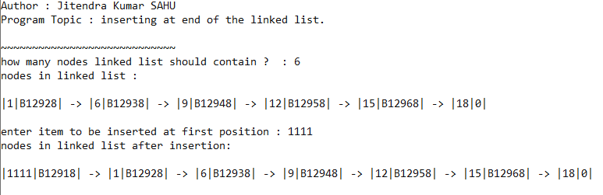**

# Program 9. WAP to insert a node at the end of the linked list.

**Code:**   
#include <stdio.h>

#include <stdlib.h>

#include "intro.c"

typedef struct node node;

struct node {

int data;

node *next;

};

node *getNode(int data) {

node *newNode = (node *)malloc(sizeof(node));

if(newNode==NULL) exit(1) ;

newNode->data = data;

newNode->next = NULL;

return newNode;

}

void traverse(node *start) {

node *loc = start;

if (!loc) {

printf("no node exist!\n");

return;

}

printf("\n");

while (loc) {

printf("|%d|%X|", loc->data, loc->next);

if (loc->next) printf(" -> ");

loc = loc->next;

}

printf("\n\n");

}

void insertAtLastNode(node *start, int data) {

node *loc = start;

// get last node

while (loc->next) loc = loc->next;

loc->next = getNode(data);

}

int main() {

printIntro("inserting end of the linked list.");

node *start = NULL;

node *loc = NULL;

int n;

printf("how many nodes linked list should contain ? : ");

scanf("%d", &n);

for (int i = 0; i < n; i++) {

if (start == NULL) {

loc = getNode(1);

start = loc;

} else {

loc->next = getNode((i + 1) * 3);

loc = loc->next;

}

}

printf("nodes in linked list : \n");

traverse(start);

int data;

printf("enter item to be inserted at end : ");

// creating and inserting node at END

scanf("%d", &data);

if (start)

insertAtLastNode(start, data);

else

start = getNode(data);

printf("After insertion: \n");

traverse(start);

return 0;

}  
 **Output:**

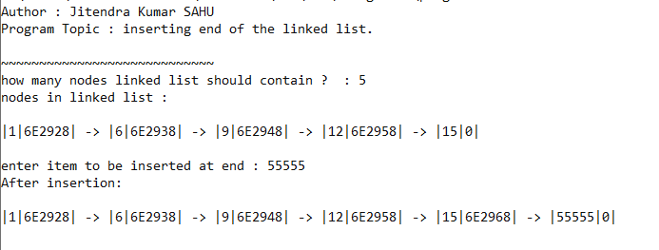

# Program 10. WAP to insert a node at the specific position of the linked list.

**Code:**   
#include <stdio.h>

#include <stdlib.h>

#include "intro.c"

typedef struct node node;

struct node {

int data;

node *next;

};

node *getNode(int data) {

node *newNode = (node *)malloc(sizeof(node));

if(newNode==NULL) exit(1) ;

newNode->data = data;

newNode->next = NULL;

return newNode;

}

void traverse(node *start) {

node *loc = start;

if (!loc) {

printf("no node exist!\n");

return;

}

printf("\n");

while (loc) {

printf("|%d|%X|", loc->data, loc->next);

if (loc->next) printf(" -> ");

loc = loc->next;

}

printf("\n\n");

}

node *insertAtPosition(node *start, const int position, int data) {

int currentPosition = 0;

node *loc, *locp;

loc = locp = start;

while (currentPosition < position) {

locp = loc;

loc = loc->next;

currentPosition++;

}

node *newNode = getNode(data);

newNode->next = loc;

locp->next = newNode;

}

int main() {

printIntro("inserting at given postion of the linked list.");

node *start = NULL;

node *loc = NULL;

int n;

printf("how many nodes linked list should contain ? ");

scanf("%d", &n);

for (int i = 0; i < n; i++) {

if (start == NULL) {

loc = getNode(1);

start = loc;

} else {

loc->next = getNode((i + 1) * 3);

loc = loc->next;

}

}

printf("nodes in linked list : \n");

traverse(start);

int position;

printf("enter position (indexing from 0) where node to be inserted : ");

scanf("%d", &position);

if (position < 0 || position > n) {

printf("invalid position!");

return 1;

}

int data;

printf("enter data : ");

scanf("%d", &data);

if (position == 0) {

node *newNode = getNode(data);

newNode->next = start;

start = newNode;

} else {

insertAtPosition(start, position, data);

}

printf("\nafter insertion : \n");

traverse(start);

return 0;

}

**Output:  
  
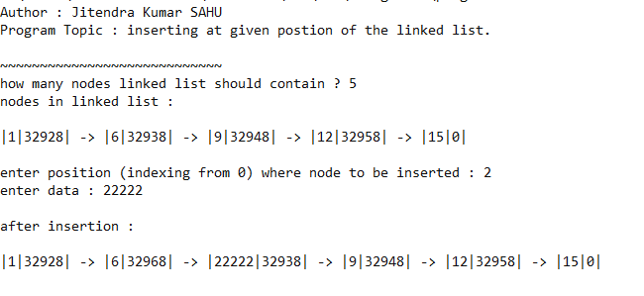**

# Program 11. WAP to delete a node at the begining of the linked list.

**Code:**   
#include <stdio.h>

#include <stdlib.h>

#include "intro.c"

typedef struct node node;

struct node {

int data;

node *next;

};

node *getNode(int data) {

node *newNode = (node *)malloc(sizeof(node));

if (newNode == NULL) exit(1);

newNode->data = data;

newNode->next = NULL;

return newNode;

}

void traverse(node *start) {

node *loc = start;

if (!loc) {

printf("no node exist!\n");

return;

}

printf("\n");

while (loc) {

printf("|%d|%X|", loc->data, loc->next);

if (loc->next) printf(" -> ");

loc = loc->next;

}

printf("\n\n");

}

int main() {

printIntro("delete from firts postion of the linked list.");

node *start = NULL;

node *loc = NULL;

int n;

printf("how many nodes linked list should contain ? ");

scanf("%d", &n);

int data;

for (int i = 0; i < n; i++) {

printf("enter data for node %d : ", i + 1);

scanf("%d", &data);

if (start == NULL) {

loc = getNode(data);

start = loc;

} else {

loc->next = getNode(data);

loc = loc->next;

}

}

printf("\nBEFORE deletion :");

traverse(start);

if (start) {

loc = start;

start = start->next;

printf("\nDELETED : %d, AT ADDRESS : %X", loc->data, loc);

free(loc);

} else {

printf("Underflow!");

}

printf("\n\nAFTER Deletion :");

traverse(start);

return 0;

}

**Output:**

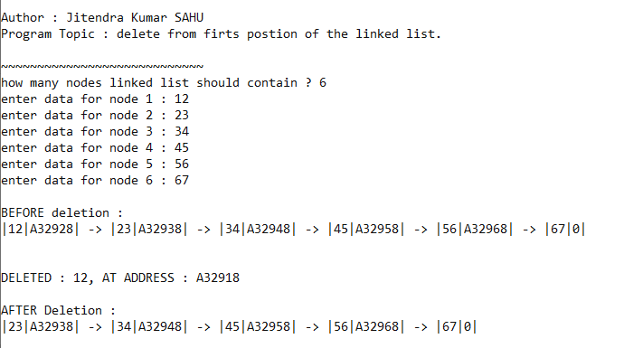

# Program 12. WAP to delete a node at the end of the linked list.

**Code:**   
#include <stdio.h>

#include <stdlib.h>

#include "intro.c"

typedef struct node node;

struct node {

int data;

node *next;

};

node *getNode(int data) {

node *newNode = (node *)malloc(sizeof(node));

if (newNode == NULL) exit(1);

newNode->data = data;

newNode->next = NULL;

return newNode;

}

void traverse(node *start) {

node *loc = start;

if (!loc) {

printf("no node exist!\n");

return;

}

printf("\n");

while (loc) {

printf("|%d|%X|", loc->data, loc->next);

if (loc->next) printf(" -> ");

loc = loc->next;

}

printf("\n\n");

}

node *deleteFromEnd(node *start) {

node *loc, *locp;

loc = locp = start;

while (loc->next) {

locp = loc;

loc = loc->next;

}

locp->next = NULL;

printf("\nDELETED : %d, AT ADDRESS : %X\n", loc->data, loc);

free(loc);

}

int main() {

printIntro("delete from END of the linked list.");

node *start = NULL;

node *loc = NULL;

int n;

printf("how many nodes linked list should contain ? ");

scanf("%d", &n);

for (int data , i = 0; i < n; i++) {

printf("enter data for node %d : ", i + 1);

scanf("%d", &data);

if (start == NULL) {

loc = getNode(data);

start = loc;

} else {

loc->next = getNode(data);

loc = loc->next;

}

}

printf("nodes in linked list : \n");

traverse(start);

if (start == NULL)

printf("underflow!"); // no node exists

else if (start->next == NULL) { // only one node exists

loc = start;

printf("\nDELETED : %d, AT ADDRESS : %X\n", loc->data, loc);

free(loc);

start = NULL;

} else

deleteFromEnd(start); // multiple node exists

printf("\nafter Deletion : \n");

traverse(start);

return 0;

}  
 **Output:**

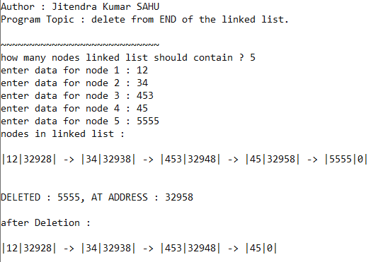

# Program 13. WAP to delete a node at the specific position of the linked list.

**Code:**   
#include <stdio.h>

#include <stdlib.h>

#include "intro.c"

typedef struct node node;

struct node {

int data;

node *next;

};

node *getNode(int data) {

node *newNode = (node *)malloc(sizeof(node));

if(newNode==NULL) exit(1) ;

newNode->data = data;

newNode->next = NULL;

return newNode;

}

void traverse(node *start) {

node *loc = start;

if (!loc) {

printf("no node exist!\n");

return;

}

printf("\n");

while (loc) {

printf("|%d|%X|", loc->data, loc->next);

if (loc->next) printf(" -> ");

loc = loc->next;

}

printf("\n\n");

}

node *deleteFromPosition(node *start, const int position) {

int currentPosition = 0;

node *loc, *locp;

loc = locp = start;

while (currentPosition < position) {

locp = loc;

loc = loc->next;

currentPosition++;

}

locp->next = loc->next;

printf("\nDELETED : %d, AT ADDRESS : %X\n", loc->data, loc);

free(loc);

}

int main() {

printIntro("delete from given postion of the linked list.");

node *start = NULL;

node *loc = NULL;

int n;

printf("how many nodes linked list should contain ? ");

scanf("%d", &n);

for (int i = 0; i < n; i++) {

if (start == NULL) {

loc = getNode(1);

start = loc;

} else {

loc->next = getNode((i + 1) * 3);

loc = loc->next;

}

}

printf("nodes in linked list : \n");

traverse(start);

int position;

printf("enter position (indexing from 0) node to be deleted from : ");

scanf("%d", &position);

if (position < 0 || position >= n) {

printf("invalid position!");

return 1;

}

if (position == 0) {

loc = start;

start = start->next;

printf("\nDELETED : %d, AT ADDRESS : %X\n", loc->data, loc);

free(loc);

} else {

deleteFromPosition(start, position);

}

printf("\nafter Deletion : \n");

traverse(start);

return 0;

}  
 **Output:**

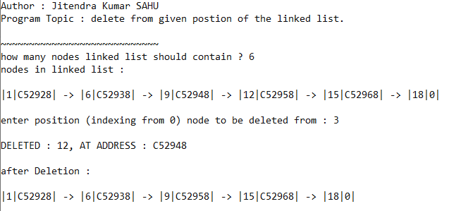

# Program 14. WAP to create a grounded header linked list.

**Code:**   
#include <stdio.h>

#include <stdlib.h>

#include "intro.c"

typedef struct node node;

struct node {

int data;

node *next;

};

node *getNode(int data, node *start) {

node *newNode = (node *)malloc(sizeof(node));

if (newNode == NULL) exit(1);

newNode->data = data;

newNode->next = NULL;

start->data += 1 ; // UPDATING VALUE AT HEADER

return newNode;

}

void traverse(node *start) {

node *loc = start;

if (!loc) {

printf("no node exist!\n");

return;

}

printf("\n");

while (loc){

printf("|%d|%X|", loc->data, loc->next);

if (loc->next) printf(" -> ");

loc = loc->next;

}

printf("\n\n");

}

void insertAtLastNode(node *start, int data) {

node *loc = start;

// get last node

while (loc->next) {

loc = loc->next;

}

loc->next = getNode(data, start);

}

int main() {

printIntro("LINKED LIST with header node.");

node HEADER = {0,NULL};

node *start = &HEADER;

node *loc = &HEADER;

int n;

printf("how many nodes linked list should contain ? : ");

scanf("%d", &n);

for (int i = 0; i < n; i++) {

if (start == NULL) {

loc = getNode(1, start);

start->next = loc;

} else {

loc->next = getNode((i + 1) * 3, start);

loc = loc->next;

}

}

printf("nodes in linked list : \n");

traverse(start);

int data;

printf("enter item to be inserted at end : ");

// creating and inserting node at END

scanf("%d", &data);

if (start)

insertAtLastNode(start, data);

else

start->next = getNode(data, start);

printf("After insertion: \n");

traverse(start);

return 0;

}  
 **Output:**

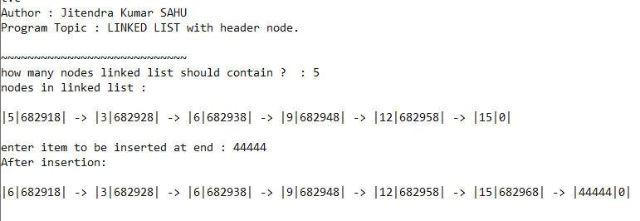

# Program 15. WAP to create a circular linked list.

**Code:**   
#include <stdio.h>

#include <stdlib.h>

#include "intro.c"

typedef struct node node;

struct node {

int data;

node *next;

};

node *getNode(int data, node *start) {

node *newNode = (node *)malloc(sizeof(node));

if (newNode == NULL) exit(1);

newNode->data = data;

newNode->next = start;

return newNode;

}

void traverse(node *start) {

node *loc = start;

if (!loc) {

printf("no node exist!\n");

return;

}

printf("\n");

do {

printf("|%d|%X|", loc->data, loc->next);

if (loc->next) printf(" -> ");

loc = loc->next;

} while (loc != start);

printf("\n\n");

}

void insertAtLastNode(node *start, int data) {

node *loc = start;

// get last node

do {

loc = loc->next;

} while (loc->next != start);

loc->next = getNode(data, start);

}

int main() {

printIntro("inserting end of the CIRCULAR LINKED LIST.");

node *start = NULL;

node *loc = NULL;

int n;

printf("how many nodes linked list should contain ? : ");

scanf("%d", &n);

for (int i = 0; i < n; i++) {

if (start == NULL) {

loc = getNode(1, start);

start = loc;

} else {

loc->next = getNode((i + 1) * 3, start);

loc = loc->next;

}

}

printf("nodes in linked list : \n");

traverse(start);

int data;

printf("enter item to be inserted at end : ");

// creating and inserting node at END

scanf("%d", &data);

if (start)

insertAtLastNode(start, data);

else

start = getNode(data, start);

printf("After insertion: \n");

traverse(start);

return 0;

}  
 **Output:**

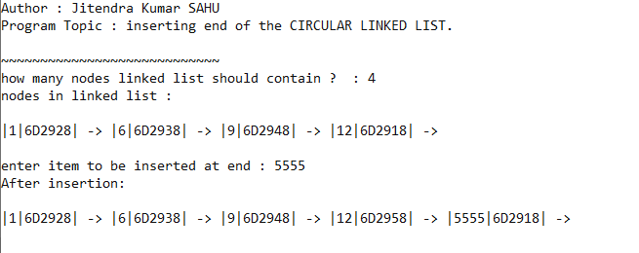

# Program 16. WAP to perform push operation in stack using array at compile time.

**Code:**   
#include <stdio.h>

#include "intro.c"

#define MAX 5 // Defining the maximum size of the stack

int stack[MAX]; // Stack array declaration

int top = -1; // Stack top initialization

// Function to return the top element from the stack

void peek() {

if (top >= 0) {

printf("%d\n", stack[top]);

return;

} else {

printf("Stack is empty\n");

return;

}

}

// Function to add an element to the stack

void push(int item) {

if (top < MAX - 1) {

top++;

stack[top] = item;

printf("pushed %d\n", item);

return;

}

printf("Stack Overflow\n");

}

// Function to remove the top element from the stack

void pop() {

if (top >= 0) {

printf("popped %d\n", stack[top]);

top--;

return;

} else {

printf("Stack Underflow\n");

return;

}

}

int main(int argc, char const *argv[]) {

printIntro("push operation on array implementation of stack");

push(5);

push(6);

push(8);

push(9);

push(2);

push(3);

printf("\n");

pop();

pop();

pop();

pop();

pop();

pop();

return 0;

}

**Output:**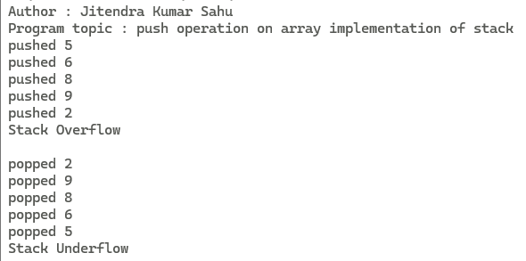

# Program 17. WAP to perform pop operation in stack using array at compile time.

**Code:**   
#include <stdio.h>

#include "intro.c"

#define MAX 5 // Defining the maximum size of the stack

int stack[MAX]; // Stack array declaration

int top = -1; // Stack top initialization

// Function to return the top element from the stack

void peek() {

if (top >= 0) {

printf("%d\n", stack[top]);

return;

} else {

printf("Stack is empty\n");

return;

}

}

// Function to add an element to the stack

void push(int item) {

if (top < MAX - 1) {

top++;

stack[top] = item;

printf("pushed %d\n", item);

return;

}

// else

printf("Stack Overflow\n");

}

// Function to remove the top element from the stack

void pop() {

if (top >= 0) {

printf("popped %d\n", stack[top]);

top--;

return;

} else {

printf("Stack Underflow\n");

return;

}

}

int main(int argc, char const *argv[]) {

printIntro("POP operation on array implementation of stack");

push(5);

push(6);

push(8);

push(9);

push(2);

push(3);

printf("\n");

pop();

pop();

pop();

pop();

pop();

pop();

return 0;

}

**Output:**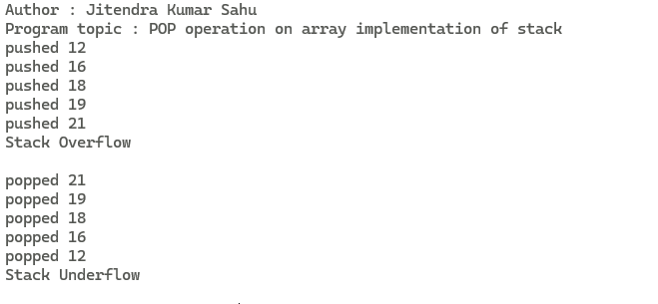

# Program 18. Write AProgram to implement Stack operation in array using switch case.

**Code:**   
#include <stdio.h>

#include "intro.c"

#define MAX 5 // Defining the maximum size of the stack

int stack[MAX]; // Stack array declaration

int top = -1; // Stack top initialization

// Function to return the top element from the stack

void peek() {

if (top >= 0) {

printf("%d\n", stack[top]);

return;

} else {

printf("Stack is empty\n");

return;

}

}

// Function to add an element to the stack

void push(int item) {

if (top < MAX - 1) {

top++;

stack[top] = item;

//printf("pushed %d\n", item);

return;

}

// else

printf("Stack Overflow\n");

}

// Function to remove the top element from the stack

void pop() {

if (top >= 0) {

printf("popped %d\n", stack[top]);

top--;

return;

} else {

printf("Stack Underflow\n");

return;

}

}

void traverse(){

if (top < 0) return ;

for(int i = top ; i >= 0 ; i--){

printf("%d ",stack[i]) ;

}

printf("\n") ;

}

int main() {

printIntro(" implement Stack operation in array using switch case. ");

printf("Enter\n1 to push\n");

printf("2 to pop\n");

printf("3 to print stack\n");

printf("0 to exit!\n");

while (1) {

int choice;

printf(">>");

scanf("%d", &choice);

int data;

switch (choice) {

case 1: // code to call push on stack

printf("enter data : ");

scanf("%d", &data);

push(data) ;

break;

case 2: // code to call pop from stack

pop();

break;

case 3:

printf("printing stack\n");

traverse();

break;

default:

printf("exiting........");

return 0;

}

}

return 0;

}

**Output:**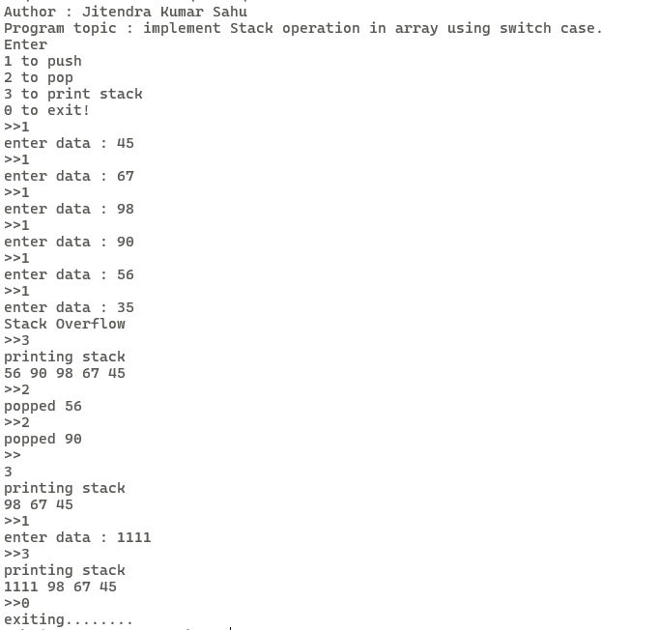

# Program 19. WAP to perform push operation in stack using linked list.

**Code:**   
#include <stdio.h>

#include <stdlib.h>

#include "intro.c"

typedef struct node node;

struct node {

int data;

node *next;

};

node *createNode(int data) {

node *newNode = (node *)malloc(sizeof(node));

if (newNode == NULL) {

printf("overflowed!");

exit(1);

}

newNode->data = data;

newNode->next = NULL;

return newNode;

}

void traverse(node *start) {

while (start) {

printf("%d ", start->data);

start = start->next;

}

}

int main() {

printIntro("linked list implementation of stack");

node *top = NULL;

printf("Enter\n1 to push\n");

printf("2 to pop\n");

printf("3 to print stack\n");

printf("0 to exit!");

while (1) {

int choice;

printf("\n>>");

scanf("%d", &choice);

int data;

switch (choice) {

case 1: // code to push onto stack

printf("enter data : ");

scanf("%d", &data);

node *loc = createNode(data);

if (top) {

loc->next = top;

top = loc;

} else {

top = loc;

}

break;

case 2: // code to pop from stack

if (top) {

printf("popped : %d\n", top->data);

top = top->next;

} else {

printf("underflow!\n");

}

break;

case 3:

printf("printing stack\n");

traverse(top);

break;

default:

printf("exiting........");

return 0;

}

}

return 0;

}  
 **Output:**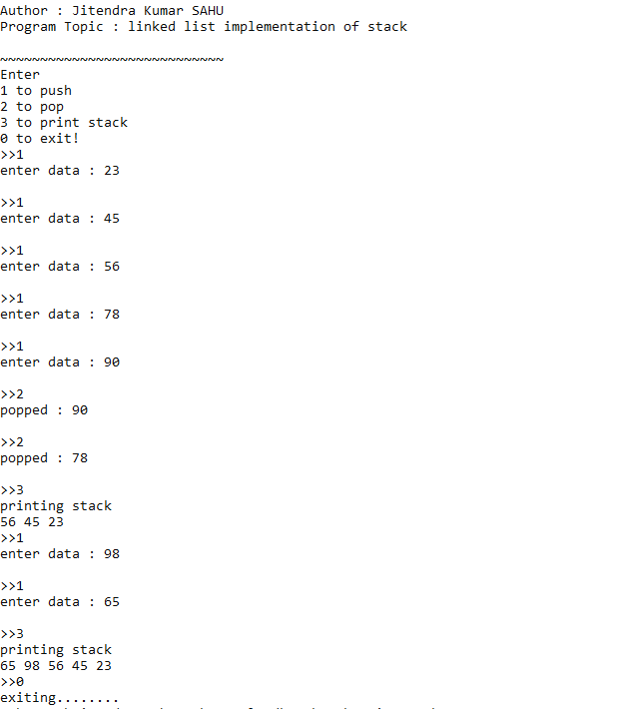

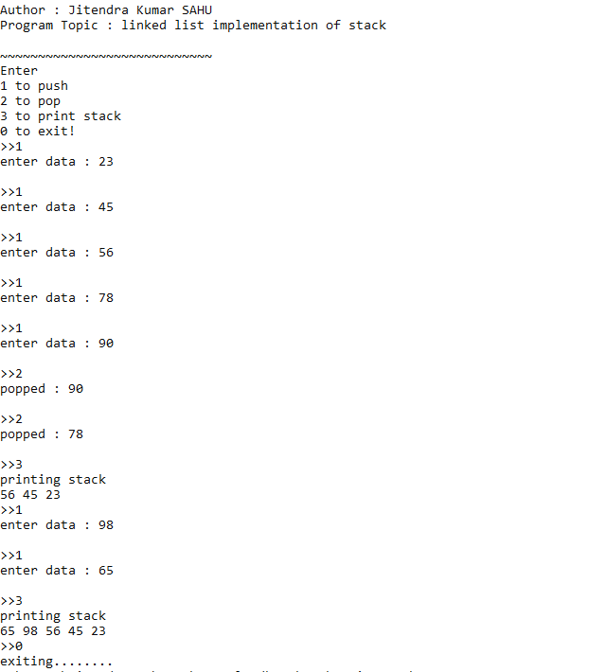

# Program 20. WAP to perform pop operation in stack using linked list.

**Code:**   
#include <stdio.h>

#include <stdlib.h>

#include "intro.c"

typedef struct node node;

struct node {

int data;

node *next;

};

node *createNode(int data) {

node *newNode = (node *)malloc(sizeof(node));

if (newNode == NULL) {

printf("overflowed!");

exit(1);

}

newNode->data = data;

newNode->next = NULL;

return newNode;

}

void traverse(node *start) {

while (start) {

printf("%d ", start->data);

start = start->next;

}

}

int main() {

printIntro("linked list implementation of stack");

node *top = NULL;

printf("Enter\n1 to push\n");

printf("2 to pop\n");

printf("3 to print stack\n");

printf("0 to exit!\n");

while (1) {

int choice;

printf(">>");

scanf("%d", &choice);

int data;

switch (choice) {

case 1: // code to push onto stack

printf("enter data : ");

scanf("%d", &data);

node *loc = createNode(data);

if (top) {

loc->next = top;

top = loc;

} else {

top = loc;

}

break;

case 2: // code to pop from stack

if (top) {

printf("poped : %d\n", top->data);

top = top->next;

} else {

printf("underflow!\n");

}

break;

case 3:

printf("printing stack\n");

traverse(top);

break;

default:

printf("exiting........");

return 0;

}

}

return 0;

}  
 **Output:**

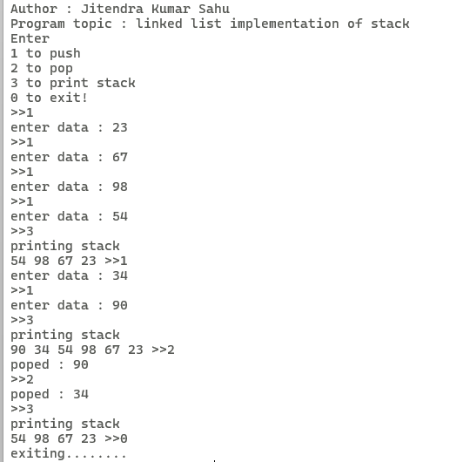

# Program 21. WAP to find factorial of a given number using Recursion.

**Code:**   
#include <stdio.h>

#include "intro.c"

long long fact(long long n) {

if (n == 0 || n == 1) return 1;

return n * fact(n - 1);

}

int main() {

printIntro("Factorial using recursion");

int num ;

printf("Enter number to calculate factorial : " ) ;

scanf("%d",&num) ;

printf("factorial %d = %lld\n",num,fact(num)) ;

return 0;

}

**Output:**

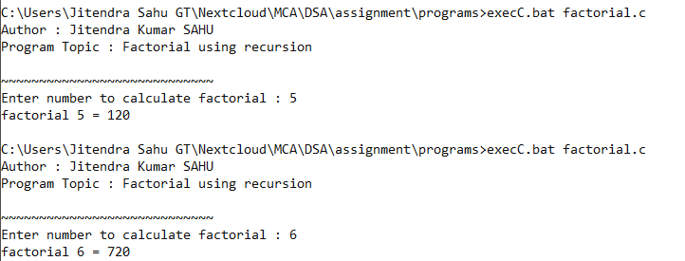

# Program 22. WAP to find fibonacci series using Recursion.

**Code:**   
#include <stdio.h>

#include "intro.c"

int fib(int n) {

if (n == 0 || n == 1) return n;

return fib(n - 1) + fib(n - 2);

}

int main() {

printIntro("Topic");

int n;

printf("Enter lenght of fibonacci series : ");

scanf("%d",&n) ;

printf("Fibonacci series of %d terms : \n", n);

for (int i = 0; i < n; i++) printf("%d ", fib(i));

return 0;

}  
 **Output:**

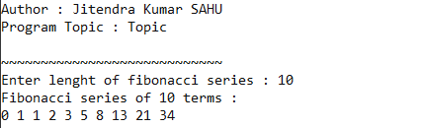

# Program 23. WAP to implement "Towers of Hanoi" problem using Recursion.

**Code:**   
#include <stdio.h>

#include "intro.c"

void tower(int n , char from , char to , char aux){

if (n == 1){

printf("%c -> %c\n",from , to) ;

return;

}

tower(n-1,from,aux,to);

printf("%c -> %c\n",from , to) ;

tower(n-1,aux,to,from) ;

}

int main(int argc, char const *argv[])

{

printIntro("Tower of hanoi") ;

int n ;

tower(3,'A','B','Z') ;

return 0;

}

**Output:**

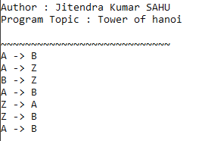

# Program 24. WAP to insert an element into a QUEUE using array.

**Code:**   
#include <stdio.h>

#include "intro.c"

#define MAX 5

typedef enum { false, true } boolean;

int FRONT = -1;

int REAR = -1;

int QUEUE[MAX];

boolean isOverflow() {

if ((FRONT == 0 && REAR == MAX - 1) || FRONT == REAR + 1) return true;

return false;

}

boolean isUnderflow() {

if (FRONT == -1) return true;

return false;

}

void insert(const int item) {

if (isOverflow()) {

printf("Overflow!\n");

return;

}

// set rear's value

if (FRONT == -1) {

FRONT = REAR = 0;

} else if (REAR == MAX - 1)

REAR = 0;

else

REAR += 1;

// set item

QUEUE[REAR] = item;

}

void delete () {

if (isUnderflow()) {

printf("Underflow!\n");

return;

}

// print item

printf("deleted : %d \n", QUEUE[FRONT]);

// set FRONT's position

if (FRONT == REAR) {

FRONT = REAR = -1;

} else if (FRONT == MAX) {

FRONT = 0;

} else

FRONT += 1;

}

int main() {

printIntro("Array implementation of Circler Queue");

printf(

"Queue created;\n1 to insert item\n2 to delete from queue\n0 to "

"exit out of program:\n");

int s;

while (true) {

printf("enter option : ");

scanf("%d", &s);

switch (s) {

case 0:

return 0;

break;

case 1:

printf("enter item to be inserted : ");

int data;

scanf("%d", &data);

insert(data);

break;

case 2:

delete ();

break ;

default:

printf("enter valid number!\n");

break;

}

}

return 0;

}

**Output:**

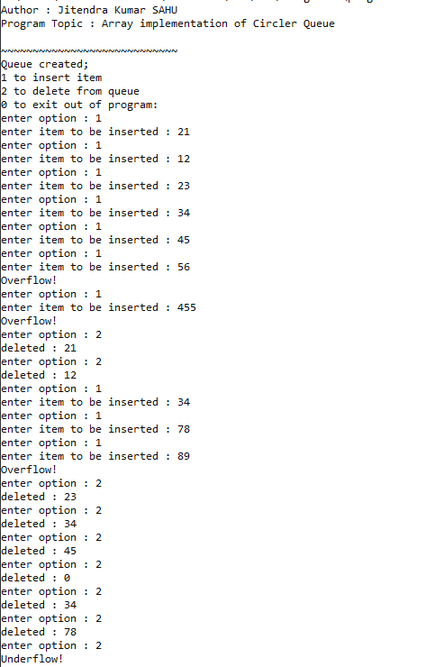

# Program 25. WAP to delete an element from a QUEUE using array.

**Code:**   
#include <stdio.h>

#include "intro.c"

#define MAX 5

typedef enum { false, true } boolean;

int FRONT = -1;

int REAR = -1;

int QUEUE[MAX];

boolean isOverflow() {

if ((FRONT == 0 && REAR == MAX - 1) || FRONT == REAR + 1) return true;

return false;

}

boolean isUnderflow() {

if (FRONT == -1) return true;

return false;

}

void insert(const int item) {

if (isOverflow()) {

printf("Overflow!\n");

return;

}

// set rear's value

if (FRONT == -1) {

FRONT = REAR = 0;

} else if (REAR == MAX - 1)

REAR = 0;

else

REAR += 1;

// set item

QUEUE[REAR] = item;

}

void delete () {

if (isUnderflow()) {

printf("Underflow!\n");

return;

}

// print item

printf("deleted : %d \n", QUEUE[FRONT]);

// set FRONT's position

if (FRONT == REAR) {

FRONT = REAR = -1;

} else if (FRONT == MAX) {

FRONT = 0;

} else

FRONT += 1;

}

int main() {

printIntro("Array implementation of Circler Queue");

printf(

"Queue created;\n1 to insert item\n2 to delete from queue\n0 to "

"exit out of program:\n");

int s;

while (true) {

printf("enter option : ");

scanf("%d", &s);

switch (s) {

case 0:

return 0;

break;

case 1:

printf("enter item to be inserted : ");

int data;

scanf("%d", &data);

insert(data);

break;

case 2:

delete ();

break ;

default:

printf("enter valid number!\n");

break;

}

}

return 0;

}  
 **Output :**

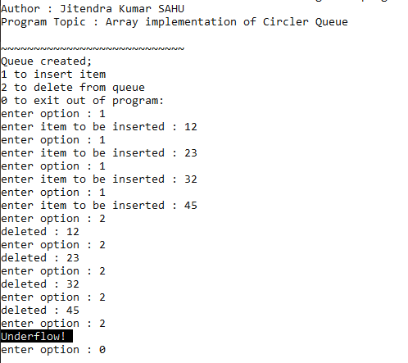

# Program 26. WAP to implement binary tree and perform preorder traversal using recursion/stack.

**Code:**   
#include <stdio.h>

#include <stdlib.h>

#include "intro.c"

typedef struct node node;

struct node {

int data;

node *left;

node *right;

};

node *createNode(int data) {

node *newNode = (node *)malloc(sizeof(node));

if (newNode == NULL) exit(1);

newNode->data = data;

newNode->left = newNode->right = NULL;

}

void preOrder(node *root) {

if (root == NULL) return;

printf("%d ", root->data);

preOrder(root->left);

preOrder(root->right);

}

int main() {

printIntro("binary tree and pre-order traversal using recursion");

node *root = NULL;

node *n1 = createNode(1);

node *n2 = createNode(5);

node *n3 = createNode(6);

node *n4 = createNode(45);

node *n5 = createNode(67);

node *n6 = createNode(66);

node *n7 = createNode(81);

root = n1;

root->left = n2;

root->right = n3;

n2->left = n4;

n2->right = n5;

n3->left = n6;

n3->right = n7;

printf("pre-order traversal of binary tree : ");

preOrder(root);

return 0;

}  
 **Output:**

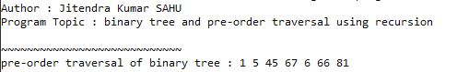

# Program 27. WAP to implement binary tree and perform inorder traversal using recursion/stack.

**Code:**   
#include <stdio.h>

#include <stdlib.h>

#include "intro.c"

typedef struct node node;

struct node {

int info;

node *left;

node *right;

};

node *createNode(int info) {

node *newNode = (node *)malloc(sizeof(node));

if (newNode == NULL) exit(1);

newNode->info = info;

newNode->left = newNode->right = NULL;

}

void inorder(node *root) {

if (root == NULL) return;

inorder(root->left);

printf("%d ", root->info);

inorder(root->right);

}

int main() {

printIntro("binary tree and in-order traversal using recursion");

node *n1 = createNode(1);

node *n2 = createNode(5);

node *n3 = createNode(6);

node *n4 = createNode(45);

node *n5 = createNode(67);

node *n6 = createNode(66);

node *n7 = createNode(81);

node *root = n1;

root->left = n2;

root->right = n3;

n2->left = n4;

n2->right = n5;

n3->left = n6;

n3->right = n7;

printf("in-order traversal of binary tree : ");

inorder(root);

printf("\n");

}

**Output:**

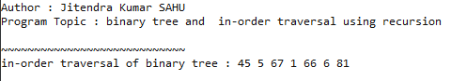

# Program 28. WAP to implement binary tree and perform postorder traversal using recursion/stack.

**Code:**   
#include <stdio.h>

#include <stdlib.h>

#include "intro.c"

typedef struct node node;

struct node {

int info;

node *left;

node *right;

};

node *createNode(int info) {

node *newNode = (node *)malloc(sizeof(node));

if(newNode==NULL) exit(1) ;

newNode->info = info;

newNode->left = newNode->right = NULL;

}

void postOrder(node *root) {

if (root == NULL) return;

postOrder(root->left);

postOrder(root->right);

printf("%d ", root->info);

}

int main() {

printIntro("binary tree and post-order traversal using recursion");

node *root = NULL;

node *n1 = createNode(1);

node *n2 = createNode(5);

node *n3 = createNode(6);

node *n4 = createNode(45);

node *n5 = createNode(67);

node *n6 = createNode(66);

node *n7 = createNode(81);

root = n1;

root->left = n2;

root->right = n3;

n2->left = n4;

n2->right = n5;

n3->left = n6;

n3->right = n7;

printf("post order traversal of binary tree : ") ;

postOrder(root);

printf("\n");

return 0;

}

**Output:**

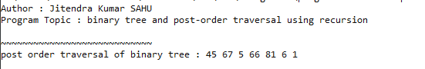

# Program 29. WAP to implement Linear search algorithm.

**Code:**   
#include <stdio.h>

#include "intro.c"

void search(int key, int arr[], int l) {

for (int i = 0; i < l; i++) {

if (key == arr[i]) {

printf("found %d at %d index\n", key, i);

return;

}

}

printf("element not found\n");

}

int main() {

printIntro("Topic");

int key, n;

printf("enter number of element in array : ");

scanf("%d", &n);

int arr[n];

printf("enter elements : \n");

for (int i = 0; i < n; i++) {

printf("enter element %d : ", (i + 1));

scanf("%d", &arr[i]);

}

printf("all items are inserted!\n");

printf("enter item to be searched : ");

scanf("%d", &key);

search(key, arr, n);

return 0;

}

**Output:**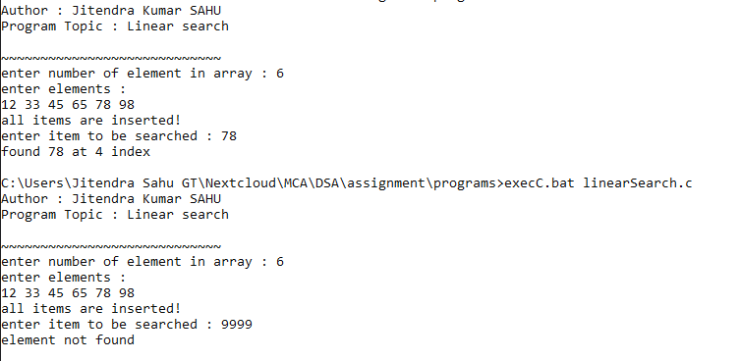

# Program 30. WAP to implement Binary search algorithm.

**Code:**   
#include <stdio.h>

#include "intro.c"

// *** there is problem in binary search algo

// larger item which are not in the list are shown to be at

// at 9th index YOU HAVE to FIX it

int search(int *arr, int n, int key) {

int start = 0, end = n, mid;

while (start <= end) {

mid = (start + end) / 2;

int currentValue = arr[mid];

if (currentValue == key)

return mid;

else if (currentValue < key)

start = mid + 1;

else

end = mid - 1;

}

return -1;

}

int main() {

printIntro("Linear search");

int key;

const int n = 9;

int arr[] = {11, 12, 13, 14, 15, 16, 17, 18, 19};

printf("The array is : ");

for (size_t i = 0; i < n; i++) {

printf("%d ", arr[i]);

}

printf("enter item to be searched : ");

scanf("%d", &key);

int res = search(arr, n-1, key);

if (res == -1) {

printf("element not found\n");

} else {

printf("element %d found at index %d\n", key, res);

}

return 0;

}

// int searchRecursivly(int *arr, int key, int start , int end){

// if (start >= end) return -1 ;

// int mid = ( start + end ) / 2 ;

// int currVlu = arr[mid] ;

// if (currVlu == key) return mid ;

// else if(currVlu < key )return searchRecursivly(arr,key,start+1,end) ;

// else return searchRecursivly(arr,key,start,end-1) ;

// }

**Output:**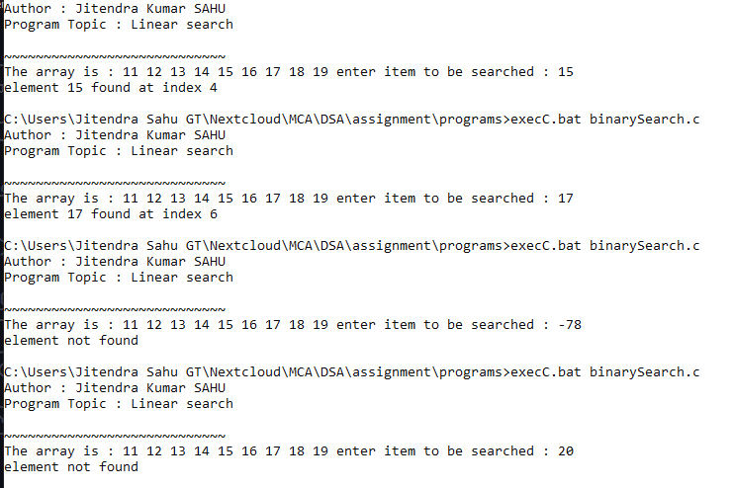

# Program 31. WAP to implement Bubble sort.

**Code:**   
#include <stdio.h>

#include "intro.c"

void bubbleSort(int arr[], int n) {

for (size_t i = 0; i < n - 1; i++) {

for (size_t j = 0; j < n - i - 1; j++) {

if (arr[j] > arr[j + 1]) {

// swap item

int temp = arr[j];

arr[j] = arr[j + 1];

arr[j + 1] = temp;

}

}

}

}

int main() {

printIntro("Bubble sort implementation");

int n;

printf("enter the number of items in array : ");

scanf("%d", &n);

int arr[n];

printf("enter items of array : ");

for (size_t i = 0; i < n; i++) {

scanf("%d", &arr[i]);

}

bubbleSort(arr, n);

for (size_t i = 0; i < n; i++) {

printf("%d ", arr[i]);

}

printf("\n");

return 0;

}  
  **Output:**

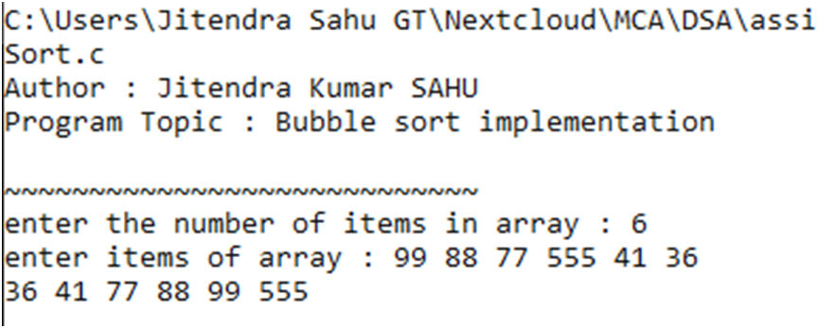

# Program 32. WAP to implement Insertion sort.

**Code:**   
#include <stdio.h>

#include "intro.c"

// Insertion Sort

void insertionSort(int arr[], int n) {

int i, key, j;

for (i = 1; i < n; i++) {

key = arr[i];

j = i - 1;

while (j >= 0 && arr[j] > key) {

arr[j + 1] = arr[j];

j = j - 1;

}

arr[j + 1] = key;

}

}

int main() {

printIntro("implementation of Insertion Sort");

int n;

printf("enter the number of items in array : ");

scanf("%d", &n);

int arr[n];

printf("enter items of array : ");

for (size_t i = 0; i < n; i++) {

scanf("%d", &arr[i]);

}

insertionSort(arr, n);

printf("Sorted array: ");

for (int i = 0; i < n; i++) printf("%d ", arr[i]);

printf("\n");

return 0;

}  
  **Output:**

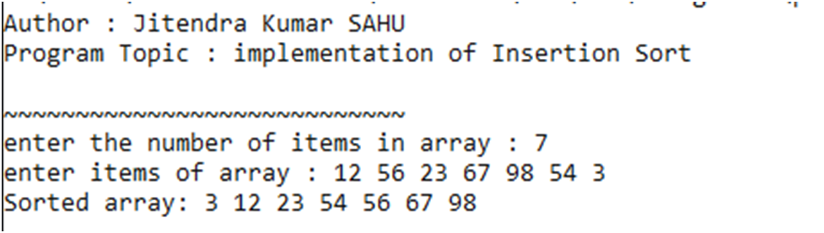

Program 33. WAP to implement Selection sort.

**Code:**   
#include <stdio.h>

#include "intro.c"

// Selection Sort

void selectionSort(int arr[], int n) {

int i, j, min_idx;

for (i = 0; i < n - 1; i++) {

min_idx = i;

for (j = i + 1; j < n; j++)

if (arr[j] < arr[min_idx])

min_idx = j;

int temp = arr[min_idx];

arr[min_idx] = arr[i];

arr[i] = temp;

}

}

int main() {

printIntro("implementation of Selection Sort");

int n;

printf("enter the number of items in array : ");

scanf("%d", &n);

int arr[n];

printf("enter items of array : ");

for (size_t i = 0; i < n; i++) {

scanf("%d", &arr[i]);

}

selectionSort(arr, n);

printf("Sorted array: ");

for (int i = 0; i < n; i++)

printf("%d ", arr[i]);

printf("\n");

return 0;

}  
  **Output:**

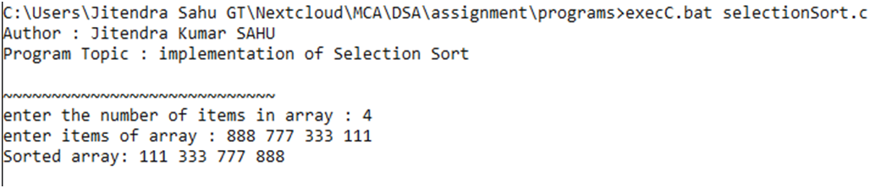

Program 34. WAP to implement Merge sort.

**Code:**   
#include <stdio.h>

#include "intro.c"

// Merge Sort

void merge(int arr[], int l, int m, int r) {

int i, j, k;

int n1 = m - l + 1;

int n2 = r - m;

int L[n1], R[n2];

for (i = 0; i < n1; i++)

L[i] = arr[l + i];

for (j = 0; j < n2; j++)

R[j] = arr[m + 1 + j];

i = 0;

j = 0;

k = l;

while (i < n1 && j < n2) {

if (L[i] <= R[j]) {

arr[k] = L[i];

i++;

} else {

arr[k] = R[j];

j++;

}

k++;

}

while (i < n1) {

arr[k] = L[i];

i++;

k++;

}

while (j < n2) {

arr[k] = R[j];

j++;

k++;

}

}

void mergeSort(int arr[], int l, int r) {

if (l < r) {

int m = l + (r - l) / 2;

mergeSort(arr, l, m);

mergeSort(arr, m + 1, r);

merge(arr, l, m, r);

}

}

int main() {

printIntro("implementation of Merge Sort");

int n;

printf("enter the number of items in array : ");

scanf("%d", &n);

int arr[n];

printf("enter items of array : ");

for (size_t i = 0; i < n; i++) {

scanf("%d", &arr[i]);

}

mergeSort(arr, 0, n - 1);

printf("Sorted array: ");

for (int i = 0; i < n; i++)

printf("%d ", arr[i]);

printf("\n");

return 0;

}  
  **Output:**

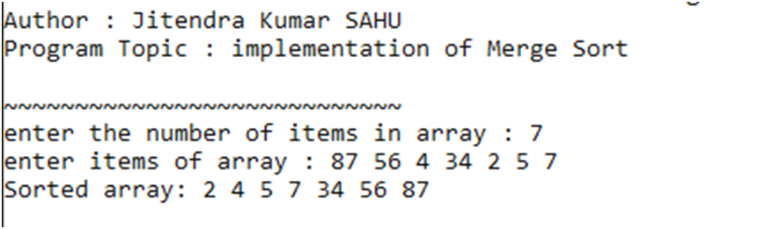

Program 35. WAP to implement Quick sort.

**Code:**  
 #include <stdio.h>

#include "intro.c"

// Quick Sort

int partition(int arr[], int low, int high) {

int pivot = arr[high];

int i = (low - 1);

for (int j = low; j <= high - 1; j++) {

if (arr[j] < pivot) {

i++;

int temp = arr[i];

arr[i] = arr[j];

arr[j] = temp;

}

}

int temp = arr[i + 1];

arr[i + 1] = arr[high];

arr[high] = temp;

return (i + 1);

}

void quickSort(int arr[], int low, int high) {

if (low < high) {

int pi = partition(arr, low, high);

quickSort(arr, low, pi - 1);

quickSort(arr, pi + 1, high);

}

}

int main() {

printIntro("implementation of Quick Sort");

int n;

printf("enter the number of items in array : ");

scanf("%d", &n);

int arr[n];

printf("enter items of array : ");

for (size_t i = 0; i < n; i++) {

scanf("%d", &arr[i]);

}

quickSort(arr, 0, n - 1);

printf("Sorted array: ");

for (int i = 0; i < n; i++) printf("%d ", arr[i]);

printf("\n");

return 0;

}  
  **Output:**

