BANK LOAN APPROVAL & RISK ANALYSIS
Name : Jitendra Walunj

Step 1 :
Importing all the libraries and the dataset.
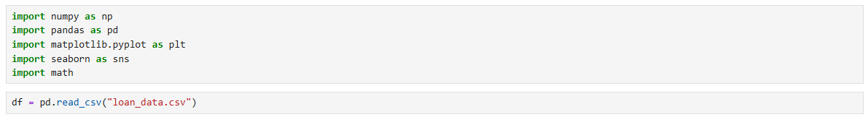

Step 2 :
Data cleaning : handling all the null values.
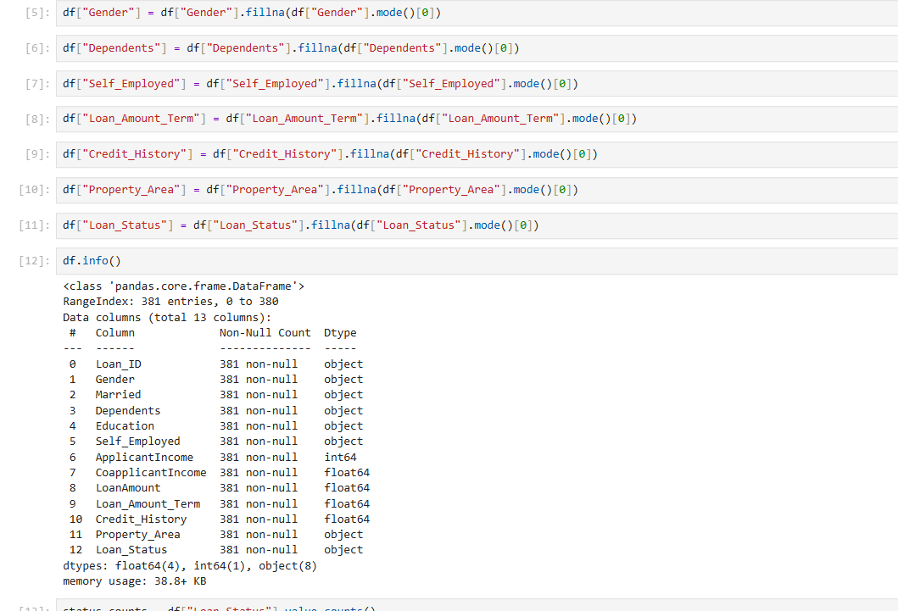

Step 3 :
Exploratory Data Analysis.

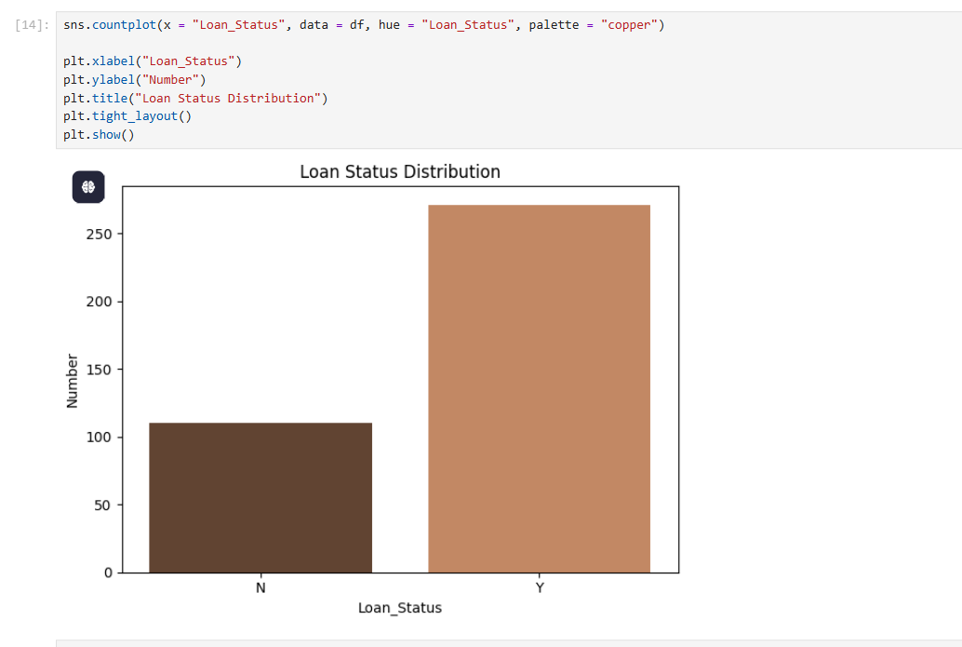

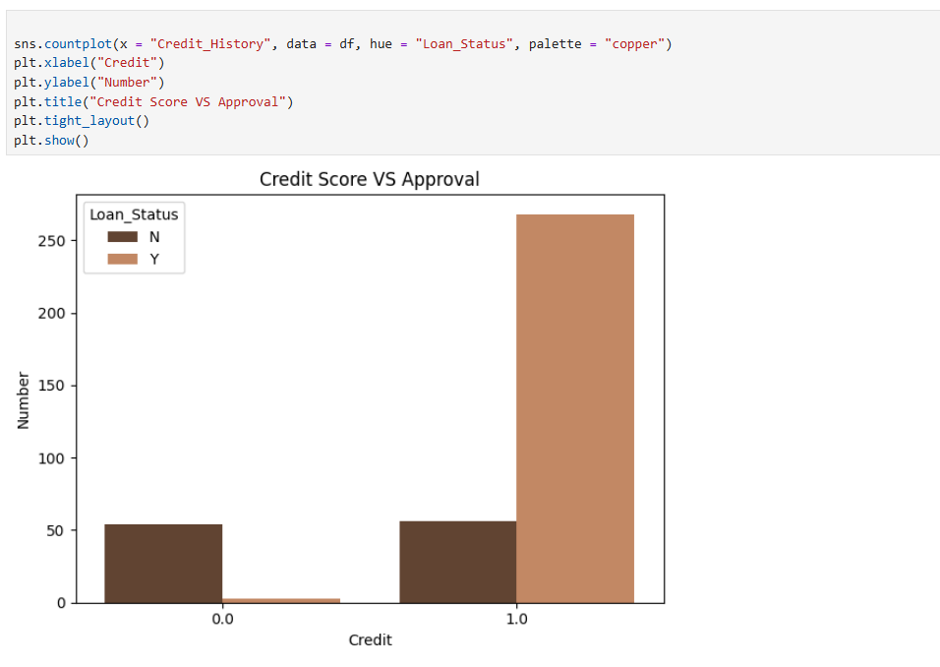
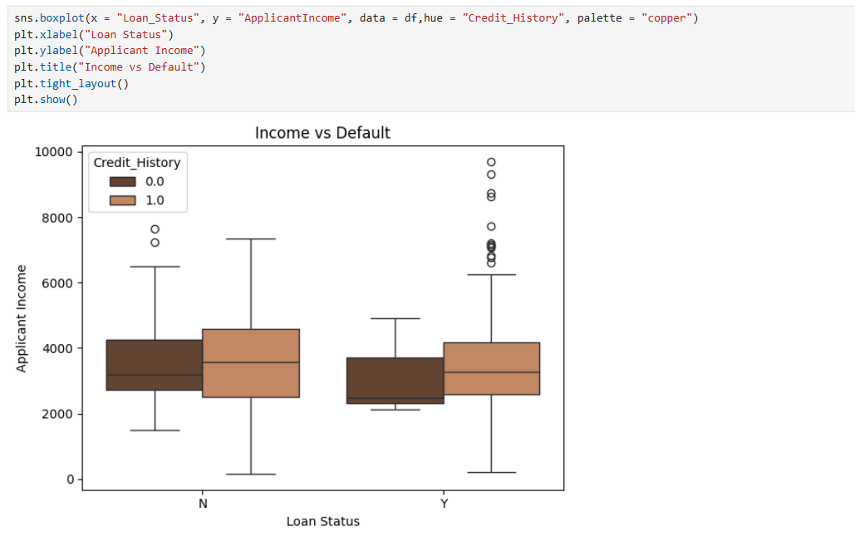
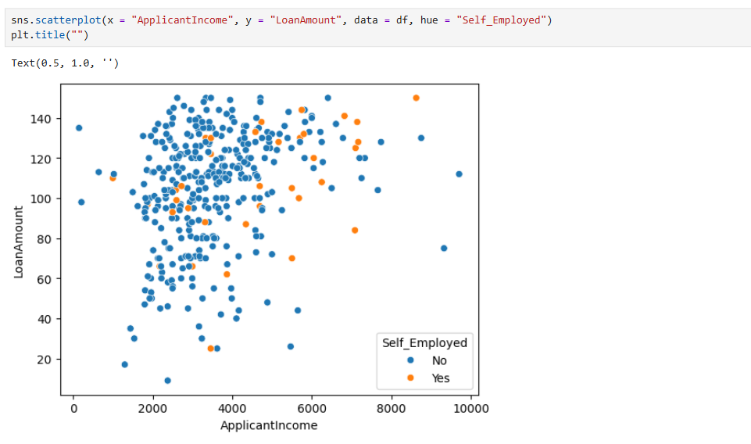

Step 4 :
combining

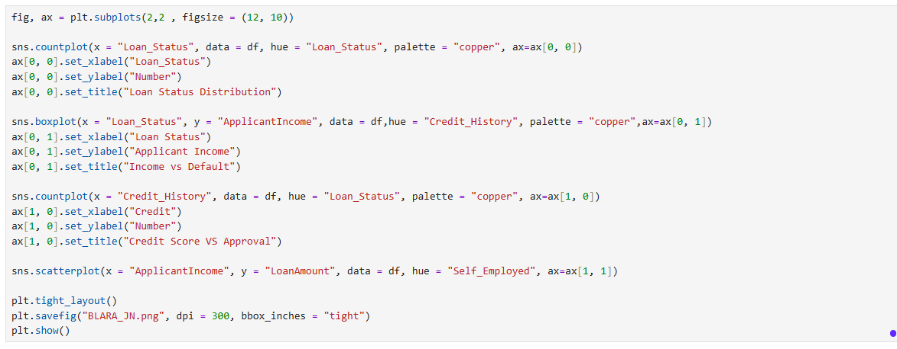

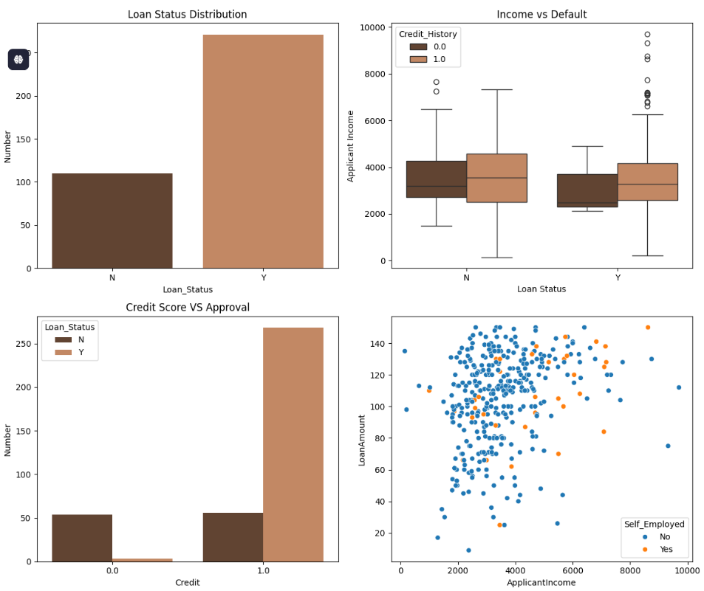

Step 5 :
Dashboard creation.
