FINANCIAL EXPENSE ANALYSIS & FORECASTING
Name : Jitendra Walunj

Step 1 :
Importing all the libraries and the dataset.
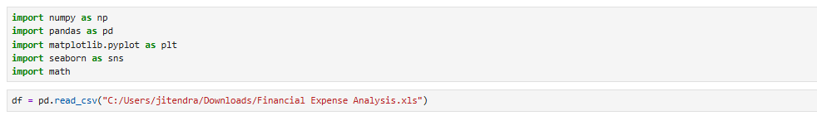

Step 2 :
Data cleaning : handling all the null values.
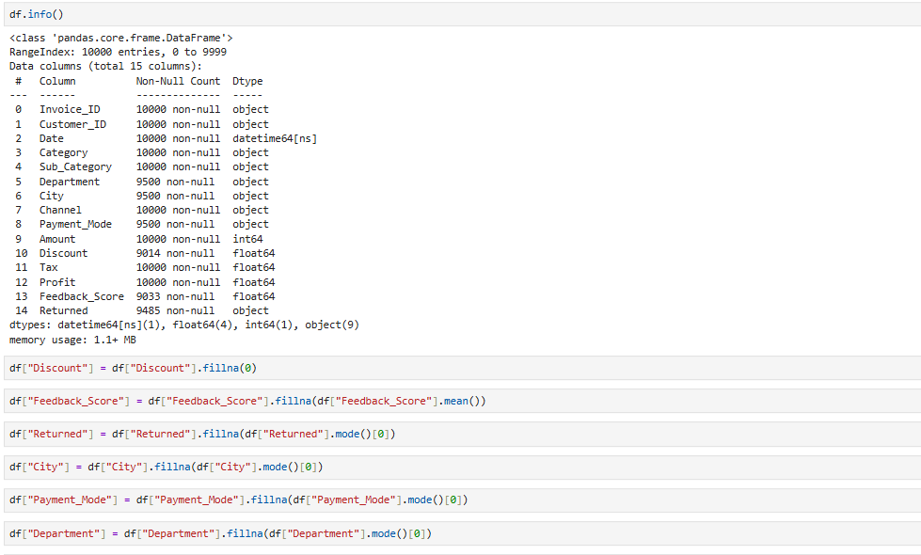

Step 3 :
Adding required columns .
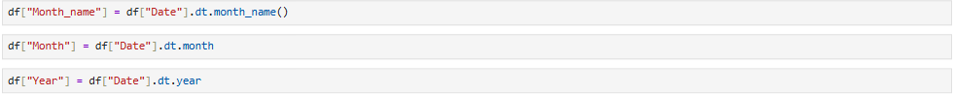

Step 4 :
Exploratory Data Analysis.
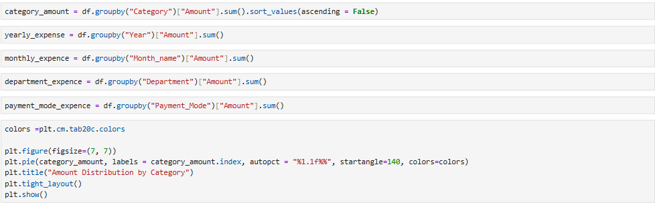
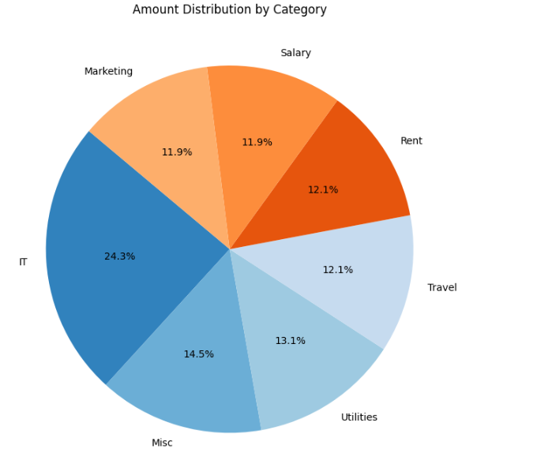
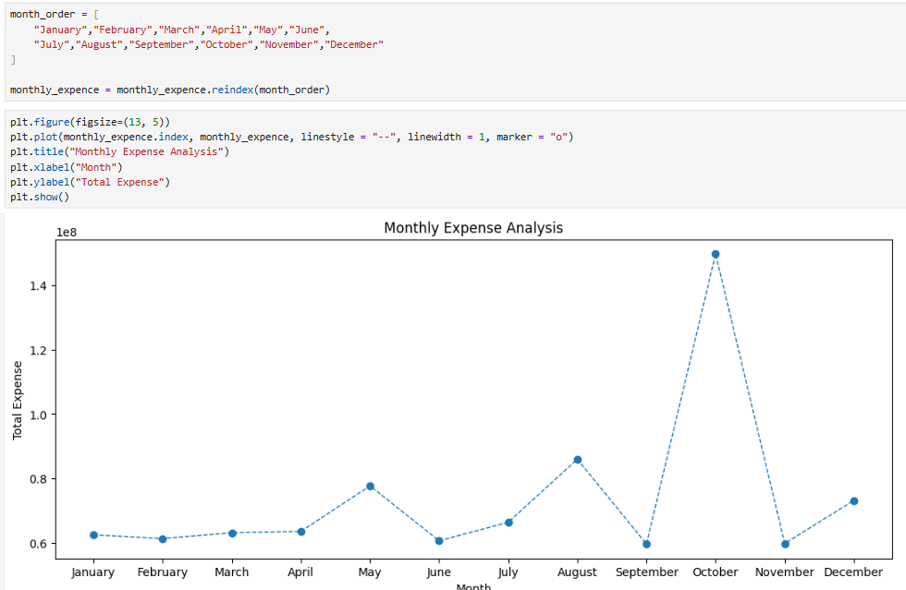

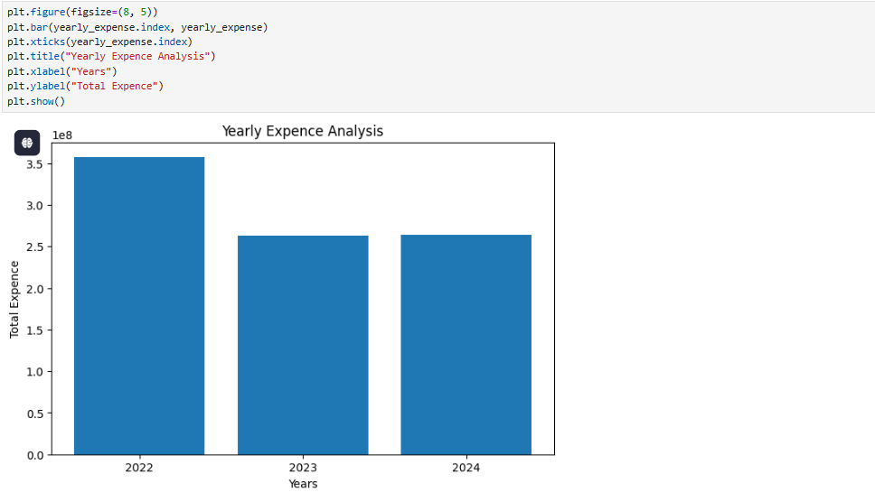
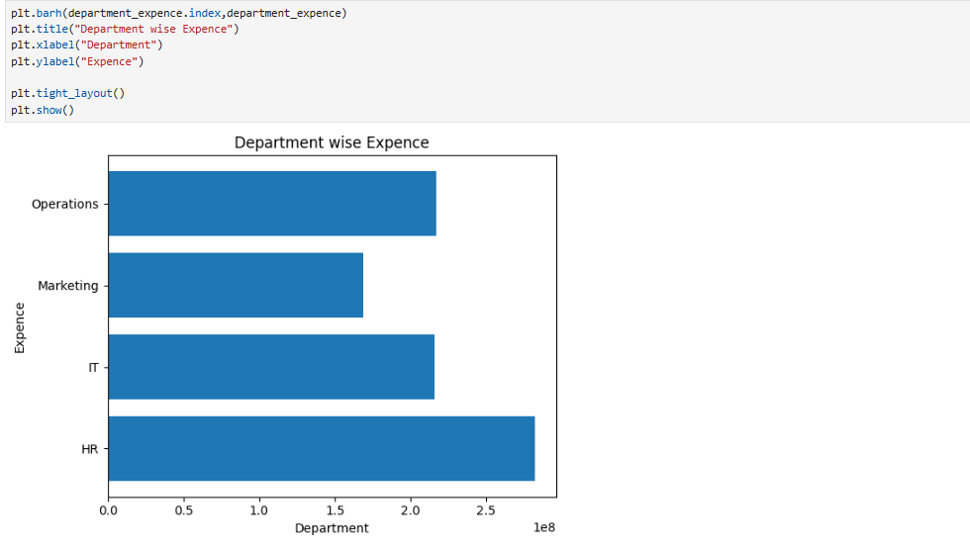
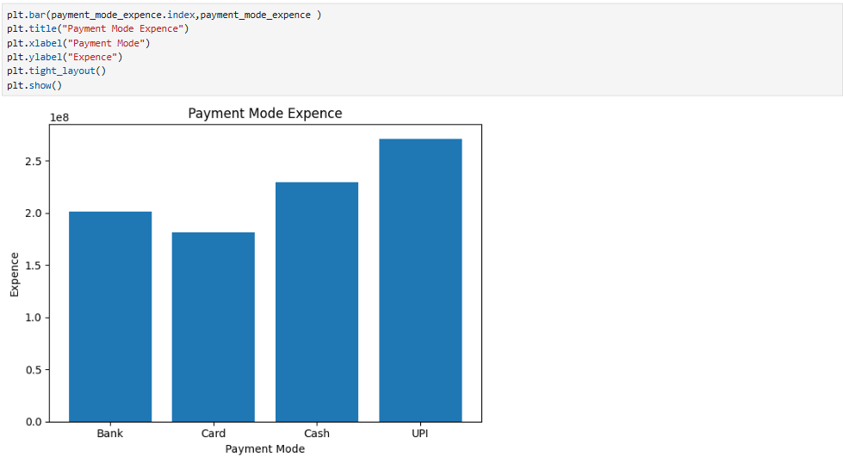

Step 5 :
Forecasting.
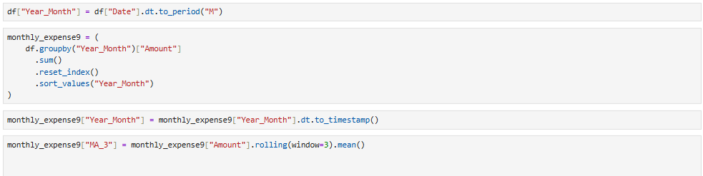

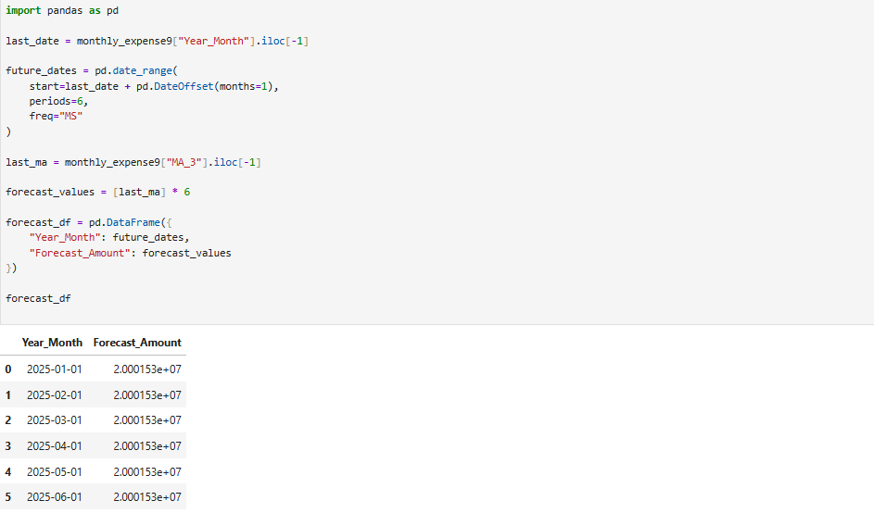
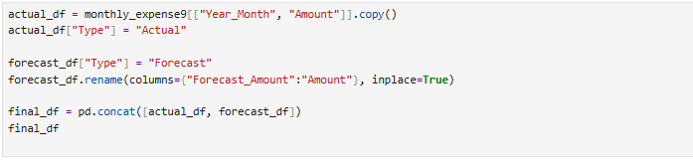

Step 6 :
Dashboard creation.
