**Steps to Install Docker in Windows 10 Home**

1. 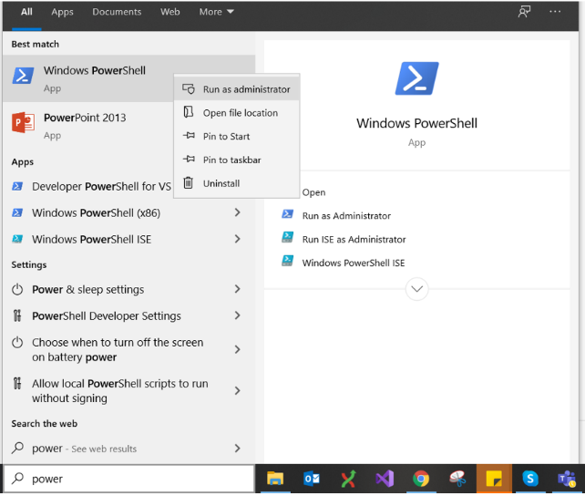Run Windows PoserShell in Administrator Mode.
2. Run below command to enabling the Virtual Machine Platform.

**dism.exe /online /enable-feature /featurename:VirtualMachinePlatform /all /norestart**

1. Run below command to enabling the Windows Subsystem for Linux.

**dism.exe /online /enable-feature /featurename:Microsoft-Windows-Subsystem-Linux /all /norestart**

1. 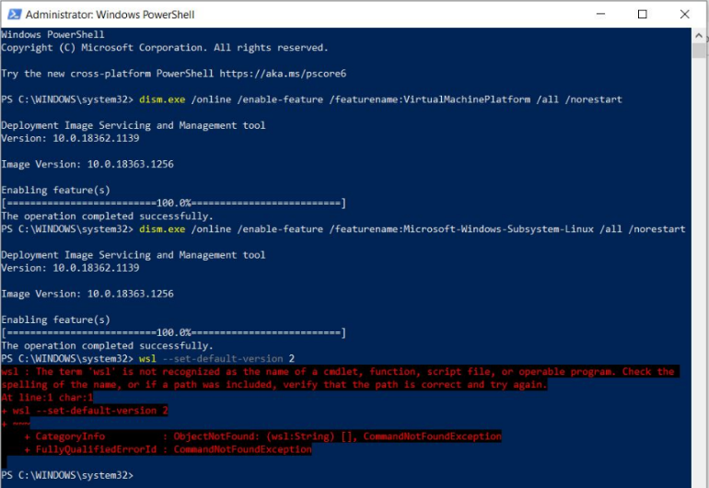Restart the computer after the 3rd step then move forward otherwise you will get an error as shown in image.
2. 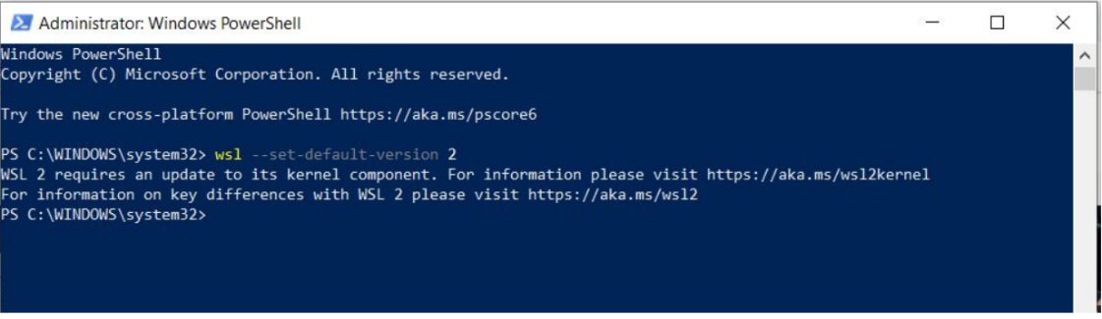After restart again open the Windows PoserShell in Administrator Mode.
3. Run the command “wsl --set-default-version 2” you will see below message.
4. 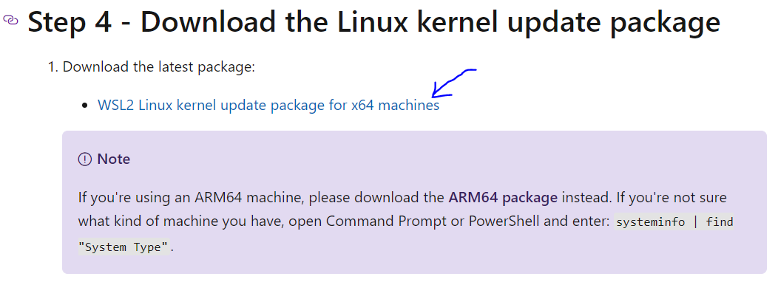Visit the given URL <https://aka.ms/wsl2kernel> and download the “[WSL2 Linux kernel update package for x64 machines](https://wslstorestorage.blob.core.windows.net/wslblob/wsl_update_x64.msi)
5. Run the downloaded “wsl_update_x64.msi” file.
6. 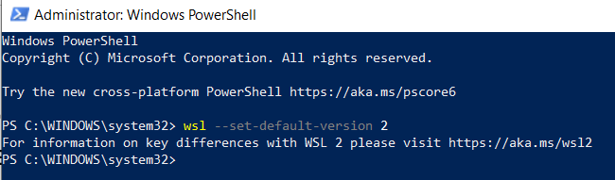Again run the command “wsl --set-default-version 2”