const details = {

    name: "Jithendra",

   age: 21,

  company: 'IBM',

    skills: ["C","Python","html","css"]

}

console.log(details.name)  // get the value using object name & property name

console.log(details.age)

console.log(details.skills)

const {name, age} = details // objects destructring

details.email = "jithendravenkat@gmail.com"  // we can add properties to the object

details.offers = ["apple","google"]

console.log(details)

console.log(details)

console.log(name)

console.log(age)

const todos = [

    {

        id:1,

        text: "take out of trash",

        isCompleted : true

    },

    {

        id:2,

        text: "take out of trash",

        isCompleted : false

    },

    {

        id:3,

        text: "take out of trash",

        isCompleted : true

    }

]; // we can pass objects into the arrays

console.log(todos[1].text)

const jsondata = JSON.stringify(todos)

console.log(jsondata)

//for(let i=0;i<todos.length;i++) {

 //   if(todos[i].isCompleted == true) {

   //     console.log(todos[i].id)

   // }

//}

for (i=0;i<todos.length; i++) {

    console.log(todos[i])

}

//forEach, map, filter

//map allows to create a new array from the existing array

//filter allows to create a new array based on the codition

todos.forEach(function(todo){  // we can pass any number of parameters inside this function it is a call back funtion

    console.log(todo)

})

const todotext = todos.map(function(todo){

    return todo.text

})

const tocompleted = todos.filter(function(todo) {

    return todo.isCompleted == true

}).map(function(todo){

    return todo.text;

})

console.log(tocompleted)

// In js if we double it wont check the data type

const addnum = ((num1,num2)=> {

    return num1+num2

})

console.log(addnum(1,2))

class Person {

    constructor(name,age){

        this.name = name

        this.age = age

    }

    getName(){

        return `${this.name}`

    }

    getAge() {

        return `${this.age}`

    }

}

const per = new Person("Jithendra",21)

console.log(per.getName())

console.log(per.getAge())

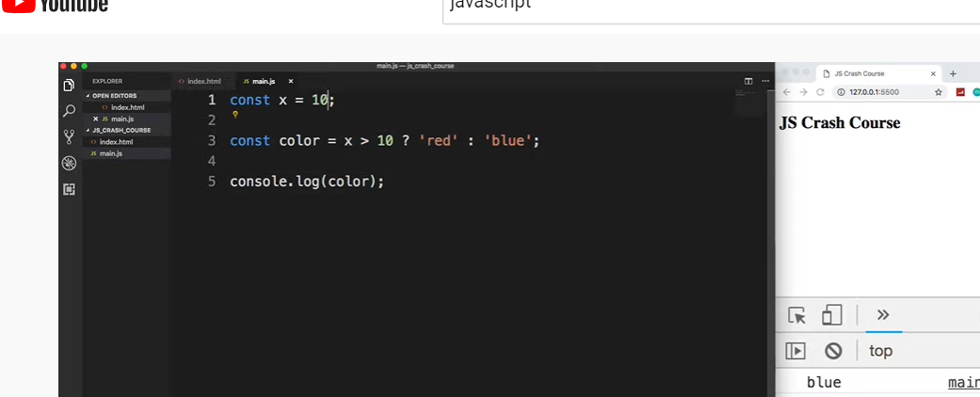

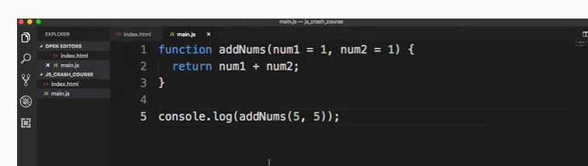

ES6 way

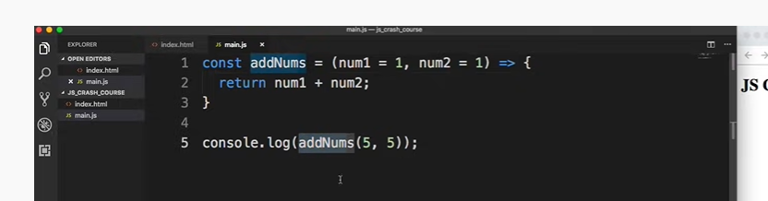

// we can get the html elements by using properties and store them in variable

//single element

console.log(document.getElementById("my-form"));

//we can select any class with requry selector

console.log(document.querySelector("h1"))

//multiple elements

const items = document.querySelectorAll(".item")

items.forEach((item) => {

    console.log(item)

})

const ul = document.querySelector('.items')

console.log(ul.children[1].innerText = 'hey')

const bttn = document.querySelector('.btn')

bttn.addEventListener('click',(e)=> {

    e.preventDefault()

    console.log(ul.children[2].innerText = 'hey')

})