# FOOD Sales KPI’s Queries

## Total Revenue:

SELECT SUM(total_price) as Total_Revenue from pizza_sales;

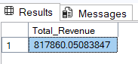

## Average Order Value:

Select SUM(total_price)/COUNT(distinct order_id) as Avg_Order_Value From pizza_sales;

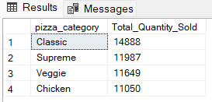

## Total Pizza Sold:

Select SUM(quantity) AS Total_Pizza_Sold From pizza_sales;

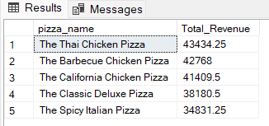

## Total Order:

Select Count(DISTINCT order_id) AS Total_Orders From pizza_sales;

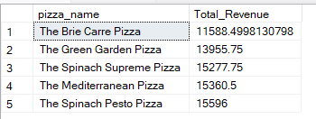

## Average Pizza’s Per Order:

SELECT CAST(SUM(quantity) AS Decimal(10,2)) /  
CAST(COUNT (DISTINCT order_id) AS Decimal(10,2))AS Average_Pizzas_Per_Order From pizza_sales

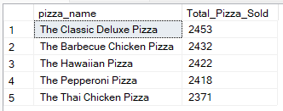

## C. Monthly Trend for Orders

select DATENAME(MONTH, order_date) as Month_Name, COUNT(DISTINCT order_id) as Total_Orders  
from pizza_sales  
GROUP BY DATENAME(MONTH, order_date)Output

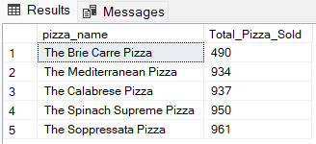

## D. % of Sales by Pizza Category

SELECT pizza_category, CAST(SUM(total_price) AS DECIMAL(10,2)) as total_revenue,  
CAST(SUM(total_price) * 100 / (SELECT SUM(total_price) from pizza_sales) AS DECIMAL(10,2)) AS PCT  
FROM pizza_sales  
GROUP BY pizza_category

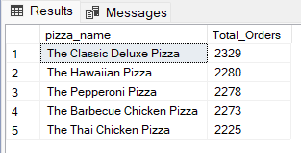

## E. % of Sales by Pizza Size

SELECT pizza_size, CAST(SUM(total_price) AS DECIMAL(10,2)) as total_revenue,  
CAST(SUM(total_price) * 100 / (SELECT SUM(total_price) from pizza_sales) AS DECIMAL(10,2)) AS PCT  
FROM pizza_sales  
GROUP BY pizza_size  
ORDER BY pizza_size

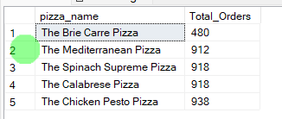

## F. Total Pizzas Sold by Pizza Category

SELECT pizza_category, SUM(quantity) as Total_Quantity_Sold  
FROM pizza_sales  
WHERE MONTH(order_date) = 2  
GROUP BY pizza_category  
ORDER BY Total_Quantity_Sold DESC

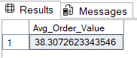

## G. Top 5 Pizzas by Revenue

SELECT Top 5 pizza_name, SUM(total_price) AS Total_Revenue  
FROM pizza_sales  
GROUP BY pizza_name  
ORDER BY Total_Revenue DESC

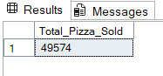

## H. Bottom 5 Pizzas by Revenue

SELECT Top 5 pizza_name, SUM(total_price) AS Total_Revenue  
FROM pizza_sales  
GROUP BY pizza_name  
ORDER BY Total_Revenue ASC

## I. Top 5 Pizzas by Quantity

SELECT Top 5 pizza_name, SUM(quantity) AS Total_Pizza_Sold  
FROM pizza_sales  
GROUP BY pizza_name  
ORDER BY Total_Pizza_Sold DESC

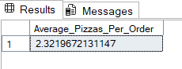

## J. Bottom 5 Pizzas by Quantity

SELECT TOP 5 pizza_name, SUM(quantity) AS Total_Pizza_Sold  
FROM pizza_sales  
GROUP BY pizza_name  
ORDER BY Total_Pizza_Sold ASC

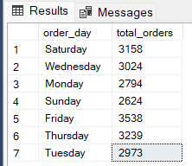

## K. Top 5 Pizzas by Total Orders

SELECT Top 5 pizza_name, COUNT(DISTINCT order_id) AS Total_Orders  
FROM pizza_sales  
GROUP BY pizza_name  
ORDER BY Total_Orders DESC

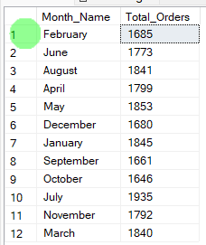

## L. Borrom 5 Pizzas by Total Orders

SELECT Top 5 pizza_name, COUNT(DISTINCT order_id) AS Total_Orders  
FROM pizza_sales  
GROUP BY pizza_name  
ORDER BY Total_Orders ASC  
SELECT Top 5 pizza_name, COUNT(DISTINCT order_id) AS Total_Orders  
FROM pizza_sales  
WHERE pizza_category = 'Classic'  
GROUP BY pizza_name  
ORDER BY Total_Orders ASC

