Assignment_2

Jitesh Rawat

2/4/2021

library(tidyverse)

## -- Attaching packages --------------------------------------- tidyverse 1.3.0 --

## v ggplot2 3.3.3 v purrr 0.3.4  
## v tibble 3.0.4 v dplyr 1.0.2  
## v tidyr 1.1.2 v stringr 1.4.0  
## v readr 1.4.0 v forcats 0.5.0

## -- Conflicts ------------------------------------------ tidyverse_conflicts() --  
## x dplyr::filter() masks stats::filter()  
## x dplyr::lag() masks stats::lag()

idata = as_tibble(iris)#loading iris dataset  
head(idata)#taking a look at data

## # A tibble: 6 x 5  
## Sepal.Length Sepal.Width Petal.Length Petal.Width Species  
## <dbl> <dbl> <dbl> <dbl> <fct>   
## 1 5.1 3.5 1.4 0.2 setosa   
## 2 4.9 3 1.4 0.2 setosa   
## 3 4.7 3.2 1.3 0.2 setosa   
## 4 4.6 3.1 1.5 0.2 setosa   
## 5 5 3.6 1.4 0.2 setosa   
## 6 5.4 3.9 1.7 0.4 setosa

plot = ggplot(data = idata, aes(y = Sepal.Length, x = factor(Species),col= Sepal.Width))#creating ggplot   
plot2= ggplot(data = idata, aes(y = Petal.Length, x = factor(Species),col= Petal.Width))

plot+geom_point()#the use of geom_point() function to plot the datas sepal length/sepalwidth

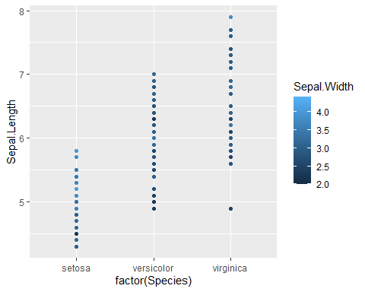

plot+geom_density()

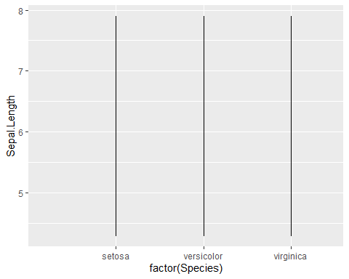

plot2+geom_density()#Ploting density

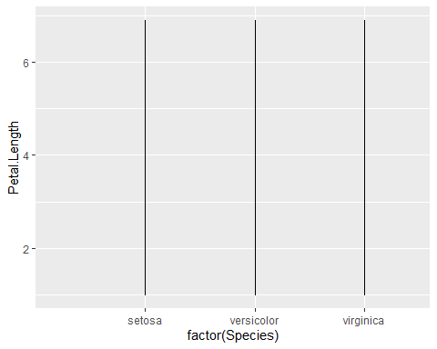

ggplot(idata, aes(x= Sepal.Length))+geom_histogram()#representing data in terms of histograms

## `stat_bin()` using `bins = 30`. Pick better value with `binwidth`.

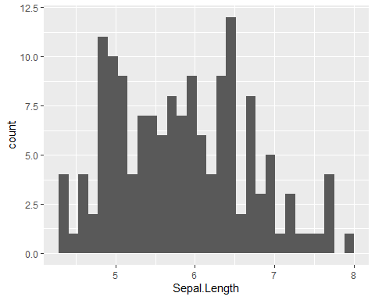

plot+geom_boxplot()#representing data in terms of boxplot

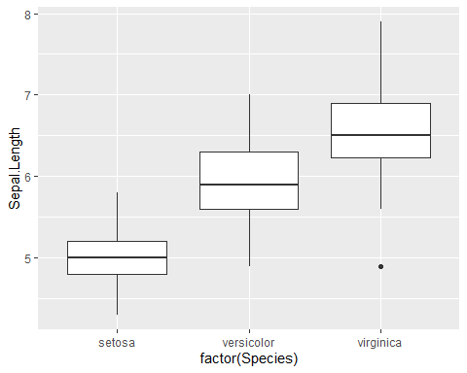

p <- ggplot(iris, aes(sample = Sepal.Width))  
p + geom_qq() + stat_qq_line()#geom qq for checking the normality of data

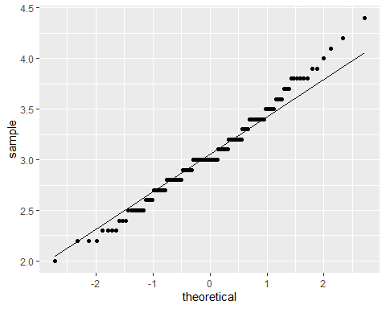

q <- plot+geom_point()  
q + facet_grid(Species~.)#faceting using facet grid

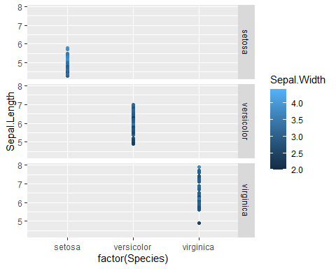

q+facet_wrap(vars(Species))#facteing using facet wrap

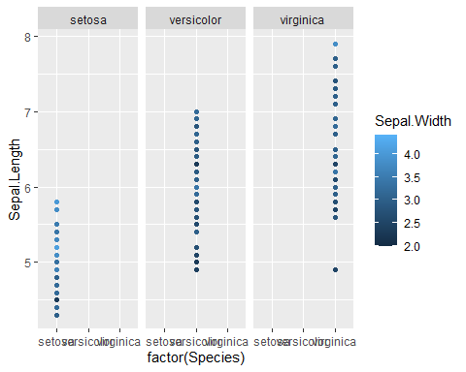

plot + stat_density()#plotting the statistical density of plot

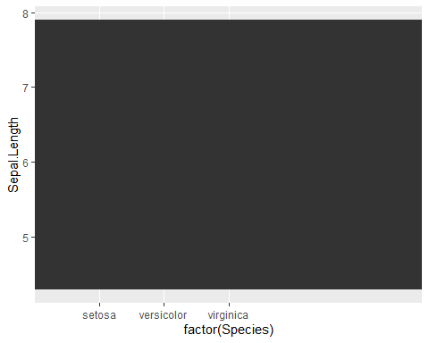

#applying logarithm to coorodinates  
plotx <- ggplot(iris, aes(x <- Sepal.Length,y <- Sepal.Width)) + geom_point()  
plotx + scale_x_log10()

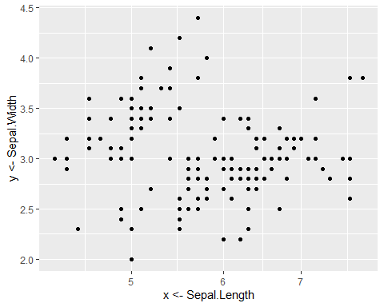

plotx + scale_y_log10()

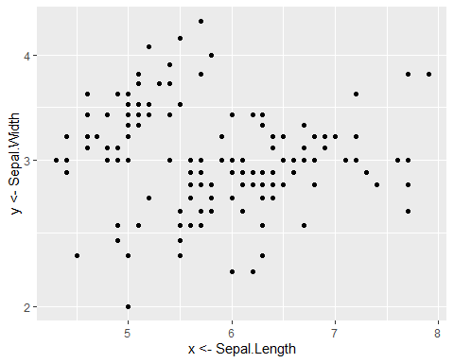

ggplot(data = idata,aes(x=Sepal.Length,y=Species,col = Sepal.Width))+geom_point()+scale_x_log10()

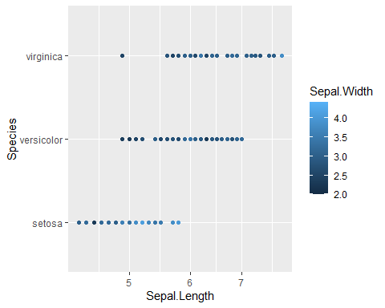

ggplot(data = idata,aes(y=Petal.Length,x=Species,col = Petal.Width))+geom_point()+scale_y_log10()

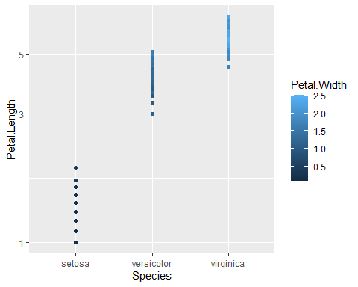

#applying square root on coordinate axes  
plotx+scale_x_sqrt()

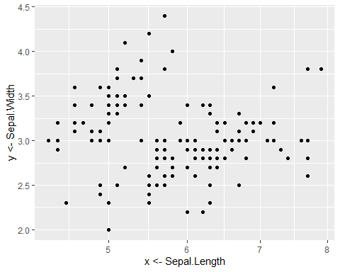

plotx+scale_y_sqrt()

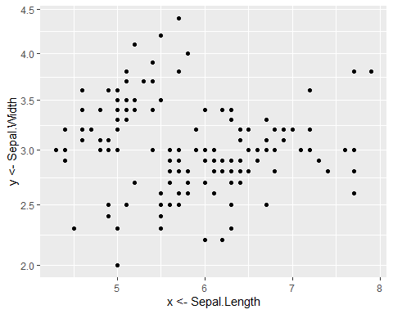

plotx + theme_classic()#theming

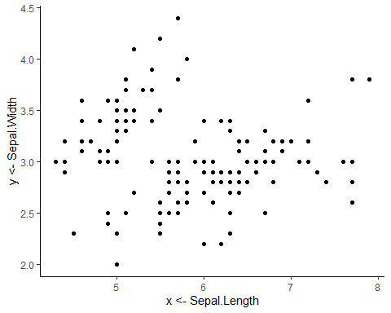

plot + geom_point() + theme_bw()#theming

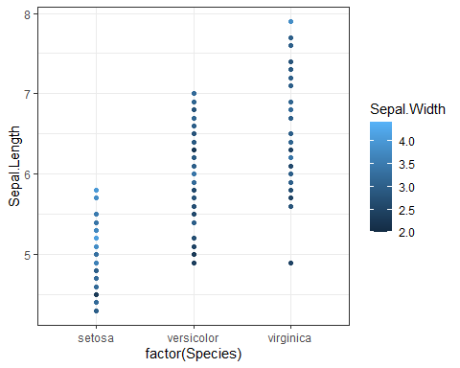

plotx + scale_x_continuous()#scaling but his is default scaling that geom point or ggplot applies

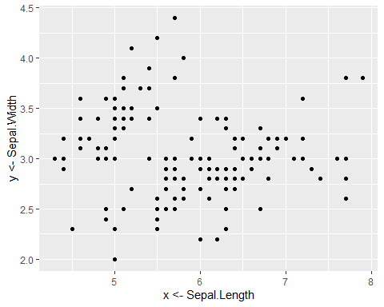

plotx + xlim(NA,8)#applying limitation in x axis up to 8 which covers entire data

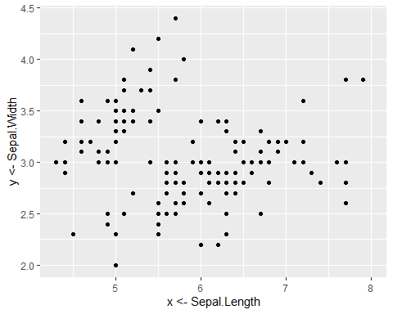

plotx + scale_y_continuous()#scaling the y axis



plotx+ ylim(1,5)#applying the limit to y axis

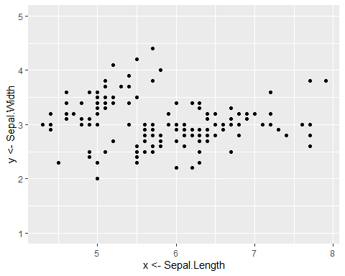

plotx+ coord_flip()

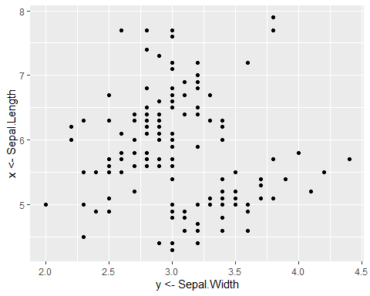

plotx+ labs(x= "Sepal length",y= "Sepal width")#applying label using label function

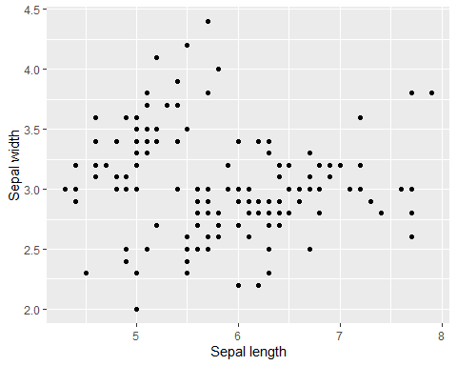

plotx+ ggtitle("Plot of sepal length and width")#giving title to plot

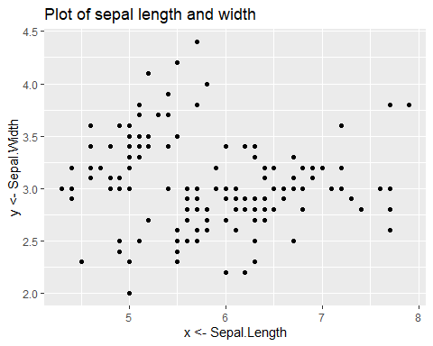

plotx + xlab("Sepal Length") + ylab("Sepal Width")#labelling

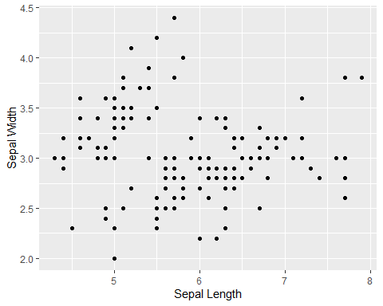

plotx+coord_cartesian(expand = TRUE)#it is often used to zoom plot



ggplot(data = idata,aes(x=Petal.Width, y=Petal.Length, position_dodge(width= NULL)))+ geom_point()#

