Assignment_2

Jitesh Rawat

1/29/2021

library("tidyverse")

## -- Attaching packages --------------------------------------- tidyverse 1.3.0 --

## v ggplot2 3.3.3 v purrr 0.3.4  
## v tibble 3.0.4 v dplyr 1.0.2  
## v tidyr 1.1.2 v stringr 1.4.0  
## v readr 1.4.0 v forcats 0.5.0

## -- Conflicts ------------------------------------------ tidyverse_conflicts() --  
## x dplyr::filter() masks stats::filter()  
## x dplyr::lag() masks stats::lag()

datasets::iris

## Sepal.Length Sepal.Width Petal.Length Petal.Width Species  
## 1 5.1 3.5 1.4 0.2 setosa  
## 2 4.9 3.0 1.4 0.2 setosa  
## 3 4.7 3.2 1.3 0.2 setosa  
## 4 4.6 3.1 1.5 0.2 setosa  
## 5 5.0 3.6 1.4 0.2 setosa  
## 6 5.4 3.9 1.7 0.4 setosa  
## 7 4.6 3.4 1.4 0.3 setosa  
## 8 5.0 3.4 1.5 0.2 setosa  
## 9 4.4 2.9 1.4 0.2 setosa  
## 10 4.9 3.1 1.5 0.1 setosa  
## 11 5.4 3.7 1.5 0.2 setosa  
## 12 4.8 3.4 1.6 0.2 setosa  
## 13 4.8 3.0 1.4 0.1 setosa  
## 14 4.3 3.0 1.1 0.1 setosa  
## 15 5.8 4.0 1.2 0.2 setosa  
## 16 5.7 4.4 1.5 0.4 setosa  
## 17 5.4 3.9 1.3 0.4 setosa  
## 18 5.1 3.5 1.4 0.3 setosa  
## 19 5.7 3.8 1.7 0.3 setosa  
## 20 5.1 3.8 1.5 0.3 setosa  
## 21 5.4 3.4 1.7 0.2 setosa  
## 22 5.1 3.7 1.5 0.4 setosa  
## 23 4.6 3.6 1.0 0.2 setosa  
## 24 5.1 3.3 1.7 0.5 setosa  
## 25 4.8 3.4 1.9 0.2 setosa  
## 26 5.0 3.0 1.6 0.2 setosa  
## 27 5.0 3.4 1.6 0.4 setosa  
## 28 5.2 3.5 1.5 0.2 setosa  
## 29 5.2 3.4 1.4 0.2 setosa  
## 30 4.7 3.2 1.6 0.2 setosa  
## 31 4.8 3.1 1.6 0.2 setosa  
## 32 5.4 3.4 1.5 0.4 setosa  
## 33 5.2 4.1 1.5 0.1 setosa  
## 34 5.5 4.2 1.4 0.2 setosa  
## 35 4.9 3.1 1.5 0.2 setosa  
## 36 5.0 3.2 1.2 0.2 setosa  
## 37 5.5 3.5 1.3 0.2 setosa  
## 38 4.9 3.6 1.4 0.1 setosa  
## 39 4.4 3.0 1.3 0.2 setosa  
## 40 5.1 3.4 1.5 0.2 setosa  
## 41 5.0 3.5 1.3 0.3 setosa  
## 42 4.5 2.3 1.3 0.3 setosa  
## 43 4.4 3.2 1.3 0.2 setosa  
## 44 5.0 3.5 1.6 0.6 setosa  
## 45 5.1 3.8 1.9 0.4 setosa  
## 46 4.8 3.0 1.4 0.3 setosa  
## 47 5.1 3.8 1.6 0.2 setosa  
## 48 4.6 3.2 1.4 0.2 setosa  
## 49 5.3 3.7 1.5 0.2 setosa  
## 50 5.0 3.3 1.4 0.2 setosa  
## 51 7.0 3.2 4.7 1.4 versicolor  
## 52 6.4 3.2 4.5 1.5 versicolor  
## 53 6.9 3.1 4.9 1.5 versicolor  
## 54 5.5 2.3 4.0 1.3 versicolor  
## 55 6.5 2.8 4.6 1.5 versicolor  
## 56 5.7 2.8 4.5 1.3 versicolor  
## 57 6.3 3.3 4.7 1.6 versicolor  
## 58 4.9 2.4 3.3 1.0 versicolor  
## 59 6.6 2.9 4.6 1.3 versicolor  
## 60 5.2 2.7 3.9 1.4 versicolor  
## 61 5.0 2.0 3.5 1.0 versicolor  
## 62 5.9 3.0 4.2 1.5 versicolor  
## 63 6.0 2.2 4.0 1.0 versicolor  
## 64 6.1 2.9 4.7 1.4 versicolor  
## 65 5.6 2.9 3.6 1.3 versicolor  
## 66 6.7 3.1 4.4 1.4 versicolor  
## 67 5.6 3.0 4.5 1.5 versicolor  
## 68 5.8 2.7 4.1 1.0 versicolor  
## 69 6.2 2.2 4.5 1.5 versicolor  
## 70 5.6 2.5 3.9 1.1 versicolor  
## 71 5.9 3.2 4.8 1.8 versicolor  
## 72 6.1 2.8 4.0 1.3 versicolor  
## 73 6.3 2.5 4.9 1.5 versicolor  
## 74 6.1 2.8 4.7 1.2 versicolor  
## 75 6.4 2.9 4.3 1.3 versicolor  
## 76 6.6 3.0 4.4 1.4 versicolor  
## 77 6.8 2.8 4.8 1.4 versicolor  
## 78 6.7 3.0 5.0 1.7 versicolor  
## 79 6.0 2.9 4.5 1.5 versicolor  
## 80 5.7 2.6 3.5 1.0 versicolor  
## 81 5.5 2.4 3.8 1.1 versicolor  
## 82 5.5 2.4 3.7 1.0 versicolor  
## 83 5.8 2.7 3.9 1.2 versicolor  
## 84 6.0 2.7 5.1 1.6 versicolor  
## 85 5.4 3.0 4.5 1.5 versicolor  
## 86 6.0 3.4 4.5 1.6 versicolor  
## 87 6.7 3.1 4.7 1.5 versicolor  
## 88 6.3 2.3 4.4 1.3 versicolor  
## 89 5.6 3.0 4.1 1.3 versicolor  
## 90 5.5 2.5 4.0 1.3 versicolor  
## 91 5.5 2.6 4.4 1.2 versicolor  
## 92 6.1 3.0 4.6 1.4 versicolor  
## 93 5.8 2.6 4.0 1.2 versicolor  
## 94 5.0 2.3 3.3 1.0 versicolor  
## 95 5.6 2.7 4.2 1.3 versicolor  
## 96 5.7 3.0 4.2 1.2 versicolor  
## 97 5.7 2.9 4.2 1.3 versicolor  
## 98 6.2 2.9 4.3 1.3 versicolor  
## 99 5.1 2.5 3.0 1.1 versicolor  
## 100 5.7 2.8 4.1 1.3 versicolor  
## 101 6.3 3.3 6.0 2.5 virginica  
## 102 5.8 2.7 5.1 1.9 virginica  
## 103 7.1 3.0 5.9 2.1 virginica  
## 104 6.3 2.9 5.6 1.8 virginica  
## 105 6.5 3.0 5.8 2.2 virginica  
## 106 7.6 3.0 6.6 2.1 virginica  
## 107 4.9 2.5 4.5 1.7 virginica  
## 108 7.3 2.9 6.3 1.8 virginica  
## 109 6.7 2.5 5.8 1.8 virginica  
## 110 7.2 3.6 6.1 2.5 virginica  
## 111 6.5 3.2 5.1 2.0 virginica  
## 112 6.4 2.7 5.3 1.9 virginica  
## 113 6.8 3.0 5.5 2.1 virginica  
## 114 5.7 2.5 5.0 2.0 virginica  
## 115 5.8 2.8 5.1 2.4 virginica  
## 116 6.4 3.2 5.3 2.3 virginica  
## 117 6.5 3.0 5.5 1.8 virginica  
## 118 7.7 3.8 6.7 2.2 virginica  
## 119 7.7 2.6 6.9 2.3 virginica  
## 120 6.0 2.2 5.0 1.5 virginica  
## 121 6.9 3.2 5.7 2.3 virginica  
## 122 5.6 2.8 4.9 2.0 virginica  
## 123 7.7 2.8 6.7 2.0 virginica  
## 124 6.3 2.7 4.9 1.8 virginica  
## 125 6.7 3.3 5.7 2.1 virginica  
## 126 7.2 3.2 6.0 1.8 virginica  
## 127 6.2 2.8 4.8 1.8 virginica  
## 128 6.1 3.0 4.9 1.8 virginica  
## 129 6.4 2.8 5.6 2.1 virginica  
## 130 7.2 3.0 5.8 1.6 virginica  
## 131 7.4 2.8 6.1 1.9 virginica  
## 132 7.9 3.8 6.4 2.0 virginica  
## 133 6.4 2.8 5.6 2.2 virginica  
## 134 6.3 2.8 5.1 1.5 virginica  
## 135 6.1 2.6 5.6 1.4 virginica  
## 136 7.7 3.0 6.1 2.3 virginica  
## 137 6.3 3.4 5.6 2.4 virginica  
## 138 6.4 3.1 5.5 1.8 virginica  
## 139 6.0 3.0 4.8 1.8 virginica  
## 140 6.9 3.1 5.4 2.1 virginica  
## 141 6.7 3.1 5.6 2.4 virginica  
## 142 6.9 3.1 5.1 2.3 virginica  
## 143 5.8 2.7 5.1 1.9 virginica  
## 144 6.8 3.2 5.9 2.3 virginica  
## 145 6.7 3.3 5.7 2.5 virginica  
## 146 6.7 3.0 5.2 2.3 virginica  
## 147 6.3 2.5 5.0 1.9 virginica  
## 148 6.5 3.0 5.2 2.0 virginica  
## 149 6.2 3.4 5.4 2.3 virginica  
## 150 5.9 3.0 5.1 1.8 virginica

head(iris)

## Sepal.Length Sepal.Width Petal.Length Petal.Width Species  
## 1 5.1 3.5 1.4 0.2 setosa  
## 2 4.9 3.0 1.4 0.2 setosa  
## 3 4.7 3.2 1.3 0.2 setosa  
## 4 4.6 3.1 1.5 0.2 setosa  
## 5 5.0 3.6 1.4 0.2 setosa  
## 6 5.4 3.9 1.7 0.4 setosa

#Basic Plotting  
  
#---------------------------Scatter Plots------------------------------------------  
  
plot( iris$Petal.Width,col= "red")

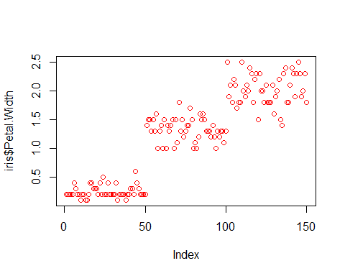

#------------------------- Histograms --------------------------------------------  
  
hist(iris$Petal.Length, main= "Histogram plot of petal length", xlab = "Petal_length", col = 'cyan')

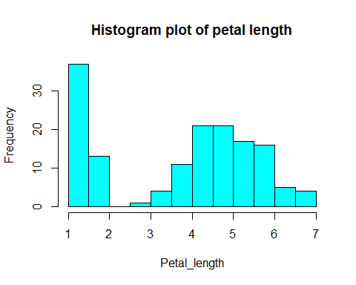

#------------------------------ Density functions -----------------------------------------------------  
  
plot(density(iris$Petal.Length),main= 'Density of Petal length' ,col="magenta")

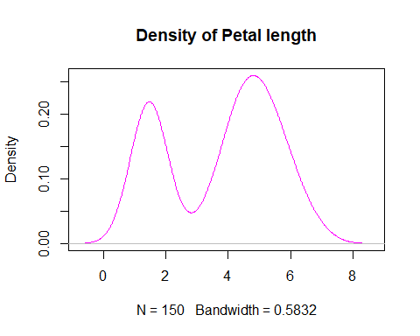

#----------------------------------- Abline function ----------------------------------  
  
plot(iris$Sepal.Length,iris$Sepal.Width, col="red" , xlab = "sepal length", ylab= "sepal width", main= "Use of abline function on iris dataset")  
abline(h=iris$Sepal.Width)

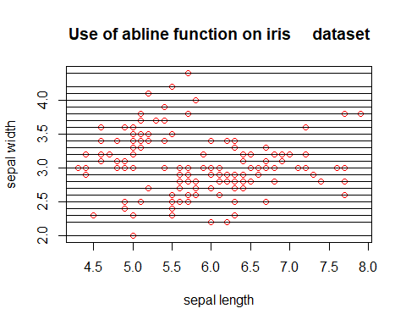

#----------------------------- Use of Legends --------------------------------------------------  
  
  
plot(iris$Petal.Width,iris$Sepal.Width, col= c("red","blue"),xlab= "petal_width",ylab= "sepal_width" )  
legend("topleft",legend= c("petal_width","sepal_width"), col = c("red","blue"), lty = 1:1)

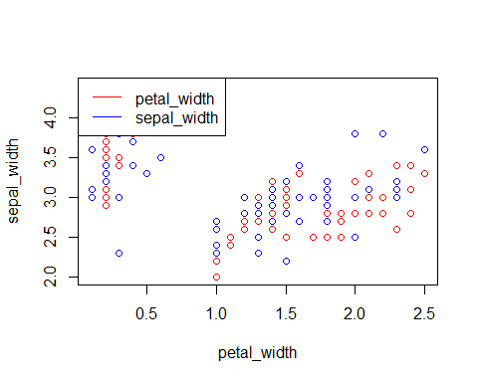

#--------------------------------- Using Pie charts ----------------------------------------  
  
table = table(iris$Sepal.Length)  
pie(table,main="sepal length")

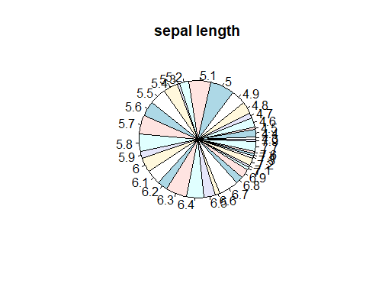

#------------------------------------- Box Plots -------------------------------------------  
  
boxplot(iris$Sepal.Length,iris$Sepal.Width,data= iris,col = c("red", "blue"))

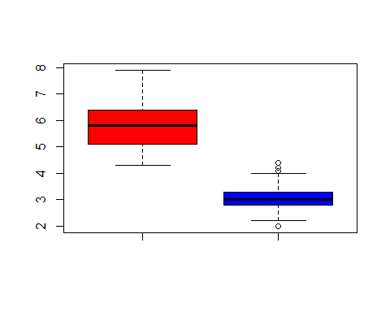

#-------------------------Using dplyr functions ------------------------  
  
#Using mutate() function  
  
changed_data= mutate(iris, Sepal_in_millimetres = 100*Sepal.Length )  
head(changed_data)

## Sepal.Length Sepal.Width Petal.Length Petal.Width Species  
## 1 5.1 3.5 1.4 0.2 setosa  
## 2 4.9 3.0 1.4 0.2 setosa  
## 3 4.7 3.2 1.3 0.2 setosa  
## 4 4.6 3.1 1.5 0.2 setosa  
## 5 5.0 3.6 1.4 0.2 setosa  
## 6 5.4 3.9 1.7 0.4 setosa  
## Sepal_in_millimetres  
## 1 510  
## 2 490  
## 3 470  
## 4 460  
## 5 500  
## 6 540

#Using mutate_at() function  
  
iris %>% mutate_at(c("Sepal.Length"), log)

## Sepal.Length Sepal.Width Petal.Length Petal.Width Species  
## 1 1.629241 3.5 1.4 0.2 setosa  
## 2 1.589235 3.0 1.4 0.2 setosa  
## 3 1.547563 3.2 1.3 0.2 setosa  
## 4 1.526056 3.1 1.5 0.2 setosa  
## 5 1.609438 3.6 1.4 0.2 setosa  
## 6 1.686399 3.9 1.7 0.4 setosa  
## 7 1.526056 3.4 1.4 0.3 setosa  
## 8 1.609438 3.4 1.5 0.2 setosa  
## 9 1.481605 2.9 1.4 0.2 setosa  
## 10 1.589235 3.1 1.5 0.1 setosa  
## 11 1.686399 3.7 1.5 0.2 setosa  
## 12 1.568616 3.4 1.6 0.2 setosa  
## 13 1.568616 3.0 1.4 0.1 setosa  
## 14 1.458615 3.0 1.1 0.1 setosa  
## 15 1.757858 4.0 1.2 0.2 setosa  
## 16 1.740466 4.4 1.5 0.4 setosa  
## 17 1.686399 3.9 1.3 0.4 setosa  
## 18 1.629241 3.5 1.4 0.3 setosa  
## 19 1.740466 3.8 1.7 0.3 setosa  
## 20 1.629241 3.8 1.5 0.3 setosa  
## 21 1.686399 3.4 1.7 0.2 setosa  
## 22 1.629241 3.7 1.5 0.4 setosa  
## 23 1.526056 3.6 1.0 0.2 setosa  
## 24 1.629241 3.3 1.7 0.5 setosa  
## 25 1.568616 3.4 1.9 0.2 setosa  
## 26 1.609438 3.0 1.6 0.2 setosa  
## 27 1.609438 3.4 1.6 0.4 setosa  
## 28 1.648659 3.5 1.5 0.2 setosa  
## 29 1.648659 3.4 1.4 0.2 setosa  
## 30 1.547563 3.2 1.6 0.2 setosa  
## 31 1.568616 3.1 1.6 0.2 setosa  
## 32 1.686399 3.4 1.5 0.4 setosa  
## 33 1.648659 4.1 1.5 0.1 setosa  
## 34 1.704748 4.2 1.4 0.2 setosa  
## 35 1.589235 3.1 1.5 0.2 setosa  
## 36 1.609438 3.2 1.2 0.2 setosa  
## 37 1.704748 3.5 1.3 0.2 setosa  
## 38 1.589235 3.6 1.4 0.1 setosa  
## 39 1.481605 3.0 1.3 0.2 setosa  
## 40 1.629241 3.4 1.5 0.2 setosa  
## 41 1.609438 3.5 1.3 0.3 setosa  
## 42 1.504077 2.3 1.3 0.3 setosa  
## 43 1.481605 3.2 1.3 0.2 setosa  
## 44 1.609438 3.5 1.6 0.6 setosa  
## 45 1.629241 3.8 1.9 0.4 setosa  
## 46 1.568616 3.0 1.4 0.3 setosa  
## 47 1.629241 3.8 1.6 0.2 setosa  
## 48 1.526056 3.2 1.4 0.2 setosa  
## 49 1.667707 3.7 1.5 0.2 setosa  
## 50 1.609438 3.3 1.4 0.2 setosa  
## 51 1.945910 3.2 4.7 1.4 versicolor  
## 52 1.856298 3.2 4.5 1.5 versicolor  
## 53 1.931521 3.1 4.9 1.5 versicolor  
## 54 1.704748 2.3 4.0 1.3 versicolor  
## 55 1.871802 2.8 4.6 1.5 versicolor  
## 56 1.740466 2.8 4.5 1.3 versicolor  
## 57 1.840550 3.3 4.7 1.6 versicolor  
## 58 1.589235 2.4 3.3 1.0 versicolor  
## 59 1.887070 2.9 4.6 1.3 versicolor  
## 60 1.648659 2.7 3.9 1.4 versicolor  
## 61 1.609438 2.0 3.5 1.0 versicolor  
## 62 1.774952 3.0 4.2 1.5 versicolor  
## 63 1.791759 2.2 4.0 1.0 versicolor  
## 64 1.808289 2.9 4.7 1.4 versicolor  
## 65 1.722767 2.9 3.6 1.3 versicolor  
## 66 1.902108 3.1 4.4 1.4 versicolor  
## 67 1.722767 3.0 4.5 1.5 versicolor  
## 68 1.757858 2.7 4.1 1.0 versicolor  
## 69 1.824549 2.2 4.5 1.5 versicolor  
## 70 1.722767 2.5 3.9 1.1 versicolor  
## 71 1.774952 3.2 4.8 1.8 versicolor  
## 72 1.808289 2.8 4.0 1.3 versicolor  
## 73 1.840550 2.5 4.9 1.5 versicolor  
## 74 1.808289 2.8 4.7 1.2 versicolor  
## 75 1.856298 2.9 4.3 1.3 versicolor  
## 76 1.887070 3.0 4.4 1.4 versicolor  
## 77 1.916923 2.8 4.8 1.4 versicolor  
## 78 1.902108 3.0 5.0 1.7 versicolor  
## 79 1.791759 2.9 4.5 1.5 versicolor  
## 80 1.740466 2.6 3.5 1.0 versicolor  
## 81 1.704748 2.4 3.8 1.1 versicolor  
## 82 1.704748 2.4 3.7 1.0 versicolor  
## 83 1.757858 2.7 3.9 1.2 versicolor  
## 84 1.791759 2.7 5.1 1.6 versicolor  
## 85 1.686399 3.0 4.5 1.5 versicolor  
## 86 1.791759 3.4 4.5 1.6 versicolor  
## 87 1.902108 3.1 4.7 1.5 versicolor  
## 88 1.840550 2.3 4.4 1.3 versicolor  
## 89 1.722767 3.0 4.1 1.3 versicolor  
## 90 1.704748 2.5 4.0 1.3 versicolor  
## 91 1.704748 2.6 4.4 1.2 versicolor  
## 92 1.808289 3.0 4.6 1.4 versicolor  
## 93 1.757858 2.6 4.0 1.2 versicolor  
## 94 1.609438 2.3 3.3 1.0 versicolor  
## 95 1.722767 2.7 4.2 1.3 versicolor  
## 96 1.740466 3.0 4.2 1.2 versicolor  
## 97 1.740466 2.9 4.2 1.3 versicolor  
## 98 1.824549 2.9 4.3 1.3 versicolor  
## 99 1.629241 2.5 3.0 1.1 versicolor  
## 100 1.740466 2.8 4.1 1.3 versicolor  
## 101 1.840550 3.3 6.0 2.5 virginica  
## 102 1.757858 2.7 5.1 1.9 virginica  
## 103 1.960095 3.0 5.9 2.1 virginica  
## 104 1.840550 2.9 5.6 1.8 virginica  
## 105 1.871802 3.0 5.8 2.2 virginica  
## 106 2.028148 3.0 6.6 2.1 virginica  
## 107 1.589235 2.5 4.5 1.7 virginica  
## 108 1.987874 2.9 6.3 1.8 virginica  
## 109 1.902108 2.5 5.8 1.8 virginica  
## 110 1.974081 3.6 6.1 2.5 virginica  
## 111 1.871802 3.2 5.1 2.0 virginica  
## 112 1.856298 2.7 5.3 1.9 virginica  
## 113 1.916923 3.0 5.5 2.1 virginica  
## 114 1.740466 2.5 5.0 2.0 virginica  
## 115 1.757858 2.8 5.1 2.4 virginica  
## 116 1.856298 3.2 5.3 2.3 virginica  
## 117 1.871802 3.0 5.5 1.8 virginica  
## 118 2.041220 3.8 6.7 2.2 virginica  
## 119 2.041220 2.6 6.9 2.3 virginica  
## 120 1.791759 2.2 5.0 1.5 virginica  
## 121 1.931521 3.2 5.7 2.3 virginica  
## 122 1.722767 2.8 4.9 2.0 virginica  
## 123 2.041220 2.8 6.7 2.0 virginica  
## 124 1.840550 2.7 4.9 1.8 virginica  
## 125 1.902108 3.3 5.7 2.1 virginica  
## 126 1.974081 3.2 6.0 1.8 virginica  
## 127 1.824549 2.8 4.8 1.8 virginica  
## 128 1.808289 3.0 4.9 1.8 virginica  
## 129 1.856298 2.8 5.6 2.1 virginica  
## 130 1.974081 3.0 5.8 1.6 virginica  
## 131 2.001480 2.8 6.1 1.9 virginica  
## 132 2.066863 3.8 6.4 2.0 virginica  
## 133 1.856298 2.8 5.6 2.2 virginica  
## 134 1.840550 2.8 5.1 1.5 virginica  
## 135 1.808289 2.6 5.6 1.4 virginica  
## 136 2.041220 3.0 6.1 2.3 virginica  
## 137 1.840550 3.4 5.6 2.4 virginica  
## 138 1.856298 3.1 5.5 1.8 virginica  
## 139 1.791759 3.0 4.8 1.8 virginica  
## 140 1.931521 3.1 5.4 2.1 virginica  
## 141 1.902108 3.1 5.6 2.4 virginica  
## 142 1.931521 3.1 5.1 2.3 virginica  
## 143 1.757858 2.7 5.1 1.9 virginica  
## 144 1.916923 3.2 5.9 2.3 virginica  
## 145 1.902108 3.3 5.7 2.5 virginica  
## 146 1.902108 3.0 5.2 2.3 virginica  
## 147 1.840550 2.5 5.0 1.9 virginica  
## 148 1.871802 3.0 5.2 2.0 virginica  
## 149 1.824549 3.4 5.4 2.3 virginica  
## 150 1.774952 3.0 5.1 1.8 virginica

#----------------------- Select function -------------------------------------------  
  
dplyr::select(iris,Sepal.Length)

## Sepal.Length  
## 1 5.1  
## 2 4.9  
## 3 4.7  
## 4 4.6  
## 5 5.0  
## 6 5.4  
## 7 4.6  
## 8 5.0  
## 9 4.4  
## 10 4.9  
## 11 5.4  
## 12 4.8  
## 13 4.8  
## 14 4.3  
## 15 5.8  
## 16 5.7  
## 17 5.4  
## 18 5.1  
## 19 5.7  
## 20 5.1  
## 21 5.4  
## 22 5.1  
## 23 4.6  
## 24 5.1  
## 25 4.8  
## 26 5.0  
## 27 5.0  
## 28 5.2  
## 29 5.2  
## 30 4.7  
## 31 4.8  
## 32 5.4  
## 33 5.2  
## 34 5.5  
## 35 4.9  
## 36 5.0  
## 37 5.5  
## 38 4.9  
## 39 4.4  
## 40 5.1  
## 41 5.0  
## 42 4.5  
## 43 4.4  
## 44 5.0  
## 45 5.1  
## 46 4.8  
## 47 5.1  
## 48 4.6  
## 49 5.3  
## 50 5.0  
## 51 7.0  
## 52 6.4  
## 53 6.9  
## 54 5.5  
## 55 6.5  
## 56 5.7  
## 57 6.3  
## 58 4.9  
## 59 6.6  
## 60 5.2  
## 61 5.0  
## 62 5.9  
## 63 6.0  
## 64 6.1  
## 65 5.6  
## 66 6.7  
## 67 5.6  
## 68 5.8  
## 69 6.2  
## 70 5.6  
## 71 5.9  
## 72 6.1  
## 73 6.3  
## 74 6.1  
## 75 6.4  
## 76 6.6  
## 77 6.8  
## 78 6.7  
## 79 6.0  
## 80 5.7  
## 81 5.5  
## 82 5.5  
## 83 5.8  
## 84 6.0  
## 85 5.4  
## 86 6.0  
## 87 6.7  
## 88 6.3  
## 89 5.6  
## 90 5.5  
## 91 5.5  
## 92 6.1  
## 93 5.8  
## 94 5.0  
## 95 5.6  
## 96 5.7  
## 97 5.7  
## 98 6.2  
## 99 5.1  
## 100 5.7  
## 101 6.3  
## 102 5.8  
## 103 7.1  
## 104 6.3  
## 105 6.5  
## 106 7.6  
## 107 4.9  
## 108 7.3  
## 109 6.7  
## 110 7.2  
## 111 6.5  
## 112 6.4  
## 113 6.8  
## 114 5.7  
## 115 5.8  
## 116 6.4  
## 117 6.5  
## 118 7.7  
## 119 7.7  
## 120 6.0  
## 121 6.9  
## 122 5.6  
## 123 7.7  
## 124 6.3  
## 125 6.7  
## 126 7.2  
## 127 6.2  
## 128 6.1  
## 129 6.4  
## 130 7.2  
## 131 7.4  
## 132 7.9  
## 133 6.4  
## 134 6.3  
## 135 6.1  
## 136 7.7  
## 137 6.3  
## 138 6.4  
## 139 6.0  
## 140 6.9  
## 141 6.7  
## 142 6.9  
## 143 5.8  
## 144 6.8  
## 145 6.7  
## 146 6.7  
## 147 6.3  
## 148 6.5  
## 149 6.2  
## 150 5.9

#-------------------------Pull Function ----------------------------  
  
pull(iris,Species)

## [1] setosa setosa setosa setosa setosa setosa   
## [7] setosa setosa setosa setosa setosa setosa   
## [13] setosa setosa setosa setosa setosa setosa   
## [19] setosa setosa setosa setosa setosa setosa   
## [25] setosa setosa setosa setosa setosa setosa   
## [31] setosa setosa setosa setosa setosa setosa   
## [37] setosa setosa setosa setosa setosa setosa   
## [43] setosa setosa setosa setosa setosa setosa   
## [49] setosa setosa versicolor versicolor versicolor versicolor  
## [55] versicolor versicolor versicolor versicolor versicolor versicolor  
## [61] versicolor versicolor versicolor versicolor versicolor versicolor  
## [67] versicolor versicolor versicolor versicolor versicolor versicolor  
## [73] versicolor versicolor versicolor versicolor versicolor versicolor  
## [79] versicolor versicolor versicolor versicolor versicolor versicolor  
## [85] versicolor versicolor versicolor versicolor versicolor versicolor  
## [91] versicolor versicolor versicolor versicolor versicolor versicolor  
## [97] versicolor versicolor versicolor versicolor virginica virginica   
## [103] virginica virginica virginica virginica virginica virginica   
## [109] virginica virginica virginica virginica virginica virginica   
## [115] virginica virginica virginica virginica virginica virginica   
## [121] virginica virginica virginica virginica virginica virginica   
## [127] virginica virginica virginica virginica virginica virginica   
## [133] virginica virginica virginica virginica virginica virginica   
## [139] virginica virginica virginica virginica virginica virginica   
## [145] virginica virginica virginica virginica virginica virginica   
## Levels: setosa versicolor virginica

#------------------------- use of sample_n() function --------------------  
  
sample_n(iris,4)

## Sepal.Length Sepal.Width Petal.Length Petal.Width Species  
## 1 5.8 2.8 5.1 2.4 virginica  
## 2 5.9 3.0 4.2 1.5 versicolor  
## 3 4.9 3.1 1.5 0.1 setosa  
## 4 5.3 3.7 1.5 0.2 setosa

#-----------------------Use of slice function ------------------------  
  
iris %>% slice(n())

## Sepal.Length Sepal.Width Petal.Length Petal.Width Species  
## 1 5.9 3 5.1 1.8 virginica

slice(iris, 1:3)

## Sepal.Length Sepal.Width Petal.Length Petal.Width Species  
## 1 5.1 3.5 1.4 0.2 setosa  
## 2 4.9 3.0 1.4 0.2 setosa  
## 3 4.7 3.2 1.3 0.2 setosa