Understanding ggplot using Iris

K.V.Raghava 20241

04/02/2021

# loading library  
library(tidyverse)  
# Data Layer   
p_data = as_tibble(iris)  
##Generating the Normal Graph Empty one  
head(p_data)

## # A tibble: 6 x 5  
## Sepal.Length Sepal.Width Petal.Length Petal.Width Species  
## <dbl> <dbl> <dbl> <dbl> <fct>   
## 1 5.1 3.5 1.4 0.2 setosa   
## 2 4.9 3 1.4 0.2 setosa   
## 3 4.7 3.2 1.3 0.2 setosa   
## 4 4.6 3.1 1.5 0.2 setosa   
## 5 5 3.6 1.4 0.2 setosa   
## 6 5.4 3.9 1.7 0.4 setosa

plot = ggplot(data = p_data, aes(y = Sepal.Length, x = factor(Species),   
col = Sepal.Width))  
#Can be done like this aes function is for adding the X-axis and Y-axis

*Using geom_point()*

plot + geom_point()

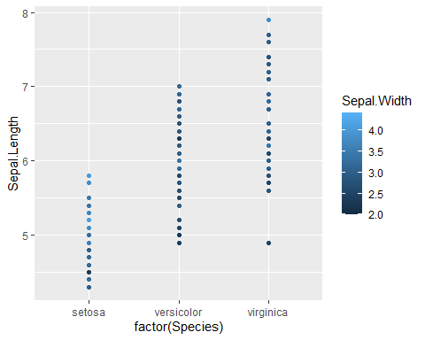

##Adding the layer where the actula plotting is done  
##Plotting is done between Species and Sepal Length

This graph suggest that Virginica is having the highest Sepal Width

*Using geom_density()*

p_data = as_tibble(iris)  
plot = ggplot(data = p_data,aes(y=Petal.Length,x=Species,col = Petal.Width))  
plot+geom_density()

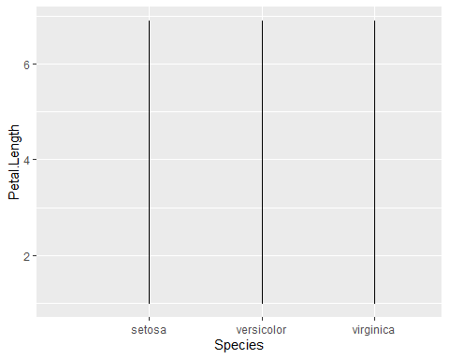

This Graph says that there is a uniformity with respect to the petal length and Species *Using geom_histogram()*

ggplot(data = p_data,aes(Petal.Length))+  
geom_histogram(binwidth =0.1)

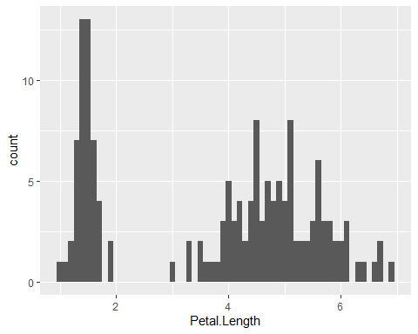 This graph infers petal length lies between 0 and 2 has the highest number *Using geom_boxplot()*

ggplot(data = p_data,aes(y=Petal.Length,x=Species))+  
geom_boxplot(fill = "white", color= "#f4511e",notch=TRUE)

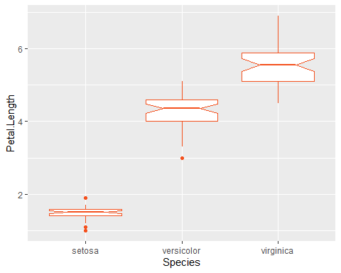 This graph infers that there is less consistency and more outliers for Setosa *Using ggsave()*

ggplot(data = p_data,aes(y=Petal.Length,x=Species))+  
geom_boxplot(fill = "white", color= "#f4511e",notch=TRUE)



ggsave("Box_Plot.pdf")#Used to save the plot

## Saving 5 x 4 in image

*Using facet_grid()*

ggplot(data = p_data,aes(y=Petal.Length,x=Petal.Width,  
))+geom_point()+facet_grid(Species~.)

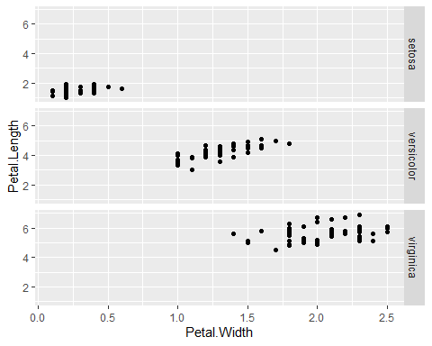 This graph infers that the Versicolor data is less scattered

*Using facet_wrap()*

ggplot(data = p_data,aes(y=Petal.Length,x=Petal.Width,  
))+geom_point()+facet_wrap(Species~.)

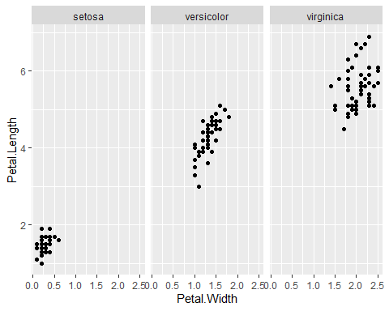

##This is same as facet_grid but ensure that the screen is used in better way

This graph infers that the ascending order of size is Setosa,Versicolor,Virginica *Using stat_density*

plot = ggplot(data = p_data,aes(y=Petal.Length,x=Species,col = Petal.Width))  
plot+stat_density()

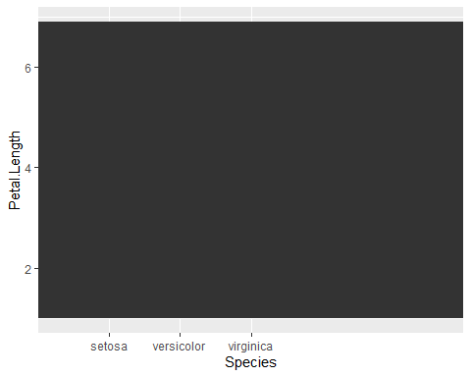 *Using scale_x_log10()*

ggplot(data = p_data,aes(x=Petal.Length,y=Species,col = Petal.Width))+geom_point()+scale_x_log10()

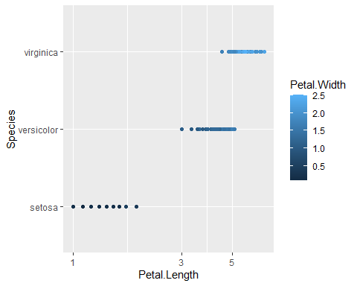

##Used for applying the Log_10 on x-axis

This graph infers that on log10scale the setosa scatter is less and size is also less than 0.5 *Using scale_x_sqrt()*

ggplot(data = p_data,aes(x=Petal.Length,y=Species,  
col = Petal.Width))+geom_point()+scale_x_sqrt()

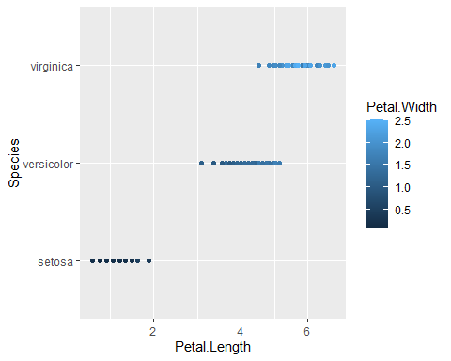

##Used for applying the sqrt on x-axis  
##Nothing much different may be the values are too small

*Using scale_y_log10()*

ggplot(data = p_data,aes(y=Petal.Length,x=Species,col = Petal.Width))+geom_point()+scale_y_log10()

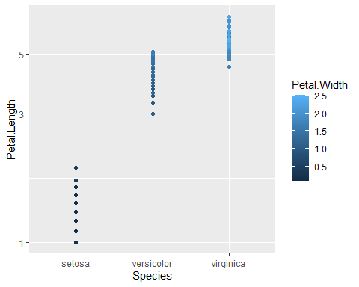

##Used for applying the Log_10 on y-axis

*Using scale_y_sqrt()*

ggplot(data = p_data,aes(y=Petal.Length,x=Species,  
col = Petal.Width))+geom_point()+scale_y_sqrt()

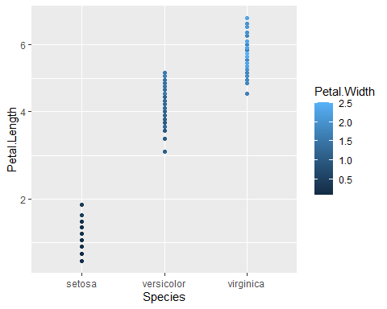

##Used for applying the sqrt on x-axis  
##Nothing much difference I think it might be my wrong implementation  
##But the datapoints are getting nearer to each other  
##This graph infers that on log10scale the setosa scatter is less and size is also less than 0.5

*Using theme_classic()*

ggplot(data = p_data,aes(y=Petal.Length,x=Petal.Width,  
))+geom_point()+facet_grid(Species~.)+theme_classic()

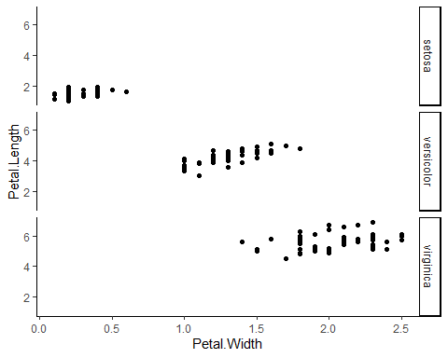

##It gives the classic(old) look for the plot

*Using theme_classic()*

ggplot(data = p_data,aes(y=Petal.Length,x=Petal.Width,  
))+geom_point()+facet_grid(Species~.)+theme_bw()

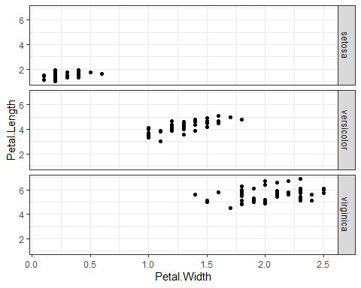

##It gives the minimilistic look for the plot with gridlines

*Using scale_x_continuous and scale_y_continuous*

ggplot(data = p_data,aes(y=Petal.Length,x=Petal.Width,  
))+geom_point()+scale_x_continuous("P-Wid")+scale_y_continuous("P-Len")

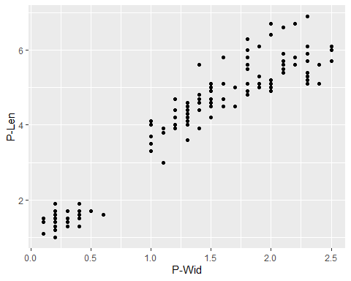

##scale_x_continuous() and scale_y_continuous() are the default scales for   
##continuous x and y aesthetics. There are three variants that set the trans   
##argument for commonly used transformations:  
## scale_*_log10(), scale_*_sqrt() and scale_*_reverse().

Nothing much difference (I think it might be my wrong implementation) May be the values are too small *Using xlim and ylim*Part of Basic R

plot(iris$Sepal.Length,iris$Sepal.Width)

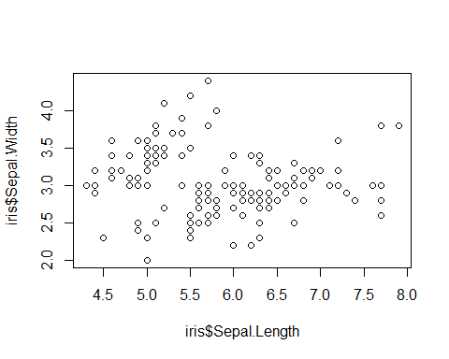

#Normal graph with no limit.Kindly note the x axis is from 4.5 to 8 y-axis 2.0 to 4  
plot(iris$Sepal.Length,iris$Sepal.Width, xlim = c(4,5))

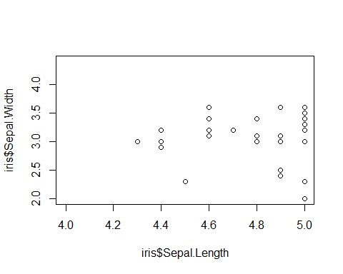

#From this plot, the absolute minimum Sepal Length is 4.2. The x-axis size is decrease  
plot(iris$Sepal.Length,iris$Sepal.Width, ylim = c(3,4))

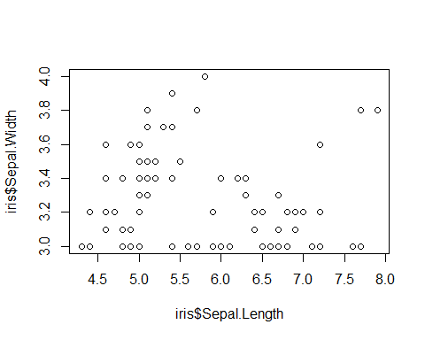

#From this plot,the max sepalwidth has the sepal length between 5.5 to 6.0  
#These both can be used together  
plot(iris$Sepal.Length,iris$Sepal.Width, xlim=c(4,5),ylim = c(2,3))

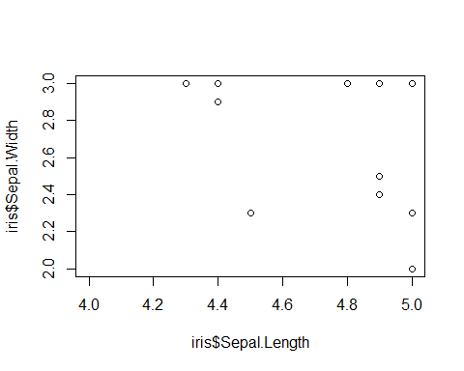

#The smalles size of the flower is 10.55

*Using xlab and ylab* (Generally These are the lables for X-axis and y-axis)Part of Basic R

plot(iris$Sepal.Length,iris$Sepal.Width, xlim=c(4,5),ylim = c(2,3),xlab="This is X"  
,ylab="This is Y")

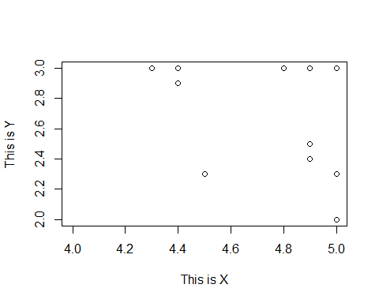 *Using Coord_flip function*

plot+geom_point()+coord_flip()

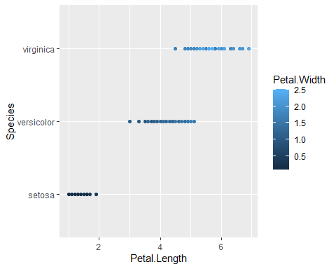

#Simply flips the x and y axis  
plot+geom_point()+coord_cartesian()

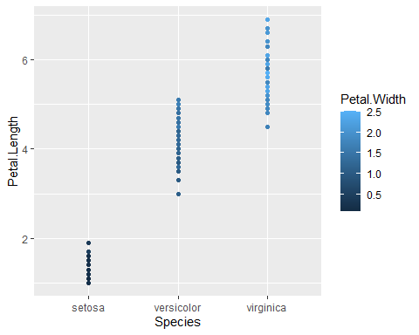

#Used to convert the given grpah to cartesian plane enables us to Zoom in and Out

*Using labs*

plot + labs(title = "Om Sri Sairam")

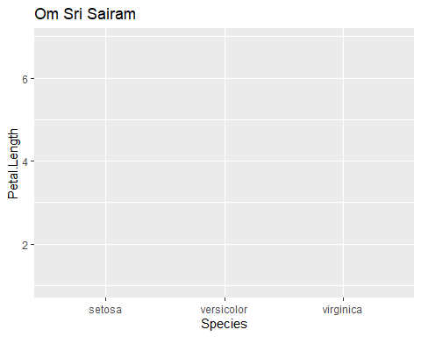

plot + labs(title = "Some Plot ", subtitle = "A subtitle")+labs(caption = "#DataNeverLies")

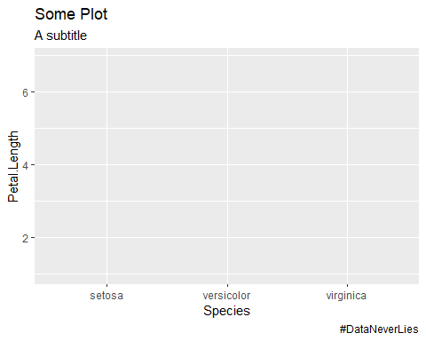

#Used for creating the labels like title,subtitle,caption,tag too

*Using ggtile*

plot+geom_point()+ggtitle("This work is done by\n\t20241")

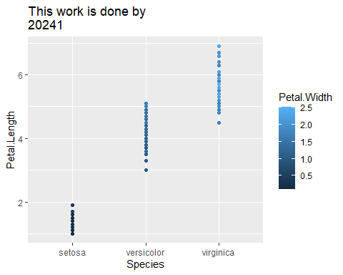 *Using Dodge*

ggplot(data = p_data,aes(y=Petal.Length))+ geom_histogram(bins=20,position = "dodge")

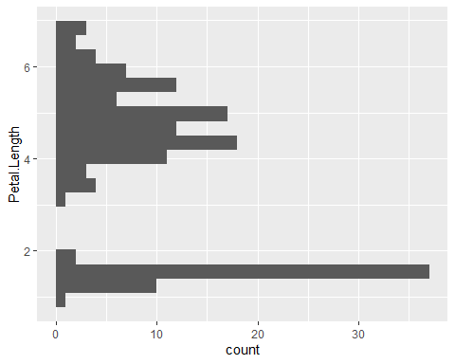 *Using qqplot*

qqplot(p_data$Sepal.Length,p_data$Sepal.Width)

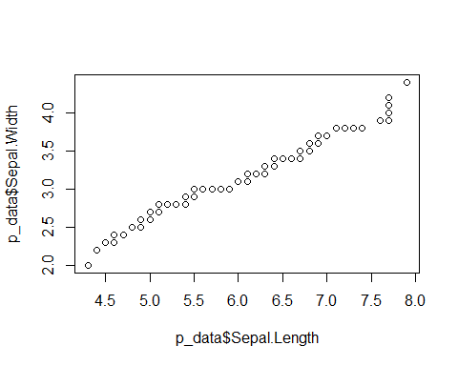

##Used for checking if the normality is present

all the points does not fall approximately along this reference line, we cannot assume normality.