Kafka is a distribution System. which means a collection of system working together to deliver a value.
Features:
- Availability & Fault Tolerance (Replication)
- Reliable Work Distribution
- Easily Scalable (Suppose adding new system or broker)
- Handling Concurrency is easy.
Kafka Cluster can have n+1 Kafka broker.
N+1 Kafka Producer → Kafka Cluster (n+1 Kafka broker) ← n+1 Kafka consumer.
Here Kafka cluster will maintain broker using zookeeper and enable to achieve all feature. If any broker fails notification will go to cluster and messaging will be handled accordingly.

In Kafka Cluster, we have 3 brokers.one will be act as a controller. This Broker will

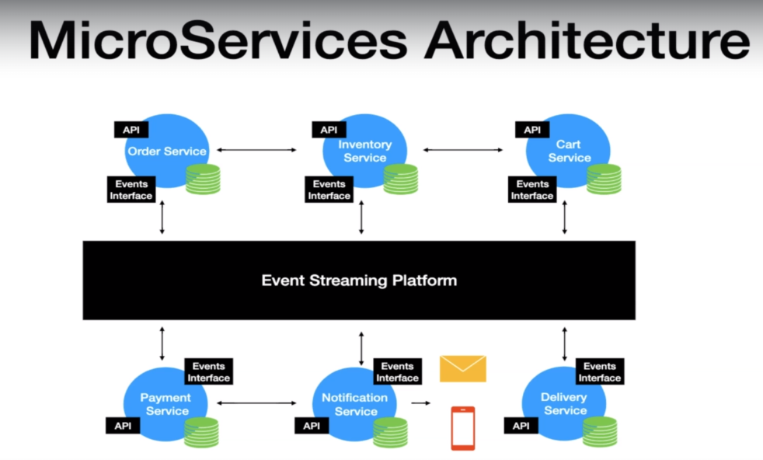

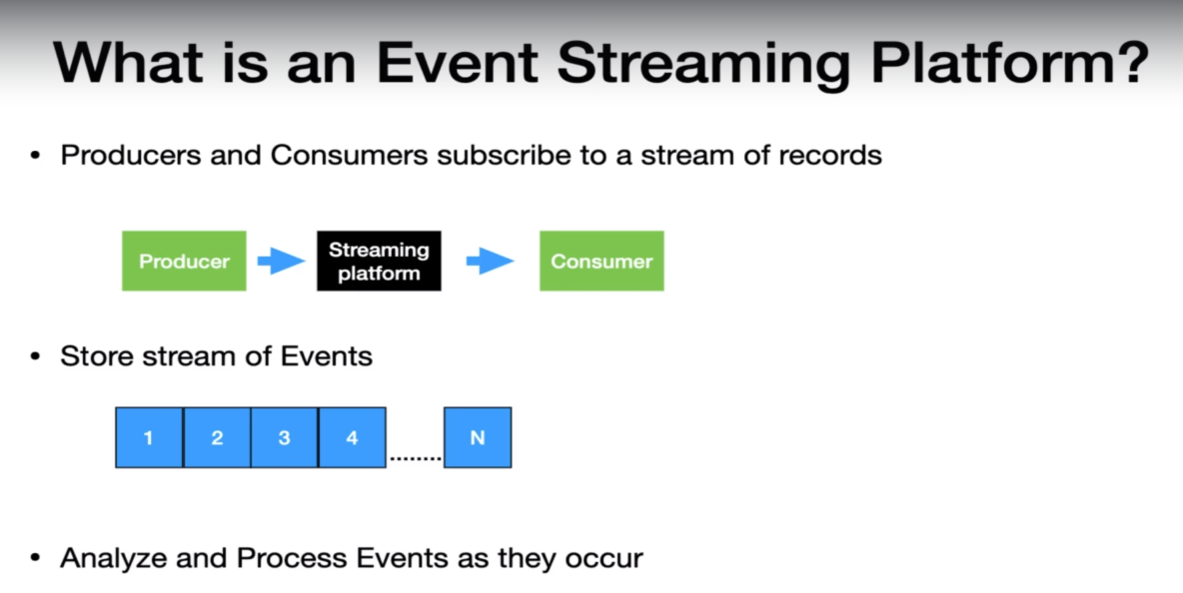

Here, Store stream event will be used to replay message. Kafka is develop based on all these features.

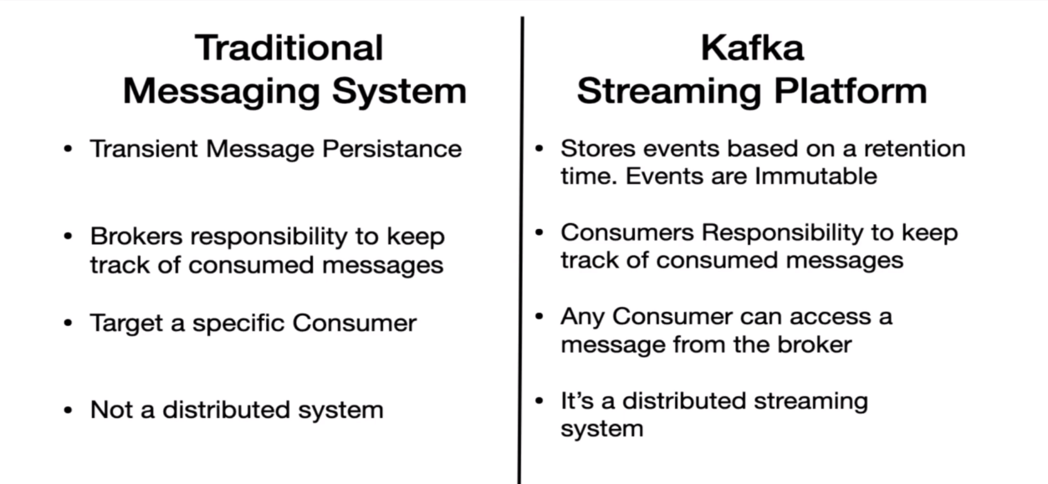

In Kafka, we have Zookeeper which manage the Kafka Broker and Kafka cluster.

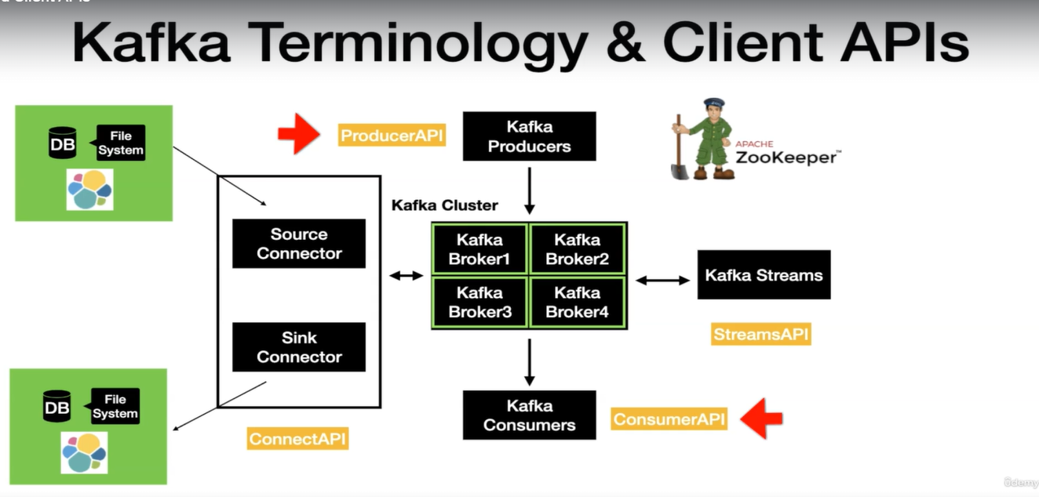

Order is possible at partitional level. Kakfa used offset to sequence of message.

- Kafka topic is an Entity in Kafka.
Kafka Producer → Kafka Broker (Topic A) → (Poll Topic A) Kafka Consumer.
Here Topic can have n+1 partitions. Partitions is where the message lives inside the topic. Producers have complete control on sending message on specific partition.

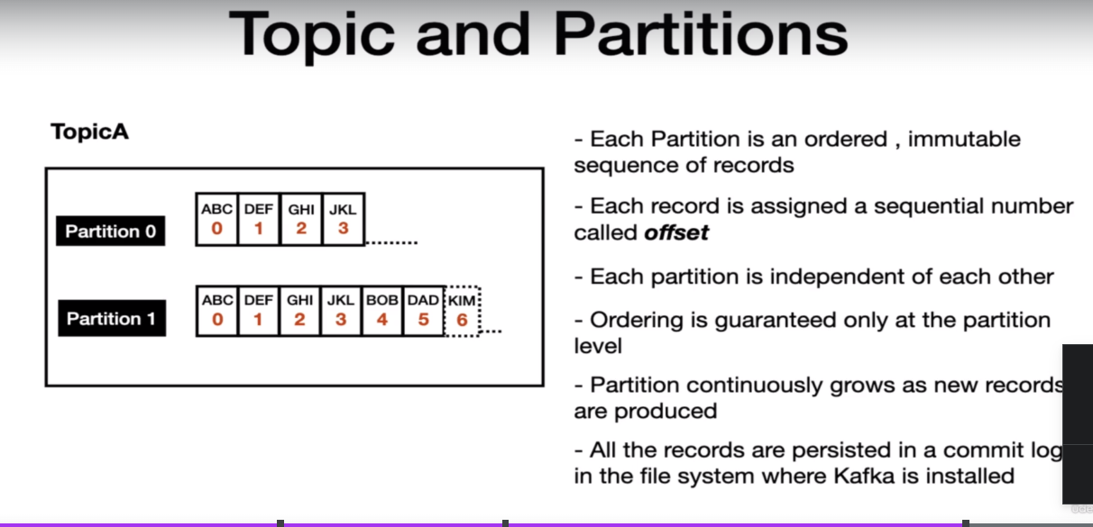

Kafka Message has two properties:
1-Key (optional)
2-Value.
Kafka Producer:
In Kafka, producer will have partitioner layer which will determine which partition to push message. We can have different approach for this partition.
Kafka Producer → Send to topic → Partitioner → | Kafka Cluster have 3 broker and partition to each broker |

Kafka Consumer has 3 options to read.
1- from-beginning
2- latest
3- specific offset.

Consumer offset:
Group.id=group1(groupName) |consumer_1| “_consumer_offsets” (inner topic maintain the offset of consumer when it is down.)
Consumer offset will read the message from the point it left.

Consumer Groups:
Use to scalable message consumptions. Each application will have unique consumer group. Kafka Broker manages the consumer-groups. Kafka broker acts as a group co-ordinator.

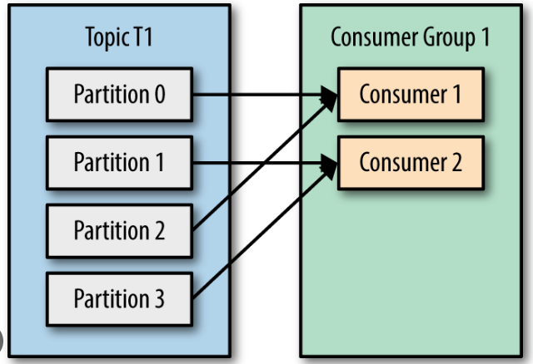

Kafka Producer → Send to topic → Partitioner → | Kafka Cluster have 3 broker and partition to each broker |

| Kafka Cluster with broker1 and partition-0 | → poll from topic partition-0 (Kafka Consumer group.id=group1)

| Kafka Cluster with broker2 and partition-01| → poll from topic partition-1 (Kafka Consumer group.id=group1)
Here, we have same group. Partition leaders are assigned during topic creation. Clients will invoke leader of partition to produce & consume data. We can have 2 leaders by making advance config

Commit log and Retention Policy.
- Property log.retention.hours in server.properties file.
- Commit log is where poll message is get logged. We have command to see content of log file.

Kafka Template:

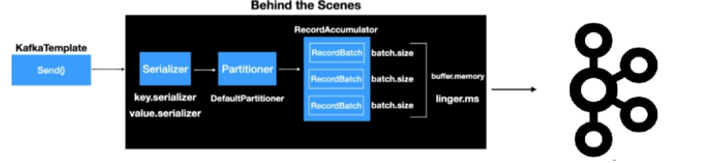

Here, we have two serializer approach (Key and value). We can have different partitioner approach.
Configuration Kafka Template:
Mandatory Values:
- Bootstrap-servers: localhost:9092, localhost:9092
- Key-serializer: org.apcahe.kafka.common.serialization.IntegerSerializer
- Value-serializer: org.apcahe.kafka.common.serialization.StringSerializer

KafkaTemplate AutoConfiguration (SpringBoot):
application.yml:
- spring:
profiles: local
kafka:
producer:
bootstrap-servers: localhost:9092, localhost:9092 // Borker ID
key-serializer: org.apcahe.kafka.common.serialization.IntegerSerializer
value-serializer: org.apcahe.kafka.common.serialization.StringSerializer

Logs to check in springboot :
2022-12-07T16:01:07.416+01:00 INFO 21656 --- [ main] o.a.k.clients.admin.AdminClientConfig : AdminClientConfig values:
bootstrap.servers = [localhost:9092]
client.dns.lookup = use_all_dns_ips
client.id =
connections.max.idle.ms = 300000
default.api.timeout.ms = 60000
metadata.max.age.ms = 300000

Kafka Producer Configuration:
- acks = 0, 1 and null
acks = 1 → guarantees message is written to a leader(default)
acks = all → guarantees message is written to a leader and to all the replicas
acks = 0 → no guarantee (Not Recommended)
- retries: Integer value (0 – int value)
- retry.backoff.ms: Values are represented in milliseconds. default 100ms

Kafka Consumer:
Options to implement Kafka Consumer:
- MessageListenerContainer
  - KafkaMessageListnerContainer (Single thread)
  - ConcurrentMessageListenerContainer
- @KafkaLisener Annotation
  - Uses ConcurrentMessageListenerContainer behind the scenes.

Import kafkaConsumer Config
- Key-deserializer
- Value- deserializer
- Group-id

Create Topic:

Without Key Example >>
\bin\windows>kafka-topics.bat --create --topic JS-test-topic --bootstrap-server localhost:9092 --replication-factor 1 --partitions 4

$ bin/kafka-console-producer.sh --topic jitesh-topic-events --bootstrap-server localhost:9092

Command to check all topic available in server:
\bin\windows>kafka-topics.bat --bootstrap-server localhost:9092 –list

Consumer console to check messages :
kafka\bin\windows>kafka-console-consumer.bat --bootstrap-server localhost:9092 --topic library-events

Recovery of message:
- Reprocess the failed record again. Eg: Service is down.
- Discard the message and move on. Eg: Parsing error , Invalid Event

Implementation of Approach 1:
- Publish the failed message to a retry topic.
- Saved the failed message in a DB and retry with a schedular.

Note : Here , For 1st solution We need to be caution to what kind of message we would like to retry. We can have custom logic for retry. We can use header which is being pushed in message.
Here , we will use retry topic for retry purpose.

