Exercise 2: Implementing the FactoryMethod Pattern

Step 1 : Create Java Project FactoryMethodExample

Step 2: Define the Factory Class (Factory.java)
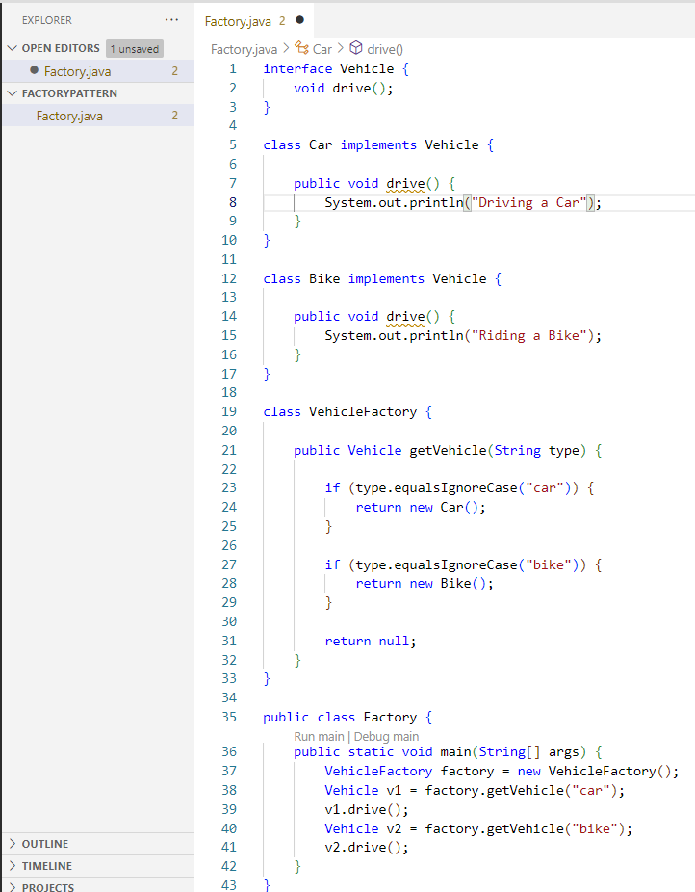

Step 3: Check OutPut :

Key Concepts:
Factory Method is a Creational Design Pattern.
Object creation is delegated to a Factory class.
Client requests an object from the factory.
Client does not directly use the new keyword.
Factory decides which object to create.
Helps achieve Loose Coupling.
Client depends on interfaces/abstractions, not concrete classes.
New object types can be added with minimal changes.
Follows the Open-Closed Principle.
Improves code maintainability.
Improves code scalability.
Centralizes object creation logic.
Reduces duplicate object creation code.
Hides implementation details from the client.

