**Network Switch**

The purpose of a network switch is to connect different devices on the network. Switch will send only the intended data packets each device on network unlike hub which send data packets to all devices and make the devices to drop the un necessary packets. They usually process they data either in Datalink layer or Network layer.

Network switches are primarily two types un-managed switches and manages switches. Un-managed switches will not have any filters, authentication and control over the devices connected. It works as plug and play configuration. Managed switches will require special configuration which includes devices to authenticate, protocols to allow and other encryption schemes.

The first switch was introduced in 1990 by Silicon Valley based company ‘Kalpana’, the purpose of this innovation is to increase the throughput of the network by replacing conventional hubs of the time.

Representation of Network switch

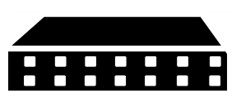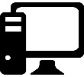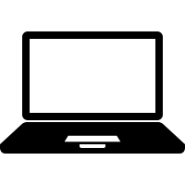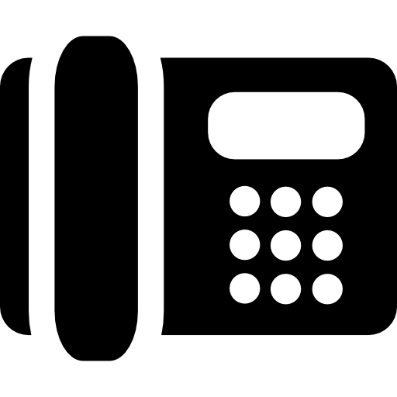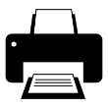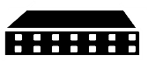

An un-managed switch doesn’t restrict devices



A managed switch can restrict devices and protocols

**Figure 1.1**

**Patch Panel**

A patch panel is not an intelligent networking device, it is designed to make the network connections to simpler and convenient. When using a patch panel if one of the networking devices connected to patch panel malfunctions, it can be safely replaced by disconnecting from the patch panel and connecting new one. Usually the devices are connected to patch panel via one of the media like Cat 5e, cat 6 etc. The networks can be switched easily either by swapping patch cables or using alternating switches.

Representation of a patch panel

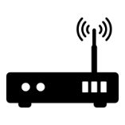

A patch panel device mechanically connects multiple devices on network.

**Figure 1.2**

All the connections in the patch panel can be swapped either by using patch cables or by using buttons.

**Network Server**

A typical network server is a centralized system that handles and replies the client requests. The servers are application specific and each server has particular type of function to serve. Some servers provide the file downloads (ftp), some servers are designed for mail system (smtp) and some server the websites (http) etc. In a typical client server architecture, the client machines connected to the server will request for certain data and Network server analyzes and responds to the client with required information.

Representation of a Network Server

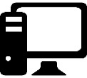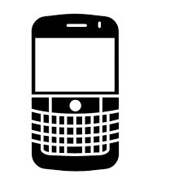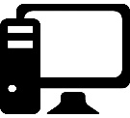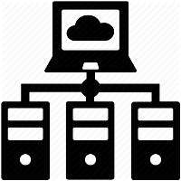

**Figure 1.3**

This figure represents a network server serving the requests of multiple devices connected to the server via network.

**Network Clients**

The network clients are end user machines that request the data from multiple network servers, for accomplishing their tasks. All our daily use mobiles are the typical example of a network client.

Network clients are typically classified into two categories thick clients and thin clients. Thick clients are the devices that run infrastructure on them and rely on server for the data alone. Information systems in airport terminal are good example of thick clients. They run the information providing software in them and they request the data from the centralized server. Thin clients don’t have any infrastructure on them they barely run a fully functional web browser. Thin clients request both infrastructure and data from the server.

In most of the cases the network clients will be connected more than one server. For example, our mobile phone we connect to different servers for social networking, weather, news and entertainment etc.

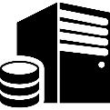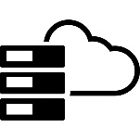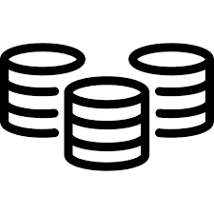

Figure 1.4

A typical network client receives information form from different servers.

**Network Interface Card**

The network interface card is a hardware device connected to computer for the implementation of physical layer and data link layer. Network interface card has a unique id called MAC address through which a computer is uniquely identified in the network. The most commonly use network interface cards are Ethernet and Wi-Fi. In a network hub configuration NIC is responsible for dropping the unintended packets. In a nutshell NIC is an electronic device responsible for the implementation of networking. Most of the modern devices will have NIC inbuilt. Laptops will have both the Wi-Fi and Ethernet inbuilt and Mobiles devices have Wi-Fi and Mobile N/W data receiver.

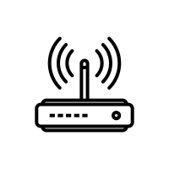

Figure 1.5

The **RED** device represents a Wi-Fi NIC which is interfaced wirelessly and the **GREEN** device represents and Ethernet NIC which is connected to networking device with a CAT cable.

**Router**

A router a networking device that is responsible for carrying the data packets in a network. A data packet contains the information about its target in the head. Once a data packet is received by the router, the router processes the information in the head (they won’t process the payload as the payload contains the data and it will be encrypted in most scenarios) depending upon the destination of the packet the router then determines the next router in the network to which the packet needs to be sent using the routing tables, algorithms and policies.

When a next router in the network is dead then the current router calculates the alternate route and pushes the packet to the available router automatically.

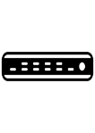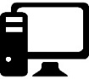

**Figure 1.6**

This figure shows the functionality of routers in a network, as one of the routers is dead they will find an alternate short and reliable route to transfer the packets.