EMPLOYEE ATTRITION AND WORKFORCE ANALYTICS
Identifying Drivers of Employee Turnover Using Machine Learning Classification

Project Report Submitted in Fulfilment of the Requirements for the Award of the Internship of
Summer Training Program by IDRA
Data Science and AI

By:
Name: Jithender Reddy
Institute: Dr. B.R. Ambedkar National Institute of Technology, Jalandhar
Institute Roll No.: 23103035
Enrollment No.: IDRA-2026-817486

Under the Supervision of
Dr. Shaheena Salam

Through the platform:
India Data Research Academy

DECLARATION

I, Jithender Reddy , hereby declare that the work presented in this report titled 'Employee Attrition and Workforce Analytics: Identifying Drivers of Employee Turnover Using Machine Learning Classification' is my own original work carried out as part of the IDRA Data Science and AI Training Program.
I confirm that the analysis, code, figures, tables, and written interpretations were prepared by me for this capstone project. Where external sources, libraries, or institutional materials were used, they have been properly cited in the references section. I understand that academic integrity requires me to explain every analytical decision in this submission and that I am accountable for the accuracy of the reported results.
I further declare that the raw dataset supplied through the LMS was used without fabrication of records, metrics, or findings. Any limitations of the dataset and model are acknowledged openly in this document. I have not submitted this work, in whole or in part, for any other degree or qualification at this or any other institution unless explicitly acknowledged.
Date: _________________________

ACKNOWLEDGEMENT
I would like to express my sincere gratitude to the India Data Research Academy (IDRA) for providing the Data Science and AI Training Program, structured capstone guidance, learning resources, and the employee attrition dataset used in this project. The program provided me with an opportunity to strengthen my understanding of data science concepts and apply them to a practical real-world problem.
I am especially thankful to Dr. Shaheena Salam for her valuable academic supervision, guidance, and continuous encouragement throughout the project. Her support and emphasis on rigorous, systematic, and evidence-based analysis helped me approach the various stages of the project with greater clarity and confidence. I also acknowledge the faculty members and peers at my institute who supported and encouraged my learning and contributed to a positive academic environment throughout the program.
I would also like to acknowledge the developers and documentation contributors of the open-source Python libraries used in this project, including pandas, scikit-learn, matplotlib, and seaborn. These tools played an important role in data preprocessing, exploratory data analysis, visualization, and machine learning model development. Their continued efforts in making open-source technologies accessible have greatly supported practical and reproducible data science work.
Finally, I would like to express my heartfelt gratitude to my family for their constant patience, encouragement, and support throughout the completion of this capstone project. Their motivation helped me remain focused during the different stages of data cleaning, exploratory analysis, feature preparation, model development, evaluation, interpretation, and report writing. Their support has been an important part of successfully completing this project.

ABSTRACT
Employee turnover can significantly affect organizational stability, knowledge retention, workforce productivity, and recruitment expenditure. This project analyzes the IDRA-supplied HR Employee Attrition dataset containing 1,470 employee records and 35 variables to identify workforce patterns associated with employee attrition and develop a transparent binary classification model for predicting potential employee departures.
The dataset underwent systematic data quality checks, confirming 0 missing values and 0 duplicate records. Categorical variables were validated, numerical ranges were examined, and potentially influential observations were reviewed using the interquartile range (IQR) method. The target variable showed an attrition rate of 16.1%, indicating class imbalance and highlighting the importance of using evaluation metrics beyond accuracy.
Exploratory Data Analysis (EDA) was conducted to examine relationships between attrition and key workforce characteristics, including overtime, job role, job satisfaction, income, age, experience, and selected numerical correlations. For model development, identifier and constant columns were excluded. Numerical features were processed using median imputation and standardization, while categorical features were transformed using one-hot encoding. All preprocessing steps were implemented through a scikit-learn pipeline and fitted exclusively on the training data to reduce the risk of data leakage.
Three classification approaches were evaluated: a dummy baseline, balanced logistic regression, and random forest. The balanced logistic-regression model was selected based on its overall performance across attrition recall, F1-score, and ROC-AUC while maintaining interpretability. On the held-out test set, the model achieved 75.9% accuracy, 36.0% precision, 66.0% recall, 0.466 F1-score, and 0.810 ROC-AUC.
The analysis identified several patterns associated with employee attrition, particularly overtime exposure, job-role differences, lower experience and income among employees who left, and engagement- and satisfaction-related factors. Based on these findings, the project recommends reviewing workload and overtime practices, providing role-specific retention support, strengthening engagement among early-career employees, and using model predictions as decision-support indicators rather than automatic determinants of HR actions. External validation, monitoring, and fairness assessment are necessary before considering operational deployment.
Keywords: Employee Attrition; Workforce Analytics; Human Resources Analytics; Machine Learning; Classification; Exploratory Data Analysis.

TABLE OF CONTENTS
Section | Page
1. Introduction | 6
2. Problem Statement and Motivation | 6
3. Objectives | 6
4. Research Questions | 6
5. Dataset Description and Data Understanding | 7
6. Data Cleaning | 8
7. Data Preprocessing | 9
8. Exploratory Data Analysis | 9
9. Statistical Analysis | 13
10. Feature Engineering | 13
11. Model Development | 13
12. Model Evaluation | 14
13. Results and Findings | 16
14. Discussion | 16
15. Limitations | 16
16. Conclusion | 17
17. Recommendations and Future Work | 17
18. References | 17
Appendix A. Selected Code | 18
Appendix B. Additional Tables | 20

1. INTRODUCTION

1.1 Background
Employee attrition is a workforce challenge because the departure of trained employees may increase recruitment expenditure, interrupt operations, and reduce accumulated organizational knowledge. Workforce analytics can help an organization examine patterns in its employee data and focus retention conversations on groups that show elevated risk, while still respecting that an employee-level prediction is not a decision by itself.

1.2 Context of the Problem
Human-resources stakeholders require evidence to distinguish broad assumptions from observable patterns. The supplied dataset combines employee demographics, role, compensation, satisfaction, work arrangement, and employment-history variables. These variables enable both descriptive comparison of employees who stayed versus left and the development of an attrition-risk classifier.

1.3 Scope of the Study
This study uses only the supplied cross-sectional dataset. It identifies predictive associations and evaluates performance on a held-out subset of the same data. It does not establish causal effects, measure the financial cost of turnover, or validate predictions on another organization or time period.

2. PROBLEM STATEMENT AND MOTIVATION
The project asks: which available employee and workplace characteristics are associated with attrition, and how accurately can the supplied data predict whether an employee will leave? A useful answer can help HR prioritize investigation of overtime, job-role, engagement, experience, and career-support patterns. The analysis is intended to support—not replace—fair, confidential, and human-led workforce decisions.

3. OBJECTIVES
- Assess the structure and data quality of the supplied employee attrition dataset.
- Identify demographic, job, work-condition, satisfaction, and employment-history patterns associated with attrition.
- Compare attrition rates across meaningful employee groups.
- Build leakage-safe classification models to predict attrition.
- Evaluate models using accuracy, precision, recall, F1-score, ROC-AUC, and a confusion matrix.
- Translate evidence into practical, non-causal workforce-retention recommendations.

4. RESEARCH QUESTIONS
- What are the size, structure, and data-quality characteristics of the supplied dataset?
- How does attrition vary by overtime status, job role, and job satisfaction?
- How do age, income, distance from home, total experience, and company tenure differ between employees who stayed and employees who left?
- Which numerical variables show the strongest descriptive association with attrition?
- How well can a classification model identify attrition on unseen held-out data?
- What retention actions are justified by the observed evidence and model results?

5. DATASET DESCRIPTION AND DATA UNDERSTANDING

5.1 Data Source
The file P_7_WA_Fn-UseC_-HR-Employee-Attrition.csv was supplied through the IDRA LMS for Project 7. The analysis uses it as provided and retains the original raw file unchanged.

5.2 Dataset Size and Structure
Item | Result
Observations | 1,470 employee records
Original variables | 35
Target | Attrition (Yes/No)
Employees who stayed | 1,233 (83.9%)
Employees who left | 237 (16.1%)
Model input variables | 30
Table 1. Summary of the supplied employee attrition dataset.
The attrition class represents 16.1% of the records, so a model that predicts every employee will stay could appear accurate while identifying no employees who actually left. Therefore, attrition-class recall and F1-score are central evaluation measures.

5.3 Data Dictionary
Column | Meaning | Type | Role
Attrition | Whether the employee left the organization | Categorical binary | Target
Age | Employee age in years | Integer | Feature
BusinessTravel | Business-travel frequency | Categorical | Feature
Department | Employee department | Categorical | Feature
DistanceFromHome | Distance from home | Integer | Feature
EnvironmentSatisfaction | Environment-satisfaction score | Ordinal integer | Feature
JobLevel | Job-level code | Ordinal integer | Feature
JobRole | Job-role category | Categorical | Feature
JobSatisfaction | Job-satisfaction score | Ordinal integer | Feature
MonthlyIncome | Monthly income | Integer | Feature
OverTime | Whether overtime is worked | Categorical binary | Feature
TotalWorkingYears | Total years of work experience | Integer | Feature
YearsAtCompany | Years at current company | Integer | Feature
EmployeeNumber | Employee identifier | Integer | Excluded identifier
Table 2. Concise data dictionary for the key fields used or explicitly excluded.

6. DATA CLEANING

6.1 Missing Values and Duplicate Records
All 1,470 records and 35 original variables were checked. The raw data contained 0 missing values and 0 exact duplicate rows. No records were deleted because neither missingness nor exact duplicates required treatment.

6.2 Data Types and Category Consistency
Text fields were checked for leading and trailing spaces. Category normalization produced 0 changes, so the supplied labels were already consistent. Numerical ranges were also inspected: Age ranged from 18 to 60, MonthlyIncome from 1,009 to 19,999, TotalWorkingYears from 0 to 40, and YearsAtCompany from 0 to 40. These values meet the stated validity expectations.

6.3 Outlier Handling
An IQR review flagged some high values in income and work-history variables. These values were retained because they are plausible employee characteristics rather than demonstrated errors; removing them could disproportionately remove senior or long-tenured employees. Scaling in the modelling pipeline reduces the influence of differing numerical scales.
Variable | Q1 | Q3 | IQR | IQR-flagged records | Decision
Age | 30 | 43 | 13 | 0 | Retained; plausible values
MonthlyIncome | 2911 | 8379 | 5468 | 114 | Retained; plausible values
DistanceFromHome | 2 | 14 | 12 | 0 | Retained; plausible values
TotalWorkingYears | 6 | 15 | 9 | 63 | Retained; plausible values
YearsAtCompany | 3 | 9 | 6 | 104 | Retained; plausible values
Table 3. Focused IQR outlier review.

6.4 Before and After Cleaning
Check | Before | Action | After
Missing values | 0 | No treatment required | 0
Exact duplicates | 0 | No removal required | 0
Category whitespace differences | 0 | Whitespace check applied | 0 changes required
Raw rows | 1,470 | All rows retained | 1,470
Table 4. Data quality before and after documented checks.

7. DATA PREPROCESSING

7.1 Feature Selection
The target was encoded as AttritionBinary, where Yes = 1 and No = 0. EmployeeNumber was excluded as an identifier. EmployeeCount, Over18, and StandardHours were excluded because each contained a single constant value and cannot distinguish attrition outcomes. The remaining 30 variables formed the model inputs.

7.2 Encoding, Scaling, and Leakage Prevention
The final feature set contains 23 numerical and 7 categorical variables. Numerical fields are median-imputed and standardized; categorical fields are most-frequent-imputed and one-hot encoded with unknown categories safely ignored. These transformations are placed inside a ColumnTransformer and pipeline, so their parameters are learned from the training partition and then applied to the held-out test partition.

7.3 Train-Test Split
The dataset was split into 1,176 training records (80%) and 294 test records (20%) using random state 42 and stratification by attrition. Stratification retains a comparable attrition proportion in both partitions.
X_train, X_test, y_train, y_test = train_test_split(
X, y, test_size=0.20, stratify=y, random_state=42
)
model = Pipeline([('preprocessor', preprocessor),
('classifier', LogisticRegression(class_weight='balanced', C=0.2,
max_iter=3000, random_state=42))])
Code 1. Simplified leakage-safe train-test and classification workflow.

8. EXPLORATORY DATA ANALYSIS

8.1 Attrition Distribution
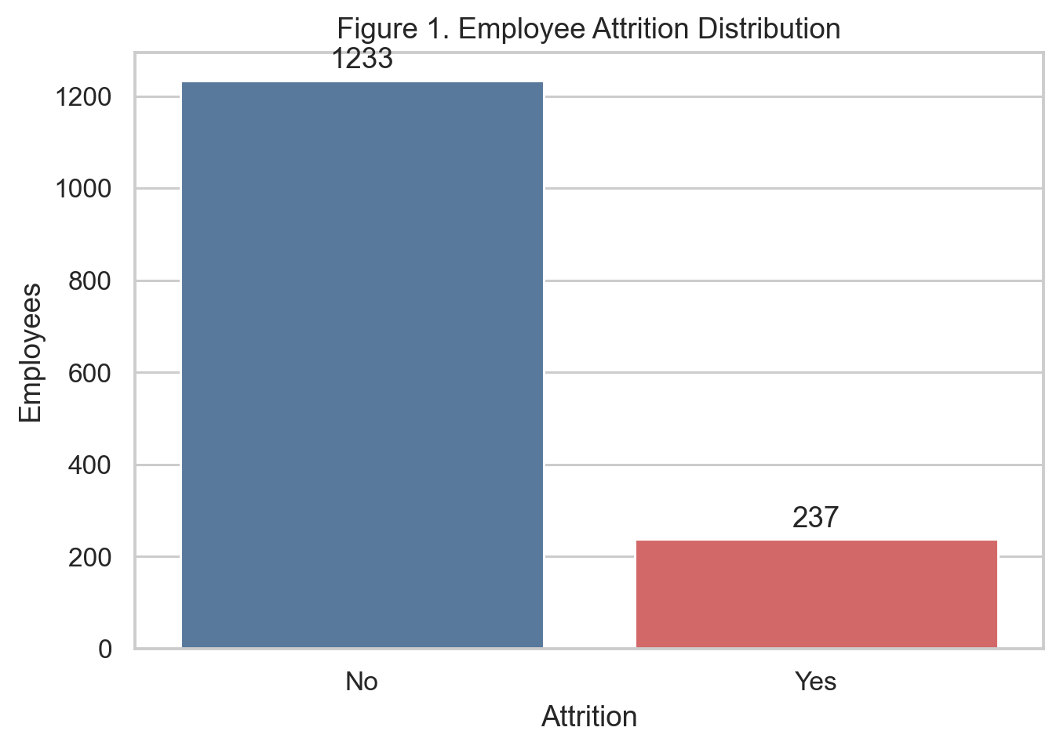
Figure 1. Employee attrition distribution in the supplied dataset.
Of 1,470 employees, 237 (16.1%) left and 1233 (83.9%) stayed. This imbalance explains why a majority-class baseline can reach high accuracy without detecting attrition.

8.2 Overtime and Role Patterns
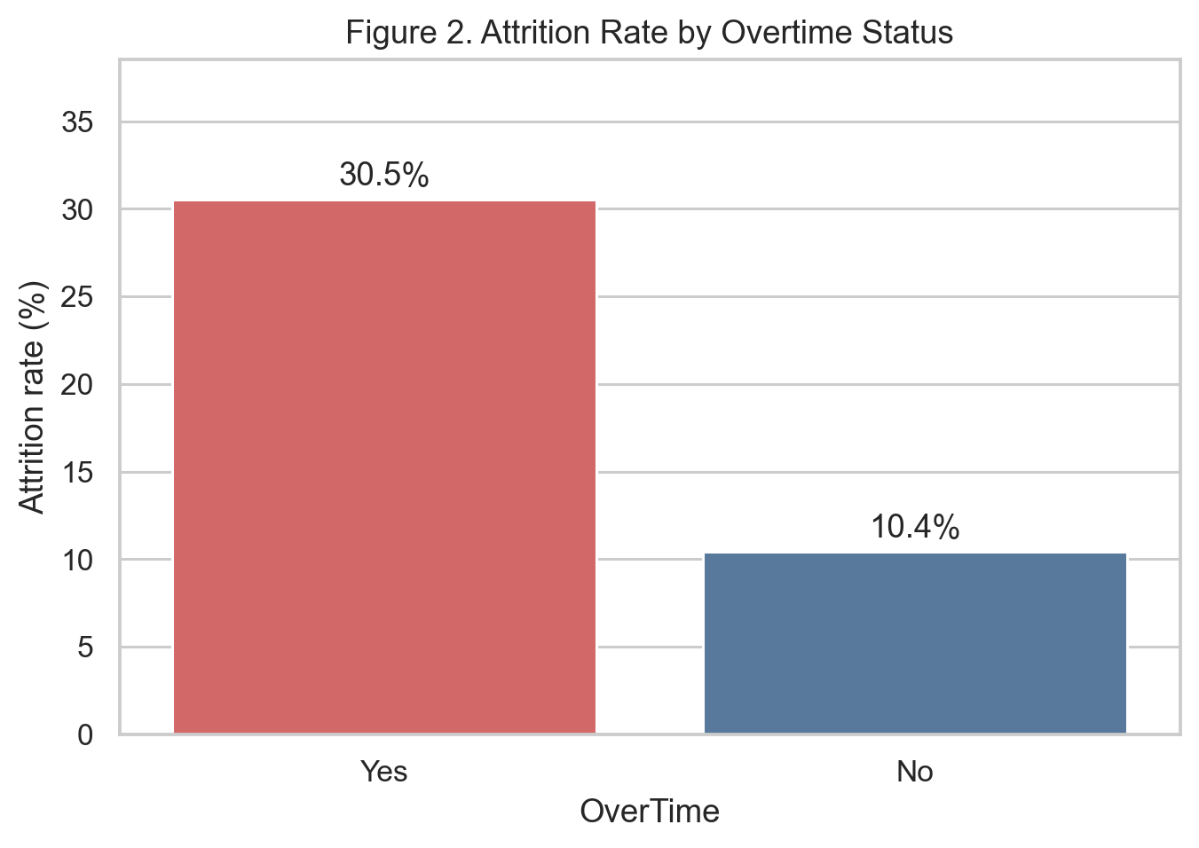
Figure 2. Attrition rate by overtime status.
Attrition was substantially higher among employees recorded as working overtime. This is a descriptive pattern, not proof that overtime causes departures; it nevertheless supports further workload and work-life investigation.
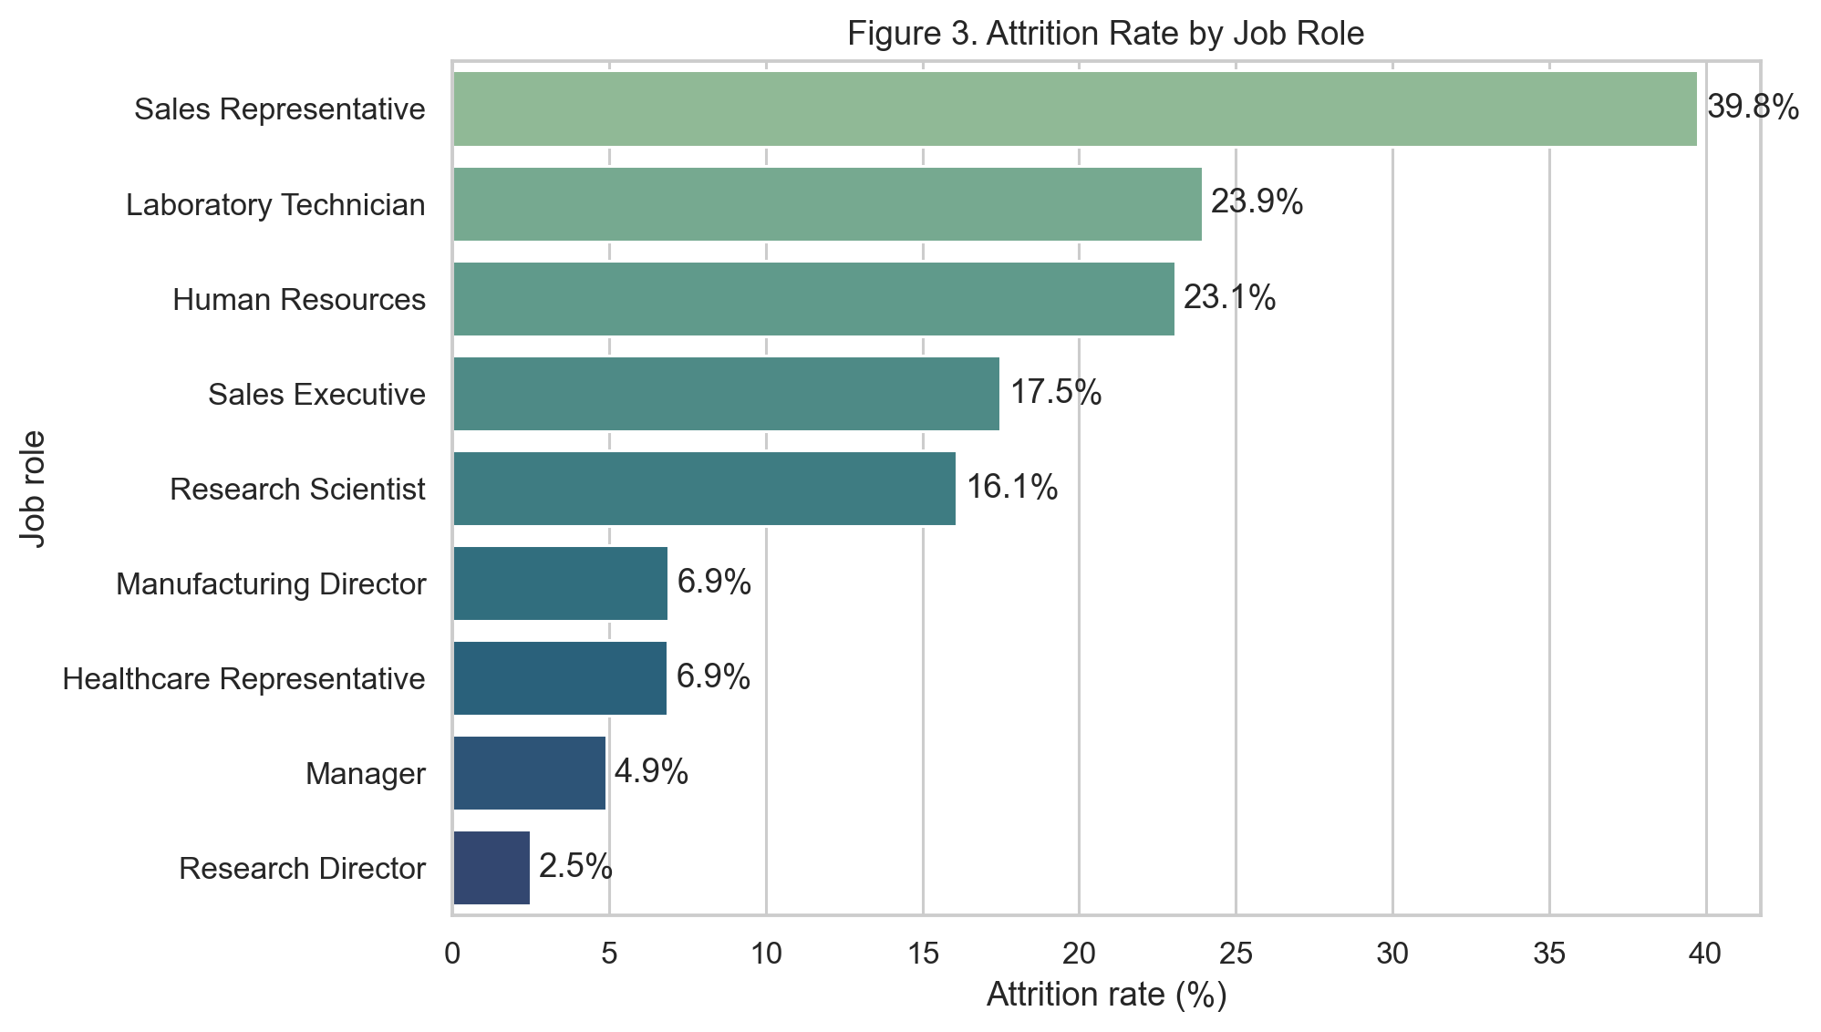
Figure 3. Attrition rate by job role.
Attrition varied materially across job roles. The report therefore treats role as an important contextual variable and recommends role-specific diagnosis rather than a one-size-fits-all retention policy.

8.3 Income and Age
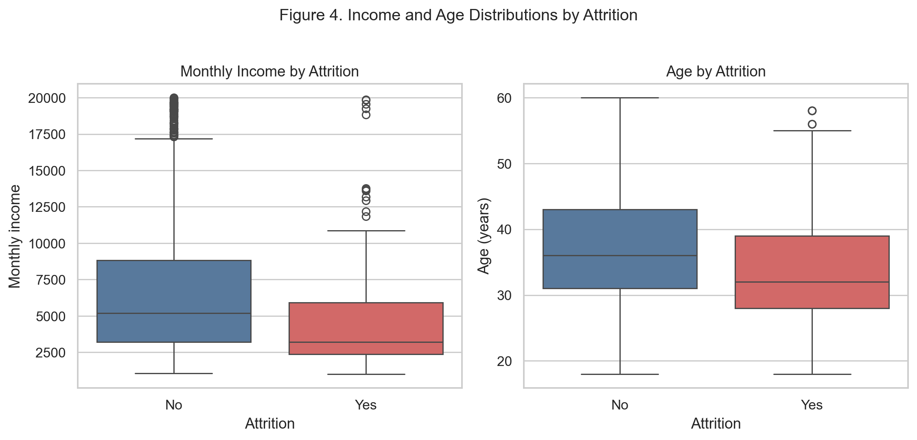
Figure 4. Monthly-income and age distributions by attrition outcome.
Employees who left had lower median income and were younger on average in this sample. The distributions overlap considerably, so neither feature alone identifies attrition; both should be interpreted with role, experience, and work-context variables.

8.4 Job Satisfaction and Correlations
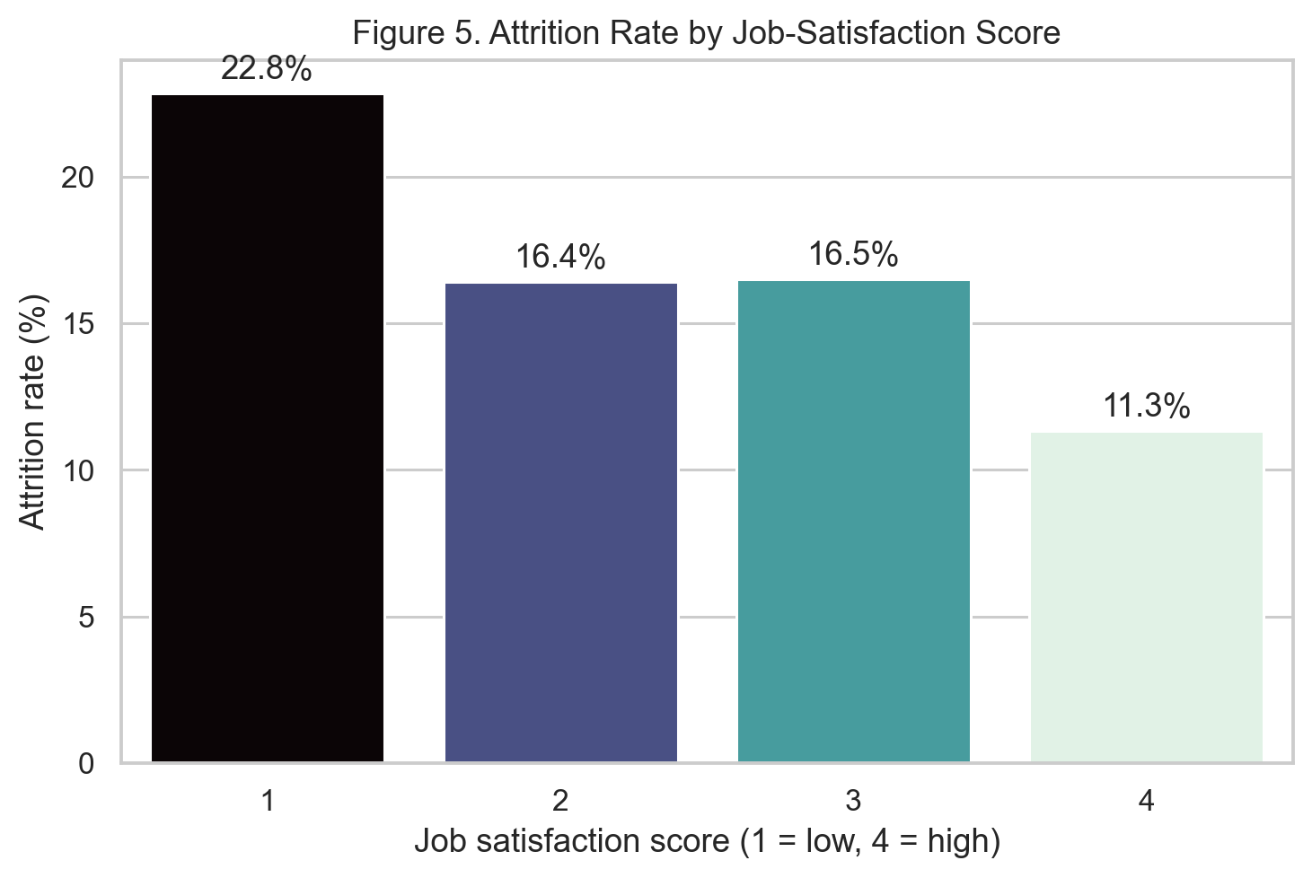
Figure 5. Attrition rate by job-satisfaction score.
The lowest job-satisfaction group had the highest attrition rate, while the highest-satisfaction group had the lowest. This supports using engagement indicators as signals for follow-up, while recognizing that satisfaction scores are subjective and correlational.
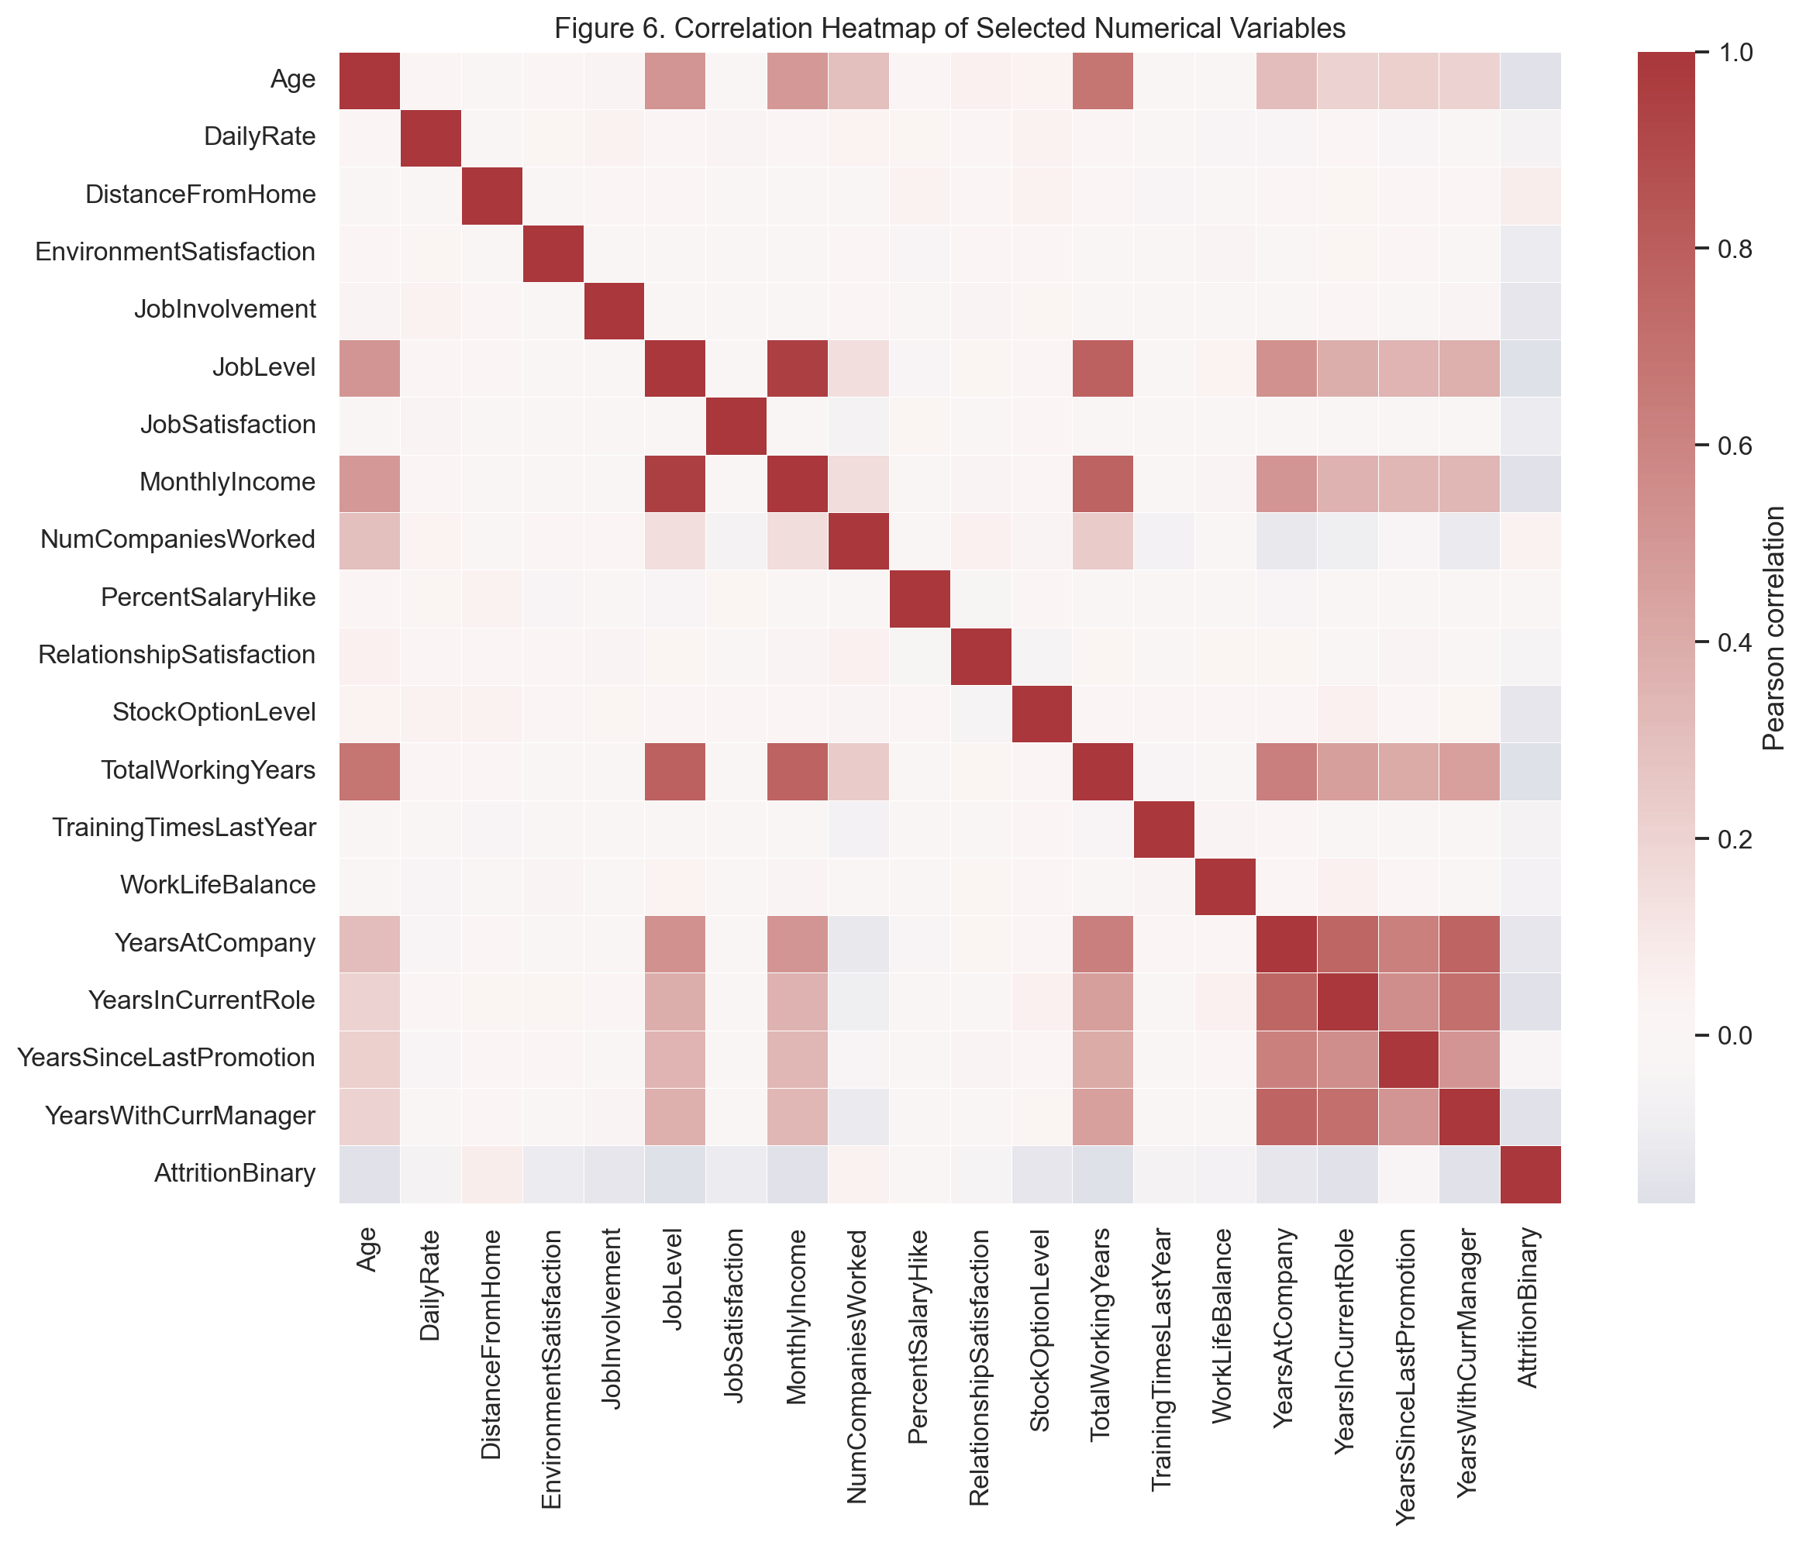
Figure 6. Correlation heatmap of selected numerical variables.
The heatmap summarizes linear relationships among selected numerical fields. Correlations are descriptive and do not establish causation. Experience, job-level, income, age, and tenure measures show negative descriptive correlations with attrition, but several are also related to one another.

9. STATISTICAL ANALYSIS
Outcome | Age mean / median | Income mean / median | Distance mean / median | Experience mean / median | Tenure mean / median
Stayed | 37.56 / 36 | 6,832.74 / 5,204 | 8.92 / 7 | 11.86 / 10 | 7.37 / 6
Left | 33.61 / 32 | 4,787.09 / 3,202 | 10.63 / 9 | 8.24 / 7 | 5.13 / 3

Table 5. Descriptive comparison of selected numerical variables by attrition outcome.
The attrition group had lower mean and median age, monthly income, total work experience, and company tenure, and a higher mean and median distance from home. Monthly income is right-skewed in both groups, as shown by means exceeding medians; the median is therefore particularly useful for typical-income comparison.
Numerical variable | Correlation with attrition
TotalWorkingYears | -0.171
JobLevel | -0.169
YearsInCurrentRole | -0.161
MonthlyIncome | -0.160
Age | -0.159
YearsWithCurrManager | -0.156
StockOptionLevel | -0.137
YearsAtCompany | -0.134

Table 6. Strongest absolute point-biserial-equivalent correlations with binary attrition among selected numerical variables.
The strongest listed correlations are modest in magnitude. This indicates that no single numerical measure is a complete explanation for attrition and motivates a multivariable model.

10. FEATURE ENGINEERING
No additional engineered variables were retained in the final model. The supplied data already contains direct, interpretable measures of age, role, income, satisfaction, travel, overtime, experience, and tenure. Retaining the original variables supports transparency and avoids creating arbitrary derived measures in a relatively small dataset.

11. MODEL DEVELOPMENT

11.1 Problem Formulation
This is a supervised binary classification problem. The positive class is Attrition = Yes. A prediction estimates risk from variables available in the supplied record; it is not an automated employment decision.

11.2 Model Selection
Three approaches were compared: a majority-class dummy baseline, balanced logistic regression, and random forest. Logistic regression is interpretable, works well with standardized numerical and one-hot categorical inputs, and its balanced class weights emphasize recognition of the minority attrition class. The random forest offers a nonlinear comparison but requires careful overfitting assessment.

11.3 Training Process
The balanced logistic-regression model used max_iter = 3000, C = 0.2, class_weight = balanced, and random_state = 42. Its preprocessing and classification stages were fit only on the 80% training partition. The held-out test set was used once for final comparison and evaluation.

12. MODEL EVALUATION
Model | Train accuracy | Test accuracy | Precision | Recall | F1 | ROC-AUC
Dummy baseline | 0.838 | 0.840 | 0.000 | 0.000 | 0.000 | 0.500
Balanced logistic regression | 0.779 | 0.759 | 0.360 | 0.660 | 0.466 | 0.810
Random forest | 0.995 | 0.830 | 0.444 | 0.255 | 0.324 | 0.796

Table 7. Held-out model comparison; precision, recall, and F1 refer to attrition.
The dummy model attains approximately 84% accuracy only because it predicts every employee will stay, yielding zero attrition recall and F1. The random forest has higher test accuracy but substantially lower attrition recall and F1, while also showing a large training-to-test accuracy gap. The balanced logistic-regression model is selected because it provides the highest attrition F1 and recall together with the highest ROC-AUC.
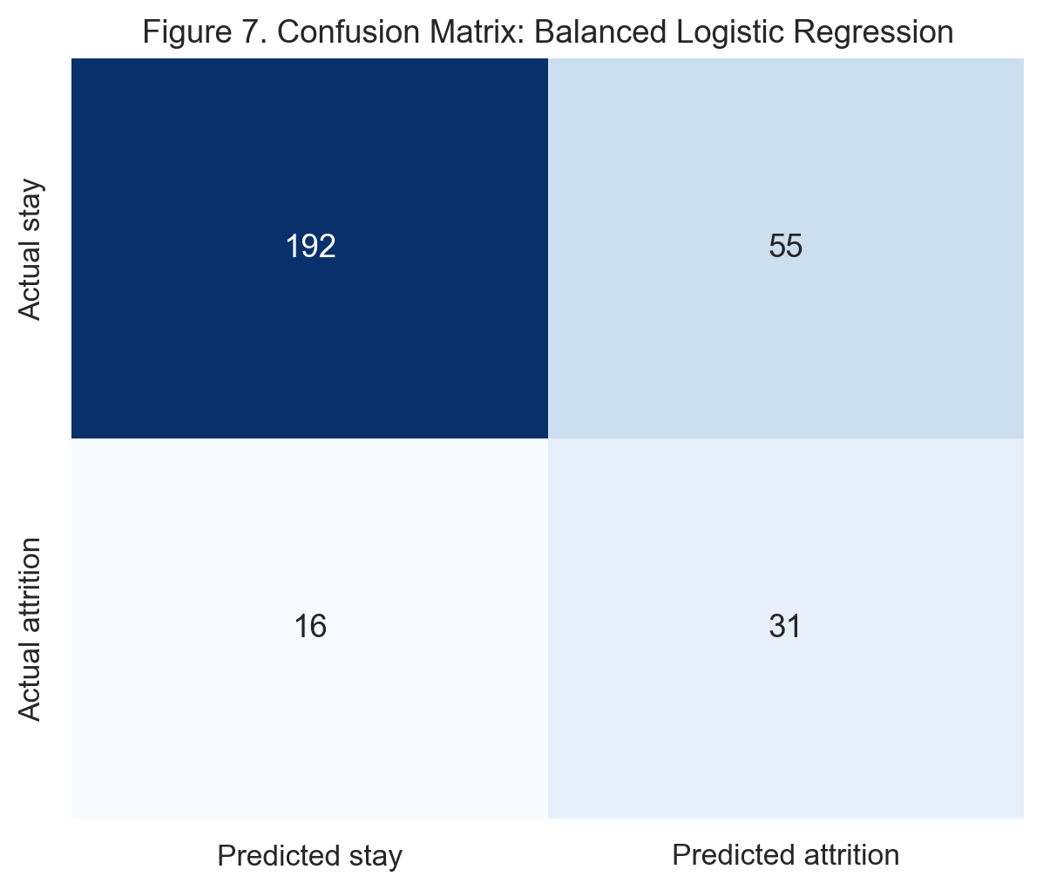
Figure 7. Confusion matrix for the selected balanced logistic-regression model.
On 294 held-out employees, the model correctly identified 31 of 47 employees who left and missed 16. It also flagged 55 employees who stayed. In a retention setting, a false negative may miss an employee who could benefit from support, while a false positive could consume resources or create an unnecessary conversation. Any practical alert should be reviewed by HR rather than acted on automatically.
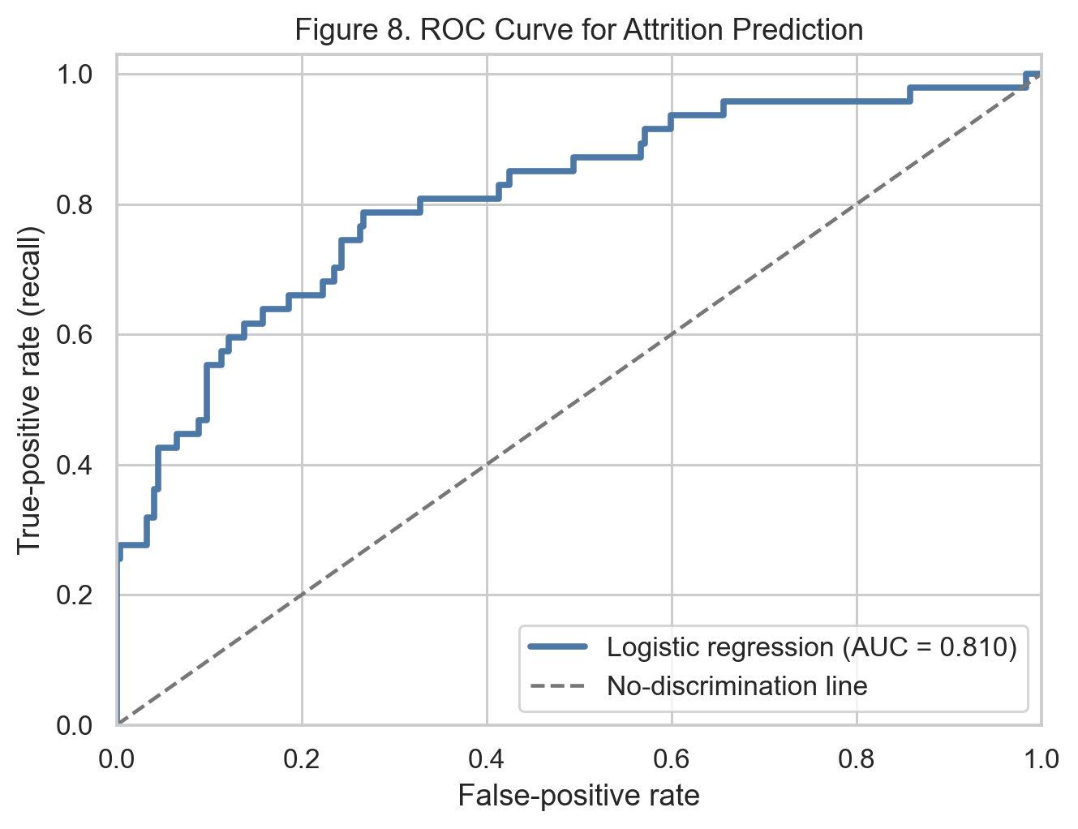
Figure 8. ROC curve for the selected attrition classifier.
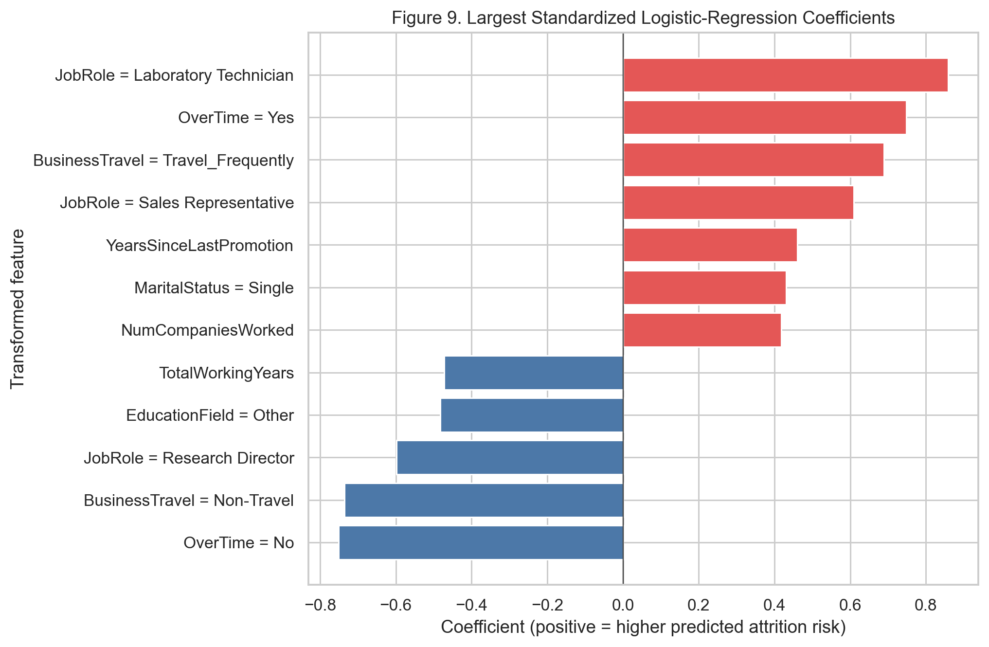
Figure 9. Largest standardized logistic-regression coefficients.
The selected model achieved 75.9% test accuracy, 36.0% attrition precision, 66.0% attrition recall, F1 = 0.466, and ROC-AUC = 0.810. Training accuracy was 77.9%, close to test accuracy, which does not indicate strong overfitting by this measure. Coefficients are predictive associations after adjustment for the included fields, not causal effects.

13. RESULTS AND FINDINGS
- Attrition affected 237 of 1,470 employees (16.1%), making minority-class-aware evaluation necessary (Figure 1 and Table 1).
- Employees working overtime had a 30.5% attrition rate compared with 10.4% among employees not working overtime (Figure 2).
- Sales Representatives had the highest observed job-role attrition rate (39.8%), followed by Laboratory Technicians (23.9%); role-specific risk patterns were visible across the data (Figure 3).
- Employees who left were younger, had lower monthly income and experience, had shorter company tenure, and lived farther from work on average than those who stayed (Table 5).
- Employees with the lowest job-satisfaction score had a 22.8% attrition rate, compared with 11.3% for the highest-satisfaction score (Figure 5).
- The selected balanced logistic-regression model achieved ROC-AUC 0.810 and recalled 66.0% of attrition cases on held-out data, but precision of 36.0% requires human review of any prediction-based intervention (Table 7 and Figure 7).

14. DISCUSSION
The EDA and model point to a coherent workforce-risk pattern: overtime, job-role context, travel, job satisfaction, experience, income, and tenure are all relevant signals. Overtime is particularly prominent both descriptively and in the model, whereas job role differentiates groups that may face distinct workloads, labor-market alternatives, or career pathways. The age, income, and experience findings should not be interpreted as a reason to target or disadvantage protected groups; rather, they suggest that early-career support, career conversations, and role-specific workload review deserve investigation.
Model choice illustrates why accuracy alone is insufficient. The dummy baseline achieved about 84% accuracy by identifying no attrition cases. The random forest improved overall accuracy but detected few employees who left and showed a large training-test gap. The balanced logistic-regression model accepts more false positives to find more true attrition cases and has the best ROC-AUC and attrition F1 of the compared models. This trade-off is appropriate for an exploratory retention-support use case, subject to careful governance and threshold review.

15. LIMITATIONS
- The dataset contains 1,470 records and may not represent another organization, labor market, job structure, or time period.
- The data is cross-sectional and contains no confirmed causal interventions or time sequence; associations cannot prove causes of attrition.
- Potentially relevant factors—such as manager quality, detailed workload, external labor-market conditions, and employee reasons for leaving—are unavailable.
- Attrition is imbalanced (16.1%), and the selected model has modest precision; predictions should not be used as automated employment decisions.
- Evaluation uses one stratified hold-out split from the same dataset. External validation, calibration checks, and fairness assessments are needed before deployment.

16. CONCLUSION
This capstone used the supplied HR dataset to study employee attrition and construct a transparent classification model. The analysis found meaningful associations between attrition and overtime, role, job satisfaction, travel, experience-related measures, income, and tenure. The selected balanced logistic-regression model reached ROC-AUC 0.810 and recalled approximately two-thirds of attrition cases on held-out data, although its precision shows that individual alerts require careful review. The study demonstrates that workforce analytics can direct retention investigation toward evidence-based patterns while maintaining the distinction between prediction and causation.

17. RECOMMENDATIONS AND FUTURE WORK

17.1 Recommendations
- Review overtime patterns and workload design. Attrition was 30.5% among overtime employees versus 10.4% among non-overtime employees; HR should examine staffing, scheduling, compensation, and work-life practices before making changes.
- Run role-specific retention reviews. Sales Representatives and Laboratory Technicians showed the highest observed attrition rates, so their leaders should investigate workload, progression, training, pay competitiveness, and team climate rather than applying generic initiatives.
- Strengthen early-career and tenure support. Employees who left had lower median age, total experience, and company tenure; structured onboarding, mentorship, early check-ins, and clear internal-mobility conversations are appropriate hypotheses to test.
- Prioritize engagement follow-up. The low job-satisfaction group had approximately double the attrition rate of the highest-satisfaction group; confidential listening sessions and targeted manager action plans should be monitored for improvement.
- Use model scores only as a review signal. The model can help prioritize voluntary retention conversations, but HR should validate performance on current data, set governance rules, test fairness, and ensure predictions never drive adverse decisions.

17.2 Future Work
Future work should validate the pipeline on a temporally newer or external workforce sample; add ethically collected variables such as manager support and employee feedback; assess probability calibration and group fairness; use cross-validation during model selection; and evaluate whether retention interventions actually improve employee outcomes.

18. REFERENCES
- India Data Research Academy. (2026). Capstone Project Guide 2026. Department of Data Science and AI.
- India Data Research Academy. (2026). P_7_WA_Fn-UseC_-HR-Employee-Attrition.csv [Dataset supplied through the LMS].
- Pedregosa, F., Varoquaux, G., Gramfort, A., et al. (2011). Scikit-learn: Machine learning in Python. Journal of Machine Learning Research, 12, 2825–2830.
- The pandas development team. (2026). pandas documentation. https://pandas.pydata.org/

APPENDIX A. SELECTED CODE
The complete executable workflow is provided in StudentName_Project7_Employee_Attrition.ipynb and project7_analysis.py. The following excerpt shows the core preprocessing specification.

A.1 Data Loading and Inspection
raw = pd.read_csv(RAW_PATH)
print('File:', RAW_PATH.name)
print('Shape:', raw.shape)
print('\nColumn dtypes:\n', raw.dtypes)
display(raw.head())
display(raw.describe(include='all').transpose().head(15))
target_counts = raw['Attrition'].value_counts()
baseline_rate = (raw['Attrition'] == 'Yes').mean() * 100
print('\nAttrition counts:\n', target_counts)
print(f'Baseline attrition rate: {baseline_rate:.2f}%')

A.2 Data Cleaning
missing = raw.isna().sum()
duplicates = raw.duplicated().sum()
print('Total missing values:', missing.sum())
print('Duplicate rows:', duplicates)

clean = raw.copy()
text_columns = clean.select_dtypes(include=['object', 'string']).columns
for column in text_columns:
clean[column] = clean[column].astype(str).str.strip()
clean['AttritionBinary'] = (clean['Attrition'] == 'Yes').astype(int)

for column in ['Age', 'MonthlyIncome', 'TotalWorkingYears', 'YearsAtCompany']:
print(column, 'min/max:', clean[column].min(), clean[column].max())

outlier_rows = []
for column in ['Age', 'MonthlyIncome', 'DistanceFromHome', 'TotalWorkingYears', 'YearsAtCompany']:
q1, q3 = clean[column].quantile([0.25, 0.75])
iqr = q3 - q1
flagged = ((clean[column] < q1 - 1.5 * iqr) | (clean[column] > q3 + 1.5 * iqr)).sum()
outlier_rows.append({'Variable': column, 'IQR_flagged': int(flagged)})
display(pd.DataFrame(outlier_rows))

clean.to_csv(CLEAN_PATH, index=False)
print('Saved cleaned data to', CLEAN_PATH)

A.3 Preprocessing
excluded = ['Attrition', 'AttritionBinary', 'EmployeeNumber', 'EmployeeCount', 'Over18', 'StandardHours']
X, y = clean.drop(columns=excluded), clean['AttritionBinary']
numeric_features = X.select_dtypes(include='number').columns.tolist()
categorical_features = X.select_dtypes(exclude='number').columns.tolist()
print('Numeric features:', len(numeric_features))
print('Categorical features:', len(categorical_features))
preprocessor = ColumnTransformer([
('numeric', Pipeline([('imputer', SimpleImputer(strategy='median')), ('scaler', StandardScaler())]), numeric_features),
('categorical', Pipeline([('imputer', SimpleImputer(strategy='most_frequent')),
('onehot', OneHotEncoder(handle_unknown='ignore'))]), categorical_features),
])

A.4 EDA and Visualization
plt.figure(figsize=(6.3, 4.5))
ax = sns.countplot(data=clean, x='Attrition', hue='Attrition', order=['No', 'Yes'], palette=PALETTE, legend=False)
ax.set(title='Figure 1. Employee Attrition Distribution', xlabel='Attrition', ylabel='Employees')
for container in ax.containers: ax.bar_label(container, padding=3)
plt.show()
save_figure('figure_1_attrition_distribution.png')

overtime_table = rate_table(clean, 'OverTime')
display(overtime_table)
plt.figure(figsize=(6.3, 4.5))
ax = sns.barplot(data=overtime_table, x='OverTime', y='AttritionRate', hue='OverTime', palette=PALETTE, legend=False)
ax.set(title='Figure 2. Attrition Rate by Overtime Status', xlabel='OverTime', ylabel='Attrition rate (%)')
plt.show()
save_figure('figure_2_overtime_attrition.png')

role_table = rate_table(clean, 'JobRole')
plt.figure(figsize=(9.2, 5.3))
ax = sns.barplot(data=role_table, y='JobRole', x='AttritionRate', hue='JobRole', palette='crest', legend=False)
ax.set(title='Figure 3. Attrition Rate by Job Role', xlabel='Attrition rate (%)', ylabel='Job role')
plt.show()
save_figure('figure_3_job_role_attrition.png')

fig, axes = plt.subplots(1, 2, figsize=(10.4, 4.8))
sns.boxplot(data=clean, x='Attrition', y='MonthlyIncome', hue='Attrition', order=['No', 'Yes'], palette=PALETTE, legend=False, ax=axes[0])
sns.boxplot(data=clean, x='Attrition', y='Age', hue='Attrition', order=['No', 'Yes'], palette=PALETTE, legend=False, ax=axes[1])
fig.suptitle('Figure 4. Income and Age by Attrition', y=1.02)
plt.show()
save_figure('figure_4_income_age_by_attrition.png')

satisfaction_table = rate_table(clean, 'JobSatisfaction')
plt.figure(figsize=(6.8, 4.6))
ax = sns.barplot(data=satisfaction_table, x='JobSatisfaction', y='AttritionRate', hue='JobSatisfaction', palette='mako', legend=False)
ax.set(title='Figure 5. Attrition Rate by Job Satisfaction', xlabel='Score (1=low, 4=high)', ylabel='Attrition rate (%)')
plt.show()
save_figure('figure_5_job_satisfaction_attrition.png')

A.5 Model Training and Evaluation
X_train, X_test, y_train, y_test = train_test_split(
X, y, test_size=0.20, random_state=RANDOM_STATE, stratify=y
)
print('Training rows:', X_train.shape[0])
print('Test rows:', X_test.shape[0])
print('Train attrition rate:', y_train.mean() * 100)
print('Test attrition rate:', y_test.mean() * 100)

model_specs = {
'Dummy baseline': DummyClassifier(strategy='most_frequent'),
'Balanced logistic regression': LogisticRegression(max_iter=3000, class_weight='balanced', C=0.2, random_state=RANDOM_STATE),
'Random forest': RandomForestClassifier(n_estimators=500, min_samples_leaf=3, max_features='sqrt', class_weight='balanced', random_state=RANDOM_STATE, n_jobs=1),
}
fitted = {}
for name, estimator in model_specs.items():
pipe = Pipeline([('model', estimator)]) if name == 'Dummy baseline' else Pipeline([('preprocessor', preprocessor), ('model', estimator)])
pipe.fit(X_train, y_train)
fitted[name] = pipe
print('Models trained:', list(fitted.keys()))

rows = []
for name, pipe in fitted.items():
pred = pipe.predict(X_test)
proba = pipe.predict_proba(X_test)[:, 1]
rows.append({
'Model': name,
'Train accuracy': pipe.score(X_train, y_train),
'Test accuracy': accuracy_score(y_test, pred),
'Precision (attrition)': precision_score(y_test, pred, zero_division=0),
'Recall (attrition)': recall_score(y_test, pred, zero_division=0),
'F1 (attrition)': f1_score(y_test, pred, zero_division=0),
'ROC-AUC': roc_auc_score(y_test, proba),
})
comparison = pd.DataFrame(rows).round(3)
display(comparison)

final_model = fitted['Balanced logistic regression']
test_pred = final_model.predict(X_test)
test_proba = final_model.predict_proba(X_test)[:, 1]
print('\nClassification report (positive class = Attrition):')
print(classification_report(y_test, test_pred, target_names=['Stay', 'Attrition']))

APPENDIX B. ADDITIONAL TABLES
Job role | Employees | Attrition rate
Sales Representative | 83 | 39.76%
Laboratory Technician | 259 | 23.94%
Human Resources | 52 | 23.08%
Sales Executive | 326 | 17.48%
Research Scientist | 292 | 16.10%
Manufacturing Director | 145 | 6.90%
Healthcare Representative | 131 | 6.87%
Manager | 102 | 4.90%
Research Director | 80 | 2.50%
Table B1. Attrition rate by job role.
Job-satisfaction score | Employees | Attrition rate
1 | 289 | 22.84%
3 | 442 | 16.52%
2 | 280 | 16.43%
4 | 459 | 11.33%
Table B2. Attrition rate by job-satisfaction score.

