Supermarket Sales Analysis (January 2019 – March 2019)

ASSIGNMENT 1

# Bar Chart – Total Sales by Product Line

**Goal:** To analyse and compare total sales across different product lines in order to determine the top-performing category.

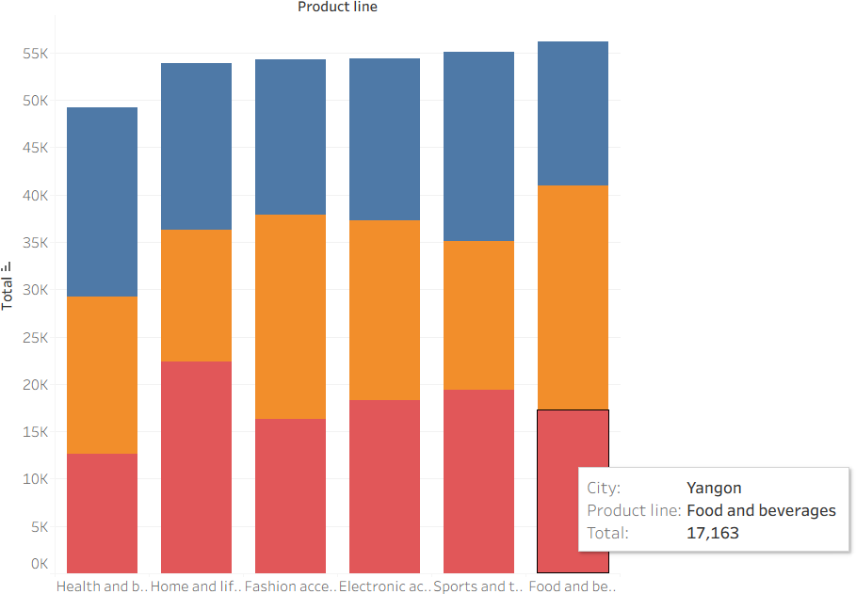

# Pie Chart – Payment Method Usage

**Goal:** To represent the percentage distribution of transactions across different payment methods.

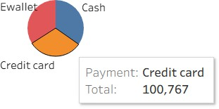

# Stacked Bar Chart – Sales by Gender in Each Product Line

**Goal:** To analyse gender-based differences in sales across product lines.

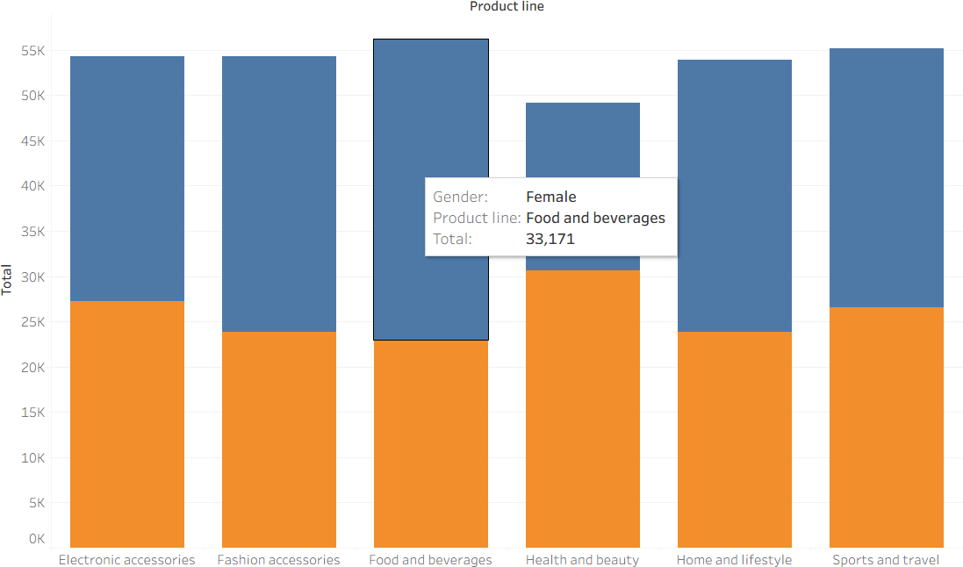

# Line Chart – Daily Sales Trend

**Goal:** To analyse variations in daily sales to identify patterns and trends over the recorded time period

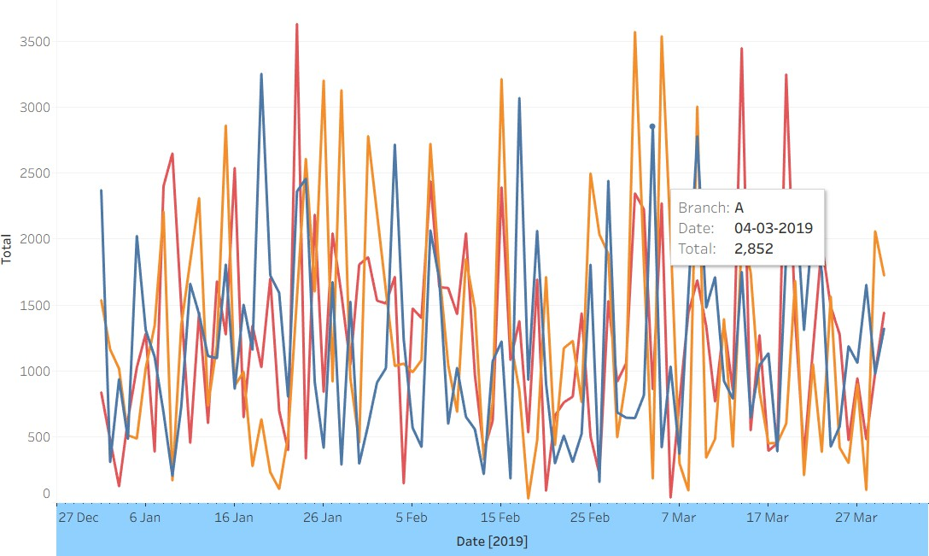

# Bubble Chart – Gross Income by City

**Goal:** To highlight and compare the total gross income generated by each city.

