Assignment 2

Supermarket Sales Analysis (Jan–Mar 2019)

# Donut Chart

* + **Use Case**: Show distribution of sales by *Payment Method* or *Customer Type*.

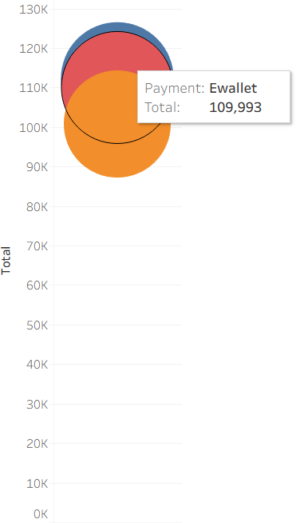

# Area Chart

* + **Use Case**: Show trend of Total Sales over time.

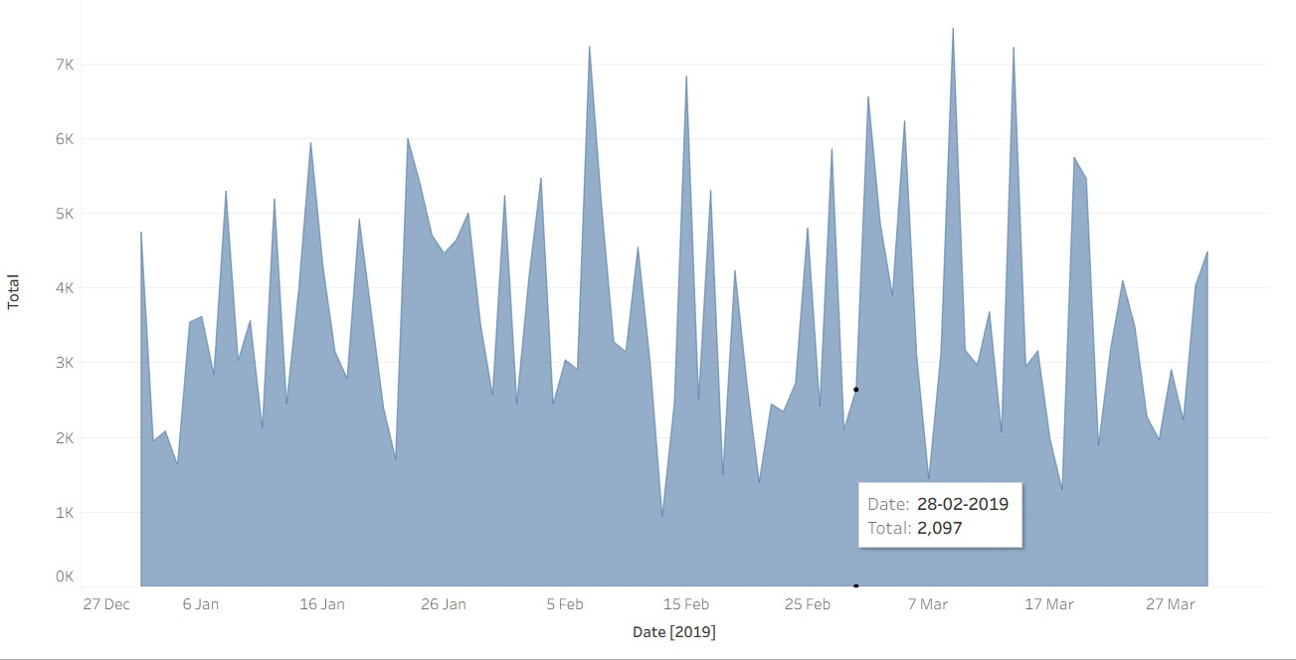

# Text Table

* + **Use Case**: Display detailed values like *Branch-wise sales*.

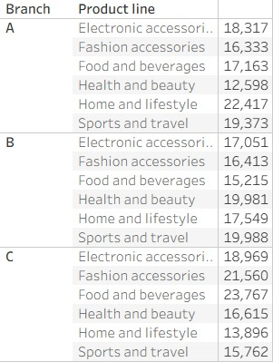

# Highlighted Table

* + **Use Case**: Visual emphasis on high or low values (e.g., *Rating by City*).

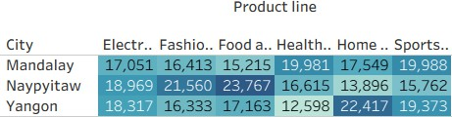

# WordCloud

* + **Use Case**: Visual frequency of product lines or customer types.

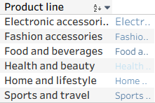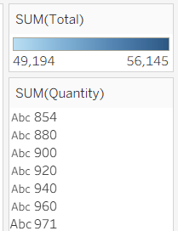

# Funnel Chart

* + **Use Case**: Show customer movement or sales quantity by stage (e.g., by Product Line).

1. 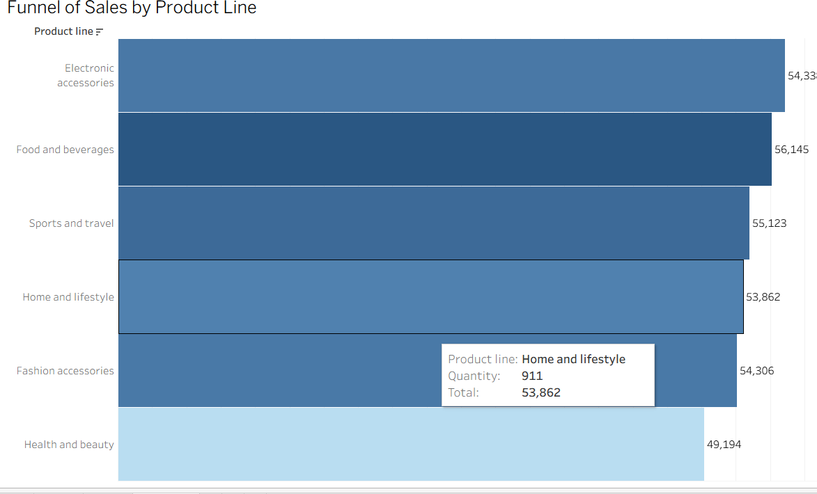**Waterfall Chart**
   * **Use Case: Show cumulative effect of sales over time or per branch.**

