ASSIGNMENT 3

Interactive Dashboard – Supermarket Sales

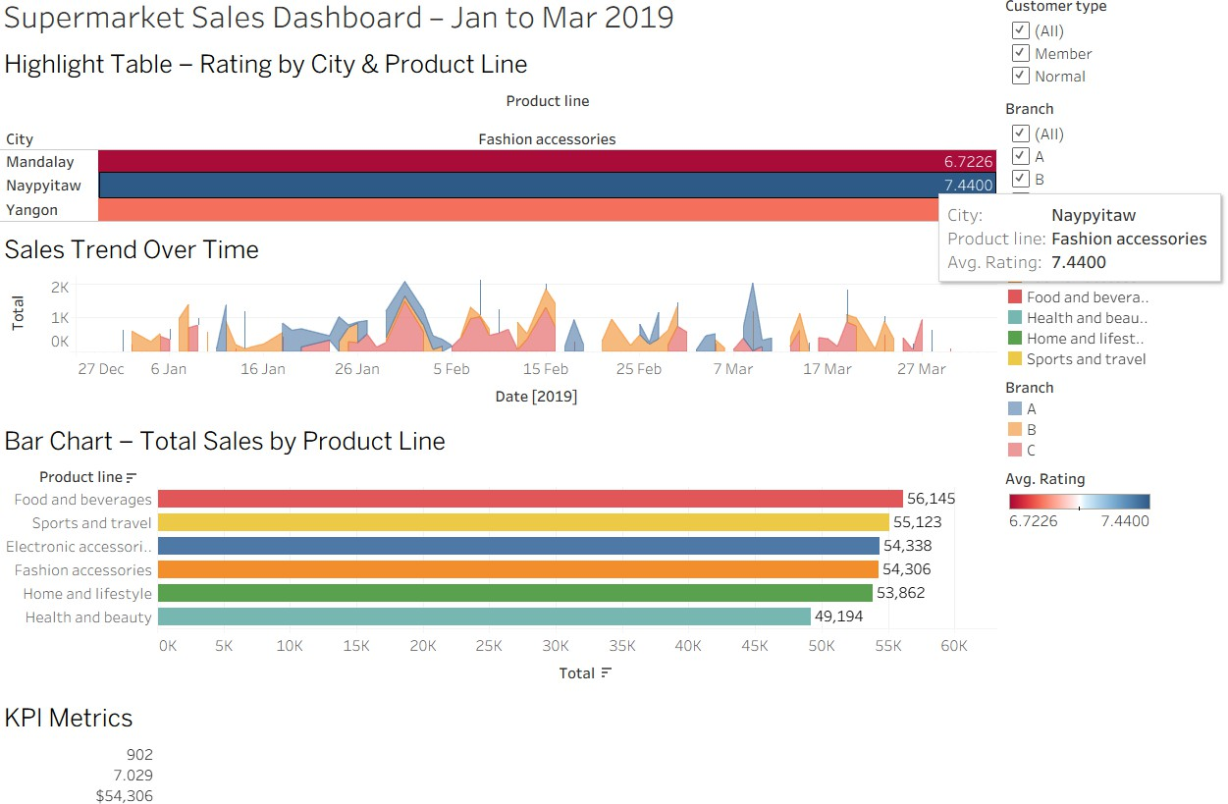

The Supermarket Sales Dashboard (Jan–Mar 2019) shows that Food and Beverages had the highest total sales (56,145), while Health and Beauty had the lowest (49,194). Naypyitaw recorded the highest average rating (7.44) for fashion accessories. The overall average rating was 7.03, with 902 invoices and total revenue of $54,306. Sales peaked around early February and mid-March.