**PCB Report- LAB 5**

**SBB PDN and slammer circuit**

**Objective:**

Using a simple slammer circuit, which can draw fast transient current from the power rail, we try to observe the noise induced by the inductance of the power rail due to the sudden surge in current over the rail. This is exactly what happens when an IC suddenly switches current as when it drives I/O signals. Furthermore, we try to reduce the noise by adding a decoupling capacitor at the desired location in the circuit.

**Component listing:**

* Op-amp: T272I
* MOSFET: IRL520N
* Resistor: 10Ω

**Napkin Sketch:**

*Fig 1.1 Circuit diagram of slammer circuit.*

**Calculation:**

Thevenin resistance of the source:

Measured Vth = 8.6V, VLoad = 8.4V when a load of 47 ohms is applied. So, the Thevenin resistance is

RLoad * (Vth - VLoad) / VLoad = 47 * (8.6 – 8.4) / 8.4 = 1.11 ohms.

Going further, our intention is to draw more current using a MOSFET for a short period of time. So, let's consider a 10-ohm resistor as the load. The maximum expected current draw will be:

I = (Threshold gate voltage – voltage drop by MOSFET)/Resistor = (5-1.5)/10 = **350mA**.

Power consumption by the resistor would be 0.25W, but the power dissipated by the resistor should be:

P = I^2 * R = (350)^2 * 10 = 1.2W

This amount of power can damage the resistor, making it unacceptable. Additionally, we want to observe the transition of current to detect noise in the power rail. Therefore, a gate signal is applied with a 5-10% duty cycle. Although our calculation allows for a duty cycle of up to 20%, we opt for a 5% duty cycle to ensure a shorter duration of current transition.

**Scope output:**

* Rise time of the Slow signal:

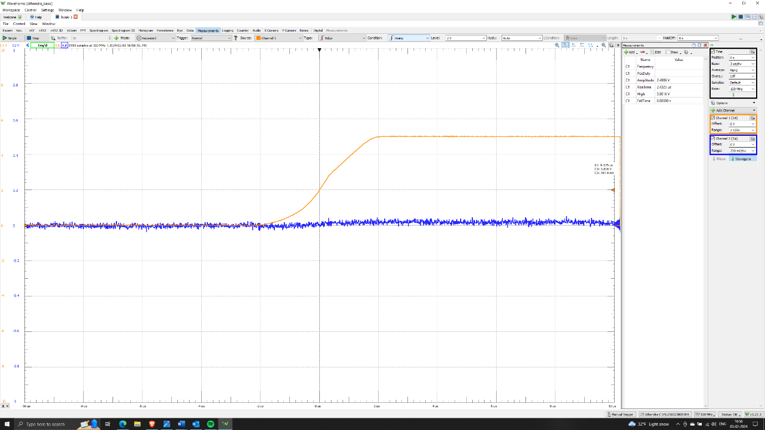

Measured rise time of 2.4us with 5% duty cycle.

* Fall time of Slow signal:

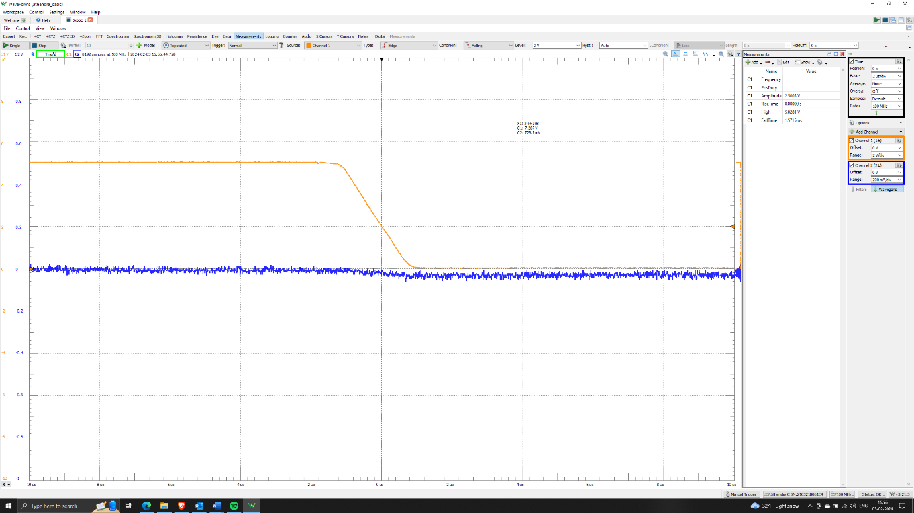

Fall time of slow signal is 1.5us and amplitude of the signal around 5V.

* Rise time of Fast signal:

Measured rise time of 35.4ns with 5% duty cycle.

* Fall time of Fast signal:

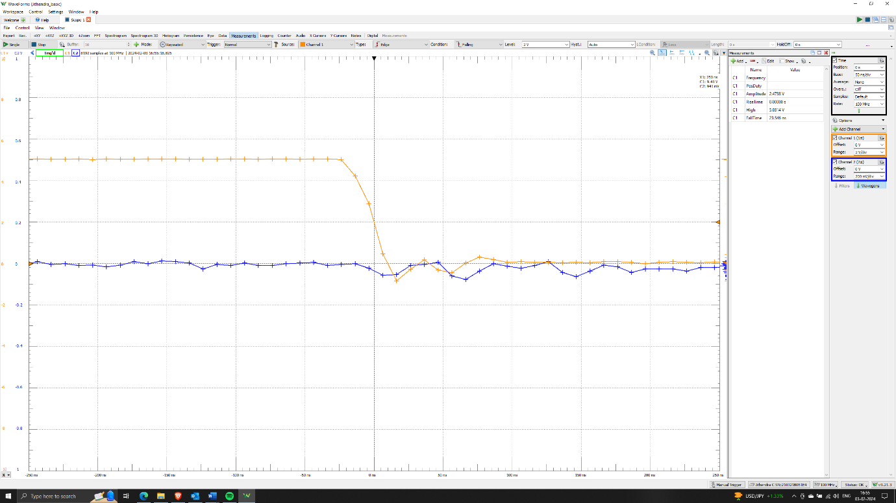

Fall time of Fast signal is 23.5ns

* Slow signal without decoupling capacitor

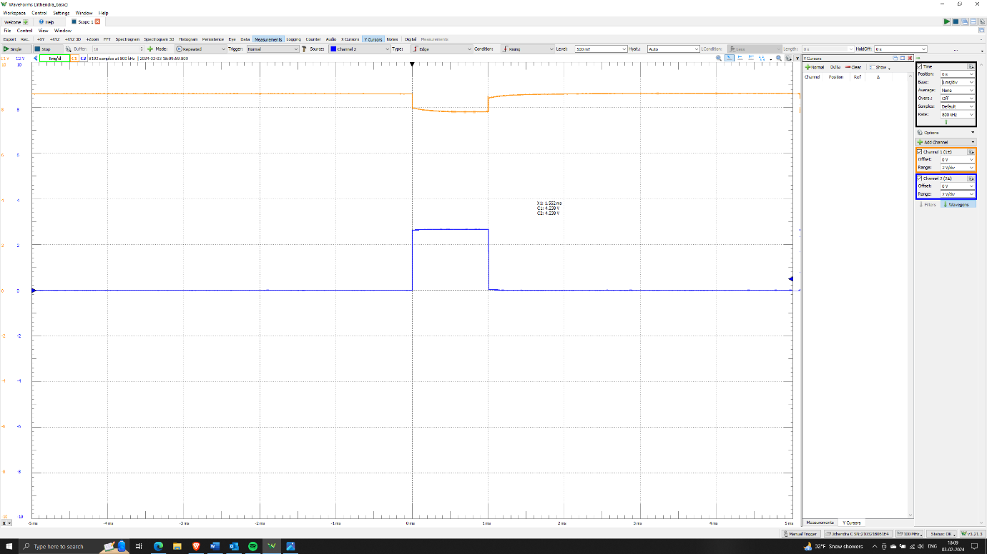

Clearly, there is a voltage drop when the MOSFET gate is turned on and starts drawing current. The observed noise here is minimal or negligible. The voltage drops seen are around 0.8 volts, but the expected voltage drop across the Thevenin resistance is only (270mA * 1.11) 0.3V. The remaining voltage drop is due to loop inductance induced during current draw, which can be calculated as the voltage change equals L *(dI/dt).

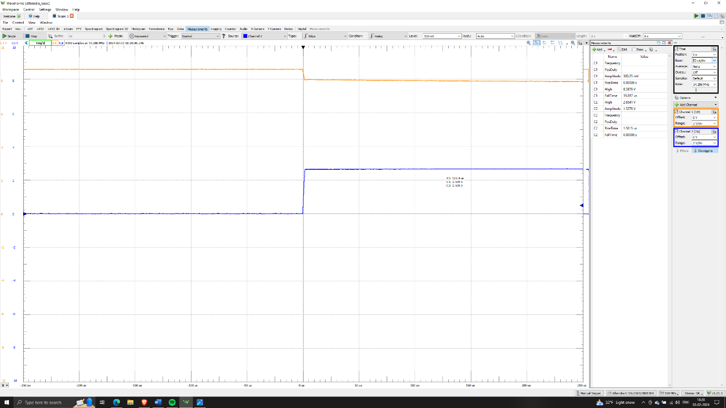

The above waveforms depict the change in voltage at the power rail (orange) during slow signal rise and fall times (blue). The measured current through the 10-ohm resistor is 270mA. From the above figures, we can easily determine that the loop inductance induced is L = voltage change due to inductance/(dI/dt) = (0.8 – 0.3)/(270mA/1.5us) = 2.7uH.

* Slow signal with decoupling capacitor

Adding a decoupling capacitor to this slow signal system may not have much impact, so further observation is not mentioned here.

* Fast signal without decoupling capacitor

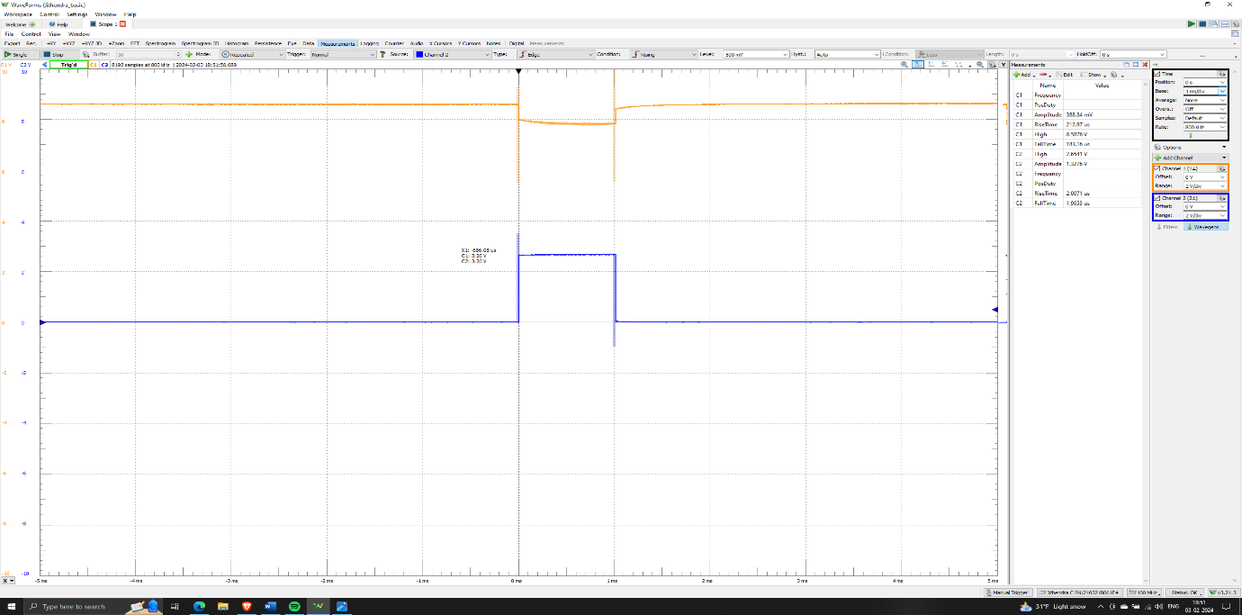

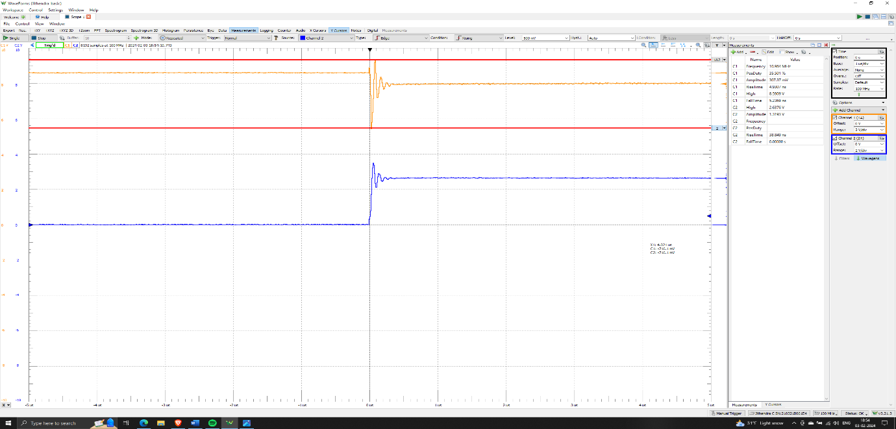

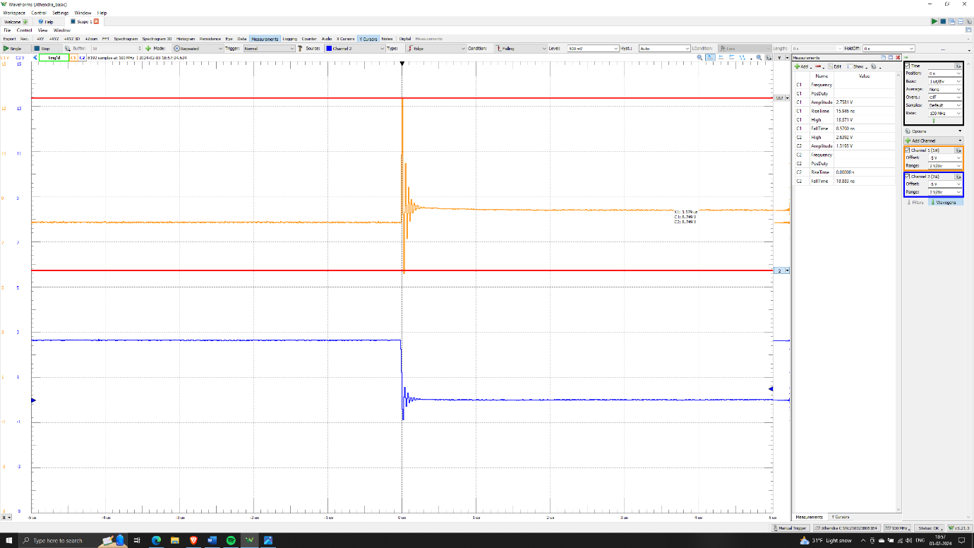

From the above output, we can observe significant noise induced during the switching of the signal from low to high and vice versa. During the rising edge, the noise voltage varies from 5.5 to 9.1 volts, and during the falling edge, it varies from 5.7 to 13.38 volts. The loop inductance induced during the rising edge is calculated as L = voltage change due to inductance/(dI/dt) = (9.1 – 5.5)/(270mA/38.8ns) = 517nH. Similarly, during the falling edge, L = (13.38 – 5.7)/(270mA/18.8ns) = 534nH. These fluctuations lead to major voltage fluctuations on high-frequency boards.

* Fast signal with decoupling capacitor

Added a suitable decoupling capacitor and placed it near the MOSFET collector led to a reduction in switching noise. The capacitor value is calculated as C = change in charge/ change in voltage = (I * t)/V = (270mA * 38.8ns)/0.8 = 13nF. However, for convenience, the behavior was verified by adding 1uF and 1000uF capacitors.

Added 1uF capacitor far from IP:  
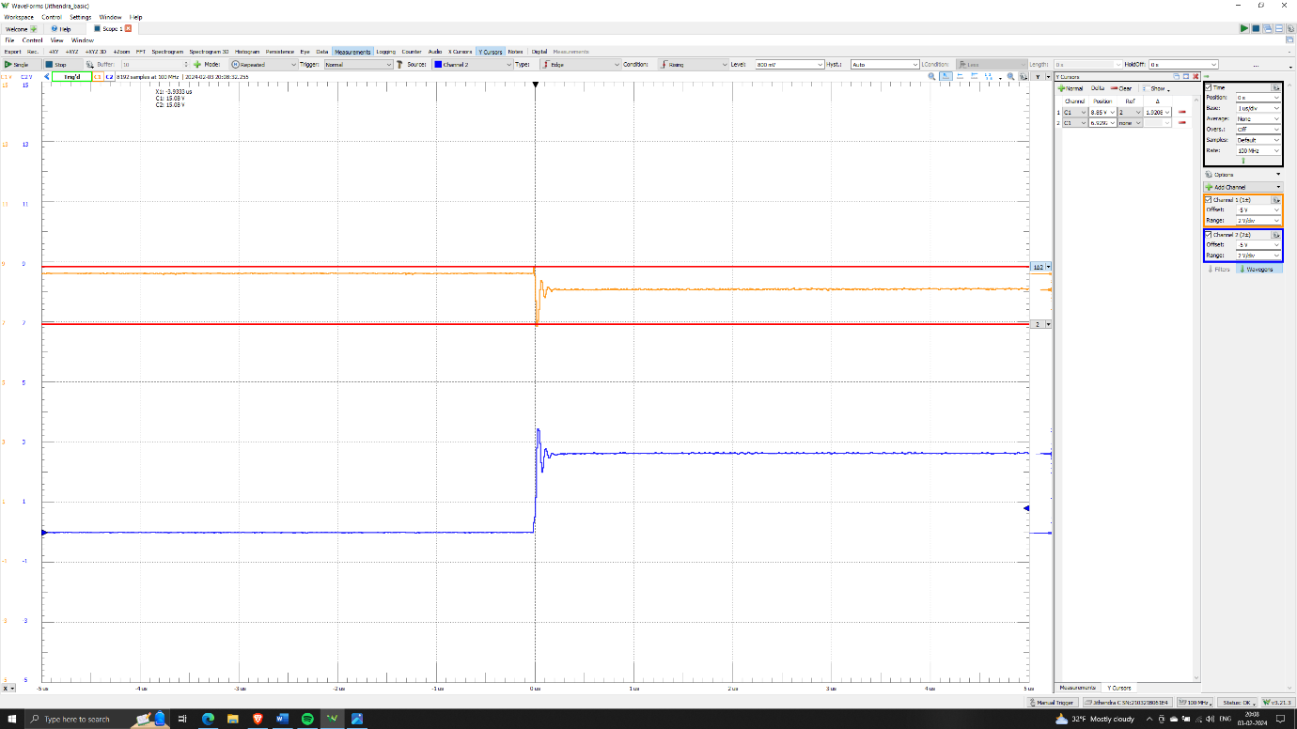

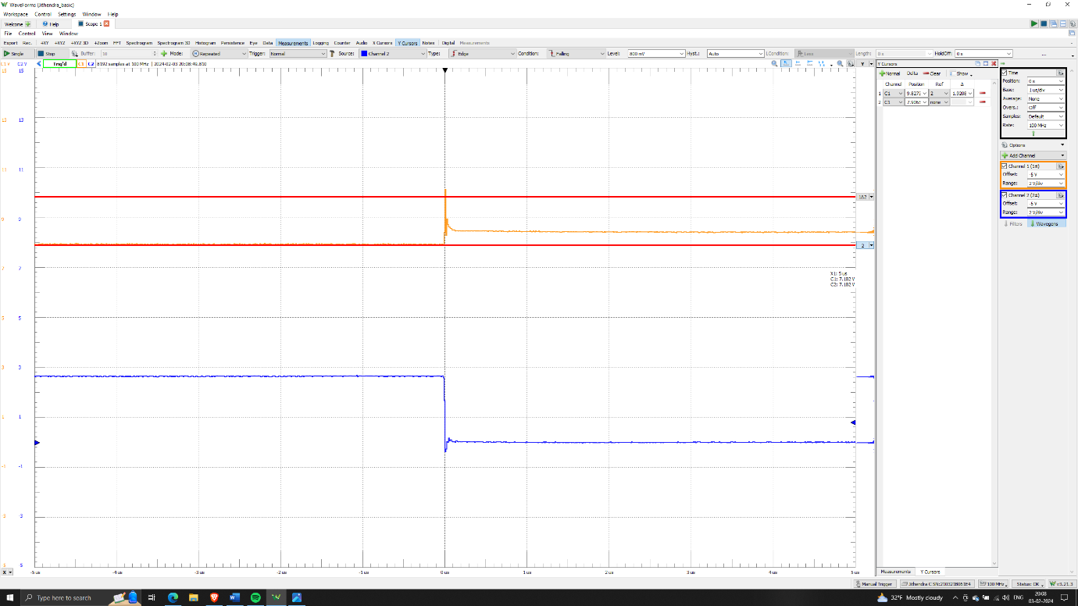

The Switching noise reduced to 1.9V, which can be seen in both rise edge and falling edge from above captures.

Added 1uF capacitor close to IP:

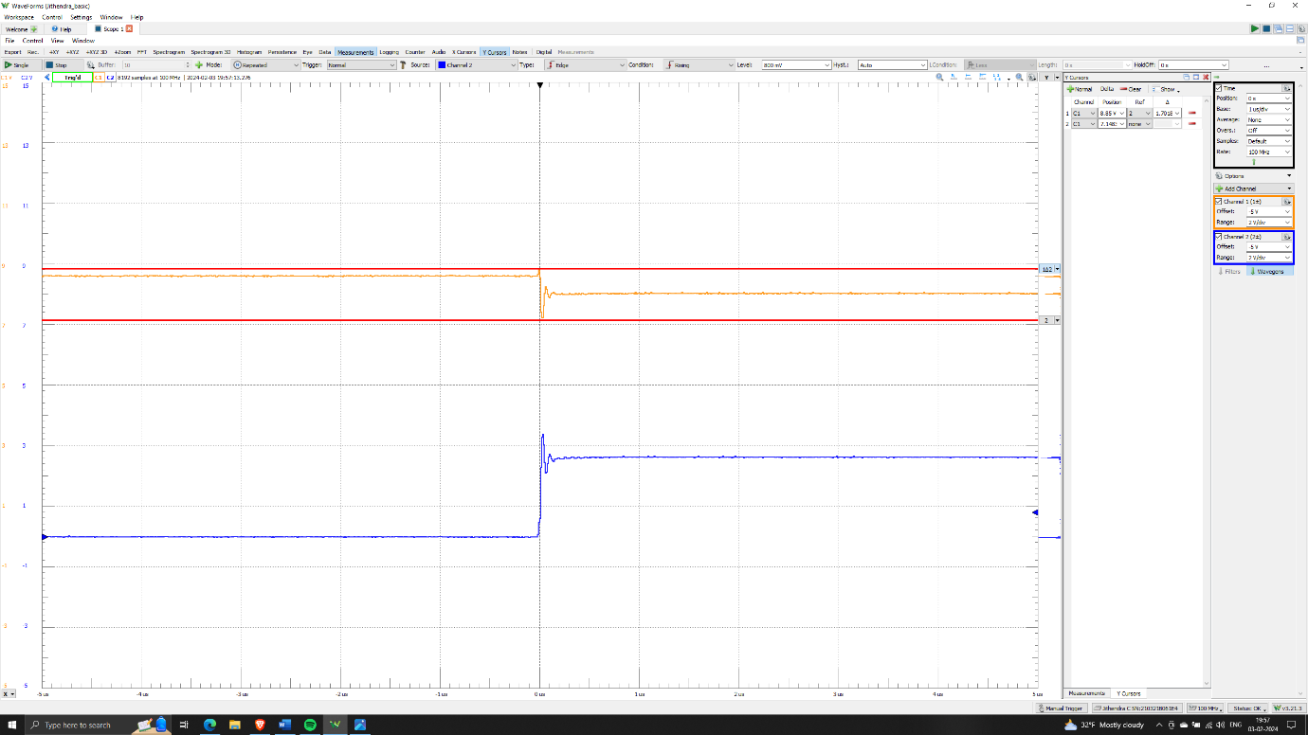

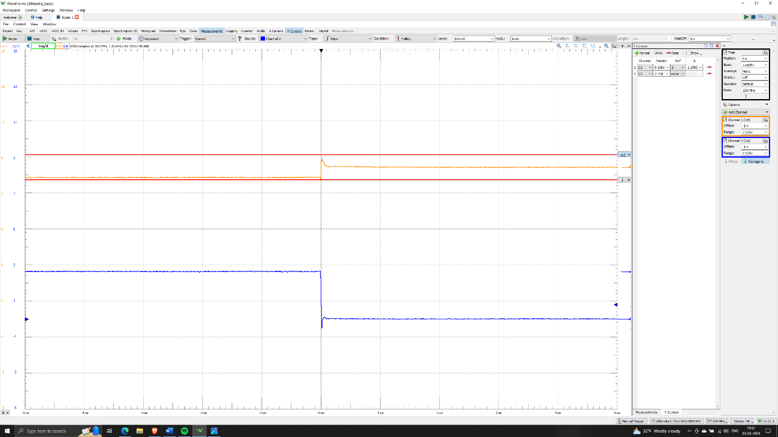

Adding a decoupling capacitor (local power source) nearer to the IP package helped reduce loop inductance drastically by eliminating the current surge/transition during signal switching over large power rail connection. The switching noise reduced to its minimum at the rise edge, measuring 1.7V, and 1.3V at the fall edge with SBB.

Added 1000uF capacitor close to IP:

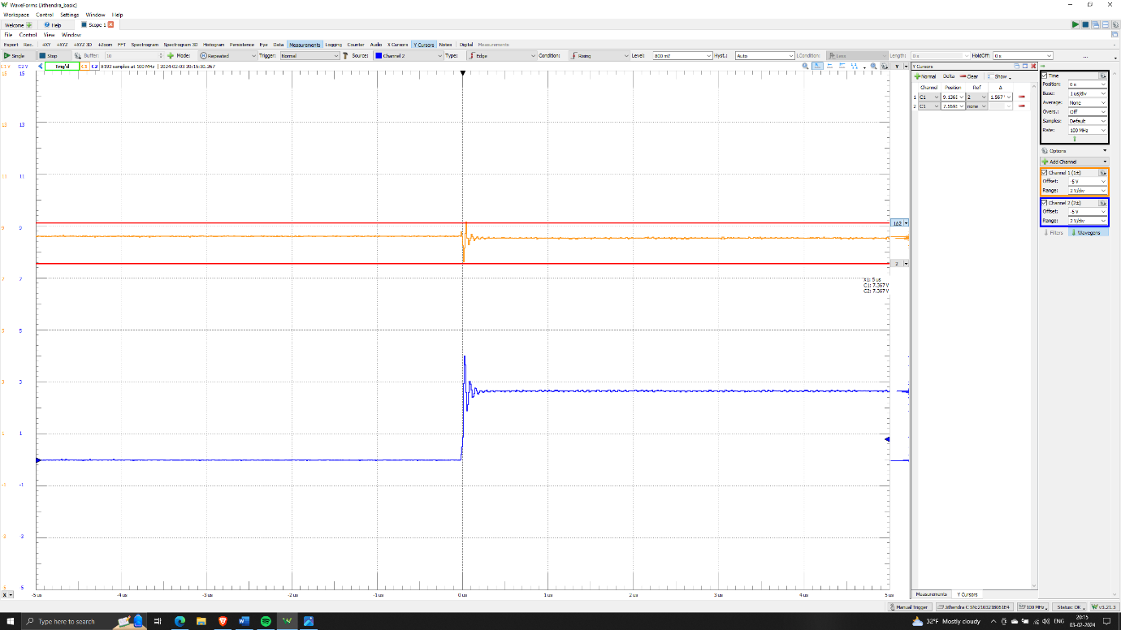

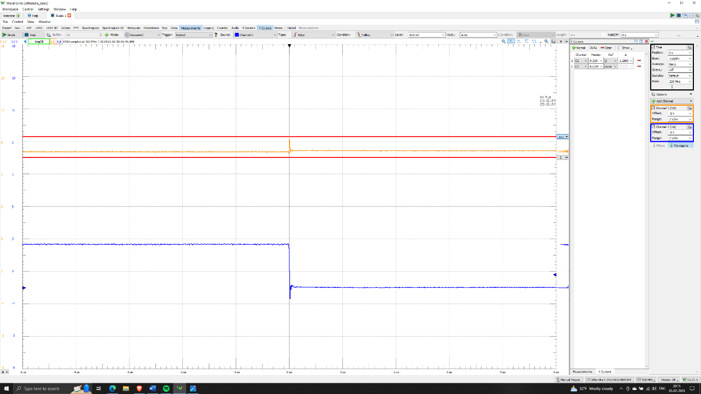

Adding a 1000uF capacitor resulted in observing 1.5V at the rising edge and 1.2V at the falling edge. However, adding such a large capacitor did not further reduce the switching noise, as the noise was already saturated at the 1uF capacitor.

Key learnings:

* Signal Dependency: Switching noise is predominantly observed with high switching signals, while it remains negligible with less frequent switching signals.
* Voltage Fluctuations Sensitivity: If voltage fluctuations exceed the threshold voltage of IP packages in the power distribution network, it can lead to the turn-off of such IPs, resulting in the reset of boards.
* Shorter Rail Benefits: Discovered the advantages of having a shorter rail to avoid self-loop inductance, consequently reducing voltage drop across the power rail.
* Decoupling Capacitors' Impact: Adding decoupling capacitors near the power source significantly reduces loop inductance and minimizes current surge/transition during signal switching over large power rail connections.
* Capacitor Size Optimization: Once the required capacitor size for the circuit is determined, adding a larger capacitor does not further reduce noise. It is crucial to use the appropriate capacitor size for optimal noise reduction.

References:

* <https://www.infineon.com/cms/en/product/power/mosfet/n-channel/irl520n/>
* https://www.ti.com/product/TLC272