**PCB Report – LAB 9**

**Cross talk between signal-return loops**

**Objective:**

In this lab, I learned about different interconnect approaches and their radically different geometrics affect the amount of crosstalk between an aggressor and victim signal-return path pair.

**Component listing:**

* Special test board.

**Board:**

*Fig 1.1 Special test board*

**Calculation:**

The yellow signal represents the voltage across the aggressor line, while the green signal represents the voltage drop across the LED and the resistor. The voltage drops across the LED and the 47-ohm resistor are measured at 1.5V. Therefore, the current drawn via the LEDs can be calculated using Ohm's Law as:I=V/R=1.5/47=31mA.

**Part 1:  
Characteristics of board third section:**1. Separate return path for all aggressor and victim lines.  
2. Victim line is in a quiet low state.

**Here, the green signal is the voltage induced across the victim line from the board's third section. From the figure of merits, we can see that the rise time of the voltage source was fluctuating between 5-5.2ns, and the voltage measured across the victim line is 320mV. The mutual inductance that generated led to this voltage at the victim can be found using:

Vvictim = M * n *dI/dt, where n is number to aggressor lines. Here we are considering 6 aggressor lines so n=6.  
The Mutual inductance can be given as M = (320mv * 5ns)/(6*31mA) = **8.9nH**

Note: A slow MOSFET turn-on on the Arduino pin results in a high rise time, indicating less change in current and therefore less switching noise. Conversely, a fast switching N-transistor pulls the Arduino pin down faster, leading to a shorter fall time and consequently higher observed switching noise.  
  
**  
Less noise is induced at victim line compared to the previous case maximum upto 160mV.

The mutual inductance would be 4.3nH. As we can see from the output, the noise is high when pin 8 is switched, which is closer to the victim line.

The above figure clearly shows that the noise induced from the pin 8 aggressor line is much higher than from the pin 13 line. This indicates that the noise will be higher when the aggressor and victim lines are closer together.  
  
  
**Part 2:  
Characteristics of board second section:**1. Common return path for all aggressor and victim lines.  
2. Victim line is in quiet low state. Also have separate return path.

**All 6 pins are switched and Victim using common return path:**

Mutual inductance here is 360nH. This is induced because of ground bounce noise.

**All 6 pins are switched and Victim using separate return path:**

Mutual inductance is 84nH. This is induced because of loop inductance.

As we can see huge difference between noise induced by aggressor lines from common and separate return path tests influence on the victim line.  
  
  
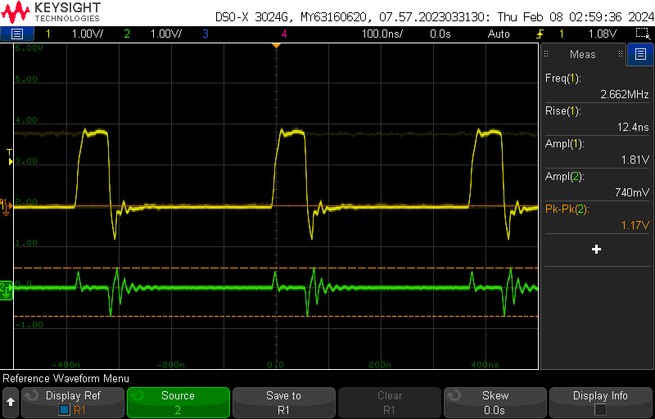  
Noise induced from pin 13.

Noise induced from pin 12.

Noise induced from pin 8.  
From the above outputs we can say that the distance between Aggressor and victim line does not influence the noise in common return path.

**Key learnings:**

* From Part 1 of this lab found that the switching noise induced will be high when number of aggressor lines switching at same time.
* Also came to know that the noise will increase when aggressor and victim lines are closely routed.
* From part 2 of this lab found that the impact of common return path resulted with ground bounce noise in the victim line.
* Still seen noise even we use separate path due to loop inductance. So to address this noise we have to use return plane instead of return path in same plane.