Using power amplifiers as high current buffers in the low Z VNA measurements
Introduction:
As clock frequencies continue to rise and signal switching intensifies, managing switching noise on the power rail (PDN) becomes increasingly critical. To mitigate this noise, PDN impedance must remain very low and stay within the target impedance across the operating frequency range. Therefore, ensuring a low PDN impedance during the design phase and verifying it after board fabrication is essential for accurately characterizing noise and maintaining power integrity.
The most accurate method for measuring DC resistance is the 4-wire Kelvin method, which eliminates lead and contact resistance errors. However, for AC resistance measurements, the 2-port shunt method is preferred over the relevant frequency range of the model.
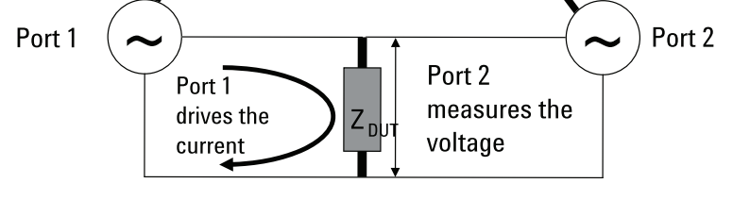
In the 2-port shunt method, as illustrated in the image below, the Device Under Test (DUT) is connected between two ports of a Vector Network Analyzer (VNA). The resistance is determined by measuring the voltage drop across the DUT, which is observed at Port 2. The measured S21 is used to calculate the impedance, which ensures precise impedance characterization across a wide frequency range.
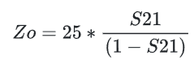

What are we trying to solve?
Every Vector Network Analyzer (VNA) port has a minimum detectable signal level, known as the noise floor. This noise floor represents the lowest signal strength the VNA can accurately measure.
When measuring impedance, if the voltage drop across the Device Under Test (DUT) is significantly lower than the VNA’s noise floor, the measurement will be limited by the noise floor itself. In such cases, instead of capturing the actual low impedance of the DUT, the VNA will only report the impedance corresponding to the noise floor, leading to inaccurate results.
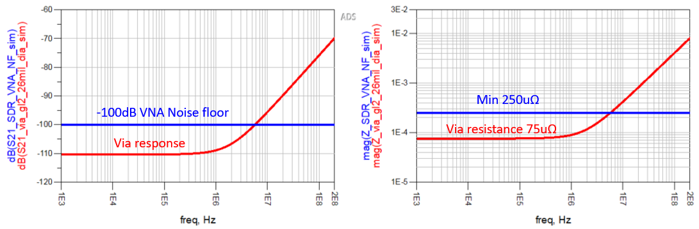
The challenge becomes particularly significant when measuring very low resistance such as via resistance, as it often falls below the VNA’s detection threshold. As shown in the image:
- The left graph indicates that the SDR VNA’s noise floor is approximately -100 dB, while the voltage drop across the via is around -110 dB.
- With this noise floor, the VNA can reliably measure impedances as low as 250 µΩ.
- However, since the via’s response lies below the noise floor, the measurement would be limited by the VNA’s sensitivity.
- As a result, instead of capturing the actual 75 µΩ impedance, the VNA would incorrectly report 250 µΩ, as it cannot distinguish signals below -100 dB.
This highlights the importance of using a VNA with a lower noise floor or alternative measurement techniques for accurately characterizing ultra-low impedance components like vias.

What could be the solution?
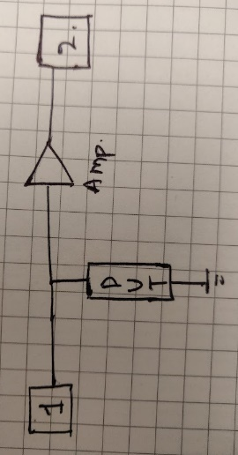
To overcome the noise floor limitation in budget VNAs, we developed a methodology that involves pre-amplifying the signal before it reaches Port 2. By amplifying the DUT’s response, we ensure that the measured signal remains above the VNA’s noise floor, allowing for more accurate impedance characterization.
After capturing the pre-amplified response, we use a SPICE simulation tool to scale the data back to its actual, unamplified value. This approach effectively compensates for the noise floor limitation, enabling the accurate measurement of ultra-low impedance components such as via resistance, even with cost-effective VNAs.

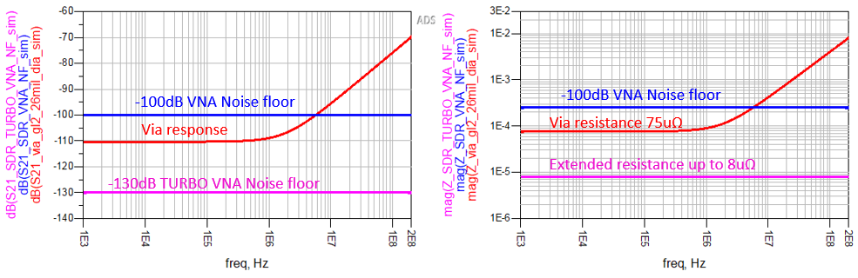
The VNA setup with pre-amplification is referred to as Turbo VNA. The Turbo VNA setup enhances the measurement capabilities of budget VNAs by incorporating a +30 dB gain amplifier before Port 2. This pre-amplification ensures that even extremely small voltage drops across the DUT are amplified before reaching the VNA, allowing for more accurate low-impedance measurements. For instance, if a DUT produces a voltage drop of -130 dB, the amplifier boosts this signal by +30 dB, making the effective voltage magnitude at Port 2 -100 dB. Despite the VNA still reading -100 dB, the actual measurement corresponds to -130 dB, effectively lowering the noise floor of the system. This improvement allows for impedance measurements as low as 8 µΩ, compared to the 250 µΩ limit of a standard setup. By extending the VNA’s sensitivity without requiring expensive equipment, Turbo VNA provides an efficient and cost-effective solution for ultra-low impedance characterization.
Building turbo VNA:
Selecting an amplifier:
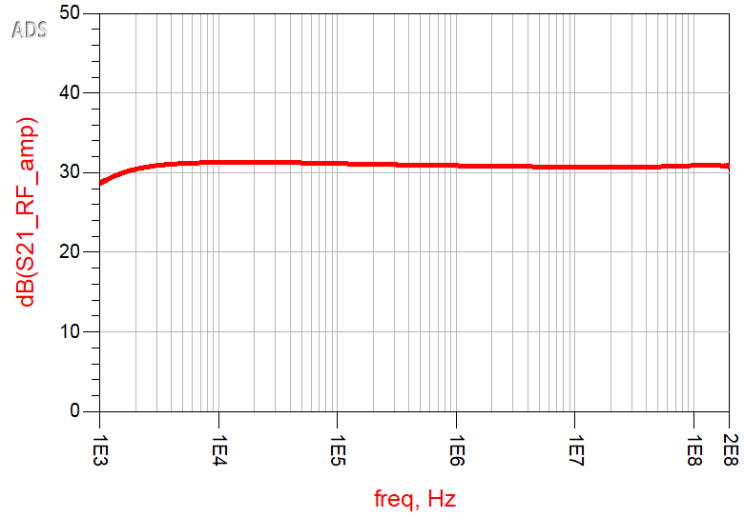
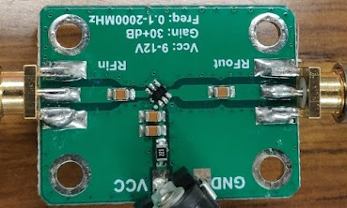
For this low-cost, low-impedance measurement application, it was essential to select an amplifier that was both affordable and effective. To achieve this, we carefully handpicked several RF amplifiers that are readily available. However, some of these amplifiers lacked datasheets, requiring us to characterize them manually before determining their suitability for this application. Among the tested amplifiers, one of the best-performing options is shown below, featuring a gain of +31 dB.

Noise floor of the SDR kit VNA:
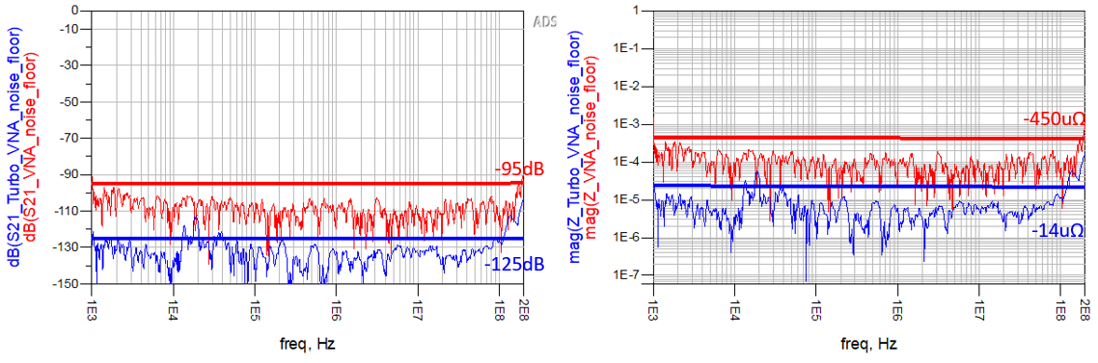
Before performing any measurements, it is crucial to understand the capabilities and limitations of the measuring device. In our case, the VNA has the ability to sweep frequencies from 1 kHz (close to DC) up to 1.3 GHz. Given our objective to measure impedance at lower frequencies and the variable noise floor behavior of the VNA, we decided to focus on a frequency range from 1 kHz to 200 MHz for both measurement and modeling. The measured noise floor for both the standard VNA and the Turbo VNA setup is shown below, providing insight into the improved sensitivity achieved by the pre-amplification approach.
According to the user guide of the VNA, the noise floor in the specified bandwidth is typically -90 dB. However, based on our measured response, we found that the VNA can reliably measure up to -95 dB without introducing errors or data loss, which corresponds to an impedance of 450 µΩ. When we added the RF amplifier, the noise floor was further lowered to -125 dB without compromising the accuracy of the data. As a result, the VNA’s impedance measurement capability improved, enabling us to measure down to an impressive -14 µΩ.

Consistency Check:
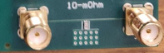
To ensure that the Turbo VNA setup and measuring system are functioning correctly, it's essential to verify the accuracy of measurements by testing a known component with a well-understood behavior. For this purpose, we measured a 10 mΩ resistor mounted on the test board. This provides a reference point to compare the Turbo VNA’s measurements, the normal VNA, and simulated results with respect to the noise floor.
The measurements from both the Turbo VNA and the normal VNA were consistent with each other, with only a 10% to 20% variation relative to the original impedance value of 10 mΩ. This small discrepancy can be attributed to factors combining two different systems and device characteristics, which are typical in low-impedance measurement scenarios. Nonetheless, the results confirm that the Turbo VNA provides a reliable and accurate method for measuring ultra-low impedances with only a modest deviation from the expected values.

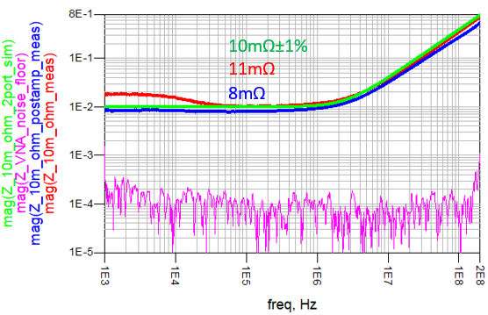
In addition to measuring resistance, we also observed an artifact in the normal VNA measurement, where the system exhibits capacitive behavior at lower frequencies. This is a known limitation of budget VNAs, which struggle to accurately determine the phase of signals at low frequencies, especially when the signal magnitude is very small. This limitation becomes more apparent when measuring low-impedance components at frequencies close to DC.
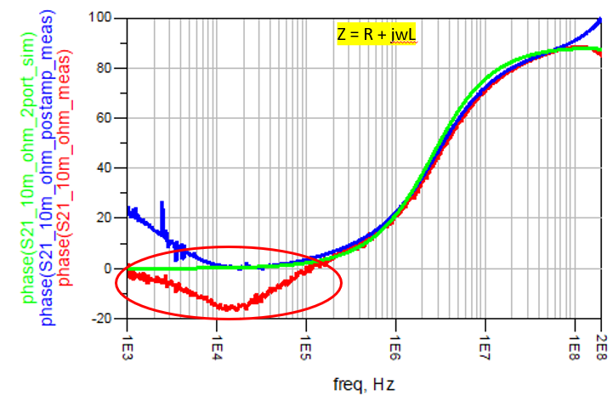
To confirm this issue, we conducted tests with different attenuator setups, and the change in phase behavior was consistently observed, further validating that the normal VNA has difficulty at low frequencies due to its inability to properly measure phase at low signal magnitudes. This behavior does not affect the Turbo VNA setup, as the added pre-amplification ensures the signal remains well above the normal VNA by +30dB during the measurement, and phase accuracy is maintained across the frequency range.

From this observation, we can conclude that the response showing the resistance of the DUT will not remain flat across the entire frequency range. This is particularly due to the phase inaccuracies at low frequencies, as observed with the normal VNA. Given this behavior, it is important to consider the lowest point of the impedance graph as the most accurate representation of the DUT's resistance.
Ultra-low Impedance measurement (Via resistance):
Finally, we attempted to measure ultra-low impedance, specifically the via resistance. The S₂₁ response of the via was observed to be slightly below the noise floor of the normal VNA, making it difficult to obtain an accurate measurement.
As a first-order estimation, we applied a rule of thumb to approximate the via resistance, which resulted in a value of 122 µΩ—well below the detection threshold of the normal VNA. To refine this estimate, we utilized the digital twin modeling approach in Keysight ADS, which provided a more accurate via resistance value of 75 µΩ.
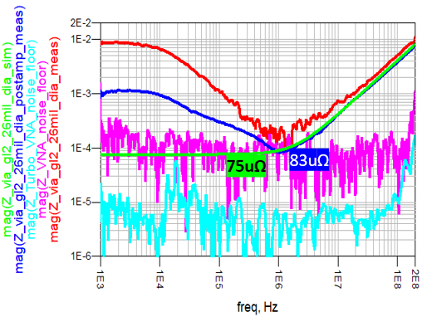
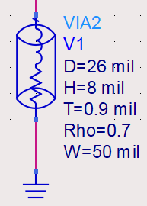
Using the Turbo VNA, we obtained a resistance measurement of 83 µΩ, which closely aligns with the ADS simulation results.
This confirms that the Turbo VNA methodology helps measure ultra-low impedance components well below normal VNA operation, making it a reliable alternative to high-end VNAs for such applications.
Conclusion:
This study demonstrates that ultra-low impedance measurements can be effectively performed using a cost-effective VNA combined with an RF amplifier, significantly improving the measurement capability beyond the limitations of standard budget VNAs. By implementing the Turbo VNA approach, we successfully extended the noise floor, enabling accurate impedance characterization down to 14 µΩ.
Additionally, we established a methodology for characterizing RF amplifiers to ensure their suitability for low-impedance measurements, particularly when datasheets are unavailable. This involved evaluating gain, noise floor impact, and signal integrity to optimize performance for ultra-low impedance applications.
Despite the phase shift limitations at lower frequencies—a common issue with budget VNAs—we demonstrated that it is still possible to obtain a close approximation of the DUT’s resistance by identifying the lowest point in the impedance response. This approach, validated through ADS simulation and Turbo VNA measurements, confirms that affordable measurement setups can achieve reliable low-impedance characterization with minimal deviation from expected values.

References:
- https://www.keysight.com/th/en/assets/7018-08474/application-notes/5989-5935.pdf
- https://www.alibaba.com/product-detail/RF-Wideband-Amplifier-30dB-Low-noise-1600090642908.html
- https://www.sdr-kits.net/index.php?route=common/home
- https://www.signalintegrityjournal.com/articles/1544-why-2-port-low-impedance-measurements-still-matter
- https://www.signalintegrityjournal.com/articles/1976-a-low-cost-capacitor-characterization-system
- https://www.picotest.com/wp-content/uploads/2024/06/Ultra-low-Impedance-20-micro-ohm-Measurement-using.pdf
- https://groups.io/g/VNWA/topic/74472949

