A MINI PROJECT REPORT ON

**Short-term Load Forecasting in Smart Grid using DNN and**

**LSTM**

**Submitted in partial fulfilment for the award of the degree of**

# BACHELOR OF TECHNOLOGY

**In**

# Artificial Intelligence and Machine Learning

## By

**K.Jithendra (22A81A6130)**

**K.V.V.S Vinay(22A81A6126)**

**N.Raja (22A81A6145)**

**E.Tirupati Rao (23A85A6102)**

## Under the Esteemed Supervision of

**Mr .V. Rama Narayana**

**Assistant Professor**



**Department of Artificial Intelligence and Machine Learning**

**SRI VASAVI ENGINEERING COLLEGE(Autonomous)**

**(Affiliated to JNTUK, Kakinada) Pedatadepalli, Tadepalligudem-534101, A.P 2024-25**

# SRI VASAVI ENGINEERING COLLEGE (Autonomous)

## Department of Artificial Intelligence and Machine Learning

### Pedatadepalli, Tadepalligudem



Certificate

This is to certify that the Project Report entitled **“Short-term Load Forecasting in Smart Grid using DNN and LSTM”** submitted by K.jithendra(**22A81A6130**),

K.V.V.S.Vinay (**22A81A6126)**, N.Raja (**22A81A6145**), E.Tirupati Rao (**23A85A6102)** for the award of the degree of Bachelor of Technology in the Department of Artificial Intelligence and Machine Learning during the academic year **2024-2025.**

|  |  |
| --- | --- |
| **Project Guide**  Mr.V.Rama Narayana  Assistant Professor | **Head of the Department**  Dr. G. Loshma  Professor & HOD |

## External Examiner

**DECLARATION**

We hereby declare that the project report entitled “**Short-term Load Forecasting in Smart Grid using DNN and LSTM**" submitted by us to Sri Vasavi Engineering College(Autonomous), Tadepalligudem, affiliated to JNTUK Kakinada in partial fulfilment of the requirement for the award of the degree of B.Tech in Artificial Intelligence and Machine Learning is a record of Bonafide project work carried outby us under the guidance of **Mr.V.Rama Narayana ,** Assistant Professor**.** We further declare that the work reported in this project has not been submitted and will not be submitted, either in part or in full, for the award of any other degree in this institute or any other institute or University.

**Project Associates**

**K.Jithendra (22A81A6130)**

**K.V.V.S Vinay(22A81A6126)**

**N.Raja (22A81A6145)**

**E.Tirupati Rao (23A85A6102)**

**ACKNOWLEDGEMENT**

First and foremost, we sincerely salute to our esteemed institute **SRI VASAVI ENGINEERING COLLEGE,** for giving us this golden opportunity to fulfill our warm dream to become an engineer.

Our sincere gratitude to our project guide **Mr.V.Rama Narayana ,** Assistant Professor, Department of Artificial Intelligence and Machine Learning**,** for his timely cooperation and valuable suggestions while carrying out this project.

We express our sincere thanks and heartful gratitude to **Dr. G. Loshma**, Professor & Head of the Department of Artificial Intelligence and Machine Learning, for permitting us to do our project.

We express our sincere thanks and heartful gratitude to **Dr. G.V.N.S.R. Ratnakara Rao**, Principal, for providing a favourable environment and supporting us during the development of this project.

Our special thanks to the management and all the teaching and non-teaching staff members, Department of Artificial Intelligence and Machine Learning, for their support and cooperationin various ways during our project work. It is our pleasure to acknowledge the help of all those respected individuals.

We would like to express our gratitude to our parents, friends who helped to complete to this Project.

**Project Associates**

**K.Jithendra (22A81A6130)**

**K.V.V.S Vinay(22A81A6126)**

**N.Raja (22A81A6145)**

**E.Tirupati Rao (23A85A6102)**

# ABSTRACT

Short-term load forecasting (STLF) is crucial for efficient operation and planning in smart grids, enabling better demand response, reduced operational costs, and improved grid stability. This paper presents a hybrid approach combining Deep Neural Networks (DNN) and Long Short-Term Memory (LSTM) networks for accurate load forecasting in a smart grid environment. The DNN model captures complex nonlinear relationships in static data, while the LSTM effectively handles sequential dependencies in time-series data. By leveraging both models, the proposed framework accurately predicts short-term load variations. Experimental results on real-world smart grid data demonstrate that this hybrid DNN-LSTM model outperforms traditional forecasting methods, achieving high accuracy and robustness across various load patterns. This approach offers a reliable solution for power utilities aiming to enhance load forecasting accuracy in dynamic and complex smart grid systems.

.

**CONTENTS**

|  |  |  |
| --- | --- | --- |
| **S.NO** | **TITLE** | **PAGE NO** |
| **Chapter 1** | **INTRODUCTION** | 8 |
| 1.1 | Introduction | 9 |
| 1.2 | Motivation | 9 |
| 1.3 | Objective | 9 |
| 1.4 | Project Outline | 10 |
| **Chapter 2** | **LITERATURE SURVEY** | 11-12 |
| **Chapter 3** | **SYSTEM STUDY AND ANALYSIS** | 13 |
| 3.1 | Problem Statement | 14 |
| 3.2 | Existing System | 14 |
| 3.2.1 | Limitations of the Existing System | 14 |
| 3.3 | Proposed System | 15 |
| 3.3.1 | Advantages of Proposed System | 15 |
| 3.4 | Functional Requirements | 15 |
| 3.5 | Non-Functional Requirements | 15 |
| 3.6 | User Interface Requirements | 15-16 |
| 3.7 | System Requirements | 16-18 |
| **Chapter 4** | **SYSTEM DESIGN** | 19-20 |
| 4.1 | System Architecture | 21 |
| 4.2 | DNN Diagrams | 22 |
| 4.3 | LSTM Diagrams | 22-23 |
| 4.4 | Use Case Diagram | 24 |
| **Chapter 5** | **TECHNOLOGIES** | 26-27 |
| **Chapter 6** | **SYSTEM IMPLEMENTATION** | 28 |
| 6.1 | Implementation Steps | 29 |
| 6.2 | Process | 29 |
| 6.3 | Methodology | 30 |
| **Chapter 7** | **OUTPUT SCREENSHOTS** | 31-32 |
| **Chapter 8** | **CONCLUSION AND FUTURE WORK** | 33 |
| 8.1 | Conclusion | 34 |
| 8.2 | Future Work | 34 |
| **Chapter 9** | **REFERENCES** | 35-36 |

# CHAPTER-1 INTRODUCTION

# INTRODUCTION

## Introduction

Smart grids are modern electrical systems that use digital technologies to improve the management of electricity. As the grid becomes more complex with the integration of renewable energy sources like wind and solar, accurately predicting electricity demand is becoming more challenging. Short-term load forecasting (STLF) is crucial for grid operators to ensure that power generation matches demand, helping to avoid blackouts or wasted energy. Traditional forecasting methods often struggle with the dynamic and unpredictable nature of the grid. In this context, machine learning techniques like Deep Neural Networks (DNN) and Long Short-Term Memory (LSTM) networks offer a promising solution. These models can better capture complex patterns in data and improve the accuracy of short-term load predictions, ultimately helping to make the grid more efficient and reliable. This research explores how combining DNNs and LSTMs can enhance short-term load forecasting for smart grids..

**1.2 Motivation**

The motivation behind this study comes from the growing need for accurate load forecasting in smart grids. As more renewable energy sources like solar and wind are integrated into the power system, predicting electricity demand becomes harder due to their unpredictable nature. Traditional forecasting methods struggle to capture these complex patterns, making it difficult to maintain grid stability. With the rise of smart grids, which are more decentralized and involve advanced technologies, there is an urgent need for better forecasting models that can adapt to changing conditions in real-time. By using advanced machine learning techniques like Deep Neural Networks (DNN) and Long Short-Term Memory (LSTM) networks, this research aims to improve the accuracy of short-term load predictions, helping grid operators optimize energy use, reduce costs, and integrate renewable energy more effectively .

## 1.3 Scope

The scope of our **“Short-term Load Forecasting Method of Smart Grid using DNN and LSTM”** project includes:

* **Predicting short-term electricity demand** in smart grids using advanced machine learning models (DNN and LSTM).
* **Allowing users to input historical load data** and receive accurate load forecasts for future time intervals (e.g., next hour or day).
* **Providing an intuitive user interface** that allows easy interaction for grid operators or utility companies to use the forecasting model.
* **Offering customizable forecasting settings**, such as time intervals and model parameters, to adjust forecasts based on specific grid requirements or user preferences.

.

z

## 1.4 Project Outline

Chapter-1 Introduction Chapter-2 Literature Survey

Chapter-3 System Study and Analysis Chapter-4 System Design

Chapter-5 Technologies Chapter-6 Implementation Chapter-7 Screenshots

Chapter-8 Conclusion and Future Work

z

# CHAPTER-2 LITERATURE SURVEY

# 2.LITERATURE SURVEY

**Lee, D**  *Short-term wind power ensemble prediction based on Gaussian processes and neural networks*. This paper presents a method for short-term wind power forecasting using a combination of Gaussian processes and neural networks. The authors propose an ensemble prediction approach that improves the accuracy of wind power predictions, making it more reliable for energy management and grid integration. ​.

**Kosek, A. M** *Ensemble regression model-based anomaly detection for cyber-physical intrusion detection in smart grids*. This paper discusses an ensemble regression model approach to anomaly detection in smart grids, aimed at identifying cyber-physical intrusions. The authors highlight how their method can improve the security and reliability of smart grids by detecting unusual patterns that could indicate potential intrusions or attacks.

**Abuella, M.** *Random forest ensemble of support vector regression models for solar power forecasting*. This paper presents a hybrid approach combining Random Forest and Support Vector Regression (SVR) for accurate solar power forecasting. The authors demonstrate that this ensemble model improves prediction accuracy by leveraging the strengths of both techniques, making it a robust solution for solar energy management.

**Zhou, M.** *Holographic ensemble forecasting method for short-term power load*. This paper proposes a novel ensemble forecasting method for short-term power load prediction, known as the holographic ensemble method. The author demonstrates how this approach effectively combines multiple forecasting models to improve the accuracy and reliability of power load predictions, which is essential for enhancing grid management and energy efficiency.

Raza, M. Q. *An ensemble framework for day-ahead forecast of PV output power in smart grids*. This paper presents an ensemble framework aimed at improving day-ahead forecasting of photovoltaic (PV) output power in smart grids. The author discusses how combining multiple forecasting models enhances the accuracy of predictions, which is essential for efficient integration of PV power into the grid and for ensuring grid stability.

# CHAPTER-3

**SYSTEM STUDY AND ANALYSIS**

## 3.1 Problem Statement

The purpose of our **“Short-term Load Forecasting Method of Smart Grid using DNN and LSTM”** system is to provide an accurate and reliable solution for predicting electricity demand in smart grids. This system addresses the challenges faced by grid operators in managing power generation, especially with the increasing complexity of modern power grids.

The primary issue is the difficulty in accurately forecasting short-term electricity demand due to factors such as the integration of renewable energy sources (solar, wind), decentralized generation, and unpredictable consumption patterns. Traditional forecasting methods often fail to account for the non-linear and dynamic nature of power load data, leading to inefficiencies, power shortages, or overgeneration. As a result, grid operators may struggle to maintain balance between supply and demand, leading to higher operational costs and potential system instability.

Our system aims to fill this gap by offering an advanced forecasting model using **Deep Neural Networks (DNN)** and **Long Short-Term Memory (LSTM)** networks. These machine learning techniques will help improve the accuracy of short-term load predictions, considering factors like time of day, weather, and historical demand patterns. By providing accurate forecasts, our system will assist grid operators in optimizing power generation and distribution, ultimately ensuring more efficient and reliable smart grid operations.

## 3.2 Existing System

Current short-term load forecasting systems face several challenges that limit their accuracy and effectiveness in managing modern smart grids. Traditional methods like ARIMA struggle to capture non-linear relationships and long-term dependencies in power load data, leading to inaccurate predictions, especially in grids with high renewable energy integration.

Machine learning approaches, such as Artificial Neural Networks (ANN) and Support Vector Machines (SVM), can handle non-linearities but often fail to effectively manage sequential data and time-series patterns. While advanced models like Long Short-Term Memory (LSTM) networks show promise, they require large datasets and fine-tuning, making them difficult to implement in real-world scenarios.

Additionally, existing systems lack customization options, making it hard for grid operators to adjust forecasts based on specific conditions like local weather or sudden demand changes. These limitations highlight the need for a more accurate, adaptable, and flexible forecasting system.

Our system addresses these challenges by combining Deep Neural Networks (DNN) and LSTM to improve the accuracy and flexibility of short-term load forecasting, providing grid operators with better tools for efficient grid management.

## Limitations of the Existing System

## 

• Limited Modeling Techniques

• Sensitivity to Hyperparameters

• Data Dependency

• Limited Adaptability

## 

## 3.3 Proposed System

The proposed **Short-term Load Forecasting Method of Smart Grid using DNN and LSTM** aims to improve electricity demand prediction in smart grids. Key features include:

* **Advanced Models**: Uses DNN and LSTM to handle complex, non-linear patterns in load data.
* **Real-Time Forecasting**: Provides up-to-date predictions, helping operators manage power generation and distribution effectively.
* **Customizable Settings**: Allows operators to adjust forecasts based on local factors like weather or demand spikes.
* **Scalable and Flexible**: Adapts to different grid sizes and environments for enhanced accuracy and performance.

## Advantages of Proposed System

• **Improved Forecast Accuracy**: The use of DNN and LSTM ensures more precise predictions by capturing complex, non-linear patterns and long-term dependencies in load data, leading to more reliable load forecasts.

• **Real-Time Predictions**: The system provides real-time load forecasting, allowing grid operators to make timely decisions regarding power generation and distribution, ensuring grid stability and efficiency.

• **Customization and Flexibility**: Operators can tailor forecasting parameters based on local conditions (e.g., weather, demand fluctuations), optimizing predictions for specific grid environments.

• **Scalability and Adaptability**: The system can scale to accommodate grids of various sizes and adapt to different operational environments, ensuring its effectiveness across diverse smart grid infrastructures.

• **Cost and Time Efficiency**: By offering accurate, real-time forecasts, the system helps prevent overproduction or shortages, reducing energy waste and operational costs, while improving the overall efficiency of grid management.

.

### 3.4 Functional Requirements

* Data Ingestion and Preprocessing
* Sequence Modeling
* Feature Extraction
* Hybrid Model Integration
* Forecasting Output
* Performance Evaluation

In the context of the **Short-term Load Forecasting** system for smart grids, functional requirements define the specific functions that the system must perform to meet the goals of accurate, real-time, and customizable load forecasting. These requirements outline the expected inputs, behaviors, and outputs of the system and guide the technical design and implementation of the software..

## 3.5 Non-Functional Requirements

* Efficiency
* Accuracy
* Scalability
* Usability
* Reliability
* Performance

## User Interface Requirements

**User-Friendly Layout**

* Simple, clean design with intuitive navigation to make it easy for grid operators to use the system.

**Data Input Forms**

* Forms to enter relevant data such as historical load data, weather information, and grid-specific parameters for forecasting.

**Forecast Results Display**

* Clear, easy-to-read presentation of forecast results, including graphs and numerical values for predicted power load over specified periods.

**Customizable Settings**

* An options menu allowing users to adjust parameters such as forecasting horizon, sensitivity to weather changes, and model configurations.

**Real-Time Alerts and Notifications**

* Visual and audible alerts to notify users of significant forecasting errors, model updates, or system performance issues.

**Performance Monitoring Dashboard**

* A central dashboard displaying key metrics like forecast accuracy, error rates, and model performance over time for easy tracking.

**Feedback Mechanism**

* A simple feedback form for users to report issues, suggest improvements, and provide feedback on the forecasting accuracy and system usability**.**

## System Requirements

## For a project on *Short-term Load Forecasting of Smart Grid using DNN and LSTM*, the system requirements include both hardware and software resources to support the intensive data processing, model training, and analysis tasks. On the hardware side, a robust setup with a multi-core CPU, such as an Intel i5 or AMD Ryzen, is necessary to efficiently manage the data pre-processing and model training workflows. Ideally, a minimum of 16 GB of RAM is recommended to handle substantial datasets smoothly; however, 32 GB may provide added support for larger datasets or more complex models. To store large volumes of historical load data and ensure quick data access, a Solid-State Drive (SSD) with at least 512 GB of storage is preferred. Additionally, a dedicated GPU, such as an NVIDIA GTX 1080 or higher, can be invaluable for accelerating the training process of deep learning models, particularly for the LSTM networks, which are computationally demanding.

## On the software front, the project requires an operating system compatible with modern machine learning frameworks, such as Windows 10/11 or Ubuntu 20.04+. Python 3.7 or later is the preferred programming language due to its extensive support in data science and machine learning libraries, particularly TensorFlow and PyTorch, which are essential for building and training DNN and LSTM models. For code development and experimentation, an environment like Jupyter Notebook or PyCharm is ideal, as it allows for interactive coding and quick iteration. Additionally, libraries such as Pandas and NumPy are crucial for data handling, enabling efficient manipulation of time-series data, while visualization tools like Matplotlib and Seaborn assist in analyzing trends and interpreting model results. Together, these system requirements ensure a comprehensive and efficient setup, enabling the accurate short-term load forecasting needed for smart grid optimization.

**3.7.1. Hardware Requirements**

* Processor (CPU): A multi-core processor (e.g., Intel i5/i7, or AMD Ryzen 5/7) is essential to handle data pre-processing and model training tasks smoothly.
* Memory (RAM): At least 16 GB of RAM is recommended to load and process large datasets efficiently without slowing down. For handling larger datasets or running multiple models simultaneously, 32 GB or more is preferable.
* Storage: A Solid-State Drive (SSD) with at least 512 GB capacity helps in faster data read/write operations, which is useful when handling large datasets. You may also consider an additional HDD for backup and data archiving.
* Graphics Processing Unit (GPU): For deep learning tasks, a dedicated GPU such as an NVIDIA GTX 1080 or newer with CUDA support significantly speeds up model training, especially for complex models like LSTM.

**3.7.2 Software Requirements**

* Operating System: Windows 10/11 or Linux (e.g., Ubuntu 20.04+) to support the development tools and libraries smoothly.
* Programming Language: Python 3.7+ is recommended, as most machine learning libraries, including TensorFlow and PyTorch, are well-supported in Python.
* Development Environment: Jupyter Notebook or an IDE like PyCharm or VS Code for efficient code writing, testing, and experimentation.

# 

# CHAPTER -4

# SYSTEM DESIGN

# 4 SYSTEM DESIGN

## 4.1 System Architecture Design

**Data Collection and Feature Collection**

* Collect raw data on demand, temperature, humidity, and holidays.
* Extract important features that influence load patterns.

**Data Preparation**

* Check for existing data and ensure it’s sufficient.
* Clean the data to remove errors.
* Select relevant features and augment data if needed.
* Normalize data and split into training and testing sets.

**Model Training**

* Train a Deep Neural Network (DNN) for general pattern recognition.
* Train a Long Short-Term Memory (LSTM) model for time-series data.

**Base Models and Prediction**

* Generate predictions from both DNN and LSTM models.
* Combine predictions to get a final forecast.

**Trained Ensemble Model and Load Estimation**

* Use the ensemble model (DNN + LSTM) for reliable load forecasting.
* Provide short-term load estimates for grid management.

**Performance Evaluation**

* Measure accuracy with RMSE, MSE, MAE, and R2 metrics.
* Use feedback to improve model performance.

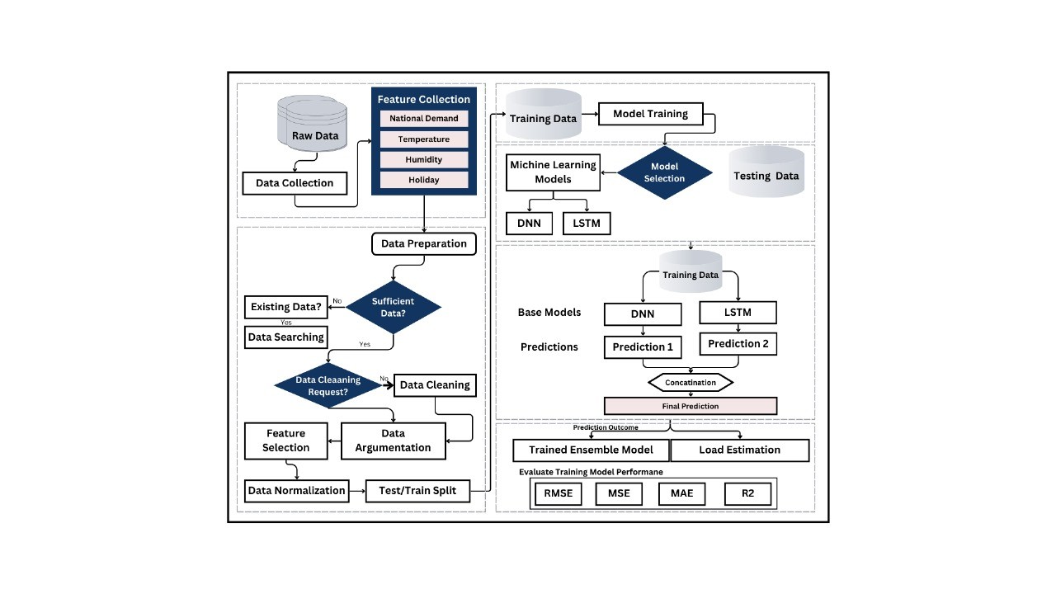Fig:4.1 System Architecture Diagram

## 4.2 DNN Diagram

## In the context of short-term load forecasting for smart grids, the Deep Neural Network (DNN) plays a crucial role in identifying complex patterns within the data. The DNN model consists of multiple layers—input, hidden, and output—that work together to learn relationships between various features, such as historical demand, temperature, and other external factors. Each layer processes the data through interconnected neurons, allowing the model to capture high-level abstractions and dependencies that might impact load demand. By adjusting weights and biases through training, the DNN is able to generalize from past data, making it an effective component for recognizing trends and fluctuations in electricity usage, which is essential for accurate load forecasting.

## 

## 4.3 LSTM Diagram

For short-term load forecasting in smart grids, the Long Short-Term Memory (LSTM) model is essential for capturing sequential dependencies in time-series data, such as changes in electricity demand over time. Unlike traditional neural networks, LSTM has a unique structure with memory cells that retain information across time steps, making it highly effective for forecasting tasks. This allows the model to remember past load patterns, seasonal variations, and recent trends, which are crucial for accurate short-term predictions. By leveraging this temporal information, the LSTM can effectively anticipate future load demand, making it a powerful tool for managing and optimizing

Fig:4.2.1 LSTM diagram

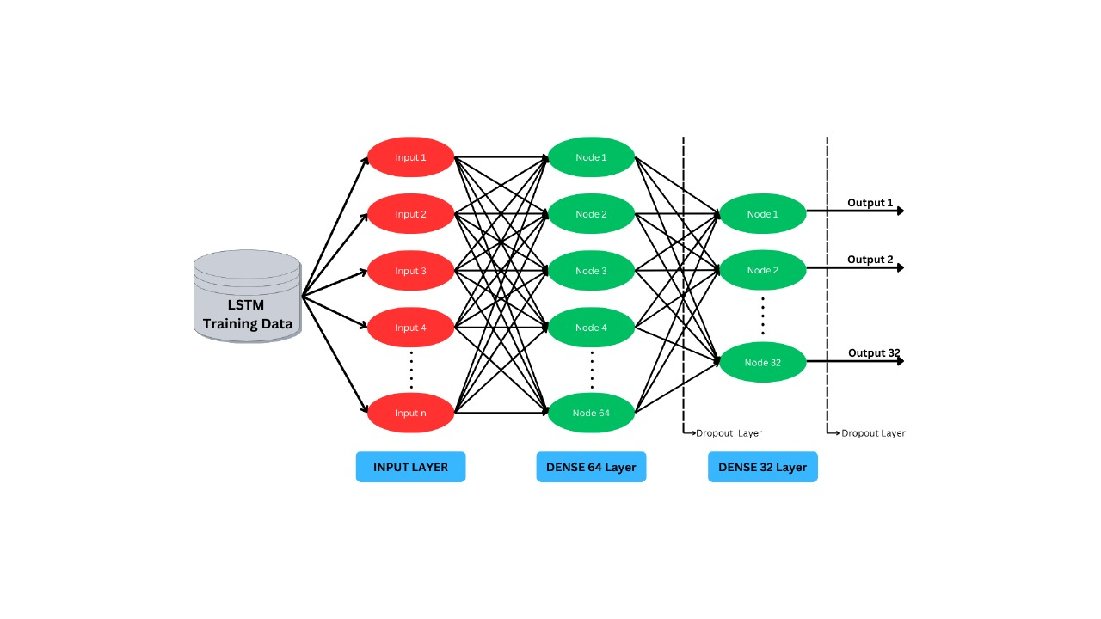

## 4.4 Use Case Diagram

This diagram depicts a system where user-provided data is processed within a central unit, the Secure Global Processing Center (SGPC), which collaborates with a Cloud Service Provider (CSP) to develop machine learning models. Users contribute data to the SGPC, which aggregates this input and sends it to the CSP as "training data." The CSP uses this data to train machine learning models, which are then returned to the SGPC.

When a new user provides data, the SGPC applies these pre-trained models to generate tailored outputs for that user. The CSP thus plays a key role by enabling scalable model training, while the SGPC maintains control over data intake and application, providing users with insights or solutions based on the trained models. This setup allows for efficient, cloud-supported data processing and machine learning, where the SGPC serves as the central hub for model deployment and user interaction.

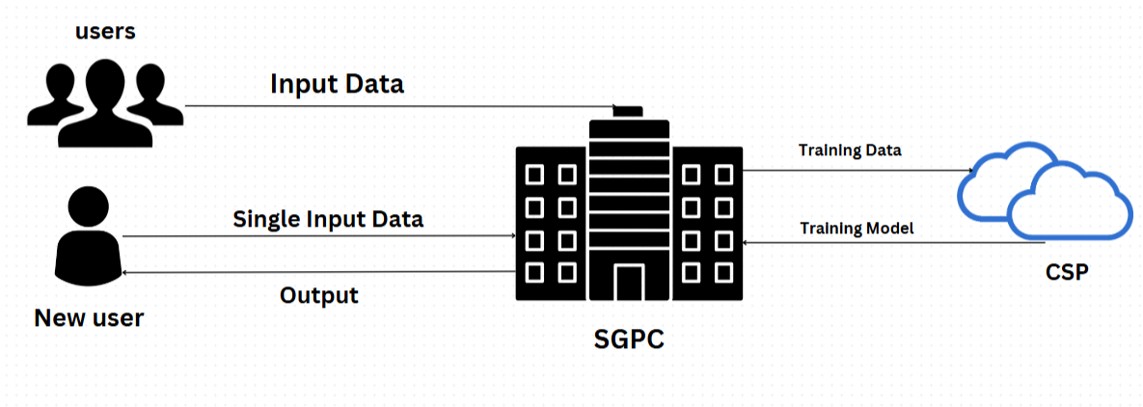

# 

# 

# CHAPTER-5

# TECHNOLOGIES

**5 TECHNOLOGIES**

**Data Collection and Preprocessing Technologies**

Smart Meters and IoT Sensors: Smart meters and IoT sensors continuously collect real-time data on electricity consumption, weather, and other exogenous variables. These devices transmit data to central systems for analysis.

**Data Storage and Processing Platforms:**

Apache Hadoop and Apache Spark: For large-scale data storage and distributed processing of load data, particularly in real-time or near-real-time processing.

SQL and NoSQL Databases (e.g., MySQL, MongoDB): Used for storing structured and unstructured data, including historical load and weather data.

Time-Series Databases (e.g., InfluxDB, TimescaleDB): Specialized databases for efficiently storing and querying time-series data, such as hourly or minute-wise electricity demand records.

**Data Preprocessing Libraries:**

Pandas and NumPy: Python libraries for data manipulation, handling missing data, and feature engineering.

SciPy: Often used for statistical analysis and data preprocessing before feeding data into machine learning models**.**

## 5.1 Features

1. **Data Collection and Integration**
   * Collects and integrates data from multiple sources, such as historical load demand, temperature, humidity, and other external factors like holidays that may influence demand**.**
2. **Feature Engineering**
   * Applies feature selection and engineering to identify and extract relevant attributes, such as time-of-day, seasonal trends, and lagged values, which enhance model performance**.**
3. **Hybrid Modeling Approach**
   * Combines Deep Neural Network (DNN) for identifying complex patterns with Long Short-Term Memory (LSTM) for capturing temporal dependencies in time-series data.
4. **Real-time Data Processing**
   * Processes incoming real-time data to provide up-to-date load forecasts, allowing for immediate response and grid management adjustments.
5. **Data Normalization and Augmentation**
   * Normalizes data to maintain consistency and applies augmentation techniques if necessary, improving model robustness and accuracy**.**
6. **Model Evaluation Metrics**
   * Utilizes metrics such as RMSE, MSE, MAE, and R-squared to evaluate forecasting accuracy, ensuring the model's reliability and performance.
7. **Forecast Visualization**
   * Provides a user-friendly visualization dashboard that displays load forecasts, trend analyses, and real-time monitoring to support grid operators.
8. **Adaptive Model Updates**
   * Includes a feedback loop that periodically updates the model with new data to adapt to changing load patterns, maintaining forecast precision over time.
9. **Scalability**
   * Designed to handle increasing data volume and incorporate additional data sources, making it adaptable to larger grid systems.
10. **Anomaly Detection**

* Detects unusual load patterns or anomalies that may indicate grid instability, helping to prevent potential disruptions.

.

**CHAPTER-6**

**IMPLEMENTATION**

**6.SYSTEM IMPLEMENTATION**

## Implementation Steps

* + **Data Collection & Preprocessing**: Gather and clean data from smart meters, weather, and time factors; engineer relevant features.
  + **Model Design**: Use a DNN for feature extraction, followed by LSTM layers to capture temporal patterns, with a dense output layer for load prediction.
  + **Training**: Train on historical data using Mean Squared Error loss; optimize with Adam and monitor validation loss.
  + **Deployment**: Set up a real-time prediction pipeline for continuous load forecasting, with periodic model updates based on new data.
  + **Monitoring**: Track model accuracy in real-time and retrain as needed for consistent performance.

**Components:**

* **Data Collection: Gather load, weather, and time data.**
* **Preprocessing: Clean, normalize, and engineer features.**
* **Model:**
  + **DNN: For feature extraction.**
  + **LSTM: For temporal patterns.**
  + **Output: For load prediction.**
* **Training: Use MSE loss, Adam optimizer, and early stopping.**
* **Prediction Pipeline: Real-time forecasting setup.**
* **Evaluation: Use MAE and RMSE metrics.**
* **Deployment: Scalable, real-time environment with API.**
* **Monitoring: Track accuracy and retrain as needed.**

## Process

• **Input Collection:** The user inputs historical load data and external factors (e.g., temperature, humidity) for analysis.

• **Feature Extraction:** Key characteristics are extracted from the input data, including time features (hour, day, month) and external conditions.

• **Machine Learning Processing:** Extracted features are fed into the trained DNN and LSTM models to predict the load demand.

• **Display of Results:** The system shows results to the user, including predicted load values and visualizations of load trends.

## Methodology

* **Data Collection and Preprocessing**
* **Data Collection: Collect historical load data, weather conditions, and other relevant datasets from smart grid sensors and external sources.**
* **Data Preprocessing:**
  + **Normalization: Scale the data to a consistent range to improve model performance.**
  + **Decomposition: Break down the data into trend, seasonality, and residual components to enhance feature extraction.**
  + **Handling Missing Data: Implement techniques such as imputation or interpolation to address gaps in the dataset.**

**Feature Extraction:** Various features are extracted for each data type, such as**:**

* Time of day (hour, day of the week)
* Seasonal trends (month)
* External factors (temperature, humidity)

**Machine Learning Model Execution:** Using algorithms like DNN and LSTM, the system analyzes the input data to predict future load demands.

**Result Presentation**: The final result, including predicted load values and visualizations (e.g., line graphs of trends), is displayed in the application interface

# 

**CHAPTER-7**

**SCREENSHOTS**

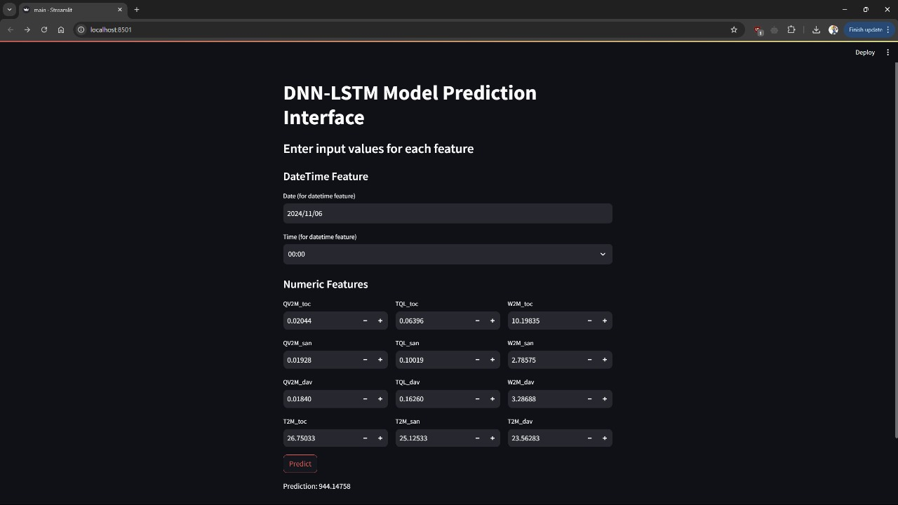

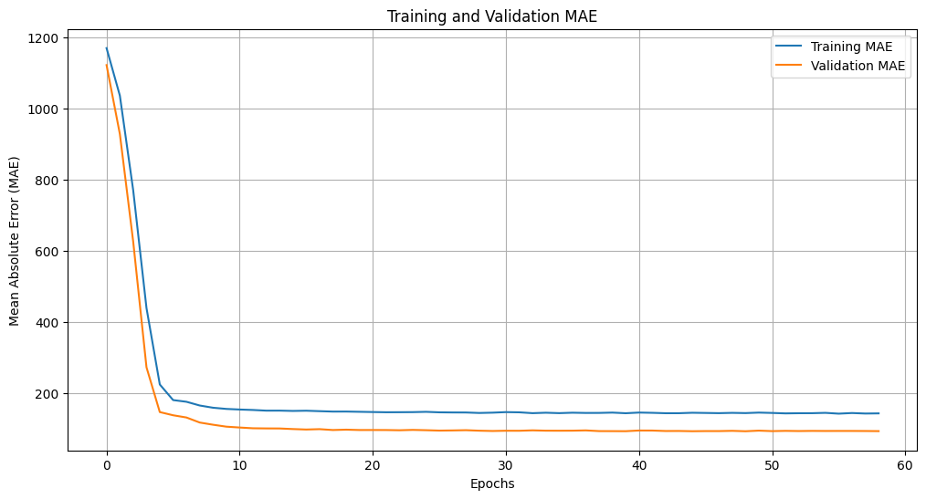

**CHAPTER-8**

**CONCLUSION AND FUTURE WORK**

**8.CONCLUSION AND FUTURE WORK**

## Conclusion

In conclusion, implementing short-term load forecasting using a combination of DNN and LSTM provides an effective way to predict energy demand in a smart grid. This approach leverages DNN for feature extraction and LSTM for capturing temporal dependencies, making it well-suited for time-series data. By maintaining a real-time prediction pipeline and regularly updating the model with new data, this system can achieve accurate, scalable, and adaptive load forecasts, ultimately improving grid efficiency and resource management.

## Future Work

Future work could enhance forecasting by using advanced models like Transformers, adding data sources (e.g., social events, weather), and enabling real-time adaptation. Improving interpretability would aid operators, while integrating with energy storage and demand response can boost load balancing. Edge deployment would allow decentralized, low-latency predictions. Expanding to mid- and long-term forecasting would support strategic grid planning.

# 9 REFERENCES

1)HM Khounsari, A Fazeli - 2024 International Conference on[**2024 International Conference on Energy and Electrical Engineering (EEE)**](https://ieeexplore.ieee.org/xpl/conhome/10709664/proceeding)

[**https://ieeexplore.ieee.org/abstract/document/10709384**](https://ieeexplore.ieee.org/abstract/document/10709384)

2)Luís, G., Esteves, J., & da Silva, N. P. (2020, October). Energy forecasting using an ensamble of machine learning methods trained only with electricity data. In *2020 IEEE PES Innovative Smart Grid Technologies Europe (ISGT-Europe)*IEEE.[**https://ieeexplore.ieee.org/abstract/document/9248865**](https://ieeexplore.ieee.org/abstract/document/9248865)

3)Canyasse, R., Dalal, G., & Mannor, S. (2017, April). Supervised learning for optimal power flow as a real-time proxy. In *2017 IEEE Power & Energy Society Innovative Smart Grid Technologies Conference (ISGT)* .IEEE.[**https://ieeexplore.ieee.org/abstract/document/8086083**](https://ieeexplore.ieee.org/abstract/document/8086083)

4)Ananthi, P., Devi, K. N., Gopinath, D., & Karthikeyan, C. (2024, March). Enhancing Cybersecurity in the Supply Chain through Predictive Analytics for Cyber Threats. In *2024 2nd International Conference on Artificial Intelligence and Machine Learning Applications Theme: Healthcare and Internet of Things (AIMLA)* IEEE.[**https://ieeexplore.ieee.org/abstract/document/10531400**](https://ieeexplore.ieee.org/abstract/document/10531400)

5)Pinto, T., Faia, R., Navarro-Caceres, M., Santos, G., Corchado, J. M., & Vale, Z. (2018). Multi-agent-based CBR recommender system for intelligent energy management in buildings. *IEEE Systems Journal*,[**https://ieeexplore.ieee.org/abstract/document/8533391**](https://ieeexplore.ieee.org/abstract/document/8533391)

6)Nugroho, R. A., Mu’Min, S., Saputro, A., Andhyka, A., Editya, A. S., &Mufliq, A. (2023, November). Forecasting of Electricity Usage of Indonesian Consumer Using Transformer Time Series. In *2023 International Conference on Advanced Mechatronics, Intelligent Manufacture and Industrial Automation (ICAMIMIA)*  IEEE.[**https://ieeexplore.ieee.org/abstract/document/10427799**](https://ieeexplore.ieee.org/abstract/document/10427799)

7)Padmashree, A., & Krishnamoorthi, M. (2022, August). Comparative Analysis of DoS Attack Detection in KDD CUP99 using Machine Learning Classifier Algorithms. In *2022 3rd International Conference on Electronics and Sustainable Communication Systems (ICESC)* IEEE.[**https://ieeexplore.ieee.org/abstract/document/9885694**](https://ieeexplore.ieee.org/abstract/document/9885694)

8)Karazor, A., &Kavaz, A. G. (2023, November). Machine Learning Ensembles for Solar Power Forecasting. In *2023 4th International Conference on Communications, Information, Electronic and Energy Systems (CIEES)*  IEEE.[**https://ieeexplore.ieee.org/abstract/document/10378818**](https://ieeexplore.ieee.org/abstract/document/10378818)

9)Hrúz, M., Kanis, J., &Krňoul, Z. (2021). Hand pose estimation in the task of egocentric actions. *IEEE Access*,[**https://ieeexplore.ieee.org/abstract/document/9319235**](https://ieeexplore.ieee.org/abstract/document/9319235)

10)Jimenez, T. R., Ibarra, N. C., & Ramirez, J. M. (2016, September). Main motor controllers and regenerative braking of an electric vehicle. In *2016 IEEE PES Transmission & Distribution Conference and Exposition-Latin America (PES T&D-LA)* IEEE.

[**https://ieeexplore.ieee.org/abstract/document/7805631**](https://ieeexplore.ieee.org/abstract/document/7805631)