EDUTRACK SYSTEM SPECIFICATION
Input Forms, Reports, and Use Case Diagrams Specification
Submission Date: June 21, 2026
Target Submission Deadline: June 24, 2026
System Version: 1.0

1. Introduction & Project Overview
EduTrack is a multi-role web-based system designed to coordinate and manage co-curricular achievements, extra-curricular activities, internships, research project milestones, and student academic progression credits. The system aims to replace manual paperwork with an automated, trackable workflow that involves multiple key stakeholders including Students, Faculty guides/coordinators, external Company recruiters/mentors, and System Administrators.
This specification documents the complete set of input forms through which data enters the EduTrack database, the resulting reports generated for different user groups, and the associated use case diagrams highlighting actor interactions.

1.1 System Actors & Roles
The system defines five primary actors:
- Guest / Unregistered User: Can access the home page, read system guidelines, and register as a Student, Faculty member, or Company.
- Student: Proposes research projects, uploads achievement certificates, registers for co-curricular activities, logs daily internship work, uploads internship reports, and monitors progression status.
- Faculty Member: Creates and manages activities, verifies co-curricular and extra-curricular registrations, validates student-uploaded certificates, approves project proposals, evaluates milestone submissions, and monitors internships under supervision.
- Company Representative: Posts internship vacancies, reviews applications from interested students, accepts/rejects applicants, monitors active interns, and reviews daily work logs, providing evaluation remarks.
- System Administrator: Configures master data (departments, programmes, categories, credit limits), approves registrations (Student, Faculty, Company), replies to complaints, reviews feedback, audits system logs, and generates consolidated student progression reports.

2. System Input Forms Analysis
A total of 31 input forms have been identified across the different modules of the EduTrack system. These forms are crucial for capturing structured user input, processing validations, and persisting data to the database.
S.No | Form Name | App Module | Input Fields | Target Actor
1 | User Login Form | Guest | Username/Email, Password | All Registered Users
2 | Student Registration Form | Guest | Full Name, Email, Password, Roll No, Department, Programme, Phone, Photo | Guest (Student candidate)
3 | Faculty Registration Form | Guest | Name, Email, Password, Department, Qualification, Designation, Phone, Joint Date | Guest (Faculty candidate)
4 | Company Registration Form | Guest | Company Name, Email, Password, Website, Address, Description, Contact Person, Phone, Logo | Guest (Company candidate)
5 | Add Department Form | Administrator | Department Name | Administrator
6 | Add Programme Form | Administrator | Programme Name, Programme Code, Associated Department | Administrator
7 | Add Activity Category Form | Administrator | Category Name, Minimum Credits Target | Administrator
8 | Credit Master Config Form | Administrator | Activity Category, Default Point Allocations, Constraints | Administrator
9 | Reply to Complaint Form | Administrator | Reply text/remarks | Administrator
10 | Report Parameters Form | Administrator | Filter metrics (Department, Programme, Activity, Date limits) | Administrator
11 | Activity Registration Form | Student | Target Activity ID (Confirm/Register click) | Student
12 | Certificate Upload Form | Student | Certificate Title, Certificate PDF/Image File, Activity Category | Student
13 | Submit Complaint Form | Student | Complaint Title, Complaint Description | Student
14 | Submit Feedback Form | Student | Feedback message content | Student
15 | Internship Daily Log Form | Student | Work Date, Work Done, Hours Spent, Tools/Tech Used, Key Challenges, Learning | Student
16 | Internship Application Form | Student | Internship ID (Confirm application click) | Student
17 | Internship Report Upload Form | Student | Internship Final Report (PDF), Completion Certificate (PDF), Remarks | Student
18 | Project Proposal Form | Student | Project Title, Project Description, Target Faculty Guide, Proposal Document | Student
19 | Project Milestone Form | Student | Milestone Title, Progress Description, Milestone Document/Deliverable file | Student
20 | Project Final Report Form | Student | Final Project Report File (PDF/ZIP) | Student
21 | Create/Edit Activity Form | Faculty | Activity Name, Category, Points, Start Date, End Date, Max Participants | Faculty
22 | Activity Registration Status Form | Faculty | Registration ID, Selection (Approve / Reject) | Faculty
23 | Activity Completion Marking Form | Faculty | Registration ID, Completion status checklist | Faculty
24 | Certificate Verification Form | Faculty | Certificate ID, Status (Approve / Reject), Points Assigned, Comments | Faculty
25 | Project Proposal Action Form | Faculty | Project ID, Selection (Approve / Reject), Comments | Faculty
26 | Project Milestone Review Form | Faculty | Milestone ID, Selection (Approve / Reject), Progress Feedback | Faculty
27 | Project Final Evaluation Form | Faculty | Project ID, Grade/Marks, Review Comments | Faculty
28 | Internship Evaluation Form | Faculty | Internship ID, Status (Approved / Completed), Final Grading, Comments | Faculty
29 | Post Internship Vacancy Form | Company | Vacancy Title, Description, Skills Required, Location, Eligibility, Start/End Dates, Duration, Slots | Company
30 | Internship Application Decision Form | Company | Application ID, Action (Accept / Reject) | Company
31 | Intern Log Remark Form | Company | Daily Log ID, Review comments / remarks text | Company

3. System Reports Generated Analysis
The system aggregates database records to generate 26 distinct reports. These dashboards and tables allow administrators, faculty, and company supervisors to track progress, logs, and audit trails.
S.No | Report Name | App Module | Key Columns/Outputs | Target Viewer
1 | System Audit Logs Report | Administrator | Log ID, User Type, Action, Target Module, Details, Timestamp | Administrator
2 | Student Verification List | Administrator | Student ID, Name, Department, Roll No, Verification Status, Timestamp | Administrator
3 | Faculty Verification List | Administrator | Faculty ID, Name, Department, Qualification, Designation, Status | Administrator
4 | Company Verification List | Administrator | Company ID, Name, Website, Contact Person, Verification Status | Administrator
5 | Student Complaints Summary | Administrator | Complaint ID, Student Name, Title, Description, Date Filed, Reply Status | Administrator
6 | Student Feedback Summary | Administrator | Feedback ID, Student Name, Feedback Content, Submission Date | Administrator
7 | Consolidated Report Generator | Administrator | Full credit progression status of students, activity summaries, department lists | Administrator
8 | Credit Progression Dashboard | Student | Total credits accumulated, Category breakdown (Co-curricular/Extra), Eligibility status | Student
9 | Browse Activities List | Student | Activity Name, Date, Available Slots, Registration Status, Associated Credits | Student
10 | Uploaded Certificates Report | Student | Certificate Title, Linked Activity Category, Status (Pending/Approved/Rejected), Credits | Student
11 | My Complaints History | Student | Complaint Title, Submission Date, Status, Admin Reply text | Student
12 | Internship Vacancies Board | Student | Company Name, Title, Skills Required, Duration, Slots Open, Eligibility, Apply Link | Student
13 | My Applied/Active Internships | Student | Company Name, Role, Date Applied, Status (Applied/Ongoing/Completed), Evaluation | Student
14 | Internship Logbook List | Student | Date, Work Done, Hours, Technologies, Review Remark from Company/Faculty | Student
15 | Project Space Dashboard | Student | Proposal status, Guide name, Milestones checked list, Evaluation grade/remarks | Student
16 | Hosted Activities Report | Faculty | Activity Name, Category, Registered Students Count, Date range, Target credits | Faculty
17 | Pending Activity Registrations | Faculty | Student Name, Activity Name, Registration Date, Action Buttons | Faculty
18 | Pending Certificates List | Faculty | Student Name, Certificate Title, File Attachment, Proposed Category, Action Link | Faculty
19 | Supervised Project Proposals | Faculty | Student Name, Project Title, Description, Date Submitted, Proposal Doc | Faculty
20 | Project Milestones Tracker | Faculty | Project Name, Student Name, Milestones Title, Review Status, Remarks | Faculty
21 | Intern Placement Supervision Roster | Faculty | Student Name, Company Name, Role, Internship Status, Grade Assigned | Faculty
22 | Student Internship Log Details | Faculty | List of student daily work entries, hours logged, company comments | Faculty
23 | Posted Internships Report | Company | Vacancy Title, Slots, Date Posted, Applications Count, Active Placements | Company
24 | Internship Applications Board | Company | Applicant Name, Resume/Profile Link, Email, Date Applied, Action Button | Company
25 | Placed Interns List | Company | Intern Student Name, Role, Start Date, End Date, Evaluation Status | Company
26 | Intern Logs Tracking Report | Company | Roster of daily logs submitted by placed student interns, with grading options | Company

4. Use Case Specifications & Diagrams
Use Case diagrams clarify actor operations and illustrate the boundaries of the EduTrack system. Below are the diagram specifications followed by visual diagrams.

4.1 System Use Cases Summary
1. Guest Use Cases:
- • Register Student / Register Faculty / Register Company
- • Authenticate / Login to System
2. Student Use Cases:
- • View Progression & Credit Dashboard
- • Browse & Register for Activities
- • Upload Co-curricular / Extra-curricular Certificates
- • Apply for Internships & Maintain Daily Logs
- • Propose Project & Log Project Milestones
3. Faculty Use Cases:
- • Create Activities & Verify Participant Registrations
- • Review & Approve Achievement Certificates (Assign Credits)
- • Approve Research Proposals & Supervise Student Milestones
- • Evaluate Projects & Submit Grades
4. Company Use Cases:
- • Post Internship Opportunities
- • Review Applications & Select Interns
- • Monitor Intern Logs & Add Performance Comments
5. Administrator Use Cases:
- • Manage Master Tables (Departments, Programmes, Categories)
- • Configure Credit Master Points
- • Approve/Reject Student, Faculty, and Company registrations
- • Reply to Student Complaints & Review Feedback
- • View System Audit Logs & Run Consolidated Report Generator

4.2 System Use Case Diagrams
Figure 1: Comprehensive System Use Case Diagram
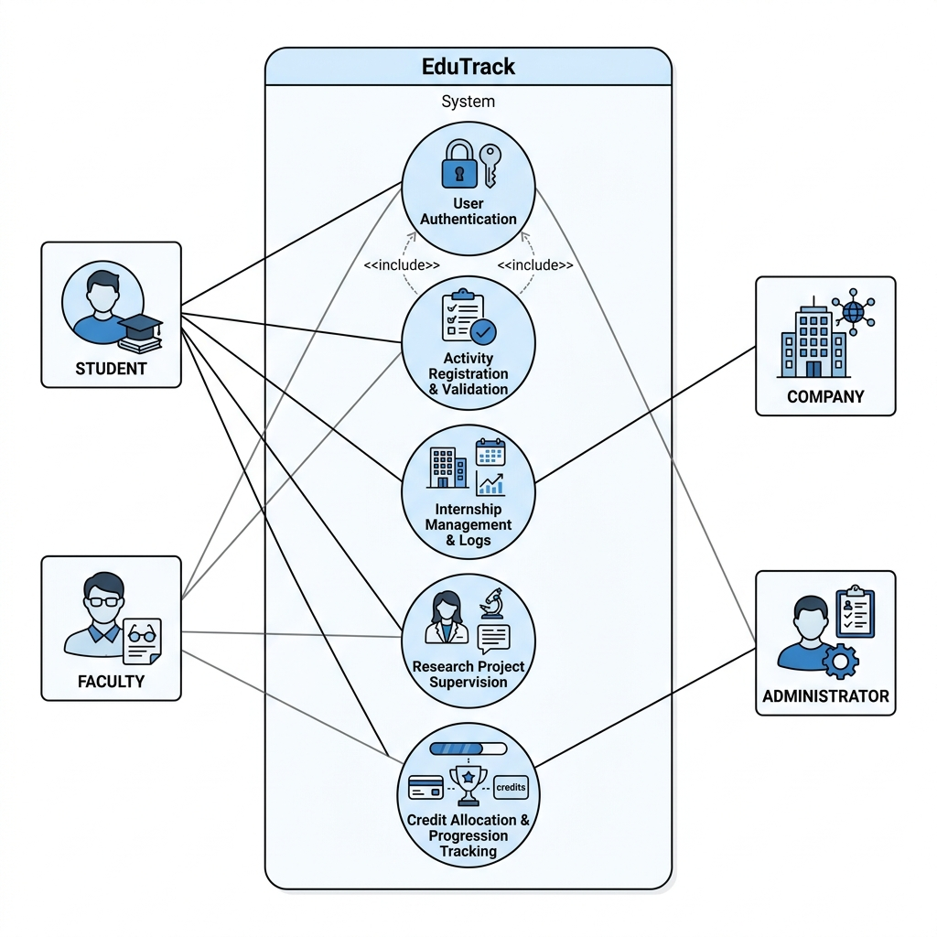
Diagram showing full actor boundaries (Student, Faculty, Company, Administrator) and their core associations.

Figure 2: Student and Faculty Workflow Use Case Diagram
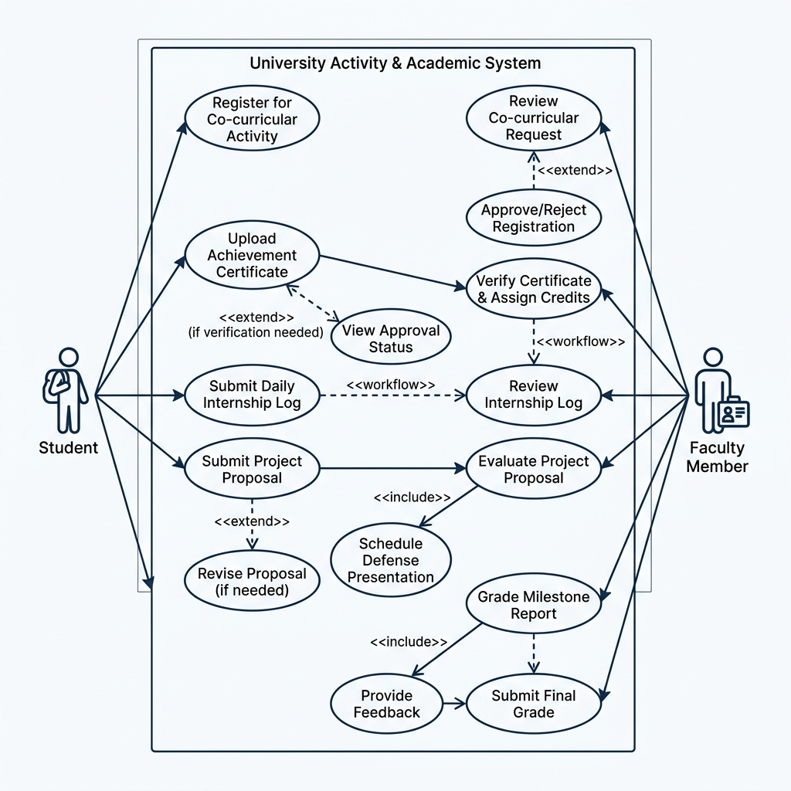
Detailing activity registration, certificate evaluation, project submission, and grading workflow.

