**Assignment3: Deploying AWS EC2 Instance and RDS Instance using CloudFormation**

Student Name: Jithin Jyothi

Student ID: 8876281

Github link: <https://github.com/JithinJyothi95/A3-IAC-Jithin-8876281>

Instructor: Prof.Vikas

# ****Overview****

This report documents the step-by-step process of deploying a basic AWS infrastructure using CloudFormation.  
It includes three key components: a networking stack (VPC and subnets), an RDS database stack, and an EC2 instance stack.  
All components were provisioned using YAML templates via the AWS CLI and verified on the AWS Console.

# ****1. Networking Stack****

Stack Name: jithin-networking-stack  
  
This stack creates a custom VPC, public and private subnets, route table, and an internet gateway.  
  
Command used:  
*aws cloudformation create-stack --stack-name jithin-networking-stack --template-body file://templates/network.yaml --capabilities CAPABILITY_NAMED_IAM*

Console and CLI Verification:

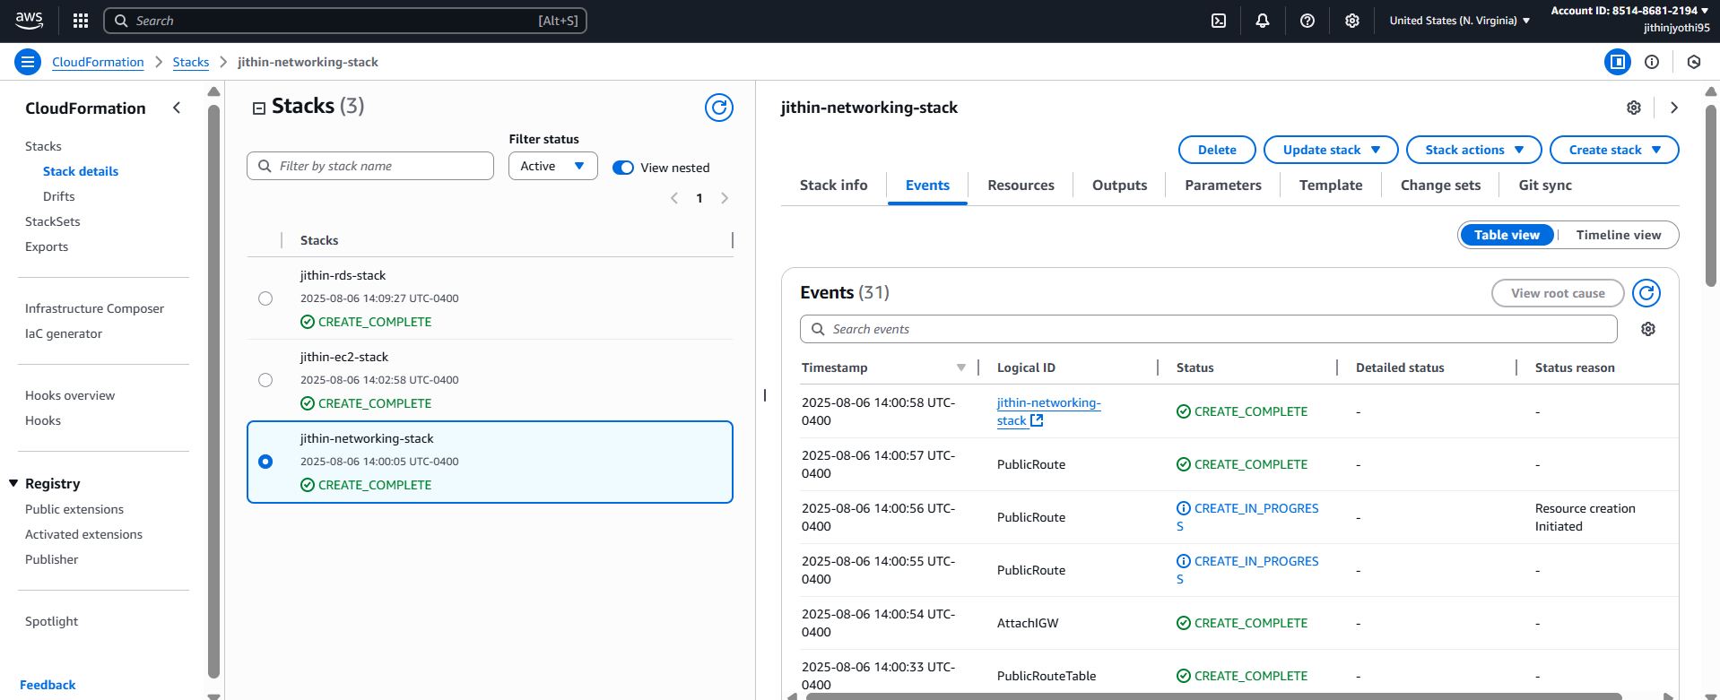

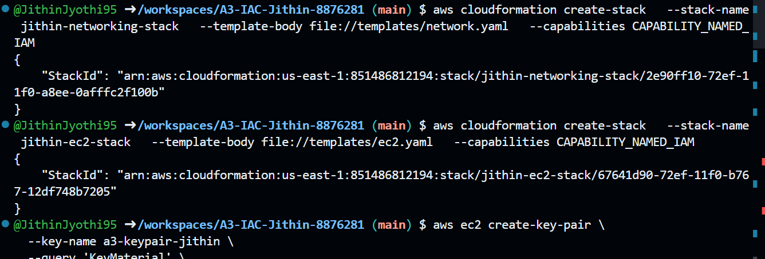

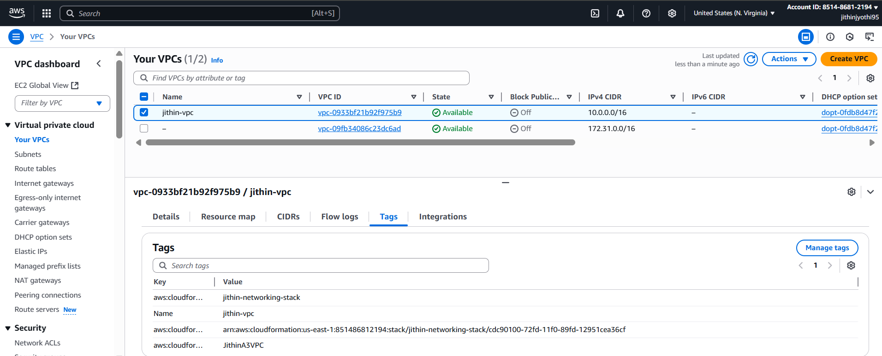

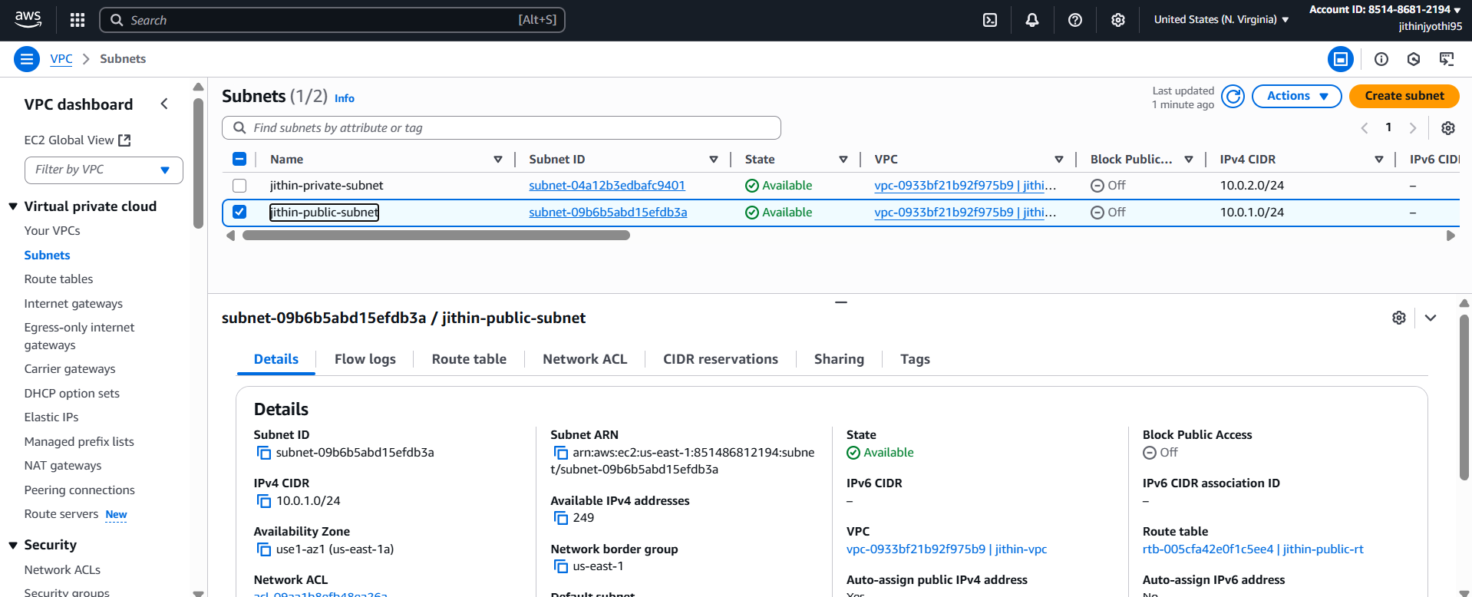

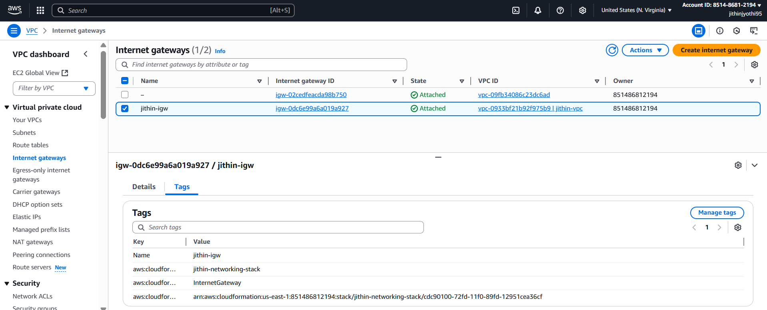

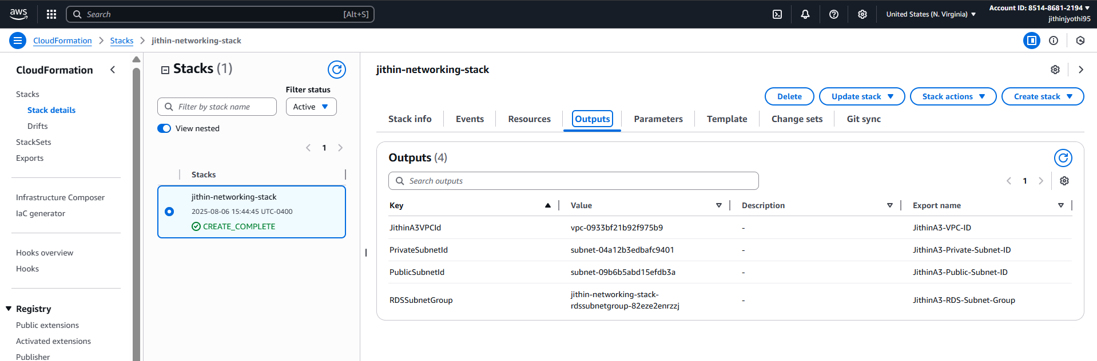

# ****2. RDS Stack****

Stack Name: jithin-rds-stack  
  
This stack provisions an Amazon RDS MySQL database in a private subnet, with security group settings to control access.  
  
Command used:  
*aws cloudformation create-stack --stack-name jithin-rds-stack --template-body file://templates/rds.yaml --capabilities CAPABILITY_NAMED_IAM*

Console and CLI Verification:

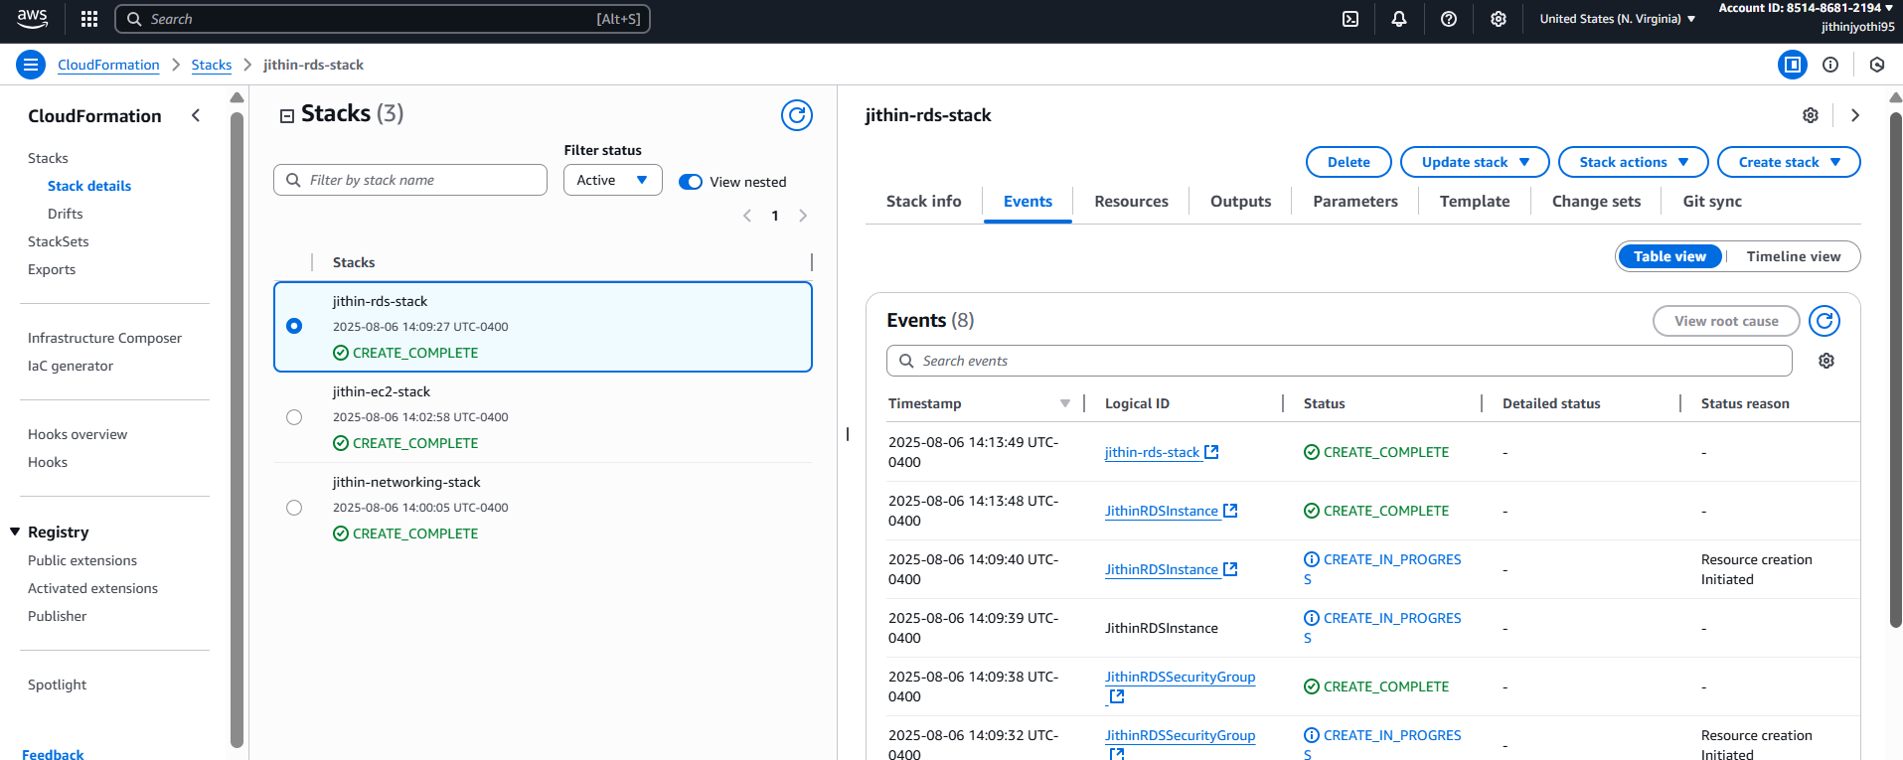

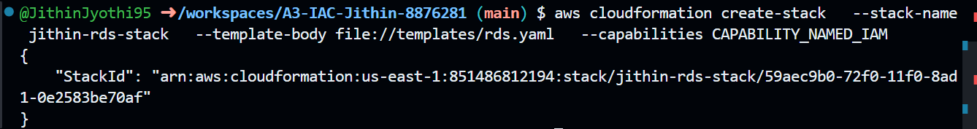

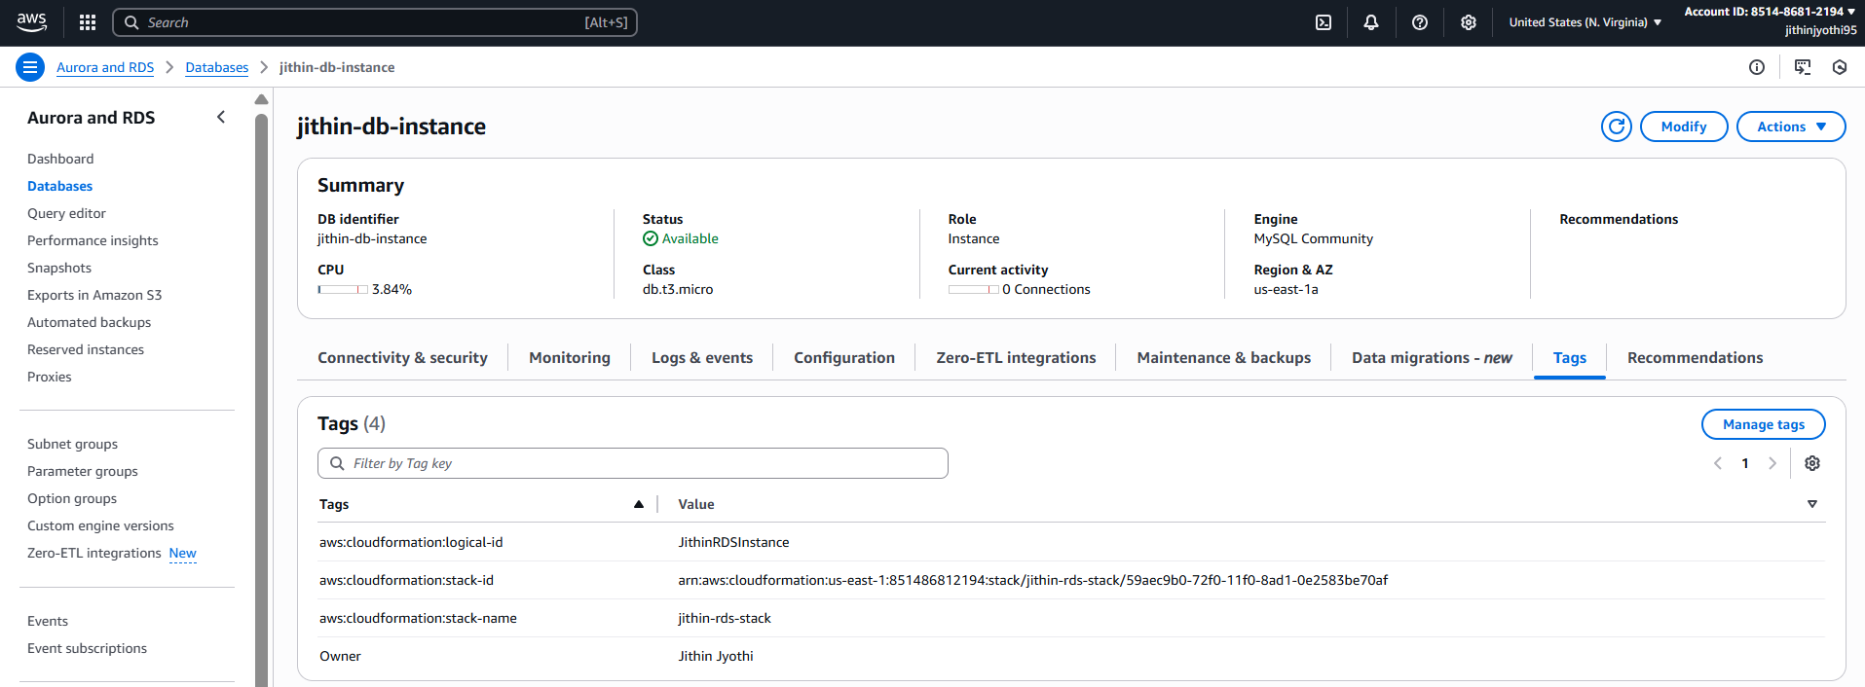

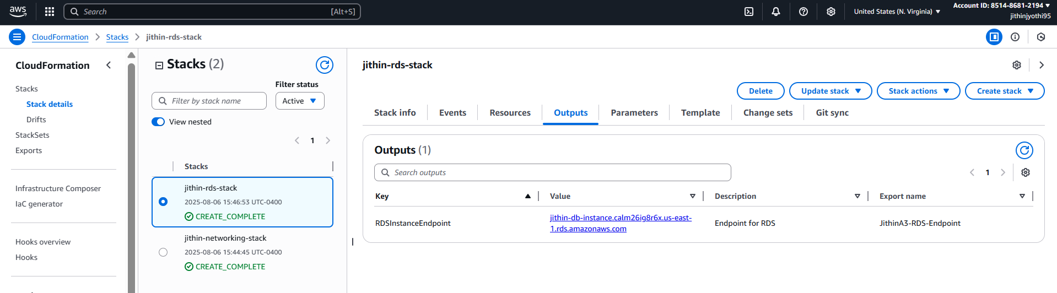

# ****3. EC2 Stack****

Stack Name: jithin-ec2-stack  
  
This stack provisions a t2.micro EC2 instance in the public subnet. It uses a previously generated key pair for SSH access and assigns a security group allowing SSH (port 22).

Command used:  
*aws cloudformation create-stack --stack-name jithin-ec2-stack --template-body file://templates/ec2.yaml --capabilities CAPABILITY_NAMED_IAM*

Console and CLI Verification:

