**1. Write a SQL statement to create a table containing the column name as follows:**

**Id, country, continent, currency.**



**2. Write a SQL statement to insert into the table the given above data in the same order as shown in above table.**

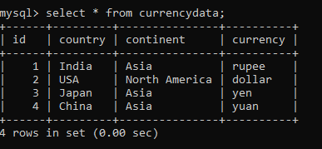

**3. Write a SQL statement to insert into the table the given data :**

**id=5, country=Bangladesh, currency=taka.**

**4. Write a SQL statement to change the continent of all the countries to “not given”.**

**5. Write a SQL statement to change the country from China to “People republic of China”.**

**6. Write a SQL statement to add a column “country_population” with default value as “no data”.**

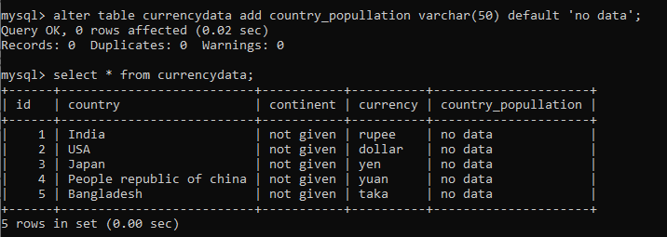

**7. Write a SQL statement to drop the column “country_population”.**

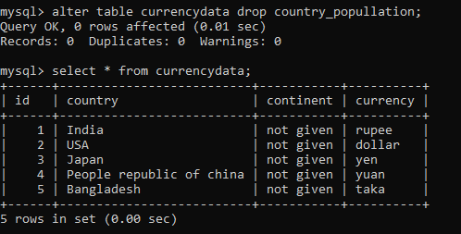

**8. Write a SQL statement to add the primary key to the id column of the given table.**



**9. Write a SQL statement to change the table name to “Country_Census”.**

**10. Write a SQL statement to display the country from the table.**

**11. write a SQL statement to display the id and continent from the table.**

**12. Write a SQL statement to delete the table data where id=3.**

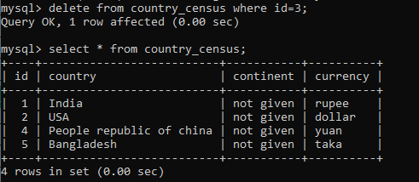

**13. Write a SQL statement to drop the table.**

**14. Create a table with table_name as “Country_data” ,same as the above table .**

**15. Insert into table data of your choice up to 3 data.**

