Coin Counting and Segmentation Using Digital Image Processing (DIP)
1.Problem statement
Image-based identification and counting of coins can be time-consuming if many coins are present and located close together or if variations in lighting and backgrounds are present in the image. Using visual counting of images, the user must look at each image individually.
This project, coin segmentation, and counting by images and Digital Image Processing (DIP) are designed to run through a coin image segmentation and counting system as per conventional image- processing techniques, namely grayscale, histogram analysis, image enhancement, spatial filtering, Otsu threshold, morphological operations, distance transformation, watershed segmentation, and connected component analysis.
The project includes image restoration in which synthetic noise of different types is added to the image, and restoration is achieved through spatial filtering, and results are studied in terms of MSE, Peak Signal to Noise Ratio, and Structural Similarity Index. This project involves application-oriented Digital Image Processing projects that consist of a real-world visual problem, image prepossessing, restoration, segmentation, implementation, testing, quantitative evaluation, failure cases and limitations, and future scope as mandated by mini-project work.
2. Objectives The objectives of the project are: 1.
Developing an image-processing system for automatic coin segmentation and counting.
2. Preprocessing of coin images using Digital Image Processing techniques like gray-scale conversion, image enhancement, etc.
3. Analyzing the intensity distribution of coin images through histograms and enhancing the images based on the histogram. 4. Studying the concept of Image Restoration on the images by introducing synthetic noise of different types. 5. Applying the mean filter, median filter, and Gaussian filter for noisy-image filtering.
6. Comparing the image-restoring performance of each filter based on the Mean Squared Error (MSE), Peak Signal to Noise Ratio, and Structural Similarity Index (SSIM). 7. Applying Otsu threshold for segmentation of coins from the background of the image.
8. Morphological opening and closing to improve the segmented regions.
9. Distance transformation and watershed-based segmentation to separate coins from the background.
10. Counting and numbering the separated coins, using connected component analysis, and comparing the number of detected coins with the number of manually verified coins.
11. Identifying failure cases for the coin counting system.
12. Identifying limitations, implementation of future research directions.

3. Dataset / Image Description
3.1 Dataset
The coin images dataset consists of five coin images for the development and testing of the proposed coin segmentation/counting system. The images in the project are: 1.png 2.png 3.png 4.png 5.png The images contain many coins with different positions and arrangements of the background. These images were used to demonstrate various Digital Image Processing operations which include image enhancement, noise restoration, thresholding, morphological processing, watershed segmentation and coin counting.
Number of Images Dataset There are total 5 images in dataset in which there are total 36 coins(confirmed by hand) detected by system 35 coins found which give overall accuracy of 97.22%.
3.2 Image Characteristics
The input images are color images which contains many coins arranged on background. We have processed the images using python as well as OpenCV. The following are the main preprocessing steps: Conversion of RGB to grayscale Histogram analysis Histogram equalization Contrast stretching Gaussian smoothing Otsu thresholding Morphological opening and closing Distance transformation Watershed segmentation 3.3 Dataset Limitations Since the dataset contains only 5 images it is quite small for the general performance evaluation. The overall 97.22 % accuracy is obtained using five test images and should not be used as the general accuracy for the entire coin image set.
4. Methodology
The proposed system uses a classical Digital Image Processing approach for coin segmentation and counting.
Approach — Classical Digital Image Processing
Input Coin Image
↓
RGB to Grayscale Conversion
↓
Histogram Analysis and Image Enhancement
↓
Gaussian Smoothing
↓
Otsu Thresholding
↓
Morphological Opening and Closing
↓
Distance Transformation
↓
Sure Foreground and Sure Background
↓
Watershed Segmentation
↓
Connected Component Analysis
↓
Coin Counting and Numbering
↓
Accuracy Evaluation
The methodology combines image enhancement, restoration, segmentation, and morphological techniques to identify individual coins from the input images. Otsu thresholding is used to separate the coins from the background, while morphological operations improve the segmented regions. Distance transformation and watershed segmentation are then applied to separate individual coins, followed by connected-component analysis for counting.

5. Digital Image Processing Method
The classical Digital Image Processing method was applied to the five coin input images to perform coin segmentation and counting.
5.1 Conversion to Grayscale
The color coin image in the input five images is first converted to grayscale in order to ease image-processing operations such as histogram analysis, filtering, thresholding, etc.
5.2 Histogram Analysis and Image Enhancement
The intensity distribution in the grayscale coin image is studied through histogram analysis.
To enhance the contrast in the image, histogram Equalization and contrast stretching are used.
They help attain the intensity contrast that is conducive for the subsequent segmentation process.
5.3 Gaussian Smoothing
In order to reduce small-scale noise and unwanted intensity variation in the image prior to segmentation, Gaussian smoothing is used. We use a 55 Gaussian filter before Otsu thresholding in the main coin-segmentation process.
5.4 Otsu Thresholding
Otsu thresholding is used to generate a global threshold to distinguish coins from the background.
Unlike choosing a threshold value based on experience, the threshold is now achieved by Otsu methods according to the distribution of intensity in the grayscale coin image.
The binary image that results from the Otsu thresholding procedure yields the initial coin segmentation.
5.5 Morphological Opening and Closing
Opening and closing are first used to improve the initial binary segmentation of the coins. They help remove small regions and noise through opening and fill gaps through closing.
5.6 Distance Transformation and Watershed Segmentation
Since the initial binary segmentation of the coins results in regions that are close to each other, a distance transformation is applied to better define the coins' center region. Sure foreground and sure background regions are then created to serve as markers for the watershed segmentation.
5.7 Connected Component Analysis
After applying watershed segmentation, connected-component analysis is used to locate all the coins in the image.
Connected regions with enough area are now counted as detected coins.
Based on the position of the centroids of the detected coin regions, numbers are mapped to number the output image of segmented coins. The final output contains the segmented/numbered coin image and the detected coin count.

6. Deep Learning Method
A deep-learning method such as U-Net was not implemented in this project. The proposed system uses traditional Digital Image Processing techniques for coin segmentation and counting.
The project focuses on understanding and applying classical image-processing operations such as grayscale conversion, histogram-based enhancement, spatial filtering, Otsu thresholding, morphological operations, distance transformation, watershed segmentation, and connected-component analysis.
These techniques were selected to demonstrate how a coin-counting problem can be solved using Digital Image Processing without requiring a deep-learning model.
6.1 Reason for Not Using Deep Learning
The project is based on a small dataset of five coin images. Since deep-learning segmentation generally requires a sufficiently large and appropriately annotated dataset for training and evaluation, a traditional DIP-based approach was used instead.
6.2 Classical Segmentation Approach
The segmentation process consists of:
- Grayscale conversion
- Gaussian smoothing
- Otsu thresholding
- Morphological opening and closing
- Distance transformation
- Sure foreground and background generation
- Watershed segmentation
- Connected-component analysis
6.3 Final Output
The final system produces a segmented and numbered coin image and calculates the number of detected coins.
The system detected 35 out of 36 manually verified coins, giving an overall counting accuracy of 97.22% on the five test images.

7. Image Processing and Restoration Experiments
Since no deep-learning model was used, the project does not involve model training, an optimizer, loss functions, or data augmentation. Instead, different Digital Image Processing techniques were applied to study image enhancement, restoration, and segmentation.
The implementation included:
- Gaussian noise generation
- Salt-and-pepper noise generation
- Rayleigh noise generation
- Gamma noise generation
- Exponential noise generation
- Mean filtering
- Median filtering
- Gaussian filtering
- MSE, PSNR, and SSIM for restoration evaluation
Noise Restoration Experiments
Synthetic noise was added to the grayscale coin image to simulate degraded image conditions. Spatial filters were then applied to restore the noisy images.
For the restoration experiments:
- A 7×7 mean filter was used.
- A 7×7 median filter was used.
- A 7×7 Gaussian filter was used for the Gaussian-noise experiment.
- A 5×5 median filter was also tested for salt-and-pepper noise.
The restored images were compared with the original grayscale image using Mean Squared Error (MSE), Peak Signal-to-Noise Ratio (PSNR), and Structural Similarity Index (SSIM).
The experiments demonstrated that filter performance depends on the type of noise. For example, the 7×7 median filter performed better than the mean filter for the salt-and-pepper noise experiment, while the 7×7 mean filter produced the best results among the tested filters for the Gaussian-noise experiment.

8. Threshold Analysis
Thresholding is an important part of the proposed coin segmentation system. Otsu thresholding was used to automatically determine a suitable threshold for separating the coins from the background.
The grayscale image was first smoothed using Gaussian filtering. Otsu's method was then applied to automatically calculate the threshold based on the image intensity distribution.
For Image 1, the Otsu threshold obtained was 148.
The resulting binary image was further processed using morphological opening and closing to improve the segmented coin regions.
For the watershed segmentation stage, the distance transform was used to identify the sure foreground regions. These foreground regions were combined with sure background markers and used to perform watershed segmentation.
The thresholding and marker-generation process was important for separating individual coins and obtaining an accurate coin count.

9. Evaluation Metrics
The project was evaluated primarily using coin-counting accuracy and image-restoration metrics.
9.1 Coin-Counting Accuracy
The detected coin count was compared with the manually verified actual number of coins in each image.
The evaluation was:
Image | Actual Count | Detected Count | Accuracy
Image 1 | 5 | 5 | 100%
Image 2 | 7 | 7 | 100%
Image 3 | 8 | 8 | 100%
Image 4 | 10 | 9 | 90%
Image 5 | 6 | 6 | 100%
Total | 36 | 35 | 97.22%
The system correctly detected the coin count in four out of five images. In Image 4, one coin was missed, resulting in an accuracy of 90% for that image.
The overall counting accuracy across the five images was 97.22%.
9.2 Image Restoration Metrics
For the noise-restoration experiments, the following metrics were used:
- Mean Squared Error (MSE) — measures the difference between the original and restored images. Lower values indicate less error.
- Peak Signal-to-Noise Ratio (PSNR) — measures the quality of the restored image. Higher values generally indicate better restoration quality.
- Structural Similarity Index (SSIM) — measures structural similarity between the original and restored images. Higher values indicate greater structural similarity.

10. Results
10.1 Coin Counting and Segmentation Results
The proposed Digital Image Processing system was tested on five coin images. The manually verified coin counts were compared with the counts obtained using the proposed segmentation and connected-component analysis method.
Image | Actual Count | Detected Count | Counting Accuracy
Image 1 | 5 | 5 | 100%
Image 2 | 7 | 7 | 100%
Image 3 | 8 | 8 | 100%
Image 4 | 10 | 9 | 90%
Image 5 | 6 | 6 | 100%
Total | 36 | 35 | 97.22%
The system correctly detected the number of coins in four out of the five test images. In Image 4, the system detected 9 coins instead of the manually verified 10 coins. The missed coin was the top ₹10 coin.
Across all five images, the system detected 35 out of 36 coins, resulting in an overall counting accuracy of 97.22%.
10.2 Image Restoration Results
The restoration experiments were performed using different types of synthetic noise and spatial filters.
For Gaussian noise with standard deviation 50, the results were:
Filter | MSE | PSNR (dB) | SSIM
Mean 7×7 | 125.047 | 27.160 | 0.661
Median 7×7 | 148.157 | 26.424 | 0.540
Gaussian 7×7 | 144.804 | 26.523 | 0.532
For salt-and-pepper noise, the results were:
Filter | MSE | PSNR (dB) | SSIM
Mean 7×7 | 160.879 | 26.066 | 0.653
Median 7×7 | 72.722 | 29.514 | 0.864
These results demonstrate that the performance of a filter depends on the type of noise present in the image. The 7×7 mean filter produced the best results among the tested filters for the Gaussian-noise experiment, while the 7×7 median filter performed better for salt-and-pepper noise.
Note: Dice and IoU scores are not reported because the project does not contain manually prepared pixel-level ground-truth masks. Therefore, the main segmentation evaluation is based on coin-counting accuracy.
11. Coin Counting Analysis
After obtaining the final segmented image through watershed segmentation, the individual coin regions were identified using connected-component analysis.
The detected number of coins was compared with the manually verified number of coins in each test image.
The counting accuracy for each image was calculated as:
Counting Accuracy = Detected Coins / Actual Coins × 100
The five test images contained a manually verified total of 36 coins. The system successfully detected 35 coins.
Therefore, the overall counting accuracy was:
Overall Counting Accuracy = 35 / 36 × 100 = 97.22%
Image 4 produced the only counting error, where 9 coins were detected instead of 10. The missed coin was the top ₹10 coin.

12. Counting and Restoration Results
12.1 Coin Counting Results
Measure | Value
Number of Test Images | 5
Total Actual Coins | 36
Total Detected Coins | 35
Overall Counting Accuracy | 97.22%
Images with Correct Count | 4
Images with Counting Error | 1
The results show that the proposed DIP-based method successfully counted the coins in most of the test images.
12.2 Restoration Results
The restoration experiments demonstrated that different filters perform differently depending on the type of noise.
For the Gaussian-noise experiment, the 7×7 mean filter achieved:
- MSE: 125.047
- PSNR: 27.160 dB
- SSIM: 0.661
For the salt-and-pepper noise experiment, the 7×7 median filter achieved:
- MSE: 72.722
- PSNR: 29.514 dB
- SSIM: 0.864

13. Failure Case Analysis
Failure-case analysis was performed to identify situations where the proposed coin segmentation and counting system did not correctly detect all coins.
The main failure cases observed in the test images include:
- Missed coin regions
- Incorrect foreground markers
- Difficulty separating individual coins when their regions are close together
- Sensitivity to lighting, shadows, and reflections
- Dependence on the quality of thresholding and watershed markers
Image 4 Failure Case
The main failure case occurred in Image 4.
The manually verified image contains 10 coins, while the proposed system detected 9 coins. The top ₹10 coin was not successfully identified as a separate region during the watershed segmentation process.
Different foreground-marker thresholds were experimentally examined, but changing the threshold did not reliably produce the correct 10 individual regions. This indicates that the quality of the foreground markers can have a significant effect on the final watershed segmentation result.
Other images were successfully processed, with Images 1, 2, 3, and 5 producing the correct coin counts.
Failure-case analysis is important because it demonstrates the limitations of the proposed DIP method and identifies areas where the segmentation and counting process can be improved.
14. Comparison of the Image Processing Techniques
Aspect | Image Enhancement / Restoration | Segmentation and Counting
Input | Grayscale coin image | Grayscale coin image
Main techniques | Histogram equalization, contrast stretching, spatial filtering | Otsu thresholding, morphology, distance transform, watershed
Main purpose | Improve image quality and reduce noise | Separate and count individual coins
Feature extraction | Intensity and image-quality information | Distance-based foreground regions and connected components
Evaluation | MSE, PSNR, SSIM | Coin-counting accuracy
Main limitation | Filter performance depends on noise type | Sensitive to thresholding and foreground-marker quality
Output | Restored/enhanced image | Segmented and numbered coin image
Comparison of Results
The restoration experiments showed that different filters perform differently for different noise types. For Gaussian noise, the 7×7 mean filter produced the best results among the tested filters, while the 7×7 median filter performed better for salt-and-pepper noise.
The segmentation and counting approach successfully detected 35 out of 36 coins, resulting in an overall counting accuracy of 97.22%. The only counting error occurred in Image 4, where one coin was missed.
This comparison demonstrates that different Digital Image Processing techniques serve different purposes within the proposed coin-counting system. Image enhancement and restoration improve image quality, while thresholding, morphology, watershed segmentation, and connected-component analysis are used for object segmentation and counting.

Images for comparison
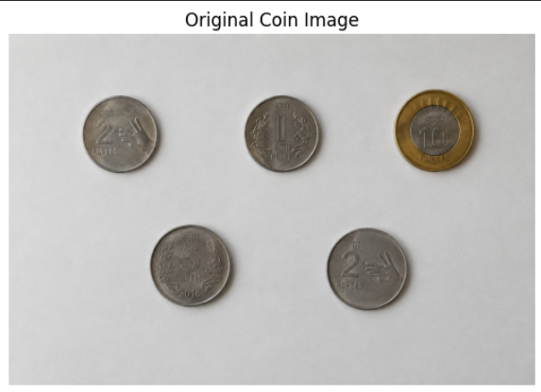

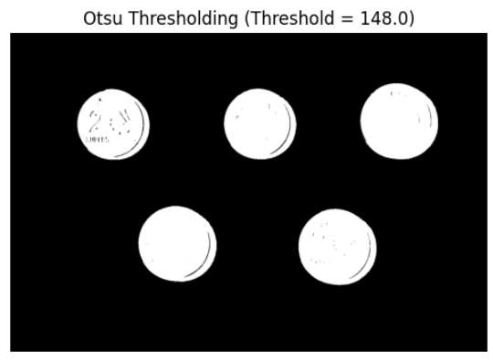
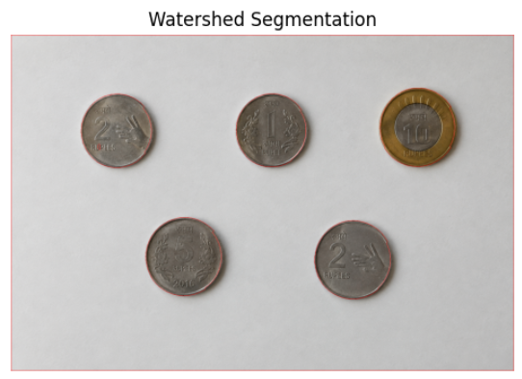

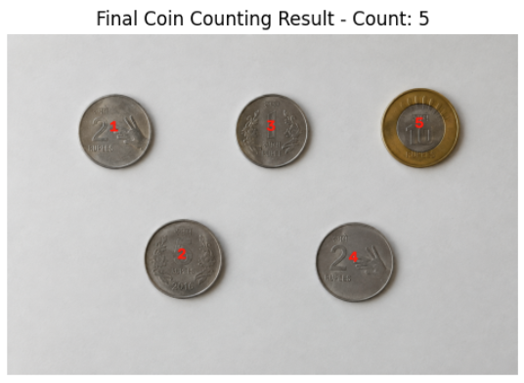
15. Limitations
The developed coin counting and segmentation system has several limitations.
1. Limited Dataset Size
Only five coin images were used for testing. Although the system achieved an overall counting accuracy of 97.22% on these images, the small dataset is not sufficient to claim that the same performance will be obtained on a larger and more diverse collection of coin images.
2. Limited Image Variety
The dataset contains only five test images with specific coin arrangements, backgrounds, and lighting conditions. Therefore, the system may not perform equally well on images with substantially different backgrounds, coin types, sizes, or arrangements.
3. Single Missed Coin
The system correctly counted four out of the five test images. In Image 4, the manually verified count was 10 coins, while the system detected 9 coins. The top ₹10 coin was missed during the segmentation process.
4. Sensitivity to Foreground Markers
The watershed segmentation process depends on the quality of the sure foreground and sure background markers. In Image 4, the top coin did not produce a suitable separate foreground marker, which resulted in one missed coin.
5. Sensitivity to Lighting and Shadows
Changes in lighting, shadows, reflections, and image intensity can affect grayscale conversion and global thresholding. Since the system uses Otsu thresholding, difficult illumination conditions may reduce segmentation accuracy.
6. Touching or Overlapping Coins
Coins that are very close together or partially overlapping may produce connected regions. Although distance transformation and watershed segmentation are used to separate such regions, incorrect foreground markers can still cause segmentation errors.
7. Limited Generalization
The obtained 97.22% counting accuracy represents the performance only on the five images used in this project. It should not be interpreted as a general accuracy for all coin-counting images.
8. Classical DIP Approach
The project uses traditional image processing techniques such as Otsu thresholding, morphology, distance transformation, watershed segmentation, and connected-component analysis. The system does not use a deep-learning model, so its performance may be limited for highly complex scenes where traditional segmentation methods are insufficient.
16. Future Scope
The developed coin counting and segmentation system can be improved in several ways:
- Increase the dataset size and diversity by using a larger number of coin images with different backgrounds, lighting conditions, and arrangements.
- Include different coin denominations so that the system can identify and count individual denominations in addition to detecting the total number of coins.
- Improve image acquisition by using higher-quality images with consistent illumination to reduce the effect of shadows and reflections.
- Improve thresholding methods by experimenting with adaptive thresholding and other segmentation techniques for images with uneven lighting.
- Improve watershed segmentation by generating more accurate sure-foreground markers to reduce missed or incorrectly separated coins.
- Develop denomination classification using coin size, shape, colour, or other visual features after segmentation.
- Develop a real-time coin counting system using a camera for applications such as automated counting and inventory management.
- Compare classical DIP with deep-learning approaches such as object detection or instance segmentation to study their performance on larger datasets.
- Improve handling of touching and overlapping coins using more advanced segmentation and contour-analysis techniques.
- Develop a web or mobile application that allows users to upload an image and automatically obtain the detected coin count.
- Evaluate the system on a larger benchmark dataset to obtain a more reliable measurement of its general performance.
- Improve false-positive and false-negative handling to make the system more robust under challenging image conditions.
These improvements can extend the proposed system from a small experimental DIP project into a more robust and practical coin detection, counting, and denomination-recognition system.

17. Conclusion
This project presented an image-based approach for coin segmentation and counting using Digital Image Processing techniques.
A classical DIP pipeline consisting of RGB-to-grayscale conversion, histogram analysis, histogram equalization, contrast stretching, Gaussian smoothing, Otsu thresholding, morphological processing, distance transformation, watershed segmentation, and connected-component analysis was developed.
The restoration experiments also demonstrated the effect of different spatial filters on different types of noise. For the Gaussian-noise experiment, the 7×7 mean filter produced the best results among the tested filters based on MSE, PSNR, and SSIM. For salt-and-pepper noise, the 7×7 median filter produced better restoration results than the mean filter.
The proposed segmentation and counting system was tested on five coin images containing a manually verified total of 36 coins. The system detected 35 coins, giving an overall counting accuracy of 97.22%. Four images were counted correctly, while Image 4 contained one missed coin.
The failure case demonstrates that the performance of the system can be affected by factors such as foreground-marker quality, lighting conditions, shadows, reflections, and the arrangement of coins.
Overall, the project demonstrates how traditional Digital Image Processing techniques can be combined for image enhancement, restoration, segmentation, and object counting without requiring a deep-learning model. The results also show that classical DIP methods can provide an effective approach for controlled coin-counting images while leaving scope for further improvement using larger datasets and more advanced segmentation methods.

18. Technologies Used
- Python
- Google Colab
- OpenCV
- NumPy
- Pandas
- Matplotlib
- scikit-image
These libraries were used for image processing, numerical computation, data analysis, visualization, and evaluation of restoration results.

19. Project Structure
The GitHub repository contains the following project files and folders:
Coin-Counting-DIP/
│
│ ├── images/
│ ├── 1.png
│ ├── 2.png
│ ├── 3.png
│ ├── 4.png
│ └── 5.png
│
│ ├── results/
│ ├── metrics.csv
│ └── comparison.png
│
│ ├── report/
│ └── DIP_Mini_Project_Report.pdf
│
│ ├── README.md
└── coin_counting_DIP.ipynb

20. GitHub Repository
Repository: Coin-Counting-DIP
The repository contains:
- Complete project notebook
- README documentation
- Input coin images
- Project results and evaluation metrics
- Comparison figure showing the major processing stages
- Complete methodology and implementation information
GitHub link: https://github.com/Jithu-Dhanapalan/Coin-Counting-DIP

