**✅ Page 1: Signup Page**

**Fields:**

* Name (input)
* Email (input)
* User Type (dropdown):
  + Team Head
  + Team Member
* [Next] button

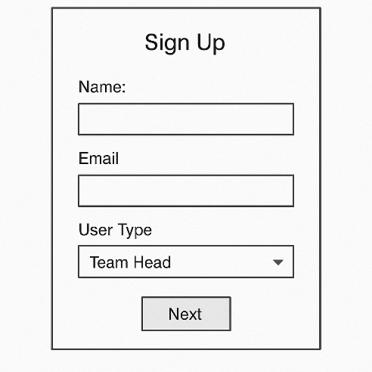

**✅ Page 2 : Create Team Page**

**Only shown if "Team Head" is selected.**

**Fields:**

* Team Name (input)
* Team Description (textarea)
* [Create Team] button

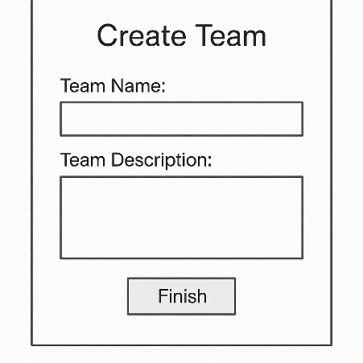

**✅ Page 3 : Team Join**

**Only shown if "Team Member" is selected.**

**Fields:**

* Team ID (Text field)
* Team Description (textarea)
* 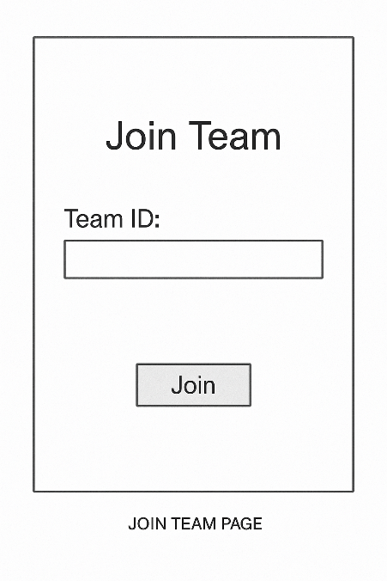[Join] button

**✅ Page 4 : Create Task Page**

**Fields:**

* Title(text)
* Description (textarea)
* Status(enum)
* DueDate(date)
* UsertoAsign(users from db)

**✅ Page 5: Create Meeting Page(stand ups)**

**Only valid for 24 hours**

**Fields:**

* Topic(text)
* Description(text)

**✅ Page 5: Common Room**

**Fields:**

* Message