AI DATA ANALYST REPORT
Automated Business Analysis
07 October 2026, 10:29 AM

1. Executive Summary
Analysis of city-wise profit by product across 18,720 rows shows Smartphones leading significantly with over 1.44 billion in profit, followed by Laptops at over 454 million.

2. Question Analyzed
city wise profit by product

3. Conversation Questions & Answers

Question 1
city wise profit by product

Answer 1
Executive Summary:
Analysis of city-wise profit by product across 18,720 rows shows Smartphones leading significantly with over 1.44 billion in profit, followed by Laptops at over 454 million.
Key Findings:
- Smartphones generated the highest total profit at over 1.44 billion.
- Laptops are the second most profitable product at over 454 million.
- Smartwatches recorded the lowest profit among the listed products at over 138.6 million.
Top Performers:
- Smartphone
- Laptop
Anomalies:
- Smartphone profit of 1,443,554,337.6 in a specific city significantly exceeds the upper bound threshold of approximately 737,662,946.77.
Recommendations:
- Investigate the underlying drivers of the high profit anomaly for Smartphones.
- Review performance across remaining product categories including Televisions, Headphones, Tablets, and Smartwatches.

4. Analysis Details
Rows matched: 18,720
Metric: profit
Operation: sum
Grouped by: product
Filters applied: None

5. Analysis Result
Product | Profit
Smartphone | ₹1,443,554,337.60
Laptop | ₹454,258,786.58
Television | ₹234,472,107.85
Headphones | ₹173,979,400.66
Tablet | ₹173,666,729.09
Smartwatch | ₹138,669,587.23

6. Visualization
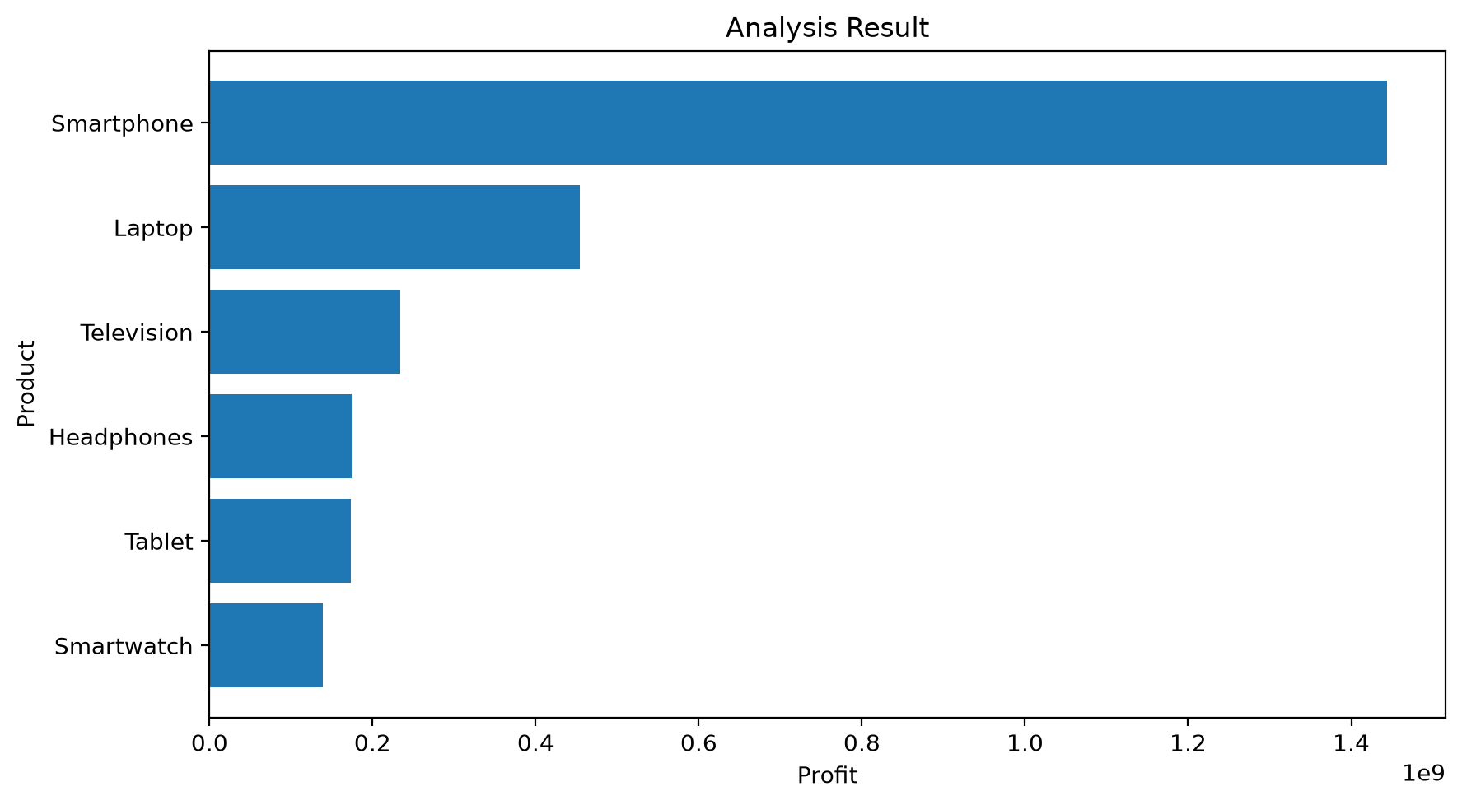

7. Key Findings
- Smartphones generated the highest total profit at over 1.44 billion.
- Laptops are the second most profitable product at over 454 million.
- Smartwatches recorded the lowest profit among the listed products at over 138.6 million.

8. Top Performers
- Smartphone
- Laptop

9. Anomalies
- Smartphone profit of 1,443,554,337.6 in a specific city significantly exceeds the upper bound threshold of approximately 737,662,946.77.

Detected Statistical Anomalies
Product | Profit | Anomaly Type | Lower Bound | Upper Bound
Smartphone | ₹1,443,554,337.60 | High | -164,605,932.89 | 737,662,946.77
Anomaly Explanation
Here is the analysis of the detected anomaly:
* The product "Smartphone" generated a profit of 1,443,554,337.6 in a specific city, which is classified as a high anomaly.
* This profit value significantly exceeds the upper bound threshold of approximately 737,662,946.77.
* Such an unusual deviation from expected profit ranges may require investigation to determine the underlying drivers.

10. AI Business Insights
* Smartphones generated the highest total profit among all listed products, reaching over 1.44 billion.
* Laptops are the second most profitable product, contributing over 454 million in profit.
* Televisions rank third in profitability, bringing in more than 234 million.
* Headphones and Tablets generated comparable profit totals, with Headphones at over 173.9 million and Tablets at over 173.6 million.
* Smartwatches recorded the lowest profit among the listed products, at over 138.6 million.

11. Business Recommendations
- Investigate the underlying drivers of the high profit anomaly for Smartphones.
- Review performance across remaining product categories including Televisions, Headphones, Tablets, and Smartwatches.

