
VENUE

Sri Sivasubrmaniya Nadar College of Engineering, Kalavakkam, Chennai, India – 603110

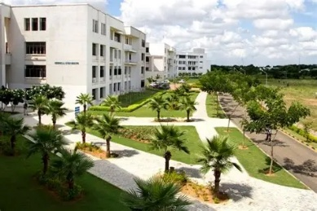
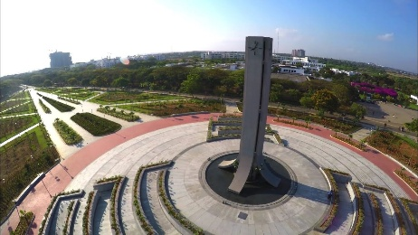
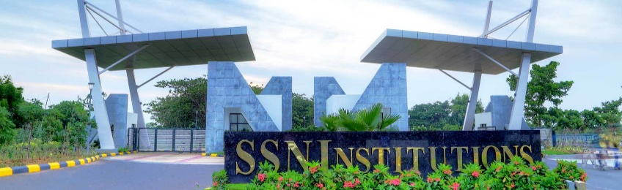


HOW TO REACH US

*By Cab:



*Direct and Comfortable * Cost: 800 INR (approx.) *Duration: 1 Hour (approx.)
Chennai International Airport (MAA)
Cab Booking (OLA/UBER)
Destination

*By Train + Bus:



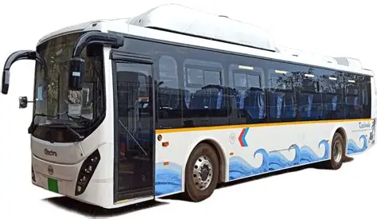
*Low cost option * Cost: 60 INR (approx.) *Duration: 3 Hour (approx.)
Chennai International Airport (MAA)
Destination
Trisulam Railway Station
Tambaram Station
Bus no.: 515, 515B, 515M

Announcement:
Transportation to the SSN campus can also be arranged through the college bus service. The institution operates its own bus facility, and upon prior request, a bus can be arranged at a specific time to pick up visitors from designated locations. This service provides a convenient and organized mode of travel directly to the campus, particularly for guests or participants arriving for CGOM’16 events.

Contact:
*Dr. P. Rajesh: +91 9445 434893
*Mr. R. Praveen Joshwa: +91 8220 497699

