**GROWTH OF 2,4-DIHYDROXY BENZOPHENONE SINGLE CRYSTAL BY VERTICAL BRIDGMAN TECHNIQUE USING TWO-ZONE FURNACE FOR OPTICAL LIMITING APPLICATIONS [TIMES NEW ROMAN, BOLD, FONT SIZE-14, UPPERCASE]**

***Mohamad Asikali Abdul Hakkim(a), Rajesh Paulraj(a)* [Times New Roman, Bold, Font Size-10, Italic, Center]***

(a)Scintillation Materials Laboratory, Department of Physics, Sri Sivasubramaniya Nadar College of Engineering, Kalavakkam, Tamilnadu, 603110.

*[Times New Roman, Font Size-10, Italic, Center]*

*\*Corresponding or Presenting author:* [*rajeshp@ssn.edu.in*](mailto:rajeshp@ssn.edu.in)

*[Times New Roman, Font Size-10, Italic, Center]*

**Abstract**

In this paper, an organic nonlinear optical (NLO) single crystal of 2,4-dihydroxybenzophenone (DHBP) was successfully grown by the vertical Bridgman method using two-zone furnace. From the DSC analysis, the melting and freezing points of the title material were found to be 149 °C and 61 °C, respectively. Single and powder X-ray diffraction analyses revealed and confirmed that the as-grown DHBP single crystal maintained its structure after crystallization. In addition, the functional groups for the molten DHBP crystal sample were investigated by FTIR analysis. From the TG and DTA analysis, the DHBP single crystal can be stable up to 175 ℃ and it was decomposed at 240 ℃. The grown crystal has 80% transparency in the entire visible region. The cut-off wavelength of the grown crystal is 390 nm, and the optical band gap energy of DHBP was found to be 3.13 eV. The photocurrent study reveals that IMGA has a negative photoconductivity nature. From the Z-scan measurement, it was found that the grown crystal exhibits two-photon absorption characteristics and the obtained NLO absorption coefficient value is 5.4 x 10-11 mW-1. Additionally, the optical limiting threshold value of DHBP was estimated to be 3.24 x 1012 Wm-2 which indicates the potential of DHBP for optical limiting applications. [Times New Roman, Font Size-10, Justify, Maximum 250 words]

**Keywords:** Crystal growth, Bridgman method, Transmittance, Photoconductivity, Optical limiters. [Maxiumum: 5 keywords, Seperated by commos]

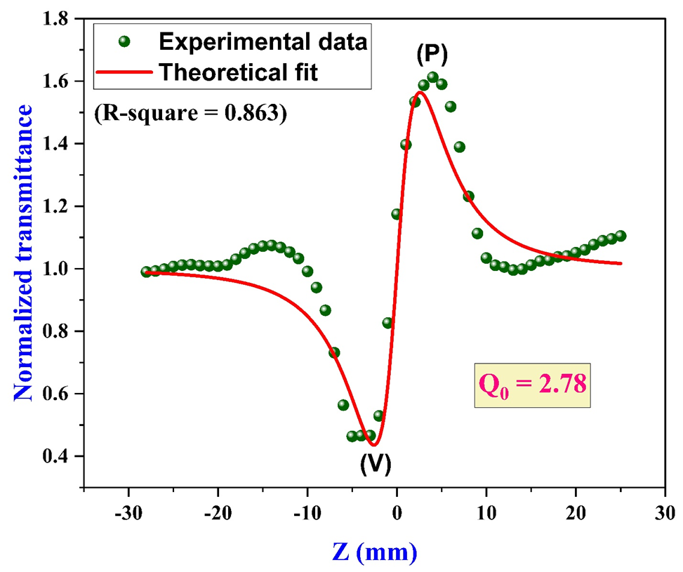

(Optional, Image Quality ≥300 dpi)