Security Challenges in Cloud

Sonal Shukla
Computer Science
Maharishi Arvind College of Engg. and Reaserch Center
Jaipur, India
Sona.shukla91@gmail.com
Bhramdutt Bohra
Computer Science
Maharishi Arvind College of Engg. and Reaserch Center
Jaipur, India
brahmdutt.bohra@gmail.com

Surrendra Yadav
Computer Science
Maharishi Arvind College of Engg. and Reaserch Center
Jaipur, India
syadav66@yahoo.in

Abstract— Cloud Computing is a term which allows user to access the set applications to perform a group of functions or tasks on the internet enabled devices. The cloud has been divided into three types: private, public and hybrid which are briefly described in this paper. SaaS, IaaS and PaaS are the services of the cloud. Cloud is generally provided by the third party, thus it faces few security challenges which are required to be resolved. In this paper we have discussed those issues and also the security architecture needed for the same.
Keywords—Cloud Computing; Security; data privacy; SaaS ;PaaS ;IaaS; architecture .

Introduction
Cloud computing for delivering hosted services over the Internet is a generic term. The term cloud computing simply referred to as “cloud" which provides resources on demand for data applications - everything starting from application to data centers over the Internet in a mode of pay-for-use basis [1]. Cloud computing is simply accessing the services through Internet including storage, applications and servers making use of remote services of another company for a fee. The store and access data or programs virtually is also provided to a company by the use of cloud computing.
Cloud computing has influenced many aspects of computing which has emerged as a new technology in globalized era. Also users can move their data to the network and are able to access services on demand. Moving of data outside its organizational boundaries and access of that through internet makes data vulnerable and owner’s side losses of control of that data. Data on cloud servers can be easily accessed instead of the data stored on your local disk to both computing providers and law enforcement agencies. The term “Cloud Computing” depends on-demand model over internet for accessing common resources.
Cloud computing related technologies include grid computing, utility computing, virtualization and autonomic computing. Cloud computing is similar to Grid computing in a aspect that here also resources are coordinated to achieve common computational objective but it is one step ahead that it leverage virtualization technology for better resource utilization and dynamic resource provisioning. Cloud computing acts as a realization of utility computing which include on-demand resource provisioning and utility based pricing scheme. Cloud computing shares the characteristics of other computing technologies to other technologies, but new safety issues arise at the same time [2].

What is Cloud computing
Cloud computing, a driving force of demand from its audiences operating system, client-server architecture, and browser to rethink their understanding of what the future of computing may be conceived as an innovative information system (IS) architecture, is. The requirements and complexity while reducing overall client-side cloud computing, hardware requirements, users have leveraged. Often called cloud computing to represent the Internet in flow charts and diagrams used was inspired by the cloud symbol. A separate migration clouds on the remote server accessible via a network, bookmarks, photos, music files and personal data, including, maintaining a growing number of 'bit by bit' with end users in recent years is taking place. Cloud computing virtualization technology is strong; In fact, the technology dates back to the 1967, but for decades the only mainframe systems [3] but was available.

Types of Clouds:

There are four types of clouds: Public, private, community and hybrid. Through a public cloud, a provider through the Internet can offer services to anyone, including storage and application. They may be provided either freely or charged on the basis of pay-per-usage method.

Public Cloud:

Applications, hardware and bandwidth costs are borne by the provider in public cloud services, thus, it is easy to install and are less expensive. They are scalable and users can only take advantage of those services. Public clouds ownership and operation is done by the companies to provide fast access to computing resources to organizations or individuals which are easily affordable. With public cloud services, users don’t have to purchase supporting infrastructure, software or hardware which is mainly owned and managed by the providers.

Private Cloud:

A private cloud or corporate cloud also known as the internal cloud, offers IT services which is provided for a limited number of end users protected via a firewall. Private cloud is generally used in businesses that want to have more control over their corresponding data. As far as the community is concerned, the requirements are similar to the one or more than one organization sharing same resources. A single company own and operate the private cloud who wants to controls the customization process of the automated services and virtualized resources. These are then further used by the various constituent groups and business lines. While providing more control over resources and over steering clear of multi-tenancy, private clouds takes advantage of many of cloud’s efficiencies. [1].

Hybrid Cloud:

A hybrid cloud is the combination of the two or more clouds. A hybrid cloud makes the use of public cloud services along with the private cloud foundation. A private cloud can’t exist in isolation from public cloud and the company’s IT resources. Many of the companies will be able to manage workloads across data centers with private clouds; this generated the need of hybrid clouds- combination of public and private clouds [1].

Different Cloud Services
The three prominent types of cloud computing services are Infrastructure-as-a-Service (IaaS) is a area where companies having large cloud computing services provides virtual infrastructure; Platform-as-a-Service (PaaS) offers the company the freedom to built their own custom applications which can be used by all of its entire workforce and Software-as-a-Service (SaaS) is a area which requires a company to subscribe to its services and access services using the Internet.

Software-as-a-Service (SaaS): SaaS can be described as a process by which Application Service Provider (ASP) provide different software applications over the Internet. This makes the customer to get rid of installing and operating the application on own computer and also eliminates the tremendous load of software maintenance; continuing operation, safeguarding and support. SaaS vendor advertently takes responsibility for deploying and managing the IT infrastructure (servers, operating system software, databases, data center space, network access, power and cooling, etc) and processes (infrastructure patches/upgrades, application patches/upgrades, backups, etc.) required to run and manage the full solution. SaaS features a complete application offered as a service on demand. Examples of SaaS includes: Salesforce.com, Google Apps.

Platform as a Service (PaaS): “PaaS is as a service without any software downloads or installation, end users or IT managers. It delivers computing platform and solution stack. It provides an infrastructure with a high level of integration in order to implement and test cloud applications. The user does not manage the infrastructure (including network, servers, operating systems and storage), but he controls deployed applications and, possibly, their configurations. Examples of PaaS includes: Force.com, Google App Engine and Microsoft Azure.

Infrastructure as a Service (IaaS): IaaS refers to the sharing of hardware resources for executing services using Virtualization technology. Its main objective is to make resources such as servers, network and storage more readily accessible by applications and operating systems. Thus, it offers basic infrastructure on-demand services and using Application Programming Interface (API) for interactions with hosts, switches, and routers, and the capability of adding new equipment in a simple and transparent manner. The client typically pays on a per-use basis. Examples of IaaS includes Amazon Elastic Cloud Computing (EC2), Amazon S3, GoGrid [4].

Cloud Architecture
Front-end and Back-end: are the sections divided into two in the cloud computing architecture. They have a network, usually connected to each other via the Internet. Front end is the client side i.e. is the computer user or end user. Back-end system is the “cloud" section. A central server is used to ensure that everything runs smoothly, it monitors traffic and customer demand. It has a set of rules called protocols and middleware software [5], a special kind of software. Infrastructure, platform, and application: Cloud architecture is developed in three layers.
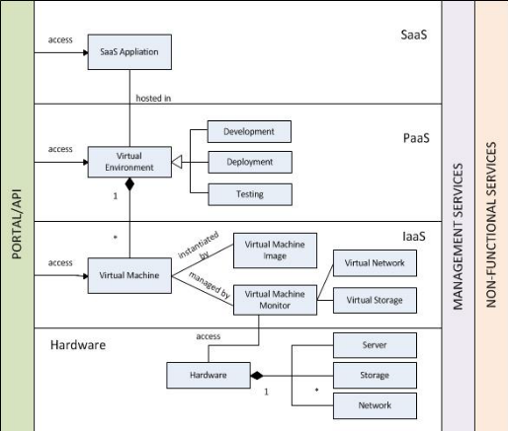

Fig.1. Cloud Architecture
These three development provision in the cloud layers of hardware and software resources with virtualization and standardization are implemented[6]. The infrastructure layer is develop with virtualized calculations, storage and network support. The outline of these hardware needs is meant to offer the facilities demanded by users. Internal, automated provisioning of resources is realized by virtualization and then infrastructure management process is optimized. The platform layer provides general-purpose and is for the iterative use of the set of software resources. At this layer, user gets the environment to develop their applications, to monitor the execution results and performance and also to text the operation flows. The users are assured with scalability, dependability, and security protection at this platform. Usually, the virtualized cloud acts as a “system middleware” between the infrastructure and application layers in the cloud architecture. The combination of all needed software modules application layer is formed for SaaS applications. Daily management work in offices, such as information retrieval, document, processing, and calendar and authentication services, etc is included in this layer. Most important concerns with cloud storage of data are that of data integrity verification at the servers which cannot be believed. For example, sometimes service provider, may experiences Byzantine failures rarely, can decide to abstract the data errors of the storage from the clients for their own benefit [7].

Cloud Specific Security Challenges
In conventional communication systems is applied to cloud security concerns, the use of cloud computing is possible or easier to carry out attacks that introduces new attack vectors [8]. In a traditional on-premise application deployment model, the delicate data of each organization continues to remain within the boundaries of institute and is subject to its logical, physical and access control policies and personnel security. However, in SaaS model, the organizations vulnerable data is stored outside the boundaries of organization, at the end of the SaaS vendor. Consequently, the SaaS vendor must involve additional security checks to their system to ensure data security and prevent an act of breaking due to security issues. For securing the IaaS layer, it is divided into two fields, the virtual environment and physical environment. There are several security requirements which are need to be included in the virtual level, which involves controlling the access of data, data encryption techniques, secure communication medium, and virtual protection of data [9].
In Cloud Computing, existing vulnerabilities, associated attacks, and threats raise several security issues. Vulnerabilities can be referred as the weak points in the security architecture of Cloud, which can be used by an adversary via important techniques to access to the internet and other resources [10]. Cloud computing security emphasize on the aspects of making cloud computing secure. Many of these factors are not unique to the cloud; it is stored, regardless of where the data is vulnerable to attack. Therefore, cloud computing security comprises of all the topics of computing security, including the minimization of attack surfaces, design of security architectures, enforcement of access control, and protection from malware. Still, some aspects of cloud computing security are:
1. The cloud is a shared resource, and others who are sharing (called tenants) may be attackers.
2. Cloud-based data is usually on purpose widely accessible by potentially protocols and APIs across public networks which are not secure.
3. Data in the cloud can be lost (e.g., accidentally deleted) or incorrectly modified by the cloud providers.
4. Data in the cloud can be retrieved easily by the cloud provider [10].
In the era of cloud, the cloud provider will be in most cases, passively processing the data, the data processor, for example, by storing it on its platform. The cloud provider's responsibilities could include providing operating system, network security, infrastructure and physical security of the premises. These responsibilities depend on the type of cloud used. On the other hand, the cloud customer will be the data controller, actively processing the data for its own purposes. Its responsibilities could include controlling the virtual infrastructure and any application security. This also depends on the service model used. To make the data secure from various attacks and for the integrity of data encryption of the data should be done before it is transmitted or stored. Various algorithms exist to encrypt the data in Cloud Computing such as DES, 3DES, blowfish, AES, etc [11].

Secured architecture for cloud
The information security and protection on cloud is an essential issue, turning into the greatest boundary of distributed computing improvement. Data Privacy and business continuity are two big items for compliance; what mechanisms providers put in place for implementing these is also a big question [12].

The cloud service provider should provide the details of the security architecture that may help or hinder security management according to the organizations’ standard. For example, the isolation between tenants should be disclosed which is generally guaranteed by the architecture of virtualization. The capability and the level of security vary from provider to provider. This often results in the unavailability of the security mechanism such as key management and data encryption.

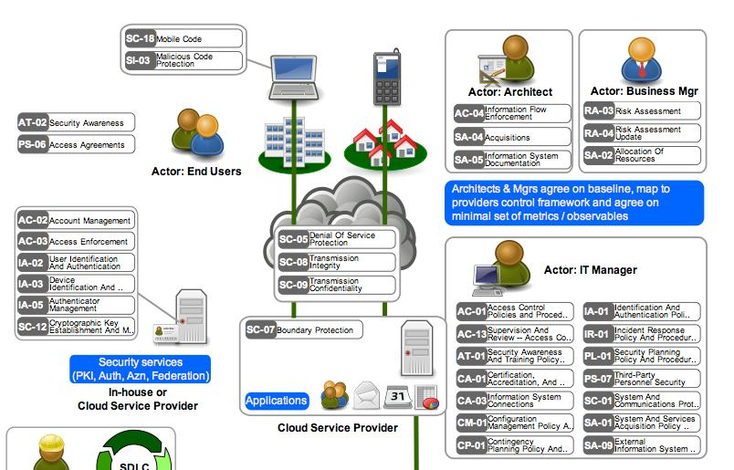

Fig.2. Secure Cloud Architecture

For example: for encrypting security artifacts and keys, AES 128 bit encryption services are included to key management services. For such kind of critical services, one should have full faith on the internal security services. For these applications which depend on the internal services, “hybrid cloud” architecture is the best solution one could suggest. Another solution is Single Sign-On (SSO) [13]. In today’s era enterprises are seriously considering the option of Single Sign-On (SSO) technology to address the password explosion because they help us to cut down multiple network and application passwords to one. To overcome such problem, it was suggested that, for security management and for implementation of strong authentication over the cloud, organizations should make use of SSO. It follows strong authentication at the user level, enabling cloud computing environments through a single login to access multiple applications and services to cloud users [14]. Here is a small part of the cloud security architecture published by open security architecture group.

The pattern above in the figure illustrates the actors i.e. architect, end user, business manager, IT manager, that are interacting with systems i.e. end point, applications hosted over the cloud, security services of data and the controls to protect the actors and systems [15].

Conclusion
Could computing is no doubt today’s need. It allows user to store their data on the more protected and managed way, even the globalization of many organization is dependent on the cloud computing. But instead of all its positive points, it also has some flaws in the security department which needs to be managed. The challenges faced by the cloud in the area of security are discussed in the paper. It also described the small part of the secure architecture of cloud and basic idea of single sign-on technology.

REFERENCES
- http://www.ibm.com/cloud-computing/in/en/what-is-cloud-computing.html
- Navdeep Aggarwal, Parshant Tyagi, Bhanu P. Dubey and Emmanuel S. Pilli, “Data Security Issues and Challenges in Cloud Computing: A Conceptual Analysis and Review”, International Journal of Computer Applications (0975 – 8887), 5/1/2013
- Dimitrios Zissis, Dimitrios Lekkas, “Addressing cloud computing security issues”, www.elsevier.com/locate/fgcs, 2012.
- Rabi Prasad Padhy, Manas Ranjan Patra, Suresh Chandra Satapathy, “Cloud Computing: Security Issues and Research Challenges”, (IJCSITS), Dec, 2011
- Pankaj Sareen, “Cloud Computing: Types, Architecture, Applications, Concerns, Virtualization and Role of IT Governance in Cloud”, International Journal of Advanced Research in Computer Science and Software Engineering, March, 2013
- Kai Hwang, Geoffrey Fox and Jack Dongarra, " Book: Distributed Computing: Clusters, Grids and Clouds", Chapter 7, Cloud Architecture and Datacenter Design pp. 57
- Qian Wang, Cong Wang, Jin Li, Kui Ren, and Wenjing Lou, "Enabling Public Verifiability and Data Dynamics for Storage Security in Cloud Computing".
- Rashmi, Dr.G.Sahoo, Dr.S.Mehfuz, "Securing Software as a Service Model of Cloud Computing: Issues and Solutions", International Journal on Cloud Computing: Services and Architecture (IJCCSA) ,Vol.3, No.4, Aug-13.
- Osama Harfoushi, Bader Alfawwaz, Nazeeh A. Ghatasheh, Ruba Obiedat, Mua’ad M. Abu-Faraj and Hossam Faris,"Data Security Issues and Challenges in Cloud Computing: A Conceptual Analysis and Review",(http://www.scirp.org/journal/cn) http://dx.doi.org/10.4236/cn.2014.61003, Feb-14.
- Mark D. Ryan, “Cloud computing security: the scientifc challenge, and a survey of solutions”, Jan-13.
- Leena Khanna and Prof. Anant Jaiswal, "Cloud Computing: Security Issues And Description Of Encryption Based Algorithms To Overcome Them", Volume 3, Issue 3, IJARCSSE, Mar-13.
- Huaglory Tianfield, “Security Issues In Cloud Computing”, 2012 IEEE International Conference on Systems, Man, and Cybernetics (SMC’12), Seoul, Korea, Oct-12.
- Subra Kumaraswamy, “Introduction to Cloud Security Architecture from a Cloud Consumer's Perspective”, http://www.infoq.com/articles/cloud-security-architecture-intro.
- Kashif Munir and Prof Dr. Sellapan Palaniappan, "SECURE CLOUD ARCHITECTURE", Advanced Computing: An International Journal ( ACIJ ), Vol.4, No.1, Jan-12.
- opensecurityarchitecturegroup.org.

