Patient Health Care & Ambulance
Monitoring System Using
Controller & Wireless Technology

Prof. D.B.kadam 1st Prof. V.S.Suryawanshi 2nd E&TC department E&TC Department P.V.P.I.T. Budhgaon. P.V.P.I.T. Budhgaon Sangli, India Sangli, India dskadam007@gmail.com vinaysurya999@gmail.com

Abstract- Proposed system presents design of such a monitoring system for emergency patient transportation with the help of ARM 7 processor module. The system will be useful for monitoring ambulance location using Google map. Numbers of road accidents in India are the highest across the world. Using advance wireless technology of GPS and GSM modems, it is possible to provide medical facility to accident victim within short period of time. For the same purpose the ambulances are specially designed to carry emergency drugs and instruments. Continuous monitoring of ambulance location and status of patient during the critical hour of patient transportation helps to improve medical care. One of the issues during transportation of patient is traffic related problems. All developed nations have a well developed transportation system with efficient traffic control on road, rail and air. It is therefore necessary to have a fast, economical and efficient traffic control.

It also include sensors to monitor heart bit rate and temperature of patient through SMS. The front end application at the monitoring system is developed using visual basic software in Personal Computers. It can display location of ambulance and status of heart bit rate and temperature of patient. After receiving SMS hospital can prepare their staff for proper treatment of coming patient.

Keywords: ARM7, GPS, GSM, sensors.

I. Introduction

Immediate medical attention to critically ill patients and accident victims requires a system to transmit vehicle location information. A centralize monitoring system required in hospital which have information of accident victim vehicle and ambulance location. The doctor needs to understand the physical and physiological condition of the patient so that the right decision regarding administration of drugs and transport destination can be appropriately taken. Hence there is a need for communication between the staff of the ambulance and the monitoring station.
The requirement can be achieved by using system in ambulance which uniquely transmits location information and status of patient through parameters i.e. heart bit rate and temperature etc. The system needs to include biomedical sensors to transmit status of patient. All systems are connected to each other through wireless communication which transmit information and data .Use of GPS and GSM modems for higher communication links will make system more effective and fast response Even with this there is also need of traffic control during transportation of emergency patient so valuable time of response can be saved. System will be interfaced with wireless RF module to transmit low signal. Including all these requirements system will found to be very useful for emergency treatment of patient during transportation. Proposed project achieves all requirements by including four units called as Ambulance unit, Monitoring Unit, Vehicle unit and Signal Unit. Ambulance became intelligent due to interfacing biomedical sensors.

II. SYSTEM ARCHITECTURE AND WORKING PRINCIPLE

The proposed system consist of

I. Hardware part and

II. Software part

Ambulance unit

Vehicle Unit

Wireless
Unit

Monitoring Unit

Signal Unit

Fig. 1 Proposed system for Patient Health Care & Ambulance Monitoring System

The proposed system contains mainly consist of ambulance unit, vehicle unit, monitoring unit and signal unit

III. Hardware

GPS Module
LM 35
Temperature
Sensor

Heart Bit

Sensor

ARM Controller

LCD Display

MAX 232

Keypad

MAX 232
RFID
module

GSM Module

Fig. 2 Block Diagram of System

Fig shows the block diagram of proposed Patient Health Care & Ambulance Monitoring System Using Wireless Technology. The proposed system is built around ARM microcontroller. It is placed at ambulance. The system consist of it consists of LM 35 temperature sensor and heart bit sensor sensors, GPS module, and GSM modem. The health statuses of patient obtain using a body temp sensor as well as heart rate sensor. These sensors capture data of patient that is the body temperature and the heart rate of patient and stored in microcontroller memory. The heart bit and temperature data can be sending through GSM modem. System in which four units are working simultaneously with GPS and GSM modem. Ambulance unit built around ARM7 with biomedical sensors and one vehicle unit .The ambulance system has built with ARM 7 microcontroller. The project can monitor location of ambulance from Hospital using Google Earth map application and integrated with commercially available GPS and GSM modems. With use of biomedical sensors it is possible to get status of heart bit rate and temperature of patient during travelling through. PIC microcontroller at vehicle unit is interfaced with GPS and GSM to send information of vehicle unit location.
It also include Server unit using 89C51 with GSM modem and Signal unit using 89C51 interfaced with RF module. Proposed project uses visual basic software in PC at monitoring unit. It can display location of ambulance and accident victim vehicle, status of heart bit rate and temperature of patient through SMS.

IV. Monitoring Unit

PC

PIC MICRO
CONTROLLER MAX 232

GSM Module

LCD Display

Fig.3 Monitoring unit of system

The diagram shows monitoring unit of system. Computer and GSM module are interfaced with PIC- Microcontroller here. The message about Patient health care in terms of heart bit and body temperature which is acme from ambulance unit are given to PIC Controller as well as it displays on LCD display.

V. Signal Unit

RF Module
Max
232

Micro

Controller
LCD

Fig. 4 Signal Unit of System

Signal unit using 89C51 shown in figure above, Signal transmitted by Ambulance unit after reading tag by RFID reader received at Signal Unit through RF module. Microcontroller 89C51 used to process signal received. Message displayed on mobile. Message includes Heart Beat Rate in Beats per minute and temperature of patient in Degree Celsius. Message transmitted by Ambulance unit GSM. Patient status can be continuously monitored after every minute. Displays continue message send after 1 min. Heart rate and temperature readings of message..

VI. Software

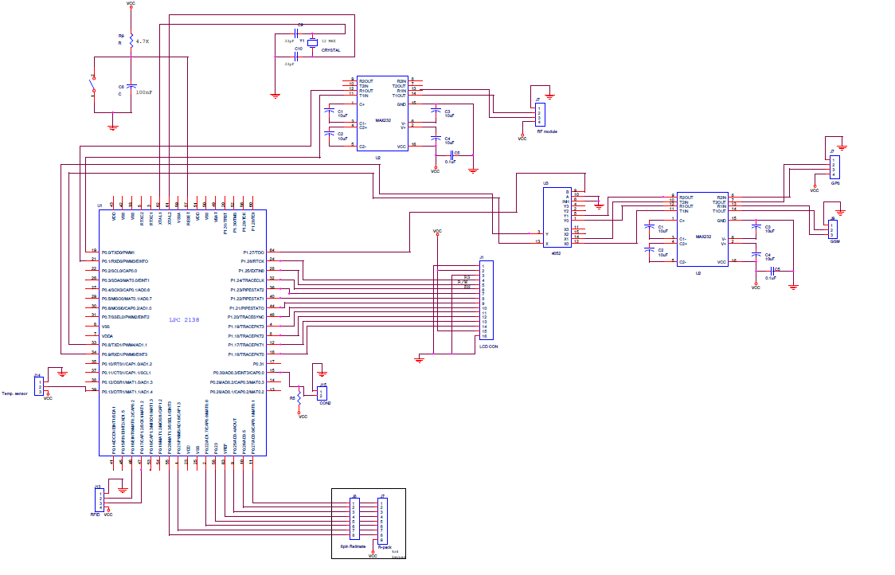

Fig.5 Simulation of Proposed system with the help of proteus
VII. Result and Conclusion

The proposed system is useful for critical patient issues it monitors status of the patient health care in terms of temperature and heart bit. System found very useful for emergency treatment of patient during transportation as expert doctors connected to the system. It provides transportation unit information and as well as patient health information, which is useful in further emergency treatment for doctors. It uses Visual basic software at PC in monitoring system to display location of ambulance by using Google map and displaying SMS. After receiving SMS hospital can prepare their staff for proper treatment of coming patient.

Future Scope

Based on same technology different of Hospital’s Monitoring unit will remain connected to each other using GPS

and GSM module.

ACKNOWLEDGMENT

The authors would like to thank the P.V.P.I.T college of Engg. & E&TC department to support in this work

References:

1) Mohammad A. Al-Khedher,’ Hybrid GPS-GSM Localization of Automobile Tracking System’

International Journal of Computer Science & Information Technology (IJCSIT) Vol 3, No 6, Dec 2011.

2) R.Ramani1, S.Valarmathy1, ‘Vehicle Tracking and Locking System Based on GSM and GPS’ I.J.

Intelligent Systems and Applications, 2013, 09, 86-93Published Online August 2013 in MECS

3) Montaser N. Ramadan, Mohammad A. Al-Khedher, Senior Member, IACSIT, ,’Intelligent Anti-Theft and

Tracking System for Automobiles’, International Journal of Machine Learning and Computing, Vol. 2, No.

1, February 2012

4) Umar Iqbal,1 Tashfeen B. Karamat,2 Aime ‘Experimental Results on an Integrated GPS and Multisensor System for Land Vehicle Positioning ,Hindawi Publishing Corporation International Journal of Navigation and Observation Volume 2009,

5) Salas K Jose, X. Anitha Mary, Namitha Mathew, ‘ARM 7 Based Accident Alert and Vehicle Tracking

System’, International Journal of Innovative Technology and Exploring Engineering (IJITEE) , ISSN:

2278-3075, Volume-2, Issue-4, March 2013

6) Upkar Varshney ‘Patient monitoring using infrastructure-oriented wireless LANs’, Int. J. Electronic

Healthcare, Vol. 2, No. 2, 2006

7) Charles V. Trappey, Amy J.C. Trappey ,’ Develop Patient Monitoring and Support System Using Mobile Communication and Intelligent Reasoning’, Proceedings of the 2009 IEEE International Conference on Systems, Man, and Cybernetics , San Antonio, TX, USA - October 2009

8) Media Aminian1 and Hamid Reza Naji2*,’ A Hospital Healthcare Monitoring System Using Wireless

Sensor Networks’, Aminian and Naji, J Health Med Inform 2013,

9) Khalil M. Yousef, Jamal N. Al-Karaki1 And Ali M. Shatnawi, ‘Intelligent Traffic Light Flow Control System Using Wireless Sensors Networks’. Journal of information science and engineering 26, 753-768 (2010)

10) ‘Intelligent Ambulance Traffic Assistance System’, (IJACSA) International Journal of Advanced

Computer Science and Applications, Vol. 4, No. 8, 2013

AUTHOR(S) PROFILE

Mr. Deepak Kadam received ME degree in Electrical from Shivaji University. Also submitted P.hd . Have completed MBA in HRM. Currently working as TPO


& Associate professor of P.V.P.I.T. College of Engg. Budhgaon.

Mr. Vinay S. Suryawanshi received M.tech in Electronics from R.I.T. College of engg. Islampur maharshtara. Currently working as Assistant Professor in E&Tc department of P.V.P.I.T. College of Engg. Budhgaon.


