Analysis of real time social tweets for opinion mining
B. M. Bandgar  Dept. of Computer Science ,  Karpagam University, Coimbatore-641021, India  Email: bapuraob@yahoo.com | Dr. Binod Kumar  JSPM’s Jayawant Institute of Computer Application,  Tathwade, Pune-411033, India  Email: binod.istar.1970@gmail.com

Abstract: We developed the indigenous Windows based user friendly application in Java to extract process and classify the real time social network tweet using unstructured models. The tweets are processed for removal of hash, tags and URL and removed the stop words from sentence and tried to detect, analyze the abbreviations or slangs. The meaningful real time tweets are obtained and the same is used for sentimental analysis. The processed meaningful tweets are classified into three different opinion mining classes positive, negative and neutral by using unstructured algorithms such as EEC, IPC and SWNC model. The SWNC Model gives better results over the EEC and IPC model. There result are compared using the confusion matrix, precision and accuracy parameter

Keyword: Real time social tweets, extraction, processing, classification, opinion mining

I. INTRODUCTION
The emergence of social media has given web users a venue for expressing and sharing their thoughts and opinions on different topics and events. Twitter, with nearly 600 million users and over 250 million messages per day, has quickly become a gold mine for organizations to monitor their reputation and brands by extracting and analyzing the sentiments of the tweets posted by the public about them, their markets, and competitors. Sentiment analysis over Twitter data and other similar micro-blogs faces several new challenges due to the typical short length and irregular structure of such content.
The numbers of researchers have carried out related works. Cui, A. et al.[2] showed that sentiment analysis of tweets is a challenging task due to multilingual and informal messages. In this paper the problem of analysis of emotion tokens is considered. They divided the approach into two steps. First, emotion tokens are extracted from the message. Second, graph propagation algorithm plots the tokens at different polarities. The technical issues observed in this works are less accuracy of sentiment analysis, difficulty in tackling sentiment analysis of Twitter stream for longer time and weak emotion representation. A. Bifet and E. Frank [3] proposed a data mining technique used for sentiment knowledge in twitter data streams. The proposed algorithm focuses on classification of data streams and performs sentiment analysis in real time. The evaluation of results is verified using a sliding window kappa statistics that works for constantly changing data streams. The tweet data used for the analysis 177 negative and 182 positive tweets were used. Only tweets containing an emoticon were considered; which is also very small sample of the tweet data and uses a balanced dataset only.
A. Bifet, G. Holmes and B. Pfahringer[4] discussed the handling of tweets in real-time. In this research paper they introduced a system MOA Tweet Reader, which processes the tweets in real-time despite their dynamic nature. The system performs two functions: First, it detects the changes in term frequencies and second, it performs sentiment analysis in real-time. Some applications of the proposed framework have also been discussed in frequent item mining and sentiment analysis of Toyota crisis and successfully claim that the MOA-TweetReader tool could have identified the crisis coming. The authors only use positive/ negative classes for sentiment analysis. S. Argamon et al[6] used a supervised learning algorithm for determining complex sentiment-related attributes. These attributes are classified as attitude type and force. The results when averaged showed that the Naïve Bayes algorithm is the best among the lot. SVM also dominates the results. The proposed algorithm is well suited where lexicons need to be generated from the scratch. X. Fu, et al.[7] presented a method for semantic extraction using information theoretic co-clustering. The proposed algorithm is based on implicit associations within evaluated features, within evaluated semantic words and between evaluated features and semantic words. A feature semantic word matrix represents the co-occurrence relationships of feature words and semantic words. Then, co-clustering algorithm is applied on this matrix for clustering of these evaluated features. The Chinese language dataset are used for testing. No detailed information is available about how the manual analysis of the online review was conducted. The experimental results showed 78% accuracy.
A. Nagy and J. Stamberger[8] proposed a technique to efficiently identify the sentiment from disaster micro-blogs. The paper presents a technique for crowd sentiment detection from informative messages that are crafted for the crowd. This technique is useful to detect the sentiment during disaster and crises. Comparing against the Bayesian network, the proposed technique achieved 27% better performance. Two main approaches used are list and classification based. The ensemble based technique is used for tweet categorization. SentiWordNet 3.0 is used for sentiment detection from tweet. The emoticon is a pictorial representation of a facial expression depicting the mood of a person as angry, sad, normal or happy. A limitation of the technique is limited ability to expand the initial seeds and continuous maintenance of lists. A. Montejo-Raez et al.[9] proposed an unsupervised approach for sentiment polarity detection from twitter tweets. The polarity scores are calculated from SentiWordNet and random walk algorithm is used to calculate the weights from the tweet. The proposed algorithm has comparable performance with SVM algorithm. The benefit of the proposed technique is that there is no need of training corpus as required in supervised learning techniques and there is no dependency on the model domain. The limitations of the algorithms are handling of negation, manual labeling process for certain tweets and facing flaws in calculation of final polarity score. R. Ortega et al.[10] proposed a technique with three phases; pre-processing, polarity identification and classification. WordNet and SentiWordNet based approach is used for the purpose of polarity detection and rule-based classification are performed. Good classification results are achieved for twitter data. However, no details about the dataset being used and the implementation of referenced algorithms are given and no comparison of results with the existing techniques with the proposed research is given. F. Bravo-Marquez, M. Mendoza and B. Poblete[11] combine the existing techniques for opinion strength, emotion and polarity prediction. The results show a great improvement in the classification process. The authors do not discuss the differences and advantages of the proposed method when comparing with other existing methods and method is not clearly presented. J. Kim et al.[12] proposed a collaborative filtering based model for predicting sentiment in Twitter. Two Twitter datasets were used for evaluation of the proposed model. The results show the effectiveness of the proposed approach for sentiment prediction and provide a solution for data sparsity problem. Few existing approaches have been used but there is no clear presentation of proposed framework which makes it very difficult to follow the method. R. Machedon, W. Rand, and Y. Joshi [13] classified social tweet messages into three categories; informative, persuasive and transformative. The tweet data is collected for 65 music bands where each tweet was labeled by human. The results show that the proposed method is effective for the ‘informative’ category only.
A. Balahur,[14] presented the sentiment analysis technique for Twitter data. Training models are generated using the proposed method and the results show good classification performance. Minimal linguistic processing is applied in order to support multilingual datasets. Tweets contain a lot of slangs and abbreviations which would not be interpreted in this case. There is no comparison of results with other techniques in order to judge the effectiveness of the proposed technique.
Farhan Hassan Khan et. al.[15] tried to improve the accuracy of text classification and resolve the data sparsity issues. They proposed hybrid model Tweet opinion Mining (TOM) system. The obtained tweets were further processed and used for the classification using three different techniques in a pipelined way which classifies the tweets into positive, negative or neutral. It has a good accuracy in the opinion mining. The limitations of this model are no information of extraction of tweets and processing method is not clear. The results obtained are given in statistical terms only. They used the integrated system of different tools in which integration is most complex and developed system based on Linux operating system which is not user friendly.
Therefore, we developed the user friendly indigenous Windows based application in Java to extract real time tweets and process and classify the opinions of the people all over the global on the particular event and geographical area from the different sources such as twitter website, news websites etc.
II. METHOD DETAILS
The twitter4j API version 1.01 downloaded from[16] and created application on the web site[16] . The token and access keys obtained, which is required for the extraction of the tweets. An indigenous application is developed using NetBeans IDE 8.0 as platform in Java based on windows operating system and extracted the real time tweets from the twitter website, news websites. The extraction is repeated for multiple times to obtain more number of tweets. The extracted raw tweets pre-processed for removal of URL and removal of all the private usernames identified by @user and the hash tags identified by the # symbol using a regular expression in Java. Lastly we removed all the special characters excluding the emoticons. The pre-processed tweets used to detect, analyzes abbreviations or slang for obtaining meaning full message[1]. These cleaned and meaning full message further used for the classification into three different opinion classes as positive, negative and neutral. The classification is done by using unsupervised learning algorithms as they do not require any training data and also the opinion mining accuracy is good over the supervised machine learning algorithms[14]. Three models used for the classification enhanced emoticon classifier(EEC), Improved polarity classifier(IPC) and SentiwordNet classifier(SWNC). Also we further extracted social tweet on different keywords and verified the outcome of the classification.
III. RESULTS AND DISCUSSIONS
The real time tweets were obtained on the Monday, 16th June 2014 at 20:52:200 IST 2014 for the keyword ‘Narendra Modi’ using indigenously developed application. The processing of the tweets is done by different methods. Initially pre-processing of the raw tweets, only useful sentences are sorted out from the garbage. We identified presence of URL using a regular expression and remove all the URL’s from the tweet. Remove all the private usernames identified by @user and the hash tags identified by the # symbol. To get the meaning of each word English dictionaries WordNet is used. The words that are not found illustrate that they are either slangs or abbreviations and SMS dictionary are used for this purpose. Further lemmatization applied to steam the word and apply corrections. Further the spell checking of the tweet is done in order to correct the effects of the lemmatizer. This step feeds the remaining words in the spell checker and substitute with the best match. To identify and remove the stop words we used the Stanford dictionary, which are then simply stripped from the tweet under process. Lastly we removed all the special characters excluding the emoticons and only English tweets are considered for classification and analysis. The sample of resulted tweet is given in table1. Further these tweets are used for the sentimental analysis using unsupervised learning algorithms. Initially the tweets are classified using the EEC model. In EEC, classification is done on the basis of emoticons. It uses regular expressions to detect presence of emoticons which are then classified into positive or negative using a rich set of emoticons which are manually tagged as positive or negative. The results obtained by this model not much useful for the sentimental analysis.

TABLE 1 The sample of results of completely processed tweets
Whats the license plate ?? PM Narendra Modi Travelled in his Armored BMW in Thimphu
======== Huge - Modi govt to reform Industrial Disputes Act || Failed and frustrated had said Modi
======== Delhi: PM Narendra Modi meets Defence Minister Arun Jaitely, Army Chief Gen. Bikram Singh and NSA in the war room of Indian
======== Watch Video: PM Shri Narendra Modi's address to Joint Session of the Parliament of Bhutan- Part4:
======== In defense of Narendra Modi government's plan to saffronise education in India
======== Watch Video: PM Shri Narendra Modi's address to Joint Session of the Parliament of Bhutan- Part 3:
======== PM concludes Bhutan tour
======== Narendra Modi's 'Nepal' slip in Bhutan fires up Twitter - NDTV
======== outdid his critics' foul imaginations by not going after bigwigs
======== New from Last Stand?"
======== Why Amrit Prajapati entered Narendra Modi's sabha with gun?
======== ministers have UPA-favoured babus as special staff
======== please share some "Confidential" info. on new Narendra Modi's Govt., please Expose Modi as soon as possible.JAI HIND
======== ISBPL: ministers have UPA-favoured babus as special staff: ministers have UPA-...
======== : ministers have UPA-favoured babus as special staff: ministers hav...
======== lulz. Kitnon ko arrest karoge? Nine students in Kerala arrested for publishing anti-Narendra Modi puzzle in college
======== Narendra Modi
======== Nine students in Kerala arrested for publishing anti-Narendra Modi puzzle in college magazine
======== Here are some pictures of a memorable welcome I received in Bhutan
======== INDIAN PM Narendra Modi’s speech acknowledging the Royal Family of Bhutan said, ''I want to begin with a tribute...

Then the classification of tweet is done by the IPC model, which uses a list of positive and negative words which are actually two text files that include positive and negative words respectively. Thus IPC model uses ‘bag of words’ approach, which are domain independent. Each word in the list has been classified as positive/negative. Every word has the same weight. There may be a combination of Positive/negative words in a tweet which may result in incorrect classification of tweet as neutral. This problem can be solved by using SWNC. The results obtained by IPC model is shown in Fig. 1.
TABLE 1. Comparison of EEC IPC, SWNC Model results
The accuracy of the classification is improved over the EEC model in the IPC model. Further the Tweets are classified using the SWNC model. It is based on classification of tweets using SentiWordNet dictionary to check the sentiments for each word in the tweet. For this purpose we used SentiWordNet_3.0.0 dictionary.
It assigns different sentiment weights to different words. It also depends on the how the word is being used in the sentence i.e. identification of part of speech for the word is necessary to be classified by SWNC. The classification results obtained by SWNC model is shown in the Fig. 2. The comparison of the result model result is carried out by using the Confusion matrix, precision and recall. It is shown in the table 2. It shows that the accuracy of the SWNC model is good over the IPC and the EEC model. We also extracted social tweet data sets on different keywords and tried to verify the outcome of the classification of the application.
Real time Extracted Dataset |  | Confusion Matrix |  |  | Results
 |  | Positive | Negative | Neutral | Precision | Recall | Accuracy
SWNC | Positive | 4 | 1 | 0 | 57.00 | 80.00 | 77.22
SWNC | Negative | 2 | 18 | 4 | 31.03 | 75.00 | 77.22
SWNC | Neutral | 1 | 10 | 39 | 90.70 | 78.00 | 77.22
IPC | Positive | 4 | 1 | 0 | 57.14 | 80.00 | 64.56
IPC | Negative | 1 | 5 | 1 | 10.42 | 71.43 | 64.56
IPC | Neutral | 2 | 23 | 42 | 97.67 | 62.67 | 64.56
EEC | Positive | 0 | 0 | 0 | 0.0 | 0.0 | 54.43
EEC | Negative | 0 | 0 | 0 | 0.0 | 0.0 | 54.43
EEC | Neutral | 7 | 29 | 43 | 54.43 | 100 | 54.43

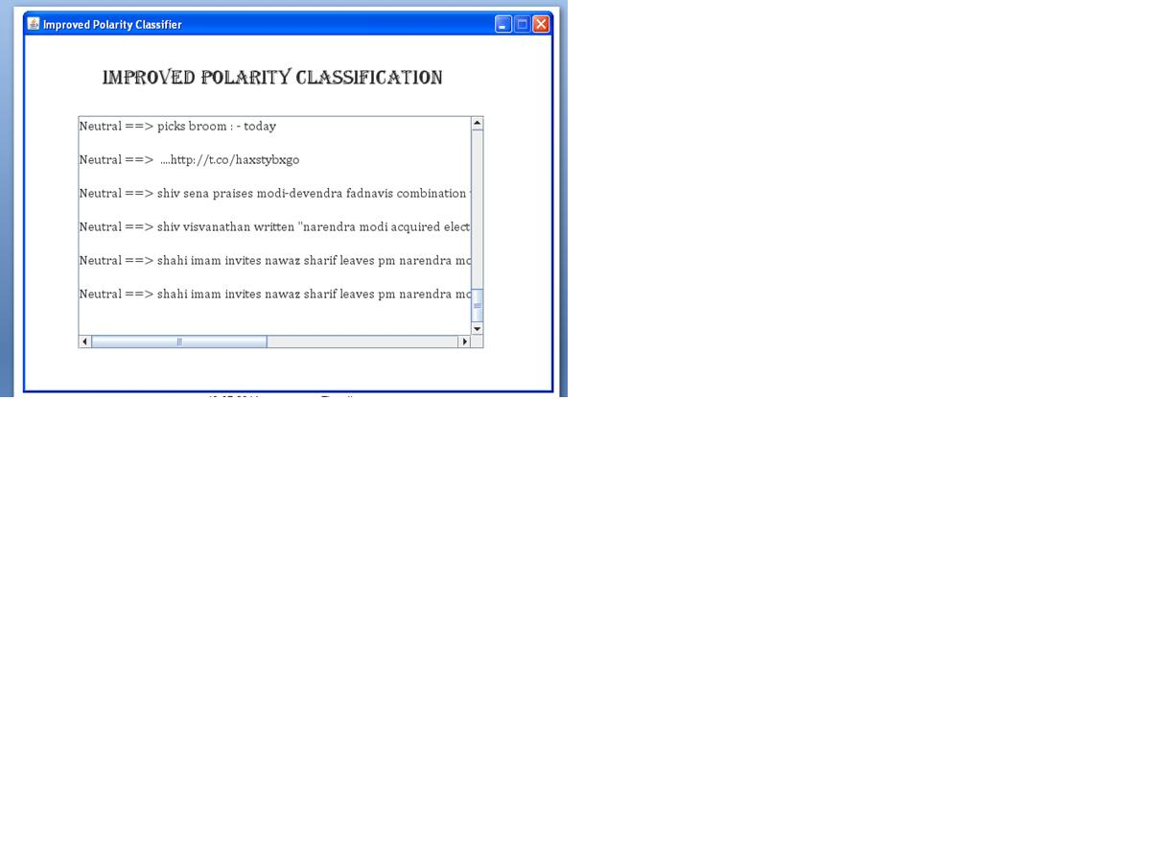
Figure 1. The sample classification results obtained by IPC Model

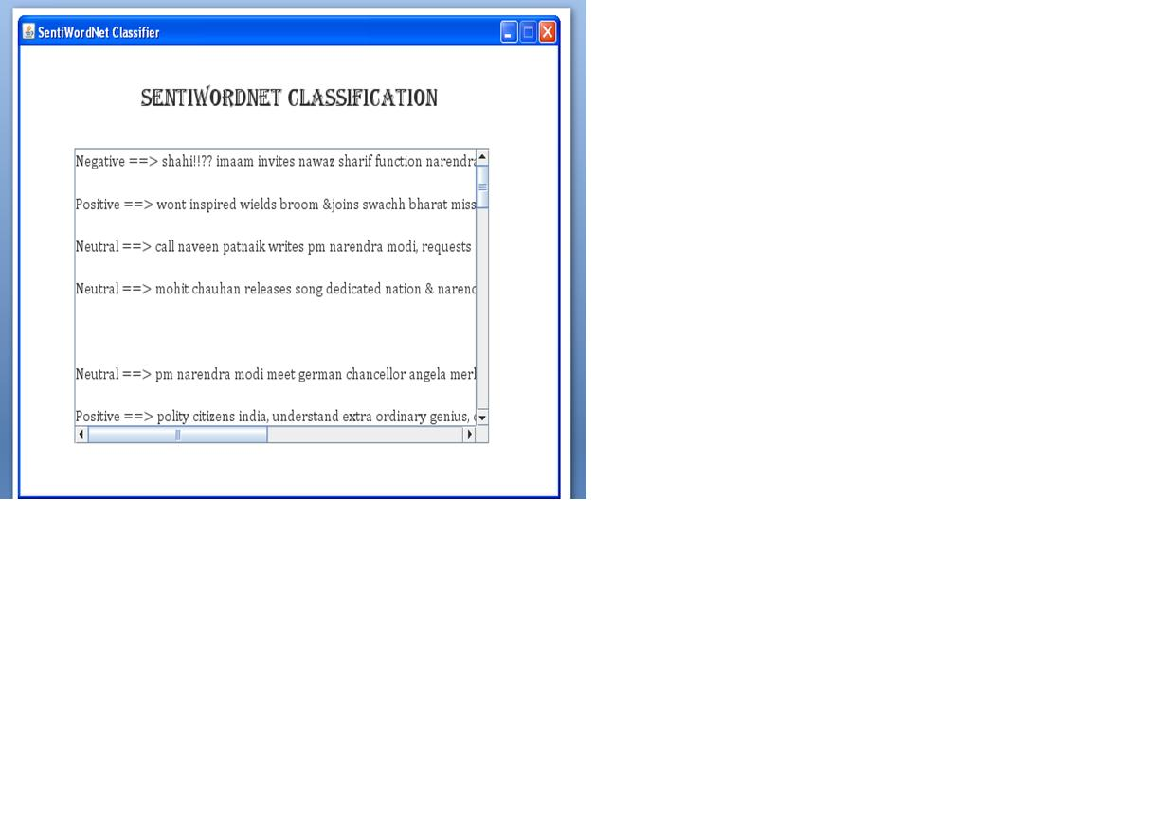

Figure 2. The sample classification results obtained by SWNC
IV. CONCLUSION
Here, we developed the user friendly indigenous application based on windows system in Java using Netbeans IDE platform to extract, process and classify the real time tweets on the social tweet English keyword from the twitter web site, news website etc. using the twitter 4j Libraries and their API’s. The extracted real time tweets are pre-processed for the removal of the URL, Hash tag using the Java regular expression. Further the pre-processed tweets were used for analyzing abbreviation, slangs and removal of stop words to obtain meaning full tweets for the sentimental analysis. The processed tweets are classified using three models unstructured models EEC, IPC and SWNC. The comparisons of the results are done by obtaining the confusion matrix, precision, recall and accuracy. The SWNC model good classification result over the IPC and EEC model as expected. Thus we obtained the real time tweets from social network site/news web etc. and processed and classified them for opinion mining by developing an indigenous user friendly application.
ACKNOWLEDGEMENT
I take an opportunity to thank Mr. Ramanand Potdar and Mr. Amar Kokare for their valuable guidance and help during this work.
REFERENCES
- B. M. Bandgar and Binod Kumar, Real time extraction and processing of social tweets, International Journal of Computer Science and Engineering, E-ISSN No.-2347-2693,, Vol.3 (3), pg. 1-6, 2015.
- A. Cui, M. Zhang, Y. Liu, S. Ma, Emotion Tokens: Bridging the Gap among Multilingual Twitter Sentiment Analysis, Springer-Verlag, Berlin, Heidelberg, 2011, pp. 238–249.
- A. Bifet, E. Frank, Sentiment Knowledge Discovery in Twitter Streaming Data,, Springer-Verlag, Berlin, Heidelberg, 2010, pp. 1–15.
- A. Bifet, G. Holmes, B. Pfahringer, MOA-Tweet Reader: real-time analysis in twitter, streaming data, in: T. Elomaa, J. Hollm'en, H. Mannila (Eds.), DS 2011, LNCS 6926, Springer-Verlag, Berlin Heidelberg, 2011, pp. 46–60.
- Lambodar Jena, Narendra Kumar Kamila, Data Extraction and Web page Categorization using Text Mining, IJAIEM, ISSN 2319 – 4847, Volume 2, Issue 6, June 2013
- S. Argamon, K. Bloom, A. Esuli, F. Sebastiani, Automatically determining attitude type and force for sentiment analysis, in: Z. Vetulani, H. Uszkoreit (Eds.), LTC2007, LNAI 5603, Springer-Verlag, Berlin Heidelberg, 2009, pp. 218–231.
- X. Fu, Y. Guo, W. Guo, Z.Wang, et al., Aspect and sentiment extraction based oninformation-theoretic co-clustering, in: J. Wang, G.G. Yen, Polycarpou M.M.(Eds.),ISNN 2012, Part II, LNCS 7368, Springer-Verlag, Berlin, Heidelberg, 2012, pp. 326–335.
- A. Nagy, J. Stamberger, Crowd sentiment detection during disasters and crises, Proceedings of the 9th International ISCRAM Conference — Vancouver, Canada, 2012.
- A. Montejo-Raez, E. Martınez-Camara, Martın- M.T. Valdivia, L.A. Urena-Lopez, RandomWalk weighting over SentiWordNet for sentiment polarity detection on Twitter, Proceedings of the 3rd Workshop on Computational Approaches to Subjectivity and Sentiment Analysis, 2012, pp. 3–10.
- R. Ortega, A. Fonseca, M. Mendoza, Y. Guti'errez, SSA-UO: unsupervised Twitter sentiment analysis, in: A. Montoyo (Ed.), Second Joint Conference on Lexical and Computational Semantics (*SEM), Volume 2: Seventh International Workshop on Semantic Evaluation (SemEval 2013), 2013, pp. 501–507, (Atlanta, Georgia).
- F. Bravo-Marquez, M. Mendoza, B. Poblete, Combining Strengths, Emotions and Polarities for Boosting Twitter Sentiment Analysis, WISDOM'13, Chicago, IL, USA, 2013.
- J. Kim, J. Yoo, H. Lim, H. Qiu, Z. Kozareva, Galstyan A., Sentiment Prediction using Collaborative Filtering, Association for the Advancement of Artificial Intelligence, 2013.
- R. Machedon, W. Rand, Y. Joshi, Automatic Classification of Social Media Messaging using Multi-Dimensional Sentiment Analysis and Crowd sourcing, 2013, 2013. http://dx.doi.org/10.2139/ssrn.2244353 (Available at SSRN: http://ssrn.com/abstract=2244353).
- A. Balahur, Sentiment Analysis in Social Media Texts, 2013, pp. 120–128, Atlanta, Georgia
- Farhan Hassan Khan et. al. , TOM: Twitter opinion mining framework using hybrid classification scheme, Decision SupportSystems,2013,http://dx.doi.org/10.1016/j.dss.2013.09.004
- https://api.twitter.com
- https://dev.twitter.com/
- http://search.twitter.com/search.format
- http://ravikiranj.net/drupal/201205/code/machine-learning/how-build-twitter-sentiment-analyzer
- J. Pasternack and D. Roth, Extracting article text from the web with maximum subsequence segmentation. In WWW '09: Proceedings of the 18th international conference on World Wide Web, page 1971{980, New York, NY, USA, 2010. ACM.
- Georgios Petasis1,2, Dimitrios Petasis1. BlogBuster: A tool for extracting corpora from the blogosphere. Software and Knowledge Engineering Laboratory National Centre for Scientific Research (N.C.S.R.) “Demokritos”, Athens, Greece, 2010.
- M. Baroni, F. Chantree, A. Kilgarri, S. Sharo, (2008). Cleaneval: a competition for cleaning web pages. In Proceedings of the 4th Web as Corpus Workshop (WAC4), - Can we beat Google?. N. Calzolari, K. Choukri, B.Maegaard, J. Mariani, J. Odjik, S. Piperidis, and D. Tapias, editors, Proceedings of the 6th International Language Resources and Evaluation (LREC 2008). Marrakech, Morocco, 2008.

