Abstract— Visual surveillance System is basically used for analysis and explanation of object behaviors. It consists of static and moving object detection, object tracking to understand the visual events of the scene. The main objective of this paper is to find out the various static and moving object detection, object tracking methods. Presence of objects in video can be done by object detection technique and then detected object can be divided into various categories such as humans, vehicles, birds, floating clouds, tree and other moving objects. Object detection for moving object is the most important and challenging task for any video surveillance system. Object Tracking is used to find the location and shape of objects in every frame in higher level application. In this paper, we used different methods such as background subtraction, statistical method, and Temporal frame differencing for moving object detection. We also described Point tracking, Silhouette Tracking, Kernel tracking methods for object tracking.
Systematic Review on Object Detection, Tracking for Video Surveillance System

Pawan Kumar Mishra  Uttrakhand Technical University  Dehradun , India  pawantechno@rediffmail.com | G.P Saroha  Maharshi Dayanand University  Rohtak , India  gp.saroha@mdurohtak.ac.in

Index Terms-Object detection, object tracking, visual surveillance

INTRODUCTION
The word surveillance was taken from French word that consists of two parts first is "sur" means "from above" and second is "veiller" means "to watch"[1]. Video surveillance is one of the most active researches in artificial intelligence, computer vision and digital image processing area. Tube cameras was used in 1930-1940 as monitoring system that deployed to broadcast and monitor the industrial processing. The traditional video surveillance systems which is known as Close-Circuit Television (CCTV) – was defective and costly because they were deployed by security teams to observe events in the scenes via visual display. The growing need for safety and security from the public has increased interest in video surveillance system. The main problem encountered in video surveillance is low resolution quality of the scenes obtained. Most of the scenes captured by a static camera are with least change in background. Outdoor Objects are often detected in far field. Already existing digital video surveillance systems depend on human observers that is used for detecting specific activities in a real-time video scene. However, there are limitations in the human capability to monitor simultaneous events in surveillance displays [2].

There are various technologies like CCD cameras, thermal cameras and night vision devices, most widely used devices in the visual surveillance market. An intelligent surveillance system extracts information from large scale data set. Visual surveillance in moving scene with multiple cameras, attempts to detect, recognize and track certain objects from image sequences, and to understand object behaviors [3].

Video surveillance is used for wide variety of applications both in public and private environments, to monitor security sensitive areas such as banks, homeland security department stores, highways, crowded public places and borders. The main goal of Video surveillance system is to solve various problems such as object detection, object tracking and classification [4]. Hence, human motion analysis in automated video surveillance has become one of the most active and attractive area of computer vision and pattern recognition [5].

Detecting object like humans in surveillance videos is a challenging task due to their different appearances and variety of poses they can adopt [6]. Biometric features such as face and gait [7] or non-biometric features such as appearance can be used for person recognition in video sequences.

In general, the processing framework of an automated visual surveillance system includes: Motion/object detection, object tracking, person identification, and camera handoff and data fusion [3]. Almost every visual surveillance system starts with motion and object detection phase. Motion detection, tracking, object behavior understanding, and personal identification at a distance can be realized by single camera-based visual surveillance systems. Visual surveillance systems using multiple camera can be helpful because the surveillance area is expanded and multiple view information can solve the problem of occlusion. Object Tracking with a single camera easily generates ambiguity due to occlusion or
depth. This ambiguity may be eliminated from another view. However, visual surveillance using multiple cameras also brings problems such as camera installation, camera calibration, object matching, automated camera switching, and data fusion.

In video surveillance system there are three generations which are called 1GSS, 2GSS and 3GSS [8].The first generation surveillance systems (1GSS, 1960-1980) were based on analog sub systems for image acquisition, transmission and processing. But in this generation there was some disadvantages like requiring high bandwidth, retrieval of events due to large number of video tape requirements. The next generation surveillance systems (2GSS, 1980-2000) were hybrids because they used both analog and digital sub systems to resolve the problems that was available in first generation. Digital video processing methods that provide help to the human operators by filtering out false events. Most of the work during 2GSS is focused on real-time event detection.

Third generation surveillance systems (3GSS, 2000) provide end-to-end digital systems. The main purpose of 3GSS is to allow video data to be used for online alarm generation to help human operators and for offline inspection effectively. In order to achieve this goal, 3GSS will provide smart systems that are able to generate real-time alarms defined on complex events and handle distributed storage and content-based retrieval of video data.

An automated Video surveillance system is used for integration of real-time and efficient computer vision algorithms and intelligence techniques. Therefore, automated video surveillance systems succeed to assist security persons by generating real-time alerts and forensics investigation due to support advanced video [9]. There are a number of famous visual surveillance systems.

- The real-time visual surveillance system W4 [10] uses a combination of shape analysis and tracking, and constructs models of people’s appearances in order to detect and track groups of people as well as monitor their behaviors even in the presence of occlusion and in outdoor environments. This system uses the single camera and grayscale sensor.
- The VIEWS system [11] at the University of Reading is a three-dimensional (3-D) model based on vehicle tracking system.

- Wren et al. [12] developed The Pfinder system that is used to recover a 3-D description of a person in a large room. Pfinder system tracks a single non-occluded person in complex scenes, and has been used in many applications.
- TI, developed by Olsen et al. As a single-person tracking system, [13], detects moving objects in indoor scenes using motion
- The system at CMU [14] can monitor all type of activities over a large area using multiple cameras that are connected into a network. It can detect and track multiple persons and vehicles within cluttered scenes and monitor their activities over long periods of time.

Object Detection
Object detection is the process of finding instances of real-world objects such as humans, animals, vehicles and buildings in images or videos. There are various domains of object detection include face detection and pedestrian detection. Object detection algorithms typically use extracted features and learning algorithms to recognize instances of an object category. It is commonly used in applications such as image retrieval, security and automated vehicle parking systems.

Categories

The object detection consists of three major categories.

Model-Based System

A model is defined for the object of interest and the system attempts to match this model to different parts of the image in order to find a fit [15].

Image Invariance Method

Method that is used for a matching on a set of image pattern relationships like brightness levels that ideally and uniquely determine the objects being searched for [16].

Example-based learning Method

The final set of object detection systems are characterized by example-based learning algorithms [17-18].

Example-based techniques have also been successfully used in other areas of computer vision, including object recognition.

Static Object Detection
Detecting static objects in video sequences has several applications in surveillance systems such as the detection of illegally parked vehicles in traffic monitoring or the detection of abandoned objects in public safety systems [19].To detect static object, each object in the system has 3 attributes:

- Age-Age records the number of frames that object has not moved
- Type –Type represents the status of objects.
- It can be new, matched and occluded.
If we want to extract the foreground objects from current frame then we will compare those objects with objects from previous frame. There are three criteria for matching:
- Similarity in shape and position
- Similarity of intensity
- Similarity in edges
If an object from previous frame matches with some object from current frame then it is called matched objects (figure 1). If it does not match well but the major parts of the object overlap with some objects in current frame, it is called occluded object (figure 2). The object from current frame does not match with any objects from previous frame are known as new object (figure 3). The new objects are added into the previous frame before processing the next frame. Any object that has age more than a certain threshold is called static object [20].
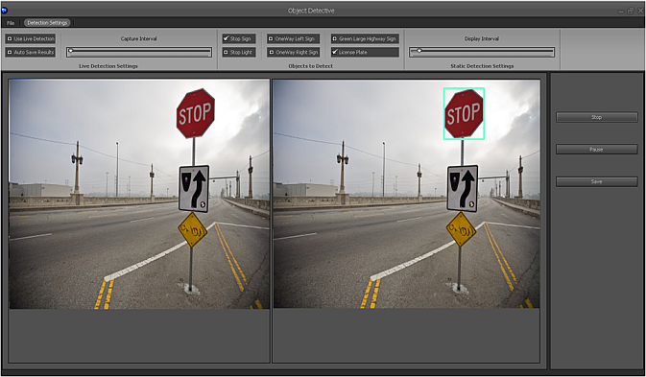

Fig.1. matched static object

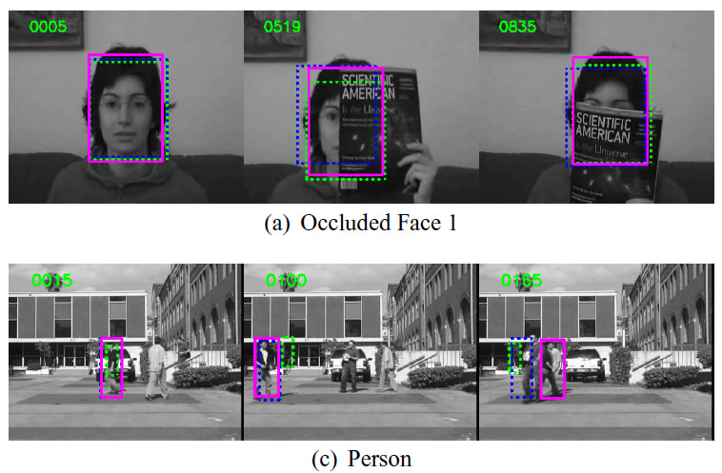

Fig.2. Ocluded static object

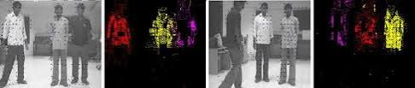

Fig.3. New static object

Moving Object detection

Object detection in a moving scene is the basic step for analysis of video. Every tracking method requires an object detection mechanism either in every frame or when the object first appears in the video. Due to environmental conditions like illumination changes, shadow object segmentation becomes difficult and significant problem. Motion detection is one of the greatest problem areas in video surveillance as it is not only responsible for the extraction of moving objects but also critical to many computer vision applications including object based video encoding, human motion analysis, and human machine interactions. A common approach for object detection is to use information in a single frame [21]. Motion detection remains important and difficult task when the camera is itself mobile. Motion detection technique usually depends on pixel level classification scheme exploiting local motion related information such as DFD, Displaced Frame Difference or the normal flow. A block diagram of moving object detection is given in figure 4.

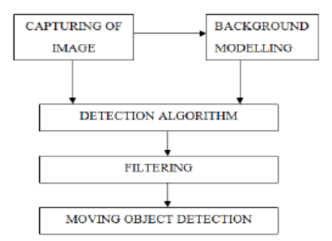

Fig.4. block diagram of moving object detection

Frame differencing (Temporal Differencing)

The presence of moving object in scene is determined by calculating the difference between two consecutive images. Its calculation is simple and easy to implement [22]. It is a highly adaptive approach to dynamic scene changes however, it fails to extract all relevant pixels of a foreground object especially when the object has uniform texture or moves slowly [23]. In temporal difference technique, extraction of moving pixel is simple and fast.

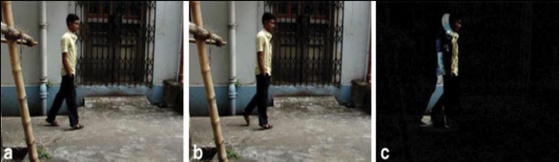

Fig.5. Temporal frame differencing. (a) Present Frame (PF)
(b) Previous Frame (Prev) (c) Result = PF – Prev

Optical Flow

Optical flow method [24] is used to calculate the image optical flow field, and do clustering processing according to the optical flow distribution characteristics of image. This method is useful to get movement information and detect the moving object from the background. But due to large quantity of calculation, sensitivity to noise, poor anti-noise performance, this method is not suitable for real-time demanding occasions. The application of optical flow includes the problem of inferring not only the motion of the observer and objects in the scene, but also the structure of objects and the environment.

Consider a five-frame clip of a ball moving from the bottom left of a field of vision, to the top right. Motion estimation techniques can determine that on a two dimensional plane the ball is moving up and to the right and vectors describing this motion can be extracted from the sequence of frames.

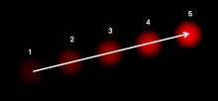

Fig.6. The optical flow vector of moving object in a video
sequence.

Background subtraction

The background subtraction method uses the difference method of the current image and background image to detect moving objects. The Pixel where the Difference is above a threshold value are classified as foreground.

First step for background subtraction is background modeling. It is the most important part of background subtraction algorithm [25]. This reference model is used in background subtraction in which each video sequence is compared with the reference model to determine possible Variation. The variations between current video frames to that of the reference frame in terms of pixels signify existence of moving object information. Background subtraction has mainly two approaches:

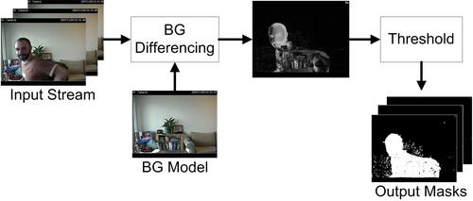

Fig.7. Background Subtraction

3.1) Recursive algorithm

Recursive techniques [26] do not maintain a buffer for background estimation. Instead, they update a single background model based on each input frame recursively. Recursive techniques require less storage, but any error in the background model can remain same for a much longer period of time. There are various methods such as approximate median, adaptive background, Gaussian of mixture.

  - Non-Recursive Algorithm

A non-recursive technique [27] uses a sliding-window approach for background estimation. It stores a buffer of the previous L video frames, and estimates the background image that is based on the temporal variation of each pixel

within the buffer. Non-recursive techniques are highly adaptive.

Statistical Methods

Statistical Methods are used to overcome basic background methods. It is also used to extract change regions from background. These statistical methods are mainly inspired by the background subtraction methods. The various statistics of background are updated dynamically during processing. At each frame this method keeps and updates dynamic statistics of pixels that belongs to background image process [28]. This approach is becoming more popular due to its reliability in scenes that contain noise, illumination changes and shadow [29].
The W4 [30] system uses a statistical background model where each pixel is represented with its minimum and maximum intensity values and maximum intensity difference between any consecutive frames observed during initial training period where the scene contains no moving objects. A pixel in the current image is classified as foreground if it satisfies:

Challenges
The images of an object may change when it moves from one frame to another through the field of view of a camera. This variation comes from three principle sources. First is variation in target pose or deformations, second is variation in illumination and third principle is partial/full occlusion of the target [31].

Illumination Changes
Illumination Changes means that background model adapts to gradual changes of the appearance of the environment. For example the light intensity typically varies during day. Illumination strongly affects the appearance of background, and cause false positive detections.

Dynamic Background
Suppose that there is big scenery that may contain movement of object such as a swaying of tree branches, movements of clouds, wave of water etc. Handling such movement of background image that is called background dynamic is a challenging task.

Occlusion
Full Occlusion or partial occlusion may affect the process of computing the background frame. In real life occlusion can occur anytime in an image. If some part of object in an image are not visible clearly then it called partial occlusion.

Presence of Shadows
There are different methods for detection of shadows in an object. Shadows cast by foreground objects often create the problem in further processing steps subsequent to background subtraction.

Motion of the Camera
Video may be captured by unstable cameras that means in vibrating mode. The jitter magnitude varies from one video to another.

Video Noise
Video signal is generally overlapped with noise. Background subtraction approaches for video surveillance have to deal with such degraded signals affected by different types of noise, such as sensor noise or compression artifacts.

Speed of the Moving Objects
If we want to detect any object, the speed of the moving object plays an important role in its detection. If the object is moving very slowly, It is very difficult for the temporal differencing method to detect the portions of the object preserving uniform region. On the other hand a very fast moving object leaves a trail of ghost region behind it in the detected foreground mask.

OBJECT TRACKING
Tracking of moving object is an important issue in human motion analysis. Tracking is basically used to detect foreground objects between consecutive frames using different feature of object like motion, velocity, color, texture. The process of tracking the object over the time by locating positions of objects in every frame of the video in surveillance system is called object tracking. In tracking approach, the objects are represented using the shape or appearance models [32]. The model represents object shape that defines the type of motion. For example, if an object is a point, then only a translational model can be used. When an ellipse is used for the object, parametric motion models like projective transformations are appropriate. The algorithm of object tracking utilizes extracted object features together with a correspondence matching scheme to track objects from frame to frame.

Single moving Object Tracking:-
A person that is a single moving object in a room is shown In Fig. 8.The yellow square represents the result of the template matching module and has been superimposed by the tracking module on the original frame.

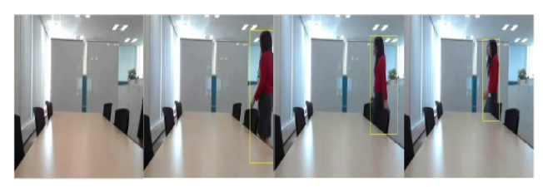

Fig.8. Tracking of a Single person walking in a room

Multiple Moving Object Tracking:-
There are three different scenes are selected to represent the Moving object tracking. The first two scenes are shown in Figure 9. A moving car and a person in walking position is shown in the leftmost figure. In the right three subfigures, two people merge and split. After the splitting, the individuals were identified correctly.

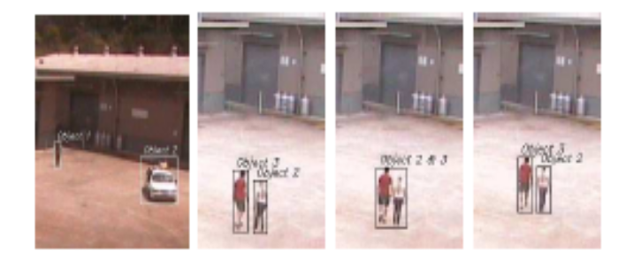

(a) (b) Before the merging (c) After the
merging d) After the splitting

Fig.9. Multiple Moving object tracking (left). Merging and
Splitting of two people in a Scene (right).

Object Tracking Methods
There are Different object tracking methods.

Point Tracking
Point tracking method is generally used to track the vehicles. This method requires deterministic or probabilistic methods [33].The tracked object is based on point which is represented in detected object in consecutive frames and association of the points is based on the previous object state which can include object position and motion. This approach requires an external mechanism to detect the objects in every frame. This method is very reliable and robust.

  - Kernel Tracking
Kernel tracking requires shape and appearance of the object. Object basically contains various features and any feature of object is used to track object as kernel. The tracking of object can be done easily after computing the motion of the kernel between consecutive frames [34].

  - Silhouette Tracking
This method is used to extract Silhouette from detected object. With the help of shape matching or contour evolution silhouettes are tracked by calculating object region in consecutive frame. We can use the information stored inside the object region by using Silhouette tracking methods [34].This information of the region can be appearance density and shape models.

  - Color
The color of an object is influenced by two physical factors i) spectral power distribution of the illuminant ii) surface reflectance properties of the object [35]. In image processing, the RGB (red, green, blue) color space is usually used to represent color.

  - Edges
The boundaries of object generate strong changes in image intensities [36]. Edge detection is used to identify these changes. Edges are less sensitive to illumination changes compared to color features,that is the most important property of edges.

  - Texture
This feature is used to identify region or object in scenes. This method requires a processing step to generate the descriptors [37].

Tracking under Occlusion

The main objective of tracking is to establish communication between objects across frames. When an object is not visible clearly in an image because some other object comes and blocking its view then occlusion occurs. Tracking objects under occlusion is very difficult because we cannot detect the accurate position and velocity of an occluded object [38]. There are different cases of occlusion are described in the following:
Inter-object occlusion: when one object blocks the view of other objects in the field of view of the camera, then Inter-object occlusion occurs. If objects enter the scene occluding each other then it is difficult to determine if inter-object occlusion is occurring. The main problem is to identify that the foreground region contains multiple objects like people usually move in groups and to determine the location of each object in the region, so detecting and resolving inter-object occlusion is important task for video surveillance applications.

Occlusion of objects due to thin scene structures: Suppose an object can be breaked into two regions due to poles or trees. Thus more than one extracted region can belong to the same object in such a scenario. The problem is compounded if multiple objects are occluded simultaneously by such a structure.

Occlusion of objects due to large structures: If an objects disappear completely for some time, i.e., there is no foreground region representing such objects. For example, a person walks behind a building or going to inside a car.A decision has to be made whether to wait for reappearance of the objects, or determine that the object has exited the scene.

Approaches in Object Tracking:

Two approaches are used in tracking objects: one is based on correspondence matching and other one based on distinct tracking by making use of position prediction or motion estimation[39].

A motion model which describes how the image of the target might change for different possible motions of the object to track. The main problem arises in video tracking, when the objects are moving fast relative to the frame rate.

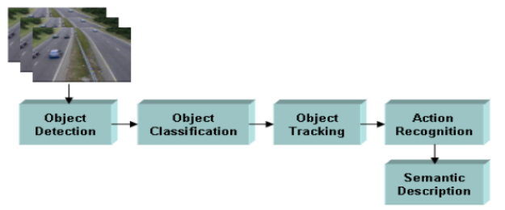

Fig.10. A generic framework for smart video processing algorithms

Tracking Methodologies

Tracking of the appearance of moving objects such as the vehicles and identify it in dynamic scene. It has to locate the position, estimate the motion of this shapeless object and follow movements of object between two consecutive frames in video scene [40]. Tracking [41] can be mainly divided into various types:-

Region Based Tracking
In this tracking the feature of detected object in one image frame are matched to the object detected in the other frame. If this is matched then the detected object in image is linked with the image in the previous frame.

Contour Based Tracking
This tracking is used to detect the energy of the boundary of the object detected in the previous frame is matched with the energy of the boundary of the object detected in the current image.

3D Model-Based Tracking Methods
A multi-vehicle tracking system is recommended for various types of vehicles such as cars, trucks and bikes and buses etc [42]. A new 3D model-based vehicle detection framework is based on a probabilistic boundary feature grouping, which used for vehicle detection and tracking process [43].

Feature-Based Tracking Methods
Feature based tracking method represents good performance for vehicle classification in surveillance videos despite of significant challenges such as limited image size, quality and dissimilarities [44].

Color and Pattern-Based Tracking Methods
This technique is used by YCrCb color space for the construction of background, vehicle location, vehicle tracking, and shade elimination [45].

Hybrid Tracking
Hybrid Tracking is designed between region-based and feature-based techniques. They utilize the advantages of two by considering first the object as an entity and then by tracking its parts.

Multi-Object Tracking System:-
Multi-object tracking system is divided into three main parts; visual tracking, track management, and online model learning [46].

Visual tracking
Object hypotheses are detected using a pre-trained detector and used as an input of the system. The provided detections are associated with existing tracks and existence probabilities of tracks are updated. Then, track states are estimated with the associated detections using particle filtering.

Track management
Existing tracks with the low existence probabilities are terminated. Terminated tracks are associated with other tracks or detections to link them. A new track is initialized using observations which are not associated with any tracks.

Online model learning
Discriminative appearance, shape and motion models of describing tracked objects are learned by updated tracking results.

conclusion
Video surveillance system is used to detect a suspicious human behavior by considering information such as: color, shape, size, etc. In this paper various phases of object detection, object tracking for video surveillance system has been described.

There are various methods for moving object detection such as frame difference, optical flow and background subtraction and there are various criteria for static object detection such as Similarity in shape and position, Similarity of intensity and Similarity in edges. It can be summarized that background subtraction is a simplest method that provides complete information about object compared to optical flow and frame difference for detecting moving objects.

In this paper Object tracking can be performed using various methods like point tracking, Kernel tracking, Silhouette Tracking, color, edges and texture. Point tracking approach requires good level of fitness of detected object. This method requires deterministic or probabilistic methods. In kernel tracking approach kernel requires shape and appearance of the object. In this approach any feature of object is used to track object as kernel like rectangular template or an elliptic shape with an associated histogram. In Silhouette Tracking approach Silhouette is extracted from detected object. With the help of shape matching or contour evolution silhouettes are tracked by calculating object region in consecutive frame. Two approaches are used in tracking objects: one is based on correspondence matching and other one based on distinct tracking by making use of position prediction or motion estimation. I have also described about multi-object tracking system that is divided into 3 parts; visual tracking, track management, and online model learning.

References
- Mann, J. N., Barry, W.: Surveillance: Inventing and Using Wearable Computing Devices. Surveillance & Society,Vol.1, No.3.(2003)
- Sulman, N., Sanocki, T., Goldgof, D., Kasturi, R.: How effective is human video surveillance performance. In 19th International Conference on Pattern Recognition, IEEE, Piscataway, 1–3.(2008)\
- Teddy, Ko.: A Survey on Behavior Analysis in Video Surveillance Applications, Video Surveillance, Prof.Weiyao Lin (Ed.), ISBN: 978-953-307-436-8, [Online].Available:http://www.intechopen.com/books/videosurveillance/a-survey-on-behavior-analysis-in-video-surveillance-applications.(2011)
- Zhang, T., Liu, S., Xu, C., Lu, H.: Mining Semantic Context information for intelligent video Surveillance of traffic Scene. IEEE transaction on Industrial informatics, Vol.9, No.1, 149-160.(2013)
- Paul. M*, Shah, M. E., Chakraborty, S.: Human detection in surveillance videos and its applications - a review. EURASIP Journal on Advances in Signal Processing, 176.(2013)
- Dalal, N., Triggs, B.: Histograms of oriented gradients for human detection. In IEEE Computer Society Conference on Computer Vision and Pattern Recognition,886-893.(2005)
- Lee, L., Grimson, W.: Gait Analysis for Recognition and Classification. In Proceedings of the 1st International Conference Automatic Face and Gesture Recognition, 155-162. (2002)
- Oberti, F., Ferrari, G., Regazzoni, C. S.: Video-Based Surveillance Systems. Kluwer Academic Publishers, Boston. (2002).
- Chamasemani, F.F, Affendey, L.L.: Systematic Review and Classification on Video Surveillance Systems. I.J. Information Technology and Computer Science, Vol. 07, 87-102. (2013)
- Haritaoglu, I., Harwood, D., Davis, L. S.: W : Real-time surveillance of people and their activities. IEEE Transactions Pattern Analysis Machine Intelligence, Vol. 22,No.8, 809–830. (2000)
- Tan, T. N., Sullivan, G. D., Baker, K. D.: Model-based localization and recognition of road vehicles. Int. J. Comput. Vis., Vol. 29, No. 1, 22–25. (1998)
- Wren, C. R., Azarbayejani, A., Darrell, T., Pentland, A. P.: Pfinder:real-time tracking of the human body. IEEE Transactions Pattern Analysis Machine Intelligence, Vol. 19, No.7,780–785.(1997)
- Olson, T., Brill, F.: Moving object detection and event recognition algorithms for smart cameras. In Proceedings DARPA Image Understanding Workshop,159–175.(1997)
- Lipton, A. J., Fujiyoshi, H., Patil, R. S. :Moving target classification and tracking from real-time video. In Proceedings IEEE Workshop Applications of Computer Vision, 8–14. (1998)
- Yuille, A.: Deformable Templates for Face Recognition. Journal.Cognitive Neuroscience, Vol. 3, No. 1, 59-70.(1991)
- Sinha, P.: Object Recognition via Image Invariants: A Case Study. Investigative Ophthalmology and Visual Science, Vol. 35, 1735-1740.(1994)
- Oren, M., Papageorgiou, C., Sinha, P., Osuna, E., Poggio,. T.: Pedestrian Detection Using Wavelet Templates. In Proceedings of Computer Vision and Pattern Recognition, 193-199.(1997)
- Papageorgiou, C., Poggio, T.: A Trainable System for Object Detection. International Journal of Computer Vision, Vol. 38, No. 1, 15-33.(2000)
- Evangelio, R. H., Sikora ,T.: Static Object Detection Based on a Dual Background Model and a Finite- State Machine. EURASIP Journal on Image and Video Processing, Volume 2011,1-11.(2011)
[20] Vang, J., Ooi, W.T.: Detecting static object in busyscenes.
Department of computer science. Cornell
University,Ithaka,NY,14853-7501,USA.
[21] Elgammal, A., Duraiswami, R., Harwood, D., Anddavis, L.:
Background and foreground modeling using nonparametric kernel
density estimation for visual surveillance. Proceedings of
IEEE,Vol.90, No.7, 1151–1163. (2002)
- Rupali, S., Bharati, R. Patil, D.: Background Subtraction Algorithm Based Human Motion Detection. International Journal of Scientific and Research Publications, Vol.3, No.5,1-4.(2013)
- Paragios, N., Deriche, R.: Geodesic active contours and level sets for the detection and tracking of moving objects. IEEE Transactions Pattern Analysis Machine Intelligence,Vol.22, No.3, 266–280.(2000)
- Chauhan, A.K., Krishan, P.: Moving Object Tracking Using Gaussian Mixture Model And Optical Flow. International Journal of Advanced Research in Computer Science and Software Engineering, Vol.3, No.4.(2013)
- Athanesious, J.J., Suresh, P.: Systematic Survey on Object Tracking Methods in Video. International Journal of Advanced Research in Computer Engineering & Technology,Vol.1,No.8, 42-247.(2012)
- Srinivasan, K., Porkumaran, K., Sainarayanan, G.: Improved Background Subtraction Techniques For Security In Video Applications. 3rd International Conference on Anti-counterfeiting, Security, and Identification in Communication,114-117.(2009)
- Cheung, S.S., Kamath, C.: Robust techniques for background subtraction in urban traffic video. Center for Applied Scientific Computing Lawrence Livermore National Laboratory EastAvenue,Livermore.(2007).[Online].Available: http://www.vis.uky.edu/~cheung/doc/UCRL-CONF-200706.pdf
- Moeslunda, TB. , Hiltonb, A., Krügerc, V.: A survey of advances in vision-based human motion capture and analysis. Journal of Computer Vision and Image Understanding, Vol.104, No.2, 90–126. (2006).
- Paragios, N., Deriche, V.: Geodesic active contours and level sets for the detection and tracking of moving objects. IEEE Transactions on Pattern Analysis and Machine Intelligence. Vol.22, No.3, 266–280.(2000)
- Haritaoglu, I., Harwood, D., Davis, L.:W4: real-time surveillance of people and their activities. IEEE Transactions on Pattern Analysis and Machine Intelligence, Vol. 22 ,No.8, 809–830.(2000)
- Gregory, D., Belhumeur, N.: Efficient Region Tracking With Parametric Models of Geometry and Illumination.IEEE Transactions on Pattern Analysis and Machine Intelligence,Vol.20,No.10, 1025–1039.(1998)
- Isard, M., Maccormick, J.: A bayesian multiple-blob tracker. In IEEE International Conference on Computer Vision, 34–41.(2001)
- Kim, I.S., Choi, H.S., Yi,K.M., Choi, J.Y., Kong,S.G.: Intelligent Visual Surveillance - A Survey. International Journal of Control, Automation, and Systems, Vol.8, No.5, 926-939.(2010)
- Elgammal, A., Duraiswami, R., Hairwood, D., Anddavis, L.: Background and foreground modeling using nonparametric kernel density estimation for visual surveillance. Proceedings of IEEE, Vol. 90, No.07, 1151–1163. (2002)
- Stauffer, C., Grimson, E.: Learning patterns of activity using real time tracking. IEEE Transaction on Pattern Analysis and Machine Intelligence, Vol. 22, No. 8, 747-757.(2000)
- Christopher R, Azarbayejani, J., Darrell, T., Alex, P.P.: Pfinder: Real-Time Tracking of the Human Body. IEEE Transactions on Pattern Analysis and Machine Intelligence, Vol.19, No7, 780-785.(1997)
- WuU, Z., Leahy, R.: An optimal graph theoretic approach to data clustering: Theory and its applications to image segmentation. IEEE Transactions on Pattern Analysis and Machine Intelligence,Vol.15,No.11, 1101-1113.(1993)
- Javed, O., Shah, M.: Tracking And Object Classification For Automated Surveillance. Computer Vision Lab, University of Central Florida,USA. [Online].Available: http://cis.temple.edu/~latecki/Courses/CIS601-04/ProjectPapers/shah_trackECCV02.pdf
- Amer, A.: Voting-based simultaneous tracking of multiple video objects. In Proceedings of SPIE International Symposium on Electronic Imaging. Santa Clara, USA, 500–511.(2003).
- Yilmaz, A., Javed, O., Shah, M.: Object Tracking : A Survey. ACM Computing Surveys, Vol. 38, No.4, 1-4.(2006)
- Rhee, S. (ed.): Vehicle Tracking Using Image Processing Techniques. In Rough Sets and Current Trends in Computing. Springer Berlin Heidelberg, Vol. 3066, 671-678. (2004)
- Bardet, F. et al.: Unifying real-time multi-vehicle tracking and categorization. In Intelligent Vehicles Symposium, IEEE, 197-202. (2009)
- ZuWhan, K., Malik, J.: Fast vehicle detection with probabilistic feature grouping and its application to vehicle tracking. In Proceedings of 9th IEEE International Conference on Computer Vision, Vol.1, 524-531.(2003)
- Xiaoxu, M., Grimson, W. E. L.: Edge-based rich representation for vehicle classification. In Proceedings of 10th IEEE International Conference on Computer Vision, Vol. 2, 1185-1192.(2005)
- Mao-Chi, H., Shwu-Huey, Y.: A real-time and color-based computer vision for traffic monitoring system. In Proceedings of IEEE International Conference on, Multimedia and Expo, Vol.3, 2119-2122.(2004)
- Bae, S.H., Yoon, K.J.: Robust Online Multiobject Tracking With Data Association and Track Management. IEEE Transaction on Image Processing, Vol. 23, No.7. (2014)

 

