Combining Automatic Thresholding and Color model based Image Segmentation

Akshay Isalkar
Assistant Professor, Department of IT
DMIETR, Wardha
India
akshay.bncoep@gmail.com
Ketan Bodhe
Assistant Professor, Department of CSE
VIIIT, Pune
India
ketan.bodhe@viit.ac.in

Abstract—In computer prophecy, image segmentation is the process of partitioning a digital image into various fragments. The penalty vicinity of segmentation is to shorten and modify the illustration of an image into incredible that is more imperative and at ease to inspect. Image segmentation is typically used to pinpoint objects and background from images. Image segmentation is a central signal processing utility that is extensively active in many areas including object-based coding, object tracking, object detection clinical organ or tissue identification, image retrieval, etc. It is really challenging to obtain a consistent segmentation without any past acquaintance about the object that is being taken out from the image. For evaluating quality of segmentation and/or for comparing segmentation the availability of clearly defined metrics is scared. The area of image segmentation grows fast in theoretical way rather than practical and very rare techniques are available that can be applied on color as well as gray image. There is no common method that can be applicable for all kinds of image. The main notion about the proposed segmentation can be work effectively for image based on automatic thresholding and color model based image segmentation. The proposed combined scheme has applicability to gray as well as color image for object detection. This approach can lead to apply a common technique for images of different types. This work can provide the comparison between automatic thresholding and color model based image segmentation approach.
Keywords—Segmentation, thresholding, object detection, color model, gray image.

Introduction
The work in this paper is inspired from a practical point of view by several disadvantages of present approaches. The first problem is the incompetence of all identified approaches to correctly segment objects from the background limited of interference from object shadows and highlights. There is inadequate investigation on the grouping of basic automatic thresholding and color model based segmentation likeness measures to advance color likeness calculations leads to advantages of improving the performance of each color images.
There are voluminous interesting problems for the expansion of a unified style to image segmentation that can be practical to all varieties of images. Even the choice of a appropriate method for a precise category of image is a difficult problem up to present study; there is no universally approved technique of quantification of segmented result. The choice of the threshold is very critical as for same fragment of the image low intensity variation may correspond to edges of under consideration, while the other region may require higher intensity variation.
Our main focus of work is on development of an optimized approach for the color image segmentation, where the concept of threshold by considering the color image statistical data. To achieve the aim, we will develop the thresholding mechanism based on local and global data analysis, and evaluation of the color image data will be consider. Main aim of the work is to present a segmentation approach for gray as well as color images based on an automatic thresholding and color models. The Quad-Tree decomposition and automatic thresholding proposed by [15] and representing image into different color models [26]. Finally, devise an approach which will provide the better experimental results for the color image segmentation.

Motivation
Now days the computing power is growing so it is essential to yield multifaceted image processing tools. Various segmentation methods are estimated now days, but there is no private technique which can be applicable to be superior for all images, nor are all schemes constantly good for a specific type of image. Similarly, technologies documented for one domain of image could not put on to other domains of image. Utmost of the image processing employments invented on binary or gray image but accurate scarce on color image segmentation. Color image behavior area grows faster in theoretical point of analysis relatively than practical point of analysis. The programmed devices are supplementary and the chip expertise rises so it makes the weight to move forward the color image segmentation more rapidly. In the new segmentation structure absences in some point of analysis that no sensitivity to grey level dissimilarity, color image confirmation in darken image is untrustworthy, no common method for managing. It has various standards to hold in color image processing that have image segmentation, image fusion, image recognition, image compression, etc. We will set up image segmentation system for color images that contracts with automatic threshold and color model based image segmentation. Image threshold is the first-step processing of image segmentation. In general, we believe that there are three notions in image segmentation. The first is the computation time. When segmenting an image, we do not want that it will take much time for processing. The second is good region connectivity of its segmenting result. While segmentation of an image, we do not want the outcome of segmented region to be separately. If the result of segmenting region is divided, we consider to take many assets in order to record the boundaries of the over segmented outcomes. It is not we desire to get the outcomes. The third is good region matching as an outcome, it will be good.

PROPOSED SYSTEM DESIGN
At the start, the iterative threshold choice system is improved to compute the initial-point threshold of the entire image or a precise block. Then, the quad-tree decomposition that starts after the complete image employs gray-level gradient features of the presently administered block to elect additional decomposition or not. After that the quad-tree decomposition, the initial-point threshold in every decomposed block is implemented to fix initial points. Furthermore, the contour threshold is determined grounded on the histogram of gradients in every decomposed block. Mostly, contour thresholds might reject unsuitable contours to raise the accurateness of the exploration and diminish the mandatory examining time. Lastly, the edge-following technique is adapted and formerly directed grounded on initial points and contour thresholds to catch contours precisely and fast. By expending the Berkeley segmentation data set with representative images, the planned method is established to take the smallest computational time for accomplishing honestly decent segmentation routine in numerous image categories [26].
Additional segmentation structure uses diverse color prototypes for automatic thresholding. The problem is to distinct cells from the background. The early segmentation maps which will then be merged together are just assumed, in this application, by the two-stage Otsu optimization method (TSMO)[22], functional on an input image conveyed by diverse color spaces and using as input the set of pixel values delivered by these images. The multilevel thresholding method is recycled to extract uniform areas, in every image, to be merged. After the mass functions are projected by the assumption of GD, the DS grouping rule is functional to get the concluding segmented image. After this, the core idea of the planned technique is to fuse, one-to-one, the pixels of the input image expressed by six color spaces. In this application, we use N segmentations provided by the N = 6 color spaces, viz. color space = {RGB, HIS, YIQ, XYZ, LAB, and LUV} color spaces. The instances expressed that the images provided by these different foundations are redundant and balancing. In this intelligence, data fusion methods give the idea as an interesting method for color image segmentation. The determination of this revision is to relate this technique for medical images segmentation [15]. We object at providing aid to automatic thresholding of color image segmentation. The flowchart illustrates the operation of proposed work in figure 1.
The main segmentation scheme emphasized on region based segmentation where different thresholds are automatically determined bestowing to spaces with different contents in a picture, consequently yielding appropriate segmentation outcomes in diverse areas.
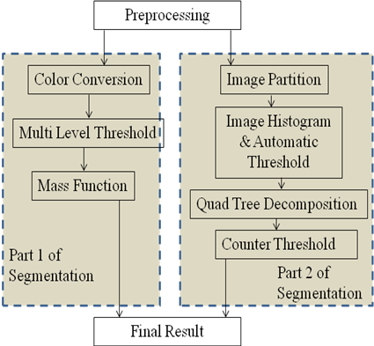
Figure 1: Flowchart of proposed work
The work is separated into investigation of an image segmentation approaches based on the modified edge-following structure and image segmentation technique by thresholds automatically determined from picture contents.

First Segmentation Scheme

Color conversion:

The image is represented in six different color models {RGB, HSV, YIQ, XYZ, LAB and LUV} as shown in figure 2.
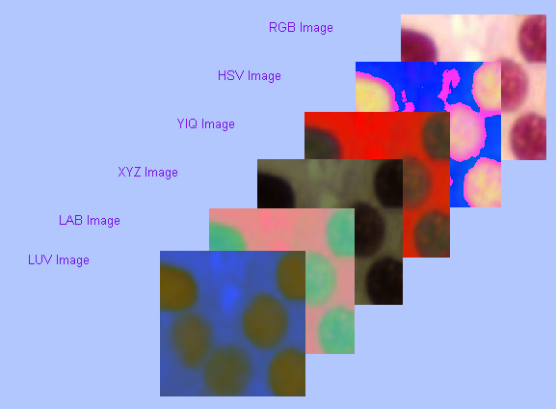

Figure 2: Representing image into six different color models.

Multilevel Threshold:

In multilevel threshold the major component {R, H, Y, X, L and L} from each six color model {RGB, HSV, YIQ, XYZ, LAB and LUV} is extracted that will used in mass function estimation. Figure 3 shows the result of multilevel threshold for major component {R, H, Y, X, La and Lu}.

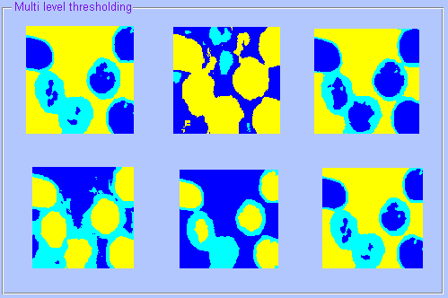

Figure 3: Result of multilevel threshold for each color component \

Mass Function and Segmentation

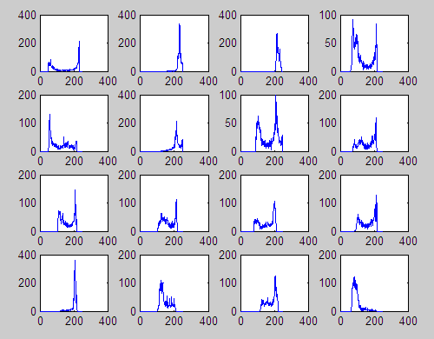
The mass function is evaluated on major components from multilevel threshold these major component are {R, H, Y, X, L and L} from each six color model {RGB, HSV, YIQ, XYZ, LAB and LUV}. The fused image from each major component each segmented as shown in figure 4.
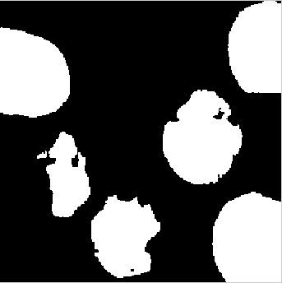

Figure 4: Fused segmented image.

Second Segmentation Scheme

Image partition:
The preprocessed image is divided into N=16 equal blocks for further processing. Figure 5 shows the portioning of image into 16 blocks.

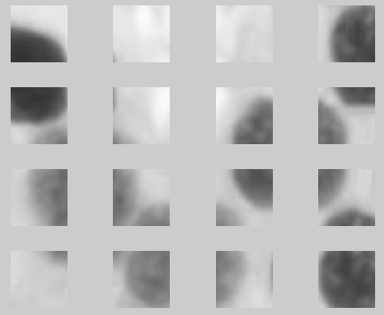

Figure 5: Decomposition of image into 16 blocks

Find the histogram
After decomposing the image into 16 equal blocks, the histogram is evaluated. The figure 6 shows the histogram for each partitioned block.

Figure 6: Image histogram for each 16 blocks.

Quad tree decomposition:

The each block is decomposed using Quad tree decomposition method. The quad tree method decomposes the block into four blocks up to lowest level. Figure 7 illustrate the working of quad tree decomposition.

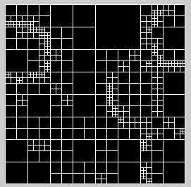

Figure 7: Result obtained after Quad – tree decomposition

Counter threshold:

The counter threshold is applied on each decomposed block from quad tree decomposition to get the final segmented image form second segmentation scheme. The figure 8 shows the segmented result from second segmentation scheme.
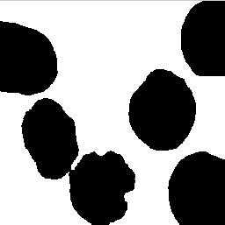

Figure 8: Segmented image from second segmented scheme.

RESULT

The experimental outcomes exhibit the proposed scheme can be common for images from medical field. In order to introduce the mechanism of proposed methods we focus on the color images form medical field employed in our study (Figure 8) Also, several simulation outcomes of color image segmentation are carried out.

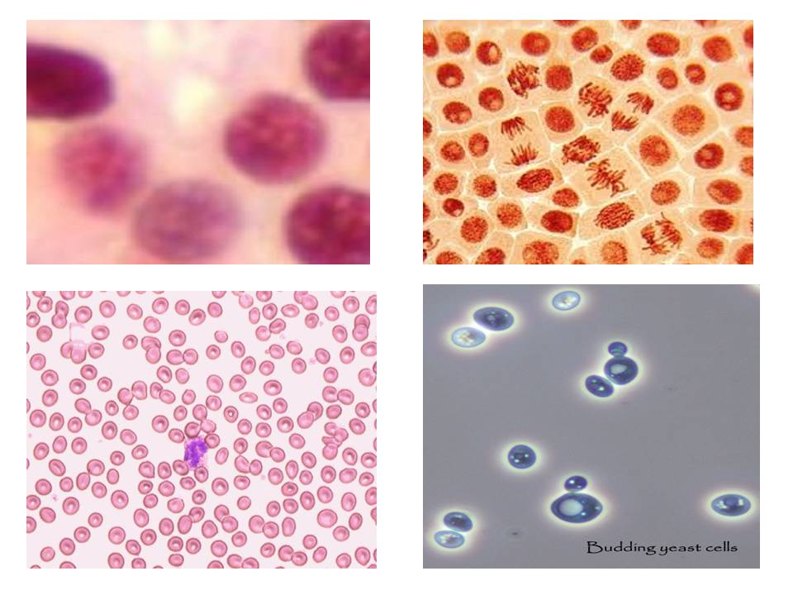
Figure 9: Data set of Medical Images

In part one of segmentation the images are initially accumulated in R-G-B layout. Each of the prehistoric colors (red, green, and blue) is correspond to 8- bits and has color intensity variety from 0 to 255. In all the trial we considered our fusion technique on initial segmentations with major components {R, H, Y, X, La and Lu}. The multilevel threshold technique in first segmentation scheme, used to determine the initial segmentations, is set to TSMO-16 [22]. We use six Color Model segmentations presented by the subsequent color spaces RGB, HSV, YIQ, XYZ, LAB, and LUV. We practical image fusion method on each major component form six color model {R, H, Y, X, La and Lu} to the same image and we evaluate the presentation of our projected algorithm to those in other available work that have just been apply to color images. The projected segmentation technique is conceptually diverse and explore a new policy; in fact, instead of bearing in mind only one image for each application [5, 8, 18], many recognitions of the similar image merged together may be cooperative to the segmentation development.
The first part of segmentation deals with color model whereas second part deals with automatic threshold of image. The second part we compute the automatic threshold using quad tree decomposition. The basic idea is to combine one-by-one the pixels coming from each segments of quad tree decomposition. After that counter threshold is set to finalize the result.
The above experiments were carried out by using MATLAB programs running on a Intel Pentium 3.10GHz CPU with Windows 7 operating system. For comparing the part 1 and part 2 segmentation scheme we use Recall and Precession as performance metrics (figure 10).

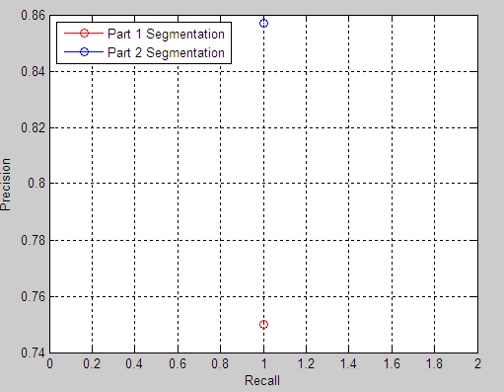
Figure 10: Precision and Recall for both image segmentation scheme

The above investigational outcomes demonstrate that the proposed methods perform better than the other methods and a represent a common framework for medical field images. The proposed method free from watershed method that has over-segmentation and under-segmentation problem.

conclusion
We proposed an innovative segmentation approach with vision to apply on any kind of image file format. The first strategy uses the color model in which six different color component from six different color model is retrieve in order to get generalize method which combines six color components.
This technique is based on image fusion process whose aim is to unite numerous segmentation to get a more consistent and well-organized segmentation scheme with good accurateness. In detail, as an alternative of considering only single image for every application, lots of understandings of the identical image merged mutually may be especially cooperative to the segmentation method. The plan is to fuse one-to-one the pixels from different six major component of six color model,
The planned segmentation method is theoretically dissimilar and investigates a novel strategy.
The second threshold mechanism is somewhat different than first in which the image is decomposed by using Quad-tree decomposition to avoid falling into wrong path. The initial point threshold from each decomposed block is decided and the counter threshold is set to get more accurate segmentation.
The results obtained illustrate the improved significant image segmentation. Key motivation behind this work is to propose a common method for all kinds of image format. The proposed work consist of two methods but first can be effective on color image and second can be best for gray images. These two methods are basically classical but has importance for effectively employed on color and gray images. If the same scenario can be advance then we can achieve a common method for all image formats.
The image fusion method leftovers general adequate to be functional in a variety of computer vision area. Finally this approach demonstrates that the planned technique could acquire the smallest amount of computational time to get strong and good quality segmentation result than the classical ones. Therefore, the planned technique can be extensively and successfully working in a variety of segmentation applications.

References

- Kwon MJ, Han YJ, Shin IH, Park H, “Hierarchical fuzzy segmentation of brain MR images”. Int J Imag Syst Technol 2003, 13:115-125.
- Navon E, Miller O, Averbuch A “Colour image segmentation based on adaptive local thresholds”. Image Vis Comput 2005, 23(1):69-85.
- Gautier L, Taleb-Ahmed A, Rombaut M, Postaire JG, Leclet H “Decision support of image segmentation by the Dempster-Shafer theory: application to a sequence of IRM images”. Edit Sc et med Elsevier SAS 2001, 22:378-392.
- Harrabi R, Ben Braiek E, “Color image segmentation using automatic thresholding techniques”. SSD’2011, Tunisia 2011, 1-6.
- Ben Chaabane S, Sayadi M, Fnaiech F, Brassart E “Color image segmentation using automatic thresholding and the fuzzy C-means techniques”. IEEE Mediterranean Electrotechnical Conference, MELECON’2008, Ajaccio-France 2008, 857-861.
- Ben Chaabane S, Sayadi M, Fnaiech F, Brassart E “Dempster-Shafer evidence theory for image segmentation: application in cells images”. Int J Signal Process 2009, 5(1):126-132.Yang Y, Zheng Ch, Lin P: Fuzzy C-means clustering algorithm with a novel penalty term for image segmentation. Opto-Electron Rev 2005, 13(4):309-315.
- Duda R, Hart P, “Pattern Classification and Scene Analysis”, Wiley New York; 1973.
- Vannoorenberghe P, Colot O, Brucq DD, “Colour image segmentation using Dempster-Shafer’s theory”, Proc ICIP’99 1999, 300-304.
- Bradley R, “A unified Bayesian decision theory”, Theory Decis 2007, 63(3):233-263.
- Shao-Long D, Jian-Ming W, Tao X, Hai-Tao L, “Constraint-based fuzzy optimization data fusion for sensor network localization”, Second International Conference on Semantics Knowledge and Grid, SKG ‘06 2006, 59-59.
- Dubois D, Prade H, “Possibility theory and its applications: a retrospective and prospective view”, The 12th IEEE International Conference on Fuzzy Systems, FUZZ ‘03 2003, 1:5-11.
- Denoeux T, “A k-nearest neighbour classification rule based on Dempster-Shafer theory”, IEEE Trans Syst Man Cybern 1995, 25(5):804-813.
- Ben Chaabane S, Sayadi M, Fnaiech F, Brassart E, “Estimation of the mass function in the Dempster-Shafer’s evidence theory using automatic thresholding for color image segmentation”, International Conference on Signals, Circuits and Systems, SCS’08, Tunisia 2008, 1-5.
- Zhu YM, Dupuis O, Rombaut M, “Automatic determination of mass functions in Dempster-Shafer theory using fuzzy C-means and spatial neighborhood information for image segmentation”, Opt Eng 2002, 41(4):760-770.
- Rafika Harrabi and Ezzedine Ben Braiek, “Color image segmentation using multi-level thresholding approach and data fusion techniques: application in the breast cancer cells images”, EURASIP Journal on Image and Video Processing 2012, 2012:11.
- R. Nock and F. Nielsen, “Semi-supervised statistical region refinement for color image segmentation,” Pattern Recognition, vol. 38, no. 6, pp. 835–846, 2005.
- L. Vincent and P. Soille, “Watersheds in digital spaces: an efficient algorithm based on immersion simulations,” IEEE Transactions on Pattern Analysis and Machine Intelligence, vol. 13, no. 6, pp. 583–598, 1991.
- Ben Chaabane S, Sayadi M, Fnaiech F, Brassart E, “Colour image segmentation using homogeneity approach and data fusion techniques”, EURASIP J Adv Signal Process 2010, 2010:1-11, ID 367297.
- R. Adams and L. Bischof, “Seeded region growing,” IEEE Transactions on Pattern Analysis and Machine Intelligence, vol. 16, no. 6, pp. 641–647, 1994.
- D. H. Kim, I. D. Yun, and S. U. Lee, “New MRF parameter estimation technique for texture image segmentation using hierarchical GMRF model based on random spatial interaction and mean field theory,” in Proceedings of the 18th International Conference on Pattern Recognition (ICPR ’06), vol. 2, pp. 365–368, Hong Kong, August 2006.
- J. Canny, “Computational approach to edge detection,” IEEE Transactions on Pattern Analysis and Machine Intelligence, vol. 8, no. 6, pp. 679–698, 1986.
- Huang DY, Wang CH, “Optimal multi-level thresholding using a two-stage Otsu optimization approach”, Pattern Recognit Lett 2009, 30:275-284.
- I. Bogdanova, X. Bresson, J.-P. Thiran, and P. Vandergheynst, “Scale space analysis and active contours for omnidirectional images,” IEEE Transactions on Image Processing, vol. 16, no. 7,pp. 1888–1901, 2007.
- I. Pitas, Digital Image Processing Schemes and Application, John Wiley & Sons, New York, NY, USA, 2000.
- Y. B. Chen and O. T.-C. Chen, “Robust fully-automatic segmentation based on modified edge-following technique,” in Proceedings of IEEE International Conference on Acoustics, Speech, and Signal Processing (ICASSP ’03), vol. 3, pp. 333–336,Hong Kong, April 2003.
- Yuan Been Chen, and Oscal T.-C. Chen,” Image Segmentation Method Using Thresholds Automatically Determined from Picture Contents”, Hindawi Publishing Corporation EURASIP Journal on Image and Video Processing Volume 2009, Article ID 140492, 15 pages doi:10.1155/2009/140492
- M. Sonka, V. Hlavac, and R. Boyle, “Image Processing, Analysis, and Machine Vision”, Brooks/Cole, New York, NY, USA, 2nd edition, 1998.
- S.-Y. Chien, Y.-W. Huang, and L.-G. Chen, “Predictive watershed: a fast watershed algorithm for video segmentation,” IEEE Transactions on Circuits and Systems for Video Technology, vol. 13, no. 5, pp. 453–461, 2003.

