A case study of Dividend Policy Decisions
On Power Grid Corporation of India Ltd
Surbhi Gupta
Assistant Professor
Amity University
sgupta11@amity.edu
Abhilasha sharma

ABSTRACT
Power Grid Corporation of India Limited (PGCIL), is an Indian state-owned electric utilities company headquartered in Gurgaon, India. Power Grid wheels about 50% of the total power generated in India on its transmission network. Power Grid has a pan-India presence with around 95,329 km circuit of transmission network and 156 EHVAC & HVDC sub-stations with a total transformation capacity of 138,673 MVA. Power Grid has consistently maintained the transmission system availability over 99.00% which is at par with the International Utilities. The power sector in India is growing rapidly and the role of PGCIL is significant in this sector. The sound financial health of the company would thus aid in achieving higher growth of the power sector. It is always important to know the financial management practices prevalent in the company. Twelve year data, i.e., from 2002-12 would be taken for the study. This study would focus on Dividend policy Decisions .
The primary objectives of study are:-
To study the Dividend policy decision of PGCIL company.
To study the impact of recession in 2007-08 on the financial performance of PGCIL.
The rationale behind the study is to examine the following major parameters:-
a)Enough funding is available at the right time to meet the needs of the business. In the short term, funding may be needed to invest in equipment and stocks, pay employees and fund sales made on credit. In the medium and long term, funding may be required for significant additions to the productive capacity of the business or to make acquisitions.
b)Whether the business is meeting its objectives? Are assets being used efficiently? Are the businesses assets secure? Does management act in the best interest of shareholders and in accordance with business rules?
c)How the financing alternatives are being considered. For example, it is possible to raise finance from selling new shares, borrowing from banks or taking credit from suppliers. Also, whether profits earned by the business are being retained rather than distributed to shareholders via dividends
Key words: Dividend payout ratio,Dividends, D/P ratio,EPS,DPS

1. Introduction
Dividend Policy Decisions :

Dividend policy is concerned with taking a decision regarding paying cash dividend in the present or paying an increased dividend at a later stage. The firm could also pay in the form of stock dividends which unlike cash dividends may provide immediate liquidity to the investors; however, it ensures capital gains to the stockholders. The expectations of dividends by shareholders helps them determine the share value, therefore, dividend policy is a significant decision taken by the financial managers of any company.
Dividends paid by the firms are viewed positively both by the investors and the firms. The firms which do not pay dividends are, in general, rated favorably by investors thus affecting the share price. Those who support relevance of dividends clearly state that regular dividends reduce uncertainty of the shareholders i.e. the earnings of the firm is discounted at a lower rate, k e thereby increasing the market value. However, its exactly opposite in the case of increased uncertainty due to non-payment of dividends.

This chapter is divided into three sections. Section I discusses about the dividend payout ratio for PGCIL over a period of twelve years, 2002-2014. It is also important to examine the stability of the dividends over the years. Section II represents the stability of dividends of PGCIL over the twelve year period. Concluding observations are contained in the Section III. It is to be seen whether subprime crisis and subsequent recession in 2007-08 had any impact on the dividends payout of PGCIL. Therefore, the data is segregated into two phases, namely 2002-03 to 2007-08 (pre-recession Phase-I) and 2008-09 to 2013-14 (post-recession Phase-II).
Section I
Dividend Payout ratios:

Dividend payout ratio is the fraction of net income, a firm pays to its stockholders in dividends. It is defined as:

➢ Dividend payout ratio = Dividends / Net income …(1)

The part of the earnings not paid to investors is left for investment to provide for future earnings growth. Investors seeking high current income and limited capital growth prefer companies with high dividend payout ratio. However, investors seeking capital growth may prefer lower payout ratio because capital gains are taxed at a lower rate. High growth firms in initial years generally have low or even zero payout ratios. As they mature,
they tend to return more of the earnings back to investors.

TABLE 1: DIVIDEND PAYOUT RATIO OF PGCIL, 2002-14
Year | D/P ratio | D/P ratio
2002-03 | 0.16 | 16%
2003-04 | 0.17 | 17%
2004-05 | 0.23 | 23%
2005-06 | 0.30 | 30%
2006-07 | 0.30 | 30%
2007-08 | 0.30 | 35%
2008-09 | 0.30 | 30%
2009-10 | 0.31 | 31%
2010-11 | 0.30 | 30%
2011-12 | 0.30 | 30%
2012-13 | 0.31 | 31%
2013-14 | 0.30 | 30%
Mean (2002-03 to 2007-08) | 0.25 | 25%
Mean (2008-09 to 2013-14) | 0.30 | 30%
Mean (2002-03 to 2013-14) | 0.27 | 27%
Median (2002-03 to 2007-08) | 0.27 | 27%
Median (2008-09 to 2013-14) | 0.30 | 30%
Median (2002-03 to 2013-14) | 0.30 | 30%

Figure 1: Dividend Payout Ratio of PGCIL, 2002-14
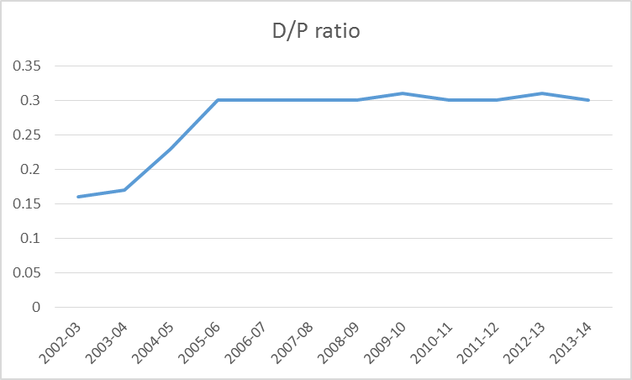

From Table 1 and Figure 1, it can be observed that the dividend payout ratio has increased steadily over the years. From 2008 onwards, the D/P ratio is constant to the tune of 30%. The high D/P ratio can be attributed to the fact that the PGCIL is a mature company and has less cash expenses. The company focuses on rewarding the investors by paying through dividends. The balance of earnings is used to grow revenues and future profits
so the dividend rate will grow over time.

SECTION II
Stability of dividends

The objective of this section is to examine the stability of dividends. The investors favor a stable dividend as much as they favor the payment of dividends (D/P ratio). The term stability of dividends refers to the consistency or lack of variability in the stream of dividends. The following bases have been used to arrive at the stability of dividends:-

➢ Earnings per share, EPS = (EAT – Preference dividend) / Number of equity shares outstanding

…(2)

➢ Dividend per share, DPS = EAT distributed as dividends among equity holders / Number of equity shares outstanding …(3)
The stability of dividends can take any of the following three forms:-
Constant dividend per share: According to the constant dividend per share, a company follows a policy of paying a certain fixed amount per share as dividend. This amount would be paid year after year irrespective of the level of earnings. The dividends per share may increase over the years when the earnings of the firm increase and it is expected that the new level of earnings can be maintained.
➢ Constant/stable D/P ratio: With constant payout ratio, a firm pays constant percentage of net

earnings as dividend to the shareholders.

➢ Constant dividend per share plus extra dividend: Under this policy, a firm usually pays a fixed dividend to the shareholders and in years of market prosperity; extra or additional dividend is paid over and the regular dividend. As soon as the normal conditions return, the firm cuts the extra dividend and pays the normal dividend per share.
From Table 2 and Figure 2, it can be observed that with increase in the earnings per share, there
has been steady increase in the dividend per share. Thus, the firm follows a stable or constant dividend
policy. (It may be noted that for period from 2002 to 2005, the face value of the share was Rs. 1000
and for period over 2006 to 2014, the face value of the share was Rs. 10)
TABLE 2: EPS, DPS AND D/P RATIO OF PGCIL, 2002-14
Year | EPS(Rs) | DPS(Rs) | D/P Ratio
2002-03 | 211.71 | 32.95 | 16%
2003-04 | 229.85 | 41.18 | 17%
2004-05 | 248.17 | 58.13 | 23%
2005-06 | 301.75 | 84.44 | 30%
2006-07 | 3.22 | 0.97 | 30%
2007-08 | 3.87 | 1.20 | 35%
2008-09 | 4.02 | 1.20 | 30%
2009-10 | 4.85 | 1.50 | 31%
2010-11 | 5.83 | 1.75 | 30%
2011-12 | 7.03 | 2.11 | 30%
2012-13 | 8.03 | 2.15 | 30%
2013-14 | 9.83 | 2.75 | 31%
Mean (2002-03 to 2007-08) | 166.43 | 36.48 | 25%
Mean (2008-09 to 2013-14) | 5.43 | 1.64 | 30%
Mean (2002-03 to 2013-14) | 102.03 | 22.54 | 27%
Median (2002-03 to 2007-08) | 220.78 | 37.07 | 27%
Median (2008-09 to 2013-14) | 5.34 | 1.63 | 30%
Median (2002-03 to 2013-14) | 6.43 | 1.93 | 30%

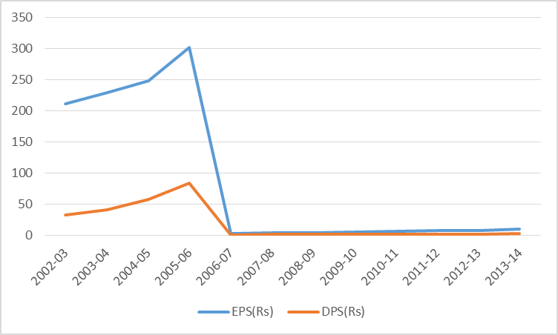
Figure 2: EPS AND DPS OF PGCIL, 2002-14

Table 1 and Figure 1 depict the various capital structure ratios for PGCIL over a period of twelve years, 2002-2014. It can be observed that there has been significant increase in the total debt to total equity ratio from 1.96 in period 2002-03 to 2007-08 to 2.82 in period 2008-09 to 2013-14. It can be inferred from data, that the PGCIL was able to create a brand image for itself by delivering the projects in time and servicing the debt in time and hence was able to raise more debt from the market.

It may be noted that the tariff structure of PGCIL is governed as per the regulations of central electricity regulatory authority (CERC), which mandates a debt:equity ratio for a project to be 70:30. In case, the equity is more than 30%, the excess equity over 30% would be treated as normative loan. The tariff computation is also regulated by the CERC orders. The tariff consists of two broad parts; annual fixed charges and the energy charges. The annual fixed charge consists of regulated ROE of 15.5% post taxes, interest on loan capital and working capital, depreciation and operation and maintenance expenses. Thus, in case PGCIL goes for higher debt, the benefits of cheaper source of funds, i.e., debt would be negated by the lost opportunity on regulated return on equity. This is emphasized from the data represented in Table 1, where-in the debt is around 70% of total assets and equity is around 30% of total assets.
Table 1 shows that there is no statistically significant difference between the pre-recession and post-recession phases in terms of capital structure ratios.
SECTION III

Concluding Observations:
This chapter analyzed the dividend policy decisions of PGCIL over the period of twelve years, 2002-14. The dividend payout ratio is steadily increasing over past years. Presently, it is around 30%. Recession during 2007-08, had minimal effect on PGCIL, as can be seen from the analysis. With increase in earnings per share, it is seen that the dividend per share is also increasing. Thus, it can be concluded that this company is secure and follows a stable dividend policy.
References:

- Baker, H. Kent and Gary Powell, (2005), Understanding Financial Management: A Practical Guide (Blackwell Publishing), pp (5-6).

- Kapil, Sheeba, (2011), Financial Management: A Practical Guide, (Pearson Publishing), pp (2-3).

- Bhat, Sudhindra, (2009), Financial Management: Principles and Practice, (Excel Books), p. 534.

- Paramasivan, C. and T. Subramanian, (2009), Financial Management, (New Age International (P) Ltd. Publishers), p. 3.

- Joy O. M. (1977), Introduction to Financial Management, (Irwin, Homewood), pp. (2-74).

- Lintner, J., (1956 ), “Distribution of Income of Corporations among Dividends, Retained Earnings and Taxes”, American Economic Review, pp (97-113).

7. Soloman, E, (1969), Theory of financial Management, (Columbia University Press, New York),
p. 8.

8. Khan, M. Y. and P .K. Jain, (2008), Financial Management – Text, Problems and Cases,
(Tata McGraw Hill Publishing Co., New Delhi), p. 1.7

Websites:

- Power Grid Corporation of India Ltd., http://www.powergridindia.com

- National Stock Exchange, http://www.nseindia.com

3. MoneyControl,http://www.moneycontrol.com

