Enhanced the Security and Quality of Image Steganography Through LSB Matching Algorithm

Divya Khanna
Research Scholar, Computer Science and Engineering Department, Thapar University, Patiala, India
divyakhanna1991@gmail.com

Rupali Bhardwaj
AP, Computer Science and Engineering Department, Thapar University,
Patiala, India
rupali.bhardwaj@thapar.edu

Abstract - Steganography is the art of hidden communications, encoding/embedding hidden information in cover media in such a way so as not to provoke an eavesdropper’s suspicion. In this paper, we propose an efficient image steganography technique which provides high embedding capacity as well as imperceptibility of stego image. Using fixed number (i.e. two) as the upper limit criteria for embedding, the target pixel, based on an equality between pixel bits and secret data bits is selected for embedding. As an indicator to determine which pixel is used for embedding, least significant bit is reversed. The experimental results showed preserving stego image quality with ability of embedding high data capacity . Results showed that the proposed method gives better results than simple LSB and inverted LSB with higher PSNR and lower MSE.

Keywords: Data Hiding, LSB, LSB Matching , PSNR

- Introduction

With rapid advancement in Multimedia technologies during the recent years, communication and information exchange have become much easier and faster but at the same time the issues related to data security and confidentiality have become a major concern of the time. To cater to this need of information security, a number of hidden and secret communication techniques have been developed.
Steganography refers to the art of hidden communications[1], encoding/embedding hidden information in cover media in such a way that it is a difficult job for a unauthorized person to see that there is something hidden in the cover media. The output is an image called stego-image that is similar to the cover media . This stego image is then sent to the receiver where the receiver retrieves the hidden mesage by applying the de-steganography. A stego-key is used for embedding/encoding process to restrict decoding or extraction of the embedded data in cover media. The modern age steganography is usually implemented computationally, where multimedia files are used as cover media. A good Steganographic mehods has three features, good hiding capacity, good imperceptibility and the last is robustness.

In this paper, we propose an efficient image steganography technique which provides high embedding capacity as well as imperceptibility of stego image. Using fixed number (i.e. two) as the upper limit criteria for embedding, the target pixel, based on an equality between pixel bits and secret data bits is selected for embedding. As an indicator to determine which pixel is used for embedding, least significant bit is reversed.
After a brief discussion of Simple LSB and Inverted LSB in Section 2, Section 3 describes the proposed method. Section 4 demonstrates experimental study. Section 5 concludes the paper.

2. Literature review
2.1 Basic Least Significant Bit (LSB) image steganography
Digital images are categorized into two parts (i) RGB (24 bit image) and (ii) Grey (8 bit image). Three bits of hidden information can be embedded in RGB image; one bit in LSB of each plane while in grey image one bit can be embedded. In basic LSB technique (in other words, eight bit technique), bit of bit plane zero of cover image is replaced by bit of the hidden message. If the LSB of the pixel value of cover image C(i,j) is equal to the message bit M(i,j) of secret massage to be embedded, C(i,j) remain unchanged; if not, set the LSB of C(i,j) to M(i,j).The message embedding procedure is given below-
1: For i = 1 to N
2: For j = 1 to N
3: If C (i, j) = even and M (i, j) = 0
4: S (i, j)= C (i, j);//no change in LSB of
C (i,j)
5: End If
6: If C (i, j) = odd and M (i, j) = 1
7: S (i, j)= C (i, j);//no change in LSB of
C (i,j)
8: End If
9: If C (i, j) = odd and M (i, j) = 0
10: S (i, j) = C (i, j) - 1; //Make it Even and Embed
11: End If
12: If C (i, j) = even and M (i, j) = 1
13: S (i, j) = C (i, j) + 1; //Make it Odd and Embed
14: End If
15: End
16: End
where C (i, j), S (i, j), means pixel value at position (i ,j) in cover image, and stego image respectively. M (i, j) means message bits value at position (i, j) .

2.2Inverted LSB image steganography
In this paper [8], an improvement in the simple LSB based image steganography through bit inversion technique is proposed and implemented. In this technique, LSBs of some pixels of cover image are inverted if they occur with a particular pattern of some bits of the pixels. In this way, less number of pixels
is modified in comparison to plain LSB method. So PSNR of stegoimage is improved. The proposed bit inversion technique provides good improvement to LSB steganography. To understand the technique, we consider the following example-
Four message bits 1101 are to be hidden into four cover image pixels 10010100, 11010100, 10100110 and 101110010.
After plain LSB steganography, stego-image pixels are
10010101, 11010101, 10100110 and 101110011. Three pixels of cover image have changed. Now, we see that the second and third LSB of two cover image pixels are 0 and 1 respectively. For two of these three pixels, LSB has changed. If we invert the LSB of these three pixels, cover image pixels will be 10010100, 11010100, 10100110 and 101110011. Now, there is only one pixel of stego-image which differs from cover image i.e. the last one. Thus, the PSNR would increase improving the quality of stego-image. For correct de-steganography, we need to store the fact that we have inverted the LSBs of those pixels in which second and third LSB are 0 and 1 respectively.

3. proposed algorithm
In this paper, we propose an efficient image steganography technique which provides high embedding capacity as well as imperceptibility of stego image. Using fixed number (i.e. two) as the upper limit criteria for embedding, the target pixel, based on an equality between pixel bits and secret data bits is selected for embedding. As an indicator to determine which pixel is used for embedding, least significant bit is reversed. If no equality occurs between pixel bits and secret data bits, data is embedded in cover image though simple LSB.

3.1 Embedding Algorithm
Input: Cover Image C of size M x N, Secret Data , P of size n .
Output: Stego-image, Key
Step 1: Embed the message, P to the LSB planes of the cover image C to get the stego-image S. The message embedding procedure is given as below -
__________________________________
- Initialise flag = 0
- While k <= n
- For i =1 to M
- For j =1 to N
- If C(i, j) = P(k) //match occurs between cover image and message
- C(i, j) = C(i, j) + 10
- Loc(k, 1, 1) = i // maintain array to get location
- Loc(k, 1, 2)= j
- k = k + 1
- Set flag = 1
- Break
- Else
- Loc(k, 1, 1) = i //array element can’t be zero
- Loc(k, 1, 2)= j
- EndIf
- EndFor
- If flag = 1
- Break
- EndIf
- EndFor
- If flag = 0 // match not found between cover image and message
- For x= 1 to M
- For y= 1 to N
- If C(x, y) =( 0 || 1)
- C(x, y) = P(k)
- C(x, y) = C(x, y) + 20
- Loc1(k, 1, 1) = x // maintain array to get location
- Loc1(k, 1, 2) = y
- k = k +1
- Set flag = 1
- Break
- EndIf
- EndFor
- If flag = 1
- Break
- EndIf
- EndFor
- EndIf
- Set flag = 0
- EndWhile
__________________________________
where C (i, j), S (i, j), means pixel value at position (i ,j) in cover image, and stego image respectively. P (k) means message bits value at position (k) .

3.2 Extraction Algorithm
After receiving of stego-image, the receiver firstly, extracts the hidden message from the stego-image. Extracting the message from the stego-image includes inverse comparison to that used in embedding. The decoding algorithm demands the same key that was used by the sender in the encoding algorithm.
Input: Stego-Image, Key Matrix.
Output: Secret Data.
The steps of the extraction phase are as follows:

- For q = 1 to n
- If S(Loc(K, 1, 1), Loc(K, 1, 2)) = C(Loc(K, 1, 1), Loc(K, 1, 2))+1
- Set msg(q) = 0
- Continue
- Elseif S(Loc(K, 1, 1), Loc(K, 1, 2)) = C (Loc(K, 1, 1), Loc(K, 1, 2))
- Set msg(q)=1
- Continue
- If S(Loc1(K, 1, 1), Loc1(K, 1, 2)) = C(Loc1(K, 1, 1), Loc1(K, 1, 2))+1
- Set msg(q)=0
- Continue
- Elseif S(Loc1(K, 1, 1), Loc1(K, 1, 2)) = C(Loc1(K, 1, 1), Loc1(K, 1, 2))
- Set msg(q) =1
- Continue
- EndIf
- EndFor
__________________________________
Where C(i, j), S(i, j), means pixel value at position (i ,j) in cover image and stego image.

4. result and analysis
In this section, some experiments are carried out to prove the efficiency of the proposed method where simulation is done on Matlab 14. A set of 8- bit greyscale image and 24- bit RGB image of size 512 × 512 are used as the cover image to hide binary and grey image of size 128 × 128 to form the stego-image. With the experimental study, we noticed that the visual differences between the original cover-images and stego images with the LSB matching can be hardly detected with naked eyes.
4.1. PSNR Analysis
MSE (Mean Square Error) and PSNR (Peak Signal to Noise Ratio) are two common quality measurements to measure the difference between the cover-image and the stego-image.
MSE is the averaged pixel-by-pixel squared difference between the cover-image and the stego-image. Mathematically, MSE is expressed as:
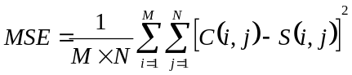
where, M and N are the rows and columns of the cover image respectively, and C(i, j) and S(i, j) means the pixel value at position (i, j) in the cover-image and the corresponding stego-image, respectively.
The PSNR is expressed in dB’s and can be calculated using MSE as
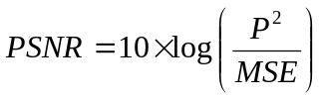 where, P is the peak signal value of the cover- image, and
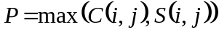
Table 2 , table 3 give the measured values of MSE and PSNR of different types of cover images of size 512×512 respectively. It is observed that when the payload increases the MSE increases and this affects the PSNR inversely and for all cover- images PSNR is greater than 50, this indicates good performance of the proposed system. Table 4 gives comparative study of proposed method with inverted LSB technique on different message images(fig. 1). It means that the stego-images created with Table 1 gives the measured values of MSE and PSNR of cover images of size 512×512 and hidden message size is 128× 128 respectively. It is observed that PSNR value of proposed method is better than simple LSB.

Table 1:MSE and PSNR value of hidden message (128x128)
COVER IMAGE  (512x512) | HIDDEN IMAGE  (128x128) | STEGO IMAGE  (512x512) | EXTARCTED HIDDEN IMAGE  (128x128) | MSE |  | PSNR
 |  |  |  | LSB | PROPOSED METHOD | LSB | PROPOSED METHOD
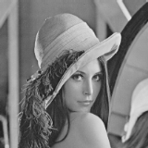 |  |  |  | 0.0314 | 0.0258 | 62.8116 | 63.6731
 |  |  |  | 0.0934 | 0.0773 | 58.4292 | 59.2494
 |  |  |  | 0.2501 | 0.1479 | 53.8020 | 56.0844
 |  |  |  | 0.7521 | 0.4436 | 49.3681 | 51.6607
TABLE 2: image steganography through simple lsb

Sender | Simple LSB
grey scale Cover Image  (512 x 512) | Msg1  4,225 bits |  | Msg2  16,384 bits |  | Msg3  24,964 bits |  | Msg4  38,416 bits |  | Msg5  48,841bits
grey scale Cover Image  (512 x 512) | MSE | PSNR | MSE | PSNR | MSE | PSNR | MSE | PSNR | MSE | PSNR
Goldhill.bmp | 0.0076 | 68.6008 | 0.0304 | 62.5911 | 0.0469 | 60.7112 | 0.0725 | 58.8160 | 0.0925 | 57.7620
Peppers.bmp | 0.0076 | 68.4045 | 0.0313 | 62.2344 | 0.0473 | 60.4458 | 0.0727 | 58.5809 | 0.0932 | 57.5036
Lena.bmp | 0.0083 | 68.5722 | 0.0314 | 62.8116 | 0.0482 | 60.9547 | 0.0736 | 59.1154 | 0.0931 | 58.0952
Baboon.bmp | 0.0076 | 68.4467 | 0.0309 | 62.3287 | 0.0474 | 60.4777 | 0.0734 | 58.5766 | 0.0930 | 57.5498

TABLE 3: image steganography through proposed method

Sender | Proposed Method
Cover Image  (512×512) | Msg1  4,225 bits |  | Msg2  16,384 bits |  | Msg3  24,964 bits |  | Msg4  38,416 bits |  | Msg5  48,841 bits
Cover Image  (512×512) | MSE | PSNR | MSE | PSNR | MSE | PSNR | MSE | PSNR | MSE | PSNR
Goldhill.bmp | 0.0068 | 69.0807 | 0.0258 | 63.311 | 0.0389 | 61.5250 | 0.0594 | 59.6864 | 0.0753 | 58.6517
Peppers.bmp | 0.0068 | 68.8560 | 0.0258 | 63.0865 | 0.0389 | 61.3004 | 0.0594 | 59.4617 | 0.0753 | 58.4271
Lena.bmp | 0.0068 | 69.4426 | 0.0258 | 63.6731 | 0.0389 | 61.8870 | 0.0594 | 60.0483 | 0.0753 | 59.0137
Baboon.bmp | 0.0068 | 68.8939 | 0.0258 | 63.1243 | 0.0389 | 61.3882 | 0.0594 | 59.4996 | 0.0753 | 58.4649
message images | cover image: Baboon
message images | psnr
message images | simple lsb | inverted lsb | proposed method
Laser | 54.34 | 54.80 | 55.3498
3things | 54.11 | 54.25 | 56.7877
Crods | 54.47 | 55.25 | 56.0055
Mandrill | 54.20 | 54.32 | 56.2722
Fishingboat | 54.30 | 54.62 | 55.8206
TestPat | 53.68 | 56.05 | 60.8495

TABLE 3: comparative study between inverted lsb and proposed method

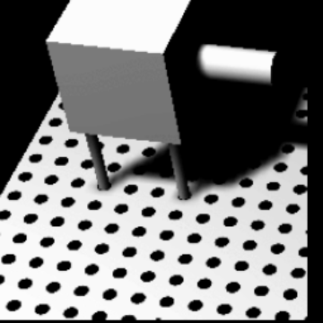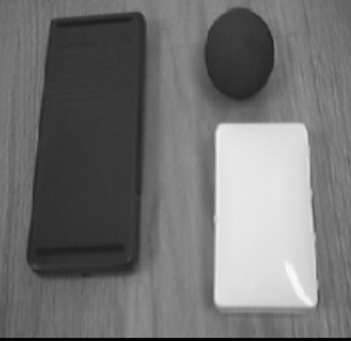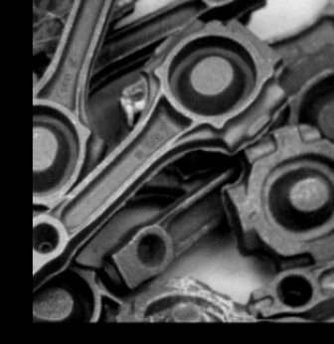

(a) (b) (c)

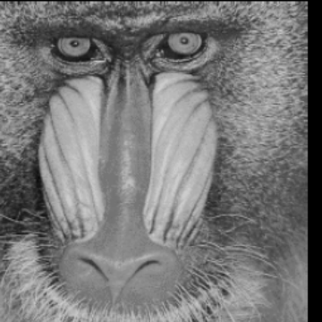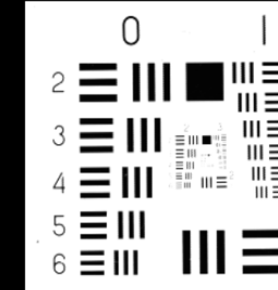
(d) (e) (f)

Figure 1. Message images (a) Laser (b) 3 things (c) Crods (d) Madrill (e) Fishing boat (f) TestPat

5. Conclusion

Steganography is the art of hidden communications, encoding/embedding hidden information in cover media in such a way so as not to provoke an eavesdropper’s suspicion. In this paper, we propose an efficient image steganography technique which provides high embedding capacity as well as imperceptibility of stego image. Using fixed number (i.e. two) as the upper limit criteria for embedding, the target pixel, based on an equalty between pixel bits and secret data bits is selected for embedding. As an indicator to

determine which pixel is used for embedding, least significant bit is reversed. Experimental study points out that the proposed system is better than simple LSB and inverted LSB method in terms of higher visual quality as indicated by the high PSNR values of hiding secrete message bits in the image thus reduces the chance of the confidential message being detected and enables secret communication. For future work we will generate random number through cellular automata as further securing system and use other type of cover-object for hiding the data.

References
[1]A. Menezes, P. Oorschot, S. Vanstone, and A. J. Menezes, “Handbook of Applied Cryptography”, CRC Press, Boca Raton, FL, 1997.
[2] http://en.wikipedia.org/wiki/Arnold%27s_cat_map
[3] V. I. Arnold, A. Avez ,”Ergodic Problems in Classical Mechanics”, New York: Benjamin,1968.
[4]D.X. Qi, “Matrix transformation and its applications to Image Hiding”, Journal of China University of Technology, 11(1):24-28,1999.
[5] F. A. Petitcolas, R.Anderson, M.Kuhn,” Information hiding: A Survey”, Proceedings of the IEEE,
vol. 87, pp. 1062—1078, July 1999.
[6] G. C. Langelaar, I. Setyawan, and R. I. Lagendijk,“Watermarking Digital Image and Video Data” in IEEE Signal Processing Magazine, pp. 20- 46, September 2000.
[7] B Li, J He, J Huang and YQ Shi., “A Survey on Image Steganography and Steganalysis”, Journal of Information Hiding and Multimedia Signal Processing, vol. 2, no. 2, pp. 142-172, 2011.
[8] Nadeem Akhtar, Pragati Johri, Shahbaaz Khan ,” Enhancing the Security and Quality of LSB based Image Steganography”, 5th International Conference on Computational Intelligence and Communication Networks, 978-0-7695-5069-5/13 © 2013 IEEE

