Automatic Ration Distribution System-A Review

Prof Swapnil R. Kurkute
Department of Electronics &Telecommunication
SIEM
Nasik, India
E-mail: swapnil.kurkute@siem.org.in

Miss. Ashlesha Revgade
Department of Electronics &Telecommunication
SIEM
Nasik, India
E-mail: ashlesharev23@gmail.com

Mr. Chetan Medhe
Department of Electronics &Telecommunication
SIEM
Nasik, India
E-mail: chetanmedhe005@gmail.com

Miss. Ashwini Kshirsagar
Department of Electronics &Telecommunication
SIEM
Nasik, India
E-mail: ashuu252@gmail.com

Abstract – In the present days many illegal activities are taking place in ration shops, which are meant to distribute the commodities to the people who are in below the poverty line, as the distribution process is manually operated and due to which it consumes a lots of time. To overcome this problem we one can use RFID technology. In this paper RFID tags are introduced, The RFID cards are instead of ration cards, which consist of all the details about the card holder like family details, type of card and its validity etc. In this paper we are going to discuss different types of automatic ration distribution system implemented for the automatic ration distribution.
Keywords – RFID Reader, RFID passive Tags, GSM module Dc Motor, Solenoid Control Circuits, PC, etc

I. INTRODUCTION
In India every Indian family is issued a Ration Card by Government of India and the families are to receive concision in food grains as per the card. Quantities of different food like rice, sugar, kerosene etc. is fixed for every month per families depending upon their income and total number of person in family.
Government of India provides various facilities for ration distribution towards poor people but such facilities do not reach up to needy and poor people due to corruption present in the chain of ration distribution. All the people must have valid a ration card to buy the any materials from the ration shops. This material has to be taken from the shopkeeper at one time in months. If any consumer does not need to buy some material then there is no monitoring of such unused material. So the shopkeepers are doing misuse of these materials by selling in the market with market less and doing the corruptions. So in this paper we are trying to explore some monitoring systems which are to be linked with government offices, shopkeeper and the ration card holder.
Identify applicable sponsor/s here. If no sponsors, delete this text box (sponsors).

In this paper we are trying to give brief review of some of the ration distribution systems which are implemented by using GSM, RFID and PIC Microcontroller.
II .Literature Survey
The most of people having the ration card to buy the materials from the ration shop first needs to submit the ration card. They will put the sign on ration card depend on the materials taken .they will issue the materials through weighting system with help of human but there are two drawbacks weight of materials may be inaccurate due human mistakes and secondly if any card holder not buy the materials end of the months then shopkeeper buy to other and doing deception.
The current public distribution system (PDS) involves corruptions and illegal activities of goods during manual ration distribution process. This is one of the widely controversial issues that grip the wrong information about utilization of material allotted for the card holders. Photo shows the existing Public Distribution System (PDS).
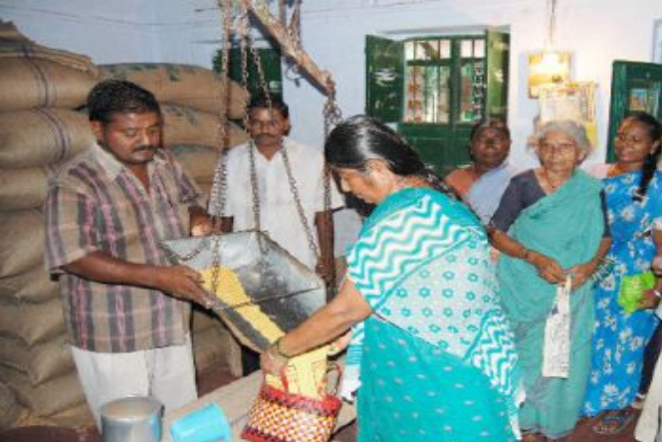
Fig2.1 .Manual ration distribution at Ration Shop

Figure 2.2 Undated Chart with prize of material in ration shop

According to environmental conditions and government rule the prize of material varies and it is different for people according to type of ration card. Many times it is observed that the ration distributers do not disclose the rate chart with proper reference date according to which the rates are decided by government of India. Due to witch consumer are forced to pay as per rate decide by distributers. Figure shows one of the pick from ration shop who does not disclose the dated rate.
Fig.2.Prices chart of various food grains without date
India’s Public Distribution System (PDS) with a network of 4.78 Lakh Fair Price Shops (FPS) is perhaps the largest retail system in the world [5]. Major problems due to this system are the inefficiency in the targeting of benefits and the resulting leakage of subsidies food grain. The PDS system today supports over 40 Cr. Indians below the poverty line with monthly supply of subsidized food grains.
“55% of the public distribution system (PDS) food grain does not reach the intended people many drawbacks of PDS like PDS leakage, scale & quality issue, system transparency and accountability, grievance redressed mechanism are overcome by making automatic distribution system.
- Methods & Algorithms
The existing conventional ration distribution system has two basic issues one is renewing the ration card every year and corruption by the distributers or by the employees by doing malpractices like diverting food grains to open market to make profit. This can be overcome using automatic ration distribution techniques. The basic fundamental elements of such system are RFID and GSM Technology [2]. Global system for mobile communication (GSM) is a globally accepted standard for digital cellular communication.[1] The RFID reader continuously transmits a 125 kHz carrier signal using its antenna. Such system can be implemented with the different processor such as system using ARM7, PLC & PIC microcontroller.
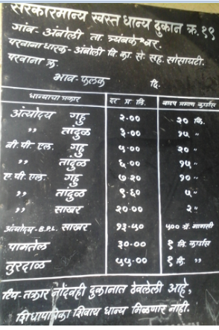
The Public Distribution System (PDS) in the country facilitates the supply of food grains to the poor at a subsidized price. However, doubts have been raised about the efficacy and cost-effectiveness of the PDS, especially in the light of the growing food subsidy and food stocks. [6]
2.1 Automatic Ration distribution using ARM 7
In this system LPC2148 (ARM7) plays an vital role of actual processing unit. The 12 MHz crystal oscillator is used to provide the required clock signals to the ARM7. It takes input from power supply of 3.3V for its operation this generation introduced the thumb 16 bit Instruction set providing improved code density compared to previous design .it is versatile processor designed for mobile device and other low power electronics. In ARM7 they are combination of c and assembly language but in ARM7 architecture used more instruction set as compared PIC microcontroller
Disadvantages of ARM7
- Cost is high
- Complex instruction set
- Complicated to designs because number of pin is more
2.2 Automatic Ration distribution using PLC
An PLC (programmable logic controllers) is an industrial computer used to monitor inputs and outputs depending upon their decisions based on its program or logic (turn on/off) its outputs to automate a machine or process but PLC based automatic ration distribution system have some disadvantages.
Disadvantages of PLC based Automatic Ration distribution
- Difficulty with changes or replacements
- Difficulty in finding errors, requiring skilful work force
- When a problem occurs, hold-up time is indefinite, usually long.
- Cost of PLC is high.
2.3 Automatic Ration distribution using PIC controller
In PIC based automatic ration distribution system microcontroller plays a vital role. PIC microcontroller is a RISC based Architecture. It is low cost and is used for real time application [7]. The size and cost of the microcontroller are less as compare to PLC and ARM7. The 4 MHz crystal oscillator is used to provide the required clock signals.
Advantages of PIC microcontroller
- Supports up to 32 Endpoints. (16 bidirectional)
- On-Chip USB Transceiver with On-Chip Voltage Regulator.
- Four Timer modules (Timer0 to Timer3).
- Dual Oscillator options allow microcontroller and USB Up to 2 Capture/Compare/PWM (CCP) modules
- High Performance RISC CPU Synchronous Serial Port (SSP) with SPI (Master mode) and I2C™ (Master/Slave)
- Experimentation
From the above review study we wish to implement an system which is design to distribute ration material automatically so as to reduce man power as well as to control the corruption in ration distributions which is to be design should be capable of identification of users information and the amount of material allotted to him according to type of card issued by the government of India. Hardware includes the controlling unit, RFID tag, material storage, automatic billing system. Most important is GSM so as to provide legal data information to GOV of India. The system must include the display which must show the following information.
User 1
Card no. 8975538244
Balance material: Rice- 20kg, Oil- 5 litre wheat-20kg
Delivered material-: 12:36pm, 05/10/2015
Available material in ration shop
Rice- 100kg, Oil- 50litre, wheat-200kg
User 2
Invalid ID
- CONCLUSION


Existing manual ration distribution system leads to corruption during ration distribution by distributers. Distributers does not release the actual rate decided by government of India for the people below poverty line according to the card issued. Hence people are pay rate according to rate given by distributers. The second important issue for the corruption in ration distribution is inappropriate or incorrect data of quantity arability at distribution center and required quantity of material to the distribution center. Another issue is up gradation of ration card. As the up gradation process is quit complicated people use to continue the same card even if number of people on the card changes due to some reasons. Hence from the above study we conclude to have Automatic Ration Distribution System which overcomes all the issues stated earlier. System must be easy to install and should be economical in favor of GOV of India.

Acknowledgment


We would like to express profound gratitude to Dr. R. G. Tated (Principal, SIEM Nasik) for his valuable support, encouragement, supervision and useful suggestions throughout this work. Also to Prof. D.P. Patil (HOD department of E&TC, SIEM Nasik), Prof. Y.R. Risodkar and Prof. M. K. Sangole of department of Electronics & Telecommunication for moral support and continuous guidance enabled us to complete this work successfully
References
- S.Valarmathy, R.Ramani “Automatic Ration Material Distributions Based on GSM and RFID Technology” I.J. Intelligent Systems and Applications, 2013, 11, 47-54
- Parvathy A, Venkata Rohit Raj, Venumadhav, Manikanta, “RFID Based Exam Hall Maintenance System’’, IJCA Special Issue on “Artificial Intelligence Techniques - Novel Approaches & Practical Applications” AIT, 2011
- K.Balakarthik,”Closed-Based Ration Card System using RFID and GSM Technology,’’ vol.2, Issue 4,Apr 2013
- Swati R.Zope, Prof. Maruti Limkar, “RFID based Bill Generation and Payment through Mobile”, International Journal of Computer Science and Network (IJCSN) Volume 1, Issue 3, June 2012 www.ijcsn.org ISSN 2277-5420
- S.Sukhumar,K.Gopinathan,S.Kalpanadevi, P.Naveenkumar, N.SuthanthiraVanitha, “Automatic Rationing System Using Embedded SystemTechnology”, International Journal Of Innovative Research In Electrical, Electronics, Instrumentation And Control Engineering Vol. 1, Issue 8, November 2013
- MahammadShafi.,K.Munidhanalakshmi,“eRationShop An Automation Tool for Fair Price Shop under the Public Distribution System in the State of Andhra Pradesh”,International Journal of ComputerApplications (0975 – 8887)
- Rubananth, T.Kavitha, “GSM based RFID approach to Automatic Street Lighting system”, journal of theoretical and applied information technology 30th april 2012. Vol. 38 no.2, ISSN: 1992-8645.
- ] RFID Journal, "Wall-mart begin RFID process changes ".http://www. rfidjournal.com/article/article
view/1385.
- Rajesh C. Pingle and P. B. Borole,“Automatic Rationing for Public Distribution System (PDS) using RFID and GSM Module to Prevent Irregularities”, HCTL Open International Journal of TechnologyInnovations and Research, vol 2,pp.102-111,Mar
2013.
Author’s Biographies
Prof. Swapnil R. Kurkute -Received BE in Electronics and Communication Engineering and ME in Communication from North Maharashtra University, Jalgaon-Maharashtra. Presently working as a Assistant Professor in department of Electronics and Telecommunication Engineering of sandip foundation’s SIEM, Nasik.

Mr. Chetan Medhe –Pursuing BE in Electronics and Tele communication engineering from department of Electronics and Communication Engineering of sandip foundation’s SIEM, Nasik.

Miss.Ashlesha Revgade –Pursuing BE in Electronics and Tele communication engineering from department of Electronics and Communication Engineering of sandip foundation’s SIEM, Nasik.

Miss.Ashwini Kshirsagar –Pursuing BE in Electronics and Tele communication engineering from department of Electronics and Communication Engineering of sandip foundation’s SIEM, Nasik.

