Comparative analysis of Contrast Enhancement Techniques of different Image
Vikash Yadav
Department of Computer Science & Engineering
Harcourt Butler Technological Institute, Kanpur, India
vikas.yadav.cs@gmail.com
Abstract:
Contrast enhancement is an important technique of image processing for the enhancement of contrast of an image in the spatial domain. Numbers of contrast enhancement techniques are available. This paper proposes comparative analysis of various contrast enhancement techniques applied on different images. PSNR and MSE value after enhancement is depicted in the tabular form as well as graphical form to analyze the best enhancement technique applied on corresponding images.
Keywords: Contrast Enhancement, Spatial Domain, Digital Image Processing Applications.

- INTRODUCTION
Enhancement is a method in which output of image is an improved form of input image. Different Enhancement techniques are there, like removal of noise, contrast enhancement, edge detection, and restoration etc. For removal of noise from the images, different types of filters are there like Median filters, Average filters, Gaussian filters etc. If some noise present in the images then after removing noise the image look as a enhance image. In a case of dimed image contrast enhancement method is applied over the image to increase the contrast of the image. In case of contrast of edge enhancement method, number of methods are there to contrast edges of the images, and after that image can be sharpened and look as an enhanced image. Number of work has been done for enhancing the images. Contrast enhancement is a one of the spatial domain method to improve the contrast of images without using segmentation it is a visually appealing area of image enhancement method, because viewer can judge about which method is working well and giving good results. Some of the intensity transformations functions are used for image enhancement like linear, logarithmic and power-law (Gamma) transformation functions. Identity function and image negative functions are part of linear function; in this negative image is a result of using negative transformation function, in which black or gray color converted in white and vice versa. Log and inverse-log transformations are part of logarithmic function. Log function used to expand dark pixel in an image and compression is used for higher-level values and vice versa for inverse-log transformation function. Power-Law (Gamma) transformation is also used for contrast enhancement. A simple and effective function of contrast enhancement is histogram equalization, which is used in many contrast enhancement applications, like medical image processing etc. Due to its simplicity and easy approach, this is a good enhancement method [3]. An image after using histogram equalization gives brighter image as compared to input image, because it shows uniform distribution. So we can say, for automatic enhancement this method is more suitable. But this method also has limitation of not taking mean brightness of an image, so for generating a specific histogram, Histogram Matching or Histogram Specification is used. One of the newly contrast enhancement method of brightness preserving bi-histogram equalization (BBHE) is proposed by Yeong-Taeg Kim[7, 8]. This algorithm is used to preserved mean brightness for enhancing images. These methods produced unnatural brightness for image contrast enhancement. Some other methods like fuzzy image enhancement, Genetic algorithm are also used for image contrast enhancement [1, 9, 4, 5]. As compare to histogram equalization and similar methods, genetic algorithm produced more bright and effective image for contrast enhanced. Genetic algorithm is based on method of optimization, which is based on natural genetics. It is more suitable for global search space to find optimal solution. It used parameters like population size, selection, crossover, type, crossover rate and mutation rate. It is used fitness function for evaluating intensity of edges of input images. Due to this algorithm, dynamically relationship between input images to output images can be changed [10]. Other enhancement method is known as Fuzzy technique [1, 2, 6], which operate on fuzzy sets just like spatial domain method operate on pixels. So fuzzy enhancement technique consider image as fuzzy set and performed various operations of fuzzy set theory it produced enhancement image. Fuzzy set theory is very popular and useful due to its capability to deal with unclear and changeable information, flexible, based on Natural language, conceptually easy to use and understand. It used to remove noise from images by using fuzzy filters and Smoothing method to enhance the images. Fuzzy Techniques has mainly three rules to enhance image :(i) Fuzzyfication of the input (ii) modification of fuzzy value (iii) Defuzzify.
This paper explains three contrast enhancement techniques, applies on different types of images and analyzed the quality after enhancement, by measuring its PSNR and MSE value.
- CONTRAST ENHANCEMENT TECHNIQUES
Several methods are available for Contrast Enhancement:
  - Contrast Stretching: It is a method to expand full range of intensity of an image, so that the overall brightness of image can increase.
Transformation function used for contrast stretching:
g(x, y) = g1 + ( 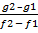)[f(x, y) – f1]
Here Mapping of gray levels [f1, f2] on new range [g1, g2].Where f1 is minimum intensity and f2 is maximum intensity of an image.
This function enhances contrast of an image, which shows equal distribution of intensity.
  - Histogram Equalization: It is widely used technique in image processing because it is automatic technique with no parameters to set. This process is based on, allocation of more gray levels, where there are most pixels, and allocation of fewer gray levels, where there are fewer pixel. So according to this most heavily populated region of the histogram, shows increment of contrast, and often bring out previously hidden detail. It changes images from an impulse histogram to one with a flat histogram.
Probability density function of Histogram equalization, p () is defined as:

P () = for k = 0, 1……L-1
Here P () represent number of pixel of a specific intensity for the histogram of input image.
Based on the probability density function, the cumulative density function is defined as:
C (X) =) where = x, for j = 0, 1……L – 1
Histogram equalization, maps the input image into the entire dynamic range,
( ), by using the cumulative density function, transform function of output image of Histogram equalization:

T () = f0 + (f1 - f0))

HE is also used for flattens a histogram.

  - Contrast-limited adaptive histogram equalization (CLAHE): This contrast enhancement technique works on only parts of an image or can say on tiles of an image. First these methods, divide image into number of tiles, then apply contrast enhancement on every tile individually and then it recombines result to give output image with enhancement. This method works better as compare to histogram equalization in most cases for contrast enhancement of images.

- QUALITATIVE ATTRIBUTES OF AN IMAGE
In image enhancement technique quality of an image can be subjective. It can be different for person to person, so because of this reason it is compulsory to establish some parameters to compare the image quality. Following are the matrix used to inquire the quality of an images:

3.1 Peak signal-to noise ratio (PSNR): It is a ratio between the maximum power of a signal and
power of corrupting noise. Here signal is the original data, and the noise is the error. The
mathematical representation of the PSNR is as follows:

PSNR = 20( )

3.2 Mean square error (MSE): It is the cumulative squared error between the compressed and the original image.

MSE = 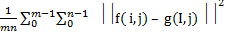

Where f = matrix data of original image,
g = matrix data of degraded image,
m = no of rows of pixels of an image,
i = index of that row,
n = no of columns of pixels of an image,
j = index of that column.
So, quality of image will be better when value of PSNR is higher and value of MSE is minimum.

- Experimental Study
Experimental study is applied by taking different types of contrast enhancement technique on different types of images. We performed analysis using statistical analyser like PSNR and MSE. Fig (1) (a) shows the original image and fig(1)(b) shows the enhanced image by using contrast starching, fig(1)(c) shows the enhanced image by using histogram equalization, fig(1)(d) shows the enhanced image by using Contrast-limited adaptive histogram equalization. PSNR and MSE values of 5 images by using above three techniques are depicted in table 1. Fig (2) and Fig (3) display the result of MSE and PSNR in graphical way.

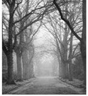  (a) | 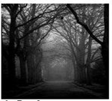  (b) | 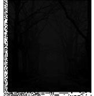  (c) | 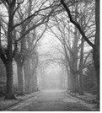  (d)
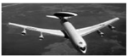  (a) | 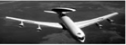  (b) | 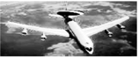  (c) | 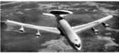(d)
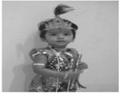(a) | 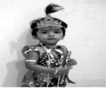  (b) | 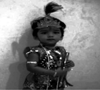  (c) | 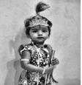  (d)
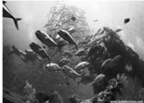  (a) | 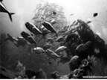  (b) | 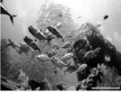  (c) | 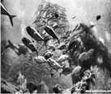  (d)
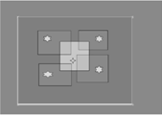  (a) | 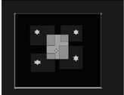(b) | 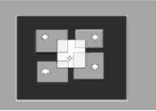  (c) | 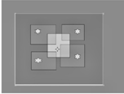  (d)

Fig 1: Results of various enhancement techniques. (a) Original Image and the enhanced image using (b) Contrast Stretching (c) Histogram Equalization (d) CLAHE.
Table 1: MSE and PSNR value of different types of images after using contrast enhanced techniques

 | For Foggy image |  | For airplane image |  | For kid image |  | For under water image |  | For square image
Contrast enhancement Techniques | Mean Square Error | PSNR | Mean Square Error | PSNR | Mean Square Error | PSNR | Mean Square Error | PSNR | Mean Square Error | PSNR
Contrast Stretching | 529.86 | 27.27 | 58.41 | 24.38 | 1638.40 | 19.63 | 166.60 | 27.47 | 12531.67 | 13.53
Histogram Equalization | 1354.54 | 23.19 | 4566.03 | 5.45 | 2400.01 | 17.97 | 499.78 | 22.70 | 3089.09 | 19.61
CLAHE | 69.73 | 36.08 | 1284.51 | 10.95 | 461.18 | 25.14 | 1495.86 | 17.94 | 7.73 | 45.62

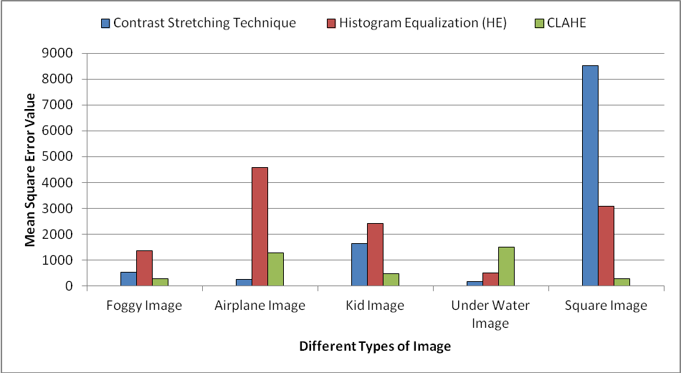

Fig 2: MSE Value of different images by using contrast enhancement techniques.

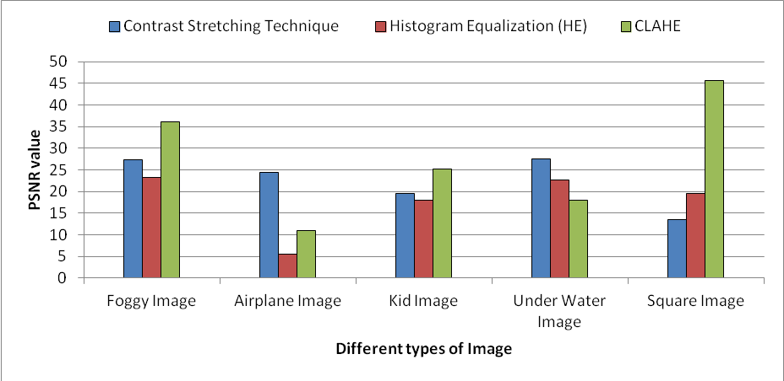

Fig 3: PSNR Value of different images by using contrast enhancement techniques.

- Conclusion and Future Scope
This paper proposed a comparative analysis of contrast enhancement techniques such as contrast starching, histogram equalization and Contrast-limited adaptive histogram equalization applied on different types of gray images like foggy images, sky image, photographic image, paint brush image and under water image. Experimental result shows that for foggy image Contrast-limited adaptive histogram equalization gives better result, for sky image contrast starching gives better result, for photographic image Contrast-limited adaptive histogram equalization gives better result, for under water image contrast starching gives better result, and for paint brush image Contrast-limited adaptive histogram equalization gives better result. So according to above experiment Contrast-limited adaptive histogram equalization gives better image quality as compare to other above methods.

REFERENCES
[1] A.Suneetha, Dr.A.Sri Krishna,”A New Method of Image Enhancement in Spatial Domain Using Histogram Equalization, Smoothing and Fuzzy Technique”, IJCST Vo l. 2, SP 1, December 2011.
[2] H.D.Cheng, Huijuan Xu,” A novel fuzzy logic approach to contrast enhancement”, Pattern Recognition, Elsevier Science Ltd, 33(2000) 809-819
[3] F.Al-samaraie,” A New Enhancement Approach for enhancement Image of Digital Cameras by changing the contrast”, International journal of advanced science and technology, Vol.32, July, 2011.
[4] Verma A., Archna,”A survey on Image Contrast Enhancement using Genetic Algorithm”, International journal of scientific and research publication, Vol 2 Issue 7, July 2012
[5] Satoh F., “Image contrast enhancement using Genetic Algorithm”, IEEE, 1999
[6] S. K. Pal and R. A. King, (1999) “Image Enhancement using Fuzzy Set”, Electronics Letters, Vol. 16, No. 10, April 1980.A novel fuzzy logic approach to contrast enhancement”, Pattern Recognition.
[7] Hojat Yeganeh, Ali Ziaei, Amirhossein Rezaie, (2008) “A Novel Approach for Contrast Enhancement Based on Histogram Equalization”, in proceedings of international conference on Computer and Communication Engineering (ICCCE 08), pp. 256-260.
[8] Y. T. Kim,( 1997) “Contrast Enhancement Using Brightness Preserving Bi-Histogram Equalization,” IEEE transactions on Consumer Electronics, vol. 43, no. 1, pp. 1-8.
[9] Verma A., Archna, (2012) “A survey on Image Contrast Enhancement using Genetic Algorithm”, International journal on scientific and research publication, Vol. 2 No. 7.
[10] Satoh F. (1999), “Image contrast enhancement using Genetic Algorithm”, in proceedings of IEEE systems, Man, Cybernetics, Vol. 4.

