Personalized Hybrid Book Recommender System
Using Neural Network

Ankit Kanojia, Om Prakash Verma, Hitesh Nirwan

Department of Information Technology Delhi Technology University, Delhi
opverma.dce@gmail.com, ankitkanojia89@gmail.com
hiteshnirwan@gmail.com

Abstract-Now day’s recommender systems play a significant role in day to day activity of a consumer as well as e-commerce industry. They provide personalized recommendation to each and every customer. In this paper we present an approach in which we use customer personalize demographic information such as sex, age and location as well as book information such as title and ISBN number together to predict rating of books within range of 1 to 5 using MLP-Neural Network. The customer location can be obtained through customer’s IP address and converted it into a unique IP number for prediction and gender differentiability hold by assigning different value to sexual categories. Parameters such as gender, age and location helps in enhance personalization factor in a recommendation process. By assuming certain threshold rating value, books which are above threshold rating can be recommended to a customer. Our approach accepts challenges of recommender system and provides innovative solution to these challenges. We evaluate present approach in Matlab.

Keywords: Recommendation, neural network, book, demographic, ISBN number, Age, IP Address

1. Introduction

Recommender system learn a customer behavior by tracking the customer activity over an internet, on the basis of learned behavior, they recommend items to the customer. Most of recommender systems are based on collaborating filtering, content based approach or knowledge based methods. These methods attempts to find similarities between items and user by referring their features. They basically implements classification and clustering techniques, which help them to overcome from challenges of the recommender system such as data sparsity, dynamic nature, scalability etc. E-commerce industry uses customer’s demographic data to suggest their items to the customer. This demographic information regarding to the customer can be easily obtained through integrated social site profile, cookies and registration data and be used to provide personalize recommendation to the individual customer. The recommender systems are also capable to handle ambiguous queries posted by a user. Therefore, help in reducing information overload by considering only selected items based upon input query. They are usually hidden from the end user; deliver them high quality information which enhances user satisfaction and system performance.

1.1 Recommender System
Recommendation system predict likelihood of a user towards certain item, with aim to suggests items, which may they like from set of items they have not considered so far[1].

1.2 Type of Recommendation
1.) Content-based recommendation technique: exploits information and features of the items, with the aim of recommending to user a set of items that have some similarity or relationship with items they brought or examined in detail during the current or past online activity.

2.) Collaborating Filtering technique: exploits similarities between users (i.e.commonalities between user profile) for suggesting items. It is based upon the assumption that people with the same opinion on an item are more likely to have same opinion on the other items too. Therefore, it is possible to predict the taste of a user by collecting preferences from other similar users.

3.) Knowledge based recommendation: considered facts to make recommendation about the user requests and liking.

A hybrid approach can be constructed which is combination of at least two above mention approaches in order to eliminate the problems of an individual approach used separately e.g. we can combine content based and collaborative filtering algorithm in such a way that they produce individual list of recommendations that can be merge to make final recommendation list from which we can recommend top elements. Experiments show they actually slightly improve performance of both [1].
1.2 Related Work

1.2.1 Content based filtering
It is predominant recommendation approach. Features of items are used in this approach, which are typically words. The majority of researcher used plain words. Jiang et at used subject, which utilized only those words and combinations of words that occurred as social tags on CiteULike[2].Some recommender systems non textual features i.e. writing style, layout information, XMLtags[3]. In this not only features of items are considered but user information also considered equally, even feedback from a user given important. Author Mohammand Hamidi Esfahani et al. considered both item features and user’s properties for recommendation, they uses both features for construction of clusters using c-Means clustering methods, which used form extract weighted Map for recommendation purpose[4]. Author also used metadata for recommendation purpose.
Most of author used machine learning techniques for content based filtering. Most popular used technique is SVM( Support Vector Machine). Author Jianying Mai et al. used Neural Network, machine learning algorithm for evaluate pre-classification results[5]. Some researcher also applied stemming and removed stop words.
Some researcher considered fact that influence of certain field have more dominance than other filed e.g. A word occurs in the abstract of paper is more dominance over word present in the body text. Nascimento et al. considered this fact, and weighted terms from the title three times stronger than terms from the body - text, and text from the abstract twice as strong[6].

1.2.2 Collaborative Filtering
The term “ Collaborative Filtering “ was first coined by Doug Terry, David Goldberg et al. in 1992, they were driven by idea that “ information filtering can be more effective when human are involved in the filtering Process[7][8]. In this approach author designed a system known as Tapestry that allowed people to mark document as interested or uninterested, then used this information to filter documents for other people. Now days this recommender technique is frequently applied.
Paul Resnick et al., after two year proposed that similar minded people like similar items. Two user considered as similar minded, when they like or positive rated same item. Collborative Filtering also offers following advantages such as content independent, count on connection i.e. rating, human provide explicitly rating which provide real time estimation of item, collaborative filtering support serendipitous recommendations because it is relies on user similarities.
Yang et al. proposed explicit rating approach allowed user to rate their research paper, but user were too “ too lazy to provide rating”[2]. To overcome this problem Yang et al. inferred implicit ratings from the number of pages user read[2].

1.2.3 Hybrid Recommender System
This technique represent hybrid approach in which previously defined approach are combined to increase accuracy. It take advantage of both technique and reduce their individual demerit. It is novel way enhance precision of the system. Mohammand Hamidi Esfahani et al. proposed hybrid approach using c-means clustering[4].
2. Challenges of Recommendation Technique and Proposed Solution

2.1 Cold Start: is a problem which occur at the starting of the system lifespan. When the machine is switched on, it doesn’t contain any record of user interaction or rating. This make impossible for system to evaluate any recommendation. This problem can be resolve by training neural network on popular books initially, after construction of initial database, neural network weights can updated according customers rating pattern.
2.2 Data sparsity : In general database tables are very sparsely occupied: the typical situation is that, upon a warehouse which contain tens millions of products, each customer may have purchased only few items at most, may have visited only few times, and may have explicitly rated or commented on just one or two. This make an effective implementation more difficult. To solve this problem our proposed approach cab be combine with a K-means clustering.
2.3 Scalability: When the number of existing users and items population grows tremendously, the traditional system undergoes from fatal scalability problems, leads acute decline in performance which goes beyond acceptable level. In proposed approach, no need to consider training set again and again because Neural Network support incremental training. So as number of books and existing users increase, it doesn’t affect much on acceptable performance.
2.4 Synonyms: It occurs when number of the indistinguishable or very similar items have a many name and recommender systems unable to reveal this hidden association, then considered these products differently. The unique ID (ISBN number) used in proposed approach easily resolve this problem.
2.5 Grey Sheep and Black Sheep: Problem occurs when a customer whose views are constantly unable to correlate in agreement or disagreement with any certain group of people. Thus customer unable to take advantage of Recommender System and known as Grey Sheep. This problem also acutely increase error rate in collaborative filtering recommender system. Customer who correlate with very limited people or none can be considered as Black sheep. This scenario makes challenging situation for recommendation system. By considering a suitable customer attribute for k-means clustering, which collaborate similar customers together for recommendation can eliminate this problem.
2.6 Fraud: Now days recommender Systems are gradually adopted by e-commercial websites. Recommender System provide financial benefits to the vendors and service provider. Unethical competition between vendors have started them to involve in different kinds of fraud in order to con the system to get their advantage. They have tried to inflate the perceived attractiveness of their own commodities(push attacks) or reduce the ratings of their competitors( nuke attacks). These attacks are also known as shilling attacks[2].Shilling attacks can be avoided by using security parameters such as Logins, firewalls and Object oriented programming approach with our proposed methodology
2.7 First Rater: When new items comes in market domain that have never purchased then it would never be recommended to customer using collaboration filtering technique. Proposed system can effectively rate any new book, no prior knowledge of review associated with a new book required. In proposed approach new book attribute and current customer attribute are sufficient to rate the book.
2.8 New User: when a new customers come, who never purchased anything cannot receive any recommendation suggestion because they cannot be linked to other customers. Our system can able to recommend new user just by obtaining attribute of the new customer.
To address above challenges we used classification and clustering techniques that can be applied over users and items, thus aggregating user or items that have similar behavior and hence labeling and keeping the common behavior through a representative set of select actions. This tremendously reduces the size of the dataset that considered for analysis.

3 Performance Measure for Recommender Systems
Recommender Systems performance can be measure by comparing predicted recommendation rating with a known user rating. These systems are commonly measured using predictive accuracy metrics, where the predicted ratings are directly compared to actually user ratings. The commonly used metrics are Mean Absolute Error( MAE) and Root Mean Error(RME) described below[9]:

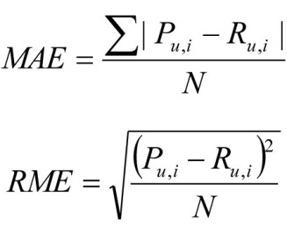
Fig 3.1 Evaluation Metrics
Where, P_{u,i} is the predicted rating for u on item i,
R_{u,i} is the actual rating
N is the total number of ratings in the test set
Predictive accuracy metrics treat all items equally.
4. Our Approach
We proposed an approach to develop a recommender system which based on a machine learning technique such as neural network. Initially neural network learn from previous available data i.e. Training dataset, after learning phase neural network classify and predict rating of books. Predicted rating is within range of 1 to 5 and specified meaning is associated with it e.g. rating 1: highly rejected book, rating 5: highly accepted book. Based on predicted rating and considered threshold rating books are recommended to a customer. The purposed recommender system is accepts all the challenges of recommendation techniques (define above) and provide innovative solution to all accepted challenges.

4.1 Appropriateness of Neural Network
In this defined approach we considered neural network for classification purpose over other available classifiers because of the following reasons:
1.) Neural Network support incremental training as compared to other techniques such as SVM, decision tree etc. In this domain every year thousands of book got published, which have different characteristic and due to advancement in accessibility of internet more customer purchase books online, each customer have different characteristic associated with them. Therefore, to deal with current scenario we need considered a classifier, which support incremental training.
2.) To deal with consequences of scalability (when degree of existing user and items increased tremendously) such as noisy data. We need a technique, which is highly tolerance to noisy data. Neural Network provide high tolerance against noisy data.
3.) Sometime classifier need to classify data, which is unseen (unseen refers here data which is highly diverse in nature from data used in training set). Neural Network able to classify appropriately unseen data as compared to other technique such as decision tree, SVM, regression classifier etc. Recommender System uses different combination of parameters for recommendation, which can lead to unseen combination as input to classifier.
4.) In current approach, we considered different parameters for recommendation e.g. publisher, title , demographic information( such as age , sex, location), which required to predict dependencies between combination of inputs. Neural Network can predict dependencies between combination of inputs efficiently and also have ability to handle complex non-linear function.
5.) Neural Network offers less space complexity only need to store connection weights as compared to other technique such as SVM, which require to store complete training data set.
4.2 Structure of Dataset
In the following approach, we construct a dataset which consist of following tables:
1.) Book Table: which contain all information associated with books such as ISBN Number, Book title, Book Authors, Book Publisher.
2.) Customer Table: which consist detail of customer, who previously purchased book from system. Customer table contain following details: customer id( auto generated), age, sex, country, IP address number.
3.) Rating Table: contain explicit rating for books previously purchased by customer. Rating table contain following details: ISBN Number, customer id, book rating.
4.)IP table: which is used to convert IP address in unique IP number and can also be used to obtain current user country name. This table contain following attributes: ID, Beginning IP, Ending IP, Two Country Code, Three Country Code, Country Name.
From below E-R Diagram, we can understand relationship between tables defined above. It’s clearly understandable one customer can by more than one book and one particular book can be purchased by more than one customer. When customer purchased a book, he/ she can also label rating of purchased book.

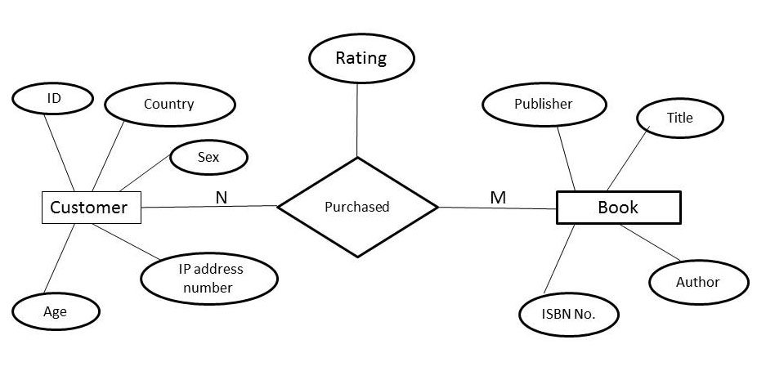
Fig 4.1 E-R Diagram of dataset

4.3 Procedure to translate IP address into IP Number
Every visitor has a unique IP address, which can be easily obtained. It can be used for tracing. IP address can also identify current location of visitor or at least it's Service Provide in the world. Sometimes difficulty arises when visitor behind a proxy of some sort, in this case we can only obtain IP address of proxy server.

Method to convert IP Address into IP Number:
As we know Internet Protocol (IPv4) divides IP address into four sub-blocks. Each block has separate weight associated with it, which are powered by 256.
The starting IP number and the finishing IP number are compute by using following formula:
IP number = 16777216*a + 65536*a + 256*c + 1*d
Or
IP number= 256³*a + 256² *b + 256¹*c + 256⁰*d
Where : IP address = a.b.c.d
e.g. considered IP Address : 205.109.50.7, then its IP number can be calculated as follow:
IP Address: 205.109.50.7 so, a= 205, b= 109, c= 50, d= 7
IP Number =16777216*205+65536*109+256*50+1*7
= 3439329280+7143424+12800+7
= 3446485511
Method to convert IP Number into IP Address:
a = integer ( IP Number / 16777216 ) % 256
b = integer ( IP Number / 65536) % 256
c = integer ( IP Number / 256) % 256
d = integer ( IP Number ) % 256
where, % denotes modulus operator and integer used to type cast return result part of division into integer.
Country name can be obtained from the IP number by using IP-country database. Through IP-country database we can tally unique record that has the IP Number that fits between the starting IP number and the finishing IP number e.g. the IP address: 205.109.50.7 is corresponding to the IP Number: 3446485511. It is associated to the following record in the database because it is between the starting and the finishing of the IP Number.
From the IP-country dataset, the country name is Malaysia and the country code is MY
By using above procedure we convert IP Address into IP Number, which can be used as input to neural network for prediction purpose. For recommendation to a current customer, we obtain it IP address and translate it into IP number. Use this IP number to recommend him/her.

4.4 Hierarchy of ISBN Number
In late 1960’s, publishers got understood that they required a unique uniform number to recognize all the books that were being published throughout the world. In 1970, the 10 digit an ISBN format is developed by the International Organization for Standardization (ISO) and was published as international standard ISO 2108.Every book, including new edition of older book, was issued ISBN number [10].
An ISBN is a “structured” number, different part associated with different meaning (similar to telephone codes). Different associated part are separated by hyphen and space (hyphen are preferred, but not necessary). The ISBN is 13- digits long if assigned on or after 1 January 2007, and 10 digit long if assigned before 2007. An International Standard Book Number consists of four parts (if it is a 10 digit ISBN) or 5 parts (for a 13 digit ISBN)[11]:
- For a 13-digit ISBN, a prefix element – a GSI prefix: so far 978 or 979 have been made available by GSI
- The registration group element,( language sharing country group, individual country or territory)
- The registrant element
- The publication element
- A checksum character or check digit
The 13 digit ISBN separates its part (prefix element, registration group, and registrant, publication and check digit) with either a hyphen or space. Other than the prefix and the check digit, no part of the ISBN has a fixed number of digits.
The 10 digit ISBN also separated its parts (registration group, registrant, publication and check digit) with either hyphen or space e.g.

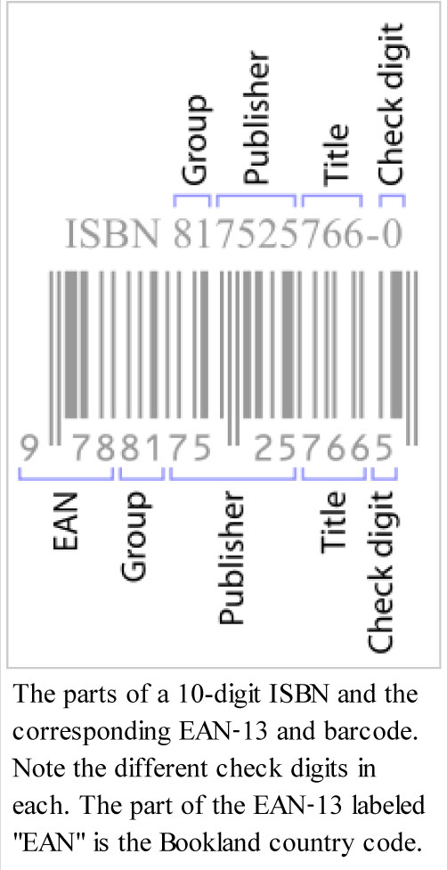

Fig 4.2 Hierarchy of ISBN Number
Registration group Identifier
This part contains 1 to 5 digits which identifies a country, region or language area participating in ISBN system within a single prefix element (i.e. one of 978 or 979). The single digit group identifiers in the 978 prefix element are:
Group Number: 0 or 1 for English speaking countries
Group Number: 2 for French speaking countries
Group Number: 3 for Germany speaking country
Group Number: 4 for Japanese speaking country
e.g. Group number 99942 is Sudan (Africa)
Book published in infrequent language usually have long Group Number.

Registrant Element
Registrant element also refers as publisher, which may contain up to seven digits. The publisher identifier directs particular identification of publication house and its address. If publisher issue title number from their initial collection then they need to provide additional publisher identifier.

Title Identifier
The third part is used to identify specific edition of specific publisher, it may contain up to 6 digits. If ISBN has less than 13 digits, then 0’s are prefix to make number 13 digit.

Check Digit
A check digit is used for error detection, which represent by single digit.
E.g. Considered an ISBN number: 81 - 8147 – 049 – 4

To calculate ISBN check digit, we need to multiply the first digit by 10, the second digit by 9, the third digit by 8, and the ninth digit by 2 and sum up all these numbers. The check digit is the number has to sum to this total to get up to a multiple of 11. For ISBN number given above we compute check digit in the following way:
8×10 + 1×9 + 8×8 + 1×7 + 4×6 + 7×5 + 0×4 + 4×3 + 9×2 =
80 + 9 + 64 + 7 + 24 + 35 + 0 + 12 + 18 = 249.
As we know 249 is between 242(22×11) and 253(23×11). We need to add up 4 to 249 in order to get 253. So, check digit number is 4.

4.5 Neural Network Input-Output parameters
In defined approach, we considered a neural network which has 5 inputs and 5 outputs, one hidden layer and one output layer. In our approach we only considered books which are belong to English speaking countries. So, Registration group Identifier can’t be act as appropriate candidate for input to neural network for classification and prediction.
Five inputs to neural network are:

Table1 Input parameters
Input |  | Data  Type | Length |  | Range
 |  | Data  Type | Min | Max | Min | Max
Registered Element (part of ISBN) |  | Integer | 1 | 7 | 1 | 9999999
Title Identifier  (part of ISBN) |  | Integer | 1 | 6 | 1 | 999999
Age |  | Integer | 1 | 3 | 10 | 100
Unique IP Number |  | Integer | 1 | 16 | 1 | 4294967265
Gender | Male | Char | 1 | 1 | - | -
Gender | Female | Char | 1 | 1 | - | -

Gender value is converted from character to integer value for gender differentiability and classification and prediction purpose. In defined approach, we converted as follow:
- Male: 1
- Female: 1000

Five outputs represent rating predicted by neural network:
Table 2 Output parameters
Rating | Associated Meaning
1 | Highly Rejected
2 | Rejected
3 | Marginal Accepted
4 | Accepted
5 | Highly Accepted

Rating values during training phase:
Table 3 Rating values during training phase
Rating | Corresponding value  ( for error evaluation)
1 | 1,0,0,0,0
2 | 0,1,0,0,0
3 | 0,0,1,0,0
4 | 0,0,0,1,0
5 | 0,0,0,0,1

Above define corresponding value is used evaluate error during training phase and errors are backpropagate to adjust weights of the neural network for prediction and classification.

Output rating during testing phase:
In order to select rating for testing phase, we obtain index of maximum value occurred at output e.g.

5 outputs of neural network:
Table 4 Output rating during testing phase
Values: | 0.95619 | 0.0119020 | 0.022318 | 0.0014514 | 0.12561
Index: | 1 | 2 | 3 | 4 | 5
Maximum value: 0.95619
Maximum value index: 1
So, consider rating of current sample as: 1

Below diagram represent inputs and outputs parameters to neural network:

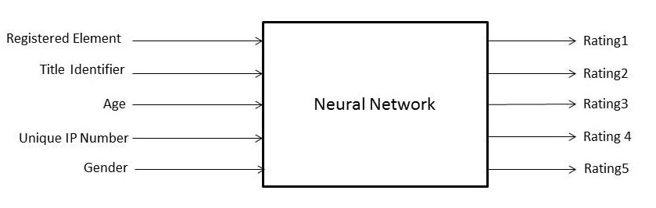
Fig 4.3 Neural Network input and output parameters

4.6 A Personalized Hybrid Book Recommender System Algorithm

The approach consists of following steps:
Initially we divide complete data set into two different set: Training Set for learning phase and Test Set for subsequent performance evaluation of the during testing phase e.g. considered data available form 10 user who at least rate two books, we divide data set as the Training Set (7/10) and the Testing Set (3/10).

// Training Phase include following Step
Step 1: Obtain Training input dataset
Step2: Obtain Training output dataset // rating of corresponding customers whose data previously retrieved
Step3: Perform data transformation // rating to corresponding value define in table 1.3 and map non numeric data to numeric
Step4: Load data for training phase
Step5: Initialize Neural Network parameters
Step6: Implement Backpropagation algorithm of MLP Neural Network // Train neural network
Step7: If ( Error < Threshold )
Go to step 8 // Testing Phase
Else repeat step 6 and 7
// Testing Phase include following step:
Step8: Obtain Testing input dataset
Step9: Obtain Expected ratings // corresponding to testing input dataset
Step10: Load data for testing phase
Step11: Implement Feed-Forward algorithm with updated weights (defined in section 3.2.3.b)
Step12: Obtain Predicted Rating // max_value_index (Rating1, Rating2, Rating3, Rating4, Rating5)
Repeat Step 11 and 12 for each testing sample
Step 13: Evaluate Mean Absolute Error // among predicted rating and expected rating

The block diagram of the proposed Personalized Hybrid Book Recommender System procedure is shown below:

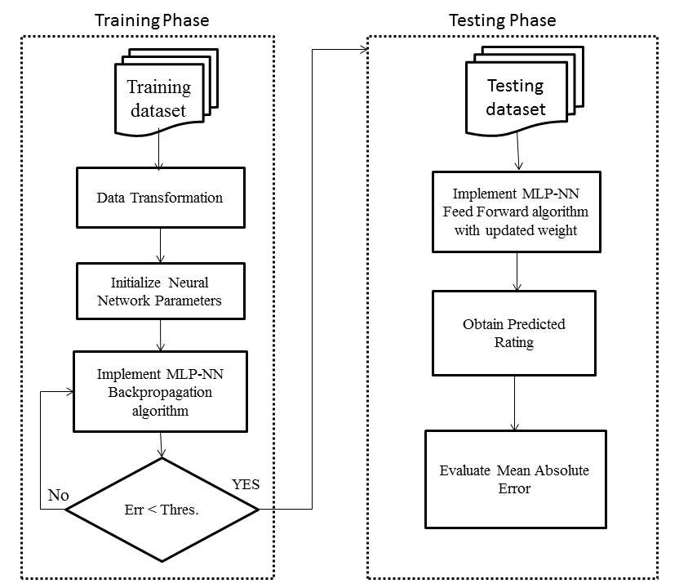

Fig 4.7 A Personalized Hybrid Book Recommender System Algorithm

5 Experiment Results

In order to select best MLP-Neural Network parameters for optimal results, we evaluated defined approach by differing parameter values (such as activation function and number of neurons at hidden layer) and estimated the results. The outstanding MLP- Neural Network is one which classified data and predict accurate rating of book. We considered index value of maximum output as rating, output value which is nearer to 1 and index values whose output nearer to 0 are rejected. Such neural network can be used for predict rating of books. Firstly, we trained MLP-Neural Network with training dataset for accurate prediction; training would stop when error threshold criteria meet. After training phase completion, we applied testing dataset to the Network for performance evaluation of the Network. As a result of testing phase, we attempt to determine optimal parameters for accurate prediction.

5.1 Expected Rating of testing dataset
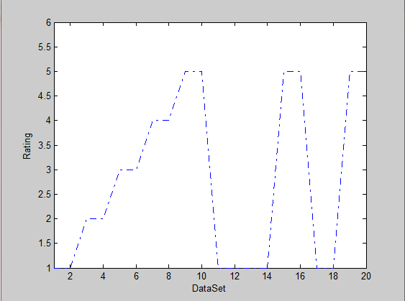
Fig 5.1 Expected rating of testing data

Figure 5.1 shows graph which represent expected rating of testing dataset. We considered 20 samples in testing dataset. Y-axis represent output rating of books and X-axis represent samples.

5.2 MLP-Neural Network performance with various activation functions

Case 1: Hidden Layer: Hyperbolic Tangent function
Output Layer: Sigmoid function
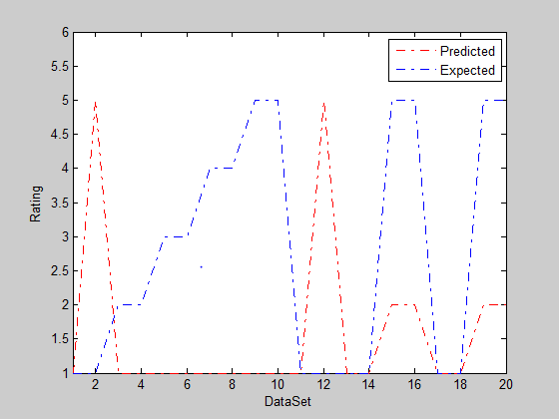
Fig 5.2 Predicted vs. Expected rating

Mean Absolute Error (MAE) on Expected rate and Predicted rate is: 2

Case 2: Hidden Layer: Sigmoid function
Output Layer: Hyperbolic Tangent function
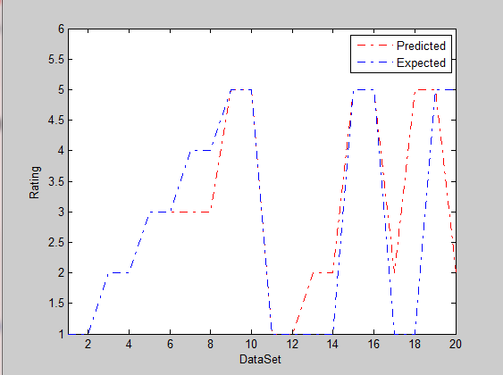
Fig 5.3 Predicted vs. Expected rating
Mean Absolute Error (MAE) on Expected rate and Predicted rate is : 0.600
Table 5 Summary of MLP Neural Network performance for various
Activation function
Serial No. | Activation Function |  | MAE on rating
Serial No. | Hidden Layer | Output Layer | MAE on rating
1 | Hyperbolic Tangent | Sigmoid | 2
2 | Sigmoid | Hyperbolic Tangent | 0.600

From table 5, results shown that activation function Sigmoid at Hidden Layer and Hyperbolic Tangent function at Output Layer delivers the optimal results. Whereas all other activation functions combination delivers nominal results. Therefore, in the subsequent experiment activation function Sigmoid at Hidden Layer and Hyperbolic Tangent at Output Layer were used.

5.3 MLP-Neural Network performance by varying numbers of neuron at hidden layer
As we know each neurons play significant role in classification and prediction in MLP-Neural Network. Performance of Network is highly influence by number of neuron present at hidden layer. In this section, we investigate performance of Network by considering different numbers of neuron at hidden layer. If we considered number of neuron to high then time complexity of Network increase significantly where as if we considered number of neuron quite low then Network unable to classify and predict. Therefore, we evaluate performance with in defined range of number of neurons

Case1: Number of neuron at hidden layer: 5
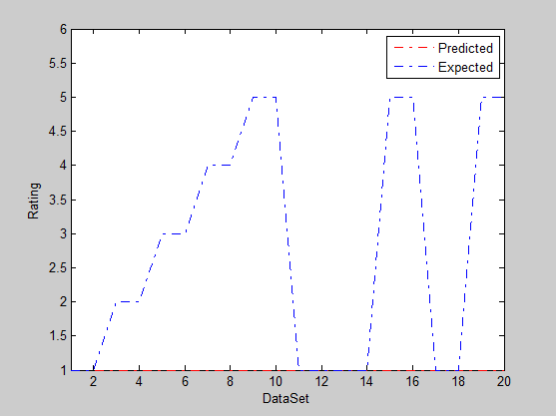
Fig 5.4 Predicted vs. Expected rating
Mean Absolute Error(MAE) on Expected rate and Predicted rate is : 1.8
Case2: Number of neuron at hidden layer: 15
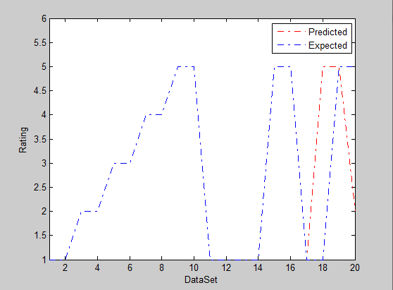
Fig 5.5 Predicted vs. Expected rating
Mean Absolute Error(MAE) on Expected rate and Predicted rate is : 0.34
Table 6 Summary of MLP Neural Network performance for different number of neurons at hidden layer
Number of neuron at Hidden Layer | MAE on rating
5 | 1.8
15 | 0.34

From table 6, result shown that when number of neurons at hidden layer is 15 then MLP-Neural Network provides optimal results. Therefore, 15 neurons can be used for optimum prediction and has a better chance to stabilize at the most optimal global solution.

IV. Conclusion
The current work has been focused on a personalized recommendation to a customer by using a book’s attributes as well as a customer’s attributes. The proposed approach efficiently rate books. For further usage of our approach, K-means can be applied on a customer attribute (e.g. age) as well as book attribute. We can cluster all existing customer according to the considered attribute. By analyzing clusters, we can easily determine from which cluster the current customer belong; whom we have to recommend books. By obtaining list of books belongs to the
associated cluster, whose attribute and the current user attribute can be used to provide personalized recommendation to the current user. However, this approach increase serendipity factor in recommendation process.

REFERENCES
[1] Stefano Ceri, Alessandro Bozzon, Marco Brambilla, Emanuele Della Valle, Piero Fraternali, Silvia Quarteroni, "Web Information Retriveal", Data-Centric Systems and Applications 2013, pp 39-56,Springer 2013
[2] Y. Jiang, A. Jia, Y. Feng, and D. Zhao, “Recommending academic papers via users’ reading purposes,” in Proceedings of the sixth ACM conference on Recommender systems, 2012, pp. 241–244
[3] D. Buttler, “A short survey of document structure similarity algorithms,” in Proceedings of the 5th International Conference on Internet Computing, 2004.
[4] Mohammand Hamidi Esfahani,Farid Khosh Alhan,"New Hybrid Recommendation system Based On c-means Clustering Method", in proceedings 5th conference on Information and Knowledge Technology,2013
[5] Jianying Mai,Yongjian Fan, Yanguang Shen," A Neural Networks-based Clustering Collaborative Filtering Algorithm on E-commerce Recommendation System", in Proceeding of the International Conference on web Information Systems and Mining, 2009
[6] C. Nascimento, A. H. Laender, A. S. da Silva, and M. A. Gonçalves, “A source independent framework for research paper recommendation,” in Proceedings of the 11th annual international ACM/IEEE joint conference on Digital libraries, 2011, pp. 297–306
[7] D. Goldberg, D. Nichols, B. M. Oki, and D. Terry, “[Using collaborative filtering to weave an information Tapestry],” Communications of the ACM, vol. 35, no. 12, pp. 61–70, 1992.

[8] D. A. Maltz, “Distributing information for collaborative filtering on Usenet net news,” in March 1997/vol. 40, no. 3 communications of the acm 1994, pp 2-10

[9] P.Melville and V.Sindhwani,"Recommender /systems", in Encyclopedia of Machine Learning, S. Verlag, ED.,ed Berlin:Springer, 2010, pp.1-9

[10] http://www- math.ucdenver .edu/~wcher owi /jcorner /isbn.html

[11] http://en.wikipedia.org/wiki/ISBN

