Modelling of Threat Evaluation for Dynamic Targets Using Bayesian Network Approach

Sushil Kumar , Vikash Yadav
Department of Computer Science & Engineering
Harcourt Butler Technological Institute, Kanpur, India

sushil0402k5@gmail.com, vikas.yadav.cs@gmail.com

Abstract –Threat evaluation is an uncertainty process to protect the assets against the various enemy targets such as aircrafts, missiles, helicopters etcetera. There is one critical thing in threat evaluation of targets is threat level or degree of threat which depends upon the enemy targets and their change in behaviors at instant, because each target has individual behavior. Analysis of individual behavior of the target is difficult task. So there are various parameters come into the picture which are extracted from multiple sensors are involved for evaluation of threat level of target to improve situational awareness and decision making. Threat level evaluation is complex task because of uncertainty involved in the process. In uncertainty case involved in threat evaluation process, Bayesian Network has great deal to overcome uncertainty in the model.
Keywords – Threat Evaluation, Intent Assessment, Capability Assessment, Bayes Theorem, Bayesian Inference, Bayesian Network, Conditional Probability Tables (CPTs), and Decision Support System.

Introduction
Threat evaluation can employ defensive as well offensive against possible enemy targets such as bomber, fighter, and transporter. But some of the countries who want to keep peace and protect their nation and places. All places are act as assets like air bases, tourist places, bridges, camps, nuclear power plants, command post, harbors, radars, monuments, parliament’s buildings, and etcetera. Threat value has an important factor to protect their nation against enemy nations.
Threat evaluation facilitates to make right decision and better situation awareness in war scenario. Commanders can build decision easily if they only one information. But it is not a real situation where gets only one information about targets. The decision making will be difficult task and also very critical with respect to available resources and time, when commanders get many number of information as evidences. In this situation, uncertainty in decision comes into the picture. Various factors are considered for a decision making augmented with human cognitive intelligence. An expert system built with the help of Bayesian Network (BN) can play an important role in decision making because it overcomes involved uncertainty in a model. Commanders obtain evidences of the enemy target time to time.
A main objective is to protect assets against enemy targets. Here an assumption is considered which is defending targets act as potential threats but targets may be friend or enemy which is decided by Identification, friend or foe (IFF) which is designed by command and control system. In this situation, prioritization of potential threats has an important factor according to threat level (Degree of threat) of detected enemy targets via multi-resources. Intelligent sensors provide the classification of target type at time to time as evidence. Threat value is a factor which decides level of dangerous threat through predicting the threat value of detected targets. Higher threat value will give higher level of dangerous and vice-versa. On the other hand, threat value is proportional to level of dangerous. Quantification of dangerous threat is difficult task when multi-sensors provide multi- information. Commanders are also facing problem to decide which target is more dangerous because of uncertainty involved in it. Threat will be very useful to decide engaging available weapon against enemy targets.
Threat evaluation is high level information fusion process in Joint Directors of Laboratories (JDL) as seen in Figure 1. For analyzing threat value, it is complicated to select which parameters and which algorithms are suitable for threat evaluation because building of mathematical formula by using selected parameters as inputs to give threat value as output is complex process. In this situation, Bayesian Network approach has great candidate to evaluate threat value.

Threat Evaluation
Threat is an expression of intension to inflict evil, injury, or damage [1]-[11]. Threat evaluation is a process based on defending targets to defended asset; consideration to protect one asset against several defending targets but in real war scenario, large numbers of assets involve and several targets come to destroy expensive and valuable assets. It is a high level information fusion technique that belongs to three level data fusion model in JDL as seen in Figure 1.
There is one famous model for information fusion is JDL Model. This model is conceptual model which describes the processes, functions and specific techniques are used for information fusion. Data fusion is the process of combining data or information to estimate or predict entity states [1].
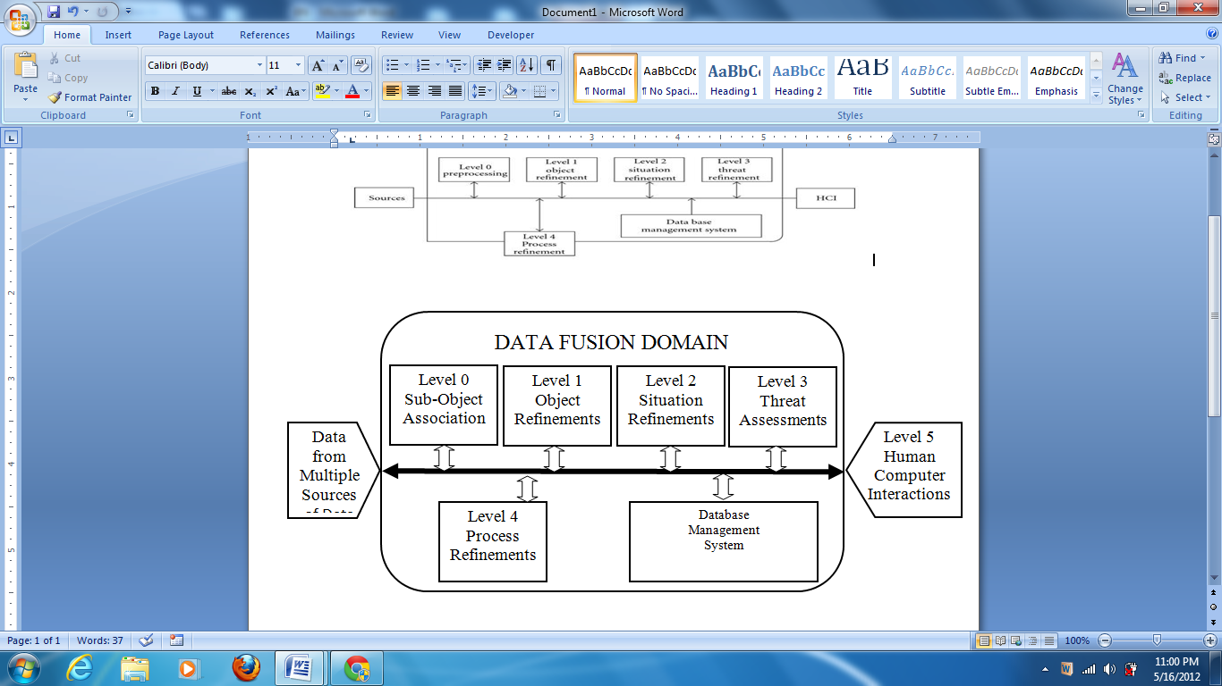
- The JDL Model
It describes how data from different multi-sources is transformed to information, this information used by decision makers. In our situation, data are extracted from different radar, sensors and databases. After estimation of information, further aggregation and improvement of information will be done and this information will help to build decision. The JDL model is divided into different levels,

Level 0: Sub-Object Data Assessment:
Estimation and prediction of signal/object observable states on the basis of pixel/signal level data association and characterization; at this level, data are accessing from deferent sensors as radar it may be localized or distributed. The main task of this level is to pre-process data by correcting biases and standardizing the input before the data is fused with other data.

Level 1: Object assessment/ refinement:
Estimation and prediction of entity states on the basis of observation-to-track association, continuous state estimation (e.g. kinematics) and discrete state estimation (e.g. Target type and ID).

Level 2: Situation Assessment:
Estimation and prediction of relations among entities, to include force structure and cross force relations, communications and perceptual influences, physical context, etc.

Level 3: Impact Assessment:
Estimation and prediction of effects on situations of planned or estimated/predicted actions by the participants; to include interactions between action plans of multiple players (e.g. assessing susceptibilities and vulnerabilities to estimated/predicted threat actions given one’s own planned actions)

Level 4: Process Refinement (an element of Resource Management):
Adaptive data acquisition and processing to support mission objectives.
Decision maker might shorten the time for observation, deciding acting activities and position one step of enemy. The OODA loop (for observe, orient, decide, and act) is a concept originally applied to the combat operations process, often at the strategic level in military operations. It is now also often applied to understand commercial operations and learning processes.

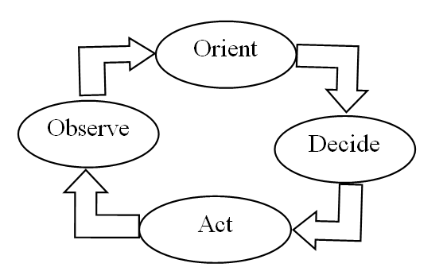
- Situational Awareness OODA LOOP

When the enemy aircraft comes into radar contact, more direct information about the speed, size, and maneuverability, of the enemy plane becomes available; unfolding circumstances take priority over radio chatter.
To determine which of several threats that represent the highest danger is of great importance, since errors such as prioritizing a lesser threat as a greater threat can result in engaging the wrong target, which often will have severe consequences [11]. Threat evaluation helps in case of weapon assignment, and intelligence sensor support system. It is very important factor to analyze the behavior of enemy tactics as well as our surveillance. Vigorous situation will come when we evaluate wrong threat value.

Threat Evaluation Model
The threat evaluation model with ‘m’ number of defended assets and ‘n’ number of defending targets is proposed in Figure 3. The model consists of:
- DA(i) = i^{th} available defended asset to protect.
- DT(j) = j^{th} attacking defending target detected.
- DA×DT= pair of available defended assets and defending targets (DA(i),DT(j)).
- Th(i,j)=threat value from of i^{th} available defended asset from j^{th} attacking target.
- Tv(j)=Overall Target value for defended target DT(j).
DA = {DA₁, DA₂, …, DA_{m}}=Set of ‘m’ defending assets to be protected. DT = {DT₁, DT₂, …, DT_{n}}=Set of ‘n’ defending targets detected from radars or sensors. Threat value Th(i,j) : (DA × DT)→[0 1] which lies between 0 to 1. Overall target value for defended asset is
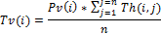
Where Pv(i)’s represent the protection value of assets lies between 0 and 1 (Pv(i)[0 1]) which is assigned by the decision maker. The protection value of an asset is the weight-value associated with the significance associated with the asset.
Threat value lies in between 0 and 1. Higher threat value indicates more severe danger threat. Threat Value helps in the decision making involved in the process of engaging the target. The overall threat values generate the knowledge which improves the situational awareness for the region of interest, which could be a city, a state, a nation or a continent.
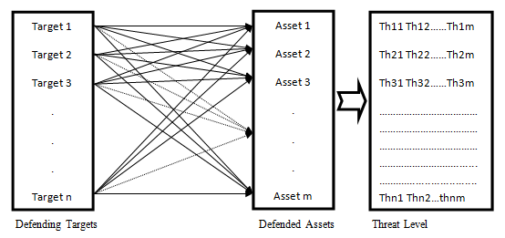
- Asset- target pairs

A. Parameters for Threat Evaluation
The variety of parameters are proposed and used by researchers for threat evaluation [1]-[11]. These parameters have varying degree of effect on the threat value. Some parameters for calculating threat value are dependent on other parameters. A number of parameters [6] are discussed with their descriptions in Annexure 1.
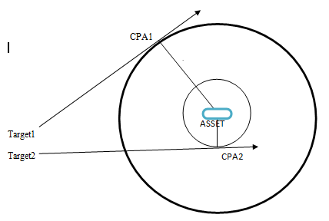
- CPA information
Closest Point of Approach (CPA) is point where the distance between asset and the direction of velocity of target will be the shortest one as seen in Figure 4, in which two targets (Target1 and Target2) are moving in different direction at particular instant with different CPA values CPA1 and CPA2.

Bayesian Network
A Bayesian Network (BN) is used to model a domain containing uncertainty in some manner. This uncertainty can be due to imperfect understanding of the domain, incomplete knowledge of the state of the domain at the time where a given task is to be performed, randomness in the mechanisms governing the behavior of the domain, or a combination of these.
The network (or graph) of a BN is a Directed Acyclic Graph (DAG), i.e., there is no directed path starting and ending at the same node. A node represents either a discrete random variable with a finite number of states or a continuous (Gaussian distributed) random variable. Throughout this document, the terms "variable" and "node" are used interchangeably. The links between the nodes represent (causal) relationships between the nodes.
If a node does not have any parents (i.e. no links pointing towards it), the node will contain a marginal probability table. If the node is discrete, it contains a probability distribution over the states of the variable that it represents. If the node is continuous, it contains a Gaussian density function (given through mean and variance parameters) for the random variable it represents.
If a node do have parents (i.e., one or more links pointing towards it), the node contains a conditional probability table (CPT). If the node is discrete, each cell in the CPT (or, in more general terms, the conditional probability function (CPF)) of a node contains a conditional probability for the node being in a specific state given a specific configuration of the states of its parents. Thus, the number of cells in a CPT for a discrete node equals the product of the number of possible states for the node and the product of the number of possible states for the parent nodes. If the node is continuous, the CPT contains a mean and a variance parameter for each configuration of the states of its discrete parents (one if there are no discrete parents) and a regression coefficient for each continuous parent for each configuration of the states of the discrete parents.
Let G =(V,E) be a Directed Acyclic Graph (or DAG), and let X = (X_{v}), v ∈ V be a set of random variables indexed by V.

Factorization definition
X is a Bayesian network with respect to G if its joint probability density function (with respect to a product measure) can be written as a product of the individual density functions, conditional on their parent variables:
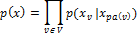
where pa(v) is the set of parents of v (i.e. those vertices pointing directly to v via a single edge).
For any set of random variables, the probability of any member of a joint distribution can be calculated from conditional probabilities using the chain rule (given a topological ordering of X) as follows:

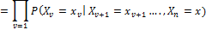
Compare this with the definition above, which can be written as:
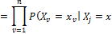
for each X_{j} which is a parent of X_{v} )
The difference between the two expressions is the conditional independence of the variables from any of their non-descendents, given the values of their parent variables.

Conditional Independence
An important concept for Bayesian networks is conditional independence. Two sets of variables, A and B, are said to be (conditionally) independent given a third set C of variables if when the values of the variables C are known, knowledge about the values of the variables B provides no further information about the values of the variables A:

Conditional independence can be directly read from the graph as follows: Let A, B, and C be disjoint sets of variables, then identify the smallest sub-graph that contains A B C and their ancestors, add undirected edges between nodes having a common child, drop directions on all directed edges.
Now, if every path from a variable in A to a variable in B contains a variable in C, then A is conditionally independent of B given C.

Inference
Meaning of inference in a Bayesian Network is to computing the conditional probability for some variables given information (evidence) on other variables.
This is easy when all available evidence is on variables that are ancestors of the variable(s) of interest. But when evidence is available on a descendant of the variable(s) of interest, we have to perform inference opposite the direction of the edges. To this end, we employ Bayes' Theorem:

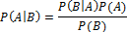

Implementation
There are different kinds of algorithms and models for threat evaluation can be tested and analyzed. We have developed a threat evaluation model based on a Bayesian Network. A reason for selecting out with a Bayesian network approach is its abilities to handle uncertainty, which most often is a central aspect in a battle field environment.
A Bayesian network characterizes a problem domain consisting of a set of random variables U = {X₁, ...,X_{n}}. These variables are in the Bayesian network represented as a set of corresponding nodes (vertices) V in an acyclic directed graph G = (V,E), where the set of edges E(VxV) specifies (conditional) independence and dependence relations that hold between variables within the domain.
Given the graph structure G, a joint probability distribution P over U can be calculated from a set of local probability distributions associated with each node1 X_{i}, using the chain rule of Bayesian networks.
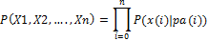
where the set of local probability distributions consists of the distributions in the product of conditional probabilities (with pa_{i} we refer to an assignment of values to the parent set PA_{i} of node X_{i}).
The joint probability distribution can be seen as a function assigning a number in the range [0, 1] to each possible combination of states of variables describing the domain. The strength of Bayesian networks is their ability to represent joint probability distributions in a compact manner, due to their encoding of conditional independences between different variables in the domain.
The structure of the actual Bayesian network looks like in Figure 5. The random variable (node) of main interest here is the query variable Threat, i.e., we want to calculate the posterior probability of Threat being in state true given some evidence on our information variables. This posterior probability P(Threat = true|z) is our assessed threat value of the pair (DT_{i},DA_{j}), for which the set of observations, z, holds. DT_{i} stands for defended targets, and DA_{i} stands for defending assets.
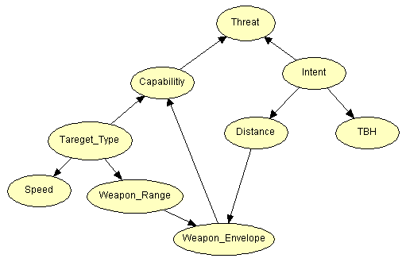
- Bayesian Network Model of Threat Evaluation
The threat variable is directly dependent upon the mediating variables Intent and Capability, which is consistent with the view that threat is a combination of capability and intent as seen in figure 5. Capability is in its turn dependent upon Target type and whether the defended asset is within the target's weapon envelope or not (Weapon Envelope). The target's intent is according to the structure the cause of the Euclidean distance between the target and the defended asset (Distance), as well as of the Time Before Hit (TBH) (e.g. total time from target to CPA, and CPA to asset).

Simulation and Results
After the structure of the Bayesian network as seen in Figure 5 has been decided and requires specifying local probability distributions. These are given in the form of Conditional Probability Tables (CPTs). To fill a CPT with appropriate numbers is often the hardest task when designing a Bayesian Network manually. The task often becomes harder as a node's number of parents and possible states grows. The numbers used for the CPTs in this paper have not been assessed by domain experts and can most probably be improved on. However, the main focus here is on the approach rather than on specific numbers in the CPTs. Moreover, the threat value ordering is of higher importance than the threat values. Searching for a way to prioritize the engagement of friendly weapon systems is to the detected targets. Initially system does not have any evidences of detected target but get evidences at time to time such as target type, weapon range and weapon envelope.
In the case of no evidence at all, Bayesian network outputs the prior probability P(Threat = true) = 0.3472 as seen in Figure 6, which thereby also becomes the threat value.

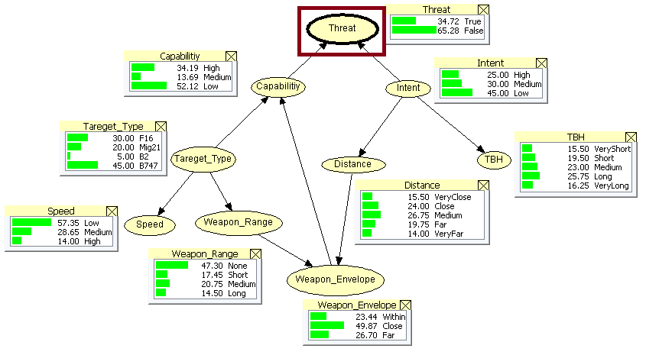
- Bayesian Network with Monitor Windows of Threat EvaluationP(threat=true)=0.3472 at without any evidences
For a high threat case with a B-2 bomber within range of its weapon systems, at very close distance and with very short time before hit, the threat value becomes 0.8429 as seen in Figure 7.
Similarly, for a low threat value with a Boeing 747 at very far distance with very long time before hit, the threat value becomes 0.0446 as seen in Figure 8.
Similarly threat value with a unknown target at high speed, close distance, and short TBH, the threat value becomes 65.93 as seen in Figure 9.
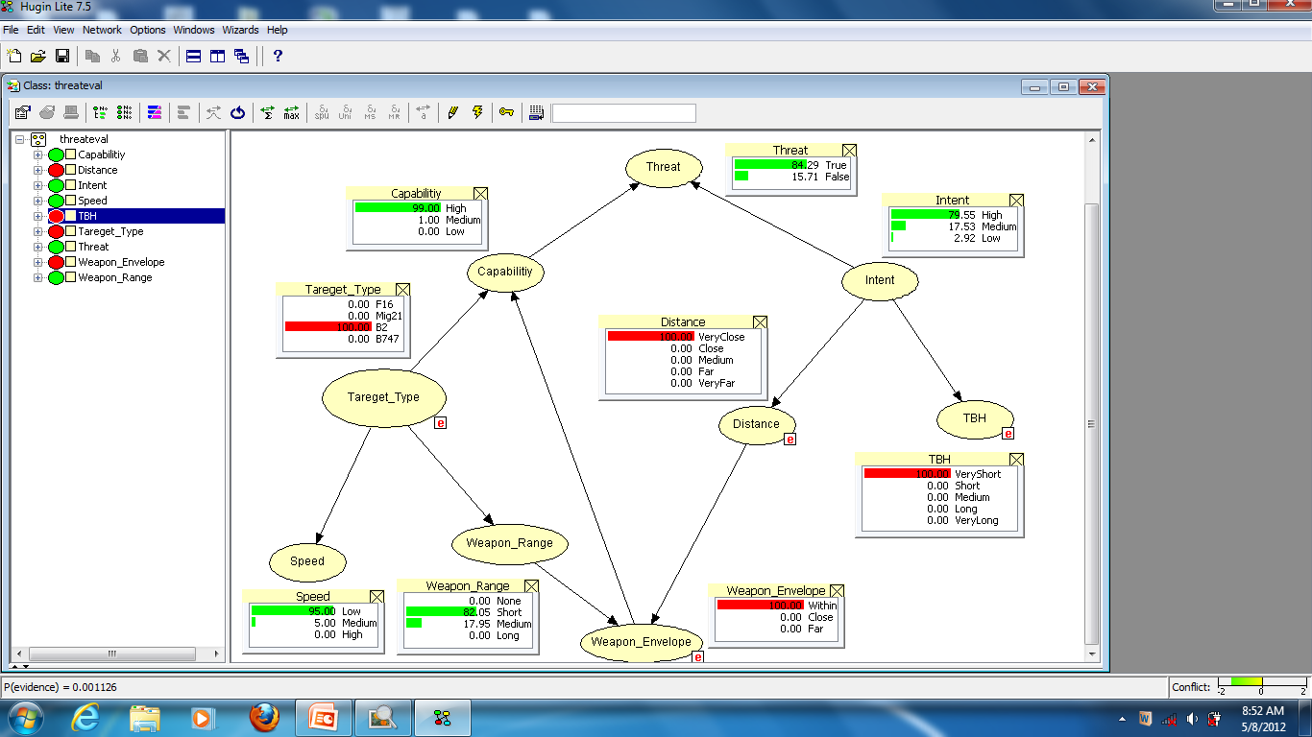

- P(threat=true)=0.8429 at B2 target Type, within weapon envelope, very close distance, and very short TBH as given evidences
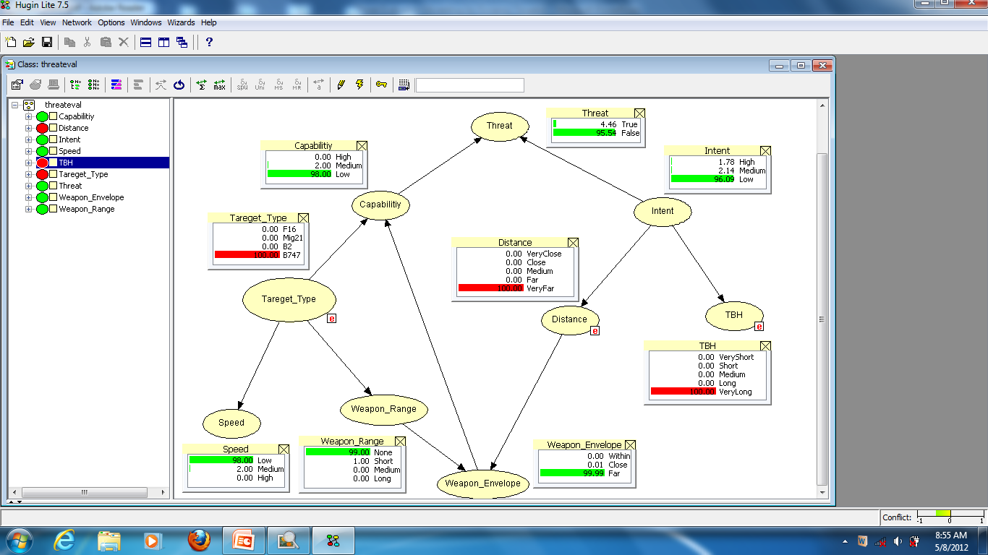

- P(threat=true)=0.0446 at B747 target Type, very far distance, and very long TBH as given evidences
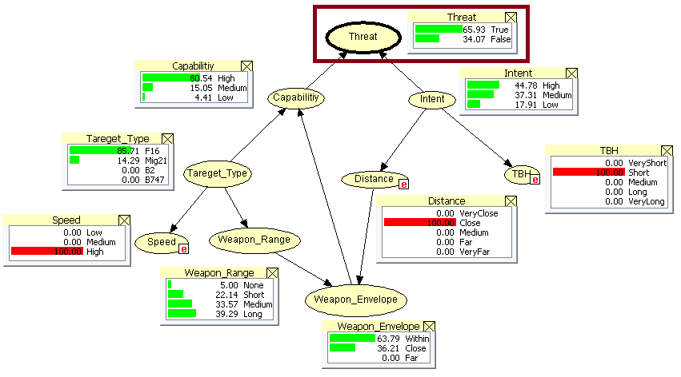
- Bayesian Network with Monitor Windows of Threat Evaluation for Dynamic Targets with Speed, Distance, and TBH as evidences, P(threat=true)=65.93

Conclusions and Future Work
For threat evaluation in Bayesian Network, various parameters have considered to build the Bayesian model. A target to a defended asset clearly is related to both capability and intent parameters. The range of a target's weapon systems and the distance between the target and the defended asset are interrelated, since a target is more threatening to a defended asset if the defended asset is within the range of its weapon systems, than if it is outside it. The number of nodes, and thereby the complexity of the Bayesian network, have been limited in order to make it easier to analyze and validate the proposed model.
The implemented threat evaluation system can apply to an air defense scenario. This system can enable in radar, aircraft, etc. An analysis of the system's threat value calculations shows that the proposed Bayesian Network model works well for dynamically moving targets.

As future work, introduce more nodes as evidence parameters such as use of countermeasures and fire control radar, and whether the air target is classified as friend, foe, or neutral etc should be added to the Bayesian Network to get more accurate threat value.

References
- Johansson, F., “Evaluating the performance of TEWA System,” Orebro University, 2010
- Johansson, F., Falkman, G., ” A Bayesian network approach to threat evaluation with application to an air defense scenario,” In: Proceedings of the 11th International Conference on Information Fusion, 2008
- Lampinen, T., Ropponen, J., Tommi Laitinen, T., ”Joint Threat Assessment with Asset Profiling and Entity Bayes Net,” In: Proceeding of the 12th International Conference on Information Fusion, Seattle, WA, USA, July 6-9
- Liang, Y., “ A fuzzy knowledge based system in situation and threat assessment’, Journal of Systems Science & Information, 4, 791–802, 2006
- Liebhaber, M., Feher,B., “ Air threat assessment: Research, model, and display guidelines,” in Proceedings of the 2002 Command and Control Research and Technology Symposium
- Liang Y., “An approximate reasoning model for situation and threat assessment,” in Proceedings of the 4th International Conference on Fuzzy Systems and Knowledge Discovery
- Nguyen X., “Threat assessment in tactical airborne environments, in Proceedings of the Fifth International Conference on Information Fusion, 2002
- Paradis, S., Benaskeur, A., Oxenham, M., Cutler, P., “Threat evaluation and weapons allocation in network-centric warfare. In: Proceedings of the 8th International Conference on Information Fusion , 2005
- Ross, T.J., “Fuzzy Logic with Engineering Applications,” Second Edition, John Wiley and Sons, 628
- Roux, J.N., Van Vuuren J.H., “Threat evaluation and weapon assignment decision support: A review of the state of the art, ORiON, vol. 23, pp. 151–186, 2007
- Roy, J., Paradis, S., Allouche, M., “Threat evaluation for impact assessment in situation analysis systems. In: Kadar, I. (ed.) Proceedings of SPIE: Signal Processing, Sensor Fusion, and Target Recognition XI, vol. 4729, pp. 329–341, 2002

Annexure 1
Attribute | Description
Air lane | A published or otherwise known commercial air route.
Altitude | Approximate feet above ground or an indication of change (e.g., climbing).
Coordinated activity | Track is communicating with, or nearby, another track.
Course Heading | Exact compass heading or indication of heading relative to own ship (i.e., opening or closing).
CPA  (Figure 4) | Closest Point of Approach Estimated distance that track will pass by own ship if the track and own ship remain on their current courses.
ESM/Radar | Electronic Support - Electronic emissions from the track (typically indicates the type of radar system the track is using).
Feet Wet/Dry | A Feet Dry track is flying over land. A Feet Wet track is flying over water.
IFF Mode | Identify Friend or Foe. Signals from a track that indicate if it is a friendly, or perhaps neutral, aircraft.
Maneuvers | Indicates the number of recent maneuvers, or if the track is following the ship.
Number/ Composition | Number of aircraft in the formation.
Origin/ Location | Indicates the country from which the track most likely originated.
Own Support | Availability of nearby friendly ships or patrol aircraft (CAP).
Range/ Distance | The track’s distance from own ship.
Speed | Approximate airspeed or an indication of change (e.g., increasing).
Visibility | Approximate number of miles, or an indication of atmospheric conditions (e.g., haze).
Weapon envelope | The track’s position with respect to its estimated weapons envelope.
Wings Clean/Dirty | A track without weapons is designated Wings Clean. A track with weapons is designated Wings Dirty.

