 | RUPA POLYMERS  Shop No.7,Rameshwar Apt,,  Murar Road, Mulund West,  Mumbai-400080  Phone : 022-25650461,  Cell:+91-9820006166  Email:info@rupapolymers.com
PRODUCT, PRICE & PACKING LIST 0F PLASTIC CAPS
SL | PRODUCT | IMAGE | PRICE | PACKING (in Pcs.)
1 | 19mm Short Flip  top Cap  Cosmetics | 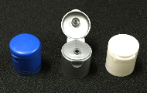 | Rs.0.85 | 4500
2 | 19mm Long Flip  Top cap  Cosmetics  top | 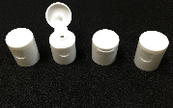 | Rs.0.85 | 4500
3 | 25mm Pilfer Proof  Cap  Pharmaceutical  28 | 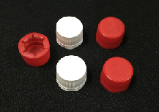 | Rs.0.46 | 5000
4 | 25mm 2 Pc cap  Pharmaceutical  28 | 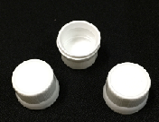 | Rs.0.80 | 5000
5 | 25mm Short Flip  Top cap  Cosmetics | 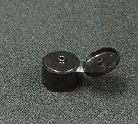 | Rs.0.85 | 12500
6 | 27mm 3 Start  Alaska Cap  Mineral Water  28 | 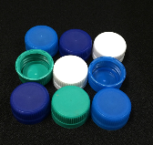 | Rs.0.28 | 7000
7 | 28mm EPE Wad  Pharmaceutical | 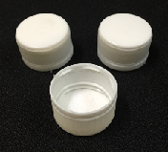 | Rs.0.54 | 3000
8 | 28mm 1881  Cap  Hot Fill Juices  28 | 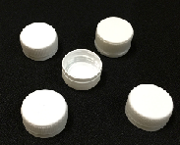 | Rs.0.46 | 4500
9 | 28mm PCO Cap  Hot Fill Juices  28 | 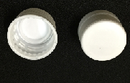 | Rs.0.67 | 5300
10 | 28mm 2 Pc Cap  Pharmaceutical  28 | 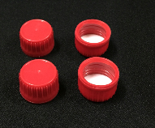 | Rs.0.88 | 5000
11 | 28mm Flip  Top cap  Cosmetics  cap | 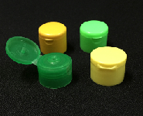 | Rs.1.10 | 3500
12 | 38mm Pilfer  Proof cap  Hot Fill Juices/  Edible Oil/  Lubricant Oil  38 | 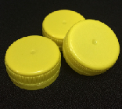 | Rs.0.73 | 3000
13 | 46mm Fridge  Bottle Cap  Household  4628 | 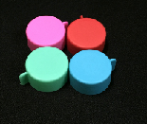 | Rs.1.35 | 3000
14 | 46mm Plain Cap  Chemical/  Pesticides  28 | 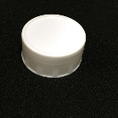 | Rs.1.35 | 2000
15 | 46mm Inner Plug  Chemical/  Pesticides  28 | 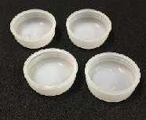 | Rs.1 | 2000
16 | 46mm Pilfer  Proof cap  Edible Oil | 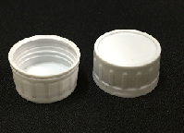 | Rs.1.40 | 2000
17 | 46mm Double  Handle  Edible Oil |  | Rs.1.90 | 2000
18 | 43mm Spout Cap  Edible Oil | 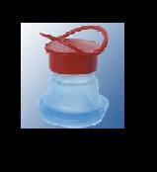 | Rs.3.05 | 1500
19 | 20 Ltr Bubble  Top Cap  Mineral Water | 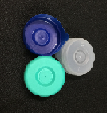 | Rs.0.65 | 8000
20 | 60mm Sipper Cap  Household  28 | 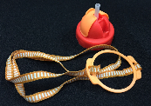 | Rs.10 | 1000
21 | Jug Handle  Household  28 | 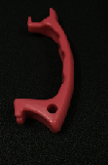 | Rs.2 | 10000
22 | Single Piece CTC  Cap  Edible Oil | 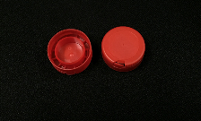 | Rs.0.39 | 9500
23 | Two Piece CTC  Cap  Edible Oil | 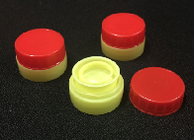 | Rs.0.73 | 6500
24 | Body Lotion pump  19mm,24mm &  28mm  Cosmetics/FMCG  28 | 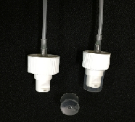 | Rs.5.40 | 2000

25 | Soap Dispenser  19mm,24mm &  28mm  Cosmetics/FMCG  28 | 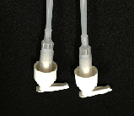 | Rs.5.40 | 2000
26 | Thumb Spray  19mm,24mm &  28mm  Cosmetics/FMCG  28 | 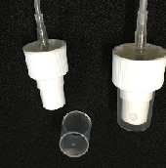 | Rs.4.40 | 3000

