QoS OPTIMIZATION BY MITIGATING STARVATION IN WLAN

Aarti Gautam Dinker¹, Arti singh², Ambar Yadav³

1. School of Information and Technology, Gautam Buddha University, Greater Noida, India
2. School of Information and Technology, Gautam Buddha University, Greater Noida, India
3. Department of Electronics and Communication, HBTI, Kanpur, India
artisingh_2428@yahoo.co.in

Abstract: The new multimedia applications (ftp, videoconferencing, VoIP, etc.) require high throughput and reduced delays. Currently, many schedulers have been introduced such as First In First Out (FIFO), Priority Queue (PQ), Weighted Fair Queue (WFQ), Deficit Round Robin (DRR), and Deficit Weighted Round Robin (DWRR). Unfortunately, the current scheduling techniques have some drawbacks on real-time applications and therefore will not be able to handle the packets in a proper way.
In this paper various existing queuing algorithms are explained like First in First out (FIFO), Priority Queue (PQ), Fair Queue (FQ), Weighted Fair Queue (WFQ) and Class based WFQ (CBWFQ). Then a comparative analysis of three queuing mechanisms FIFO, PQ and PQDWRR is performed. PQDWRR technique has a superior quality than the other queuing mechanism.

Keywords: DWRR, PQ, WLAN, PQDWRR, QoS

- INTRODUCTION

IEEE 802.11 wireless LAN (WLAN) is one of the most deployed wireless technologies all over the world and is likely to play a major role in next-generation wireless communication networks. The main characteristics of the 802.11 WLAN technologies are simplicity, flexibility and cost effectiveness. However, the low efficiency of its medium access control (MAC) and physical (PHY) layer protocols restricts its applications to support high data rate multimedia services [1].
Current WLAN systems endure difficulties with the increasing expectations of end users and with volatile bandwidth and delay-boundary demands from new higher data rate services, such as high-definition television (HDTV), video teleconferencing, multimedia streaming, voice over IP (VoIP), file transfer, and online gaming [2]. Thus, multimedia applications have experienced an explosive growth. There is a huge demand for integrating voice and data into same network. Voice is judged as real-
time application on an IP network. Special treatment or priority is given to achieve high quality voice. In order to maintain a required performance for such applications, Internet network systems have been facilitating Quality-of-Service (QoS) to enable the network systems to prioritize traffic according to the application’s service types. However, multimedia applications require some quality of
service (QoS) support as guaranteed bandwidth,delay,jitter

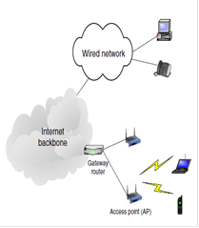

Fig.1. Architecture of WLAN supporting voice and data services [13]

and error rate.Normally, QoS issues in wired LAN are neglected since the physical layer bandwidth of wired LAN is high enough (1Gbps is now a common link speed between switches in enterprise LANs while 10Gbps 802.3ae Ethernet will appear soon). However, wireless LAN has some distinct features from wired LAN: high bit error rate, high delay and low bandwidth. The characteristics of the wireless channel make high data rate very difficult to achieve. IEEE 802.11 WLAN is originally designed for best-effort services. The error rate at physical layer is more than three orders of magnitude larger than that of wired LAN.
Moreover, high collision rate and frequent retransmissions cause unpredictable delays and jitters, which degrade the quality of real-time voice and video transmission. Enhanced QoS-aware coordination can reduce overhead, prioritize frames, and prevent collisions to minimize delay and jitter in mobile environment. Typically, time-bounded services such as Voice over IP, or audio/video conferencing require specified bandwidth, delay and jitter, but can tolerate some losses.
Each router in the network must implement some queuing discipline that governs how packets are buffered while waiting to be transmitted [3]. In networks, packets can be handled first come first serve basis, but in certain circumstances such as speed mismatches, when the packet is entering the device congestion occurs. The devices have to buffer for allowing the higher priority packets to exit sooner than lower priority ones, which is called as queuing. Queuing algorithm are activated, when congestion is triggered and deactivated when congestion clears available queuing techniques are covered in the following sections.
Since WLAN endpoints share a common transmission medium, voice applications must compete with data applications for access and bandwidth. The biggest problems in a network are related to the allocation of network resources, as buffers and link band width, to different users [4]. As such, voice quality and capacity can be significantly affected by the simultaneous transmission of data traffic in these networks. So it is also critical to understand the effects of data transmissions on voice performance and capacity [VoIP]. Most of the existing bandwidth allocation models do not consider variable utilization of queues or bandwidth redistribution of unassigned link capacity.
PQ currently uses static configuration and thus does not automatically adapt to changing network requirements. PQ introduces a fairness problem in that, packets classified to lower priority queues might not get serviced in a timely manner or at all, depending upon the bandwidth used by packets sent from the higher-priority output queues. For this reason we proposed our iterative mathematical model for bandwidth allocation of PQDWRR [5].
The first section of the paper describes the QoS parameters which are responsible for a network performance. The second section presents the various QSD algorithms FIFO, PQ, FQ and DWRR along with their Bandwidth constraint models. The third section describes the drawback of PQ model. In the fourth section the proposed model for average bandwidth allocation of the PQDWRR algorithm is described followed by their comparative analysis proving the proposed model.

- BACKGROUND

A. Quality of Service
QoS is commonly defined as the service users’ degree of satisfaction [2]. In a multimedia context, QoS is no less measure of success. It represents the guarantee of successfully delivering packets, without delaying or dropping any, therefore the guarantee of providing high quality experience for end-users.
The fundamental parameters for defining QoS, are:
- latency – the delay that may occur in a packet delivery,
- jitter – the delay in delivering a packet may vary,
- bandwidth – the number of bits/second being successfully delivered, and
- packet loss – the occurrence of dropping a packet.
These parameters are independent of the nature of the packet. However, there is a direct and high impact of the four parameters on voice quality, video streaming, data traffic etc.
For instance, packet loss is argued to be “the dominant factor that affects perceptual multimedia quality” [6]. Jitter is not far less important than packet loss when it comes to video applications [7]. In consequence, there have been derived constraints and requirements which regard the impact such parameters expose on multimedia traffic. In literature, there is plenty of evidence on recommended requirements in terms of the four fundamental factors.

B. Queuing Techniques
Queuing algorithms take effect when congestion is experienced. If the link is not congested, then there is no need to queue packets. In the absence of congestion, all packets are delivered directly to the interface [8]. One way network elements handle an overflow of arriving traffic is to use a queuing algorithm to sort the traffic, and then determine some method of prioritizing it onto an output link.
The various queuing mechanism can include:
a) First-In First-Out (FIFO) Queuing
b) Priority Queuing (PQ)
c) WRR Queuing
d) DWRR Queuing

a) FIFO Queuing
The default form of queuing on nearly all interfaces is First-In First-Out (FIFO). This form of queuing requires no configuration, and simply processes and forwards packets in the order that they arrive. If the queue becomes saturated, new packets will be dropped (tail drop) [9].This form of queuing may be insufficient for real-time applications, especially during times of congestion. FIFO will never discriminate or give preference to higher-priority packets. Thus, applications such as VoIP can be starved out during periods of congestion.
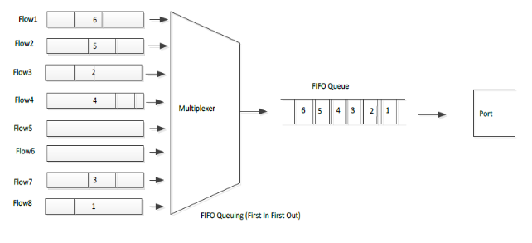
Fig. 2 FIFO Queuing [19]

b) Priority Queuing (PQ)
Priority Queue (PQ) is the basis for various queuing mechanisms. In this packets are classified into different priority queues as High queue, Medium queue, Normal queue (the default queue) and Low queue [10]. Scheduling prefers packets in the same order. Each class uses one FIFO queue, where packets are dropped if a queue is full. In Strict priority queue, first packets in High queue are scanned if there exist packets in high queue then these packets are scheduled first otherwise move to next queue and scan the medium and so on.
While in rate controlled Priority queue, higher priority packets are scheduled before lower priority one if the amount of traffic is below the user-configured threshold. Employs four separate queues:
• High
• Medium
• Normal (default)
• Low
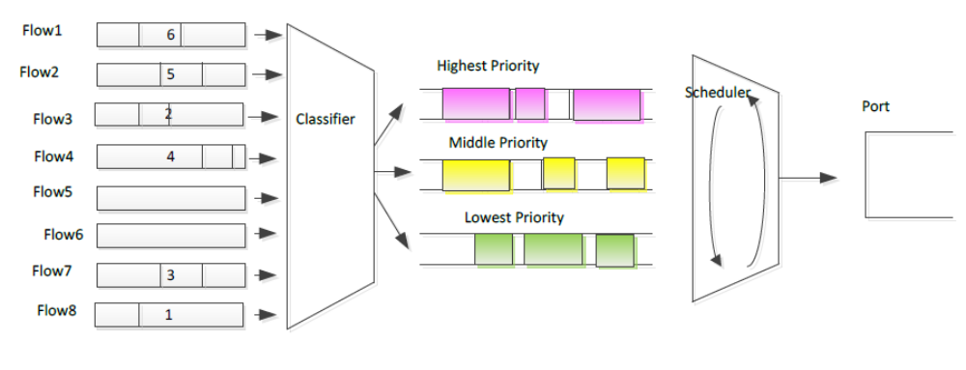
Fig. 3. Priority Queuing [19]

c) WRR Queuing
Weighted Round Robin Queuing was designed to address the limitations of FQ and PQ models (Jon and Bennett, 1996).
•WRR supports flows with significantly different bandwidth requirements. Each queue can be assigned a different percentage of the output port's bandwidth.
•WRR addresses the limitations of the strict PQ model by ensuring that lower priority queues are given access to the output bandwidth. At least one packet is removed from each queue during the service round.
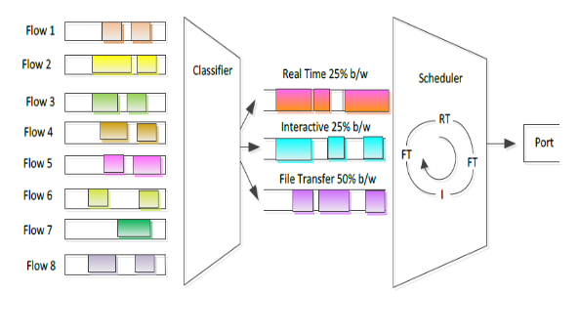
Fig. 4. WRR Queuing [19]

d) DWRR Queuing
Deficit weighted round robin (DWRR) queuing allows a network administrator to group traffic into classes. A “class” is an entity the network administrator defines to receive distinct treatment in the queue. A class can be as refined as a single flow, perhaps only for the VoIP conversations of the CEO, or a broad group of flows, such as all UDP traffic or even all IP traffic. In other words, where WFQ classifies traffic per session, DWRR uses administrator-defined traffic classes, which are less granular but more application-specific.
Each class is given its own queue. Like weighted round robin (WRR) each queue is serviced proportionately to its weighting. However, the weighting operates at the byte or bit level. In fact, each queue can be considered to have a token bucket associated with it. The token accumulation is related to the percentage allocated to that queue. When the queue is visited by the scheduler, packets are transmitted from the queue as long as there are sufficient tokens in the bucket. If the next packet in the queue exceeds the remaining tokens in the bucket, the scheduler moves on to the next queue.
Consider the case of a 100 Mbps transmission facility, and three queues that have been allocated 50 percent, 30 percent, and 20 percent. We will call these the high (yellow), medium (red) and low (blue) queues, respectively. This means the yellow queue is accumulating tokens at 50 Mbps, the red queue at 30 Mbps, and the blue queue at 20 Mbps [11]. There is also usually a defined maximum queue depth that is likewise proportionate. In our example, these limits are 50 kilobits, 30 kilobits, and 20 kilobits, respectively.
Let's assume the network is idle and the queues have all filled their buckets. Suddenly a flood of packets arrives impacting all queues. The scheduler visits the yellow queue, where the packets are all 1200 bits long. Packets are sent from this queue (over 40 of them) until the number of tokens in the bucket drops below 1200, at which point there are not enough tokens for the next packet, so the scheduler moves on to the red queue. Here the packets are all 6000 bits long. After the third packet, there are not enough tokens left to transmit the fourth, so the scheduler moves on. In the final queue the packets are around 10,000 bits long. After two of these the token bucket is exhausted, so the scheduler returns to the yellow queue. While the other two queues were being serviced, this queue was accumulating tokens, so transmission can begin again.
When one of the queues becomes empty, it is removed from the algorithm and the token rates for the other buckets are adjusted proportionately, ensuring that all of the bandwidth of the facility is fully utilized. If only one queue has traffic, it easily gets all of the bandwidth.
DWRR manages all elements of queuing in one technology that is (relatively) easy to use, yet powerful enough to answer granular QoS needs. While it can do this, DWRR does suffer from one drawback. Since it employs a weighted fair queue, some very delay-sensitive traffic, like voice, can still be subject to jitter as each of the variable queues are serviced.
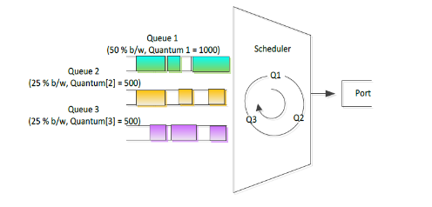
Fig.5. DWRR Queuing [19]

III. RELATED WORK

In WLAN, QoS is an important factor which effects the network performance. Throughput is one of the important parameter of QoS which can be provided efficiently by scheduling algorithms. Rajesh, et. al., [12] suggested queue scheduling algorithms to be a very efficient, high throughput scheme for scheduling in networking where data, voice and video is integrated. There are many scheduling algorithms present today, each of them having its own advantage and limitations. A comparative analysis was made by Salil Bhalla, et.al., [13] between FIFO and PQ scheduling mechanisms. In this it was found that FIFO packets dropped as the queue was filled whereas in PQ a preference was given to higher priority queue in which queue having highest Type Of Service got more delay.
Catalina, et. al., [14] identified more appropriate queuing technique under different traffic circumstances. For mission-critical traffic, traversing various WAN links PQ provides priority treatment. But PQ used static configuration and thus cannot automatically adapt to changing network requirements. Moreover, PQ introduced a fairness problem due to which packets classified to lower priority queues might not get serviced in a timely manner or at all, depending upon the bandwidth used by packets sent from the higher-priority output queues. Radhika [17] made a comparative analysis between Deficit Round Robin (DRR) scheduling scheme and original Dual Queue (DQ) i.e. strict priority queue scheduling scheme with respect to the set of QoS parameters. It was seen that the value of the throughput of real time data using DRR scheme is higher than the throughput of real time data using DQ scheme.
Zahirul and Mirza, [16] performed a comparative analysis of basic and hybrid queuing methods and saw their impact on the VoIP traffic delay within the network. Hybrid queuing method was formed by combining priority queuing (PQ), custom queuing (CQ) and weighted fair queuing (WFQ) with class-based weighted fair queuing (CBWFQ). PQ-CBWFQ hybrid method gave best results among the various queuing methods.
Tomas and Martin, [4] proposed a model having a combination of PQ and DRR queues. This model provided low delay, packet loss and jitter for high priority queues by supplying them strict priority. If the high priority class does not exceed the available output capacity other classes were serviced as classical WRR.

IV. PROPOSED WORK

In priority queue scheduling algorithm packets are dequeued from the head of a lower priority queue only if all queues with higher priority are empty [4]. This may lead lower priority queues to suffer bandwidth starvation. In order to avoid this problem a combination of PQ and DRR has been implemented. In this model if the higher priority queue packets are not occupying the whole link capacity, the lower priority queue packets are also send along with them, but using WRR mechanism. Thus lower priority queue packets will also get some bandwidth and have not to wait till all packets of higher priority packets are dequeued.
But in this approach also there is a drawback. If a packet of lower priority queue is having more length as compared to other packets and that much link capacity is not available for it to transmit, the lower length packets will be transmitted by using WRR mechanism. The packet having more length will have to wait. But if at some instance more link capacity is available, then the lower priority queue should not be scheduled by WRR mechanism. It should be scheduled according to the DWRR mechanism so that the packet having larger length gets the link first at that instance as it was deficit from a long time. Thus bandwidth can be provided more efficiently to the packets along with a reduction in delay .

V. COMPARATIVE ANALYSIS OF QUEUING
TECHNIQUES

S.No | Queuing  Algorithm | Description | Advantages | Limitations | Applications
1 | FIFO | -no. of queues= 1  -based on first come first  served  -packet by packet  dispatching  -tail drop mechanism used  -enabled when bandwidth is more than 2 Mbps  -high processing speed | -simple and fast  -no need to configure  -low computational  load  -predictable in nature  -no reordering  -supported on all  platforms | -unfair bandwidth  allocation  -causes starvation  -causes jitter  -do not allow  routers to  organize buffer  packets | gives benefits to  UDP flows over  TCP flows and  gives acceptable  results for FTP
2 | PQ | -no. of queues= 4  -high priority packets are  serviced first  -packet by packet  dispatching  - tail drop mechanism used  -designed for low  bandwidth links  -low processing speed | -low delay to high priority packets  -low computational  load  - allow routers to  organize buffer  packets | - unfair  bandwidth  allocation  -starvation of  lower priority  packets  -need to be  configured  -low processing  speed | Used in real time  applications as  VoIP
3 | PQDWRR | serviced upto threshold level  -designed to avoid bandwidth starvation | high and low priority are serviced in rate controlled way. | -need to be configured  -causes jitter | Work best in real time application (video conferencing)

REFERENCES

VI. CONCLUSION AND FUTURE SCOPE
After surveying the various existing queuing mechanisms and comparatively analyzing the queuing mechanisms FIFO, PQ and PQDWRR we conclude that PQDWRR perform the best among above mentioned mechanisms in most of the applications. FIFO is simple and fast queuing mechanism in which there is no need of reordering and Starvation problem. So PQDWRR gives good performance in Optimizing network performance. These queuing mechanisms are applied in the network layer. In future, we will concentrate our work in the application layer which will further decrease the delay and hence optimize the network performance.

- Qiang Ni, Lamia Romdhani, Thierry Turletti,” A Survey of QoS Enhancements for IEEE 802.11 Wireless LAN”, Qiang Ni, et al. Journal of Wireless Communications and Mobile Computing, Wiley. 2004, Volume 4, Issue 5: pp.547-566.
- Dionysios Skordoulis , Qiang Ni,Hsiao-Hwa Chen,Adrian P. Stephens, Hangwen Liu and Abbas Jamalipour, “IEEE 802.11n MAC frame aggregation mechanisms for next-generation high-throughput WLANS”, IEEE Wireless Communications, February 2008.
- Mohammad Mirza Golam Rashed and Mamun Kabir, “A comparative study of different queuing techniques in VoIP, video conferencing and file transfer”, Daffodil International University Journal of Science and Technology, Volume 5, Issue 1, January 2010.
- Tomas Balogh and Martin Medvecky, “Average Delay and Queue Length Model for WRRPQ”, WSEAS Transactions on Communications, Volume 13, 2014.
- S. Shah, W. Ali, I. Ahmad, S. Jabbar, A. Minhas, “Performance analysis of queuing mechanism in voice applications”, Proceedings of World Congress on Engineering, pp 3-5, July 2013.
- Raghavendra Ganiga, Balachandra Muniyal, Pradeep, “Characteristic Analysis of VoIP Traffic for Wireless Networks in Comparison with CBR using QualNet Network Simulator”, International Journal of Computer Applications,Volume 50, No.11, July 2012.
- Sutanu Ghosh, “Comparative study of various VoIP applications in 802.11a wireless network scenario,” International Journal of Mobile Network Communications & Telematics(IJMNCT), Vol. 3, No.5, October 2013.
- M. Rashed and M. Kabir, “A comparative study of Queuing Techniques in VoIP, Video conferencing and File Transfer”, Daffodil International University Journal of Science and Technology, Vol. 5, Issue 1, January 2010.
- Khyati Marwah and Dr. Gurpal Singh, “VoIP over WMN: Effect of packet aggregation”, International Journal on Computer Science and Engineering (IJCSE), Vol. 3, No. 6, June 2011.
- Shubhangi Rastogi, Samir Srivastava, “Comparative analysis of different queing mechanisms in heterogenous networks”, International Journal of Advanced Research in Computer and Communication Engineering Vol. 2, Issue 8, August 2013
- Deficit weighted round robin queuing [ONLINE] Available at “http://www.hill2dot0.com/wiki/index.php?title=Deficit_weighted_round_robin
- Kitti Wongthavarawat and Aura Ganz, “Packet Scheduling for QoS support in IEEE 802.16 broadband wireless access systems”, International journal of communication systems ,Int. J. Commun. Syst., 2003.
- Ping Wang, Hai Jiang and Weihua Zhuang, “Capacity Improvement and Analysis for Voice/Data Traffic over WLANs”, IEEE Transactions on Wireless Communications, Vol. 6, No. 4, April 2007.
- Rajesh Kochher and Vinay Chopra, “Scheduling Algorithm and IP Queue Types In WLAN”, International Journal for Science and Emerging Technologies with Latest Trends, Vol. 1, No. 1, pp 24-30, 2012.
- Salil Bhalla, Kulwinder Singh Monga and Rahul Malhotra, “ Optimization of Computer Networks”, International Journal of Engineering Research and Applications (IJERA), Vol. 2, Issue 3, pp.2276-2281, May- Jun 2012.
- Catalina Mancas and Mihai Mocanu, “QoS Optimization in Congested Multimedia Networks”, IEEE, 2013.
- Radhika J. Dhanal, “Queue-Based Traffic Regulation on Wireless 802.11 Networks”, International Journal of Innovative research in Computer and Communication Engineering, Vol 1, Issue 4, June 2013.
- Md. Zahirul Islam and Md. Mirza Golam Rashed, “A Comparative analysis on traditional Queuing and Hybrid Queuing Mechanism of VoIP’s QoS Properties”, International Journal Of Advance Innovations, Thoughts & Ideas,
- KILKKI, K. 2002. Differentiated services for the Internet. Interpretation, 1, 00-99

