Load Balancing in Peer-to-Peer System: Inter-Clustering Method

Rupali Bhardwajª
ª AP, Computer Science and Engineering Department, Thapar University
Patiala, India
rupali.bhardwaj@thapar.edu

ABSTRACT

One of the challenges of Peer-to-Peer system is to perform load balancing efficiently; several solutions are suggested to solve this problem but they have some restrictions. In earlier, nodes are classified as heavy, light or normal loaded node in load balancing algorithm through threshold value, which is fixed and predetermined. Now, today’s requirement is to change classification of nodes through a dynamic process. So that, a dynamic technique based on fuzzy inter-clustering is presented in this paper. To minimize communication overhead ,nodes are divided into 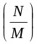 subgroups formed with M subsets per subgroup. Now subgroups structured into quorum groups of size k₁ = 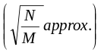 in a scheme like to that used in Maekawa’s algorithm.

Keywords: heavy weighted, light weighted, fuzzy system, clustering, load balancing

1. Introduction
Load balancing is a critical issue in Peer-to-Peer system because of irregular system structure and unpredictable load on system. Load balancing using fuzzy logic is a dynamic process and it enhances performance of algorithm without depending on threshold values. A coterie under U (U is the collection set of all the nodes in the peer-to-peer system) consists of a set of quorums in which each quorum is a subset of U, and the intersection of any pair of quorums is nonempty; it is called the intersection property. The other property of quorums is minimality that no quorum contains another quorum. With these two properties; a coterie can be used to solve the load balancing problem in peer-to-peer system with minimum communication overhead and less response time.
The following paper contents are as follows: Section 2 feature literature review. Section 3 presents partitioning algorithm in brief. Section 4 includes proposed load balancing algorithm. Section 5 presents evaluation study of proposed algorithm. Section 6 includes conclusion and future scope of proposed algorithm.
2. Literature Review
In this paper [1], dynamic load balancing algorithm based on fuzzy logic is presented. Load balancing in distributed computing systems through fuzzy functions and work out uncertainty difficulty in state information and in task selection is presented in this paper [2]. Clustering is a tool for data analysis, its purposes is to allocate cases (people, objects, events etc.) into clusters, so that the degree of association is to be strong between objects of the same cluster [3]. Numerical technique for fuzzy clustering is shown in this paper [4].Load balancing in distributed systems through fuzzy grouping technique is presented in this paper[5].Some fuzzy methods for grouping clustering numerical data is presented in these papers [6,7,8]. This paper [9] improves performance of network through load balancing which is based upon fuzzy logic technique. Fuzzy logic is a mathematical model in presenting linguistic information and use to solve problems that have imprecise information [10]. This paper [11] presents convergence theorem for fuzzy ISODATA.

3. A Partitioning Method
Each node is connecting to all other nodes in a network is called full mesh topology where 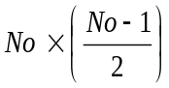 is required number of communication links , where overall number of nodes in the network is No. In partitioning algorithm[12] a network topology for minimization of network traffic and number of communication links is presented that is distinctive in terms of node connection. After scheming of topology, different methods to calculate the communication sets are presented: (1) n −1 is a prime digit (2) n −1 is not a prime digit, through this method communication between two nodes is independent of network size by traversing at most two nodes by separating the nodes into subgroups of magnitude M where M ≥ 1, which are then arrange into cluster of quorums of magnitude k1 = 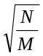approx. in an approach like to that applied in Maekawa’s algorithm [13] apart from that now designing of cluster of quorums are through subgroups instead of nodes.
4.Proposed Algorithm: Fuzzy Inter-Clustering
4.1 Fuzzy c-Means Clustering Load Balancing (FCMCLB)
According to dynamic cluster node, assume group of dynamic cluster heads in a hierarchical approach. For designing of dynamic clusters, following things are required-
- Similarity - Similarity is required for routing through the data space and designing the clusters [14].
Partitioning - Partitioning is based on an optimal value of 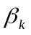, which is given by Krishnampuram and Keller [15] -
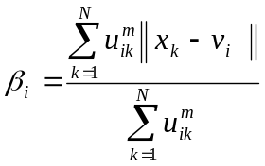 (1) Distance - Formally the dissimilarity 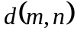, fulfilling following conditions [15]-
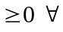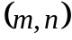 (2)
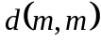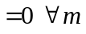 (3)
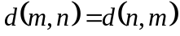 (4) For distance metric, triangular inequality must be satisfied-
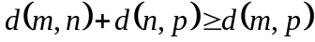 (5) Canberra distance function between two sample m and n is
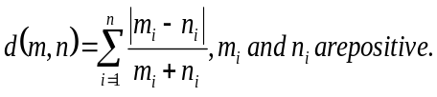(6)
Through this, clusters are designed as dynamic hierarchical clusters and classified as very light, light, heavy and very heavy clusters.
4.2 Complete-Link Technique
This technique is based on the distance between two farthest away patterns belongs to different clusters .
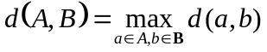 (7)
Lance-Williams recurrence method, show distance between clusters X, Y and cluster Z, as given below-.
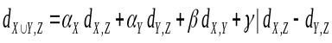 (8)
where 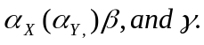 have adaptable values. In complete link technique, these values are ½, 0 and ½. Partition matrix,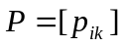, i =1,2,...,c, k=1,2,....,N, which is required for clustering the patterns. Partition matrix, P has binary values and pattern k belongs to cluster c when 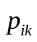=1. The same pattern is discarded from the cluster when 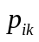=0. Partition matrices satisfy constraint, given below-
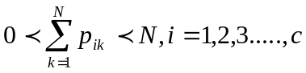 (9)
Partition matrices are a attractive structure for representation of patterns. For instance, the matrix designed for a pattern S₁= {1 2 3 4 5 6 7 8 9} spilt into c=4 clusters is given in equation 10.
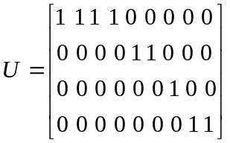 (10)
4.3 Inter-Partition Load Balancing Algorithm
Peer-to-Peer system is partitioned into clusters using partitioning algorithm described in section 3; such that the intersection between any two clusters is not null. The partitioning is done in a manner such that one intersecting element, which we call set representative, connect different clusters. The inter-partition load balancing(fig.1) is executed by common set representative; after that intra-partition load balancing using complete link method is executed. Consider following subsets-
S₁ = {1, 2, 3, 4, 5, 6}
S₂ = {2, 7, 12, 17, 22, 27}
S₄ = {4, 8, 15, 17, 24, 28}
2 2
13 4 5 6 7 12 17 22 27

17
4 8 15 24 28
Fig. 1: Inter-Partition Load Balancing
Step1. Each cluster consist one of k (k-1) + 1 communication sets.
Step 2.Calculate following terms-
  - weight of term in node 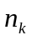is calculated through formula given by Salton [16]-
=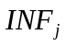 ( 11)
where = 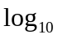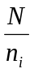 (12)
where N represents total number of peer nodes , represents inverse peer node frequency of term, 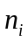 represents number of peer nodes which includes term and 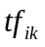represents frequency of term occurring in node.
- Calculate degree of peer node, 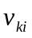of term with respect to peer node based on inverse peer node frequency factor 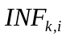of term, where [0, 1].
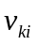 = 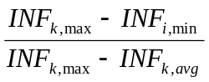 (13)
- Compute the ‘relative time to live’ of every term in node, where
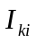 = 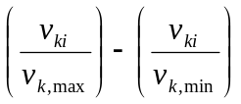 (14) where [0, 1]
Step 3.Apply the complete link formula on communication set for partitioning nodes.
Step 4.find partition matrix P.
Step5. Set representative for each cluster, transfer the work load among different clusters using following rules-
Assuming sender initiated load balancing algorithm, proposed knowledge base is as follows-
Rule 1: If (load_cluster is very_light) then (status_cluster is reciever).
Rule 2: If (load_cluster is light) then (status_cluster is receiver).
Rule 3: If (load_cluster is moderate) then (status_cluster is normal).
Rule 4: If (load_cluster is heavy) then (status_cluster is sender).
Rule 5: If (load_cluster is very_heavy) then (status_cluster is sender).
After that intra-partition load balancing using complete link method is exexuted.
Step6.Maximum bandwidth constraint should not be violated by 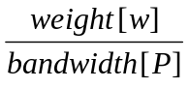 and scheduling time t.
Step 6.break
Step 7.end for
Step 8.end for
5. Experimental Study
5.1. Performance Evaluation
Fig. 2 captures the tradeoff between numbers of nodes and total execution time.
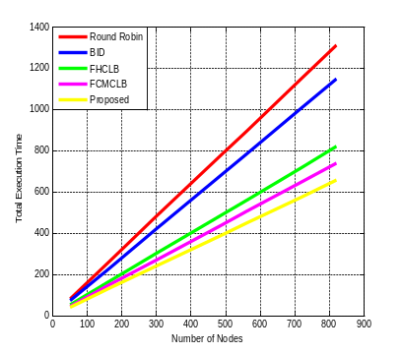
Fig. 2: Total execution time vs. number of nodes
5.2. Performance Evaluation of Sender vs. Receiver Node
Using fuzzy clustering, compare performance of sender node with receiver node(fig.3).
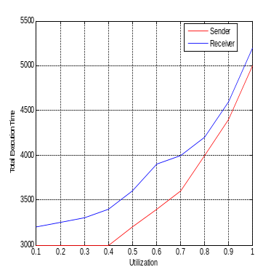
Fig. 3: Total execution time vs. utilization
4.3. Effect of Node Failure
In case of node failure, node transmission through fuzzy clustering is more reliable as compare to non fuzzy system; shown in fig. 4.
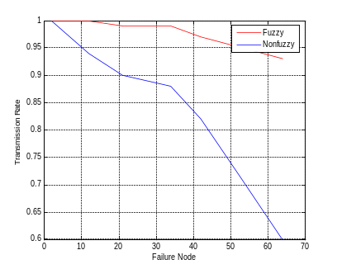
Fig. 4: Transmission rate vs. failure node

6. Conclusion
A new technique, to work out problem of dynamic load balancing in P2P system using fuzzy inter-clustering is presented. Whole peer-to-peer system is partitioned into number of subsets equal to number of nodes. After partitioning; fuzzy inter-clustering load balancing is executed. Proposed algorithm can be enhanced through probabilistic clustering.
References

[1] A..Karimi, F.Zarafshan, A.b.Jantan, A.Ramil, M.Iqbal b. Saripan,”A New Fuzzy Approach for Dynamic Load Balancing algorithm”, International Journal of Computer Science and Information Security, Vol.6, No.1, 2009.
[2] Ally E. EI-Bad, ”Load Balancing in Distributed Computing Systems Using Fuzzy Expert Systems”, TCSET’2002, Lviv-Slavsko, Ukraine
[3] Clark F. Olson,” Parallel algorithms for hierarchical clustering”, Technical report, University of California at Berkeley, December 28, 1996
[4] E.Ruspini,” Numerical Methods for Fuzzy Clustering” Information Sciences,Vol.2, pp.319-350, 1970.
[5] Hyo Cheol Ahn,Hee Young Youn,Kyu Yeong Jeon, Kyu Seol Lee,”Dynamic Load Balancing for Large-scale Distributed System with Intelligent
Fuzzy Controller”, , 2007 IEEE.
[6] J.C.Bezdek,”A Convergence Theorem for the Fuzzy ISODATA Clustering Algorithms”,IEEE Transcations on Pattern Analysis and Machine Intelligence,Vol.2,No.1,pp. 1-8,1980.
[7] J.C.Bezdek,”Pattern Recognition with Fuzzy Objective Function Algorithms,”Plenum,NY,USA,1981.
[8]J.C.Bezdek,R.J.Hathawy,M.J.Sabin,W.T.Tucker,”Convergence Theory for Fuzzy C-Means:Counterexamples and Repairs”, IEEE
Transcations on Systems, Man Cybernetics,Vol.17 ,No.5,pp 873-877,1987.
[9] M.C.Huang, S.H.Hosseini, K.Vairavan,”A Receiver Initiated Load Balancing Method In Computer Networks Using Fuzzy Logic Control”, GLOBECOM 2003.
[10]Timothy J. Ross,” Fuzzy Logic with Engineering Applications”, McGraw Hill, 1995.
[11] Y.J. Horng, S.M.Chen and C.H.Lee, ”Fuzzy Information Retrieval Using Fuzzy Hierarchical Clustering and Fuzzy Inference Techniques”, Proceedings of the 13th International Conference on Information management, Taipei, Taiwan, Republic of China,Vol.1,pp. 215-222,2002
[12] Rupali Bhardwaj,V.S.Dixit, Anil Upadhyay,“A 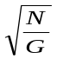 Method for Generating Communication Sets”, Computer Science Journal of Moldova, V.19, N3 (57), pp 288-303.
[13] M. Maekawa.,” A 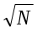 Algorithm for Mutual Exclusion in Decentralized Systems”, ACM Transactions on Computer Systems, 3(2):145–159, May 1985.
[14] Witold Pedrycz ,”Knowledge-Based Clustering”, ISBN 0-471-46966-1 ,Copyright 2005 John Wiley & Sons, Inc.
[15 R. Krishnapuram, J. Keller, “The Possibilistic C-Means Algorithm: insights and recommen-dations”, IEEE Trans. on Fuzzy Systems, 4, 1996, 385–393.
[16]G.Salton, ”The Smart Retrieval System-Experiments in Automatic Document Processing”, Prentice Hall, Englewood Cliffs,NJ,USA,1971.

