THRESHOLDING TECHNIQUES COMPARSION

ON

GRAYSCALE IMAGE SEGMENTATION

Vinay Kumar^{#1} Prof.(Dr.) C.Ram.Singla^{#2}
¹ St.Peter’s University, Research Scholar (P.hD)ECE, Cheenai, INDIA vinay_nassa@rediffmail.com²
Dronacharya College of Engg (Gurgaon)ECE, Gurgaon, INDIA

ABSTRACT
Image processing in general is to extract the primitive objects in a scene. A step in image processing where the knowledge obtained about objects is used to interpretate high level objects is termed as scene analysis. No unique segmentation technique exists for image processing. Instead various methods and techniques are used for image segmentation. Output of segmentation varies with various parameters like method used, heuristic rules, parameter values and technique used .Here in the paper a common 512 * 512 pixel image is considered for various analyses. Threshold techniques including like histogram thresholding, mean thresholding, edge thresholding, variable thresholding and percentile (P%-tile) exists. Algorithms are applied using MATLAB coding on the considered image. White Pixel Ratio (WPR) parameter is used for analysis of various methods. Similar to the theoretical concept, practical approach shows that WPR is better for histogram thresholding as compared to other techniques.

Keywords- : Segmentation, Image Processing, Edge, Histogram pixel, P- tile and WPR.

Introduction
One of the most important step towards image analysis is segmentation which involves identifying homogeneous regions in the image having same properties / features.
Segmentation is hard as well as difficult because:

- Homogeneity can be defined in terms of visual attributes as well as semantic boundaries.
- Due to diversity of attributes, problem formulation is difficult.
Segmentation in general can be defined as partitioning the image pixels into classes depending upon pixel intensities as for foreground and background.
In short by Image segmentation a given image boundary or region R is divided into a set of component regions Ri.

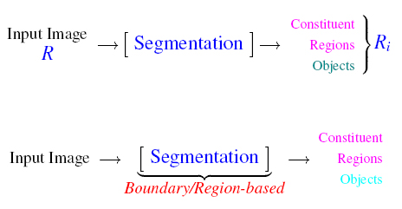
Fig 1: Segmentation Method
Segmentation is the process of partitioning a digital image into multiple segments (sets of pixels, also known as super pixels [1].

There are two broadly classification of segmentation techniques viz:
- Discontinuously based: based on detecting edge points and linking them to form region boundaries.
- Similarity based: here the pixels which have similar visual attributes like intensity color and texture are grouped together.

All such techniques involve formulating some homogeneity criteria.
It is found that correct segmentation must have following features:
- Should be able to extract the details required for output.
- Difficult and hard problem
- Environment specific setting for image acquisition and processing need to be used.
- Techniques are application specific.

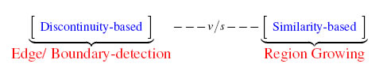
Fig 2: Segmentation Comparison Method

- ORGANISATION OF PAPER
The paper is organized into various sections. Here the 3rd section discusses the basic concepts of Image thresholding 4th selection of thresholding following 5th section as various thresholding techniques introduction. The results obtained by MATLAB CODE are explained in the 6th section following conclusion. Simplest way of segmentation is threshold base classification of image pixels in predefined classes is observed.

- IMAGE THRESHOLDING

Simplest way of image thresholding is to segment an image into various regions based upon intensity and comparison of each pixel with a suitable threshold value.
Pixel is assigned to one of the class labels based upon comparison. Depending upon threshold value chosen, threshold methods vary as Global techniques, Adaptive (Local techniques) and variable thresholding (Split, merge and grow) technique. Homogeneity and geometrical proximity are the basic features involved in all techniques.
Depending upon threshold value above techniques segments the pixels.

In Global thresholding threshold value is applied equally to all pixels in the image. Images having bimodal histogram having distinct valley separating modes are suitable for Global threshold based segmentation.

In Adaptive thresholding the threshold value is taken as intensity of neighbour pixel for the next pixel comparison.

Variable thresholding involves each pixel have its own different threshold value for comparison .

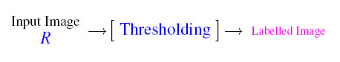
Fig 3: Image Thresholding

Threshold technique can be expressed as:
T=T[x, y, p(x, y), f(x, y]-----------1
where T is the threshold value.
p (x, y) ,f (x, y) are points the gray level image pixels.
Final labeling result . (SINGLE THRESHOLD T)
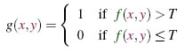
--------------------2
Final labeling result (TWO THRESHOLD T1,T2)
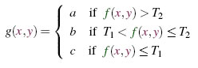
--------------------3

- THRESHOLD SELECTION
The most important in thresholding process is to find or decide the threshold value (or values). Several methods to choose a threshold value exists. Success of thresholding depends upon width and depth of valleys separating the histogram peaks.
Valleys in the image are dependent on several factors like variances and illumination gradient in the image. Large variances indicate that there is no pronounced valleys in the histogram. Similarly absence of illumination gradient results in no pronounced valleys in histogram.
There are various ways to select the threshold values. one such is user can manually choose a value or a thresholding algorithm can compute a value automatically, which is known as automatic thresholding [1] .
Another way is to choose the mean and median values, which means that if objects pixels are brighter than the background, they should be also brighter than average. This method is best suitable for wireless images with uniform background. However this will generally not the case always.
Another sophisticated approach might be to prepare a histogram of the image pixel intensities and use valley points as the threshold and employ the valley techniques.
However this method employs large computational effort and expensive.
However in some cases image histogram may not have clearly defined valley points.
In short, it is difficult often to select the accurate threshold value.
- VARIOUS THRESHOLDING TECHNIQUES
Based upon the selection of threshold values, various image thresholding techniques are classified as :
5.1Percentile (P-tile) Thresholding
It is one of the earliest method which is based upon grey level histogram. It is generally termed as automatic threshold method which uses the knowledge about area size of the desired object. In this if the prior knowledge about the object and image is known then the first P% of area below the histogram is considered as threshold.
This fixed percentage of picture area is known as P%. The threshold is defined as the grey level.
  - Mean Thresholding
As the name implies this method make use of mean value of the pixels as the threshold value. This method is employed strictly in cases where images have half of the pixels that belong to object and other half to the background. This technique case rarely happens [1].
The algorithm is explained as –
- Choose an initial value of threshold to classify the pixels to belong any of two groups depending upon that the pixel’s intensity is greater or less than threshold.
- Mean value is computed for each of the group and update the value which is average of mean values of intensity for the two groups.
- Using the updated value of threshold again classify the pixels.
- Repeat the process till the value of the threshold stabilizes between successive iterations.

Features of mean thresholding :
- The output of the method depends upon the initial threshold.
- Method is simple but time consuming.
- Means are to be computed at every iteration (Time complexity increases with size of the images)
5.3 Histogram Thresholding(HDT)
The disadvantage of mean thresholding (Iterative) is the increase in time complexity by increasing the number of iterations in large sized images.
This can be overcome by estimating the threshold value that seperates the two homogenous region of the objects and background of an image. This is known as histogram technique.
This requires that, the image formation be of two homogenous separated regions and there exists a threshold value that seperates two segments [0]. The HDT is suitable when all regions of objects and background are homogenous except the area between objects and background.
We compute as the fraction of pixels in the image which have the intensity level i

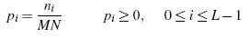
------------------ 4

for given L intensity levels, MN is the number of pixels. For a normalized histogram we have 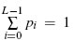
5.4 Edge Thresholding
Some times in the images for ground object of interest is so small that have negligible effect in the histogram due to domination by background intensities. Then use of histogram technique in this case, is difficult to separate both background and foreground regions.
Since the Computed threshold will simplify divide the background region itself into two classes and it is edge to extract the edge pixels in the image by applying suitable edge conditions.
Edge pixels generally belong to the boundary region of the foreground regions. Here similar to histogram techniques Computation is done only to the pixels near to edge pixels. Since in this technique boundary of a region or object that is closed is detected, here no. of objects of interest is equal to the number of boundaries in an image [4].

  - Variable Thresholding
In variable thresholding separate threshold value is assigned for each pixel to classify (into one of the given classes) for different set of pixels.
Here the images are divided into patches and each patch is given a separate threshold depending upon path contents. Generally the threshold value is taken to be weighted sum of mean intensity value of a path and global threshold value. Here better results are obtained in case illuminated and reflectance varies across image.
Pixel classification in variable thresholding can be adopted by defining some predicate function Ɵ which may be a function of local parameters (and may be thresholds).

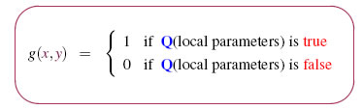
---------------------5

- EXPERMENTAL RESULTS AND DISCUSSION
The whole image is divided into patches of same size. An image of 512 ×512 is divided into eight equal patches. Binarisation of each patch is done by using any of thresholding method using MATLAB .
The ratio of the foreground image pixels to the background image pixels is known as White Pixel Ratio. This parameter is selected for comparison since each color image can be represented in binary form as Gray Scale Image. The method with high WPR is a good thresholding method.

- Tank Image

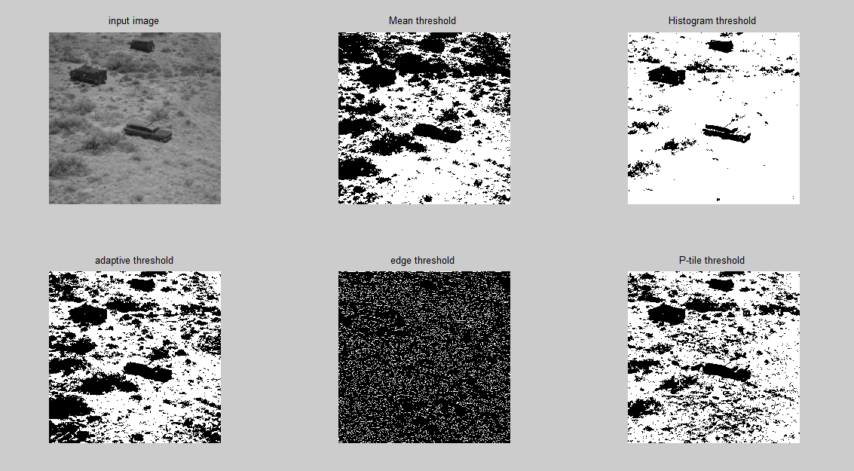

Fig.4 Comparision of thresholding techniques of Tank image from left to right Input image

Table:1 WPR of Tank Image

Thresholding techniques | Black to white pixel ratio | WPR (%AGE)
Mean | 113663:148481 | 56.64
Histogram | 24660:237484 | 90.05
Edge | 224499:37645 | 14.36
Variable | 107002:155142 | 59.18
P-tile | 80919:181225 | 69.13
- Couple image
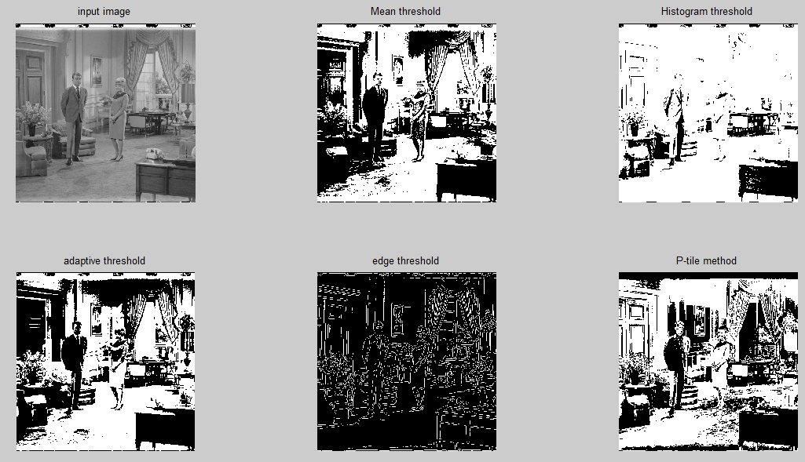
Fig.5 Comparision of thresholding techniques of Couple image from left to right Input image.

Table:2 WPR of Couple Image

Thresholding techniques | Black to white pixel ratio | WPR(%AGE)
Mean | 121031:141113 | 53.83
Histogram | 43302:218842 | 83.48
Edge | 235688:26456 | 10.09
Variable | 127356:134788 | 51.41
P-tile | 118882:143262 | 54.65

- Girl image
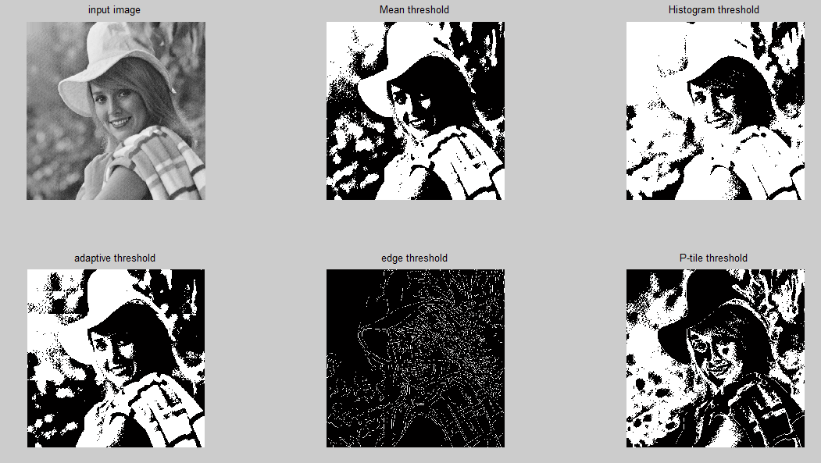
Fig.6 Comparision of thresholding techniques of Girl image from left to right Input image.
Table:3 WPR of Girl Image

Thresholding techniques | Black to white pixel ratio | WPR(%AGE)
Mean | 133411:128733 | 49.10
Histogram | 7313:189031 | 72.10
Edge | 243815:18329 | 6.99
Variable | 131864:130280 | 49.69
P-tile | 162299:99845 | 38.08

D Plane image
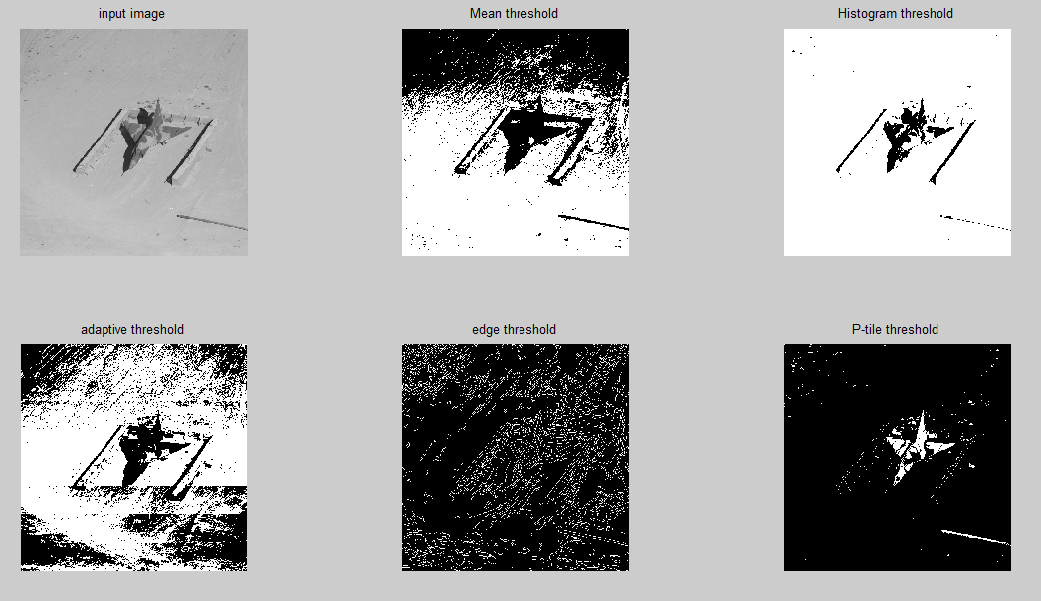

Fig.7 The comparision of thresholding techniques of Girl image from left to right Input image.
Table:4 WPR of Plane Image

Thresholding techniques | Black to white pixel ratio |  | WPR(%AGE)
Mean | 98994:163150 | 62.23
Histogram | 9988:252156 | 96.18
Edge | 238387:23757 | 9.06
Variable | 87898:174246 | 66.46
P-tile | 254746:7398 | 2.82

Conclusion
From the above tables it is observed that Mean thresholding and Histogram thresholding methods show better WPR. The image having more number of white pixels is considered good binary image. In mean thresholding, threshold is chosen by calculating mean of pixel value. The calculated mean becomes threshold value for image. In histogram thresholding, the mid-point method is used to calculate threshold. The mid- point method is also called as global thresholding method. The Calculated value becomes threshold for whole image. From the images it is analyzed that the unwanted information from the image is easily removed. The object and the background is easily separated. Variable thresholding manages to get the borders of the shapes slightly more correct, but also produces a little more junk. From the above results we conclude that in histogram thresholding WPR is appreciable as compared to other methods.

REFERENCES
[1] Salem Saleh Al-amri, N.V. Kalyankar and Khamitkar S.D,“Image Segmentation by Using Thresholding Techniques”, journal of computing, vol. 2, issue 5, may 2010, ISSN 2151-9617.
[2] Orlando J. Tobias and Rui Sear,“Image Segmentation by Histogram Thresholding Using Fuzzy Sets”, IEEE Transactions On Image Processing, vol. 11, NO. 12, December 2002.
[3] Per Christian Henden, “ Exercise in Computer Vision
A Comparison of Thresholding Methods –NTNU”,20th November 2004.
[4] F. Samopa, A. Asano., “Hybrid Image Thresholding Method using Edge Detection", IJCSNS International Journal of Computer Science and Network Security, vol.9 No.4, PP.292-299, April 2009.
[5] Tranos Zuva, Oludayo O. Olugbara, Sunday
O. Ojo and Seleman M. Ngwira, “Image Segmentation, Available Techniques, Developments and Open Issues”, Canadian Journal on Image Processing and Computer Vision Vol. 2, No. 3, March 2011.
[6] Zhi-Kai Huang, Kwok-Wing Chau, “A New Image Thresholding Method Based on Gaussian Mixture Model” Applied Mathematics and Computation, Vol. 205, No. 2, 2008, pp 899-907.
[7] Omar Banimelhem and Yahya Ahmed Yahya
“Multi-Thresholding Image Segmentation Using Genetic
Algorithm”.Segmentation: Region and Boundary Information Integration. Springer: 408 - 422.

